**Instructions for Starting Jupyter Notebooks**

**1. Logging onto the AOS computers**

When you arrive in the AOS computer lab, you’ll be prompted to enter a username and password to login. You can use “guest” for a username and password to login, but you will not be able to save any of your data. Therefore, you should login with your UCLA Bruin-Online ID (e.g. “joebruin”) and your password.

**2. Accessing the Notebooks and data files on Google Drive**

All materials for the AOS51 lab are contained on a Google Drive accessible through the following URL:

<https://drive.google.com/open?id=16ggzqhkBUOUphSkjWjKYoi-DYea20CRf>

In this folder, you will see two sub-folders:

1. *Lectures* – containing all the Jupyter Notebooks used for in-class lectures
2. *Data* – containing all data files for in-class lectures and for the final assignment

**3. Downloading lab materials to your local computer**

We need to download the Jupyter Notebooks and data files to our local computers and move those files into appropriate folders to work with them.

*Step 1: Download file from Google Drive*

In the Lectures or Data folders in the Google Drive, right click on the filename (control + mouse-click) and select “Download”.

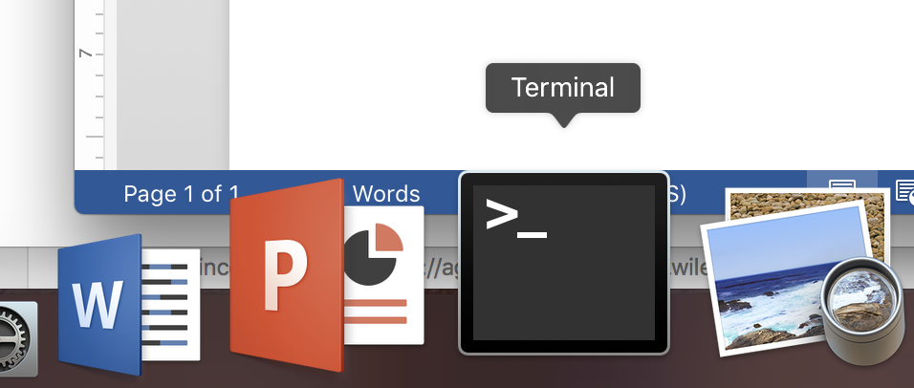*Step 2: Open the Terminal Application*

We will be working on the terminal command line throughout the quarter. First, we need to open a new Terminal shell by opening the Terminal Application, which is a black square with a white carrot prompt symbol in the upper left-hand corner. This application should be located somewhere in the application dock on your screen.

*Step 3: Create a new folder (or “directory”) to store all of your copies of the lab lectures and data files*

Click inside the new Terminal shell and type (the >>> means prompt that you’ll enter text after, don’t type-in those arrows):

>>> pwd

“pwd” is a linux command that means print working directory. This shows us where we currently are inside the terminal.

You should see a new line printed in the terminal something like

>>> /Users/nberg/

Of course, “nberg” will be your username (I’ll use “joebruin” from here on out), not mine!

This means that we are inside two folders/directories:

**| Users** (top-level directory)

**| ------- > joebruin** (sub-directory)

Let’s create a new directory called “AOS51” inside of **/Users/joebruin**:

>>> mkdir AOS51

“mkdir” is a linux command that means make directory and the text that follows “mkdir” will be the name of the new directory, in this case “AOS51”.

We now have a directory structure of:

**| Users**

**| ------- > joebruin**

**| ---------------------- > AOS51**

Let’s list the contents of **/Users/joebruin** to see our newly created directory AOS51.

>>> ls

“ls” is a linux command that means list contents of the current directory.

You should see a new line printed beneath the “ls” command that displays the new AOS51 folder.

Next, let’s first change location to the new AOS51 directory and then create two more sub-directories inside AOS51 called “lectures” and “data”.

>>> cd AOS51

“cd” is a linux command that means change directory and the text that follows “cd” will be the name of the new directory that you want to enter, in this case “AOS51”.

We can confirm that we are now in **/Users/joebruin/AOS51** by again entering

>>> pwd

to print the working (or current) directory.

Now that we are inside of **/Users/joebruin/AOS51**, we can create two more sub-directories:

>>> mkdir lectures

>>> mkdir data

This will give us a final directory structure of:

**| Users**

**| ------- > joebruin**

**| ---------------------- > AOS51**

**| ----------------------------------- > lectures**

**| ----------------------------------- > data**

*Step 4: Move the Jupyter Notebooks and data files downloaded from Google Drive into lectures or data directories.*

Everything that we download from the web is stored in a directory called **/Users/joebruin/Downloads**. We need to move or copy the desired files from the Downloads directory to our personal lectures and data directories.

There are two linux commands to move or copy files from where they currently are located (the “source directory”) to where you want them to be (the “target directory”).

The syntax to move or copy is:

>>> mv [source directory path and filename] [target directory]

>>> cp [source directory path and filename] [target directory]

For example:

>>> mv /Users/joebruin/Downloads/AOS51_2019W_#1.ipynb /Users/joebruin/AOS51/lectures

will move the 1st lab lecture file (AOS51_2019W_#1.ipynb) from **/Users/joebruin/Downloads** to **/Users/joebruin/AOS51/lectures.**

NOTE: Do not use spaces when naming files or directories in linux! Instead, use:

* Underscores (e.g. “mkdir final_lab_project”)
* Dashes (e.g. “mkdir final-lab-project”)
* camelCase (e.g. “mkdir finalLabProject”)

*Step 5: Enter the directory storing your Jupyter Notebooks and launch them*

Let’s enter the lectures folder where we moved the downloaded Notebook:

>>> cd /Users/joebruin/AOS51/lectures

OR take a short-cut if you are, for example, already inside of **/Users/joebruin/AOS51**:

>>> cd lectures

Confirm that the Jupyter Notebook is there:

>>> ls

You should see AOS51_2019W_#1.ipynb, for example.

Launch Jupyter Notebook with:

>>> jupyter-notebook

*Step 6: Close Jupyter Notebook connect when finished*

When finished working on the Notebook, return to your terminal shell and type the following command after clicking anywhere in the terminal (you won’t be able to access the command line yet since the Notebook is running on it):

>>> Control + C

This will then prompt you with a question of whether you want to shutdown this notebook server (y/[n])?

Type the letter “y” and hit “Enter”. You should exit the Notebook server and return to the command line prompt. Sometimes you need to type “control + C” again to make that happen, though.

*Step 7: Exit the terminal and logout of computer*

>>> exit

Will exit the terminal session, then you can close the terminal application and logout of your computer.

BONUS: General Linux Information

Getting comfortable with the Linux command line interface is a valuable skill to hone. It will make you a faster and more efficient programmer…and help you understand the guts of computers more!

There are tons of Linux commands, but you only need to know 10-20 to accomplish most of the stuff needed in climate data analyses. Here is a good article going over many of those commands:

<https://maker.pro/linux/tutorial/basic-linux-commands-for-beginners>

BONUS: Learning how to Google questions

Official documentation, stackoverflow and countless blog posts/articles are your roadmaps to learning anything code-related on the web. It all starts with good Google searches.

I usually follow this pattern when searching for help:

[name of language/software] [task I want to do] [possible error message]

So, if I want to learn how to compute the mean in Python, I would google “python compute mean”. The first search result is the Stackoverflow page showing you exactly how to do that.

Stuck on something that is giving you an error message? Copy the message and google it…you’ll be surprised how often that ends up revealing the answer! Of course, first take a moment to read the error message and try to debug your code first ☺.