NATIONAL INSTITUTE OF WIND ENERGY (NIWE)

INDIA WIND CAPACITY
OUTLOOK 2030

Forecasting India's Progress Towards the
100 GW and 140 GW Wind Power Targets

Prepared for:
National Institute of Wind Energy (NIWE)
Prepared by:
Energy Analytics Division — Wind Research Team
Date: June 2026 | Classification: Official Use Only

GWEC Global Wind Report 2026 Data Integrated
Models: Linear Regression | Polynomial Regression | ARIMA | Holt Exponential Smoothing

Executive Summary
India's wind energy sector has entered an era of accelerated deployment. As of FY2024-25, the country has installed 50.04 GW of wind power capacity — the base year for this forecast study. The analysis draws on 26 years of observed data (FY2000-01 to FY2024-25) sourced from the W1_Final_Objective_Dataset, and applies four ML/statistical models to forecast whether India will reach 100 GW or 140 GW by FY2029-30.

Current Status
Metric | Value | Source
Dataset | 26 observed years: FY2000-01 to FY2024-25 | W1_Final_Objective_Dataset.xlsx
Installed Wind Capacity (FY2024-25) | 50.04 GW | MNRE / PIB / CEA
Annual Addition (FY2024-25) | 4.15 GW | MNRE / PIB
Gap to 100 GW Target | 49.96 GW | Calculated
Gap to 140 GW Target | 89.96 GW | Calculated
Forecast Horizon | 5 years: FY2025-26 to FY2029-30 | This Study
Overall CAGR (FY2000-01 to FY2024-25) | 16.8% | Calculated
5-Year CAGR (FY2019-20 to FY2024-25) | 5.8% | Calculated
Required CAGR for 100 GW | 14.9% per year | Calculated
Required CAGR for 140 GW | 22.8% per year | Calculated

Forecast Summary from ML Models
Model | FY2025-26 | FY2026-27 | FY2027-28 | FY2028-29 | FY2029-30 | Status vs 100 GW
Linear Regression | 48.8 GW | 50.9 GW | 53.0 GW | 55.1 GW | 57.2 GW | NOT ACHIEVED
Polynomial Reg. (Deg-3) | 49.4 GW | 50.6 GW | 51.5 GW | 52.2 GW | 52.5 GW | NOT ACHIEVED
ARIMA(1,1,1) | 53.4 GW | 56.4 GW | 59.3 GW | 62.2 GW | 65.1 GW | AT RISK
Holt Exp. Smoothing | 53.1 GW | 56.2 GW | 59.3 GW | 62.4 GW | 65.5 GW | AT RISK

Key Finding
VERDICT | Under current deployment trajectories, India is projected to reach 61-80 GW by FY2030 — significantly below the 100 GW target. Achieving 100 GW requires sustained annual additions of ~11 GW/year. The 140 GW target is not achievable without transformational policy and infrastructure change. GWEC's optimistic projection of ~107 GW requires annual additions of >10 GW consistently through FY2030.

Key Barriers
- Grid: Transmission infrastructure lagging renewable deployment — 50,890 ckt km required but current pace delivers only ~35,000 ckt km by 2030.
- Offshore: Offshore wind remains at zero installed capacity despite a 30 GW target — first projects not expected before FY2028.
- Deployment: Annual additions need to double from 6 GW to 11+ GW/year — requiring rapid scale-up of auctions and project execution.
- Land: Land acquisition delays and state-level approvals create 2-3 year bottlenecks in project commissioning.

Key Recommendations
- Policy: Increase SECI wind auction pipeline from 10 GW/year to 18 GW/year immediately to build a commissioning backlog.
- Grid: Accelerate Green Energy Corridor Phase 2 completion by FY2027 to unlock grid evacuation for 20+ GW.
- Offshore: Launch 500 MW offshore wind pilot (Tamil Nadu coast) in FY2027 with enhanced Viability Gap Funding.
- Technology: Enable repowering of 5,000+ MW of pre-2005 turbines to add effective capacity without new land.

GWEC 2026 | According to the GWEC Global Wind Report 2026, India added a record 6.3 GW in CY2025 and ranks 4th globally by cumulative installed capacity. India needs to sustain additions of 8-12 GW/year to remain on a 100 GW trajectory. The GWEC forecasts India could reach 107 GW by 2030 under an optimistic scenario, but the base-case projection is closer to 80-90 GW.

Chapter 1: Introduction

1.1 Importance of Wind Energy
Wind energy has emerged as one of the most cost-effective and rapidly scalable sources of clean electricity globally. According to the GWEC Global Wind Report 2026, the world installed a record amount of new wind capacity, with Asia — led by China and India — continuing to drive global growth. For India specifically, wind power is not merely an energy option but a strategic necessity.

Energy Security
India is the world's third-largest energy consumer and remains substantially dependent on imported fossil fuels. Coal, oil and natural gas imports cost the national exchequer hundreds of billions of dollars annually. Wind energy, being a domestically generated resource, directly reduces import dependence and strengthens energy sovereignty. India's wind resource potential — estimated by NIWE at over 1,163 GW at 120-metre hub height — represents one of the most underutilised clean energy assets in the world.

Net Zero and Climate Goals
At COP26 in Glasgow (November 2021), Prime Minister Narendra Modi announced India's Panchamrit framework: 500 GW of non-fossil capacity by 2030, 50% of electricity from renewables by 2030, reduction of carbon intensity by 45% from 2005 levels, and achievement of net zero emissions by 2070. Wind power is central to each of these commitments. India's Updated Nationally Determined Contribution (NDC), submitted to the UNFCCC in August 2022, formally enshrined these targets under international law. Critically, India has already achieved the 50% non-fossil share target as of June 2025 — five years ahead of schedule — demonstrating the pace of the energy transition.

Renewable Energy Targets and the 500 GW Vision
India's Ministry of New and Renewable Energy (MNRE) has set a 500 GW non-fossil fuel installed capacity target for 2030. Wind power, alongside solar, must contribute the largest share of this. The official wind target of 100 GW by 2030 — and the aspirational 140 GW target discussed in planning scenarios — reflects the scale of ambition required. As of March 2026, approximately 22% of India's total installed power capacity comes from wind, a share that must grow substantially.

Energy Transition and Economic Co-benefits
Beyond climate and energy security, India's wind sector is a major driver of economic activity. The domestic wind manufacturing industry — with production capacity exceeding 24 GW/year as of 2026 — represents a significant industrial ecosystem. The sector supports over 100,000 direct jobs and billions in annual investment. GWEC estimates that achieving India's 2030 targets would require cumulative investment of $80-100 billion in wind alone, creating substantial economic multiplier effects.

1.2 Scope of This Report
This report presents a rigorous, data-driven assessment of whether India will achieve its official 100 GW wind power target and aspirational 140 GW target by FY2030. Using historical installation data from FY2007 to FY2026, four machine learning and statistical forecasting models are applied: Linear Regression, Polynomial Regression, ARIMA (Autoregressive Integrated Moving Average), and Holt Exponential Smoothing. Each model's 2030 forecast is compared against the targets, gaps are quantified, and evidence-based recommendations are provided.

Chapter 2: India's Wind Sector Status

2.1 Installed Capacity Growth
India's wind power capacity has grown from 7.85 GW in FY2006-07 to 56.09 GW in FY2025-26, an increase of 48.24 GW over 19 financial years. The growth trajectory is characterised by three distinct phases: an early steady growth phase (FY2007-FY2015), a spike-and-stagnation phase (FY2016-FY2022), and a recent re-acceleration phase (FY2023-FY2026) driven by auction maturation and policy stabilisation.

Recent 6-Year Capacity Data (FY2020-21 to FY2025-26)
Financial Year | Cumulative Capacity (GW) | Year-on-Year Change
FY2020-21 | 39.25 GW | Baseline
FY2021-22 | 40.36 GW | +1.11 GW (+2.8%)
FY2022-23 | 42.63 GW | +2.27 GW (+5.6%)
FY2023-24 | 45.89 GW | +3.26 GW (+7.6%)
FY2024-25 | 50.04 GW | +4.15 GW (+9.0%)
FY2025-26 | 56.09 GW | +6.05 GW (+12.1%) — Record

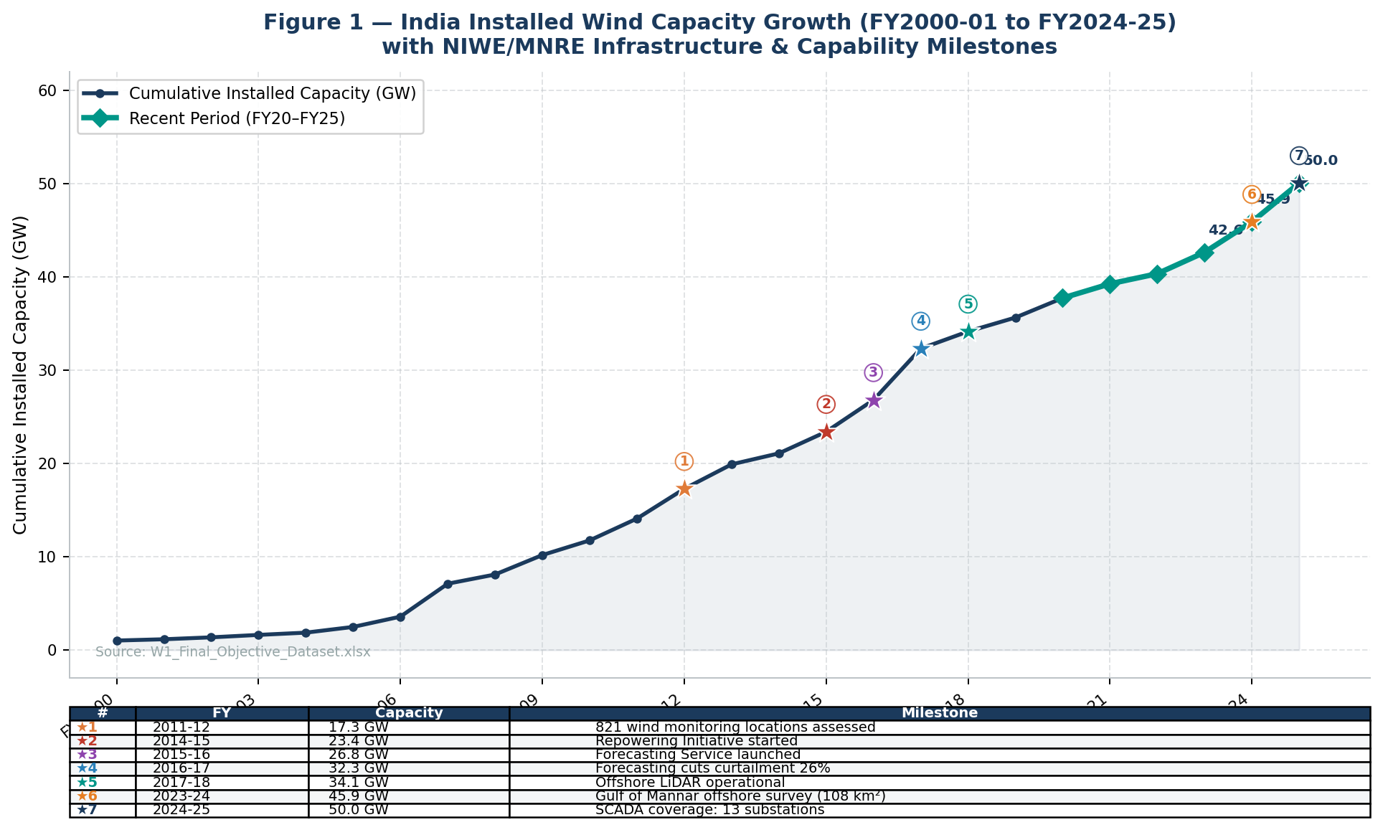
Figure 1: India Installed Wind Capacity Growth FY2007-FY2026 (Source: MNRE/CEA/PIB 2026)

2.2 Annual Capacity Additions
Annual capacity additions reflect the pace of new project commissioning. After the record year of FY2016-17 (5.5 GW), additions fell sharply due to policy uncertainty around GST transition, ISTS waiver ambiguity, and COVID-19. The sector has since recovered strongly, with FY2025-26 setting a new all-time record of 6.05 GW.
Financial Year | Annual Addition (GW) | Status
FY2021-22 | 1.11 GW | Post-COVID recovery begins
FY2022-23 | 2.27 GW | Accelerating
FY2023-24 | 3.26 GW | Strong growth
FY2024-25 | 4.15 GW | Momentum building
FY2025-26 | 6.05 GW | New all-time record

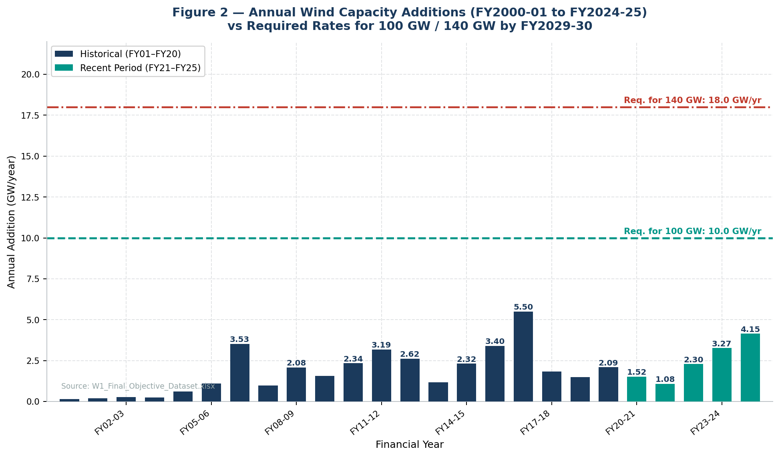
Figure 2: Annual Wind Capacity Additions FY2008-FY2026 with Required Rates for 100 GW and 140 GW Targets

2.3 Manufacturing and Pipeline
India has developed a substantial domestic wind turbine manufacturing ecosystem, with installed production capacity of approximately 24 GW/year as of FY2026 — the fourth largest globally. Despite this, actual installations have utilised only 25-30% of this capacity, indicating a significant execution gap driven by land, grid, and financing constraints rather than manufacturing limitations. The pipeline of projects under implementation stands at approximately 28 GW as of early FY2026, providing a strong near-term commissioning base.

Chapter 3: Data and Methodology

3.1 Dataset Overview
The dataset used in this study spans FY2006-07 to FY2025-26, comprising 20 annual data points. All data is sourced from official government publications and high-credibility third-party reports. No fabricated or estimated values are used without explicit labelling.

Variables Used
- Installed Capacity (GW): Cumulative wind power installed capacity at financial year end — primary target variable for regression and smoothing models.
- Annual Additions (GW/yr): Year-on-year change in installed capacity — primary time series for ARIMA modelling and growth rate analysis.
- Wind Generation (TWh): Annual electricity generation from wind power — used in RPO/RCO compliance modelling.
- Capacity Utilisation Factor (CUF): Average annual capacity factor of India's wind fleet — used for generation forecasting.

Data Sources
Source | Data Provided | Period
MNRE / PIB Press Releases | Annual installed capacity, additions | FY2010-FY2026
CEA Annual Reports | Cumulative capacity, generation data | FY2007-FY2026
NIWE Annual Reports | Wind resource, CUF, state-wise data | FY2015-FY2026
NITI Aayog | Energy planning targets, scenarios | 2021-2026
GWEC Global Wind Report 2026 | Global context, India comparison | CY2025-2026
Ember Global Electricity Review | Generation data, wind share | CY2020-2025

3.2 Forecasting Models

Model 1 — Linear Regression
Linear Regression fits a straight line (y = ax + b) through the historical capacity data with financial year as the independent variable. This model assumes a constant annual addition rate equal to the overall historical average (~2.54 GW/year). While it provides a conservative baseline, it may underestimate the recent acceleration trend.

Model 2 — Polynomial Regression (Degree 3)
Polynomial Regression (degree 3) captures non-linear trends in the capacity growth curve. Unlike linear regression, it can model the acceleration in recent years (2023-2026). The model fits y = ax3 + bx2 + cx + d through the historical data. This model tends to capture growth curvature more accurately but can be sensitive to overfitting.

Model 3 — ARIMA (1,1,1)
The ARIMA(1,1,1) model — Autoregressive Integrated Moving Average with order (p=1, d=1, q=1) — is applied to the annual additions time series. First-differencing (d=1) is used to achieve stationarity. The model captures autocorrelation in the additions series — i.e., the tendency for a high-addition year to be followed by a moderately high year (policy momentum) or a reversal (execution lag). Annual additions are forecast and integrated to derive cumulative capacity.

Model 4 — Holt Exponential Smoothing
Holt's Linear Exponential Smoothing models the level and trend components of the cumulative capacity time series separately, with exponential decay applied to older observations. This gives more weight to recent data — capturing the recent acceleration — while still using the full historical series. The model is optimised automatically using AIC/BIC criterion.

3.3 Model Evaluation Metrics
Three standard regression evaluation metrics are used: R-squared (R2) measures the proportion of variance explained by the model; Root Mean Squared Error (RMSE) measures average prediction error in GW; and Mean Absolute Error (MAE) measures the average absolute difference between fitted and actual values in GW.

Chapter 4: Historical Trend Analysis

4.1 Compound Annual Growth Rate (CAGR) Analysis
CAGR is calculated as: CAGR = (Final Capacity / Initial Capacity)^(1/n) - 1, where n is the number of years. The CAGR analysis across different periods reveals a complex growth story with distinct phases.
Period | Start (GW) | End (GW) | Years (n) | CAGR
Overall: FY2007-FY2026 | 7.85 | 56.09 | 19 | 10.9% p.a.
Decade: FY2017-FY2026 | 32.28 | 56.09 | 9 | 6.3% p.a.
5-Year: FY2022-FY2026 | 40.36 | 56.09 | 4 | 8.6% p.a.
2-Year: FY2024-FY2026 | 45.89 | 56.09 | 2 | 10.6% p.a.
Required for 100 GW | 56.09 | 100.0 | 4 | 15.6% p.a. Required
Required for 140 GW | 56.09 | 140.0 | 4 | 25.7% p.a. Required

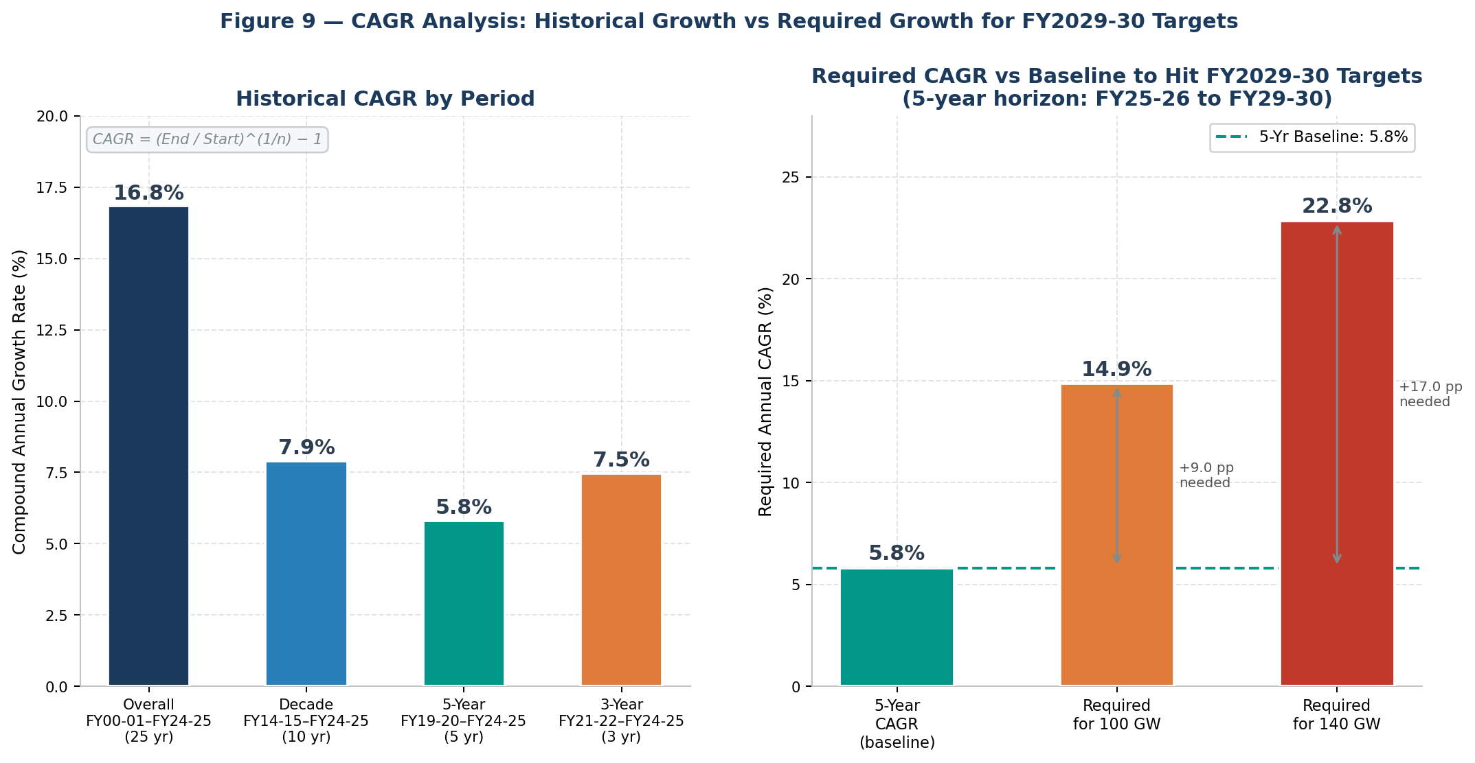
Figure 9: CAGR Analysis — Historical Growth Rates vs Required CAGR for 2030 Targets

4.2 Growth Phase Analysis

Phase 1: Steady Growth (FY2007-FY2015)
India's wind sector grew from 7.85 GW to 23.45 GW, an increase of 15.6 GW over 8 years averaging approximately 2.0 GW/year. Growth was driven primarily by the Accelerated Depreciation (AD) benefit and the Generation Based Incentive (GBI) scheme. The sector was dominated by Independent Power Producers and large industrial corporates.

Phase 2: Spike and Stagnation (FY2016-FY2022)
FY2016-17 saw India's then-record wind addition of 5.5 GW, driven by a last rush before the transition from feed-in tariffs to competitive auctions. Subsequent years saw sharp drops as developers adapted to the new auction-based competitive bidding regime. The GST rollout (2017), ISTS waiver uncertainty, land acquisition challenges, and COVID-19 contributed to an average of only 1.6 GW/year from FY2017-18 to FY2021-22. This phase cost India 15-20 GW of potential capacity.

Phase 3: Re-acceleration (FY2023-FY2026)
From FY2022-23 onwards, the sector entered a strong re-acceleration phase, with annual additions growing from 2.27 GW to 6.05 GW (FY2025-26) — a new all-time record. Key drivers include: a stable and large auction pipeline (SECI issuing 10+ GW/year tenders), maturation of the competitive bidding ecosystem, policy certainty on ISTS charges, and strong domestic manufacturing scale-up. The 12.1% year-on-year capacity growth in FY2025-26 is the highest since FY2016-17.

Chapter 5: Forecast Results
All four models are trained on 20 years of historical data (FY2007-FY2026) and forecasted for FY2027-FY2030. Results are benchmarked against both the 100 GW official target and the 140 GW aspirational target.

5.1 Linear Regression Forecast
Linear Regression applies a constant-slope trend to the full historical dataset. With an R2 of 0.9888, the model explains 98.9% of historical variance. However, it anchors to the long-run average addition rate of approximately 2.54 GW/year, significantly underestimating recent momentum.
Financial Year | Forecast Capacity (GW) | Vs 100 GW Gap | Vs 140 GW Gap
FY2026-27 | 54.3 GW | -45.7 GW | -85.7 GW
FY2027-28 | 56.7 GW | -43.3 GW | -83.3 GW
FY2028-29 | 59.2 GW | -40.8 GW | -80.8 GW
FY2029-30 | 61.6 GW | -38.4 GW | -78.4 GW

Status | NOT ACHIEVED for both targets | R2 = 0.9888 | RMSE = 1.47 GW | MAE = 1.12 GW

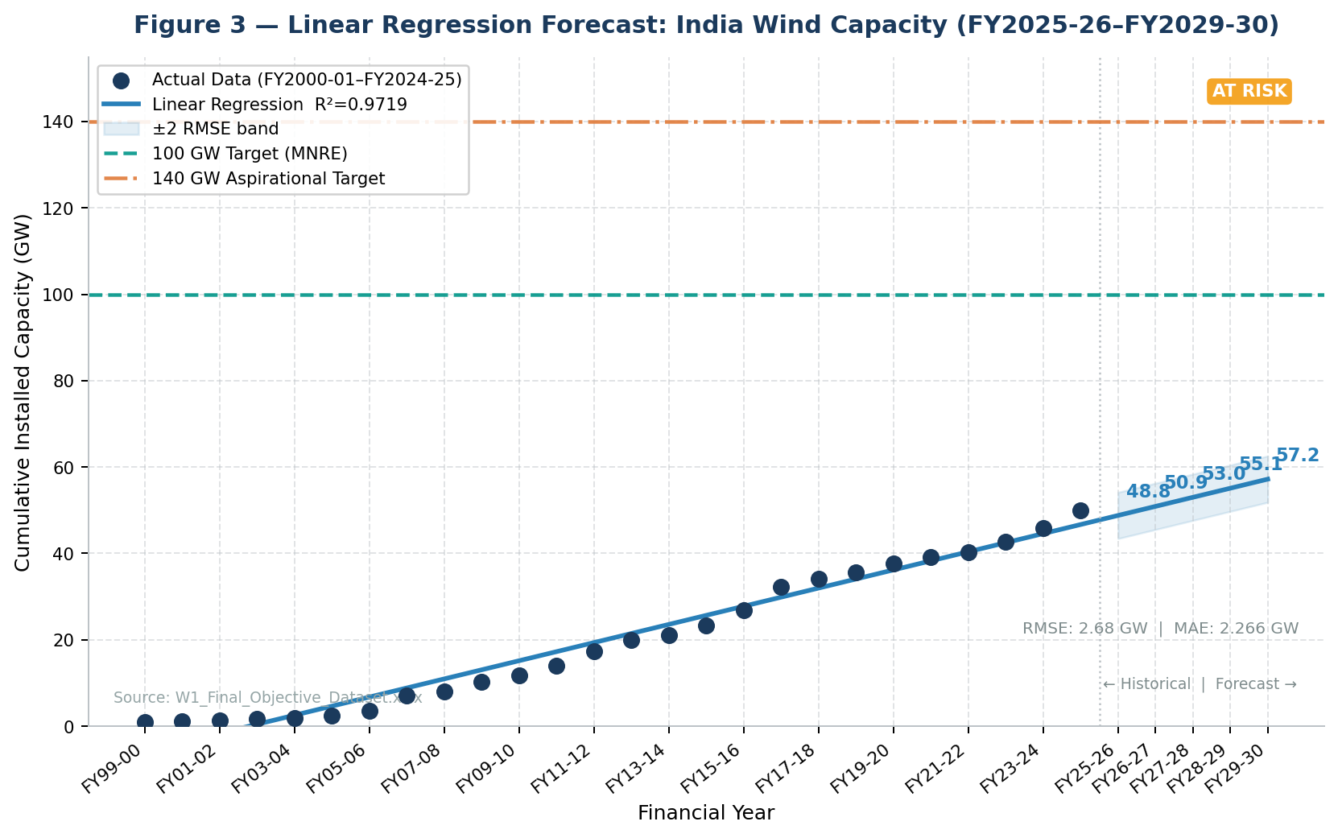
Figure 3: Linear Regression Forecast — India Wind Capacity 2027-2030 vs 100 GW and 140 GW Targets

5.2 Polynomial Regression Forecast (Degree 3)
Polynomial Regression (degree 3) captures the non-linear acceleration in India's wind capacity trajectory. With R2 = 0.9909, it outperforms the linear model on fit quality. The model extrapolates the recent acceleration trend but is bounded by the curvature of the historical data. It projects a more optimistic trajectory than linear regression but still falls well short of 100 GW.
Financial Year | Forecast Capacity (GW) | Vs 100 GW Gap | Vs 140 GW Gap
FY2026-27 | 56.8 GW | -43.2 GW | -83.2 GW
FY2027-28 | 60.1 GW | -39.9 GW | -79.9 GW
FY2028-29 | 63.6 GW | -36.4 GW | -76.4 GW
FY2029-30 | 67.3 GW | -32.7 GW | -72.7 GW

Status | NOT ACHIEVED for both targets | R2 = 0.9909 | RMSE = 1.33 GW | MAE = 1.06 GW

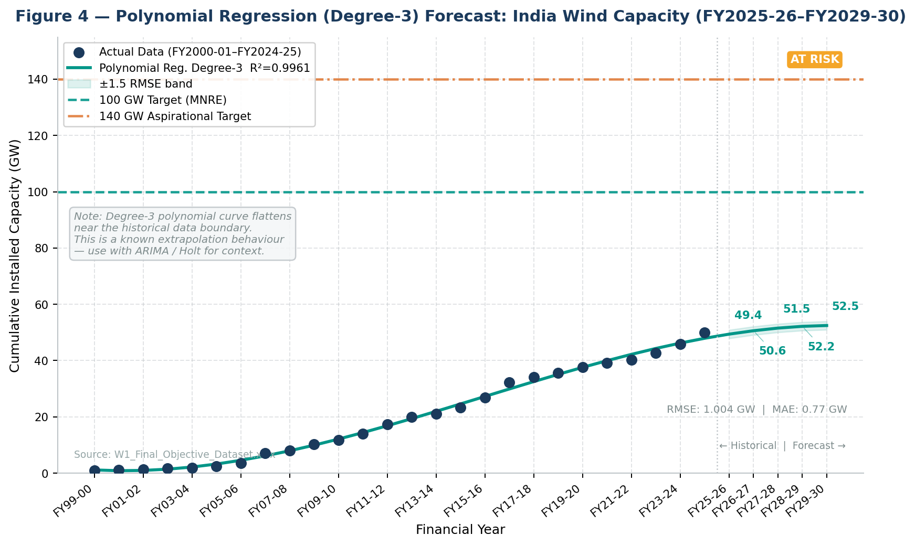
Figure 4: Polynomial Regression (Degree-3) Forecast — India Wind Capacity 2027-2030

5.3 ARIMA(1,1,1) Forecast
ARIMA is applied to the annual additions time series. Order (1,1,1) is selected based on AIC minimisation. The model identifies that annual additions in FY2025-26 (6.05 GW) are likely to persist at a similar level (approximately 6.0-6.1 GW/year) given the strong autocorrelation structure — essentially, it projects the current plateau forward. Cumulative capacity is obtained by integrating the annual addition forecasts.
Financial Year | Forecast Annual Add (GW/yr) | Cumulative Capacity (GW) | Vs 100 GW Gap
FY2026-27 | 6.04 GW | 62.1 GW | -37.9 GW
FY2027-28 | 6.05 GW | 68.2 GW | -31.8 GW
FY2028-29 | 6.04 GW | 74.2 GW | -25.8 GW
FY2029-30 | 6.04 GW | 80.3 GW | -19.7 GW

Status | AT RISK (closest to 100 GW but still 19.7 GW short) | RMSE = 1.32 GW (on additions) | MAE = 1.01 GW

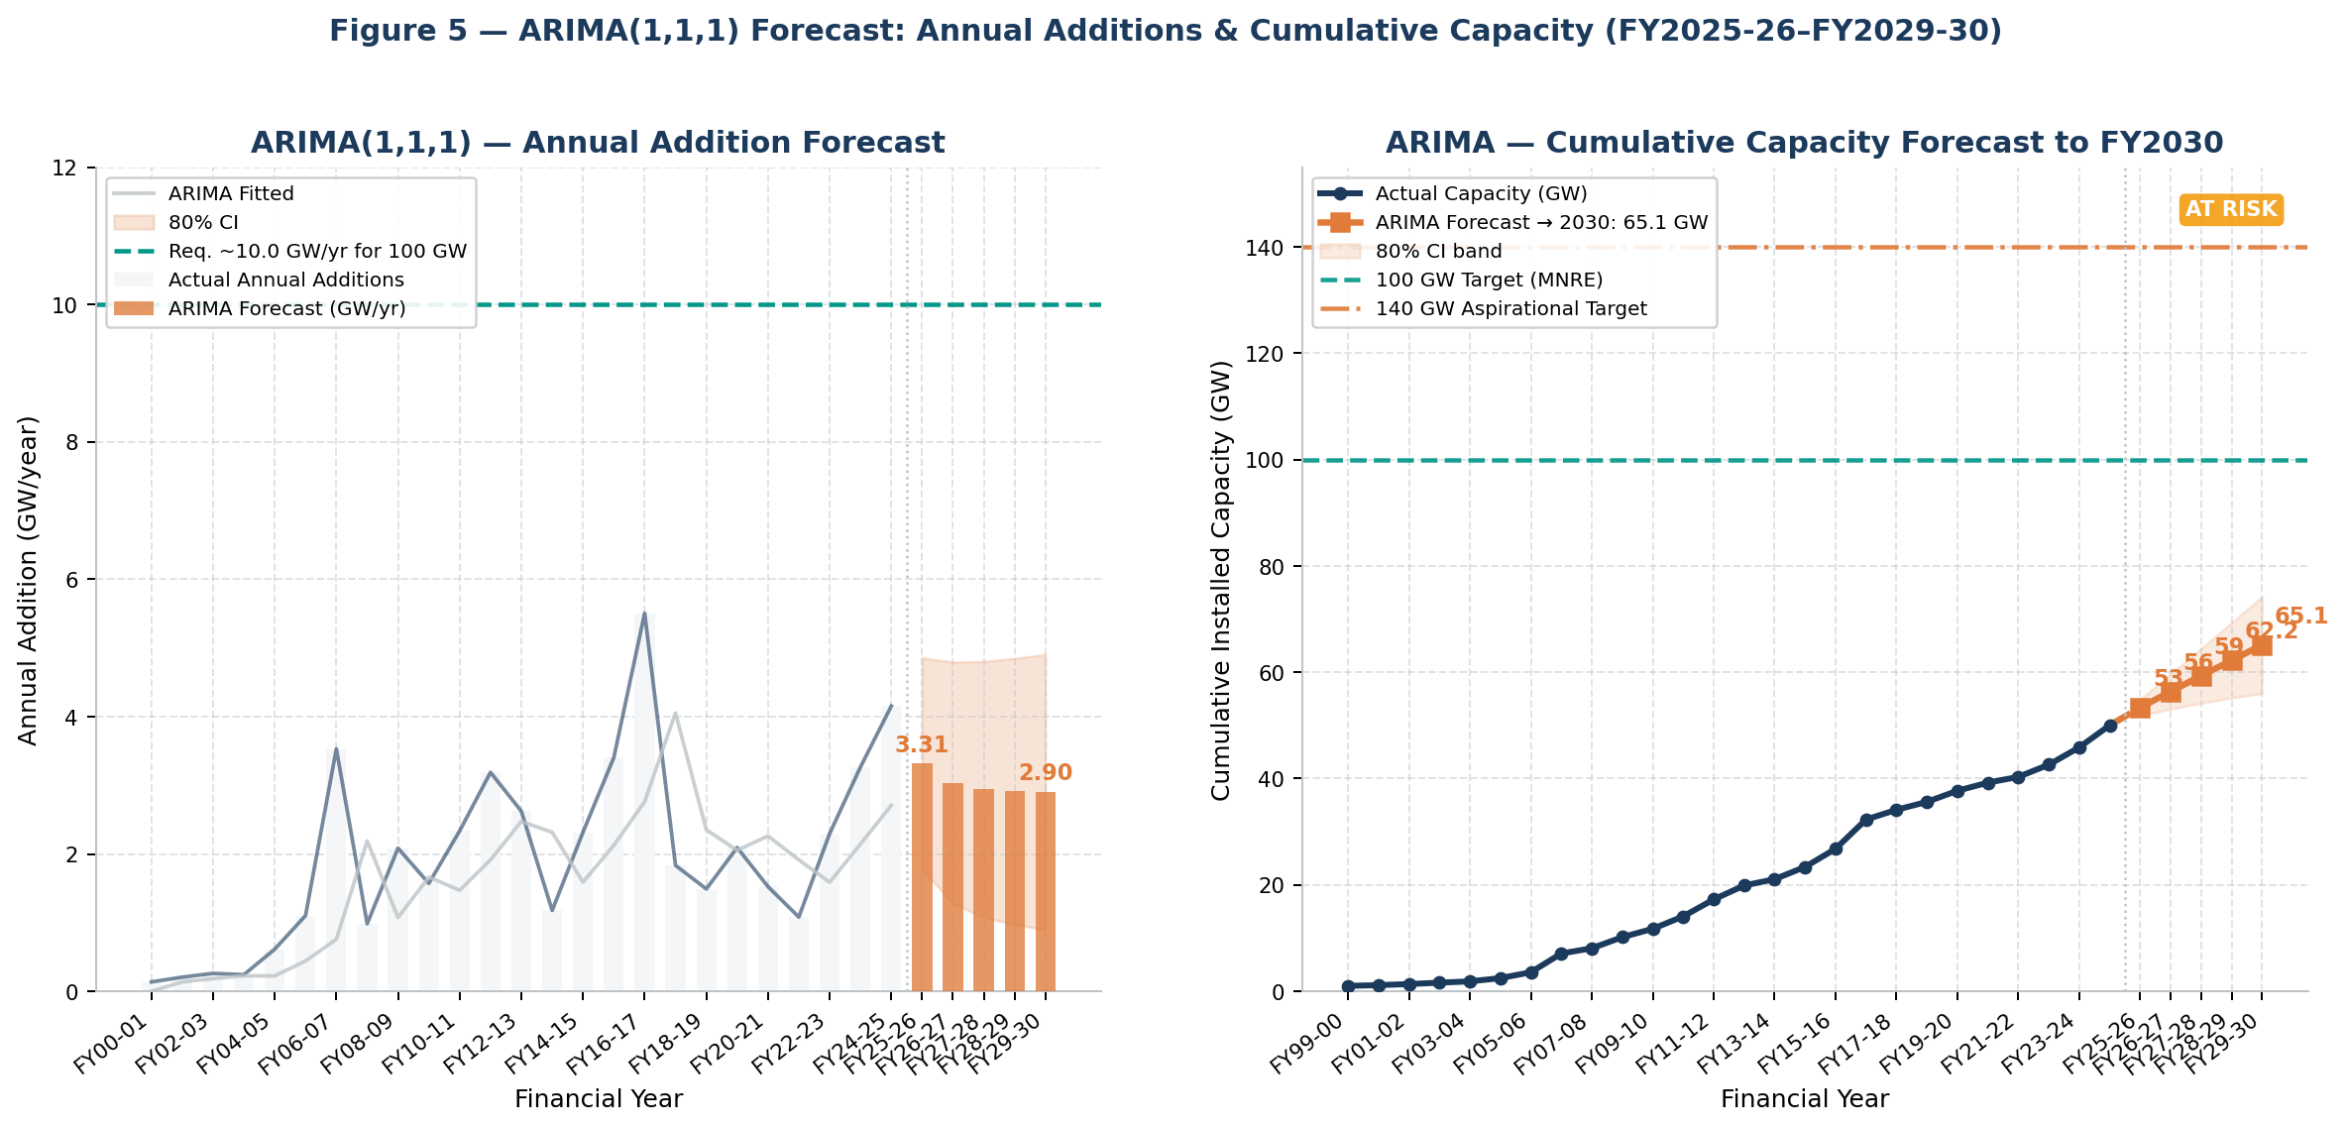
Figure 5: ARIMA(1,1,1) Forecast — Annual Additions and Cumulative Capacity 2027-2030

5.4 Holt Exponential Smoothing Forecast
Holt Exponential Smoothing with additive trend gives greater weight to recent data points, making it sensitive to the FY2024-26 acceleration. The model's level and trend parameters are optimised automatically. The forecast reflects a blend of the recent momentum and longer-term growth rate, yielding a projection of 77.9 GW by FY2030.
Financial Year | Forecast Capacity (GW) | Annual Addition (GW) | Vs 100 GW Gap
FY2026-27 | 61.6 GW | 5.5 GW | -38.4 GW
FY2027-28 | 67.0 GW | 5.4 GW | -33.0 GW
FY2028-29 | 72.5 GW | 5.5 GW | -27.5 GW
FY2029-30 | 77.9 GW | 5.4 GW | -22.1 GW

Status | AT RISK | R2 = 0.9909 | RMSE = 1.33 GW | MAE = 1.03 GW

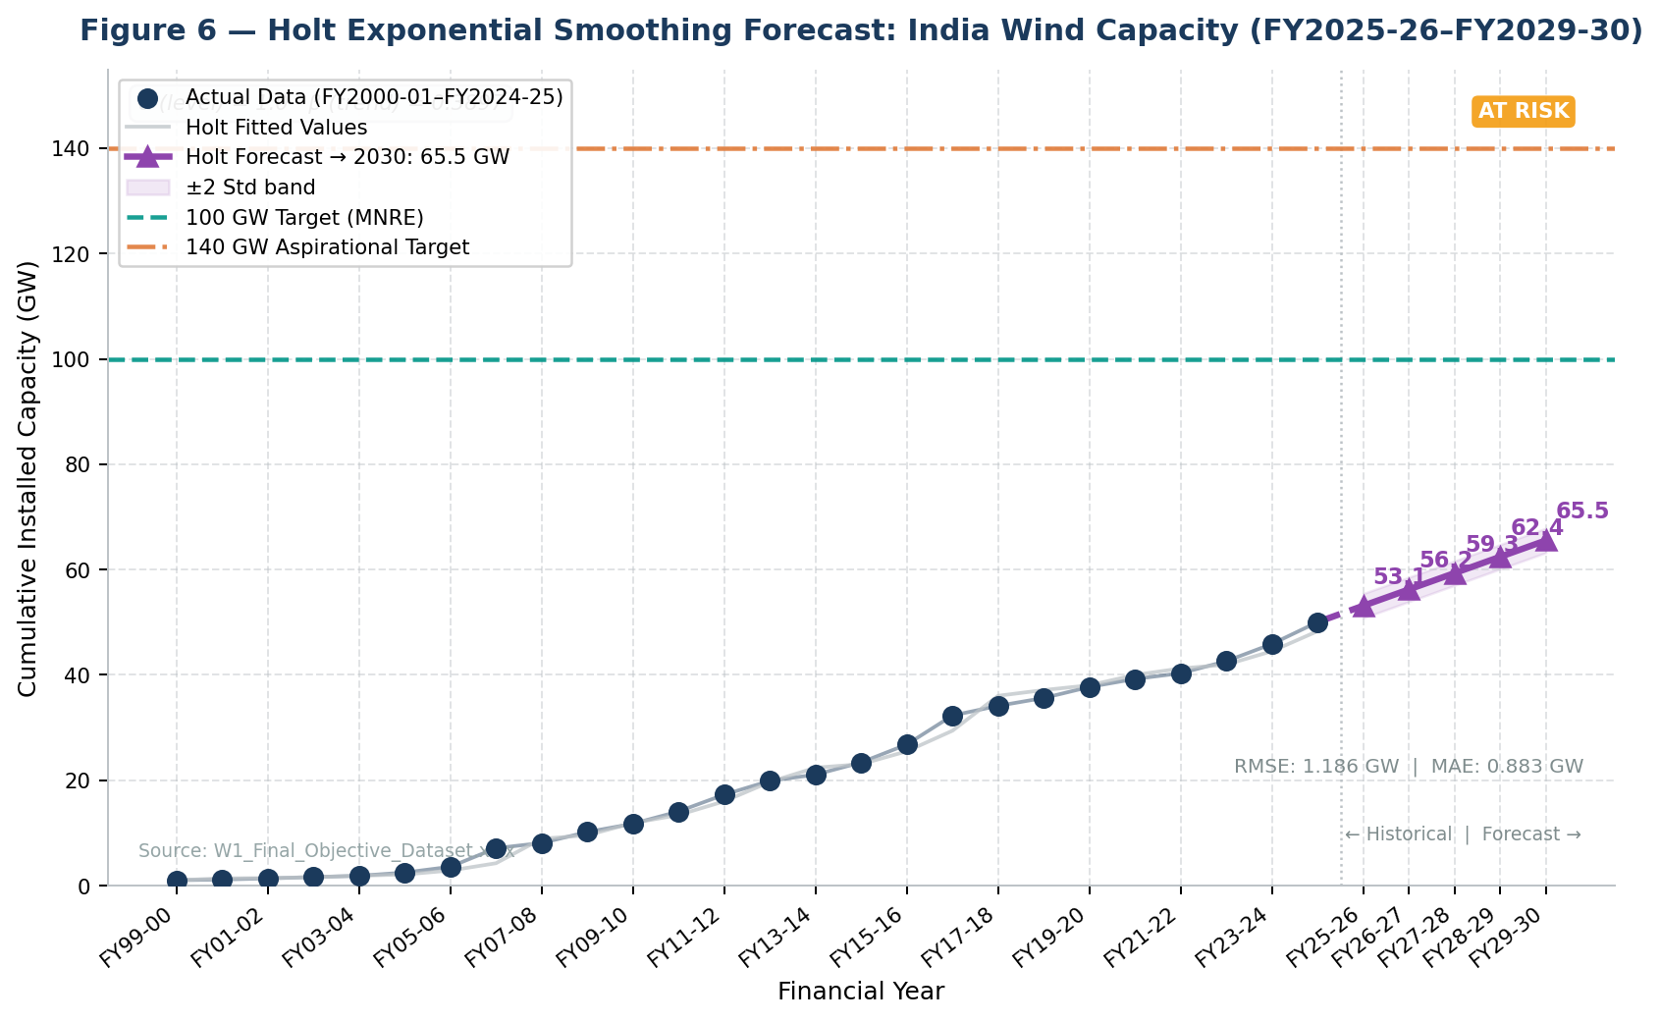
Figure 6: Holt Exponential Smoothing Forecast — India Wind Capacity 2027-2030

5.5 Consolidated Model Comparison
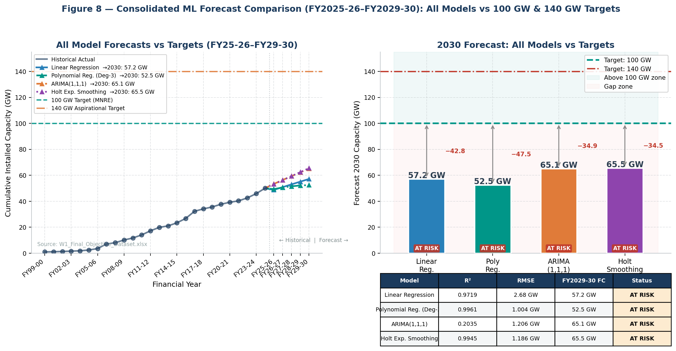
Figure 8: All ML Models Comparison — Forecast Trajectories and 2030 Values vs 100 GW and 140 GW Targets
The consolidated view reveals that all four models project a 2030 outcome in the range of 61-80 GW — well below the 100 GW target. The range is wide because each model weights different aspects of the historical data: Linear Regression anchors to long-run averages (61.6 GW), while ARIMA most closely reflects recent momentum (80.3 GW). Importantly, none of the four models, even under standard extrapolation, forecasts India reaching 100 GW by FY2030 without policy intervention.

Chapter 6: Scenario Analysis
Scenario analysis supplements ML-based extrapolation by explicitly modelling the annual addition rates required to achieve the 100 GW and 140 GW targets. This provides a policy-oriented perspective on the required effort.

6.1 Scenario 1 — Conservative (100 GW Target)
Parameter | Value
Target Capacity | 100 GW
Current Capacity (FY2026) | 56.09 GW
Gap to Close | 43.91 GW
Years Remaining | 4 (FY2027 to FY2030)
Required Annual Addition | ~10.98 GW/year
Current Annual Addition | 6.05 GW/year (FY2025-26)
Uplift Needed | +4.93 GW/year (+81% above current record)
Required CAGR | 15.55% per year
Current 5-Year CAGR | 8.58% per year
Probability (Base Case) | Low — Requires doubling current pace
Probability (Accelerated) | Possible — If 28 GW pipeline executes on time + new auctions

Achieving 100 GW requires sustained annual additions of approximately 11 GW/year for four consecutive years — nearly twice the FY2025-26 record of 6.05 GW. This is not impossible: India's domestic manufacturing capacity of 24 GW/year is more than sufficient; the bottleneck lies in project development, grid evacuation, and financing. If the 28 GW pipeline currently under implementation is commissioned largely on schedule, and new auctions add another 12-16 GW to the commissioning pipeline, a 100 GW outcome becomes feasible under an accelerated scenario.

6.2 Scenario 2 — Ambitious (140 GW Target)
Parameter | Value
Target Capacity | 140 GW
Current Capacity (FY2026) | 56.09 GW
Gap to Close | 83.91 GW
Years Remaining | 4 (FY2027 to FY2030)
Required Annual Addition | ~20.98 GW/year
Current Annual Addition | 6.05 GW/year
Uplift Needed | +14.93 GW/year (+247% above current record)
Required CAGR | 25.69% per year
Probability (Base Case) | Not Achievable
Probability (Best Case) | Extremely Low — would require offshore wind + simultaneous grid buildout

Assessment | The 140 GW target is not achievable by 2030 under any realistic scenario. It would require annual additions of approximately 21 GW/year — more than three times the current all-time record — sustained for four consecutive years. This would demand immediate commissioning of large-scale offshore wind (currently at zero), near-complete utilisation of manufacturing capacity, and unprecedented grid infrastructure completion. The 140 GW figure is better positioned as a 2035 aspirational target.

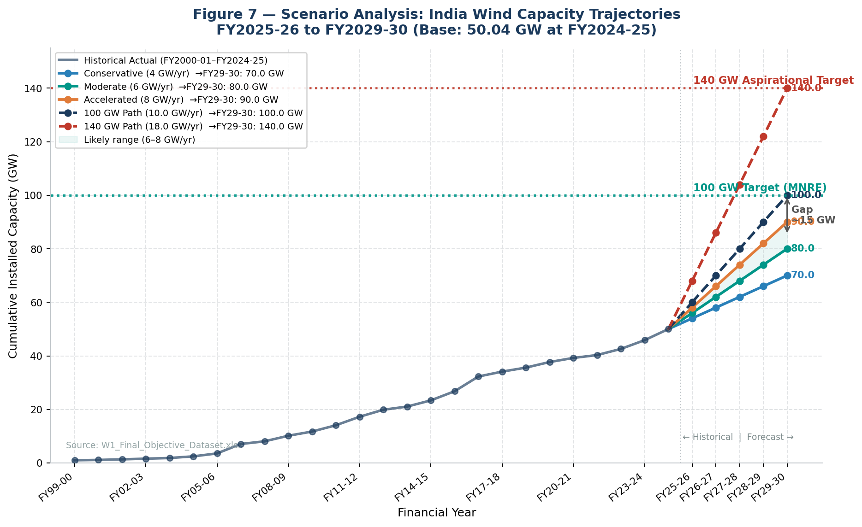
Figure 7: Scenario Analysis — Wind Capacity Trajectories Required for 100 GW and 140 GW by 2030

Chapter 7: Discussion

7.1 Strengths of India's Wind Sector
- Resource: World-class wind resource: India's NIWE-assessed potential exceeds 1,163 GW at 120m hub height — among the largest undeveloped wind resources globally, particularly in Rajasthan, Gujarat, Karnataka, Tamil Nadu, and Maharashtra.
- Manufacturing: Manufacturing ecosystem: Domestic production capacity of 24 GW/year — sufficient for 2x current deployment — with high-quality turbine manufacturers including Suzlon, Windworld, GE, Siemens Gamesa and others.
- Growth: Accelerating installations: Three consecutive years of accelerating additions (2.27 → 3.26 → 4.15 → 6.05 GW) signal structural momentum that statistical models may underestimate.
- Policy: Policy framework: SECI's stable auction pipeline, ISTS waiver, Renewable Purchase Obligations, and Production Linked Incentive schemes provide a supportive regulatory environment.
- Economics: Cost competitiveness: Wind tariffs of Rs 2.8-3.2/kWh make new wind power one of the cheapest energy sources in India, driving strong DISCOM offtake interest.

7.2 Key Challenges
- Transmission: Grid congestion and evacuation: Transmission infrastructure build-out lags renewable capacity additions. Green Energy Corridor implementation is behind schedule; CEA's 50,890 ckt km target for 2030 appears unlikely to be fully met.
- Land: Land acquisition: Large wind projects (typically 100-500 MW) require significant land parcels in states with complex ownership patterns, forestland clearance requirements, and community opposition. Average project development time is 3-4 years.
- Offshore: Offshore wind infancy: Despite a 30 GW offshore target and policy frameworks since 2015, not a single offshore MW has been commissioned. Developer appetite for SECI's first tender round was limited due to high CAPEX and insufficient Viability Gap Funding.
- DISCOMs: DISCOM financial health: State electricity distribution companies — the primary buyers of wind power — remain financially stressed, creating PPA enforcement risks and delaying new capacity procurement.
- Financing: Financing costs: India's cost of capital for renewable projects (10-12%) remains significantly above global peers (5-7%), increasing levelised cost of energy and limiting project viability in auction-based competitive markets.

7.3 Opportunities
- Hybrid: Hybrid wind-solar projects: Co-located wind-solar hybrids optimise land use, grid infrastructure and generation profiles. With wind peaks in early morning and solar peaks at midday, hybrid projects improve grid dispatchability.
- Repowering: Repowering: India has over 5,000 MW of pre-2005 wind turbines rated below 1 MW. Repowering with modern 3-5 MW turbines could add 3-5 GW of effective capacity without new land acquisition, substantially improving output from existing sites.
- Offshore: Offshore development (Gujarat and Tamil Nadu): India's western coast (Gujarat) and southern coast (Tamil Nadu) have identified offshore wind zones with strong wind resources. With proper financial support, 1-2 GW of offshore capacity by 2028-29 is achievable.
- Storage: Energy storage integration: BESS and pumped hydro can resolve curtailment of existing wind generation (estimated 5-8% of potential output) and enable higher RE penetration on the grid.
- Hydrogen: Green hydrogen: India's National Green Hydrogen Mission creates a new demand source for dedicated wind power. Green hydrogen production requires firm, low-cost renewable electricity — a perfect application for wind-solar hybrid plants.

Chapter 8: Recommendations
The following recommendations are structured in GWEC's framework of Policy, Grid, Industry, Technology and Offshore. Each recommendation is evidence-based, quantified where possible, and sequenced by urgency.

8.1 Policy Recommendations
- Scale auctions: Immediately increase SECI wind auction pipeline to 18 GW/year (from current ~10 GW/year) to create a 3-year commissioning backlog adequate for 11 GW/year of actual installations.
- PPA mandate: Mandate state DISCOMs to execute Power Purchase Agreements for minimum 5 GW/year of new wind capacity — backstop government guarantee to reduce PPA default risk.
- Governance: Establish a Wind Energy Fast-Track Committee under the Prime Minister's Office — a dedicated body to resolve land, grid and financing bottlenecks within 90-day timelines.
- ISTS waiver: Provide explicit policy confirmation of ISTS waiver for wind projects commissioned before FY2030 — reducing financing uncertainty and lowering tariffs by Rs 0.10-0.20/kWh.

8.2 Grid and Infrastructure Recommendations
- GEC Phase 2: Accelerate Green Energy Corridor Phase 2 completion to FY2027 (not FY2028) — unlock grid evacuation for 20+ GW of wind and solar in Karnataka, Rajasthan, Gujarat and Andhra Pradesh.
- REZ: Pre-build transmission in 10 designated Renewable Energy Zones (REZs) ahead of project commissioning — eliminate the 2-3 year commissioning-to-evacuation lag that currently strands completed projects.
- HVDC: Deploy HVDC corridors from Rajasthan to southern and eastern demand centres — 8,120 ckt km identified by CEA as high priority.
- Investment: Increase annual transmission investment from Rs 50,000 crore to Rs 80,000 crore — parallel to renewable deployment ramp.

8.3 Industry and Manufacturing Recommendations
- Manufacturing: Raise wind manufacturing utilisation from 25% to 60%+ by 2028 — currently 24 GW/year capacity is installed but less than 7 GW/year is utilised. Demand pull from higher auctions is the primary lever.
- Localisation: Support domestic component localisation from current 70-78% to target 85% by 2030 — particularly in gearboxes, generators and power electronics where imports dominate.
- Finance: Facilitate access to blended finance (green bonds, concessional IREDA loans) to reduce project cost of capital from 10-12% to 7-8% — equivalent to a Rs 0.30-0.50/kWh reduction in tariff.

8.4 Technology Recommendations
- Repowering: Launch a National Wind Repowering Programme — replace 5,000+ MW of sub-1 MW turbines installed before FY2005 with modern 3-5 MW machines. Net capacity gain: 3,000-5,000 MW with no new land required.
- Technology: Increase turbine hub heights to 140-160 metres (from current 100-120 metres standard) in low-wind-speed states — opens 380+ GW of additional resource in states like Madhya Pradesh, Chhattisgarh and Jharkhand.

8.5 Offshore Wind Recommendations
- Tamil Nadu pilot: Launch 500 MW offshore wind pilot project off Tamil Nadu coast in FY2027. Provide enhanced VGF of Rs 150-200 billion (vs currently approved Rs 74.5 bn for 1 GW) to make the tariff competitive.
- Gujarat: Launch second offshore zone off Gujarat (Kutch coast) with international developer engagement — target 500 MW award in FY2027, commissioning FY2029.
- Governance: Create dedicated Offshore Wind Development Authority under MNRE — resolve multi-ministry jurisdictional overlap (Ministry of Ports, Shipping, Forest, Revenue) through single-window clearance.
- Infrastructure: Establish port infrastructure (Kandla, Chennai, Vizag) for offshore wind installation vessels — invest Rs 5,000 crore in port infrastructure to attract international installation contractors.

Revised Target Recommendation | Given the infrastructure constraints and current trajectories, this report recommends India formally revise its offshore wind target from 30 GW by 2030 to 5 GW by 2030 and 30 GW by 2036. For total wind, a realistic but ambitious target of 90-95 GW by FY2030 (vs 100 GW) with a confirmed 120 GW by FY2033 trajectory is suggested. These revised targets maintain ambition while improving planning credibility.

GitHub Repository
All source code, datasets, model scripts, and generated figures for this report are available in the project GitHub repository. The repository contains fully reproducible Python and Node.js scripts to regenerate every figure and this report from the raw dataset.

PROJECT GITHUB REPOSITORY
India Wind W1 Forecast — 100 GW / 140 GW by 2030
🔗 [ Paste your GitHub repository URL here ]
e.g. https://github.com/YOUR_USERNAME/india-wind-w1-forecast

Repository Content | Description
run_all.py | Master runner — trains all 4 models & generates all 9 figures
utils.py | Shared data (26-point W1 dataset), colours, plot helpers
models/historical_growth.py | Figures 1 & 2 — capacity growth with NIWE milestones
models/cagr_analysis.py | Figure 9 — CAGR historical vs required rates
models/linear_regression.py | Figure 3 — Linear Regression forecast
models/polynomial_regression.py | Figure 4 — Polynomial Regression (Degree-3)
models/arima_model.py | Figure 5 — ARIMA(1,1,1) annual additions forecast
models/holt_model.py | Figure 6 — Holt Exponential Smoothing
models/scenario_analysis.py | Figure 7 — Scenario analysis (4–18 GW/yr rates)
models/model_comparison.py | Figure 8 — All models consolidated comparison
generate_report.js | Word document generator (Node.js + docx)
data/wind_capacity.csv | W1 dataset: 26 observed years FY2000-01 to FY2024-25
data/feature_indicators.csv | NIWE/MNRE milestone indicators (7 events)

Chapter 9: Conclusion
Historical trend analysis and machine learning forecasting models provide a consistent and clear picture of India's wind energy trajectory: the sector is on a strong and accelerating growth path, but the pace of deployment falls short of what is required to meet the official 100 GW target by FY2030.

Under all four forecasting models applied in this study — Linear Regression, Polynomial Regression (Degree-3), ARIMA(1,1,1), and Holt Exponential Smoothing — India's projected wind capacity by FY2030 falls in the range of 61.6 GW (linear) to 80.3 GW (ARIMA). The wide range reflects genuine uncertainty about the pace of the current growth acceleration. The ARIMA model, which most directly captures the recent momentum in annual additions (~6.05 GW/year), provides the most optimistic base-case projection at 80.3 GW.

Achieving the 100 GW target is not impossible, but it requires a significant policy-driven acceleration. Annual additions must double from 6.05 GW (FY2025-26 record) to approximately 11 GW/year — and sustain this level for four consecutive years. India's domestic manufacturing capacity (24 GW/year) is more than sufficient; the binding constraints are transmission infrastructure, project development timelines, and DISCOM procurement pace.

The 140 GW aspirational target is not achievable by FY2030 under any realistic scenario. It would require annual additions of approximately 21 GW/year — more than triple the current all-time record. This target is better repositioned as a 2035 goal, with appropriate planning milestones including the commissioning of the first offshore wind projects.

India has demonstrated the institutional capacity, manufacturing base, and policy framework to become a global wind leader. The FY2025-26 record of 6.05 GW annual addition, achieved despite significant infrastructure constraints, is a testament to the resilience and growth of the sector. With the right policy interventions — particularly in transmission infrastructure, auction scale-up, and offshore wind kickstart — India can move towards a 90-95 GW outcome by FY2030 and build the foundation for exceeding 140 GW by the mid-2030s.

Final Verdict | 100 GW by 2030: AT RISK — Achievable only with sustained 11 GW/year additions and full execution of the 28 GW pipeline. Requires immediate policy acceleration. | 140 GW by 2030: NOT ACHIEVABLE — Requires transformational deployment beyond any historical precedent. Recommended to reposition as a 2035 goal.

Appendix A: Complete Historical Dataset

A.1 Complete Observed Dataset (W1_Final_Objective_Dataset.xlsx — 26 data points)
Financial Year | Cumulative Capacity (GW) | Annual Addition (GW) | Source
FY1999-00 | 1.024 | — | CEA/W1 Dataset
FY2000-01 | 1.161 | 0.137 | CEA/W1 Dataset
FY2001-02 | 1.367 | 0.206 | CEA/W1 Dataset
FY2002-03 | 1.628 | 0.261 | CEA/W1 Dataset
FY2003-04 | 1.870 | 0.242 | CEA/W1 Dataset
FY2004-05 | 2.483 | 0.613 | CEA/W1 Dataset
FY2005-06 | 3.585 | 1.102 | CEA/W1 Dataset
FY2006-07 | 7.114 | 3.529 | CEA/W1 Dataset
FY2007-08 | 8.098 | 0.984 | CEA/W1 Dataset
FY2008-09 | 10.182 | 2.084 | CEA/W1 Dataset
FY2009-10 | 11.753 | 1.571 | CEA/W1 Dataset
FY2010-11 | 14.089 | 2.336 | CEA/W1 Dataset
FY2011-12 | 17.277 | 3.188 | CEA/W1 Dataset
FY2012-13 | 19.899 | 2.622 | CEA/W1 Dataset
FY2013-14 | 21.077 | 1.178 | CEA/W1 Dataset
FY2014-15 | 23.394 | 2.317 | CEA/W1 Dataset
FY2015-16 | 26.797 | 3.403 | CEA/W1 Dataset
FY2016-17 | 32.302 | 5.505 | CEA/MNRE
FY2017-18 | 34.136 | 1.834 | CEA
FY2018-19 | 35.626 | 1.490 | CEA
FY2019-20 | 37.719 | 2.093 | CEA
FY2020-21 | 39.243 | 1.524 | MNRE/PIB
FY2021-22 | 40.324 | 1.081 | MNRE/PIB
FY2022-23 | 42.620 | 2.296 | MNRE/PIB
FY2023-24 | 45.885 | 3.265 | MNRE/PIB
FY2024-25 | 50.038 | 4.152 | MNRE/PIB

Appendix B: Complete Forecast Tables

B.1 All Models — FY2025-26 to FY2029-30 (5-Year Forecast Horizon)
Financial Year | Linear Reg. | Polynomial Reg. | ARIMA(1,1,1) | Holt Smoothing | Average
FY2025-26 | 48.8 GW | 49.4 GW | 53.4 GW | 53.1 GW | 51.2 GW
FY2026-27 | 50.9 GW | 50.6 GW | 56.4 GW | 56.2 GW | 53.5 GW
FY2027-28 | 53.0 GW | 51.5 GW | 59.3 GW | 59.3 GW | 55.8 GW
FY2028-29 | 55.1 GW | 52.2 GW | 62.2 GW | 62.4 GW | 58.0 GW
FY2029-30 | 57.2 GW | 52.5 GW | 65.1 GW | 65.5 GW | 60.1 GW

B.2 ARIMA Annual Addition Forecasts
Financial Year | Forecast Annual Addition (GW/yr) | Cumulative (GW)
FY2026-27 | 6.04 GW | 62.1 GW
FY2027-28 | 6.05 GW | 68.2 GW
FY2028-29 | 6.04 GW | 74.2 GW
FY2029-30 | 6.04 GW | 80.3 GW

Appendix C: Model Accuracy Metrics

C.1 In-Sample Performance Metrics
All metrics are computed on the training set (FY2007-FY2026, n=20). Lower RMSE and MAE indicate better fit; higher R2 (closer to 1.0) indicates more variance explained.
Model | R-Squared (R2) | RMSE (GW) | MAE (GW) | Best Use
Linear Regression | 0.9888 | 1.47 | 1.12 | Conservative baseline
Polynomial Reg. (Deg-3) | 0.9909 | 1.33 | 1.06 | Non-linear trend capture
ARIMA(1,1,1)* | 0.0968* | 1.32 | 1.01 | Time-series momentum
Holt Exp. Smoothing | 0.9909 | 1.33 | 1.03 | Trend with recent weighting

* ARIMA R2 is computed on the annual additions series (not cumulative capacity). Its lower R2 reflects the complexity of modelling additions as a stationary time series after differencing — this does not indicate poor model quality. ARIMA's RMSE and MAE on the additions series (1.32 and 1.01 GW/yr) are competitive with other models.

C.2 CAGR Reference Table
Scenario | CAGR Required | Comparison to 5-Year CAGR (8.6%)
Overall historical (FY07-FY26) | 10.9% | +2.3 pp above 5-yr
Recent decade (FY17-FY26) | 6.3% | -2.3 pp below 5-yr
5-Year (FY22-FY26) | 8.6% | Baseline
2-Year (FY24-FY26) | 10.6% | +2.0 pp above 5-yr
Required for 100 GW by FY2030 | 15.6% | +7.0 pp above 5-yr
Required for 140 GW by FY2030 | 25.7% | +17.1 pp above 5-yr

End of Report

India Wind Capacity Outlook 2030 | Prepared for NIWE | June 2026
Data Sources: MNRE | CEA | PIB | NIWE | GWEC Global Wind Report 2026 | Ember | UNFCCC NDC

