# CIA 2503: Web Application Development

# Lab 3/Implementing the Design Features of Bootstrap - SOLUTION

Course Learning Outcome: CLO2- Create rich web-based user interfaces using current standards-compliant client-side web technologies

Chapters: Chapter 3

Cognitive Levels: Apply

Aim: The student should be able to:

* Apply Bootstrap Semantics to implement front-end frameworks for faster and easier web development
* Apply Bootstrap to include HTML and CSS based design templates for typography, forms, etc…….
* Apply Bootstrap Form elements
* Apply Responsive web design (RWD) using Bootstrap

Tools: Laptop, Notepad++, Brackets, Text Editor, Bootstrap CDN

Document Revision Control: 001

|  |  |  |  |  |
| --- | --- | --- | --- | --- |
| Version | Author | Effective Date | Change Description | DRC No |
| 1.0 | Dr. Madeleine Togher | August 2022 | First Version | 001 |

# [MCQ- APPLY LEVEL]

1. Select container class to provide a responsive but full width container size (Content spans whole length of the page) for our web page which uses Bootstrap

a. <div class="container-fluid">

b. <div class="container">

c. <<div class="contains">

d. <<div class="contains-fluid">

2. Which section of code which uses Bootstrap will create a row with 3 equal columns?

a. <div class="row">

<div class="col p-3 bg-primary text-white">.col</div>

<div class="col p-3 bg-dark text-white">.col</div>

<div class="col p-3 bg-primary text-white">.col</div>

</div>

b. <div class="row">

<div class="col p-1 bg-primary text-white">.col</div>

<div class="col p-2 bg-dark text-white">.col</div>

<div class="col p-3 bg-primary text-white">.col</div>

</div>

c. <div class="row">

<div class="col p-3 bg-primary text-white">.col</div>

</div>

d. <div class="row">

<div class="p-3 bg-primary text-white">.col</div>

</div>

# Exercise 1- APPLY LEVEL

*We will use the same theme of the travel Website from Week 2 to demonstrate some of our bootstrap features.*

*Download extract the files which can be found in Week 3 Lab 3. Open file index.html in Brackets++.*

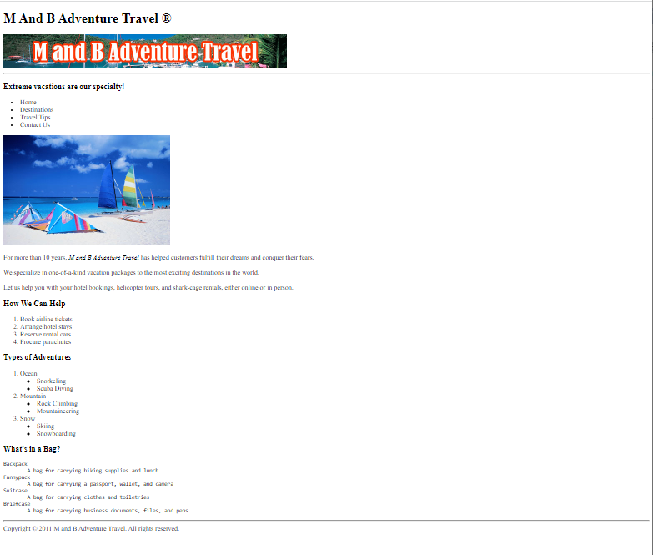

*This web page currently does not use RWD or Bootstrap.*

*Update the html file to include Bootstrap and RWD. Add some codes references to the <head> section. Use* ***CDN*** *for the purpose of this Lab.*

SOLUTION

<head>

<title>M And B Adventure Travel</title>

<meta charset="utf-8">

<meta name="viewport" content="width=device-width, initial-scale=1">

<link href="https://cdn.jsdelivr.net/npm/bootstrap@5.1.3/dist/css/bootstrap.min.css" rel="stylesheet">

<script src="https://cdn.jsdelivr.net/npm/bootstrap@5.1.3/dist/js/bootstrap.bundle.min.js"></script>

</head>

# Exercise 2- APPLY LEVEL

*Place the content of the html page into a container class which will provides a responsive but fixed width container size (Padding for the fixed width).*

*Hint: surround the internal content of the <body> with <div></div> tags and set the container class.*

**SOLUTION**

<body>

<div class="container" >

…..web page content

</div>

</body>

Save your file and preview in the browser to see the notable differences.

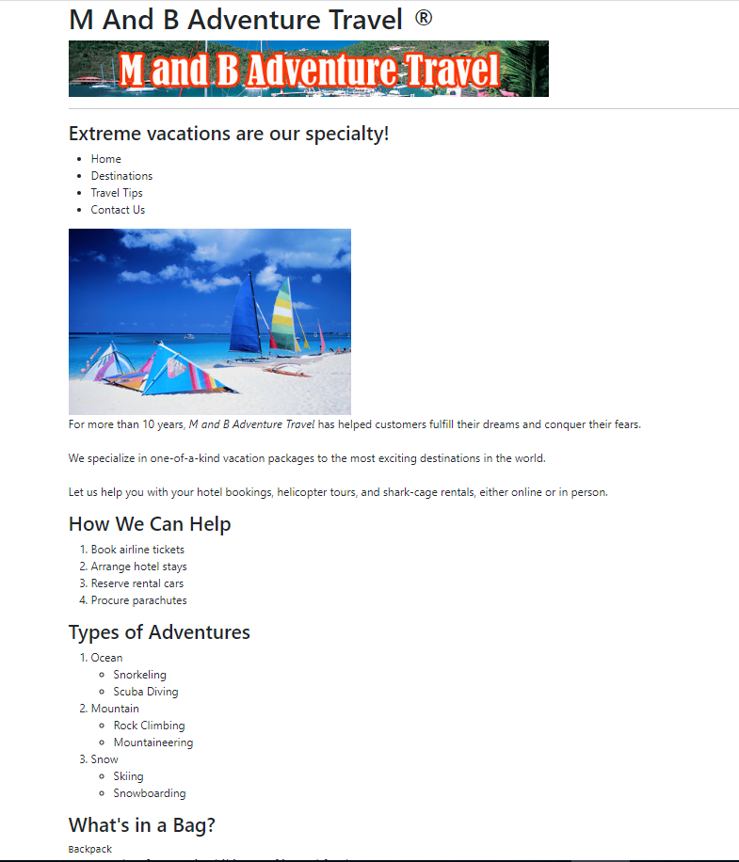

# Exercise 3- APPLY LEVEL

*Let’s alter the 2nd image in our web page. Make it a round circle as shown below.*

*Hint: Add the class directly to the image source code.*

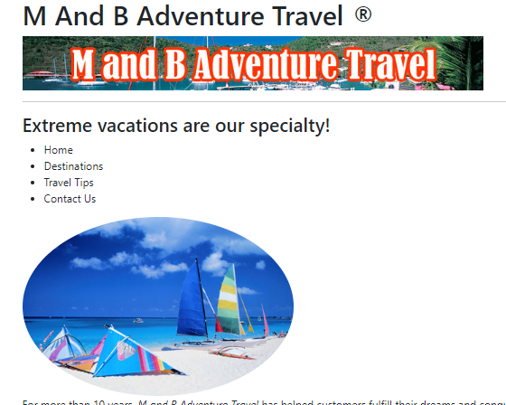

**SOLUTION**

**<img src="windsurfing_boards.JPG" class="rounded-circle">**

# Exercise 4- APPLY LEVEL

*Alter the text color for the <h1> and for all <h3> using Bootstrap. See image below:*

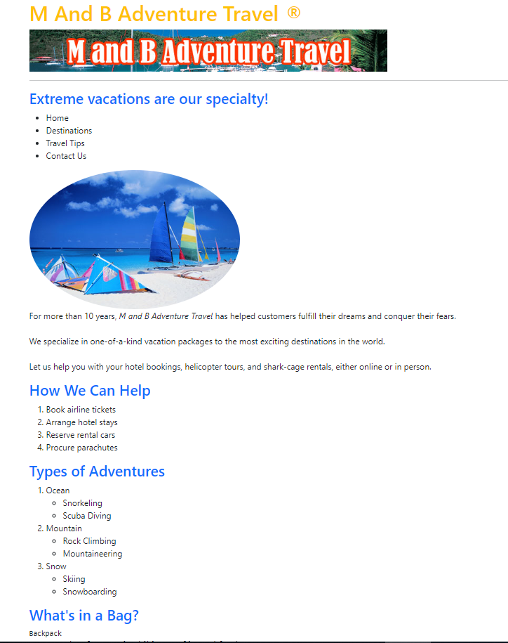

**SOLUTION**

<h1 class ="text-warning">M And B Adventure Travel &reg</h1>

<h3 class ="text-primary">Extreme vacations are our specialty!</h3>

<h3 class ="text-primary">How We Can Help</h3>

<h3 class ="text-primary">Types of Adventures</h3>

<h3 class ="text-primary">What’s in a Bag?</h3>

# Exercise 5- APPLY LEVEL

*Set the back ground of the text to light blue and the foreground writing to white as seen in the image.*

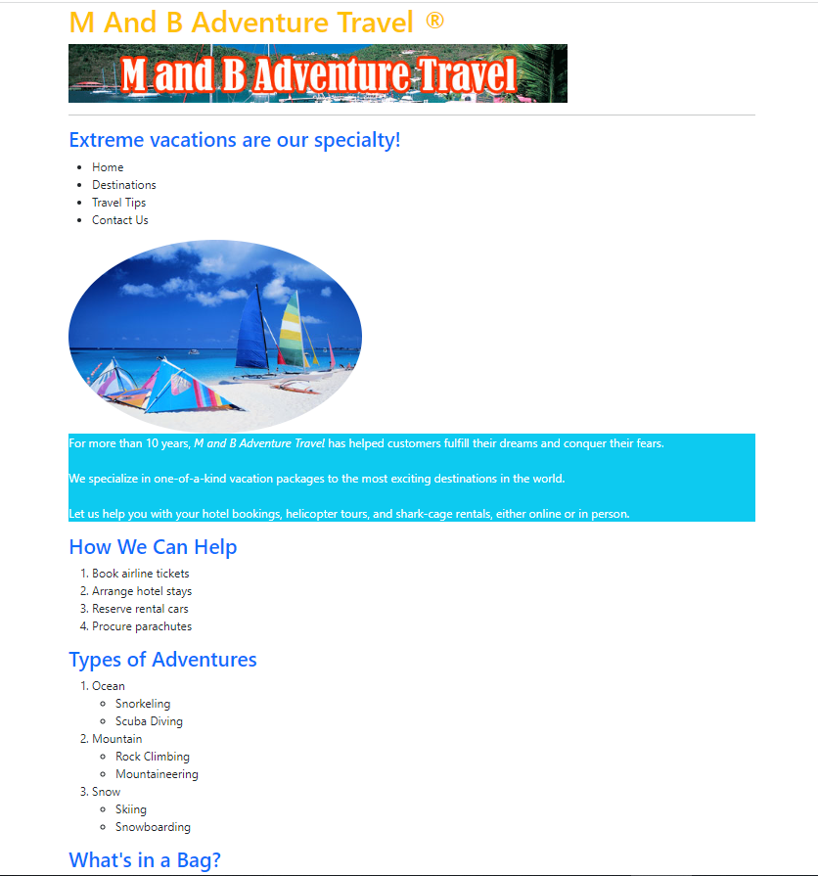

**SOLUTION**

<p **class = "bg-info text-white"**>

For more than 10 years, <i>M and B Adventure Travel</i> has helped customers fulfill their dreams and conquer their fears. <br><br>We specialize in one-of-a-kind vacation packages to the most exciting destinations in the world.<br><br>Let us help you with your hotel bookings, helicopter tours, and shark-cage rentals, either online or in person.

</p>

# Exercise 6- APPLY LEVEL

*Set the text in the list to* ***UPPERCASE*** *and* ***red*** *as seen in the image below:*

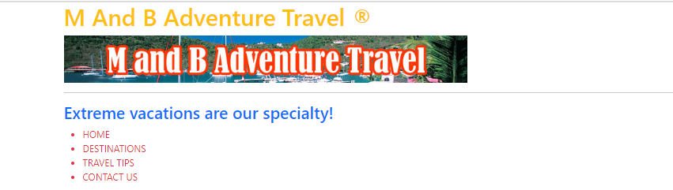

**SOLUTION**

<ul **class="text-uppercase** **text-danger** ">

<li>Home</li>

<li>Destinations</li>

<li>Travel Tips</li>

<li>Contact Us</li>

</ul>

# Exercise 7- APPLY LEVEL

*Add some pagination to your index page as shown below. You will to move between the index page and a Customer Form. We will create the customer form in the next step.*

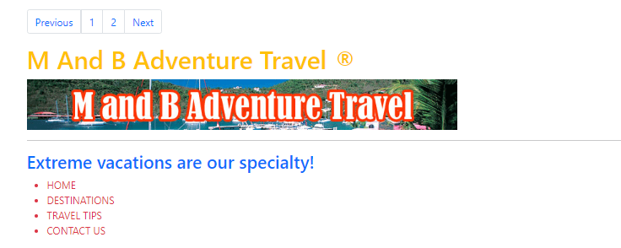

**SOLUTION**

<ul class="pagination">

<li class="page-item"><a class="page-link" href="#">Previous</a></li>

<li class="page-item"><a class="page-link" href="#">1</a></li>

<li class="page-item"><a class="page-link" href="#">2</a></li>

<li class="page-item"><a class="page-link" href="#">Next</a></li>

</ul>

# Exercise 8 - APPLY LEVEL

*Create a basic Customer Registration form which we can link to using our Bootstrap pagination. See below:*

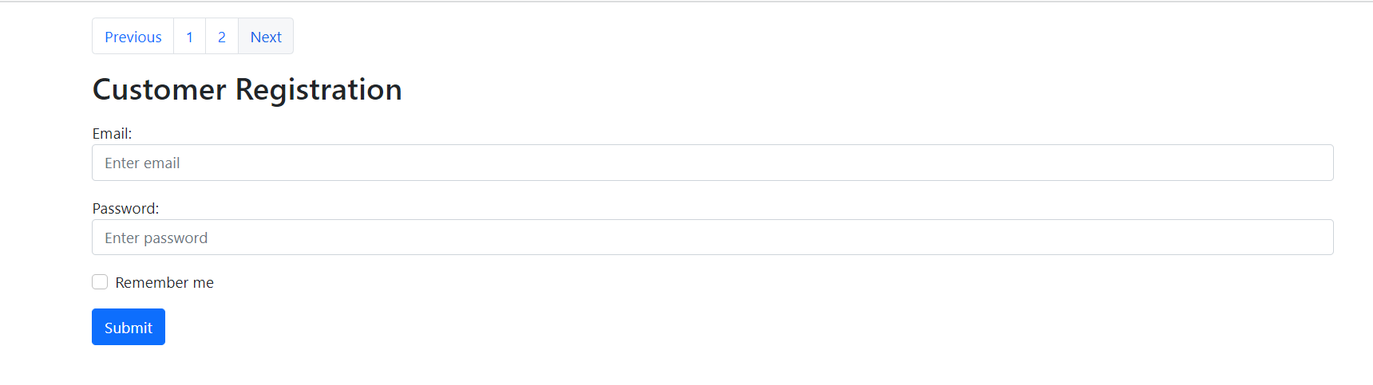

**SOLUTION**

<h2>Customer Registration</h2>

<form action="/action_page.php">

<div class="mb-3 mt-3">

<label for="email">Email :</label>

<input type="email" class="form-control" id="email" placeholder="Enter email" name="email">

</div>

<div class="mb-3">

<label for="pwd">Password :</label>

<input type="password" class="form-control" id="pwd" placeholder="Enter password" name="pswd">

</div>

<div class="form-check mb-3">

<label class="form-check-label">

<input class="form-check-input" type="checkbox" name="remember"> Remember me

</label>

</div>

<button type="submit" class="btn btn-primary">Submit</button>

</form>

# Exercise 9 - APPLY LEVEL

*Update the Pagination code on each of the html pages to move easily back and forward within the website. Hint: html files will need to be saved/located in the same folder*

**SOLUTIONS**

**index.html Pagination**

<ul class="pagination">

<li class="page-item"><a class="page-link" href="**index.html**">Previous</a></li>

<li class="page-item"><a class="page-link" href="**index.html**">1</a></li>

<li class="page-item"><a class="page-link" href="**customer.html**">2</a></li>

<li class="page-item"><a class="page-link" href="**customer.html**">Next</a></li>

</ul>

**customer.html Pagination**

<ul class="pagination">

<li class="page-item"><a class="page-link"href="**index.html**">Previous</a></li>

<li class="page-item"><a class="page-link" href="**index.html**">1</a></li>

<li class="page-item"><a class="page-link" href="**customer.html**">2</a></li>

<li class="page-item"><a class="page-link" href="**customer.html**">Next</a></li>

</ul>

-------------------------------------------------------------------------------------------------------------------------------------

**FINAL SOLUTION - Complete Code**

**index.html**

<!DOCTYPE html>

<html>

<head>

<title>M And B Adventure Travel</title>

<meta charset="utf-8">

<meta name="viewport" content="width=device-width, initial-scale=1">

<link href="https://cdn.jsdelivr.net/npm/bootstrap@5.1.3/dist/css/bootstrap.min.css" rel="stylesheet">

<script src="https://cdn.jsdelivr.net/npm/bootstrap@5.1.3/dist/js/bootstrap.bundle.min.js"></script>

</head>

<body>

<!--start of the body-->

<div class="container mt-3">

<ul class="pagination">

<li class="page-item"><a class="page-link" href="index.html">Previous</a></li>

<li class="page-item"><a class="page-link" href="index.html">1</a></li>

<li class="page-item"><a class="page-link" href="customer.html">2</a></li>

<li class="page-item"><a class="page-link" href="customer.html">Next</a></li>

</ul>

<h1 class ="text-warning">M And B Adventure Travel &reg</h1>

<img src="mbadventure.png" width="680" height="80">

<hr>

<h3 class ="text-primary">Extreme vacations are our specialty!</h3>

<ul class="text-uppercase text-danger">

<li>Home</li>

<li>Destinations</li>

<li>Travel Tips</li>

<li>Contact Us</li>

</ul>

<img src="windsurfing_boards.JPG" class="rounded-circle">

<p class = "bg-info text-white">

For more than 10 years, <i>M and B Adventure Travel</i> has helped customers fulfill their dreams and conquer their fears. <br><br>We specialize in one-of-a-kind vacation packages to the most exciting destinations in the world.<br><br>Let us help you with your hotel bookings, helicopter tours, and shark-cage rentals, either online or in person.

</p>

<h3 class ="text-primary">How We Can Help</h3>

<ol>

<li>Book airline tickets</li>

<li>Arrange hotel stays</li>

<li>Reserve rental cars</li>

<li>Procure parachutes</li>

</ol>

<h3 class ="text-primary">Types of Adventures</h3>

<ol>

<li>Ocean<ul>

<li>Snorkeling

<li>Scuba Diving</ul>

<li>Mountain<ul>

<li>Rock Climbing

<li>Mountaineering</ul>

<li>Snow<ul>

<li>Skiing

<li>Snowboarding</ul>

</ol>

<h3 class ="text-primary">What's in a Bag?</h3>

<pre>

Backpack

A bag for carrying hiking supplies and lunch

Fannypack

A bag for carrying a passport, wallet, and camera

Suitcase

A bag for carrying clothes and toiletries

Briefcase

A bag for carrying business documents, files, and pens

</pre>

<hr>

Copyright &copy 2011 M and B Adventure Travel. All rights reserved.

</div>

</body>

</html>

**customer.html**

<!DOCTYPE html>

<html>

<head>

<title>M And B Adventure Travel</title>

<meta charset="utf-8">

<meta name="viewport" content="width=device-width, initial-scale=1">

<link href="https://cdn.jsdelivr.net/npm/bootstrap@5.1.3/dist/css/bootstrap.min.css" rel="stylesheet">

<script src="https://cdn.jsdelivr.net/npm/bootstrap@5.1.3/dist/js/bootstrap.bundle.min.js"></script>

</head>

<body>

<div class="container mt-3">

<ul class="pagination">

<li class="page-item"><a class="page-link"href="index.html">Previous</a></li>

<li class="page-item"><a class="page-link" href="index.html">1</a></li>

<li class="page-item"><a class="page-link" href="customer.html">2</a></li>

<li class="page-item"><a class="page-link" href="customer.html">Next</a></li>

</ul>

<h2>Customer Registration</h2>

<form action="/action_page.php">

<div class="mb-3 mt-3">

<label for="email">Email:</label>

<input type="email" class="form-control" id="email" placeholder="Enter email" name="email">

</div>

<div class="mb-3">

<label for="pwd">Password:</label>

<input type="password" class="form-control" id="pwd" placeholder="Enter password" name="pswd">

</div>

<div class="form-check mb-3">

<label class="form-check-label">

<input class="form-check-input" type="checkbox" name="remember"> Remember me

</label>

</div>

<button type="submit" class="btn btn-primary">Submit</button>

</form>

</div>

</body>

</html>