**Clockster Dashboard**

Group Project Assignment 2 at Refocus Digital Academy

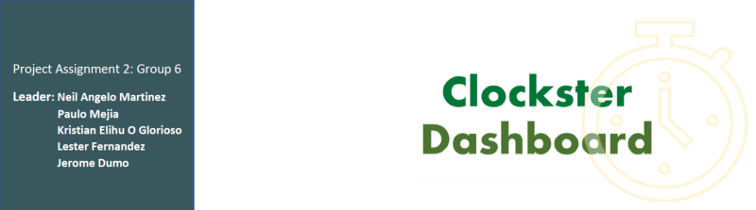The project is an actual task assigned by the company, which provides insight into the work of a real data analyst. Upon completion of the project, the group will receive feedback and be able to add the project to their portfolio, thereby gaining a significant advantage when pursuing a data analytics job.

*Interact with the dashboard here:* <https://www.novypro.com/project/clockster-dashboard-b3g6>

**Overview**

You are working as a data analyst team for the HR department in a medical company. The [data provided by the HR department](https://drive.google.com/file/d/1AXekCqXF4cFlyOm_IEzrNvNgOKW1Qj0a/view) includes 10–15 parameters per day per year (arrival/departure time, vacations, sick days, time off, etc.) on 1000+ employees of the company. Your task is to answer the following questions, which the CEO formulated:

**Business Objectives**

1. Identify the most disciplined and undisciplined employees in divisions;
2. Create a visualization with the analysis of weekdays and months when  
   most employees were late/absent (either for vacation or sick leave);
3. Answer the following questions. Which heads of departments tend to forgive employees for lack of discipline? Are there any favorites for any heads of departments(perhaps some employees are always forgiven for being late, given time off, etc.)?

**Objectives**

1. Use SQL or Excel to clean the data.

2. Find metrics for data manipulation and analysis to answer each business objective.

3. Create a dashboard using Power BI.

4. Recommend improvements based on the insights generated.

**Business Objective 1:**

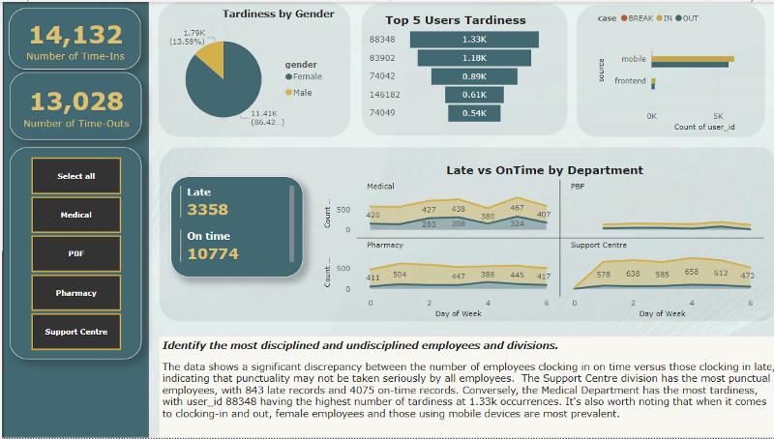

The data shows a significant discrepancy between the number of employees clocking in on time versus those clocking in late, indicating that all employees may not take punctuality seriously. The Support Centre division has the most punctual employees, with 463 late records and 3563 on-time records. Conversely, the Medical Department has the most tardiness, with user_id 74049 having the highest number of tardiness at 542 occurrences. It’s also worth noting that female employees and those using mobile devices are the most prevalent when it comes to clocking-in and out.

**Business Objective 2:**

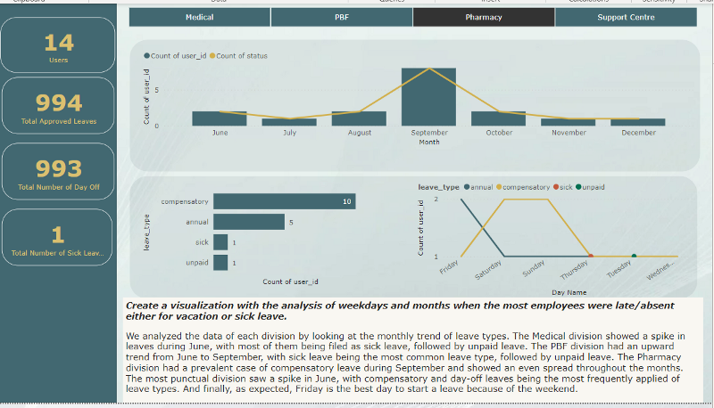

We analyzed the data of each division by looking at the monthly trend of leave types. The Medical division showed a spike in leaves during June, with most of them being filed as sick leave, followed by compensatory leave. The PBF division had an upward trend from June to September, with sick leave being the most common leave type, followed by unpaid leave. The Pharmacy division had a prevalent case of compensatory leave during September and showed an even spread throughout the months. The most punctual division saw a spike in June, with compensatory and day-off leaves being the most frequently applied leave types.

**Business Objective 3:**

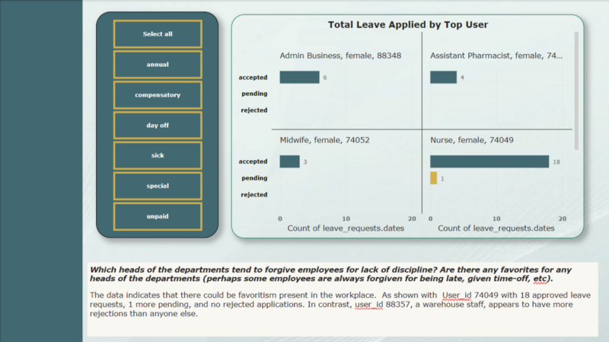

The data indicates that there could be favoritism present in the workplace. As shown with User_id 74049 with 18 approved leave requests, 1 more pending, and no rejected applications. In contrast, user_id 88357, a warehouse staff, appears to have more rejections than anyone else.

**Conclusion**

The analysis revealed specific trends and patterns in terms of attendance, punctuality, and leave requests among employees. The insights and recommendations provided in this project can be used by the organization to improve employee discipline and increase productivity. Additionally, by implementing a system to track and monitor leave requests, overtime or extra work hours, and tardiness among employees, the organization can identify and address specific issues related to employees taking excessive leaves or having high rates of tardiness. The analysis of the data will enable the organization to develop strategies to improve the performance and productivity of its employees.

**Recommendations:**

* Implement stricter policies and consequences for tardiness and early leaving.
* Provide regular training and education on the importance of punctuality and attendance.
* Conduct regular performance evaluations for employees, with a focus on attendance and punctuality.
* Consider implementing a system for employees to request time off in advance to minimize last-minute absences.
* Consider conducting investigations to identify the root cause of high numbers of tardiness, early leaving, and leave requests among specific employees or departments.
* Implement a system of rewards for employees who consistently demonstrate good punctuality and attendance.
* Implement a system to track and monitor leave requests, overtime or extra work hours, and tardiness among employees.
* Consider implementing policies to encourage employees to take their leaves at different periods of the year to avoid peak leave request times.
* Implement a system to monitor the leaves and tardiness of doctors and nurses, as they are vital for a hospital or a health center.

Check out the repository here: <https://github.com/neilangelomartinez/clockster-dashboard>

Visit my website: <https://bit.ly/neilmartinez>  
BI Portfolio: <https://bit.ly/neilmartinez-novypro>  
Check out my other blogs: <https://bit.ly/neilmartinez-medium>  
LinkedIn: <https://bit.ly/neilmartinez-linkedin>