2021 Product Management Survey on the current state-of-practice

[Neil Chalk](https://www.researchgate.net/profile/Neil_Chalk)

2021-02-11

## Organisations

What is the make up of the organisations that the respondents are working in?

|  |  |  |
| --- | --- | --- |
|  | org.industry | org.employees |
|  | Software / IT :36 | < 10 :12 |
|  | Banking / Finance : 9 | 10-49 :16 |
|  | Private / Consumer : 6 | 50-249 :13 |
|  | Retail / Wholesale : 3 | 250-4499:15 |
|  | Medical / Health Care: 2 | >= 4500 :10 |
|  | aquamarine : 1 | NA |
|  | (Other) : 9 | NA |

|  |  |  |  |
| --- | --- | --- | --- |
|  | org.TTM | org.releases | org.prodteamsize |
|  | Less than 4.5 months :27 | More than 12 releases a year :26 | < 4 :22 |
|  | 4.5 months to < 9 months :16 | 5-12 releases a year :18 | 4-9 :21 |
|  | 9 Months to < 18 months :12 | 3-4 releases a year :10 | 10-19 :12 |
|  | More than 18 months : 3 | About 2 releases per year : 5 | 20-49 : 5 |
|  | Don’t know and cannot estimate: 8 | About 1 release per year : 2 | 50-249: 3 |
|  | NA | Less than one release per year: 0 | > 250 : 3 |
|  | NA | No release so far : 5 | NA |

And where are they located?

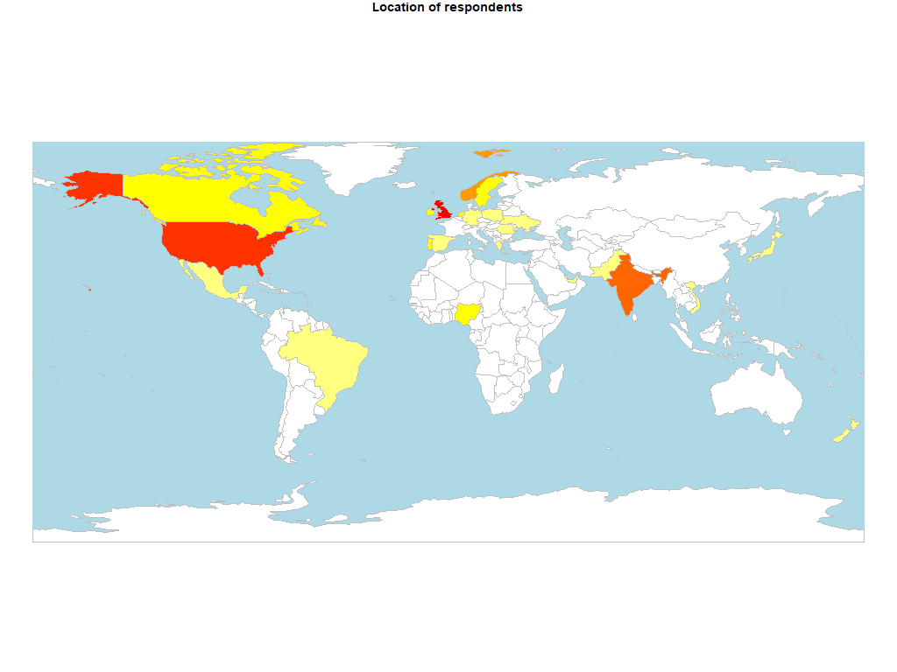

Location of respondents to the survey

## Role

How happy were the respondents with their roadmap process and level of responsibilty in the role?

|  |  |  |  |
| --- | --- | --- | --- |
| Job.title | n | roadmap.happiness | role.happiness |
| Associate/Junior Product Manager | 3 | 3.333333 | 3.666667 |
| CEO | 6 | 3.500000 | 4.500000 |
| Continuous improvement specialist | 1 | 2.000000 | 3.000000 |
| CTO | 5 | 4.800000 | 5.000000 |
| Director of Product Design | 1 | 5.000000 | 4.000000 |
| Engineering Manager | 1 | 5.000000 | 5.000000 |
| FP&A | 1 | 4.000000 | 5.000000 |
| Freelancer ( Products & Growth ) | 1 | 4.000000 | 4.000000 |
| Head of Product/VP/Director/CPO | 10 | 3.500000 | 4.200000 |
| Lead Product Manager | 5 | 4.400000 | 4.400000 |
| Operational Manager | 2 | 5.000000 | 4.000000 |
| Product Consultant | 1 | 4.000000 | 4.000000 |
| Product Manager | 15 | 3.466667 | 3.800000 |
| Product Marketing Manager | 1 | 3.000000 | 5.000000 |
| Senior Product Manager | 12 | 3.666667 | 3.833333 |
| Senior Product Marketing Manager | 1 | 5.000000 | 5.000000 |

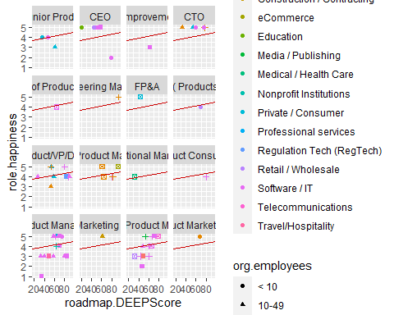

Where do people go to get their information?

|  |  |  |  |  |  |  |  |  |  |
| --- | --- | --- | --- | --- | --- | --- | --- | --- | --- |
| Job.title | Events and conferences | Blogs | Books | Online Communities | Professional Bodies | Professional Certification | Professional Training | Tool Vendor material | Google |
| Associate/Junior Product Manager | 66.66667 | 66.66667 | 33.33333 | 66.66667 | 0.000000 | 33.333333 | 33.33333 | 0.00000 | 0 |
| CEO | 50.00000 | 33.33333 | 16.66667 | 50.00000 | 16.666667 | 0.000000 | 16.66667 | 16.66667 | 0 |
| Continuous improvement specialist | 0.00000 | 0.00000 | 0.00000 | 0.00000 | 0.000000 | 0.000000 | 0.00000 | 0.00000 | 100 |
| CTO | 60.00000 | 60.00000 | 60.00000 | 60.00000 | 20.000000 | 20.000000 | 20.00000 | 40.00000 | 0 |
| Director of Product Design | 0.00000 | 0.00000 | 0.00000 | 100.00000 | 0.000000 | 0.000000 | 0.00000 | 0.00000 | 0 |
| Engineering Manager | 100.00000 | 0.00000 | 0.00000 | 100.00000 | 0.000000 | 0.000000 | 0.00000 | 0.00000 | 0 |
| FP&A | 0.00000 | 0.00000 | 0.00000 | 0.00000 | 0.000000 | 0.000000 | 0.00000 | 100.00000 | 0 |
| Freelancer ( Products & Growth ) | 0.00000 | 100.00000 | 100.00000 | 100.00000 | 0.000000 | 0.000000 | 0.00000 | 0.00000 | 0 |
| Head of Product/VP/Director/CPO | 20.00000 | 80.00000 | 50.00000 | 90.00000 | 0.000000 | 0.000000 | 0.00000 | 10.00000 | 0 |
| Lead Product Manager | 60.00000 | 80.00000 | 60.00000 | 40.00000 | 0.000000 | 0.000000 | 0.00000 | 40.00000 | 0 |
| Operational Manager | 100.00000 | 0.00000 | 0.00000 | 100.00000 | 0.000000 | 100.000000 | 0.00000 | 0.00000 | 0 |
| Product Consultant | 0.00000 | 100.00000 | 100.00000 | 100.00000 | 0.000000 | 0.000000 | 0.00000 | 100.00000 | 0 |
| Product Manager | 40.00000 | 86.66667 | 66.66667 | 80.00000 | 6.666667 | 6.666667 | 26.66667 | 33.33333 | 0 |
| Product Marketing Manager | 0.00000 | 100.00000 | 0.00000 | 0.00000 | 0.000000 | 0.000000 | 0.00000 | 0.00000 | 0 |
| Senior Product Manager | 58.33333 | 66.66667 | 83.33333 | 75.00000 | 8.333333 | 8.333333 | 0.00000 | 41.66667 | 0 |
| Senior Product Marketing Manager | 0.00000 | 100.00000 | 100.00000 | 100.00000 | 0.000000 | 0.000000 | 0.00000 | 100.00000 | 0 |

Which professional bodies are they members of?

|  |  |  |  |  |  |  |  |  |  |
| --- | --- | --- | --- | --- | --- | --- | --- | --- | --- |
| Job.title | ACM | AIPMM | AMI | APM | BCS | IAOIP | ISPMA | PDMA | None |
| Associate/Junior Product Manager | 0 | 0 | 0 | 0 | 0.000000 | 0 | 0.00000 | 0.00000 | 66.66667 |
| CEO | 0 | 0 | 0 | 0 | 0.000000 | 0 | 16.66667 | 16.66667 | 66.66667 |
| Continuous improvement specialist | 0 | 0 | 0 | 0 | 0.000000 | 0 | 0.00000 | 0.00000 | 100.00000 |
| CTO | 0 | 0 | 0 | 0 | 20.000000 | 0 | 0.00000 | 0.00000 | 80.00000 |
| Director of Product Design | 0 | 0 | 0 | 0 | 0.000000 | 0 | 0.00000 | 0.00000 | 100.00000 |
| Engineering Manager | 0 | 0 | 0 | 0 | 0.000000 | 0 | 0.00000 | 0.00000 | 100.00000 |
| FP&A | 0 | 0 | 0 | 0 | 0.000000 | 0 | 0.00000 | 0.00000 | 100.00000 |
| Freelancer ( Products & Growth ) | 0 | 0 | 0 | 0 | 0.000000 | 0 | 0.00000 | 0.00000 | 100.00000 |
| Head of Product/VP/Director/CPO | 0 | 10 | 0 | 0 | 0.000000 | 0 | 0.00000 | 0.00000 | 90.00000 |
| Lead Product Manager | 0 | 0 | 0 | 0 | 0.000000 | 0 | 0.00000 | 0.00000 | 100.00000 |
| Operational Manager | 0 | 0 | 0 | 0 | 0.000000 | 0 | 0.00000 | 0.00000 | 100.00000 |
| Product Consultant | 0 | 0 | 0 | 0 | 0.000000 | 0 | 0.00000 | 0.00000 | 100.00000 |
| Product Manager | 0 | 0 | 0 | 0 | 6.666667 | 0 | 0.00000 | 0.00000 | 73.33333 |
| Product Marketing Manager | 100 | 0 | 0 | 0 | 0.000000 | 0 | 0.00000 | 0.00000 | 0.00000 |
| Senior Product Manager | 0 | 0 | 0 | 0 | 0.000000 | 0 | 0.00000 | 0.00000 | 75.00000 |
| Senior Product Marketing Manager | 0 | 0 | 0 | 0 | 0.000000 | 0 | 0.00000 | 0.00000 | 100.00000 |

## Roadmap

How mature were the roadmap processes by job title of respondent? Also did happiness with the roadmap process lead to a higher maturity score?

|  |  |  |  |
| --- | --- | --- | --- |
| Job.title | n | roadmap.DEEPScore | roadmap.mat_level |
| Associate/Junior Product Manager | 3 | 48.00000 | 3.333333 |
| CEO | 6 | 50.33333 | 3.166667 |
| Continuous improvement specialist | 1 | 62.00000 | 4.000000 |
| CTO | 5 | 59.80000 | 3.600000 |
| Director of Product Design | 1 | 64.00000 | 4.000000 |
| Engineering Manager | 1 | 94.00000 | 5.000000 |
| FP&A | 1 | 43.00000 | 3.000000 |
| Freelancer ( Products & Growth ) | 1 | 69.00000 | 4.000000 |
| Head of Product/VP/Director/CPO | 10 | 67.20000 | 3.900000 |
| Lead Product Manager | 5 | 76.00000 | 4.200000 |
| Operational Manager | 2 | 32.00000 | 3.000000 |
| Product Consultant | 1 | 80.00000 | 4.000000 |
| Product Manager | 15 | 60.86667 | 3.800000 |
| Product Marketing Manager | 1 | 61.00000 | 4.000000 |
| Senior Product Manager | 12 | 56.16667 | 3.500000 |
| Senior Product Marketing Manager | 1 | 68.00000 | 4.000000 |

