Delayed?
Paid.
Flight Delay Insurance · Instant Payout
Customer Journey & Process Flow — Full Reference

1. Process Flow Diagram
The diagram below shows the complete end-to-end customer journey across three lanes: Customer, Platform / API, and External services. Coloured nodes indicate lane ownership; dashed lines indicate exception or retry paths.

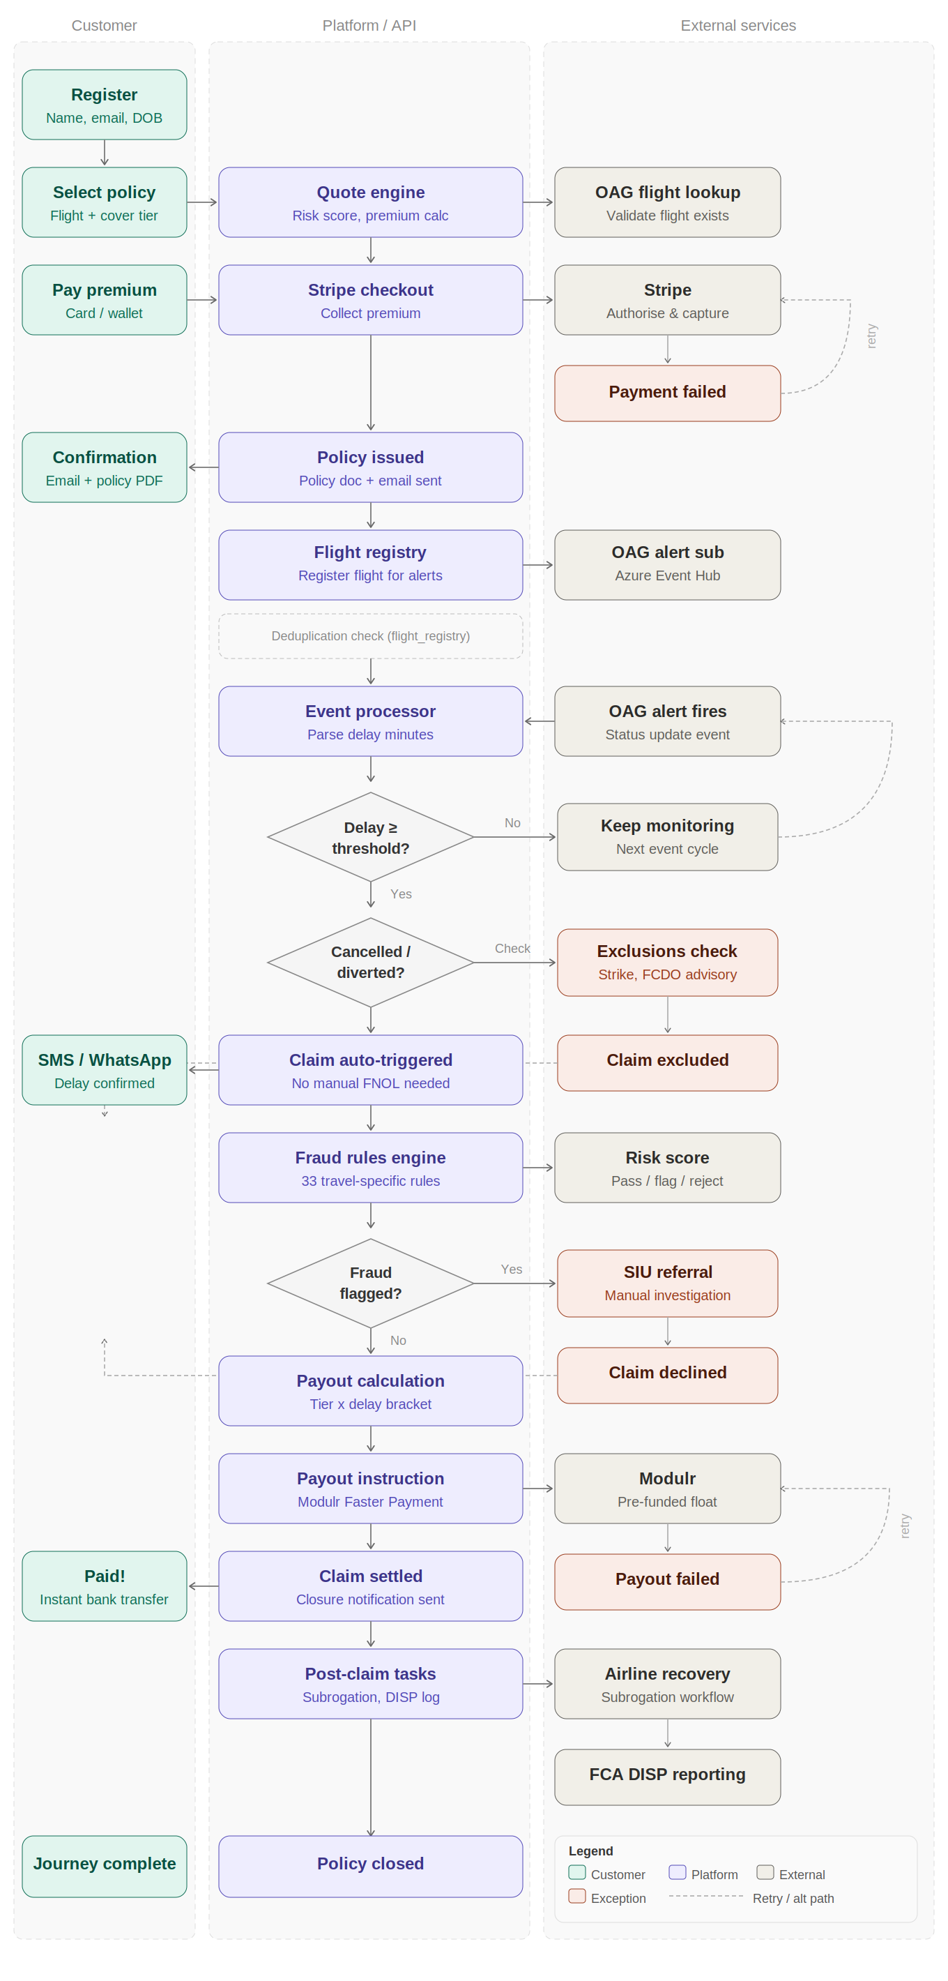

2. Overview
This document describes the end-to-end process flow for the Delayed? Paid. flight delay insurance product, from customer registration through to claim payout and post-claim obligations. It covers the happy path, all branching scenarios, and the external service integrations involved at each stage.

Three lanes are referenced throughout this document:
- Customer — actions and notifications received by the policyholder
- Platform / API — internal processing, rules engine, and orchestration
- External services — OAG, Stripe, Modulr, Azure Event Hub

3. Happy Path — Stage by Stage
The table below documents each stage of the standard (no-exception) journey from registration to payout.

# | Stage | Lane | Description
1 | Customer registration | Customer | Customer provides name, email address, and date of birth to create an account.
2 | Select policy | Customer | Customer selects the flight to insure and chooses a cover tier (e.g. 2-hour, 3-hour, 4-hour delay bracket).
 | Quote engine | Platform / API | Platform calculates a risk score and premium based on flight route, time of year, and cover tier selected.
 | OAG flight lookup | External | OAG API is called to validate the flight exists and retrieve schedule data.
3 | Pay premium | Customer | Customer pays the premium via card or digital wallet through the Stripe checkout flow.
 | Stripe checkout | Platform / API | Platform initiates a Stripe payment session. Stripe authorises and captures the premium.
4 | Policy issued | Platform / API | On successful payment, the platform generates a policy document and sends a confirmation email to the customer.
5 | Flight registry | Platform / API | The confirmed flight is registered in the flight_registry deduplication store and subscribed to OAG real-time alert events via Azure Event Hub (AMQP/Kafka).
6 | OAG alert fires | External | On the day of travel, OAG publishes a flight status update event to the Azure Event Hub.
 | Event processor | Platform / API | The platform consumes the event, parses the delay duration in minutes, and evaluates against the policy threshold.
7 | Threshold check | Platform / API | If the delay meets or exceeds the insured threshold, the claim is automatically triggered. No manual FNOL is required.
8 | Claim auto-triggered | Platform / API | Platform creates a claim record. Customer receives an SMS and/or WhatsApp notification confirming the delay and that a payout is being processed.
9 | Fraud rules engine | Platform / API | The claim passes through the fraud rules engine (33 travel-specific rules). A risk score of Pass, Flag, or Reject is assigned.
10 | Payout calculation | Platform / API | The payout amount is calculated based on the cover tier and delay bracket (e.g. 2 hours = Tier A amount, 4+ hours = Tier B amount).
11 | Payout instruction | Platform / API | A UK Faster Payment instruction is sent to Modulr, drawn from the pre-funded float account.
 | Modulr | External | Modulr processes the Faster Payment. Funds arrive in the customer's bank account typically within seconds.
12 | Claim settled | Platform / API | Platform records the claim as settled. A closure notification is sent to the customer.
13 | Post-claim tasks | Platform / API | Subrogation workflow initiated for airline cost recovery. Claim logged in the DISP complaints/FCA register. Policy marked as closed.

4. Exception & Branching Paths
The following table documents every point in the flow where the journey can deviate from the happy path, including the trigger condition and how it is resolved.

Branch | Trigger | Resolution
Payment failure (Stripe) | Card declined or authorisation fails at Stripe checkout | Customer is returned to the checkout screen. A retry loop is available. The policy is not issued until payment is successfully captured.
OAG flight not found | Flight cannot be validated against OAG schedule data at quote stage | Customer is shown an error. Policy cannot be issued for an unverifiable flight. Customer is advised to check flight details.
Delay below threshold | Delay minutes in OAG event are below the insured threshold | The event is noted but no claim is triggered. The platform continues monitoring subsequent OAG events for the same flight until it lands or the threshold is met.
Exclusion applied | Delay caused by an excluded event (industrial action, FCDO advisory, extraordinary circumstances) | Claim is automatically excluded. Customer receives a notification explaining the exclusion reason. Policy is closed. No payout is made.
Fraud flagged | Fraud rules engine returns a Flag or Reject score on the claim | Claim is escalated to the SIU (Special Investigations Unit) for manual review. Investigation outcome determines whether payout proceeds or claim is declined. Declined claims are notified to the customer in writing.
Flight cancellation / diversion | OAG event indicates flight cancelled or diverted rather than delayed | Treated as a qualifying event if within policy terms. Claim auto-triggered on the same path as a delay. Exclusions check still applies.
Payout failure (Modulr) | Faster Payment instruction rejected by Modulr (e.g. invalid sort code/account number, float insufficient) | Retry logic is applied. If retries are exhausted, the claim is held in a Pending Payout state and operations team is alerted. Customer is not notified of the technical failure until resolution.
Customer complaint | Customer raises a complaint at any point in the journey | Logged to the FCA DISP complaints register. Handled within the Consumer Duty framework. SMCR-accountable manager assigned. 8-week resolution target.

5. External Service Integrations

4.1 OAG Flight Info Alerts API
- Used for real-time flight status and delay data
- Integrated via Azure Event Hub using AMQP/Kafka protocol
- flight_registry deduplication pattern prevents the same flight alert being processed more than once, avoiding duplicate API charges and duplicate claim triggers
- OAG is called at two points: (a) at quote stage to validate the flight exists, and (b) on the day of travel via live event alerts

4.2 Stripe
- Premium collection via Stripe checkout
- Stripe Connect used for white-label partner distribution (airlines, banks, travel agencies)
- Partners receive a revenue share via Stripe Connect split payments

4.3 Modulr
- UK Faster Payments for claim payouts
- Pre-funded float account maintained to ensure instant payment capability
- Payout instruction sent programmatically on claim approval
- Float balance monitored; low-balance alerts trigger a top-up workflow

4.4 Azure Event Hub
- Kafka-compatible event streaming infrastructure on Azure
- Consumes OAG alert events in real time
- Triggers the event processor function to evaluate delay thresholds

5. Post-Claim & Regulatory Obligations

5.1 Subrogation
Once a claim is paid, ERGO retains the right to pursue cost recovery from the responsible airline. A subrogation workflow is initiated automatically, referencing the OAG event data and the claim record. Recovery amounts are reconciled against the Modulr float.

5.2 FCA DISP Obligations
All claims are logged in the DISP complaints and claims register. Declined claims, excluded claims, and any customer complaints are flagged for monthly FCA MI reporting. The Compliance Hub tracks open items against the 8-week resolution clock.

5.3 Consumer Duty
The product is designed to meet FCA Consumer Duty outcomes: price and value, products and services, consumer understanding, and consumer support. Payout decisions and exclusion notifications are reviewed as part of the quarterly Consumer Duty assessment.

5.4 SMCR
An SMCR-accountable Senior Manager is designated for the Delayed? Paid. product line. Significant operational failures (e.g. systemic payout delays, mass exclusion events) are escalated to this individual and recorded in the SMCR accountability map.

7. Distribution Channels

The Delayed? Paid. product is available through two distribution models:

6.1 B2C — Direct
- Customer-facing web application at delayedgetpaid.com
- Full self-service registration, quote, purchase, and claim journey
- SMS and WhatsApp Business API notifications throughout the journey

6.2 B2B — White-Label
- API-first distribution to airlines, banks, and travel agencies
- Partner embeds the product within their own checkout or loyalty flows
- Stripe Connect manages the revenue split between ERGO and the distributing partner
- White-label partners can configure cover tiers, branding, and notification templates

8. Glossary

Term | Definition
AMQP | Advanced Message Queuing Protocol — used by Azure Event Hub to stream OAG flight alert events
Consumer Duty | FCA regulatory framework requiring firms to deliver good outcomes for retail customers
DISP | FCA Dispute Resolution: Complaints sourcebook — governs how firms must handle customer complaints
FNOL | First Notice of Loss — the initial notification of a claim event. Automated in this product; no manual submission required
Modulr | UK-licensed payment institution providing Faster Payments infrastructure and virtual accounts
OAG | Official Airline Guide — provider of flight schedule and real-time status data used to trigger claim events
SIU | Special Investigations Unit — team responsible for investigating potentially fraudulent claims
SMCR | Senior Managers and Certification Regime — FCA accountability framework for financial services firms
Stripe Connect | Stripe's multi-party payment platform used for white-label partner revenue splitting
Subrogation | The right of the insurer to pursue recovery from a third party (e.g. the airline) after paying a claim

