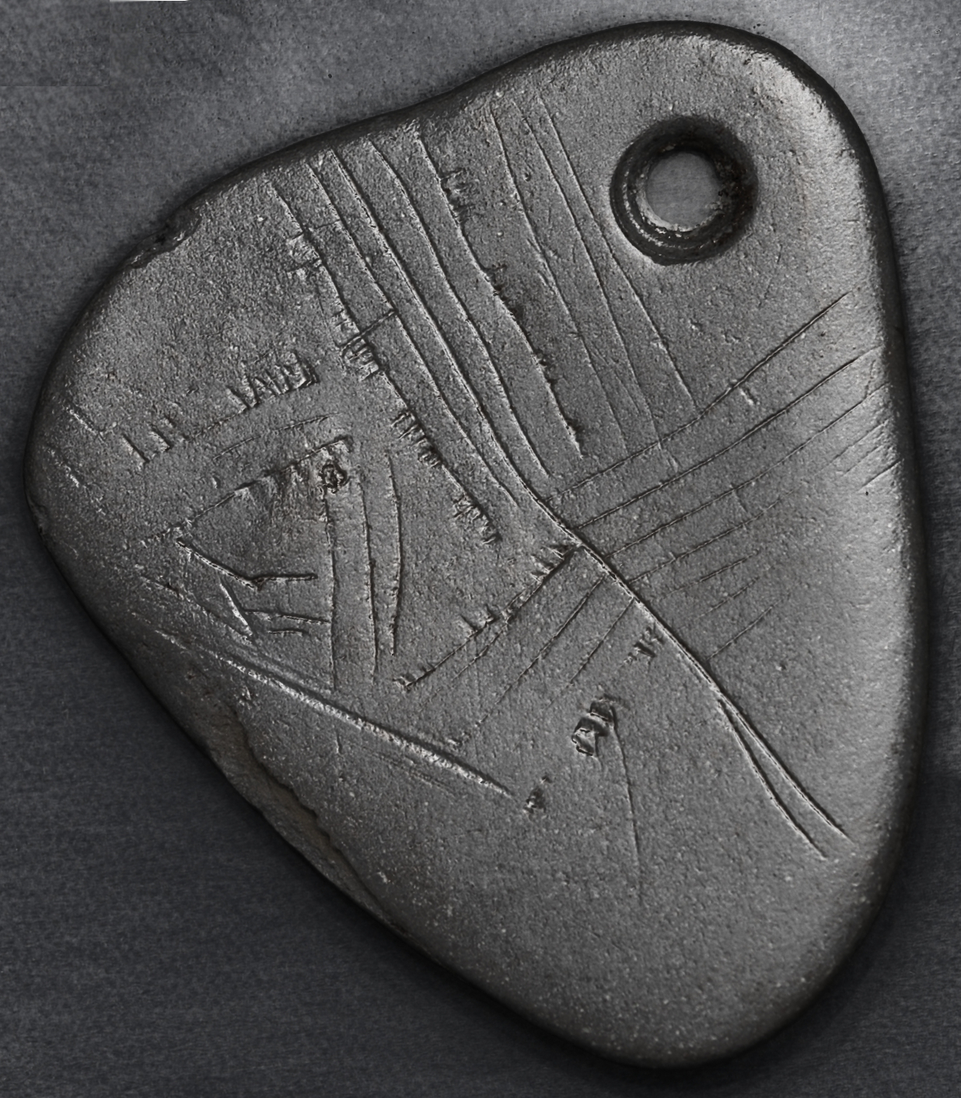

3.5 cm long by 3 cm wide

What is it? | A pendant for wearing from a cord around the neck.
What was it made from? | A smooth pebble of shale.
When was it made? | During the Mesolithic (Middle Stone Age), around 11,000 years ago.
Where was it found? | At the archaeological excavation at Star Carr, in the Vale of Pickering, North Yorkshire.
Why was it made? | We are not sure! It might have been -  - just a nice decoration to wear;  - a symbol of someone's status;  - representing an activity they specialised in;  - a way of showing the campsite by the lake in the forest.  Or something we can't think of yet!

WHAT DO THESE LINES SHOW?
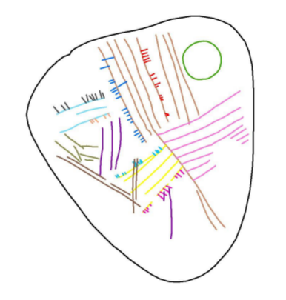

Write below why you agree or disagree with these answers.
The tree trunks of the forest

A way of counting days or hunting trips

Planks of a wooden jetty at the lake edge

Fishing lines strung out across the water

People in canoes on waves in the lake

Can you think of another answer yourself? Write it down and say why.

NOW MAKE YOUR OWN PENDANT.

You will make it out of modelling clay or plasticine.

Choose what shape you want it to be.
A circle, a square, a rectangle, a tear-drop or any other that you like.

Choose the size you want it to be.
Make it large enough to draw a design on, but small enough to be comfortable when you wear it.

Decide what you want to show in the design.
It could be something about you, something you like or a place you enjoyed visiting.
You could design a pendant to represent the whole class or the school itself.

Think about how to show it without directly drawing it!
For example, your classroom could be a square, the pupils could be dots or short lines and the teacher could be a bigger dot or long line.

Decide how to show it.
Inscribe lines, or paint – or both?

SYMBOLS

We often use symbols to represent something without having to write out its name or a long description.

Here are some modern symbols. Can you recognise what they mean?

Some symbols you might have seen. |  | Make your own symbols here.
☺ | A smiley, saying I am happy. |  | School
☼ | The sun, or sunshine on a weather map |  | Motor car
♫ | Music
⬇ | A star
♂ | Men and boys
♀ | Women and girls
♥ | Love
₤ | The pound, money
& | And
F | Go right
 | Christianity
Z | Islam
Y | Judaism
N | Poisonous. Or pirates!
 | Girls' toilet
 | Boys' toilet

Now make up your own symbols for things around school, your classroom, or for how you feel or things that you do.

