Neil Gupte Cs559 hw 2

Problem 1 (30pt): [Perceptron Algorithm]

1. For boolean OR function, is the negative class and positive class linearly separable?

* To prove that or is linearly seperable lets design a truth table for OR

1

0

|  |  |
| --- | --- |
| 0 | 1 |
| 1 | 1 |

1

0

Thus we can separate the data by line which separates all 0’s from the 1’s,same can be proved by plotting on the graph. Thus OR is linearly seperable.

As we know we can apply pca on linearly seperable data we can solve the given problem.

2] Is it possible to apply the perceptron algorithm to obtain the linear decision

boundary that correctly classify both the positive and negative classes? If so, write down the

updation steps and the obtained linear decision boundary. (You may assume the initial decision

boundary is x2 = 1

2 , and sweep the 4 points in clockwise order, i.e., (P1; P2; P3; P4; P1; P2; : : : ), note

that you can not write down the arbitrary linear boundary without updation steps. )

* So the initial vector can be calculated to w=[0 , 1, -0.5]: from Given
* So take all the points and run perceptron algo
* We loop over if f ti(wT xi) ≤ 0 ie. error is made:
* 1st iteration take point p1(0,1)

Ti=1 wTp1=

= ti(wT p1)=0.5 therefore it is classified correctly no need to update w

* Now take p2(1,1)

Ti=1 wTp2=

= ti(wT p2)=0.5 therefore it is classified correctly no need to update w

* Now take p3(1,0)

Ti=1 wTp3=

= ti(wT p3)= -0.5 this is an error

Mistake on positive :

w(τ+1) ← w(τ) + xi

+ = so new Wis now this 

* Now take p4(0,0)

Ti=1 wTp4=

= ti(wT p3)= -0.5 this is an error

Mistake on negative :

w(τ+1) ← w(τ) - xi

- = so new Wis now this 

* 2nd iteration take point p1(0,1)

Ti=1 wTp1=

= ti(wT p1)=0.5 therefore it is classified correctly no need to update w

* Now take point p2(1,1)

Ti=1 wTp2=

= ti(wT p2)=1.5 therefore it is classified correctly no need to update w

* Now take point p3(1,0)

Ti=1 wTp3=

= ti(wT p4)=0.5 therefore it is classified correctly no need to update w

* Now take point p4(0,0)

Ti=1 wTp4=

= ti(wT p4)=0.5 therefore it is classified correctly no need to update w

SO FINAL WEIGHT VECTOR IS Wf= WHICH SEPERATES POSITIVE AND NEGATIVE CLASSES.

Question 2] OUTPUT

Python 3.6.1 |Anaconda 4.4.0 (64-bit)| (default, May 11 2017, 13:25:24) [MSC v.1900 64 bit (AMD64)]

Type "copyright", "credits" or "license" for more information.

IPython 5.3.0 -- An enhanced Interactive Python.

? -> Introduction and overview of IPython's features.

%quickref -> Quick reference.

help -> Python's own help system.

object? -> Details about 'object', use 'object??' for extra details.

Restarting kernel...

In [**1**]: runfile('C:/CS 559 Machine learning/hw2/neil_pca2.py', wdir='C:/CS 559 Machine learning/hw2')

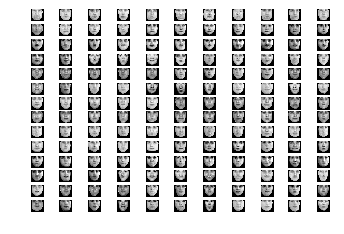

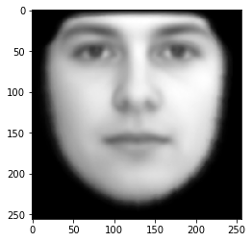

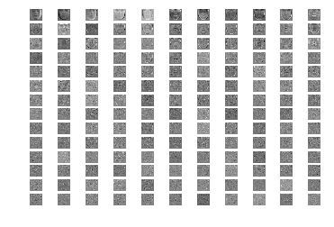

K=10-------------------------->

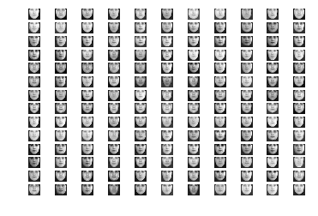

K=30------------------------------>

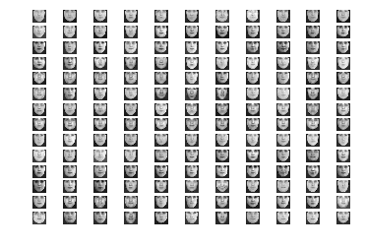

K=50---------------------------------------->

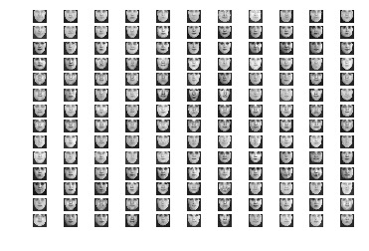

K=100--------------------------------->

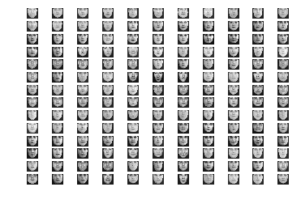

K=10

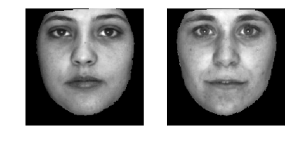

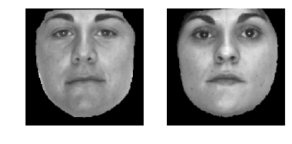

K=30





K=50





K=100





Partial outputs pasted here actual in the code