Data Analysis Project

Data Analysis of Note Taking

Taghreed Adnan, Gilbert.Pimentel and Michael Henry

STP 420: Introduction to Applied Statistics

Neil Hatfield

May 4th, 2017

Introduction

Data analysis is one of the most important aspects of communicating statistical findings in research questions. In order to solve the world’s biggest problems our groups have decided to stay close to the classroom issues. With the help of Neil Hatchfield, instructor of STP 420 course at ASU, we were able to use previously analyzed data from Pam A. Mueller and Daniel M. Oppenheimer research article “The Pen Is Mightier Than the Keyboard: Advantages of Longhand Over Laptop Note Taking”. They conducted their research in 3 courses of study, with an improvement in method from study one to two, and two to three. (2014) Since their research consisted of three studies, for the purpose of this project our group choose to only focus on study three.

The results of the study show that when taking notes by hand your brain retains more information than when you take notes by typing on a laptop. Although when taking notes on a laptop the word count is higher

Our intention going into the project was to understand how did the researchers reach their conclusion, “In three studies, we found that students who took notes on laptops performed worse on conceptual questions than students who took notes longhand.”(Mueller, 2014) Our proposed research questions is if there is a statistically significant difference in conceptual understanding between longhand and laptop note taking. Some background information about study three specifically: the researchers wanted to understand why students dod not encode as much information as written when they record information via laptop. Students who use longhand record significantly more content (2014). In order to testify such theory the researchers completed a study on participants (students). Total count of students was 109, 27 sex was male. from the University of California, Los Angeles Anderson Behavioral Lab subject pool. The study was divided by certain sessions: session 1 is lecture (Presentation), and session 2 is the examination. 145 participants completed Session 1, but only 118 returned for Session 2. Of those 118, 8 participant were removed from the study for reasons such as: not having taken notes, failing to respond to the test questions, and 1 was removed because of a recording error. Participants were paid $6 for the first session and $7 for the second session.(2014). Session 1 and 2 were both large groups. They were all given either a laptop or pen and paper and were required to take notes as if they were doing in their standard learning habits.

The lecture was via computer, headphones were used to listen. In preparation of session 2 specific number of students were required to return and receive 10 min to study their notes before being tested. Those in the other condition which is n--study, did not get any time to study, they took the test right away. Every student had the same 40 questions.

Data Analysis

In this analysis whenever we refer to the word: longhand, that’s an a representation of notes being taken by student on a paper with a pen. And laptop is an indication that the notes taken in lecture are by student’s laptop.

The first variable of interest is the count correlation of students. The second variable of interest is the word count of longhand or laptop note taking. The third variable of interest grade point average (GPA) for those who were longhand or laptop note taking. The fourth variable of interest “factual” performance between study and no study. The fifth variable of interest “conceptual” performance between longhand and laptop and study and no study. The sixth variable of interest “final” performance between longhand and laptop. The seventh variable of interest is word count or verbatim overlap between the study and no-study conditions. The eight variable of interest is the year in college, background knowledge correlation, and longhand or laptop note taking. The ninth variable of interest is overall performance of students’ 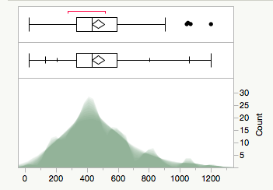

Figure 1. Words count written by students

The first variable of interest is the count and students. The box plot below (Fig 1) assisted us in knowing the five-point summary statistic. The x-axis represents the word count, and the y-axis represents the count of students who took notes: longhand and laptop. The median word count is 433. The lower quartile was 332.5 words/student, which meant that 25% of the students in lecture took this words in lecture. The upper quartile was 1058.25 words/student, which meant that 75% of the students in lecture were writing this many words. The sample arithmetic mean was 470.4128 words per student. Another observation is that 1057 words, 1203 words, 1046, and 1071 words were pointed out as outliers. The shadow gram below demonstrates one modal clump from about 300 to 500 words to about 5 to 25 students.

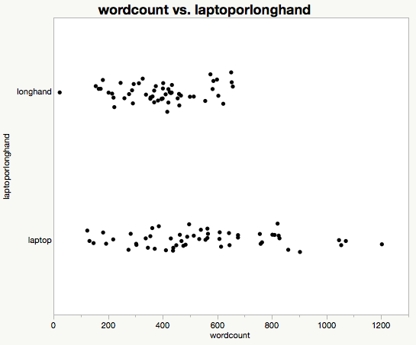

Fig. 2 Word count by longhand and laptop

The second variable of interest is the word count of longhand or laptop note taking.

Looking at figure 2 you can examine the relationship between the wordcount and the type of notes taken by students. The x-axis represents the word count and the y-axis represents the type of note taking. Comparing the word count, number of students, and the type of note taking strategy longhand and laptop respectively the words written longhand is statistically significantly lower than laptop. (t(107)=-4.0037, p-value=0.0001)

|  |  |  |  |  |  |
| --- | --- | --- | --- | --- | --- |
| Level | Number | Mean | Std Error | Lower 95% | Upper 95% |
| laptop | 55 | 548.727 | 27.790 | 493.64 | 603.82 |
| longhand | 54 | 390.648 | 28.046 | 335.05 | 446.25 |

Table 1. Means for OneWay Anova.

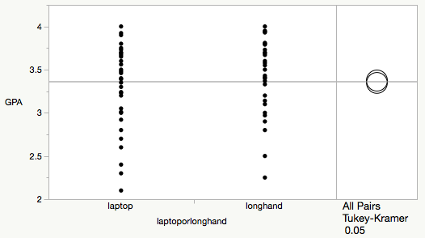

Fig. 3 Grade point average (GPA) and tote taking strategy

The third variable of interest grade point average (GPA) for those who were longhand or laptop note taking. The GPA has demonstrated a statistically significant difference between longhand and laptop (q=1.99832, p value=0.7492) The Sample arithmetic mean of laptop is 3.3505 grade point average per student. While the Sample arithmetic mean of longhand is 3.3782 grade point average per student. The two way sample test Tukey's honest effect size difference statistic showed medium probability of superiority, longhand beats laptop (0.5174) with a threshold of unusualness of 0.05 (Cohen's 0.06251) With that being said the GPA has no correlation with the performance and understanding during this study. This factor is completely independent.

The fourth variable of interest “factual” performance between study or no study.

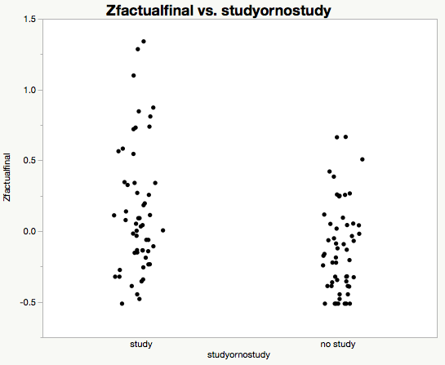

Fig. 3 Study and no study performance via Z-factual finale.

The fifth variable of interest “conceptual” performance between longhand and laptop and study and no study.

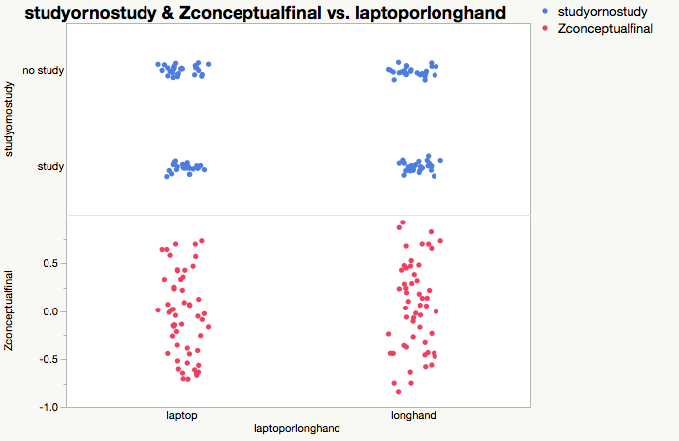

The sixth variable of interest is word count or verbatim overlap between the study and no-study conditions.

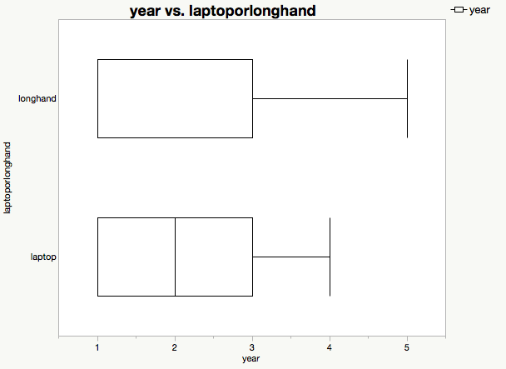

Fig 5. Year in college and laptop/long hand.

The seventh variable of interest is the year in college, background knowledge correlation, and longhand or laptop note taking.

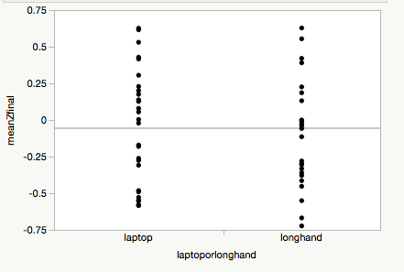

Fig 5. Z-finale performance no study and laptop/long hand.

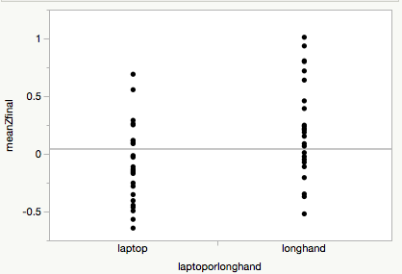

Fig 6. Z-finale performance study and laptop/long hand.

The ninth variable of interest is overall performance of students’. All the indicated above variables were solely analyzed and independently. The performance of each and all of the students was actually calculated previously by the researchers and when we conducted the statistical analysis and test came up to the same conclusion. See further discussion.

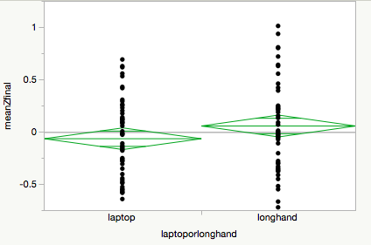

Fig. 4 Final performance

|  |  |  |  |
| --- | --- | --- | --- |
| Difference | 0.12157 | t Ratio | 1.639773 |
| Std Err Dif | 0.07414 | DF | 107 |
| Upper CL Dif | 0.26853 | Prob > |t| | 0.1040 |
| Lower CL Dif | -0.02540 | Prob > t | 0.0520 |
| Confidence | 0.95 | Prob < t | 0.9480 |

Table 2. Mean Z-Finale One way Anova Results

Discussion and Conclusion

Overall performance as seen above, repeatedly has demonstrated that there is a statistically significant difference (t(107)=1.639 and p-value=0.1040). The finale performance z value is already a summed value of the performance with an account of application, factual, and conceptual performance values that each student was graded on. Comparing our findings with the researchers, they indicated that, “longhand note takers wrote significantly fewer words (M = 390.65, SD = 143.89) than those who typed (M = 548.73, SD = 252.68), t(107) = 4.00, p < .001, d = 0.77 (see Fig. 2). As in the previous studies, there was a significant difference in verbatim overlap, with a mean of 11.6% overlap (SD = 5.7%) for laptop note taking and only 4.2% (SD = 2.5%) for long- hand, t(107) = 8.80, p < .001, d = 1.68 (see Fig. 3). There were no significant differences in word count or verbatim overlap between the study and no-study conditions.”(2014) Comparing this back to our original statistical research question you can see that the above findings strongly support and go above and beyond is explaining the participants performance as a whole and accounting for all the outliers that could have affected the verbatims.

Something to take away from this statistical analysis is there was no difference between study and no-study. That specific addition to the process did not contribute to any functions, neither did that condition show any statistically significant difference. Furthermore, being able to achieve very close analysis of research of this project allowed us to further be brave and interpret further research inquiries to find any misconceptions or differences that were not accounted or recorded.

One might think that the usage of technology can enhance one's’ conceptual understanding but according to the statistical findings that we have shared with you that is incorrect. There seems to be insignificant changes with factual as if you were to take notes longhand or by laptop there is no correlation. THe performance on factual questions in the last study is the only thing that makes the difference between this study and others. See below for sample of questions.

“F = Factual

SD = Seductive detail

C = Conceptual

IS = Inferential, same-domain

ID = Inferential, other-domain

Respiration:

F1 The lungs are the component of the human respiratory system responsible for oxygenation of the blood and the removal of carbon dioxide. What other major function do they serve?

F2 What areas in the brain automatically control the rate of breathing?

SD1 What can a horse not do, in terms of respiration?

SD2 About how large is the surface area of the lungs' alveoli?

C1 Gas exchange occurs in a part of the human respiratory system called the alveoli. How does the process of gas exchange work?

C2 Describe the flow of air from the nose or mouth through the lungs. What structures must the air pass through to reach the alveoli?

References

JMP Pro. (2015). (Version 12.0.2). Cary, NC: SAS Institute Inc.

Mueller, P. A., & Oppenheimer, D. M. (2014). The pen is mightier than the keyboard:

Advantages of longhand over laptop note taking. *Psychological Science, 25*(6),

1159-1168. doi:10.1177/0956797614524581