Arizona State University

Immigration into the United States 1990-2016

Ciara McPeake, Rastko Stojsin, Alan Nguyen

STP 420

Neil Hatfield

May 4, 2017

Executive Summary:

The following report is an analysis of the how the United States government's political parties affect immigration. The United States has been and is the largest hub of immigrants and is often referred to as the melting pot. Immigration is one of the core basis to the fruition of the United States. This fundamental idea has contributed to the United States’s largest political divide it has ever seen. This report looks at the raw numbers without any bias to answer how the United States’s political parties affect who can enter the United States. From the data analysis it shows that over time, immigration has decreased in the United States but is slowing making a comeback. When a republican president is in office they generally have a greater range in the amount immigrants that are allowed to enter the United States but they also have generally had more immigrants enter the country while they were in office. Next given the available data of either a majority democrat congress or a majority republican congress, or a house of representatives and senate with conflicting political parties, the majority democrat congress let the most immigrants in and the majority republican congress let the least amount in. At the peak of immigration into the United States, the United States favored men over women but overall the United States favors women over men in the time that was have researched. Lastly when it came to the apprehension of immigrants who came illegally, the democrats had a greater range in the amount of immigrants that were apprehended but that number goes in line with the total immigrants into the United States for those years.

Introduction:

Immigration into the United States is influenced by many factors. This paper looks at immigration into the United States and takes into consideration the year, political party of the executive branch of that year, political party of the senate of that year, political party of the house of representatives of that year, the region of the immigrants, the gender of the immigrants, and number of immigrants that were apprehended.  The information is directly taken from the Department of Homeland Security’s yearbook of statistics. The Department of Homeland Security’s yearbook of statistics is “A compendium of tables that provide data on foreign nationals who are granted lawful permanent residence (i.e., immigrants who receive a “green card”), admitted as temporary nonimmigrants, granted asylum or refugee status, or are naturalized. The *Yearbook* also presents data on immigration enforcement actions, including apprehensions and arrests, removals, and returns“ (Yearbook of Immigration Statistics). After each fiscal year the Department of Homeland releases one of these yearbooks. This paper looks as far back as 1990, and as recently as 2015. This time frame was chosen because 1990 was when the Department of Homeland Security changed their formatting for the yearbook. Anything prior to 1990 does contain equally consistent reports that can be utilized with the yearbooks that date past 1990. There were other resources that provided data about the number of immigrants that entered the United States but the Department of Homeland Security’s yearbook was chosen due to their extensive database and relevance to the topic of research. Information regarding political power such as political party of the executive branch of that year, political party of the senate of that year, political party of the house of representatives of that year were taken from the Library of Congress, the Library of Congress provides an accurate detail of records relevant to political aspects in question “The mission of Library Services is to develop qualitatively the Library's universal collections, which document the history and further the creativity of the American people and which record and contribute to the advancement of civilization and knowledge throughout the world, and to acquire, organize, provide access to, maintain, secure, and preserve these collections.” (Library of Congress). Through these particular data sets, the following statistical research questions discussed in this paper are:

1. How did total immigration into the United States change between 1990 and 2015?
2. What is the relationship between political party and total immigration count?
3. How do immigration rates of females and males differ?
4. Does one political party apprehend more immigrants than the other?

Data Analysis:

10 Definitions for Univariate Data (columns):

(Column 1) Origin area for Immigrants: Countries are divided into regions from where the immigrants immigrated from based on geographical area.This is done so that the data would not be divided up into too small of pieces (countries) and for continuity's sake as countries divided and changed over time. The geographical regions included are: Eastern Europe, Western Europe, Asia, North America, South America, Africa, Oceania, Middle East. Countries that fell within each selected regions include:

|  |  |
| --- | --- |
| East Europe (23) | Albania, Austria, Belarus, Bosnia and Herzegovina, Bulgaria, Croatia, Czech Republic, Estonia, Greece, Hungary, Latvia, Liechtenstein, Lithuania, Macedonia, Moldova, Montenegro, Poland, Romania, Russia, Serbia, Slovak Republic, Slovenia, Ukraine |
| West Europe (27) | Andorra, Belgium, Czech Republic, Denmark, Faroe Islands, Finland, France, Germany, Gibraltar, Guernsey, Holy See, Iceland, Ireland, Isle of Man, Italy, Jersey, Luxembourg, Malta, Monaco, Netherlands, Norway, Portugal, San Marino, Spain, Sweden, Switzerland, United Kingdom |
| Asia (27) | Afghanistan, Armenia, Azerbaijan, Bahrain, Bangladesh, Bhutan, Brunei, Burma, Cambodia, East Timor, Georgia, Indonesia, Kazakhstan, Kyrgyzstan, Laos, Macau, Malaysia, Maldives, Mongolia, Nepal, Pakistan, Singapore, Sri Lanka, Tajikistan, Thailand, Turkmenistan, Uzbekistan |
| North America (40) | Canada, Greenland, Mexico, Saint Pierre and Miquelon, Anguilla, Antigua and Barbuda, Aruba, Bahamas, Barbados, Bermuda, Bonaire, British Virgin Islands, Cayman Islands, Cuba, Curacao, Dominica, Dominican Republic, Grenada, Guadeloupe, Haiti, Jamaica, Martinique, Montserrat, Puerto Rico, Saba, Saint Barthelemy, Saint Kitts and Nevis, Saint Lucia, Saint Vincent and the Grenadines, Sint Eustatius, Sint Maarten, Trinidad and Tobago, Turks and Caicos Islands, U.S. Virgin Islands Belize, Costa Rica, El Salvador, Guatemala, Honduras, Nicaragua, Panamá |
| South America (14) | Argentina, Bolivia, Brazil, Chile, Colombia, Ecuador, Falkland Islands, French Guiana, Guyana, Paraguay, Perú, Surinam, Uruguay, Venezuela |
| Africa (60) | Algeria, Angola, Benin, Botswana, Burkina Faso, Burundi, Cameroon, Cape Verde, Central African Republic, Chad, Comoros, Cote d’Ivoire, Democratic Republic of the Congo, Djibouti, Egypt, Equatorial Guinea, Eritrea, Ethiopia, Gabon, Gambia, Ghana, Guinea, Guinea-Bissau, Kenya, Lesotho, Liberia, Libya, Madagascar, Malawi, Mali, Mauritania, Mauritius, Mayotte, Morocco, Mozambique, Namibia, Niger, Nigeria, Republic of the Congo, Reunion, Rwanda, Saint Helena, Sao Tome and Principe, Senegal, Seychelles, Sierra Leone, Somalia, South Africa, South Sudan, Sudan, Swaziland, Tanzania, Togo, Tunisia, Uganda, Western Sahara, Zambia, and Zimbabwe |
| Oceania (27) | American Samoa, Australia, Christmas Island, Cocos (Keeling) Islands, Cook Islands, Federated States of Micronesia, Fiji, French Polynesia, Guam, Kiribati, Marshall Islands, Nauru, New Caledonia, New Zealand, Niue, Norfolk Island, Northern Mariana Islands, Palau, Papua New Guinea, Pitcairn Islands, Samoa, Solomon Islands, Tokelau, Tonga, Tuvalu, Vanuatu, Wallis and Futuna Islands |
| Middle East (14) | Cyprus, Iran, Iraq, Israel, Jordan, Kuwait, Lebanon, Oman, Qatar, Saudi Arabia, Syria, Turkey, United Arab Emirates, Yemen |

(Column 2) Years: This column lists the years looked at, 1990-2015

(Column 3) Total Immigrants: This is the total number of people who immigrated into the United States per year. This has nothing to do with the region they come from, it is the total.

(Column4) Migration Number by Region: This is the total number of people from the specific region that immigrated into the United States in that  year.

(Column 5) Executive Branch: This is the political party of the President that was in office that year. This is important because the Executive branch of government influences things such as immigration laws.

(Column 6) Congress make up: Congress is made up of the House of Representatives and the Senate. This column represent majority party in the US House of Representatives and the US Senate respectively per Year. These are important because this branch of the government can influence things such as immigration laws. There are four possible combinations for this column that are possible;

|  |  |
| --- | --- |
| HD SD | House of Representatives Majority: Democrat  Senate Majority: Democrat |
| HD SR | House of Representatives Majority: Democrat  Senate Majority: Republican |
| HR SD | House of Representatives Majority: Republican  Senate Majority: Democrat |
| HR SR | House of Representatives Majority: Republican  Senate Majority: Republican |

(Column 7) House Democrats:  Number of members of the United States House of Representatives who were Democrats that year.

(Column 8) House Republicans:  Number of members of the United States House of Representatives who were Republicans that year.

(Column 9) Senate Democrats:  Number of members of the United States Senate who were Democrats that year.

(Column 10) Senate Republicans:  Number of members of the United States Senate who were Republicans that year.

(Column 11) Aliens Apprehended: This is the total number of foreign nationals who are determined inadmissible, apprehended, removed, or returned for violating the Immigration and Nationality Act . These actions occur at the borders of the United States, in the interior of the country, and at designated sites outside the United States, in that year.

(Column 12) Males: Number of immigrants that year that were male. Every 1995 will have the same number as this column looks at the total number of male immigrants that year, this column is not looking at any particular region.

(Column 13) Females: Number of immigrants that year  that were female.  Every 1995 will have the same number as this column looks at the total number of female immigrants that year, this column is not looking at any particular region.

Data Visualizations:

How did total immigration into the united states change between 1990 and 2015? 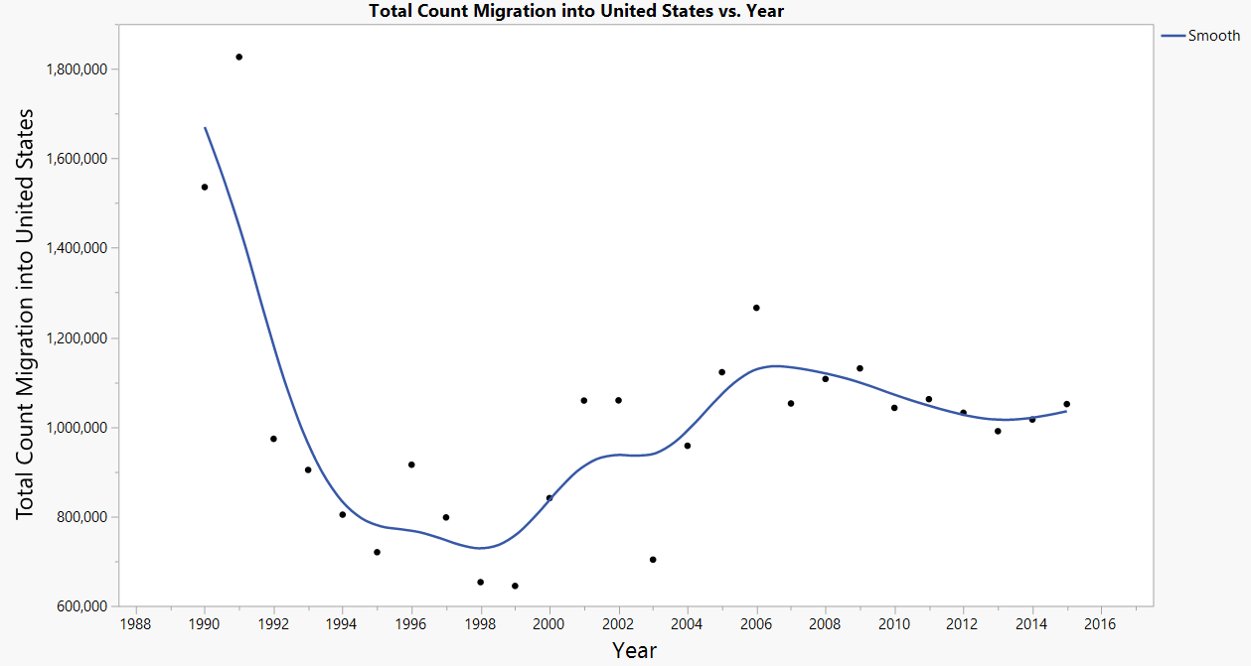

Figure 1

Figure 1  shows the total number of immigrants let into the United States by year. Included is a trend line. Immigration fell dramatically from 1990-1998. The year with highest immigration was 1992. Immigration rose from 1998-2006, then fell slightly and remained steady. Immigration may be steady from 2006-2015 because the same president was in power from 2008-2015. The economy crashed causing a recession  in 2008 which may be why immigration did not continue to rise. There was a recession in the early 1990s which may be why immigration fell so much. In 2001 immigration rates fell sharply, possibly due to the September 11, terrorist attack. This caused many Americans to have a heightened sense of patriotism and caused some fear of middle easterners and other immigrants.

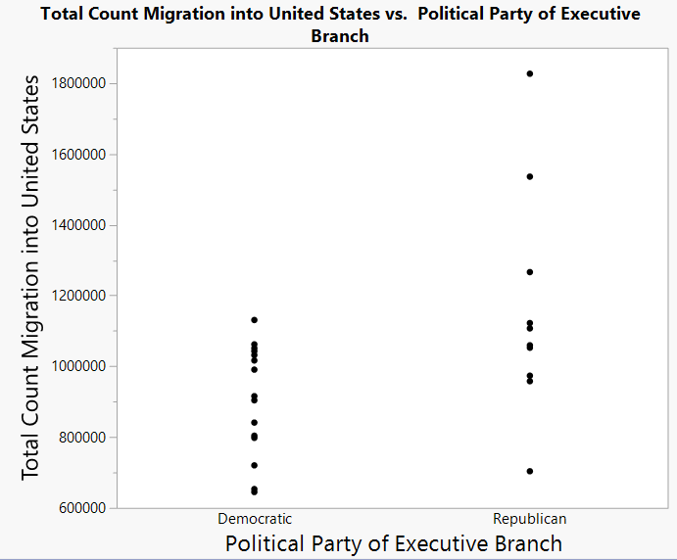

Figure 2.1

Figure 2.1 shows the total count migration under different political party of Executive Branches. It appears Republican has a larger value for range than Democrat. Some information to consider is that a presidential term is 4 years. Immigration reforms one president makes may carry over to the next presidency, even if the ideas are against common beliefs of the new president’s party.

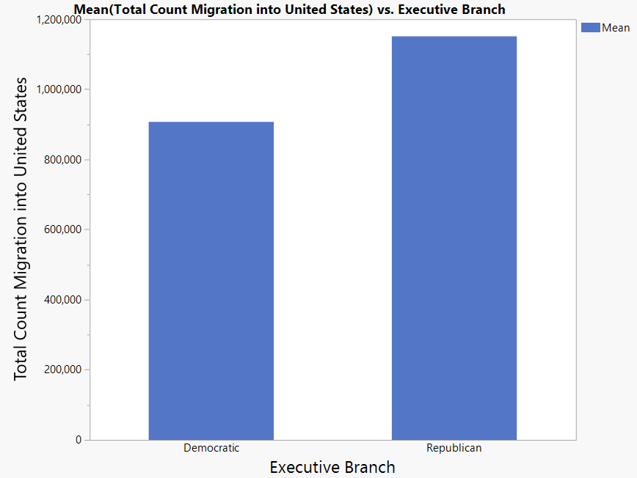

Figure 2.2

Figure 2.2 shows the sample arithmetic mean values for total immigration count under the two different Executive parties. The Republicans accumulated immigration is larger than the Democrats accumulated immigration.

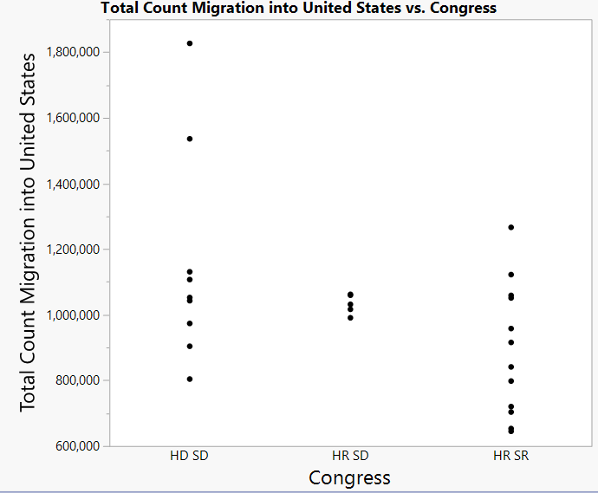

Figure 2.3

Figure 2.3 shows the total immigration into the United States broken up by the Congress majority. Most years congress had both the Senate and House of Representatives as the same political party. It appears that when the congress had a Democrat majority more immigrants were let in. A Senate term is six years and a House of representative term is two years. Congress makes up the Legislative branch of the US government and has power over making laws, including immigration laws.

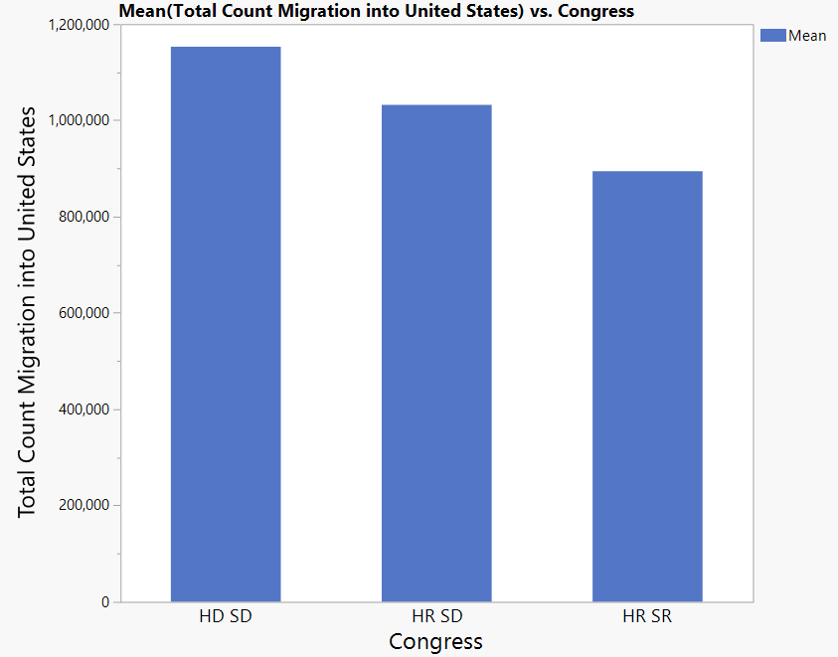

Figure 2.4

FIgure 2.4 shows the sample arithmetic mean of total immigration count under the three Congress majorities. This is included to make more clear that the accumulated number of immigrants let into the US is highest when there is a majority Democrat, followed by when the House of Representatives is Republican and the Senate is Democrat, and then last when congress has a Republican majority. Generally, Republicans and Democrats have conflicting immigration ideas, with Democrats being more in favor of immigration.

Total count migration per year based on Executive party Dem or Rep:

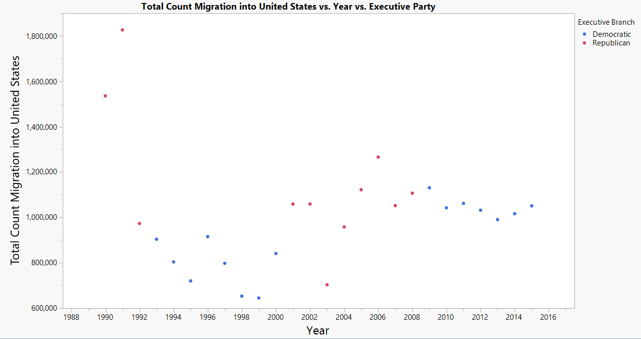

Figure 2.5

Figure 2.5 looks at total immigration by year and by political party of the Executive branch. The blue dots represent years that a Democrat was in office and the red dots represent a year that a Republican was in office. The dots are grouped together by color because a presidential term is four years. It looks like between 1992 and 2000 a democrat was in office and immigration rates were low. Immigration rates look to be fairly steady from 2006-2016. This may be because from 2008-2016 the same president was in office the entire time.  This is actually a very interesting visualization because at first when you look at the graph it is clear that whenever there is a republican president there seems to be higher levels of immigration than when there is a democratic president. But upon further analysis you can clearly see that whenever there was a republican presidency the immigration numbers slope down towards the end of the presidency (we assume this is when their executive actions concerning immigration kick in). Near the tail end of the democratic presidencies you can see that the immigration numbers start sloping up (we assume this is when their executive actions concerning immigration kick in). This is why the total immigration numbers have been moving up and down so consistently.

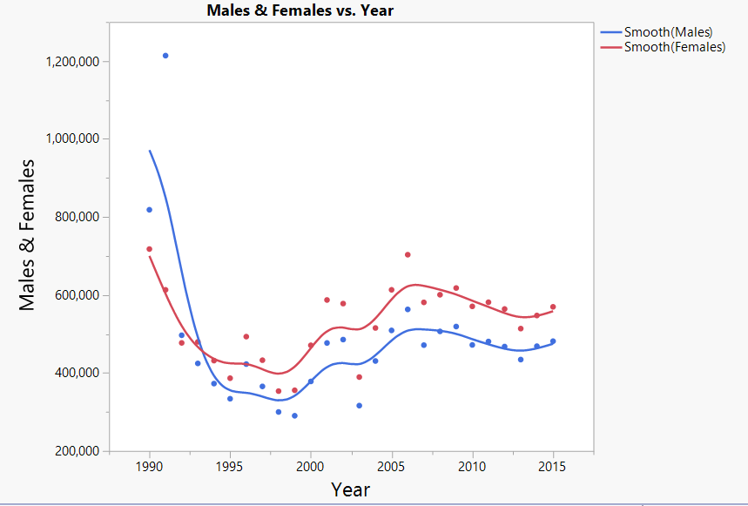

Figure 3.0

Figure 3.0 shows the total immigration by year, broken up by males and females. Blue represents male and pink represents female. The lines are trend lines which show the trend. In 1990 and 1992 many more males were let into the US than females, However after that generally more females were let into the US.

A two-sample t-test is done to answer, “Is there a statistically significant difference in immigration into the US if there is a Democrat as President vs Republican?”

H_0: SAM(R)-SAM(D)>=0

H_1:SAM(R)-SAM(D)<0

Threshold of unusualness: 0.05

P-value: 0.0001

T Ratio: 7.20237

Cohen’s d: 1.1043 (large)

Probability of Superiority, Republican beats Democrat:: 0.78256

The null hypothesis is rejected as the threshold of unusualness is larger than the p-value. There is a statistically significant difference between immigration rates under a Democrat vs Republican (p:0.0001, t:7.20237) because the p-value of 0.0001 is less than our threshold of 0.05. Cohen’s d is 1.1043 which is considered large, meaning there is a large difference in immigrants let in when a Republican is in office vs a Democrat. The probability that more immigrants will be let in when a Republican is in office vs Democrat is approximately 78%.

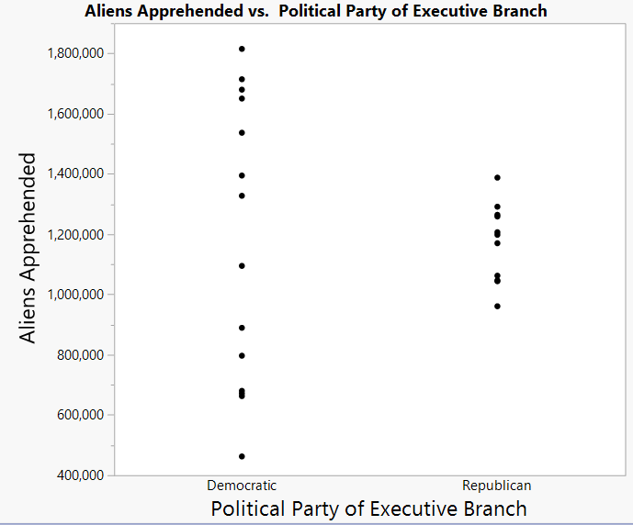

Figure 4.0

Figure 4.0 depicts the number of immigrants apprehended by the political party of the Executive Branch. Although it appears that many more aliens are apprehended when a Democrat is in power, this may be because many more immigrants are let into the US when there was a democrat in power. The larger number of aliens apprehended may not be caused by the political party of the executive branch, rather it is a result.

Discussion/Conclusion:

Through this exploratory data analysis, we looked at the following questions:

1. How did total immigration into the United States change between 1990 and 2015?

The total immigration started out high in the 1990’s and then took a sudden large dip, but has been recently been making its way back up.

1. What is the relationship between political party and total immigration count?

It seems that when congress and the president are democrats the immigration rates are lower than when they are republican, but the immigration rates rise during the prevalence of a democrat presidency and congress. On the other hand when there is a republican congress and presidency the immigration rates are higher, but the immigration rates are usually declining when there is a republican congress and presidency

1. How do immigration rates of females and males differ?

During the 1990’s men were much more favored than women to be accepted as immigrants, but as of 1993 women have been favored over men, and the margin by which they have been favored by has been very consistent till today.

1. Does one political party apprehend more immigrants than the other?

They both apprehended roughly the same amount of immigrants on average but the variation of immigrants apprehended has been much bigger when the political party has been democratic while when republicans where the party in charge the immigrants apprehended rate has been roughly the same historically (less variable).

The implications of these results show that since the political climate in the US has generally gone republican, democrat, republican, democrat, pretty consistently, this has caused a sort of up and down variation in immigration numbers into the united states. When republicans are in office they bring immigration numbers down, when democrats are in office they bring immigration numbers up. So although at first glance it looks like, just by looking at the numbers without context, it looks as though republicans are more supportive of immigration into the united states, upon further analysis it appears not. Knowing this is useful because we could be able to more accurately predict future trends in immigration and be able to adapt to them.

References:

JMP Pro. (2015). (Version 12.0.1). Cary, NC: SAS Institute Inc.

Library of Congress. (n.d.). Retrieved May 04, 2017, from https://www.loc.gov/

Yearbook of Immigration Statistics. (n.d.). Retrieved May 04, 2017, from

https://www.dhs.gov/immigration-statistics/yearbook