Area ReSTIR: Resampling for Real-Time Defocus and Antialiasing
SONG ZHANG∗, University of Utah, USA
DAQI LIN∗, NVIDIA, USA
MARKUS KETTUNEN, NVIDIA, Finland
CEM YUKSEL, University of Utah, USA
CHRIS WYMAN, NVIDIA, USA
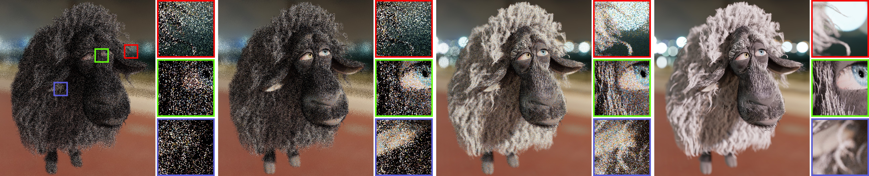
(a) Path tracing (1spp), 4.2 ms (b) ReSTIR PT, 9.5 ms (c) Area ReSTIR (Ours), 14.0 ms (d) Ground Truth
Fig. 1. Prior ReSTIR methods [Bitterli et al. 2020] reuse paths between fxed subpixel locations. Randomizing paths’ subpixel locations avoids aliasing, but changes their primary hits. In pixels with high-frequency content, the changing normals and occlusions often make the new primary hits incompatible with later vertices (from reused, shifted paths), preventing efective reuse. Here the Franck model, with complex fur, is lit by the Blue Lagoon HDR environment. (a) Path tracing has high variance at low sample rates. On smoother surfaces, (b) ReSTIR PT [Lin et al. 2022] reuses samples for large quality improvements while shading only one path per pixel. But reusing samples in a higher-dimensional ray space, including subpixel and lens coordinates, allows our (c) Area ReSTIR to reuse even more paths (despite bokeh and high-frequency content) also while shading just one sample per pixel. This approaches the quality of (d) converged path tracing. Note: (a), (b), and (c) all use the same number of independent paths each pixel.

Recent advancements in spatiotemporal reservoir resampling (ReSTIR) lever-age sample reuse from neighbors to efciently evaluate the path integral. Like rasterization, ReSTIR methods implicitly assume a pinhole camera and evaluate the light arriving at a pixel through a single predetermined subpixel location at a time (e.g., the pixel center). This prevents efcient path reuse in and near pixels with high-frequency details.
We introduce Area ReSTIR, extending ReSTIR reservoirs to also integrate each pixel’s 4D ray space, including 2D areas on the flm and lens. We design novel subpixel-tracking temporal reuse and shift mappings that max-imize resampling quality in such regions. This robustifes ReSTIR against high-frequency content, letting us importance sample subpixel and lens coordinates and efciently render antialiasing and depth of feld.
CCS Concepts: • Computing methodologies → Rendering.
Additional Key Words and Phrases: real-time ray tracing, resampled impor-tance sampling, ReSTIR, depth-of-feld, antialiasing

∗Joint frst authors; equal contribution.

Authors’ addresses: Song Zhang, song.zhang@utah.edu, University of Utah, USA; Daqi Lin, daqil@nvidia.com, NVIDIA, USA; Markus Kettunen, mkettunen@nvidia.com, NVIDIA, Finland; Cem Yuksel, cem@cemyuksel.com, University of Utah, USA; Chris Wyman, chris.wyman@acm.org, NVIDIA, USA.

Permission to make digital or hard copies of part or all of this work for personal or classroom use is granted without fee provided that copies are not made or distributed for proft or commercial advantage and that copies bear this notice and the full citation on the frst page. Copyrights for third-party components of this work must be honored. For all other uses, contact the owner/author(s).
© 2024 Copyright held by the owner/author(s). 0730-0301/2024/7-ART98
https://doi.org/10.1145/3658210
ACM Reference Format:
Song Zhang, Daqi Lin, Markus Kettunen, Cem Yuksel, and Chris Wyman. 2024. Area ReSTIR: Resampling for Real-Time Defocus and Antialiasing. ACM Trans. Graph. 43, 4, Article 98 (July 2024), 13 pages. https://doi.org/10. 1145/3658210

INTRODUCTION
Reservoir-based spatiotemporal importance resampling, or ReSTIR [Bitterli et al. 2020], uses weighted reservoir sampling [Chao 1982] to aggregate spatial and temporal neighbor samples in a streaming fashion, giving efective sample counts up to 100× higher than naive independent sampling. This has been applied to various rendering problems: many-light sampling [Bitterli et al. 2020], difuse global illumination [Ouyang et al. 2021], and more general light paths [Lin et al. 2022] including volumetric scattering [Lin et al. 2021].
But these algorithms shade only at pixel centers, essentially using a delta function as the pixel flter; this introduces aliasing. But more interesting pixel flters cause problems. Near subpixel detail, such as foliage or hair, randomizing subpixel locations forcibly changes the reused path’s primary hit, making it difcult to reuse secondary path vertices from neighbors. Thus, high-frequency detail often causes signifcant quality degradation.
We introduce Area ReSTIR, which expands ReSTIR to sample pixel footprints. Our samples estimate radiance over the entire pixel rather than a single point. Besides pixel areas, our method also integrates over camera aperture, resampling primary rays in a 4D ray space. The intuition goes: ReSTIR PT [Lin et al. 2022] already estimates

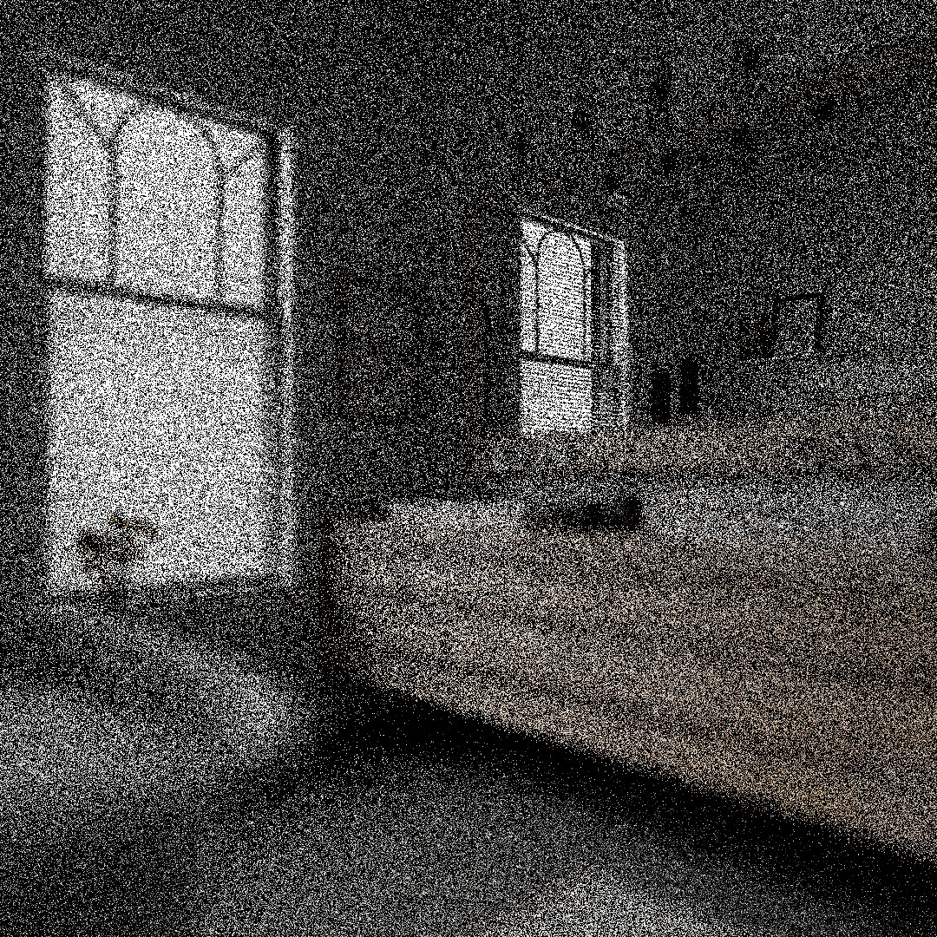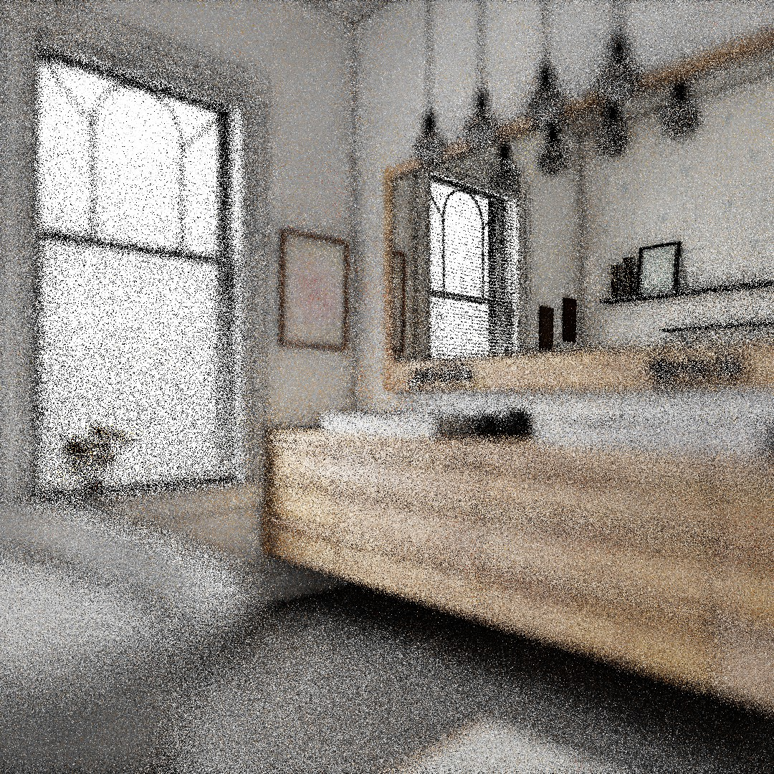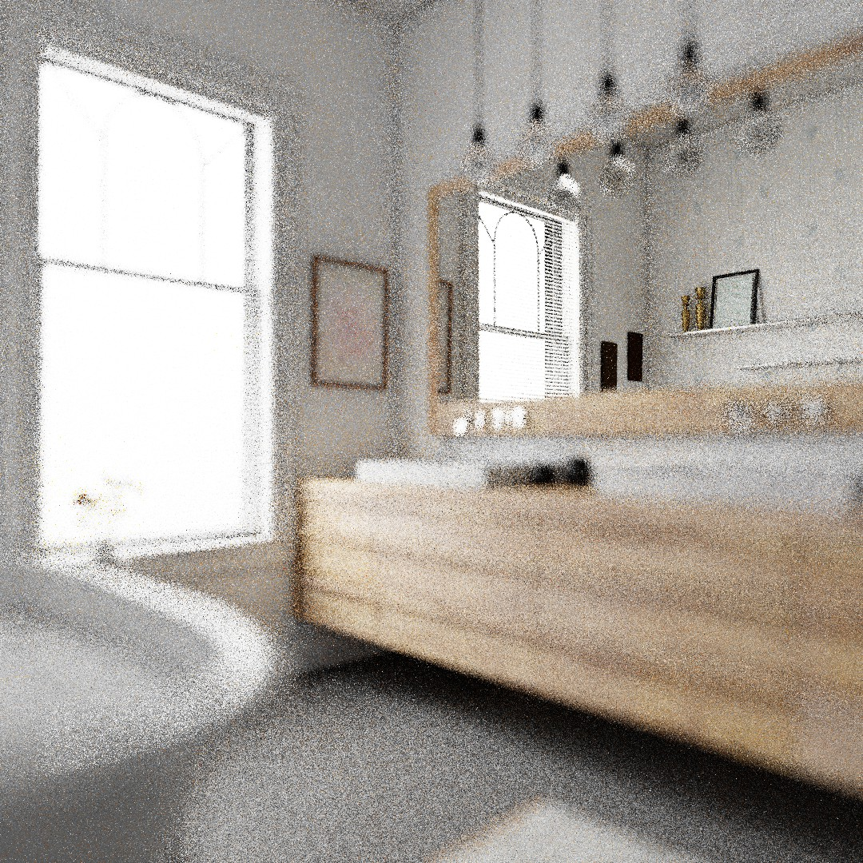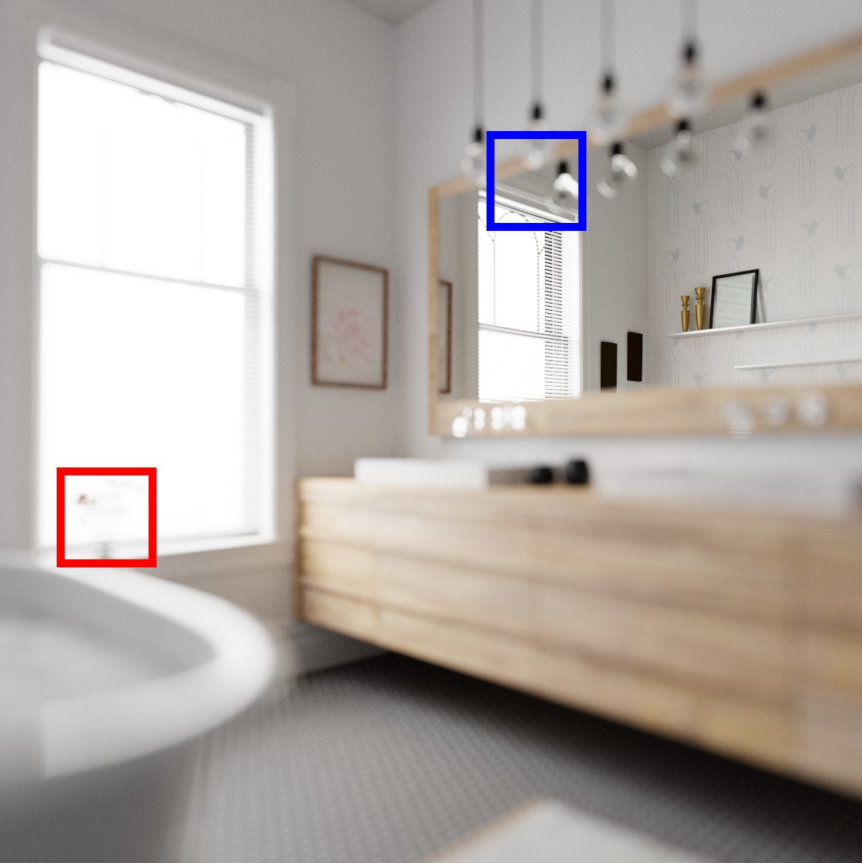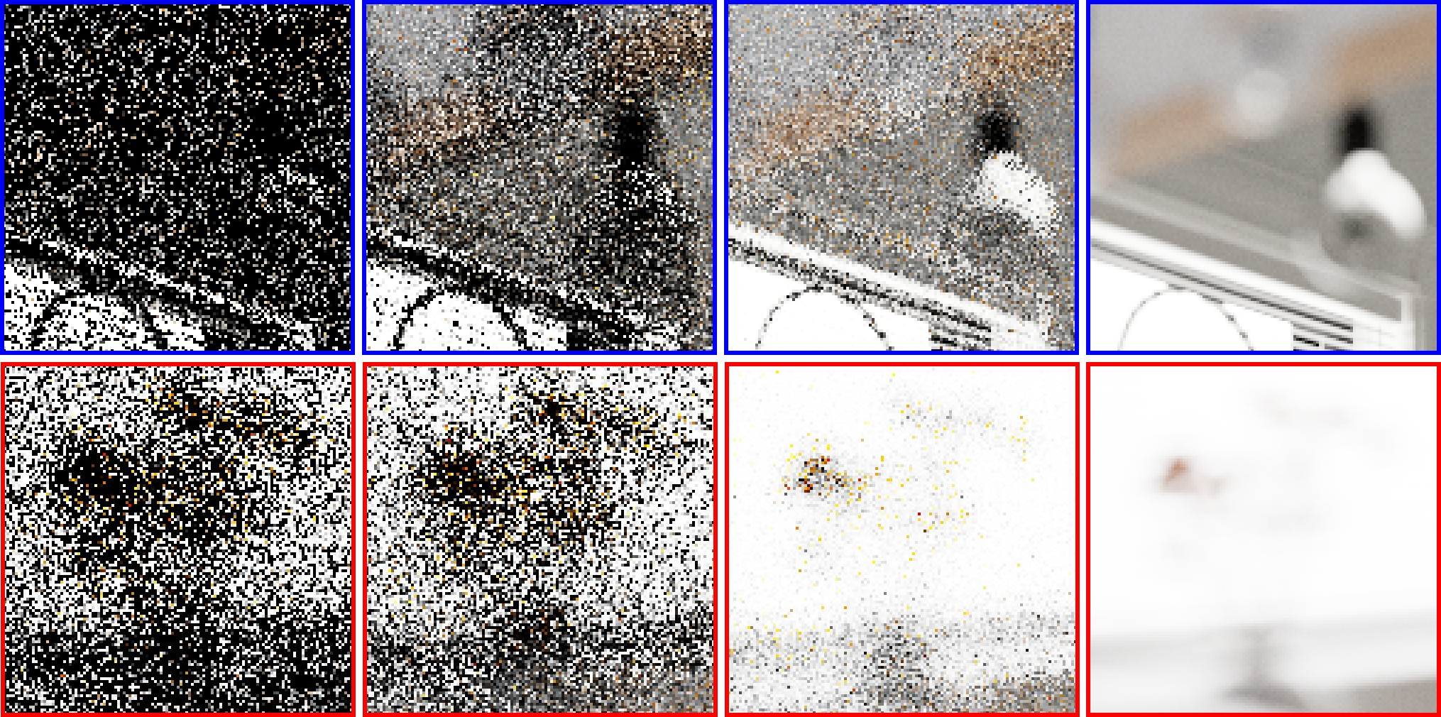
(a) Path tracing, 4.4 ms (b) ReSTIR PT, 13.8 ms (c) Area ReSTIR, 16.0 ms (d) Ground Truth (a) (b) (c) (d)
Fig. 2. Depth of feld in the Contemporary Bathroom with focal plane on the (refected) far wall. (a) With one independent path per pixel, no reuse occurs. (b) ReSTIR PT [Lin et al. 2022] reuses samples, but struggles to identify reusable paths in defocused areas with complex geometry, specular efects, or edge discontinuities. (c) Our new Area ReSTIR reuses signifcantly more samples in these regions, as we analyze the signal in the measurement equation’s higher-dimensional space. (d) A converged path traced reference.

high-dimensional integrals over complex domains; we should be able to include a few more dimensions, e.g., subpixel location (, ) and aperture (, ).
Instead of reusing samples to solve the rendering equation for one subpixel location at a time, we reuse to solve the higher-dimensional measurement equation, which integrates over the pixel flter and camera parameters, enhancing analysis of overlaps among adjacent pixel domains or reservoirs. Counterintuitively, estimating a higher-dimensional integral increases quality at a given sampling rate. By enabling more efective reuse, fewer pixels discard their history and must restart aggregation; this reduces noise (e.g., see Figure 1).
We initially aimed to reduce aliasing with ReSTIR, but discovered our method also improves reuse on areas with e.g., high-frequency normal maps and geometry. Our Area ReSTIR also naturally ex-tended to depth of feld. This follows the general direction of extend-ing reuse dimensions in ReSTIR literature (see Figure 2); ReSTIR was frst designed to reuse direct illumination, then extended to global illumination, and now also to subpixel and aperture coordinates.
Our specifc contributions include:
- Importance sampling pixel footprint and depth of feld by applying ReSTIR to the measurement equation,
- Subpixel-tracking temporal reuse by reprojection with non-integer motion vectors, drawing samples from multiple over-lapping prior reservoirs (Section 4.2),
- Robustifying temporal reuse in pixels with high-frequency geometry or normals (Section 4.3),
- A new shift mapping and MIS weights to improve sample reuse for depth of feld (Sections 4.6 and 5.3),
- Direct support for advanced (non-box) pixel flters in ReSTIR, which may improve temporal reuse (Section 4.4).
We show that when shading just one sample per pixel, spatiotem-poral sample reuse allows complex primary ray efects in real-time, including antialiasing and depth of feld.

RELATED WORK
Renderers typically solve the intensity of a pixel by the measurement equation [Veach 1998], integrating radiance over all paths through a pixel. Most algorithms do this by point sampling the rendering equa-tion [Kajiya 1986] for one or more incident directions. Recovering the accurate intensity from few point samples spawned entire new research felds (e.g., postprocess antialiasing [Yang et al. 2020] and
depth of feld [Demers 2004]), to perform higher-quality fltering despite a low sampling budget.

Spatiotemporal Reservoir Resampling
We extend reservoir-based spatiotemporal importance resampling (ReSTIR) [Bitterli et al. 2020] to solve the measurement equation by explicitly integrating over camera and pixel footprints. Gener-ally, ReSTIR enables complex sample reuse, even between varied integration domains, by unbiased resampling and reweighting us-ing reservoir sampling [Chao 1982] to efciently leverage modern GPUs’ stream computation model.
Bitterli et al. [2020] applied ReSTIR to direct lighting, and it has been extended to difuse global illumination [Jiang et al. 2023; Ouyang et al. 2021], and more complex paths [Lin et al. 2022, 2021]. Recently, Chang et al. [2023] and Wang et al. [2023] both adapt ReSTIR to diferentiable rendering, and Sawhney et al. [2024] inte-grates Markov Chain Monte Carlo mutations with ReSTIR to reduce correlations. But most of these methods use reservoirs to estimate radiance through a single point in screen space and reuse only subpaths leaving the corresponding primary hit point.
A few techniques apply ReSTIR in other spaces. Kettunen et al. [2023] resample in conditional probability spaces, Weinrauch et al. [2023] use reservoirs in object space, and Boissé [2021] stores reser-voirs in world space hash grids. Boksansky et al. [2021] use reser-voirs in voxels, but keeping this unbiased is tricky. Pixels using voxels with high-frequency geometry may see arbitrarily diferent parts of the scene (compared to voxel centers); this is hard to track. And as Wyman et al. [2023] emphasize, knowing and accounting for supports is key to keeping ReSTIR unbiased.
Area ReSTIR breaks the convention of integrating at points. Our reservoirs act as estimators over an integration domain including pixel footprint and camera aperture. A reservoir is no longer associ-ated with a single point, but a region. If we jitter the pixel (, ) or aperture (, ), we can often continue reusing our temporal history. These area sample domains overlap, so many samples can still help estimate a future frame’s (higher-dimensional) integral.

Gradient-Domain Rendering
Researchers have explored other path reuse techniques. Bekaert et al. [2002] reuse samples within a single integration domain and Bauszat et al. [2017] expand to reuse between domains with appropriate

shift mappings. Shift maps come from gradient-domain rendering [Kettunen et al. 2015; Lehtinen et al. 2013], which computes discrete image gradients between a pixel sample and shifted neighbor.
Many shift mappings exist (see Hua et al.’s [2019] survey), but Lin et al. [2022] design a hybrid shift, combining random replay and reconnection shifts, optimized for ReSTIR-based path reuse on the GPU. In all previous shift mappings, primary hits are given as fxed, and the shift mapping produces the rest of the path vertices.
In Area ReSTIR, we must also decide how to shift map primary hits (i.e., subpixel locations) between only partially overlapping pixel footprints (due to motion between frames). In this paper, we extend existing shift mappings to this context and defne a new shift mapping to improve bokeh of directly visible emissives.

Depth of Field
Frequently, renderers approximate depth of feld from a thin-lens
spatiotemporal reuse gives an unbiased estimate of the perfectly antialiased image, while only shading one sample per pixel.

PRELIMINARIES
Before introducing our work, we frst review ReSTIR and key related concepts. See Wyman et al. [2023] for a more in-depth review.

Resampling and ReSTIR
Resampled importance sampling (RIS) [Talbot et al. 2005] provides an unbiased way to estimate an integral ( ) d using samples resampled from a set of independent candidates . By drawing candidates with a cheap distribution ( ) and resampling with user-selected target function ˆ( ), ’s sample distribution converges to
∫Ω
∫Ω
¯( ) = ˆ( )/ ˆ( ) d as grows. Picking ˆ ≈ means such
estimates the integral of with low variance. This has the form

camera using a postprocess blur [Potmesil and Chakravarty 1982]. ˆ
= ∑ , (1)

Distributed ray tracing [Cook et al. 1984] and accumulation bufers [Haeberli and Akeley 1990] use Monte Carlo sampling to accurately estimate depth of feld, but both are generally infeasible in real time.
⟨ ⟩RIS = ( )
, where
1 1 ( )
ˆ( ) ( )
=1

Specialized reconstruction flters improve the quality of such Monte Carlo estimates [Bako et al. 2017; Belcour et al. 2013; Li et al. 2012], but these typically require providing relatively high sample counts as input, limiting use in real time.
Real-time applications typically postprocess a pinhole camera image, often split into multiple layers using depth peeling [Everitt 2001], and then processing with pyramidal processing [Kraus and Strengert 2007], difusion [Kass et al. 2006], or layer traversal via ray queries [Lee et al. 2009]. Production games often use a complex mix of multiple techniques [Abadie 2018; Jimenez 2014] to ameliorate the artifacts inherent in postprocessing, including light leaking, over-blurring, ghosting, and hallucination (of occluded samples).
Our work instead expands integration to include camera aperture,
letting ReSTIR integrate depth of feld. Shading only a single sample
where the sum better approximates ˆ( ) d as increases, i.e.,
≈ 1/¯( ).
∫Ω
Generalized RIS (GRIS) [Lin et al. 2022] formally defnes an un-biased contribution weight (UCW) as any weight satisfying E[ | ] = 1/ ( ), meaning Monte Carlo integration can use these weights instead of a sample PDF (as in Equation 1, left).
Lin et al. [2022] show UCWs can replace not just simple PDFs; UCWs often exist where exact PDFs are impossible to practically evaluate, as in resampling over frames with diferent per-pixel in-tegration domains. If reusing from varied domains, a per-domain shift mapping maps candidates into ( ) in the common target domain. In this case, a more general form of Equation 1 is

ˆ( )

per pixel, we get an unbiased, high-quality estimate.
= 1 ∑ , for = � ( ) ˆ � ( ) , (2)
=1

2.4 Antialiasing
Renderers sampling pixels at few deterministic locations (e.g., pixel centers) leave the image aliased, and require postprocess fltering to remove these artifacts. This has challenged real-time renderers for decades, leading to techniques like hardware multisampling
where are per-candidate resampling weights, are resampling MIS weights, and is chosen from ( ) proportionally to . The candidates are treated as diferent sampling strategies, and these MIS weights normalize their coverage over the target domain.
Mathematically, the form a partition of unity over these strate-

[Akeley 1993], inferring edges from the image [Jimenez et al. 2011;
gies, so every target domain point has Í () = 1. If strategy

Lottes 2009; Reshetov 2009], or the recently ubiquitous temporal antialiasing [Karis 2014; Korein and Badler 1983; Yang et al. 2020]. More recently, researchers and developers have leveraged neural networks to antialias and upsample images (e.g., DLSS and XeSS) [Hasselgren et al. 2020; NVIDIA 2019; Xiao et al. 2020]. After long training over giant datasets, these networks predict high-quality weights for nearby spatiotemporal pixels to guess an antialiased image from aliased inputs (plus some other benefts, like denoising). Compared to point-sampling real-time renderers, our work ex-pands the integration domain over pixel footprints, allowing us to deterministically apply MIS weighting [Veach and Guibas 1995] to spatiotemporally reuse samples without any training process. This
=1
cannot generate with positive PDF, then () = 0. Incorrect , as when assuming constant = 1/ during spatiotemporal reuse, are a common cause of bias when implementing ReSTIR.
When reusing from many domains, the union of candidate sup-ports must cover the target domain (any path with ˆ > 0 must be producible by at least one strategy). To guarantee coverage, we take at least one canonical sample (a sample from the current pixel). This is one role played by new independent, per-pixel candidates in each frame.
GRIS allows resampling passes to be iteratively chained without bias. This enables the feed-forward chain of sample distributions, improving over time, that characterizes ReSTIR [Bitterli et al. 2020].

Eficient Streaming Sampling
Efcient feed-forward reuse relies on weighted reservoir sampling [Chao 1982], a constant-space algorithm to randomly pick one el-ement from a stream. It has many nice properties, including the ability to combine choices from many streams without replaying any of them. This allows paths to improve render quality long after they no longer reside in memory, as only chosen paths must be re-evaluated each frame. Other samples contribute indirectly via the chosen sample’s weight and distribution.
Weighted reservoir sampling uses a reservoir data structure to store its current state. Fundamentally, reservoirs only need to store
the current selected sample and a running sum of weights (equiva-
even if using fxed u at pixel centers, but the issues are magnifed when rendering with camera jittering for antialiasing.

AREA RESTIR
Our Area ReSTIR improves robustness near high frequencies occur-ring within pixels by targeting the full path space U × Ωˆ to integrate
instead of the varying ˆ (u ). In other words, we let ReSTIR also importance sample subpixel locations. We store samples over pixel footprints in area reservoirs, defned in Section 4.1. Area reservoirs no longer always reside on a pixel grid, so we analyze how fractional ofsets afect reuse in Section 4.2.
We extend Area ReSTIR to also improve depth of feld by letting

lently, either or Í ). But ReSTIR often localizes reservoirs
ReSTIR control the coordinates s ∈ S = [0, 1]² that map to lens area

=1
to a particular sampling location, so reservoirs may also include,
e.g., a pixel ID, path or shading data, a count of seen samples, or
∫ ˆ
in a fnite-aperture camera, e.g. via disk sampling. Pixel intensity is then given by

other implementation dependent details. After sampling a new path, the reservoir is updated with a short, simple algorithm (see Bitterli
= ℎ (u) (u, s, xˆ) d(u, s, xˆ). (7)
U×S×Ω

et al. [2020], Algorithm 2).

3.3 Issues with the Measurement Integral
Path tracing computes radiance by solving the rendering equation [Kajiya 1986],
(x, ) = (x, ) +∫ 2 (x, , )(x, ) |(x)· | d, (3)

with incident direction integrated over the sphere ², and (x, ), the outgoing radiance in direction from surface point x with normal (x). This surface may emit light , or refect other incident light from directions ∈ ² according to the surface BSDF .
The intensity of pixel is determined by the measurement equa-
tion [Veach and Guibas 1997],
The ideal target function1 becomes ˆ(u, s, xˆ) = ℎ (u) (u, s, xˆ), and Area ReSTIR spatiotemporally reuses triplets (u, s, xˆ) via shift map-pings.
Prior methods reprojected, shifted, and reused samples on a pixel grid at integer precision. To achieve good subpixel-accurate reuse, we must carefully design our new temporal reuse (see Section 4.3) as multiple prior-frame reservoirs may now contain reusable samples (see Figure 3); we discuss spatial reuse in Section 4.5.
Earlier work [Lin et al. 2022] only shifts xˆ and randomizes earlier path vertices. As those randomized vertices are vital for good path reuse with depth of feld, we design a new shift mapping specifcally to handle defocused areas (see Section 4.6).
Sample reuse with area reservoirs, target function ˆ(u, s, xˆ), our

= ∫ ℎ (x¯) (x¯) dx¯, (4)
temporal reuse, and enhanced shift mapping greatly improve reuse robustness compared to prior work (see Figure 1). While we start

Ω
given as an integral over ¯
by assuming area integration with a box flter, our method also

∈ Ω, all paths connecting emitters to the sensor, and ℎ is the pixel flter, is the measurement contribution function. We reparametrize the primary hit x₁ with image plane position u ∈ U = [0, ] × [0, ]. Separating image coordinates from
supports more advanced flters ℎ in ˆ (see Section 4.4).

Area Reservoirs
As our reservoirs now span a screen-space area and the path space

the rest of the path xˆ = x2x3 · · · ∈ Ωˆ gives:
x
u,
behind it (supp(ℎ ) × Ωˆ ), we call these area reservoirs to distinguish

∫ ∫
ℎ (u) (u, x)
U Ω
them from prior work’s point reservoirs covering path space behind a single point (i.e., {u } × Ωˆ ). Our ℎ may be any common flter with

=
ˆ

ˆ dˆ d

(5)

where ℎ (u) is the pixel flter with ℎ (u) du = 1.
∫ U
Prior ReSTIR work estimates by fxing image coordinates u ∈ R² inside pixel each frame, spatiotemporally sharing subpaths in Ωˆ to integrate
fnite support around pixel centers; we start by assuming a box flter before later generalizing.
Area reservoirs store paths parametrized as x = (u, s, xˆ) along with their unbiased contribution weights x . Image-space location
2

ˆ ∫
ˆ dˆ (6)
u lies in ℎ ’s support and lens coordinate s lies in [0, 1) . Here, u and

(u ) = ˆ ℎ (u ) (u, x) x
Ω
s defne path vertices x₀ and x₁, and xˆ defnes subsequent vertices.
We use path contribution ˆ (u, s, xˆ) = ℎ (u) (u, s, xˆ) as our target

for each pixel. Earlier work assumes a box flter, supporting other kernels by splatting [Lin et al. 2022].
For best results, ReSTIR should choose target functions matching the integrand, which in prior work means ˆ(xˆ) = (u, xˆ), as u is within pixel . Randomizing u mutates ReSTIR’s target distribution, potentially invalidating temporal reuse where changes quickly due to high-frequency normal maps, glinty materials, hair, or foliage. Camera or object motion can degrade reuse quality in these regions
function. A key takeaway: area reservoirs need not have integer u or be fxed to pixel centers, but as in Figure 3, reservoir footprints may be ofset from the pixel grid.
To get samples, we trace candidates by generating path x. We sample u proportionally to the pixel flter, u = ℎ , and s uniformly

1 ℎ (u) should be used in ˆ if the flter (e.g. Mitchell–Netravali [1988]) has negative values (as ˆ cannot be negative). We drop the absolute value for simplicity.

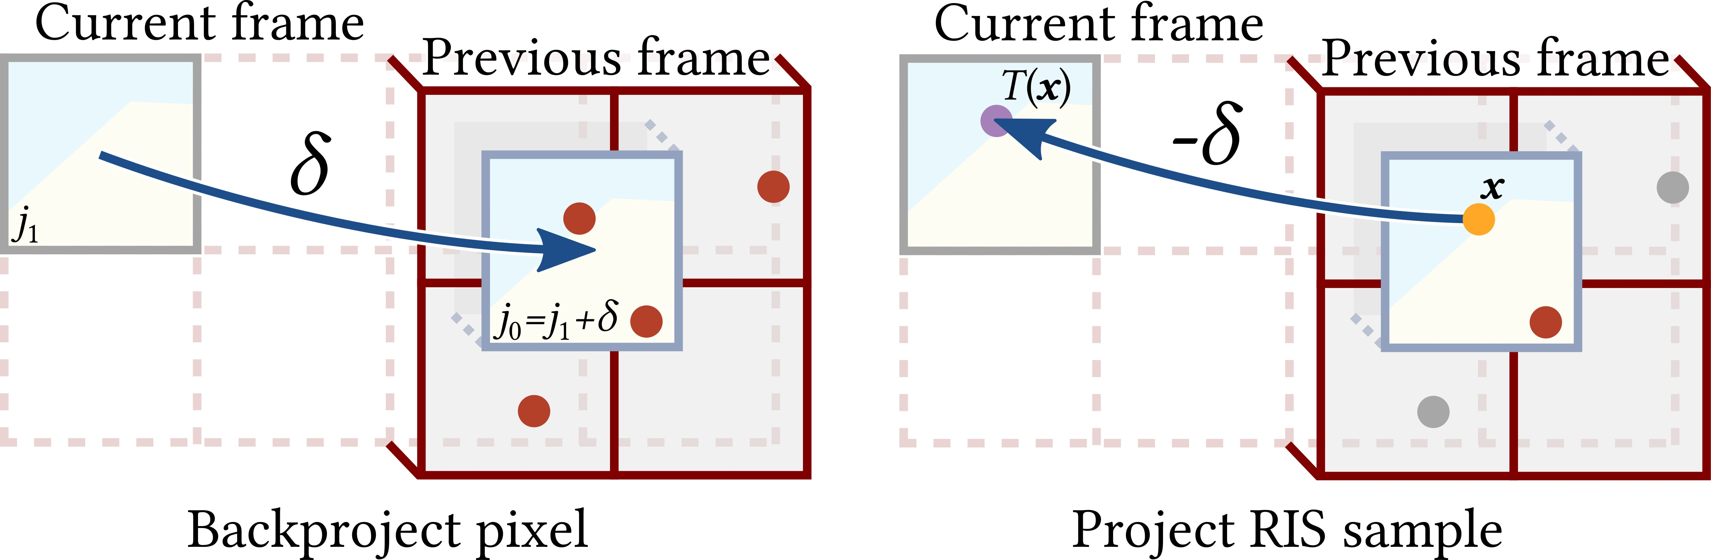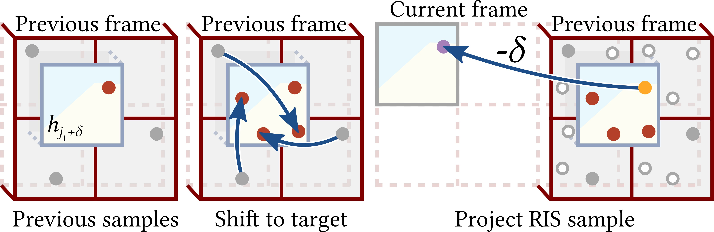

Fig. 3. Our subpixel-aware shift map frst backprojects the current pixel to the previous frame by motion vector (left). The projected pixel’s support overlaps 2 × 2 prior pixels, each with one reservoir sample (red). We select one via RIS, discarding those outside the support (gray). We then reproject the chosen sample (orange) forward to the current frame by shifting by −.

from [0, 1)2. These defne path vertices x0 and x1, and remaining vertices xˆ are produced by path tracing. This gives initial path can-didates a PDF (x) = 1 · u (u) (xˆ|u, s). While we initially sample subpixel location u proportional to the pixel flter, reuse via ReSTIR quickly improves this subpixel distribution.

Fractional Matching in Area Reservoirs
Previous resampling methods used integer backprojection, i.e., pro-jecting to the nearest discrete prior frame pixel. This is problematic where small subpixel ofsets drastically impact the path contribution. Area reservoirs improve robustness due to fractional backprojection, fnding reservoirs with (partially) overlapping integration domains, resampling with appropriate MIS weights, and allowing subpixel-precise reuse.
Let us compare a simplifed version of our subpixel-aware reuse to the older method. Consider a static scene with moving camera. Assume the camera moves from frame 0 to 1 such that pixel 1 exactly corresponds to of-grid pixel2 0 = 1 + in the previous frame, where may be fractional. Any x = (u, s, xˆ) in ₁ in frame 1 and (u + , s, xˆ) in ₀ in frame 0 represent the same geometric path, yielding the same path contribution in the two frames, i.e.
1 (u, s, xˆ) = 0 (u + , s, xˆ).
Following Figure 3, we can defne a temporal shift from frame 0 to 1, (u, s, xˆ) = (u−, s, xˆ) that translates u by the motion vector and keeps s and xˆ the same. This yields the same geometric path.
Sample reuse quality largely depends on how well the two frames’ target functions match, with ratios close to one lowering resampling variance [Wyman et al. 2023]. Assuming a box flter and denoting the target function of frame by ˆ , we get ratio
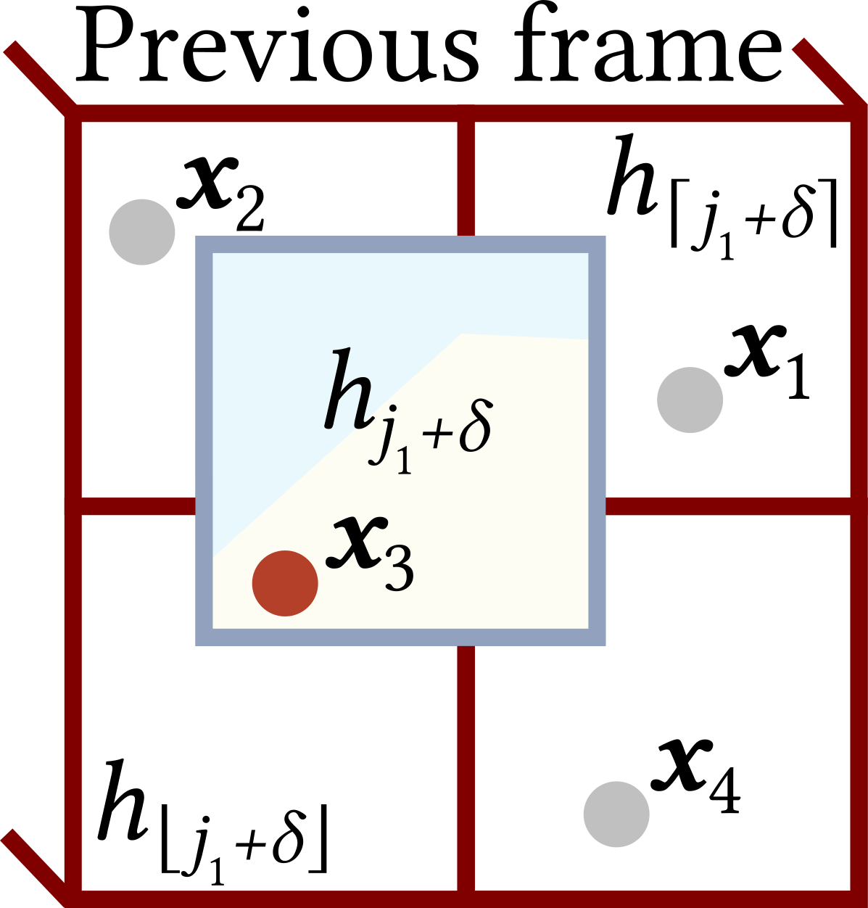
ˆ1 ( (u0, s0, xˆ0)) 1 (u0 −, s0, xˆ0) 0 ((u0 −) +, s0, xˆ0)
Fig. 4. Our advanced shift reduces variance by always giving RIS the same number of candidates (right). Prior frame samples outside the pixel support (gray) are shifted to the target pixel but retain their subpixel coordinates (middle). We select one by RIS (orange) and repro-ject it to the current frame by a shift of −. Conceptually, we shift all prior frame samples to their 2 × 2 neighbors, but these virtual samples (white) are only needed for MIS weights and proving correctness.

This also explains why prior ReSTIRs are sensitive to visual frequencies, even without jittering or depth of feld. Denote = round() and assume shading at pixel centers. Then,
ˆ1 ( (xˆ0)) = ˆ1 (xˆ0) = 0 ( 1 + + 0.5, xˆ0) , (10)
ˆ0 (xˆ0) ˆ0 (xˆ0) 0 ( 1 + + 0.5, xˆ0)
i.e., subpixel detail may degrade reuse for any non-integer motion.

Temporal Reuse
Area ReSTIR reduces this frequency sensitivity by carefully match-ing paths at subpixel precision for temporal reuse. To temporally reuse area reservoirs, we backproject current flter ℎ1 ’s footprint into the previous frame. See Figure 3, which depicts a box flter; Section 4.4 generalizes to fnite support flters. Backprojection can map to an arbitrary pixel-sized area. We use a real-time convention, approximating motion with a translation along a motion vector , leaving more general projections as future work. We then select an overlapping sample from the prior frame by RIS, and fnish by shifting the selection back − to the current frame.
We outline two options for identifying previous frame samples: a fast option that picks from samples overlapping the backprojected pixel (Figure 3), and a more expensive and robust option that ensures all nearby samples can contribute, by shifting them onto the pixel’s support (Figure 4). We start with the fast option, which is simpler to implement and provides a constructive step towards realizing the robust version. Additionally, it allows trading some quality to achieve closer to baseline performance.
    - Option (Fast): Using samples as-is. Consider resampling path

ˆ0 (u0, s0, xˆ0)
= 0 (u0, s0, xˆ0) =
0 (u0, s0, xˆ0)
= 1. (8)
x from four inputs x = (u, xˆ ) from area reser-

Consider the point reservoirs in the same situation. We read xˆ0
from reservoir + round(). The target function ratio is
ˆ1 ( (xˆ0)) = ˆ1 (xˆ0) = 1 (u1, s1, xˆ0) = 0 (u1 + , s1, xˆ0) , (9)
ˆ0 (xˆ0) ˆ0 (xˆ0) 0 (u0, s0, xˆ0) 0 (u0, s0, xˆ0)
where u0, u1, s0 and s1 are random, and u1+ and u0 may be diferent. If ₀ varies fast as other parameters change, the ratio may vary wildly. But if ₀ is insensitive to other parameters, reuse may be efcient.
2We explain how to populate this of-grid pixel with reusable samples in Section 4.3.
voirs overlapping the backprojected pixel’s foot-print ℎ1 + in the prior frame. If pixel coordi-nate u lies in kernel ℎ1 + , sample x gets a
positive resampling weight with ˆ1 + (x ) =
ℎ1 + (u ) (u, xˆ ); we reuse with the identity shift. Otherwise we consider x invalid, with no contribution. This gives MIS weights
(1 ∈ supp x
() = 1supp x () =
. (11)
0 otherwise

This trivially satisfes Í4 () = 1, guaranteeing unbiased inte-
gration (over supp ℎ
=1
1 + ) using GRIS (see Section 2.1).
reworking the MIS weights in Equation 11 to account for overlaps:

While the fast option is unbiased and reduces variance from high
frequency content, it is imperfect: prior frame samples can only be
() = , (12)

Í4
ℎ
()
′=

1 ′ ℎ ′ ()

reused if they lie in backprojected flter ℎ1 + . Such samples may not exist; x may all lie outside of the reprojected pixel’s area (ℎ1 + ), in which case temporal reuse returns a null sample. This randomly resets temporal history in motion, and is thus not an ideal reuse solution in all cases. We still report results with this fast option due to its good performance, but we default to use the following, more robust option.
    - Option (Robust): Guaranteeing coverage. To address this prob-lem, we propose adjusting the positions of samples x located out-side of the flter ℎ1 + by one-pixel shifts. This brings outside sam-ples back to the flter range (see Figure 4).
For 2 × 2 prior frame reservoirs, imagine mapping each sample x to all neighbors via one-pixel shifts vertically, horizontally and diagonally (Figure 4, center). Exactly one (potentially shifted) copy of each will lie in backprojected pixel ℎ1 + ; the other shifts need not be executed (Figure 4, white circles). This allows reusing all four neighbor samples, ideally as-is, but shifting into ℎ1 + as a backup.
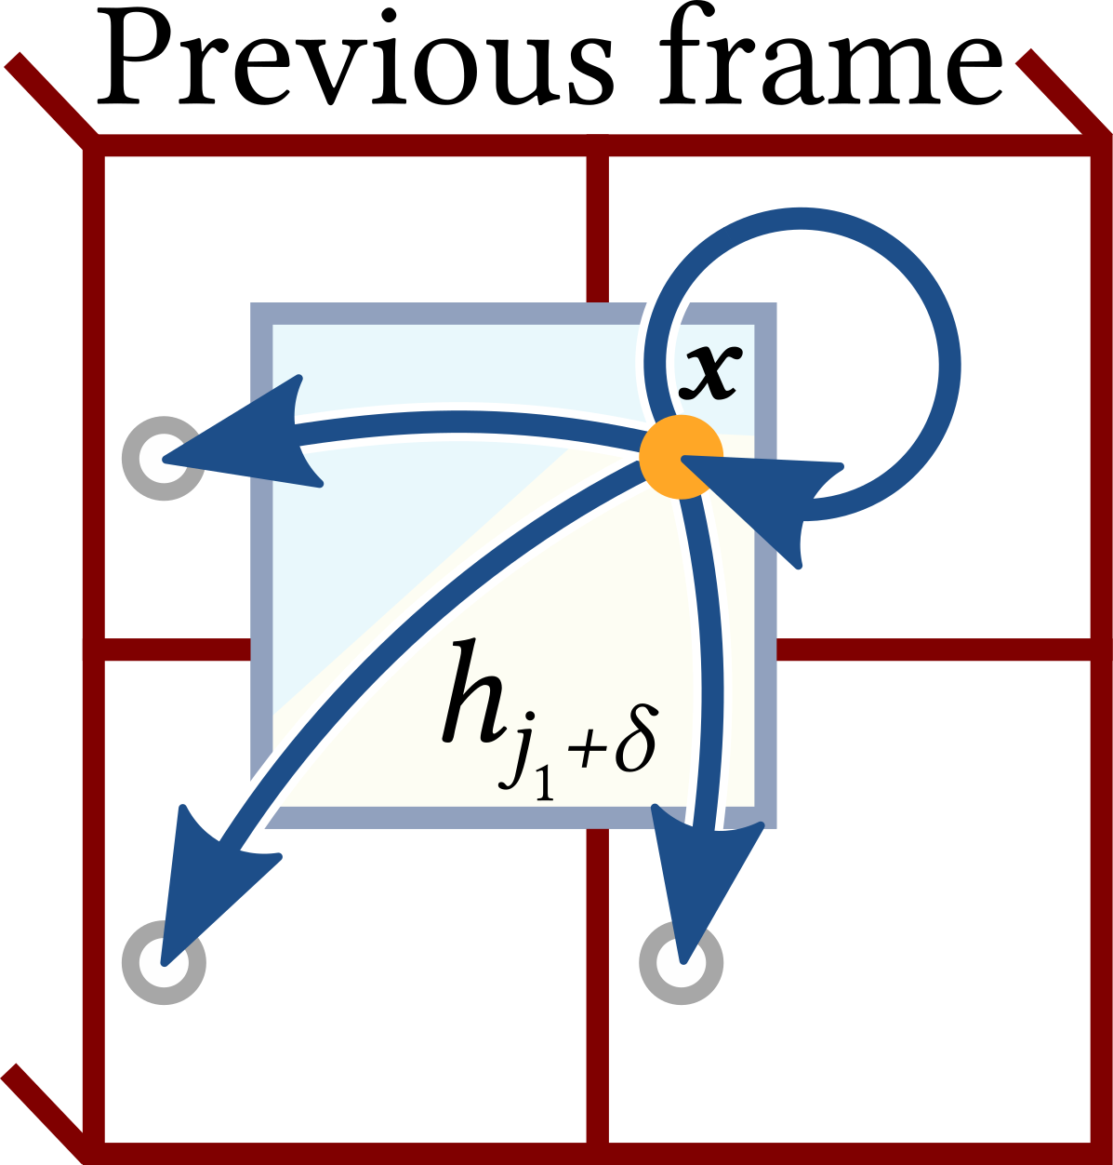
For MIS weights to combine these four candi-dates, we use the generalized balance heuristic [Lin et al. 2022]. This requires knowing all neigh-
bors’ probability densities of generating the se-lected sample x = (u, xˆ), with u in ℎ1 + . We shift x to all four pixels and evaluate the pixels’ target
functions as proxies for the unknown PDFs in the balance heuristic. One of the shifts is identity and returns x.
Considering quality, this method improves on the option in Sec-
tion 4.3.1. When backprojected flter ℎ1 + overlaps prior samples, they provide good low-variance reuse. The balance heuristic bounds variance degradation [Veach 1998] from the worst neighbors. When all samples are outside ℎ1 + ’s support, the fast option produces a null sample. The robust option can avoid resetting temporal his-tory by borrowing neighbor samples; if just one shift succeeds, our current-frame pixel inherits that pixel’s history.
    - Mapping Back to the Current Frame. After choosing a prior
where are bilinear interpolation weights for the backprojected flter relative to the four overlapping reservoirs.
This accounts for flter importance and increases the weight of better-matching areas: if the backprojected flter exactly aligns with a single temporal reservoir, that will be the only reservoir used. Box flters (Equation 11) are a special case of Equation 12.
Theoretically, with larger pixel flter footprints, samples could be borrowed from a larger number of pixels, but this is not required for unbiased results. We leave optimizing this for future work.

Spatial Reuse
Fractional motion vectors help our temporal sample reuse. But we do not use fractional motion vectors for spatial reuse: that requires frst fnding subpixel correspondences between nearby pixels.
Instead, like prior work [Bitterli et al. 2020; Lin et al. 2022, 2021], we sample random neighbors from a screen-space neighborhood at integer distances (essentially, integer ) and rely on shift mappings between their domains and careful MIS weighting for spatial reuse. Moving to ofine rendering, where larger pixel flters may be desirable, the integration domains of very nearby spatial neigh-bors may once again overlap, making the shift in Section 4.3.1 also
interesting for spatial reuse.
However, unlike prior work, our spatial shift maps can also map lens coordinates (as described in Section 4.6). This improves spatial reuse in the presence of depth of feld.

Depth of Field
When reusing sample x = (u, xˆ) in Section 4.3, we left the shift map unspecifed, e.g., xˆ could be shifted by vertex copy ( (xˆ) = xˆ) [Lehtinen et al. 2013] (e.g. when building Area ReSTIR on ReSTIR DI) or by Lin et al.’s [2022] hybrid shift (when building on ReSTIR PT).
For non-pinhole cameras, we must also shift lens position s or, equivalently, path vertex x₀. Generalizing, our lens vertex copy reuses

frame sample to reuse (from ℎ

1 +
), we shift this sample back to
lens coordinate s, extending how prior methods reuse pinhole cam-
era paths (where x₀ must remain fxed). This shift should work for

the current frame by subtracting the motion vector from its u coordinate, and apply GRIS to combine with the canonical sam-ple from current frame’s pixel. (This canonical sample is the new independent path shot each frame in every pixel.)
Variance depends mainly on how well area reservoirs overlap between frames, errors due to approximating backprojection via translation, and how well the used shift mapping adapts to temporal changes to the scene.

Extension to General Pixel Filters
For general pixel flters, we assume each flter ℎ ’s support is a rectangle containing pixel [Pharr et al. 2016]. The analysis in Sections 4.2 and 4.3 largely still applies; we still backproject flter ℎ to the prior frame as ℎ + , overlapping prior area reservoirs. But prior reservoir contributions are no longer disjoint, which requires
small apertures and has a Jacobian of 1.
But large apertures can have big circles of confusion. This spreads bright lights (or refections) at primary hitpoints x₁ into large, glow-ing bokehs with shape dependent on camera aperture. Since x₀ and x₁ together defne the pixel, a shift mapping that reuses the camera vertex x0 necessarily must have diferent primary hit x1 for neighbor pixels. Thus, prior shifts fail to signifcantly reduce variance inside bokehs, as x₁ is not reused.
We introduce a new shift mapping that reuses vertex x₁. Instead, we produce the shifted camera position x′ by projecting x₁ through the focal plane at sample u′ onto the lens and compute s′ correspond-ing to x′ (see Figure 5). We call this the primary hit reconnection shift and derive its Jacobian in Appendix A.
0
0
As with any shift map, this is not universally applicable. Repro-jecting x₁ onto the lens may hit a point x′ outside the aperture. The
0

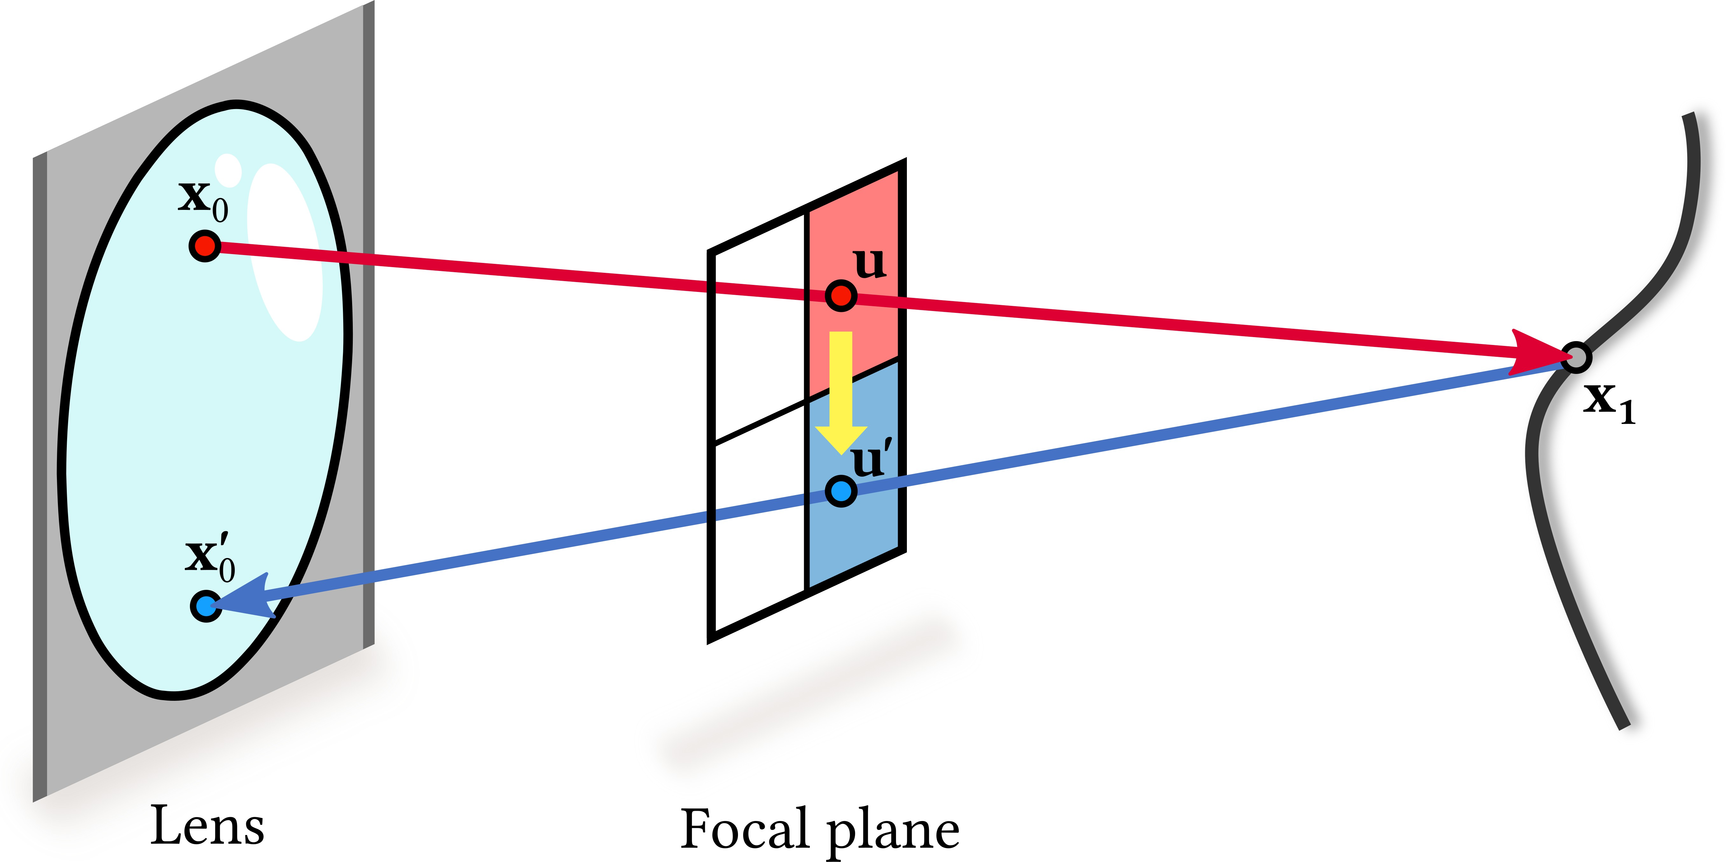
Fig. 5. Computing new lens position x′ using the primary hit re-
We no longer use Bitterli et al.’s [2020] depth and normal based neighbor rejection heuristic in our Area ReSTIR’s spatial reuse im-plementation, as we found its efect imperceptible when using Lin et al.’s [2022] pairwise MIS. These depth and normal based heuristics are also incompatible with depth of feld rendering.

Ray Tracing Optimization
In ReSTIR, shifting samples always requires more visibility tests for correct MIS weights (and thus avoid bias). Area ReSTIR must test visibility (x0 →x1) in every pixel we shift into or any pixel that may have generated a selected sample. As pixels have varying

connection shift
0
. Project the input path’s primary hit
x1 back to the
lens and subpixel positions, this needs more visibility tests than

camera through the shifted path’s position u′ on the focal plane and compute s′ corresponding to x′ . The shift fails if x′ is outside the lens
prior work. As an example, our fast temporal reuse (Section 4.3.1) requires tracing two primary rays per pixel besides the two shadow

0 0
or the ray x1 →x′ is occluded.
0
rays traced in the original ReSTIR. We need to trace new primary hits, while the original ReSTIR reads them from the G-Bufer.
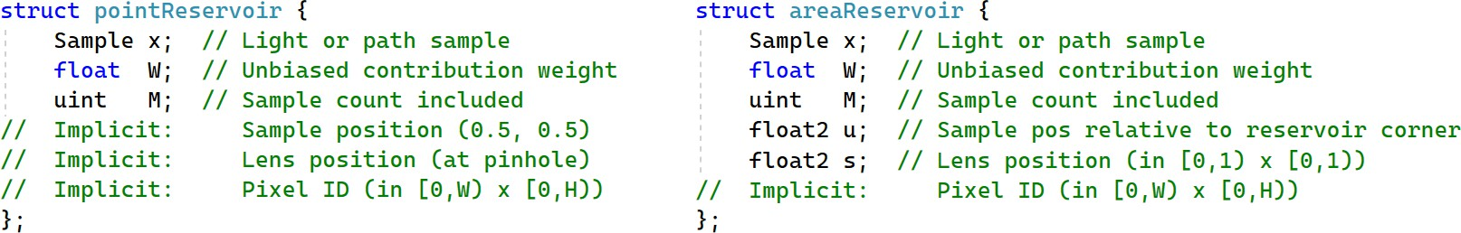
Our robust temporal reuse shifts four paths to the target pixel (Figure 4, right). For each, three more target function evaluations are needed for MIS weights to account for potential sources. A naive unbiased implementation of our robust temporal reuse (Sec-tion 4.3.2), thus requires 12 additional primary rays for each pixel

Fig. 6. Key diferences between prior ReSTIR reservoirs (e.g., Bitterli
et al. [2020]) and our area reservoirs. Previously, subpixel sample and camera locations were fxed per frame, allowing reservoirs to implicitly reference them. Area reservoirs must store a lens sample and the fractional subpixel location, relative to the reservoir boundary.

primary ray between x₁ and reprojected x′ could also be occluded.
(and 12 shadow rays for direct light).
But pixels only have 8 neighbors. Using a scatter approach, we can exhaustively compute visibility to neighbors’ reservoir samples. This requires only 8 primary (and shadow) rays per pixel, rather than gathering visibility for all 16 samples. The eight neighbor rays are also highly coherent; we coalesce tracing to maximize coherent memory accesses during traversal. Compared to a naive approach, this runs 40-60% faster on scenes in our test suite.

In either case, the shift becomes invalid. 0

For small apertures and vertices x₁ near the focal plane, primary hit reconnections are unlikely to succeed. Using MIS between our two shifts thus often produces a valid sample. Generalized RIS [Lin

Shif Mappings
Earlier ReSTIR work reuses paths by shift mapping x0x1x2 into
x′ x′ x′ with vertices x0 and x1 fxed or randomized as needed

0 1 2

et al. 2022] can handle this MIS by duplicating a reservoir and assigning diferent shifts to each. Alternatively, half of our randomly selected spatial neighbors can be assigned each shift; this typically improves performance signifcantly.

IMPLEMENTATION DETAILS
Area ReSTIR can augment any screen-space ReSTIR algorithm. We built upon Bitterli et al.’s [2020] direct illumination algorithm for simplicity, while also adapting ReSTIR PT [Lin et al. 2022] to verify the generalizability of our approach. Area ReSTIR afects just lens and primary hit points, so this was straightforward.

Reservoirs, Reuse, and G-Bufers
Extending to area reservoirs is fairly simple, as shown in Figure 6. Previously implicit data like lens sample s and fractional subpixel positions u must be stored. Storing these values in the range [0, 1) promotes numerical robustness.
Due to independent lens and subpixel samples, Area ReSTIR cannot rely on rasterized G-bufers. As ReSTIR defers shading until after spatiotemporal reuse, to avoid retracing we still store primary hits in a bufer. We also store motion vectors for temporal reuse (in Section 4.3) and depth (for MIS scaling in Section 5.3).
by the implementation. In Area ReSTIR, it is necessary to explicitly
shift map these frst two vertices.
In Section 4.6 we described two possible ways, the lens vertex copy and primary hit reconnection shifts.
Neither is always better, so we opt to perform both and combine them via MIS weights. We also weight these strategies via a heuristic modelling their expected quality. This is important, as MIS increases variance when combining a known-good and a bad estimator. We know primary hit reconnections fail for pinhole cameras (or on the focal plane) and the lens copy is less valuable with large circles of confusion. Our heuristic accounts for this domain knowledge.
This heuristic defnes a scaling factor multiplied in as a conf-dence weight [Wyman et al. 2023] when computing these shift’s MIS weights. = 1 forces selection of the lens vertex copy, and = 0 selects the primary hit reconnection.
We leave theoretical derivation of the scaling factor for future work, and instead derived one empirically. We found image quality somewhat insensitive to the exact values of , and we use
( ) = min 1.0, 0.2 + 6.2 , (13)
− 5.6
where is the circle of confusion diameter in pixels. While resolution-dependent, we tested it works well over varying resolutions (from

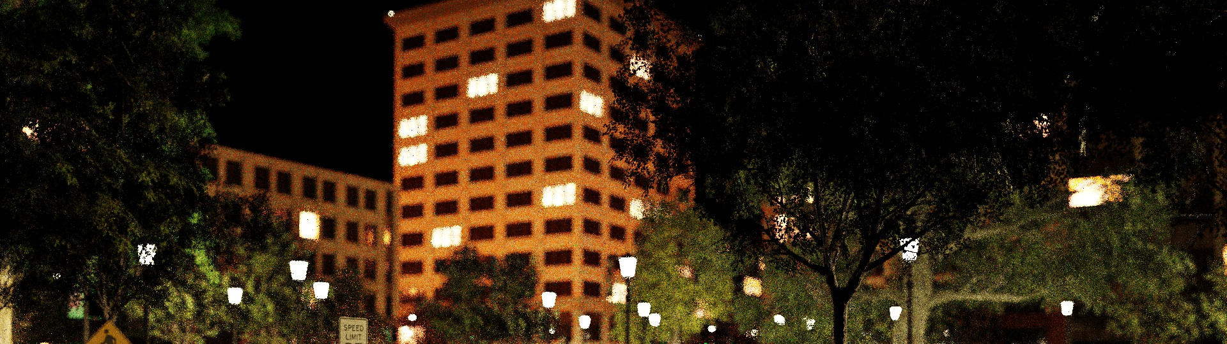
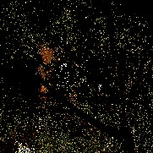
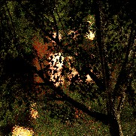

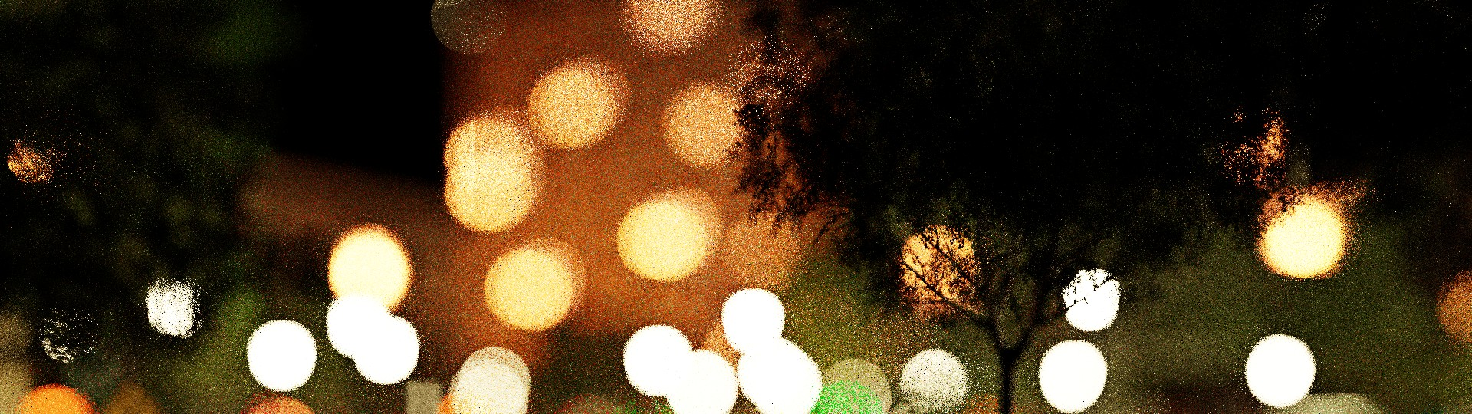
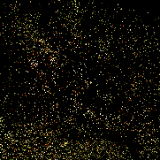
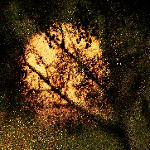

Emerald Sqare (Ours) ReSTIR Ours Reference
Small Aperture

Time: 19 ms ↑ 31 ms / ↓ 40 ms
Large Aperture
Fig. 7. Our path reuse works well with various lens apertures, ranging from small to large. We show two very diferent sized lenses here in Emerald Square, but Area ReSTIR outperforms baseline reuse in both cases. These results were captured without camera motion.
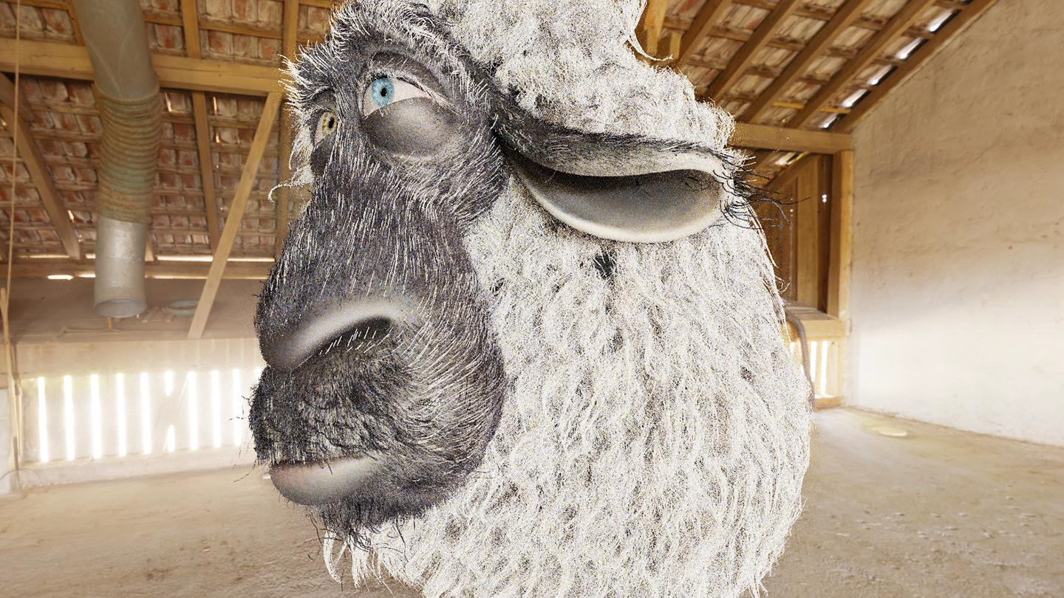




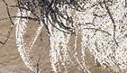

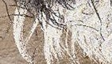

Ours ReSTIR (0.5, 0.5) ReSTIR (Jitter) Ours Reference
Time:
12.6 ms
12.6 ms
18.1 ms
Franck (1 spp)

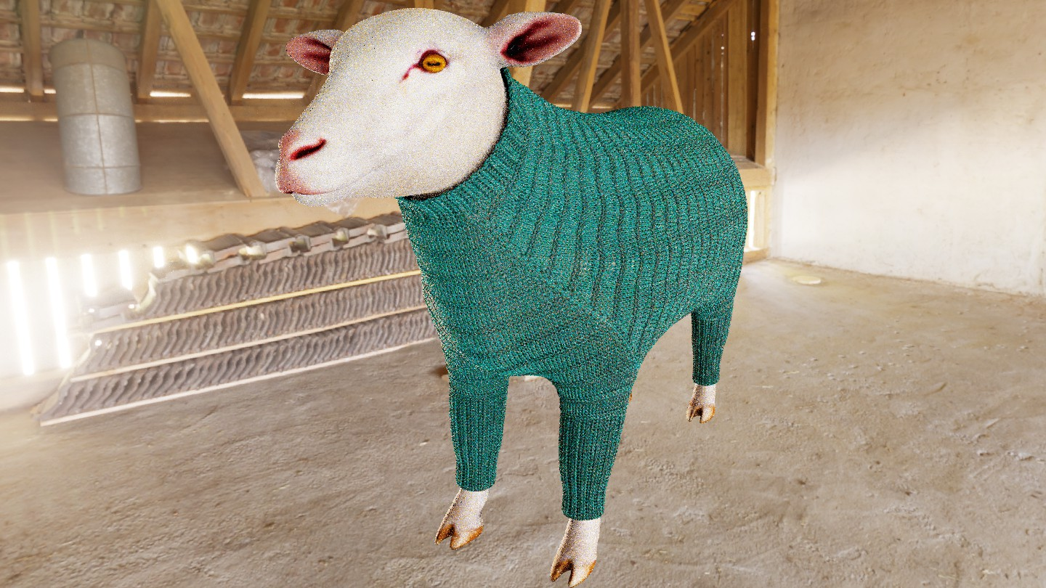



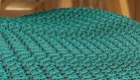




Fig. 8. When shading pixel centers, ReSTIR gives aliasing. If converged, jittering removes aliasing but does not help quality at 1 spp. Our Area ReSTIR improves temporal reuse, giving higher-quality antialiasing. Note that, based on our MIS scaling function in Section 5.3 (i.e. = 1 for pinhole camera), only lens vertex copy shift is applied here. Images captured with a static pinhole camera. Franck uses global illumination and ReSTIR PT baseline [Lin et al. 2022]. Sheep Sweater only uses direct lighting and compares to Bitterli et al. [2020].
Time:
13.7 ms
13.7 ms
15.7 ms
Sheep Sweater (1 spp)

720p to 2160p) and generally found this heuristic handled all scenes well, regardless of aperture size.
When temporally reusing a sample selected from the prior frame, we apply both mappings when shifting back to the current frame (Section 4.3.3), using scaling factor as part of our MIS weights. For spatial reuse, we split neighbors into two groups (in a : 1− ratio) and each group uses just one type of shift map. We use four spatial neighbors and always assign at least one to use a lens vertex copy.

RESULTS
Our prototype builds on the Falcor framework [Kallweit et al. 2022]. Comparisons use the same geometry, lighting, and code framework. We measured performance on an NVIDIA RTX 4090 with an AMD Ryzen 9 7950X and 64GB RAM in resolution 1920 × 1080. Error values are reported using mean absolute percentage error3 (MAPE). Note that our prototype has no assumptions stipulating any part of the scene is static (e.g., no precomputations on load).

3 gt
−gt !

˜gt

We use MAPE(,
) = mean , for
0.01·mean gt +gt
( ˜ ) ˜
a grayscale ground-truth.

Carousel (Ours)
Lens Vertex Primary Hit
Copy Reconnection MIS Reference

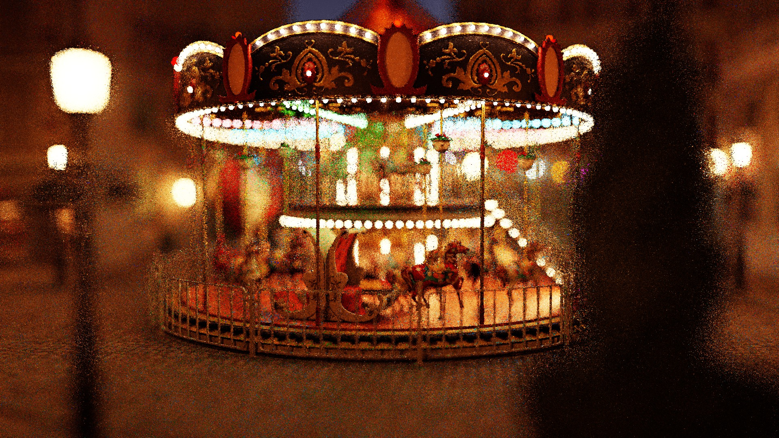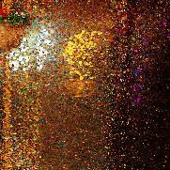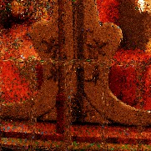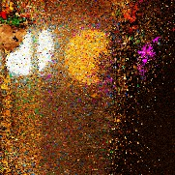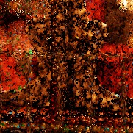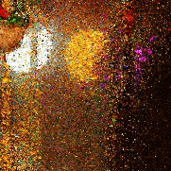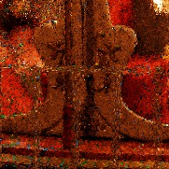
Time: 47.8 ms 42.6 ms 46.7 ms
Fig. 9. The lens vertex copy and primary hit reconnection shifts (Section 4.6) work better in diferent situations. The vertex copy works best for regions in focus, while the hit reconnection works better in bokeh and out of focus regions. We MIS between these shift maps (Section 5.3) to achieve good quality everywhere. These Carousel results were captured with camera motion, using our robust temporal reuse (Section 4.3.2) and the same shift map (either lens vertex copy or primary hit reconnection) for both spatial and temporal reuse.

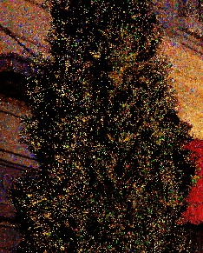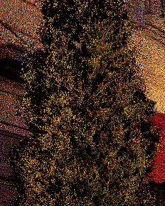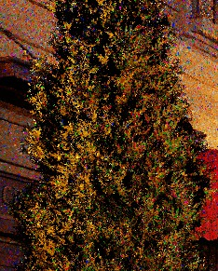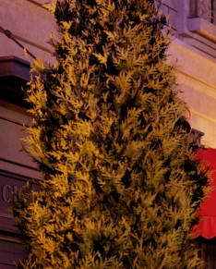
(a) Integer motion (b) Fast reuse (c) Robust reuse (d) Reference Time: 23 ms Time: 24 ms Time: 32 ms -
Fig. 10. Fractional motion vectors enable better reuse across our scenes. Here we compare our method (a) using integer motion vectors to (c) fractional motion vectors with our robust reuse. With fractional motion, our fast reuse (b) also improves quality, but may not fnd suitable candidates for all pixels. Images captured with camera motion in Bistro.
Temporal Spatial Spatiotemporal
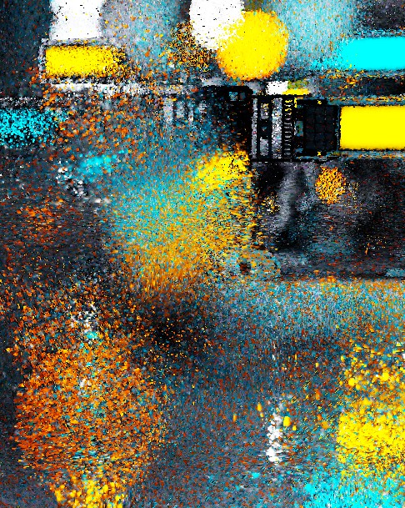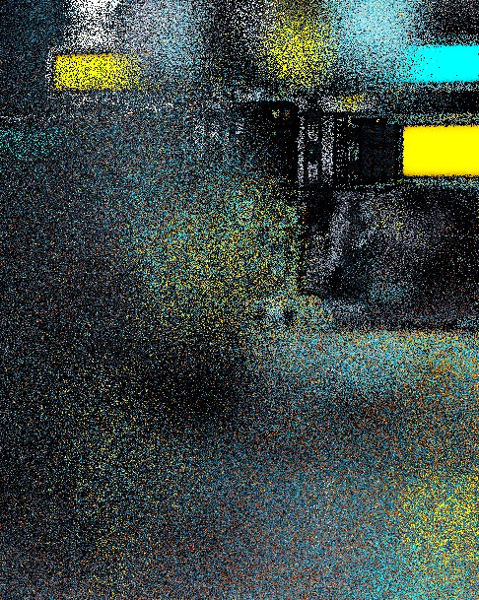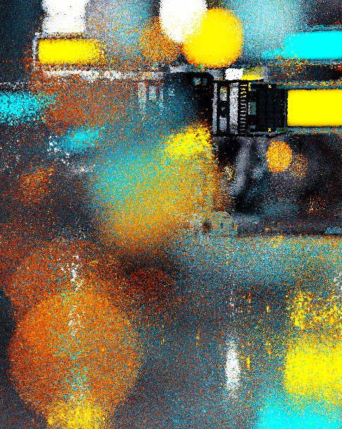
Fig. 11. Combined spatiotemporal reuse is much more powerful than spatial or temporal reuse alone with Area ReSTIR, especially in areas with strong depth of feld. Picture with camera motion in Zero Day.

All ReSTIR variants shown shade just one path per pixel, though many samples contribute via its unbiased contribution weight. We use identical ReSTIR settings between Area ReSTIR and our baseline. For direct lighting, we use 32 light and 1 BSDF candidate samples per pixel [Bitterli et al. 2020]. For path tracing, we use 1 candidate path
tree per pixel [Lin et al. 2022]. For temporal reuse, we set history length to 20 (Wyman et al. [2023], Chapter 4.4). For spatial reuse, we reuse 4 neighbors randomly selected in a 30 pixel radius.
Result images were captured either during motion or with a static camera, as listed. Please see our supplementary video for more evaluation under motion.
Improved sample reuse in bokeh. Our new primary hit reconnec-tion shift (Section 4.6) drastically improves sampling of bokeh com-pared to baseline ReSTIR. Our approach enables hierarchical reuse of bokeh samples, maintaining a well importance sampled set of samples between frames. In Figure 7 we study this beneft for both small and large lens apertures.
Area ReSTIR improves antialiasing and robustness. Prior resam-pling methods sufer near high subpixel frequencies (see Section 4.2). Figure 8 evaluates our improvements on Franck the sheep with mesh geometries, and Sheep Sweater with actual curve geometries. Both rendered with a still camera and no depth of feld. Shading only pixel centers causes visible aliasing. Jittering removes the aliasing (at high sample counts) but fails to improve quality with just one sample per pixel. Area ReSTIR improves antialiasing and is more robust on those high-frequency fur or fabric.
Robustness with MIS between shift mappings. Since our new pri-mary hit reconnection shift works best for defocused pixels, and the lens vertex copy shift works best for in-focus pixels, we combine the two with MIS (see Section 5.3). We explore the benefts in Figure 9, showing our MIS scaling heuristic works well across pixels with varying levels of focus.
Fractional motion vectors improve robustness. To show the impor-tance of fractional motion, Figure 10 combines diferent pieces of our work. With area reservoirs and new shift maps, but only integer motion vectors we still have signifcant noise near edges. Using fractional motion with our fast reuse (Section 4.3.1) improves re-sults but not consistently, as it still resets temporal history when

Ours (Robust) ReSTIR PT Ours (Fast) Ours (Robust) Reference

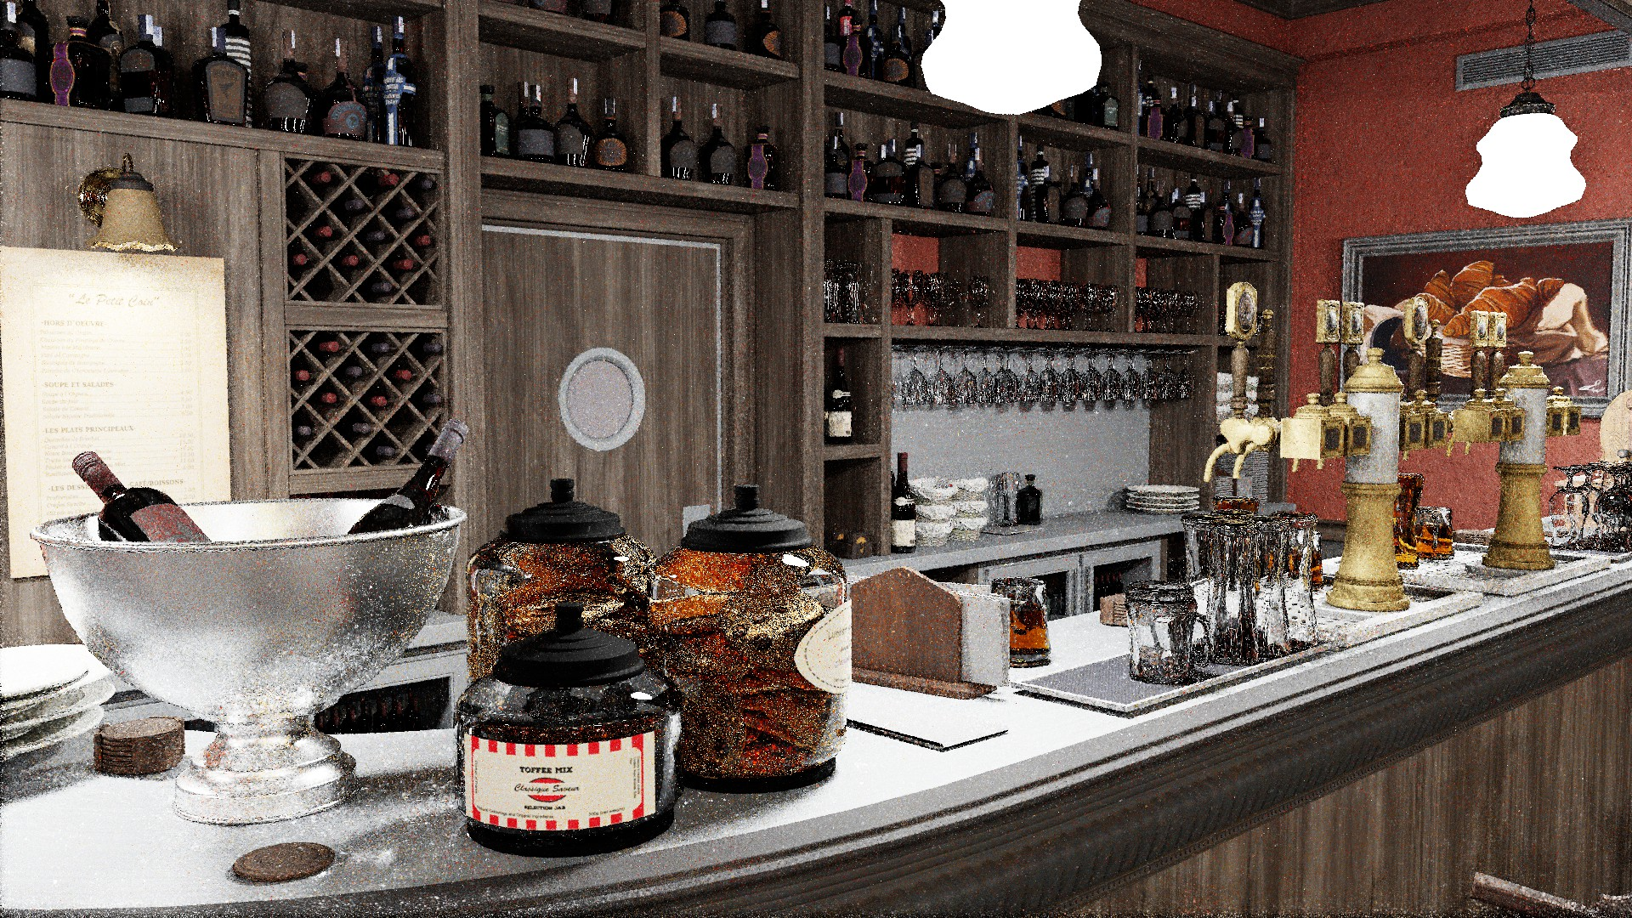
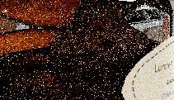
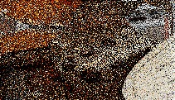
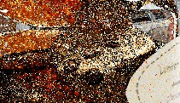

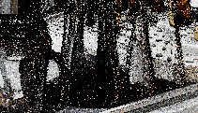
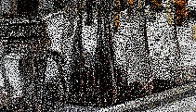
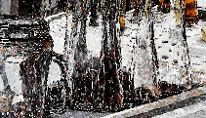

Time / MAPE: 18.2 ms / 0.3696 25.6 ms / 0.4849 28.2 ms / 0.2657
Bistro Interior
Fig. 12. Compared to Lin et al.’s [2022] ReSTIR PT, our Area ReSTIR improves path reuse for complex paths like L(S)DSE paths on the cookie jar (top inset) and the L(D)S+E paths for the glasses (bottom) due to more stable temporal reuse and invalidating fewer accumulated sample distributions. While our fast version has higher MAPE than baseline ReSTIR PT, the more difcult, hard-to-denoise paths are sampled signifcantly better. This scene captured with camera motion.

Ours, Box Ours, Gaussian Reference Reference
1 × 1 px = 0.7 px Box Gaussian
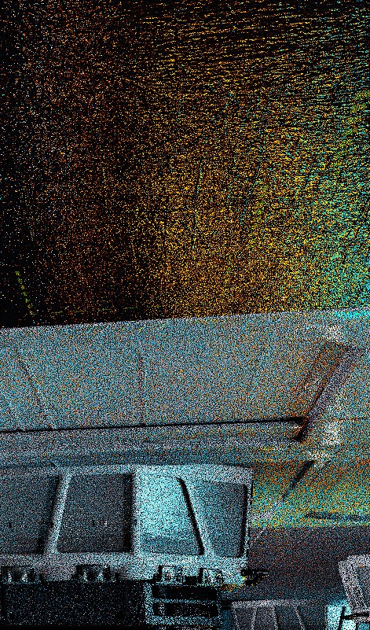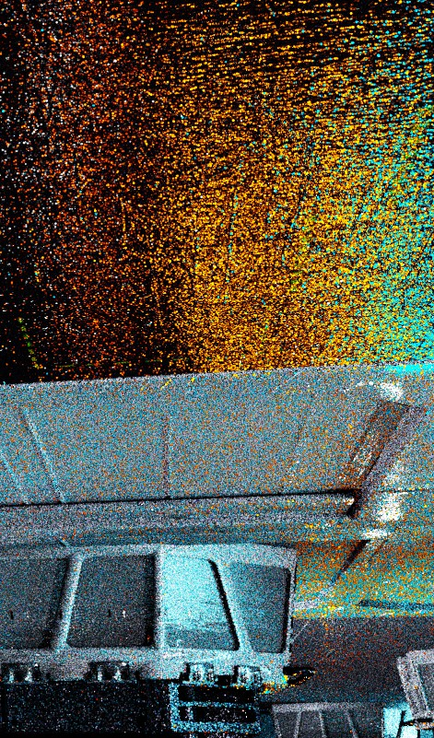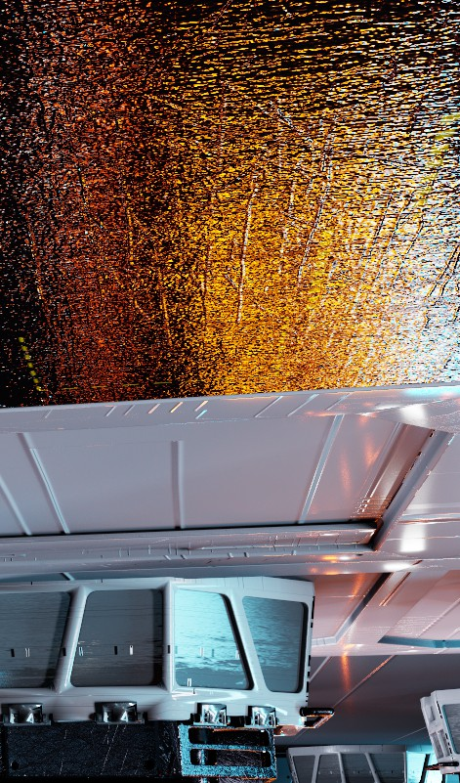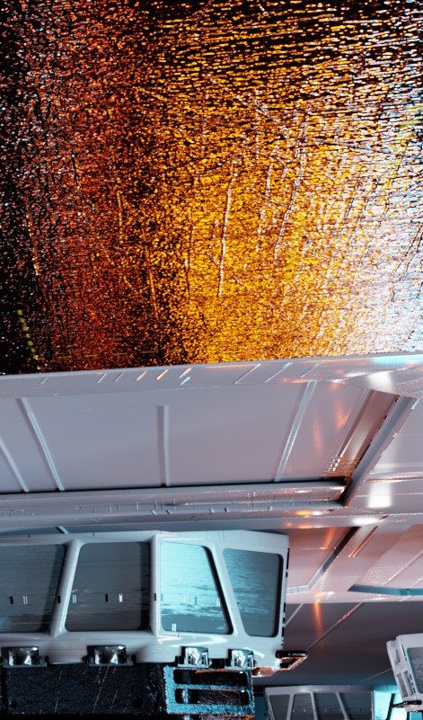
12.0 ms
12.1 ms
-
-
Fig. 13. Area ReSTIR with our fast reuse benefts from larger pixel flters. Here we compare the 1×1 box flter against a truncated Gaussian with a two-pixel radius and fnd improvement in reuse quality. Picture with camera motion in Zero Day.

the reuse fails. Our robust reuse (Section 4.3.2) improves quality further, though at a performance cost.
Spatial and temporal reuse are both important. Prior work found temporal samples contribute most improvement in ReSTIR [Wyman and Panteleev 2021]. While still true, Figure 11 shows combining spatiotemporal samples remains valuable. Spatial reuse helps break up correlations that accumulate during complex nonlinear motion. This is especially true with strong depth of feld.
Area ReSTIR improves glossy refections. Specular paths are highly direction-dependent, which makes reuse tricky, especially under motion. Figure 12 shows our higher dimensional space improves reuse of these tricky paths. This results from our smaller sensitivity to pixel-level details (Section 4.2) and our potential to better reuse nearby paths’ primary hit points.
Better reuse with advanced pixel flters. While most of our results use a 1 ×1 box flter, Section 4.4 extends our work to other pixel flters without using kernel splatting. Larger flter supports can improve our temporal reuse, perhaps making such flters attractive for real-time use. We show an example with our fast temporal reuse (Section 4.3.1) in Figure 13.
General performance and quality evaluation. In Figure 15, we eval-uate our quality by comparing to prior ReSTIR algorithms [Bitterli et al. 2020; Lin et al. 2022] as a baseline. Our comparisons cover various geometric and lighting scenarios: direct lighting v.s. global illumination; emissive geometry v.s. environment map lighting; dif-fuse v.s. specular or glossy materals; varying aperture sizes; and high-frequency foliage and normals maps.
Area ReSTIR and baseline ReSTIR use identical independent sam-ple counts and the same number of spatial neighbors, but our area reservoirs allow much better temporal reuse. This gives consistent quality improvement in Figure 15. Our robust temporal reuse (Sec-tion 4.3.2) gives better quality than the fast reuse (Section 4.3.1), albeit at higher cost due to more visibility rays for MIS weights. Additionally, running multiple instances of the baseline ReSTIR and averging their results provides very limited improvement in challenging regions, still falling short of the quality achieved by our method at equal time.
Performance overheads grow in scenes with costly ray tracing, e.g., more triangles, complex BVHs, large bokeh with incoherent primary rays, or lots of alpha testing4. This overhead comes from tracing rays to compute unbiased MIS weights.
To quantify this ray overhead, we measured our optimized visibil-ity passes (Section 5.2), which coalesce the extra visibility rays into separate ray wavefronts. For the scenes in Figure 15, this overhead was 4.9 ms for Bistro, 4.2 ms for Zero Day, 11.1 ms for Emerald Sqare, 4.1 ms for Sidewalk, and 4.7 ms for Bistro Interior. This accounts for most overhead moving from our fast to our robust reuse. As correct MIS weights ensure unbiasedness, cheaper alternatives may exist for renderers willing to accept some bias.
Figure 15 includes the Crown scene, using a pinhole camera and thus only antialiasing. Zoom in on the insets to see our antialiasing quality (particularly the robust reuse). In this scene, our fast reuse produces higher total error than the baseline due to failures to fnd prior-frame samples inside the backprojected flter. This reduces quality in the large in-focus, easy-to-sample areas, but the fewer high-frequency areas are sampled better.

4We do not yet use opacity micromaps to improve alpha testing performance.

LIMITATIONS AND FUTURE WORK
Overall, using area reservoirs and integrating over additional lens and subpixel dimensions greatly improves quality, both in static images and under motion. However, there are limitations and inter-esting future directions.
We expect area reservoirs can be extended one more dimension to handle motion blur. But motion blur interacts with the ray ac-celeration structure in complex ways, especially when aiming to reuse temporal samples. We aimed to solve the challenges of area reservoirs in a simpler domain before adding complex engineering challenges.
As most prior work, we resample a scalar target function. This means we do not importance sample variations between RGB chan-
nels; this causes color noise, especially in scenes with many multi-

𝑛𝑛(𝐱𝐱1)
𝐱𝐱𝐱0
𝐮𝐮𝐱
𝐱𝐱1
Δ𝐱𝐱𝟏𝟏
Δ𝜔𝜔
𝐮𝐮 Δ𝜔𝜔
Δ𝐱𝐱𝟎𝟎
𝐱𝐱0

Lens
Focal plane
Fig. 14. Important parameters for deriving the primary hit recon-nection shift’s Jacobian in Appendix A.

lens sampler, so we have |x0/s| = ( s′/x′ )−1 = lens area. As a result, |s′/s| = x′ /x0 . Thus, we must just fnd x′ /x0 .
0

0 0
0

color lights (e.g., the Bistro).
Our assumption that pixels simplistically translate between frames
With u′ acquired, reusing x1 gives a new x′ ≠ x0 (Figure 14), and

x′
x′
x1

limits reuse quality when zooming or in scenes with more complex motion. Clearly, we miss some relevant samples in integration do-mains of interest. But it is unclear if the cost of more complex
0 = 0 . (14)
x0 x1 x0
We must fgure how x0 and x′ change with x1, given fxed u and

projections and querying arbitrary footprints leads to sufcient reuse benefts. This is worth exploring.
0
u′. Figure 14 shows a solid angle change Δ at the focal plane

We apply area sampling only during temporal reuse, as spatial neighbors’ 1 × 1 box flters do not have overlapping domains. But for pixel flters with larger domains (e.g., Mitchell-Netravali or Sinc),
(corresponding to u) changes Δx₀ and Δx₁ diferently. We can apply
the solid-angle to area measure Jacobian to get
x1 2 | · (x0) |

spatial neighbors may have overlapping footprints. While such
= 1
2 , (15)

flters are typically too costly for real time, future work might fnd these costs can overlap with better sample reuse.
x0 | · (x1) | 0
given the direction along x₀x₁, lens and surface normals , and distances 0 and 1 between the focal plane and x0, x1. Similarly,

CONCLUSION
x′
x′
′ ′2
|′ · (x₁) |

0 = 0
= 0 , (16)

We introduced Area ReSTIR, a real-time algorithm extending spatio-
x1 ′
x1 ′ · (x′ ) ′2

temporal path reuse to importance sample pixel and aperture foot-
0 1

where ′, ′, ′ are similarly defned with x1, x′ , and u′. Note that

prints. Prior work reuses discretely sampled paths from an image;
0 1 0

this misses reusable neighbor paths near high frequencies. By ex-plicitly integrating over image-space, our work fnds better reuse candidates. This allows building real-time path tracers that handle bokeh, foliage, hair, and detailed normal maps all with only one shaded sample per pixel (per frame).
While the curse of dimensionality is real, our work shows inte-grating in higher-dimensional domains gives benefts if it permits more efective reuse than lower dimensions. If ReSTIR better reuses samples, it greatly improves quality.

ACKNOWLEDGMENTS
We want to thank Aaron Lefohn for discussions on and support of this research, and the anonymous reviewers for their valuable comments and feedback. This project was supported in part by NSF Grant #1956085.

A JACOBIAN OF PRIMARY HIT RECONNECTION
Consider shifting path sample (u, s, xˆ) to (u′, s′, xˆ′) with our pri-mary hit reconnection, copying x′ = x . We frst acquire u′ as a
(x′ ) can vary from (x0) if the lens moves.
Given u′ and s′, we can now fnish the full shift by acquiring xˆ ′ from xˆ by any existing path shift, such as Lin et al.’s [2022] hybrid shift. The full (u, s, xˆ) is shifted by concatenating the three partial shifts, and hence the full Jacobian is the product of the three Jacobians.
0

REFERENCES
Guillaume Abadie. 2018. Life of a bokeh. In SIGGRAPH Course Notes: Advances in Real-Time Rendering. https://advances.realtimerendering.com/s2018/index.htm
Kurt Akeley. 1993. Reality Engine graphics. In Proceedings of SIGGRAPH. https:
//doi.org/10.1145/166117.166131
Steve Bako, Thijs Vogels, Brian Mcwilliams, Mark Meyer, Jan NováK, Alex Harvill, Pradeep Sen, Tony Derose, and Fabrice Rousselle. 2017. Kernel-predicting convolu-tional networks for denoising Monte Carlo renderings. ACM Trans. Graph. 36, 4, Article 97 (Jul 2017), 14 pages. https://doi.org/10.1145/3072959.3073708
Pablo Bauszat, Victor Petitjean, and Elmar Eisemann. 2017. Gradient-domain path reusing. ACM Trans. Graph. 36, 6, Article 229 (Nov 2017), 9 pages. https://doi.org/ 10.1145/3130800.3130886
Philippe Bekaert, Mateu Sbert, and John H Halton. 2002. Accelerating path tracing by re-using paths. In Rendering Techniques. 125–134. https://doi.org/10.2312/EGWR/ EGWR02/125-134
Laurent Belcour, Cyril Soler, Kartic Subr, Nicolas Holzschuch, and Fredo Durand. 2013. 5D covariance tracing for efcient defocus and motion blur. ACM Trans. Graph. 32,

1 1 3, Article 31 (Jul 2013), 18 pages. https://doi.org/10.1145/2487228.2487239

translation by the locally constant motion vector, so the Jacobian of that part is 1. Next, we want to shift s to s′, producing some Jaco-bian |s′/s|, given u′. Camera vertex x0 comes from s by a uniform
Benedikt Bitterli, Chris Wyman, Matt Pharr, Peter Shirley, Aaron E. Lefohn, and Woj-
ciech Jarosz. 2020. Spatiotemporal reservoir resampling for real-time ray tracing with dynamic direct lighting. ACM Trans. Graph. 39, 4, Article 148 (Jul 2020), 17 pages. https://doi.org/10.1145/3386569.3392481

Guillaume Boissé. 2021. World-space spatiotemporal reservoir reuse for ray-traced global illumination. In SIGGRAPH Asia Technical Communications. 22:1–4. https:
//doi.org/10.1145/3478512.3488613
Jakub Boksansky, Paula Jukarainen, and Chris Wyman. 2021. Rendering many lights with grid-based reservoirs. In Ray Tracing Gems II, Adam Marrs, Peter Shirley, and Ingo Wald (Eds.). APress, 351–365. https://doi.org/10.1007/978-1-4842-7185-8_23 Wesley Chang, Venkataram Sivaram, Derek Nowrouzezahrai, Toshiya Hachisuka, Ravi Ramamoorthi, and Tzu-Mao Li. 2023. Parameter-space ReSTIR for diferentiable and inverse rendering. In SIGGRAPH (Conference Track). 1–10. https://doi.org/10.
1145/3588432.3591512
Min-Te Chao. 1982. A general purpose unequal probability sampling plan. Biometrika
69, 3 (1982), 653–656. https://doi.org/10.2307/2336002
Robert L. Cook, Thomas K. Porter, and Loren C. Carpenter. 1984. Distributed ray tracing.
Proceedings of SIGGRAPH. https://doi.org/10.1145/964965.808590
Joe Demers. 2004. Depth of feld: A survey of techniques. In GPU Gems. Addison-Wesley, Chapter 23, 375–390.
Cass Everitt. 2001. Interactive order-independent transparency. White Paper, NVIDIA. Paul Haeberli and Kurt Akeley. 1990. The accumulation bufer: Hardware support for high-quality rendering. In Proceedings of SIGGRAPH. https://doi.org/10.1145/97879.
97913
Jon Hasselgren, Jacob Munkberg, Marco Salvi, Anjul Patney, and Aaron Lefohn. 2020. Neural temporal adaptive sampling and denoising. Computer Graphics Forum 39, 2 (May 2020), 147–155. https://doi.org/10.1111/cgf.13919
Binh-Son Hua, Adrien Gruson, Victor Petitjean, Matthias Zwicker, Derek Nowrouzezahrai, Elmar Eisemann, and Toshiya Hachisuka. 2019. A survey on gradient-domain rendering. Computer Graphics Forum 38, 2 (2019), 455–472. https://doi.org/10.1111/cgf.13652
Jie Jiang, Xiang Xu, and Beibei Wang. 2023. A ReSTIR GI Method Using the Sample-Space Filtering. In Computer Graphics International. 79–92. https://doi.org/10.1007/ 978-3-031-50078-7_7
Jorge Jimenez. 2014. Next generation post processing in "Call of Duty: Advanced Warfare". In SIGGRAPH Course Notes: Advances in Real-Time Rendering. https:
//advances.realtimerendering.com/s2014/index.html
Jorge Jimenez, Diego Gutierrez, Jason Yang, Alexander Reshetov, Pete Demoreuille, Tobias Berghof, Cedric Perthuis, Henry Yu, Morgan McGuire, Timothy Lottes, Hugh Malan, Emil Persson, Dmitry Andreev, and Tiago Sousa. 2011. Filtering approaches for real-time anti-aliasing. In SIGGRAPH Course Notes. https://www.iryoku.com/ aacourse/
James T Kajiya. 1986. The rendering equation. In Proceedings of SIGGRAPH. 143–150. https://doi.org/10.1145/15886.15902
Simon Kallweit, Petrik Clarberg, Craig Kolb, Tomáš Davidovič, Kai-Hwa Yao, Theresa Foley, Yong He, Lifan Wu, Lucy Chen, Tomas Akenine-Möller, Chris Wyman, Cyril Crassin, and Nir Benty. 2022. The Falcor rendering framework. https://github.com/ NVIDIAGameWorks/Falcor
Brian Karis. 2014. High-quality temporal supersampling. In SIGGRAPH Course Notes: Advances in Real-Time Rendering. https://advances.realtimerendering.com/s2014/ index.html
Michael Kass, Aaron Lefohn, and John Owens. 2006. Interactive depth of feld using simulated difusion on a GPU. Pixar Technical Memo, #06-01.
Markus Kettunen, Daqi Lin, Ravi Ramamoorthi, Thomas Bashford-Rogers, and Chris Wyman. 2023. Conditional resampled importance sampling and ReSTIR. In SIG-GRAPH Asia (Conference Track). https://doi.org/10.1145/3610548.3618245
Markus Kettunen, Marco Manzi, Miika Aittala, Jaakko Lehtinen, Frédo Durand, and Matthias Zwicker. 2015. Gradient-domain path tracing. ACM Trans. Graph. 34, 4, Article 123 (Jul 2015), 13 pages. https://doi.org/10.1145/2766997
Jonathan D. Korein and Norman I. Badler. 1983. Temporal anti-aliasing in computer generated animation. Proceedings of SIGGRAPH, 377–388. https://doi.org/10.1145/ 800059.801168
M. Kraus and M. Strengert. 2007. Depth-of-feld rendering by pyramidal image process-ing. Computer Graphics Forum 26, 3 (2007), 645–654. https://doi.org/10.1111/j.1467-8659.2007.01088.x
Sungkil Lee, Elmar Eisemann, and Hans-Peter Seidel. 2009. Depth-of-feld rendering with multiview synthesis. ACM Trans. Graph. 28, 5 (Dec 2009), 1–6. https://doi.org/ 10.1145/1618452.1618480
Jaakko Lehtinen, Tero Karras, Samuli Laine, Miika Aittala, Frédo Durand, and Timo Aila. 2013. Gradient-domain Metropolis light transport. ACM Trans. Graph. 32, 4, Article 95 (Jul 2013), 12 pages. https://doi.org/10.1145/2461912.2461943
Tzu-Mao Li, Yu-Ting Wu, and Yung-Yu Chuang. 2012. SURE-based optimization for adaptive sampling and reconstruction. ACM Trans. Graph. 31, 6, Article 194 (Nov 2012), 9 pages. https://doi.org/10.1145/2366145.2366213
Daqi Lin, Markus Kettunen, Benedikt Bitterli, Jacopo Pantaleoni, Cem Yuksel, and Chris Wyman. 2022. Generalized resampled importance sampling: Foundations of ReSTIR. ACM Trans. Graph. 41, 2, Article 75 (Aug 2022), 23 pages. https:
//doi.org/10.1145/3528223.3530158
Daqi Lin, Chris Wyman, and Cem Yuksel. 2021. Fast volume rendering with spatiotem-poral reservoir resampling. ACM Trans. Graph. 40, 6, Article 279 (Dec 2021), 18 pages.

https://doi.org/10.1145/3478513.3480499
Timothy Lottes. 2009. FXAA. White Paper, NVIDIA.
Don P. Mitchell and Arun N. Netravali. 1988. Reconstruction flters in computer-graphics. SIGGRAPH Comput. Graph. 22, 4 (Jun 1988), 221–228. https://doi.org/10. 1145/378456.378514
NVIDIA. 2019. Deep learning super sampling. https://developer.nvidia.com/rtx/dlss [Online; accessed 15-January-2024].
Yaobin Ouyang, Shiqiu Liu, Markus Kettunen, Matt Pharr, and Jacopo Pantaleoni. 2021. ReSTIR GI: Path resampling for real-time path tracing. In Computer Graphics Forum, Vol. 40. 17–29. https://doi.org/10.1111/cgf.14378
Matt Pharr, Wenzel Jakob, and Greg Humphreys. 2016. Physically Based Rendering: From Theory to Implementation (3rd ed.). Morgan Kaufmann, Cambridge, MA. https://pbrt.org/
Michael Potmesil and Indranil Chakravarty. 1982. Synthetic image generation with a lens and aperture camera model. ACM Trans. Graph. 1, 2 (Apr 1982), 85–108. https://doi.org/10.1145/357299.357300
Alexander Reshetov. 2009. Morphological antialiasing. In High Performance Graphics.
109–116. https://doi.org/10.1145/1572769.1572787
Rohan Sawhney, Daqi Lin, Markus Kettunen, Benedikt Bitterli, Ravi Ramamoorthi, Chris Wyman, and Matt Pharr. 2024. Decorrelating restir samplers via mcmc mutations. ACM Trans. Graph. 43, 1 (2024), 1–15. https://doi.org/10.1145/3629166
Justin Talbot, David Cline, and Parris Egbert. 2005. Importance resampling for global illumination. In Eurographics Symposium on Rendering. 139–146. https://doi.org/10. 2312/EGWR/EGSR05/139-146
Eric Veach. 1998. Robust Monte Carlo Methods for Light Transport Simulation. Ph. D. Dissertation. Stanford, CA, USA. https://dl.acm.org/doi/10.5555/927297
Eric Veach and Leonidas Guibas. 1995. Optimally combining sampling techniques for Monte Carlo rendering. In Proceedings of SIGGRAPH. 419–428. https://doi.org/10. 1145/218380.218498
Eric Veach and Leonidas J. Guibas. 1997. Metropolis light transport. In Proceedings of SIGGRAPH. 65–76. https://doi.org/10.1145/258734.258775
Yu-Chen Wang, Chris Wyman, Lifan Wu, and Shuang Zhao. 2023. Amortizing Sam-ples in Physics-Based Inverse Rendering using ReSTIR. ACM Trans. Graph. 42, 6 (December 2023), 1–17. https://doi.org/10.1145/3618331
Alexander Weinrauch, Wolfgang Tatzgern, Pascal Stadlbauer, Alexis Crickx, Jozef Hladky, Arno Coomans, Martin Winter, Joerg H. Mueller, and Markus Steinberger. 2023. Efect-based multi-viewer caching for cloud-native rendering. ACM Trans. Graph. 42, 4, Article 87 (Jul 2023), 16 pages. https://doi.org/10.1145/3592431
Chris Wyman, Markus Kettunen, Daqi Lin, Benedikt Bitterli, Cem Yuksel, Wojciech
Jarosz, Pawel Kozlowski, and Giovanni De Francesco. 2023. A gentle introduction to ReSTIR: Path reuse in real-time. In ACM SIGGRAPH Courses. https://doi.org/10. 1145/3587423.3595511
Chris Wyman and Alexey Panteleev. 2021. Rearchitecting spatiotemporal resampling for production. In High-Performance Graphics. 23–41. https://doi.org/10.2312/hpg. 20211281
Lei Xiao, Salah Nouri, Matt Chapman, Alexander Fix, Douglas Lanman, and Anton Kaplanyan. 2020. Neural supersampling for real-time rendering. ACM Trans. Graph. 39, 4, Article 142 (Aug 2020), 12 pages. https://doi.org/10.1145/3386569.3392376
Lei Yang, Shiqiu Liu, and Marco Salvi. 2020. A Survey of temporal antialiasing tech-niques. Computer Graphics Forum 39, 2 (2020), 607–621. https://doi.org/10.1111/cgf.
14018

Ours (Robust)
ReSTIR ReSTIR
(Equal-Sample) (Equal-Time) Ours (Fast) Ours (Robust) Reference

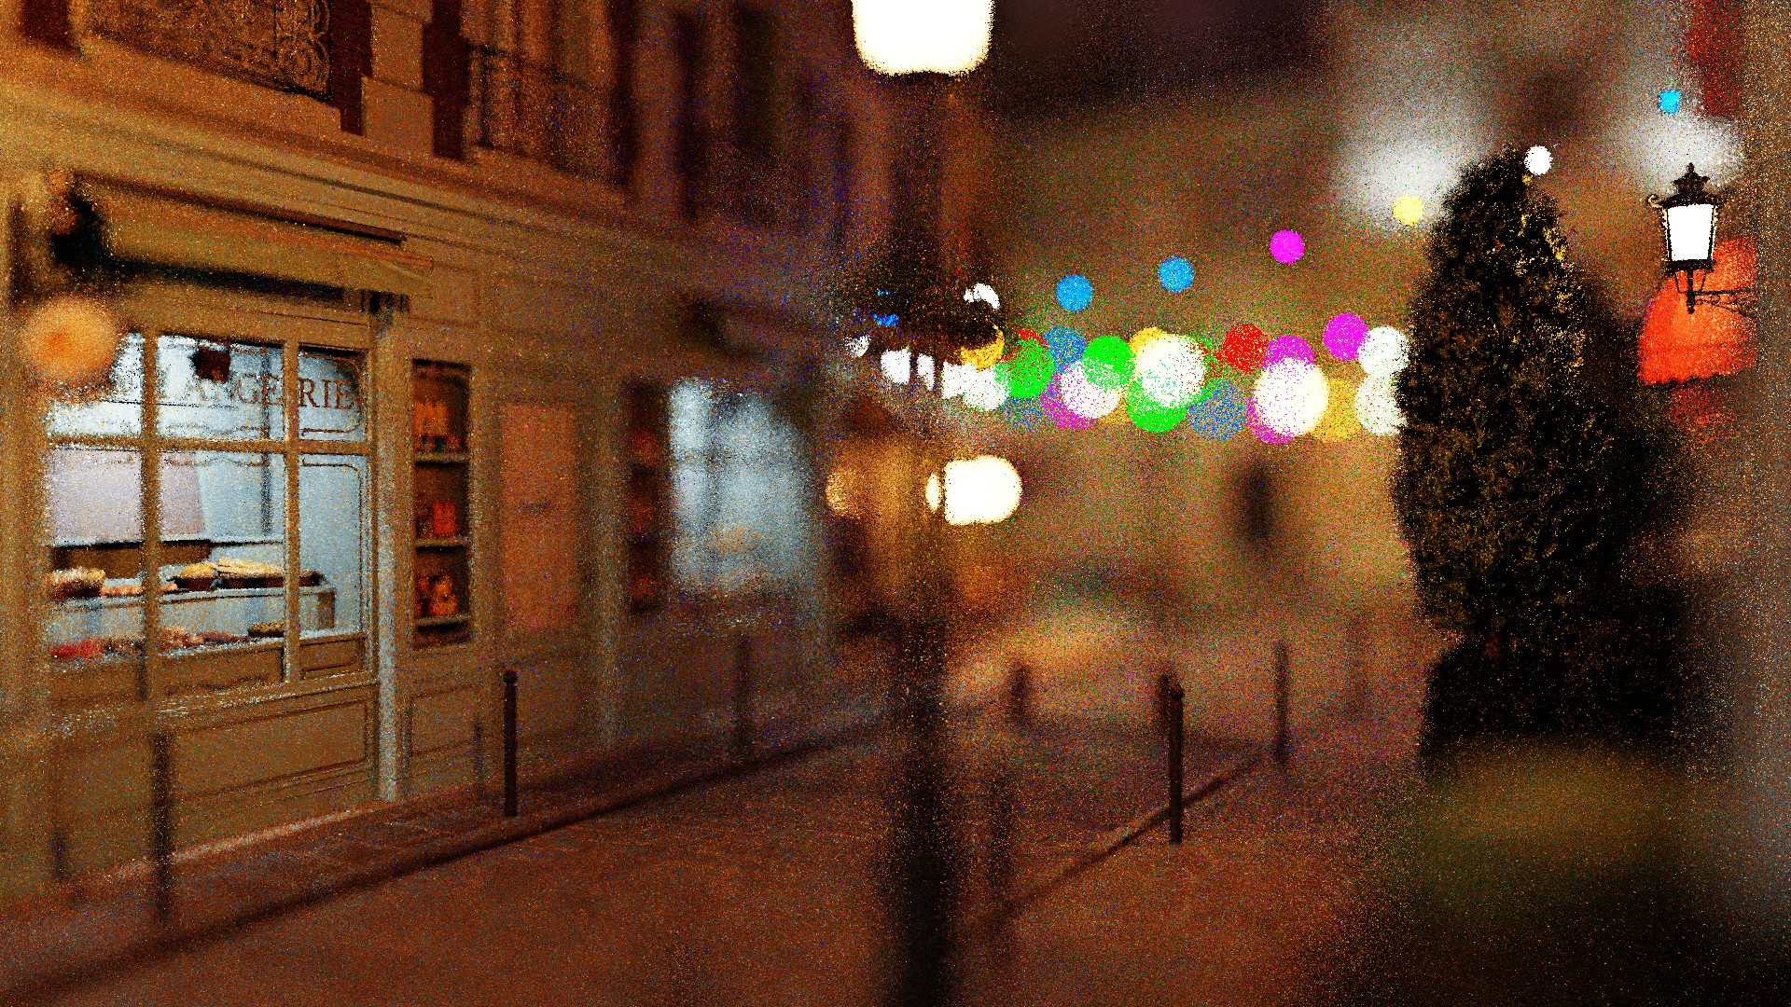
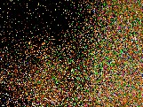
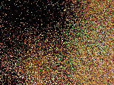
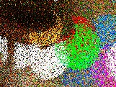
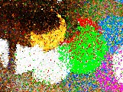

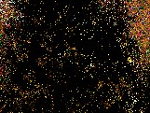
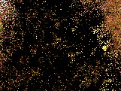
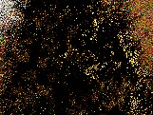
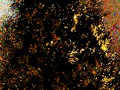

Averaged ReSTIR instances / Time / MAPE: 1 / 18.1 ms / 0.855 2 / 31.2 ms / 0.772 1 / 24.7 ms / 0.725 1 / 32.3 ms / 0.501
Bistro

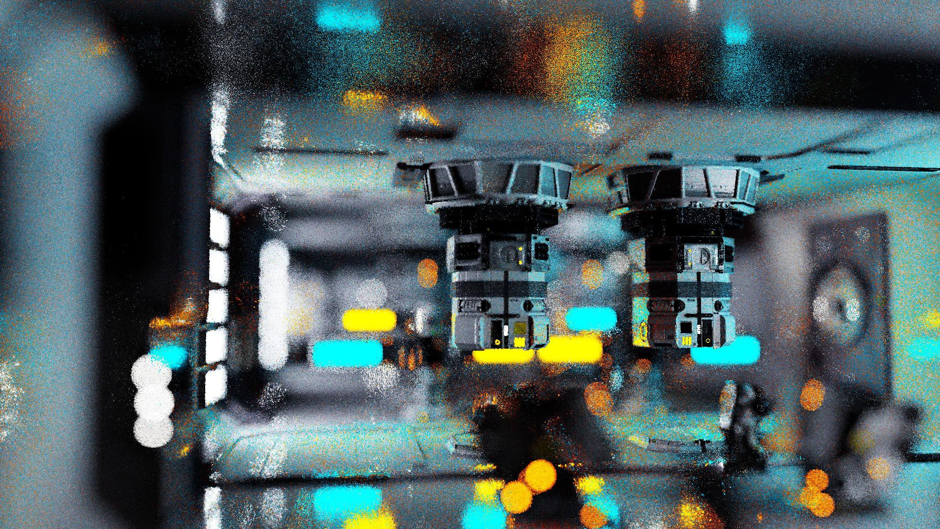
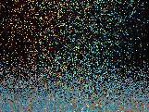
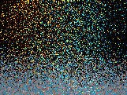
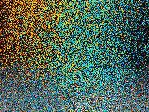
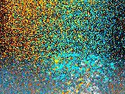

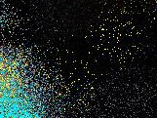
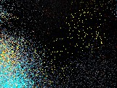
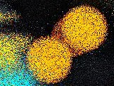
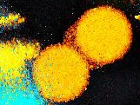

Averaged ReSTIR instances / Time / MAPE: 1 / 12.6 ms / 1.011 2 / 21.5 ms / 0.945 1 / 16.8 ms / 0.815 1 / 21.6 ms / 0.589
Zero Day

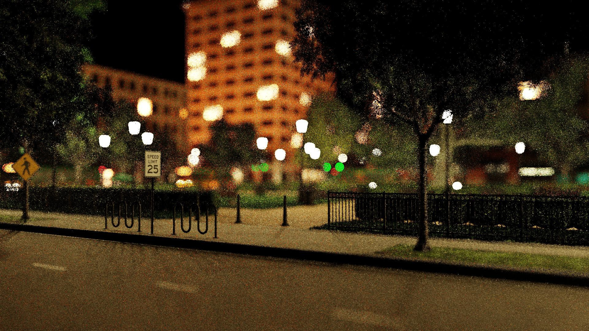
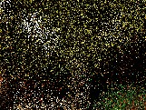
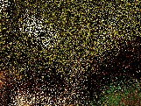




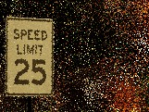
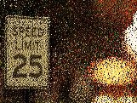
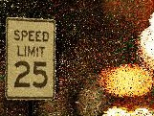

Averaged ReSTIR instances / Time / MAPE: 1 / 18.4 ms / 0.649 3 / 49.7 ms / 0.594 1 / 34.5 ms / 0.526 1 / 47.2 ms / 0.387
Emerald Sqare

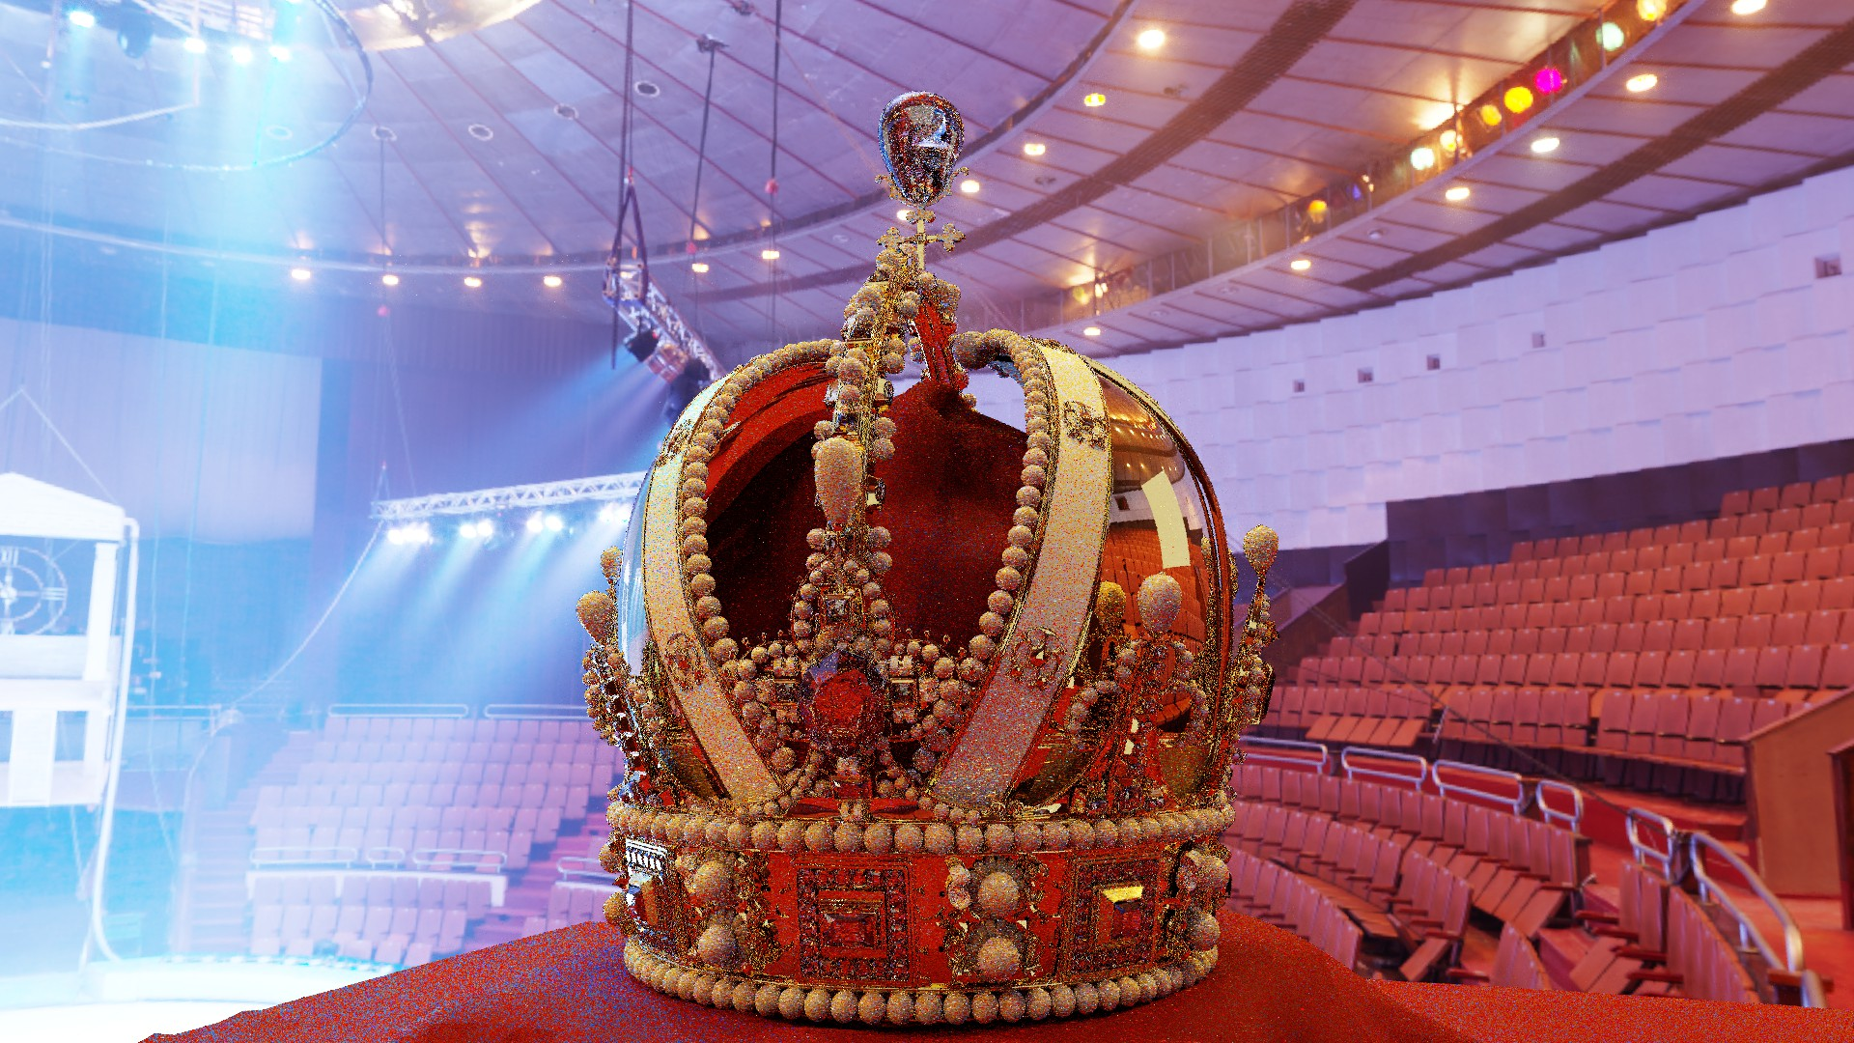
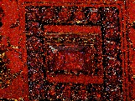
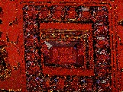




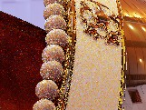
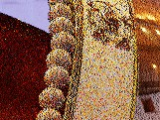


Averaged ReSTIR instances / Time / MAPE: 1 / 5.7 ms / 0.223 3 / 16.1 ms / 0.187 1 / 9.0 ms / 0.234 1 / 13.1 ms / 0.188
Crown ★

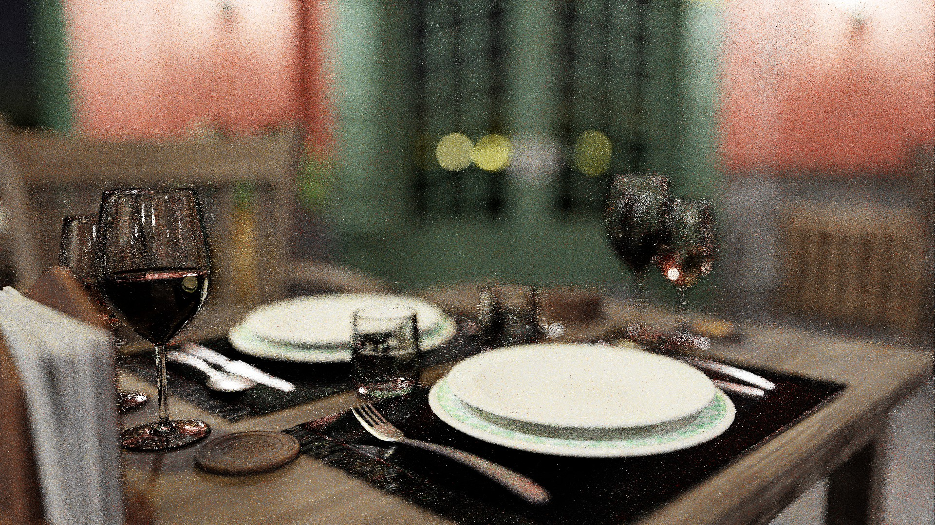
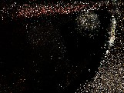

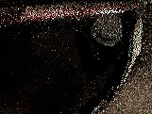

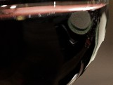
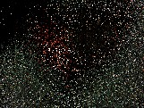
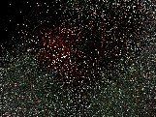
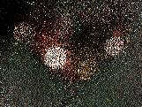
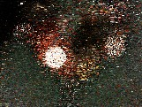

Averaged ReSTIR instances / Time / MAPE: 1 / 19.4 ms / 0.930 2 / 36.4 ms / 0.857 1 / 28.0 ms / 0.622 1 / 32.7 ms / 0.438
Bistro Interior ★
Fig. 15. Comparing our Area ReSTIR with prior ReSTIR baselines. Starred (★) scenes use global illumination and a ReSTIR PT baseline [Lin et al. 2022], other scenes use only direct lighting and compare to Bitterli et al. [2020]. Except the second column, we use the same number of independent samples within each comparison. In the second column, we try to match baseline ReSTIR’s rendering time to our robust version by running multiple independent copies of ReSTIR and averaging their results. All scenes were captured under camera motion. Performance numbers are averaged over a 10 second animation.

