ECE496Y Project Proposal Grading Form - Draft A
Project ID | 2011017 | Supervisor(s): | Jason Anderson | Section:7
Project Title: | Virtual FPGA fabrics: Implementation of a virtual FPGA architecture |  |  | Administrator: Gillett

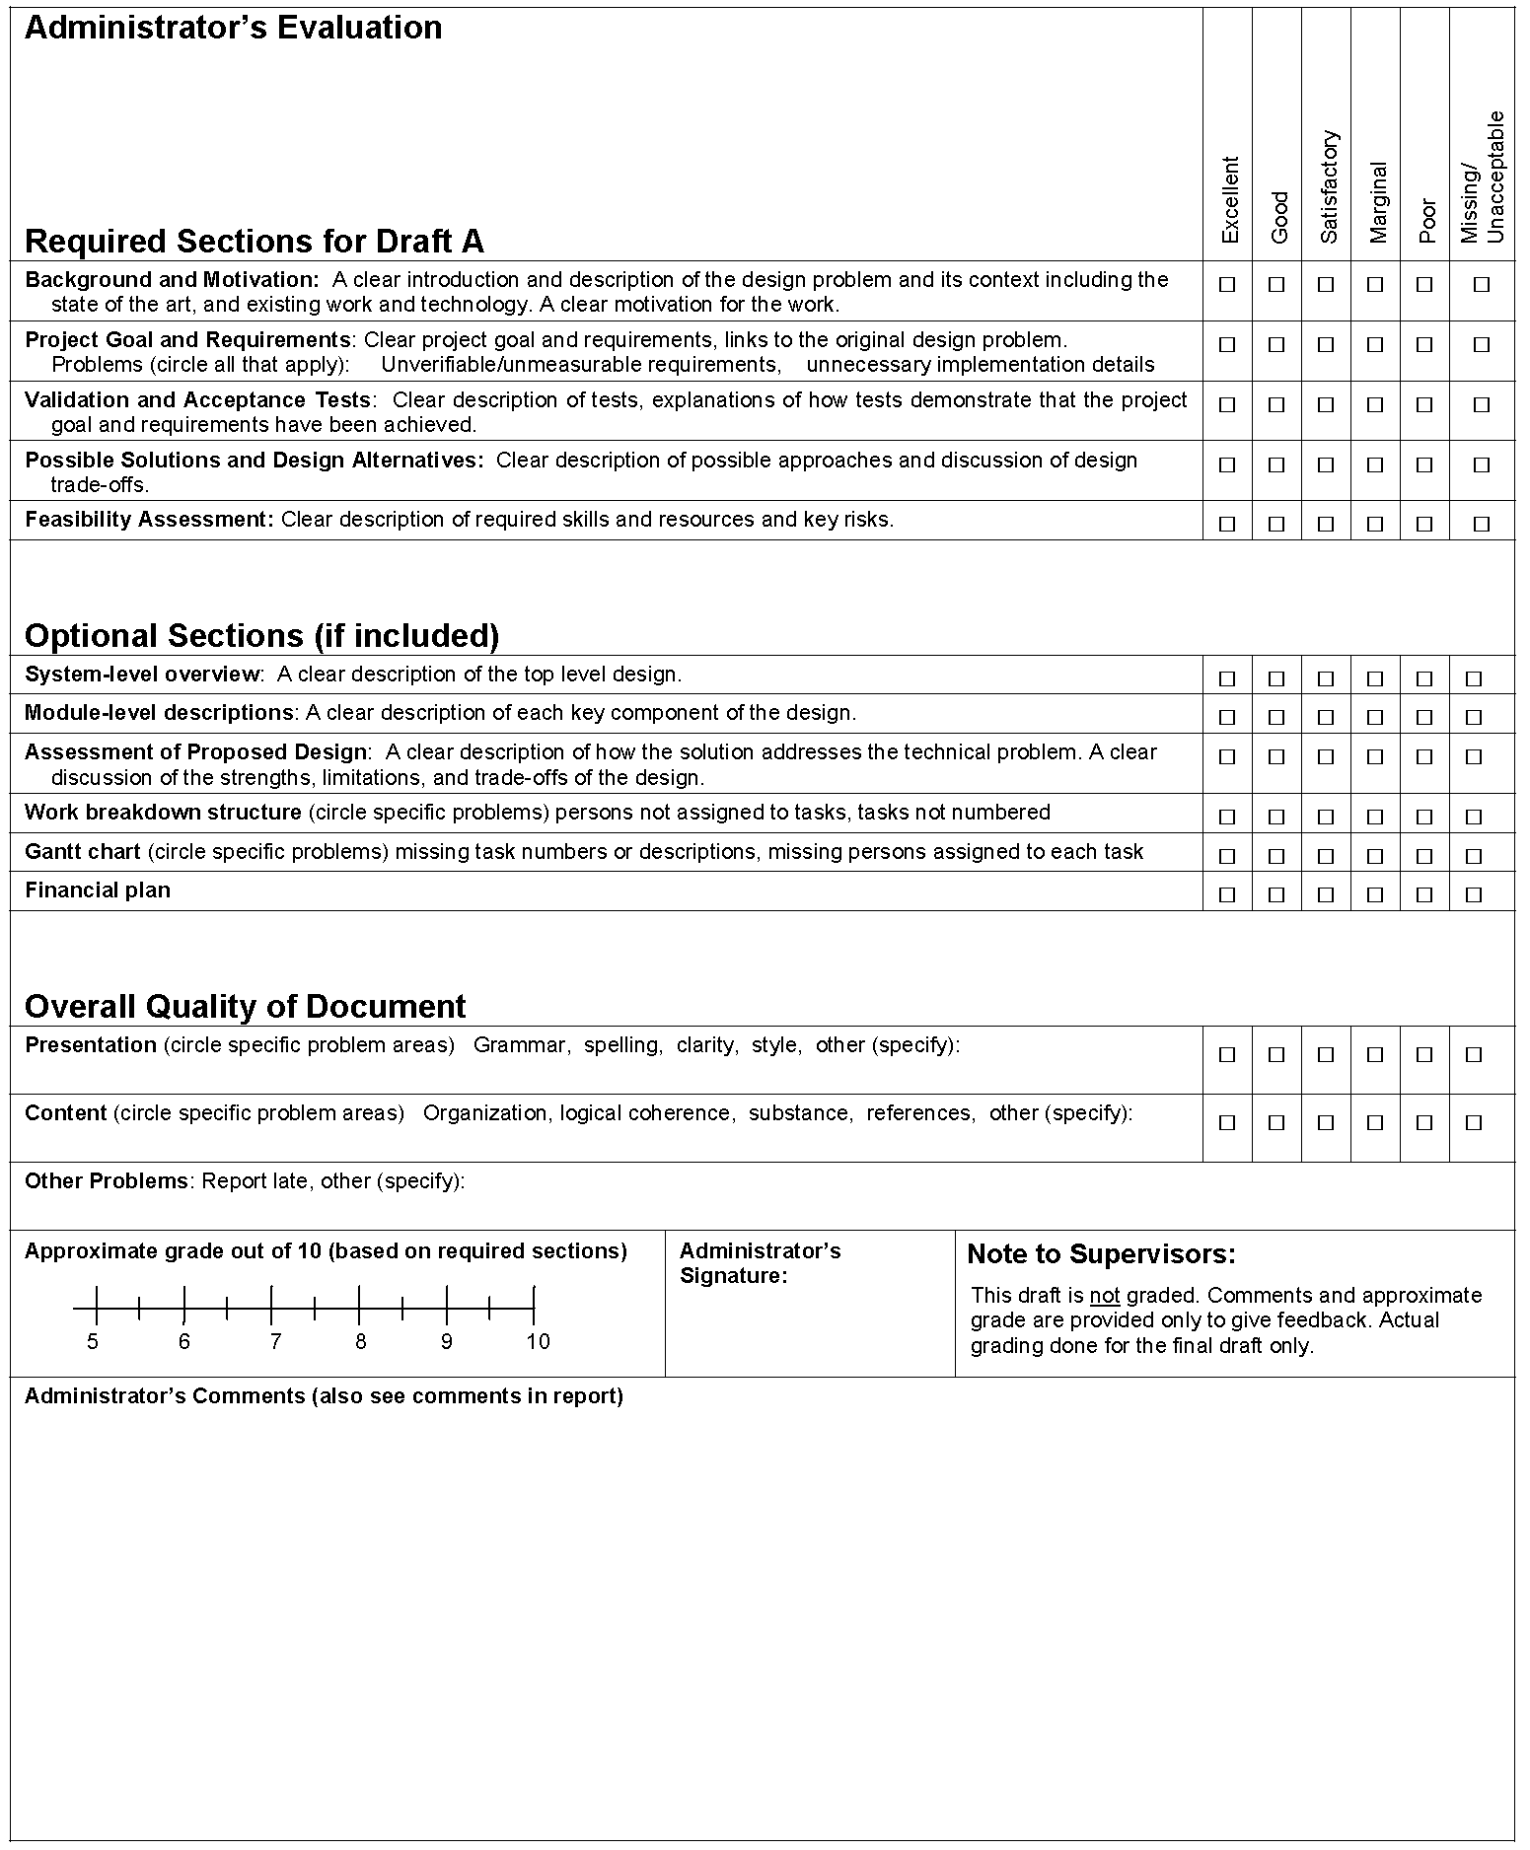

The Edward S. Rogers Sr. Department of
Electrical and Computer Engineering

University of Toronto

ECE496Y Design Project Course

Group Project Proposal (Draft A)

Title: Virtual FPGA fabrics: Implementation of a virtual FPGA architecture

Project I.D.#: | 2011017
Team members:  (Select one member to be the main contact. Mark with ‘*’) | Name: | Email:
 | Neil Isaac * | n.isaac@utoronto.ca
 | Keyi Shi | keyi.shi@utoronto.ca
Supervisor: | Jason Anderson
Section #: | 7
Course Administrator: | Gillett
Date: | September 20, 2011

