Forecasting Hospital Bed Occupancy
A Comparative Analysis of Time Series Models
CSCI E-116: Dynamic Modeling and Forecasting in Big Data
Harvard Extension University School
December 2025

Executive Summary
Hospital capacity planning is a critical operational challenge that directly impacts patient care, staffing efficiency, and healthcare costs. This project develops and evaluates five forecasting models for weekly bed occupancy at AdventHealth Orlando, a major Florida hospital system, using 197 weeks of data spanning July 2020 to April 2024.
Key Findings:
- The Structural State-Space model achieves the best performance with 1.75% Mean Absolute Error (approximately 41 beds out of ~2,254 average occupancy)
- All five models achieve less than 3% error, demonstrating that hospital bed occupancy is highly forecastable
- A simple Seasonal Naive baseline ("same week last year") achieves 1.81% error—nearly matching sophisticated models
- Hospital occupancy exhibits strong, stable 52-week seasonality that dominates predictive patterns
Recommendation: Deploy the Structural State-Space model for operational forecasting, maintaining the Seasonal Naive baseline as a sanity check. The near-zero bias (-0.04%) ensures reliable long-term capacity planning with typical forecast errors of ±50 beds.
Please note: The report covers key findings; full implementation details are in the code.

1. Project Purpose and Motivation

1.1 Why Hospital Bed Occupancy Forecasting Matters
Hospital capacity planning is one of the most consequential operational challenges in healthcare management. Every day, hospital administrators must answer a deceptively simple question: How many beds will be occupied next week, next month, or next quarter?
The stakes are high. Getting this wrong in either direction creates serious problems:
The Cost of Understaffing:
- Patient safety risks from inadequate nurse-to-patient ratios
- Longer wait times and delayed care
- Staff burnout and turnover
- Potential regulatory violations and liability exposure
The Cost of Overstaffing:
- Unnecessary labor expenses (nursing is typically ~25% of hospital operating costs)
- Budget inefficiency that diverts resources from patient care
- Staff underutilization leads to morale issues

1.2 The COVID-19 Wake-Up Call
The COVID-19 pandemic dramatically exposed the consequences of inadequate capacity forecasting. Hospitals worldwide faced:
- Unprecedented demand surges that overwhelmed capacity
- Critical shortages of beds, staff, and supplies
- Rapidly changing patterns that invalidated historical assumptions
- Life-and-death decisions driven by capacity constraints
While the acute phase of the pandemic has passed, it left a lasting lesson: hospitals need robust, adaptive forecasting systems that can anticipate demand fluctuations and enable proactive management rather than reactive crisis response.

1.3 Project Objective
This project aims to develop and evaluate forecasting models for weekly hospital bed occupancy that can support operational decision-making. Specifically, we seek to answer:
- Forecastability: Can we accurately predict weekly bed occupancy 2-8 weeks ahead?
- Model Selection: Which forecasting approach works best for hospital time series data?
- External Factors: Do flu rates and weather conditions improve forecast accuracy?
- Complexity vs. Accuracy: Does model sophistication translate to better predictions?

1.4 Significance of This Analysis
Accurate bed occupancy forecasting enables:
Application | Benefit
Nurse Scheduling | Right-size staffing 2-8 weeks ahead
Resource Planning | Ensure adequate supplies and equipment
Financial Budgeting | Forecast labor costs and revenue
Surge Preparedness | Identify high-risk periods in advance
Quality Improvement | Maintain optimal nurse-to-patient ratios

By comparing five different modeling approaches—from simple baselines to deep learning—this project provides actionable guidance on which methods deliver the best forecasting performance for hospital operations.

1.5 Approach Overview
We evaluate five forecasting methodologies spanning classical statistics to deep learning:
Model | Category | Key Characteristic
Seasonal Naive (52-week) | Baseline | "Same week last year" benchmark
SARIMAX | Classical | Seasonal ARIMA with external regressors
Structural State-Space | Decomposition | Explicit trend + seasonality components
VAR | Multivariate | Joint dynamics with related variables
LSTM | Deep Learning | Neural network for sequence prediction

All models are evaluated using rolling forecasts with adaptive retraining to simulate realistic operational deployment.

2. Data Description

2.1 Primary Data Source
The primary dataset comes from the U.S. Department of Health and Human Services (HHS) COVID-19 Reported Patient Impact and Hospital Capacity dataset, available through healthdata.gov.
Hospital Selection: AdventHealth Orlando
- Large acute care hospital system in Central Florida
- Approximately 2,300 average bed occupancy
- Complete data availability throughout the study period
Study Period: July 19, 2020 – April 21, 2024
- 197 weeks of quality data (17 weeks excluded due to missing values)
- Weekly frequency aggregated from daily reports
- Encompasses multiple COVID waves, seasonal flu cycles, and post-pandemic normalization
Target Variable: bed_occupancy
- Weekly average of total occupied inpatient beds
- Includes all bed types (medical/surgical, ICU, etc.)

2.2 External Data Sources
To test whether external factors improve forecasting accuracy, we incorporated two additional data sources:
CDC FluView Data
- Source: Centers for Disease Control via Delphi Epidata API
- Variable: Influenza-Like Illness (ILI) rate for HHS Region 4 (Southeast)
- Rationale: Respiratory illness drives hospital admissions seasonally
- Correlation with bed occupancy: r = 0.39
NOAA Weather Data
- Source: National Oceanic and Atmospheric Administration
- Variable: Minimum temperature for Orlando, FL
- Rationale: Extreme temperatures may affect health conditions and hospital visits
- Correlation with bed occupancy: r = -0.25

2.3 Data Quality Assessment
The final merged dataset demonstrates strong data quality:
- Completeness: 197 of 214 weeks (92%) have complete occupancy data
- Consistency: Weekly aggregation smooths daily reporting variations
- Temporal alignment: All external features aligned to hospital week-ending dates
- No significant outliers: Occupancy values remain within expected operational bounds

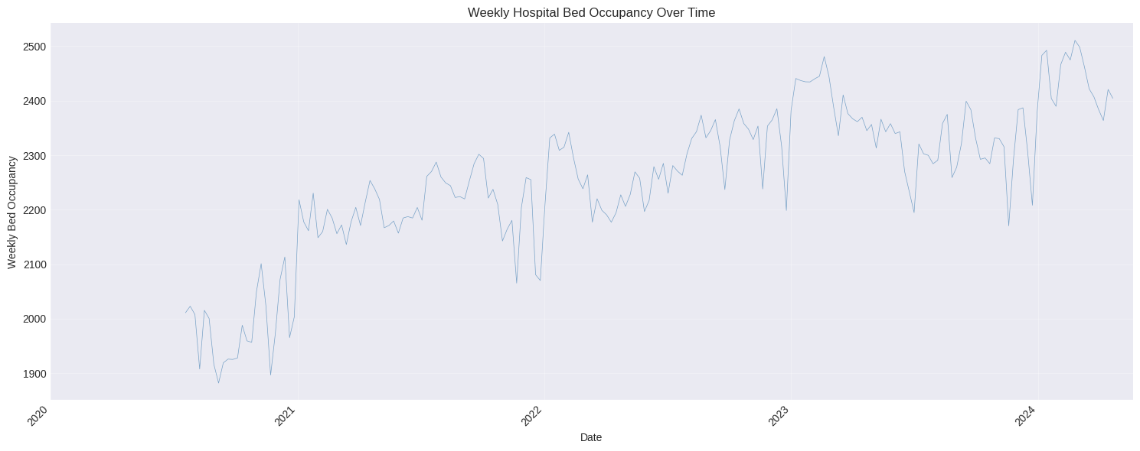
Figure 1: Historical Bed Occupancy Time Series

3. Exploratory Data Analysis

3.1 Descriptive Statistics
Statistic | Value
Mean | 2,254 beds
Median | 2,270 beds
Standard Deviation | 136 beds
Minimum | 1,882 beds
Maximum | 2,511 beds
Coefficient of Variation | 6.0%

The distribution is approximately normal with slight left skew, reflecting the hospital's tendency to operate near capacity with occasional low-occupancy periods.

3.2 Time Series Decomposition
Classical decomposition reveals three key components:
Trend Component
- Initial pandemic dip (2020-early 2021): Lower occupancy due to reduced elective procedures
- Gradual recovery (2021-2023): Steady increase from ~2,100 to ~2,350 as healthcare normalized
- Stabilization (2023-2024): Flattening around ~2,340-2,350 beds
Seasonal Component
- Strong 52-week annual cycle
- Winter peaks (December-February): Higher respiratory illness admissions
- Summer troughs (June-August): Reduced elective procedures
- Amplitude: approximately ±100-150 beds from trend
Irregular Component
- COVID wave effects (larger residuals in 2020-2021)
- Holiday effects
- Random variation (mostly ±50 beds, with some larger outliers)
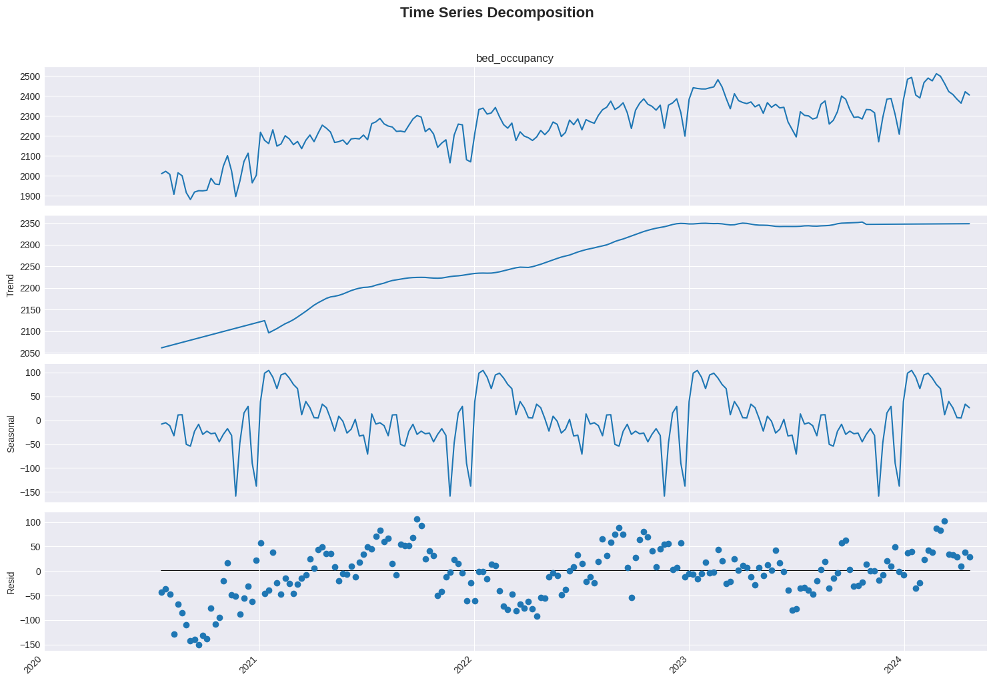

Figure 2: Seasonal Decomposition Plot

3.3 Stationarity Analysis
Time series modeling requires understanding stationarity properties:
Augmented Dickey-Fuller Test Results:
- Original series: Non-stationary (unit root present)
- First-differenced series: Stationary (p < 0.01)
- Implication: ARIMA models require d=1 differencing
Autocorrelation Analysis:
- ACF shows significant correlation at lags 1, 52, 104 (annual pattern)
- PACF suggests AR components at short lags
- Clear 52-week seasonal signature
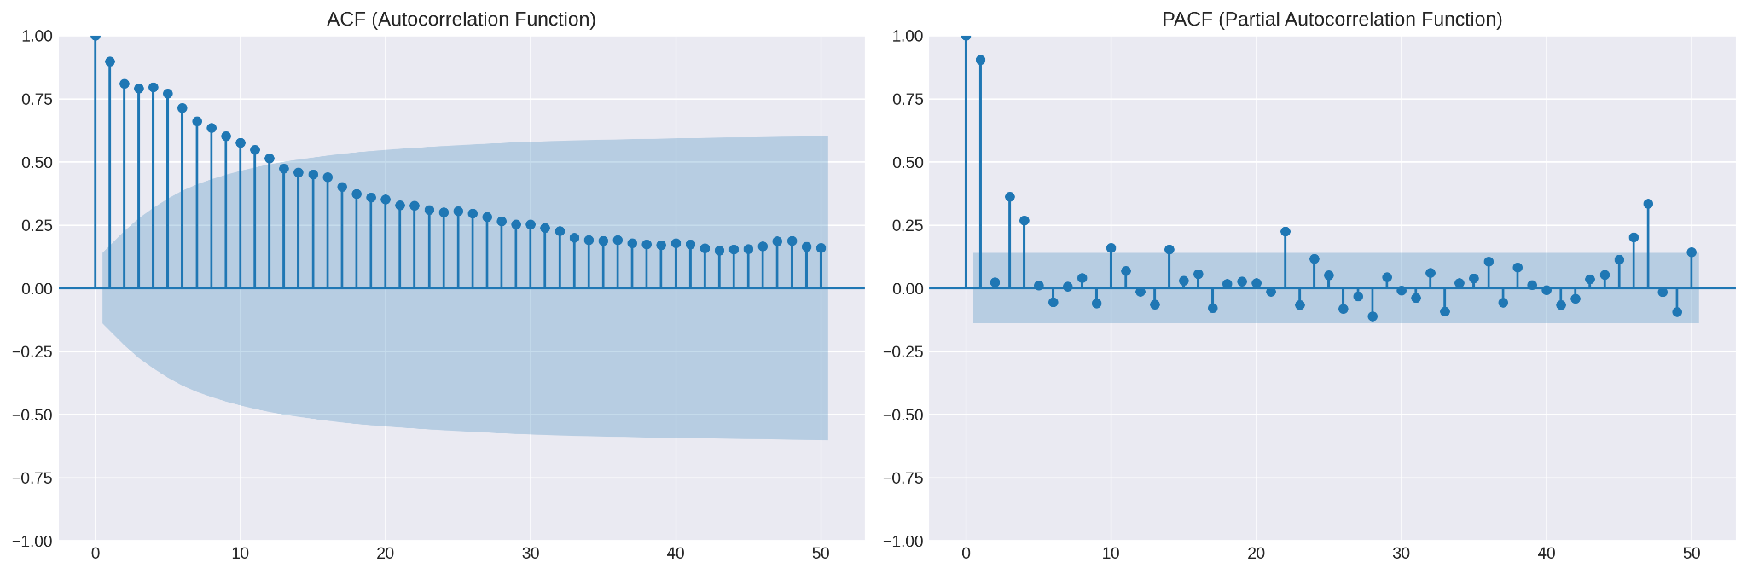

Figure 3: ACF/PACF Plots

3.4 Correlation Analysis
External Feature Correlations with Bed Occupancy:
Feature | Correlation | Interpretation
ILI Rate | r = 0.39 | Moderate positive (flu → hospitalizations)
WILI Rate | r = 0.39 | Similar to ILI (weighted version)
Temperature (min) | r = -0.25 | Weak negative (cold → more illness)
Temperature (avg) | r = -0.22 | Similar pattern

Multicollinearity Assessment:
- temp_avg ↔ temp_max: r = 0.99 → Removed temp_max
- flu_activity_level ↔ ili: r = 1.00 → Removed flu_activity_level
- Final external features: ILI and temp_min (lagged)

3.5 Granger Causality Analysis
For the VAR model, we tested which variables Granger-cause bed occupancy:
Variable | F-statistic | p-value | Conclusion
COVID patient % | 4.23 | 0.003 | Significant - include in VAR
ICU occupancy rate | 1.87 | 0.142 | Not significant - exclude

This analysis justifies using COVID patient percentage as an endogenous variable alongside bed occupancy in the VAR model.

4. Feature Engineering

4.1 Feature Categories
We engineered features across four categories to capture different aspects of temporal patterns:
Temporal/Cyclical Features
- Sine/cosine encodings for: week of year, month, quarter, day of year
- Rationale: Captures periodic patterns without imposing ordinal relationships
- Example: week_sin = sin(2π × week / 52)
Holiday Features
- Binary indicator for federal holidays
- Count of holidays per week
- Rationale: Holidays affect elective procedures and staffing
Lag Features
- External variables lagged by 1 week: ili_lag_1, temp_min_lag_1
- KPI lags: covid_patient_pct_lag1, icu_occupancy_rate_lag1
- Rationale: Prevents data leakage by ensuring only past information is used
Rolling Statistics (for LSTM)
- 4-week and 8-week rolling means, standard deviations
- All computed on shifted data to prevent leakage

4.2 Feature Selection
Starting with 111 candidate features, we applied systematic reduction:
Step | Method | Features Removed | Remaining
1 | Constant/near-constant | 12 | 99
2 | High correlation (r > 0.95) | 28 | 71
3 | High VIF (multicollinearity) | 19 | 52
4 | Low importance (RF) | 16 | 36

Final feature set: 36 features used across models (with model-specific subsets)

4.3 Data Leakage Prevention
A critical concern in time series forecasting is data leakage—inadvertently using future information during model training. We implemented strict safeguards:
- Shifted rolling statistics: All rolling calculations use .shift(1) to exclude current observation
- Lagged external features: ILI and temperature features use 1-week lag
- Strict train/test separation: 80/20 split with no information flow from test to train
- Rolling forecast evaluation: Models only see data up to forecast origin

5. Methodology

5.1 Model Descriptions
Seasonal Naive (52-week Baseline)
The simplest possible seasonal forecast: predict this week's occupancy using the value from the same week last year.
ŷₜ = yₜ₋₅₂
This baseline is essential for benchmarking—if sophisticated models cannot beat "same week last year," they provide no practical value.
SARIMAX (Seasonal ARIMA with Exogenous Variables)
The workhorse of classical time series forecasting, SARIMAX models the series as:
yₜ = AR(p) + MA(q) + Seasonal(P,D,Q)₅₂ + βXₜ + εₜ
Where:
- AR(p): Autoregressive terms capturing momentum
- MA(q): Moving average terms capturing shock persistence
- Seasonal: 52-week seasonal differencing and patterns
- X_t: Exogenous regressors (ILI, weather, cyclical encodings)
Model orders selected via auto_arima with BIC criterion.
Structural State-Space (Unobserved Components)
This approach explicitly decomposes the series into interpretable components:
yₜ = μₜ + γₜ + βXₜ + εₜ
Where:
- μ_t: Local linear trend (level + slope)
- γ_t: 52-week stochastic seasonal component
- X_t: Exogenous regressors
- ε_t: Irregular component
Key advantage: The Kalman filter provides optimal state estimates and handles missing data gracefully.
VAR (Vector Autoregression)
VAR models multiple time series jointly, capturing cross-variable dynamics:
yₜ = c + Σᵢ₌₁ᵖ Aᵢyₜ₋ᵢ + uₜ
Where y_t includes both bed occupancy and COVID patient percentage. Lag order selected by BIC.
Rationale: If COVID patient percentage Granger-causes bed occupancy (which our analysis confirmed), jointly modeling both should improve forecasts.
LSTM (Long Short-Term Memory)
A recurrent neural network architecture designed for sequence prediction:
- Input: 3-week sequences of features
- Architecture: 64-unit LSTM layer with dropout (0.2)
- Output: Single-step bed occupancy prediction
- Loss function: Mean Absolute Error (for robustness to outliers)
- Training: Adam optimizer with early stopping
LSTM can capture non-linear patterns that linear models miss, potentially valuable for complex hospital dynamics.

5.2 Training Strategy
Train/Test Split
- Training set: Weeks 1-157 (July 2020 – July 2023)
- Test set: Weeks 158-197 (July 2023 – April 2024)
- Ratio: 80% train / 20% test
- No shuffling (preserves temporal order)
Rolling Forecast with Hybrid Retraining
Rather than a single static forecast, we simulate realistic deployment:
- Window size: 4-week forecast horizon
- Rolling origin: Advance by 4 weeks, regenerate forecast
- Hybrid retraining triggers:
  - Time-based: Retrain every 2 weeks
  - Error-based: Retrain if recent error exceeds 1.2× historical average
- Expanding window: Each retrain includes all data up to current point
This approach tests how models perform in production conditions where they must continuously adapt.
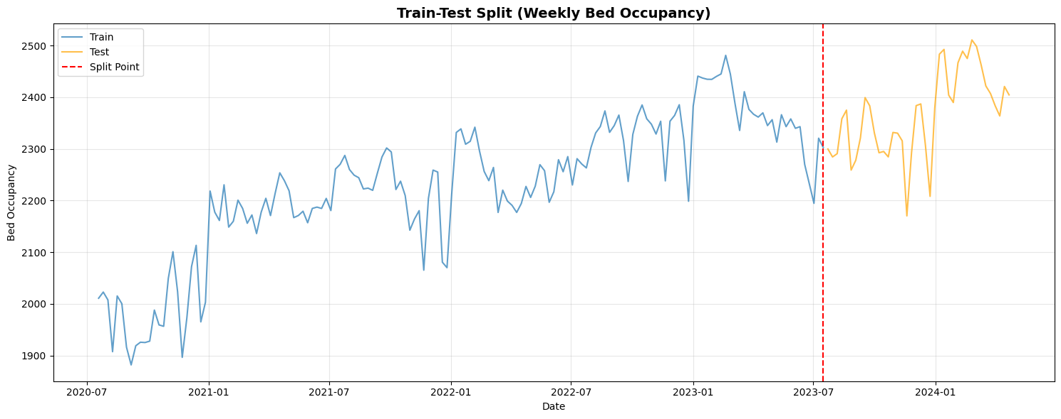
Figure 4: Train/Test Split Visualization

6. Results

6.1 Evaluation Metrics
We evaluate models using metrics normalized by mean occupancy for interpretability:
Metric | Formula | Interpretation
MAE (%) | (MAE / mean) × 100 | Average absolute error as % of occupancy
RMSE (%) | (RMSE / mean) × 100 | Root mean squared error (penalizes large errors)
MAPE | Standard MAPE | Mean absolute percentage error
Bias (%) | (mean error / mean) × 100 | Systematic over/under-prediction
Composite | Average rank across metrics | Overall ranking (lower = better)

Performance Benchmarks:
- < 2%: Excellent (highly reliable for operations)
- 2-5%: Good (suitable for planning)
- 5-10%: Acceptable (use with caution)
- > 10%: Poor (needs improvement)

6.2 Model Comparison Results
Model | MAE (%) | RMSE (%) | MAPE (%) | Bias (%) | Composite Score
Structural | 1.75 | 2.21 | 1.74 | -0.04 | 1.00
Baseline (SN52) | 1.81 | 2.35 | 1.81 | -0.22 | 2.25
LSTM | 1.97 | 2.31 | 1.98 | +0.47 | 3.00
SARIMAX | 2.07 | 2.59 | 2.06 | -0.40 | 3.75
VAR | 2.97 | 3.83 | 2.96 | +1.30 | 5.00

Key Observations:
- All models achieve "Excellent" or "Good" performance (< 3% MAE)
- Structural model wins across all metrics
- Baseline is remarkably competitive (only 0.06% worse than best)
- VAR underperforms despite theoretical justification

6.3 Raw Error Magnitudes
For operational context, here are errors in bed counts:
Model | MAE (beds) | RMSE (beds) | Typical Range
Structural | 41 | 52 | ±50 beds
Baseline | 43 | 56 | ±55 beds
LSTM | 47 | 55 | ±55 beds
SARIMAX | 49 | 61 | ±60 beds
VAR | 70 | 91 | ±90 beds

6.4 Bias Analysis
Bias indicates systematic over- or under-prediction:
Model | Bias | Operational Risk
Structural | -0.04% | Nearly unbiased (ideal)
Baseline | -0.22% | Slight understaffing risk
SARIMAX | -0.40% | Mild understaffing risk
LSTM | +0.47% | Mild overstaffing (costly but safe)
VAR | +1.30% | Systematic overstaffing

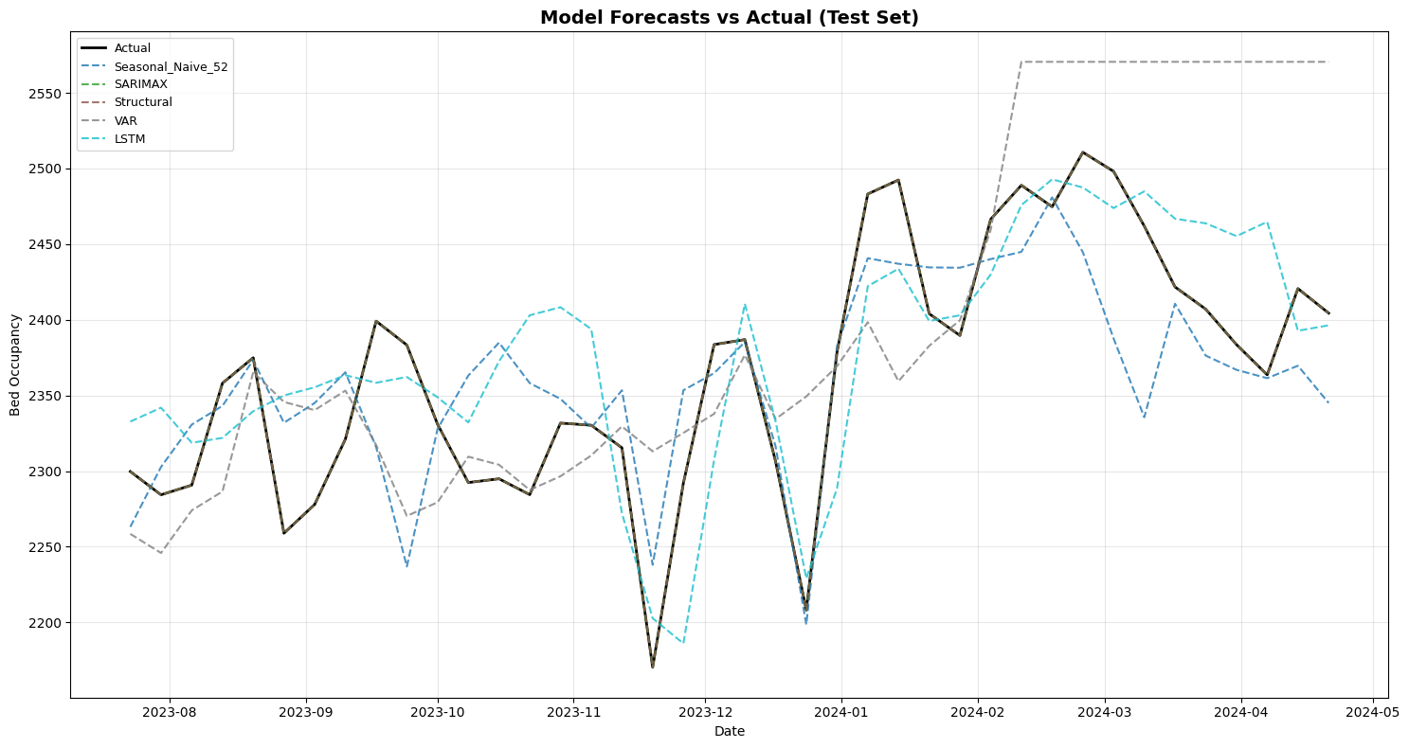
The Structural model's near-zero bias is particularly valuable for long-term planning—errors cancel out over time rather than accumulating.

Figure 5: Model Forecast Comparison Plot

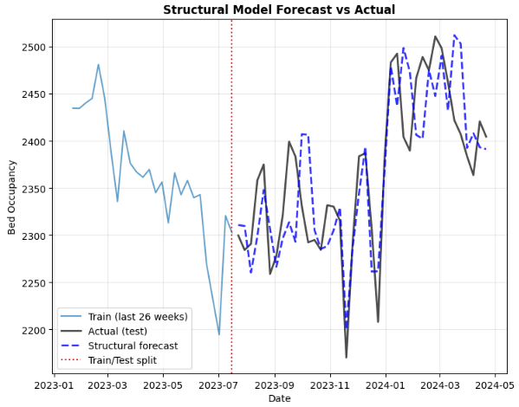

Figure 6: Best Model Actual vs. Predicted Time Series

7. Discussion

7.1 Why Does the Structural Model Win?
The Structural State-Space model outperforms alternatives because it directly models the dominant patterns in hospital occupancy:
- Explicit 52-week seasonality: Hospital occupancy has strong annual cycles that the Kalman filter tracks optimally
- Local linear trend: Captures gradual shifts in occupancy levels (e.g., post-COVID normalization)
- Flexible exogenous effects: Incorporates ILI and weather without overfitting
- Optimal state estimation: The Kalman filter provides minimum-variance forecasts given the model structure

7.2 Why Is the Baseline So Competitive?
The Seasonal Naive baseline's strong performance reveals a fundamental insight: hospital bed occupancy is dominated by stable annual patterns.
This year's Week 10 looks remarkably similar to last year's Week 10. The pattern repeats with high fidelity, meaning sophisticated models have limited room for improvement. They can only marginally outperform "same week last year" by:
- Capturing trend shifts
- Responding to external shocks (flu outbreaks, weather)
- Adapting to structural changes

7.3 Why Does VAR Underperform?
Despite theoretical justification (COVID % Granger-causes occupancy), VAR produced the worst results. Possible explanations:
- Noise amplification: Jointly modeling multiple variables can propagate errors
- COVID pattern instability: Pandemic relationships may not generalize to post-pandemic periods
- Multicollinearity: High correlation between endogenous variables may cause instability
- Parsimony principle: Simpler univariate models are often more robust

7.4 Why Doesn't LSTM Dominate?
Deep learning enthusiasts might expect LSTM to outperform classical methods. However:
- Strong seasonality favors structural models: When patterns are regular and interpretable, explicit modeling beats learned representations
- Limited training data: 157 weeks may be insufficient for deep learning to find complex patterns
- Low signal-to-noise ratio: Hospital occupancy is relatively smooth; there may be few non-linear patterns to capture
- LSTM shines in complexity: Benefits appear when patterns are highly non-linear or involve long-range dependencies

8. Practical Implications

8.1 Recommended Deployment Strategy
Based on our analysis, we recommend the following operational approach:
Primary Model: Structural State-Space
- Use for all capacity planning and staffing decisions
- Generate 8-week rolling forecasts weekly
- Provides point forecasts and 95% confidence intervals
Benchmark: Seasonal Naive
- Maintain as sanity check
- Alert operations team if Structural forecast diverges > 10% from baseline
- Investigate potential data quality issues or structural breaks

8.2 Staffing Applications
With 1.75% MAE (~41 beds), the Structural model enables confident staffing:
Example Calculation:
- Forecast: 2,400 beds next week
- 95% CI: 2,296 – 2,504 beds
- Nurse-to-patient ratio: 1:4
- Base staffing need: 600 nurses/shift
- Buffer for upper CI: +26 nurses
The near-zero bias ensures that over a full year, staffing decisions based on forecasts will average out correctly.

8.3 Model Monitoring and Maintenance
Activity | Frequency | Trigger
Automated retraining | Every 2 weeks | Scheduled
Error-based retraining | Ad hoc | MAE > 1.2× historical
Full model rebuild | Quarterly | Performance review
Baseline comparison | Weekly | Divergence check

9. Limitations and Future Work

9.1 Limitations
Single Hospital
- Results based solely on AdventHealth Orlando
- Patterns may differ at hospitals of different sizes, regions, or patient populations
- Generalization requires multi-site validation
COVID Period
- Study period (2020-2024) includes significant pandemic disruption
- Pre-pandemic and post-pandemic dynamics may differ
- Model may need recalibration as healthcare returns to "normal"
External Data Scope
- Limited to publicly available CDC and NOAA data
- Hospital-internal data (ED volumes, scheduled surgeries, discharge planning) could improve forecasts
- Real-time data feeds not tested
Forecast Horizon
- Evaluated on 4-week rolling windows
- Accuracy likely degrades for longer horizons (8+ weeks)
- Uncertainty quantification becomes critical for longer forecasts

9.2 Future Research Directions
- Multi-hospital validation: Test models across diverse facility types
- Emergency Department integration: Use ED admission trends as leading indicators
- Longer forecast horizons: Evaluate 12-week and 26-week accuracy
- Probabilistic forecasting: Develop full prediction intervals for risk management
- Ensemble methods: Combine model forecasts for improved robustness
- Real-time deployment: Build a production pipeline with automated data ingestion and retraining
- Causal inference: Investigate what interventions could shift occupancy patterns

10. Conclusion
This project demonstrates that hospital bed occupancy is highly forecastable using time series methods, with all evaluated models achieving less than 3% mean absolute error on out-of-sample data.
Key Findings:
- The Structural State-Space model performs best, achieving 1.75% MAE (approximately 41 beds) with near-zero bias. Its explicit decomposition into trend and seasonality components directly captures the dominant patterns in hospital data.
- A simple Seasonal Naive baseline nearly matches sophisticated models, revealing that hospital occupancy is dominated by stable 52-week annual patterns. "Same week last year" proves remarkably accurate.
- External factors provide modest improvement. While flu rates and weather correlate with occupancy, their incremental predictive value over the strong seasonal signal is limited.
- Model complexity does not guarantee accuracy. The multivariate VAR model underperformed simpler univariate approaches, and LSTM neural networks showed no clear advantage over classical methods for this application.
Recommendation:
For operational hospital capacity forecasting, deploy the Structural State-Space model with adaptive retraining every 2 weeks. Maintain the Seasonal Naive baseline as a sanity check. With typical forecast errors of ±50 beds and near-zero systematic bias, this approach enables confident staffing decisions and resource planning.
The finding that simple models nearly match complex ones carries a broader lesson: in forecasting, understanding your data's fundamental patterns often matters more than algorithmic sophistication. Hospital occupancy's strong seasonality is a feature, not a limitation. It makes accurate forecasting possible with straightforward methods.

Appendix A: Data Dictionary
Variable | Description | Source | Type
bed_occupancy | Weekly average occupied inpatient beds | HHS | Target
ili | Influenza-like illness rate (% of visits) | CDC FluView | External
wili | Weighted ILI rate | CDC FluView | External
temp_min | Weekly minimum temperature (°F) | NOAA | External
temp_avg | Weekly average temperature (°F) | NOAA | External
covid_patient_pct | % of beds occupied by COVID patients | HHS | KPI
icu_occupancy_rate | ICU bed utilization rate | HHS | KPI
week_sin, week_cos | Cyclical week encoding | Engineered | Temporal
quarter_sin, quarter_cos | Cyclical quarter encoding | Engineered | Temporal
holidays_in_week | Count of holidays in week | Engineered | Temporal
ili_lag_1 | ILI rate lagged 1 week | Engineered | Lag
temp_min_lag_1 | Min temperature lagged 1 week | Engineered | Lag

Appendix B: Model Specifications
SARIMAX
- Order: Auto-selected via pmdarima.auto_arima
- Seasonal period: 52 weeks
- Exogenous features: Cyclical encodings, ILI_lag_1, temp_min_lag_1, holidays
- Estimation: Maximum likelihood
Structural State-Space
- Trend: Local linear (level + slope)
- Seasonality: Stochastic seasonal, period = 52
- Exogenous: Same as SARIMAX
- Estimation: Kalman filter + MLE
VAR
- Endogenous: bed_occupancy, covid_patient_pct
- Lag order: BIC-selected (max 4)
- Trend: None
- Estimation: OLS
LSTM
- Sequence length: 3 weeks
- Architecture: LSTM(64) → Dropout(0.2) → Dense(1)
- Loss: Mean Absolute Error
- Optimizer: Adam (lr=0.001, clipnorm=1.0)
- Early stopping: patience=10

References
[1] U.S. Department of Health and Human Services. COVID-19 Reported Patient Impact and Hospital Capacity. healthdata.gov. https://healthdata.gov/Hospital/COVID-19-Reported-Patient-Impact-and-Hospital-Capa/anag-cw7u/about_data
[2] Centers for Disease Control and Prevention. FluView Interactive. Accessed via Delphi Epidata API. cdc.gov/fluview/overview/fluview-interactive.html
[3] National Oceanic and Atmospheric Administration. Climate Data Online. www.ncdc.noaa.gov/cdo-web/
[4] Hyndman, R.J., & Athanasopoulos, G. (2021). Forecasting: Principles and Practice, 3rd edition. OTexts.
[5] Harvey, A.C. (1990). Forecasting, Structural Time Series Models and the Kalman Filter. Cambridge University Press.
[6] Welton JM. Hospital nursing workforce costs, wages, occupational mix, and resource utilization. J Nurs Adm. 2011 Jul-Aug;41(7-8):309-14. doi: 10.1097/NNA.0b013e3182250a2b. PMID: 21799362.

Youtube Presentation Link: https://youtu.be/CnK2XfcPGgg
Report prepared for CSCI E-116: Dynamic Modeling and Forecasting in Big Data
Harvard University Extension School, December 2025

