Summary Exercise 'getGDCcfg'

Part 1
Write a Genero program that reads and displays a list of the Application entries from the config.xml file on the client machine.

The program will allow the user to browse for a config.xml file on their local machine, then copy that file back to the server. Before retrieving the file you must check that the file does not already exist locally. The local file name will be same as the remote file name ( without the path! ).
If the file does already exist locally then you must ask the user to confirm before overwriting the file.

An empty shell for the program and form exists in training project as 'getGDCcfg'
The config.xml file is located on the client machine in the install directory of the GDC/etc

The program should use the following classes:
ui.interface.loadActionDefaults
ui.interface.frontCall
os.path.exists ( and other os.path methods )
also the following functions:
fgl_winmessage (utility function)
fgl_getfile (built in function) NOTE: This sets STATUS

The program should use the following variable types:
om.domDocument
om.domNode
om.NodeList
String

The screen FORM should have the following elements:
TOPMENU
TOOLBAR
GROUP
TABLE

Part 2
Create a desktop shortcut on your client machine that will execute your program.

Part 3 (Optional)
Make the program multi language.
To do this you will need to create a strings file for your program (getgdccfg.str ) then use the fglmkstr to compile it to a .42s, the strings file is referenced from fglprofile. The following files will contain strings to be localized:
form.per main.4gl <yourname>.4ad

Summary:

- Get the remote file name
- Copy file from client to server
- Load the xml file into memory.
- Get the root node of the xml file
- Find the nodes you want
- Loop for each node in the list
- Get node within the loop to process
- Populate the array elements from those nodes
- Display the Array

Summary with hints :)

- Get the remote file name ( winopenfile )
- Copy file from client to server ( fgl_getfile )
- Load the xml file into memory. ( om.domDocument.createFromXMLFile )
- Get the root node of the xml file( getDocumentElement )
- Find the nodes you want( selectByTagName )
- Loop for each node in the list
- Get node in loop to process (om.nodelist.item)
- Populate the array (om.node.getAttribute)
- Display the Array (DISPLAY ARRAY)

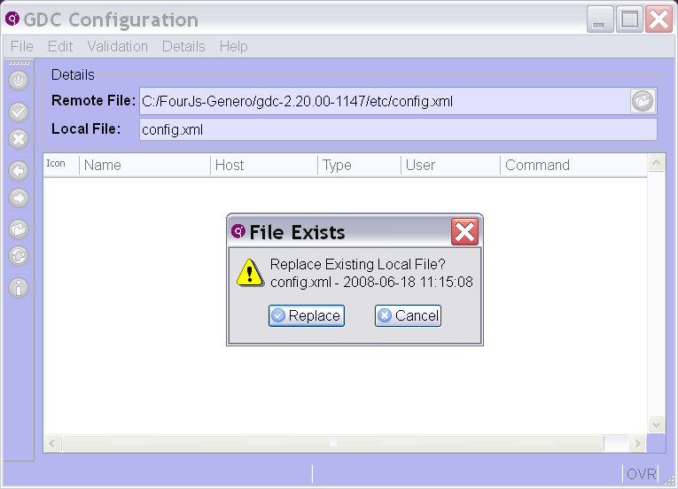
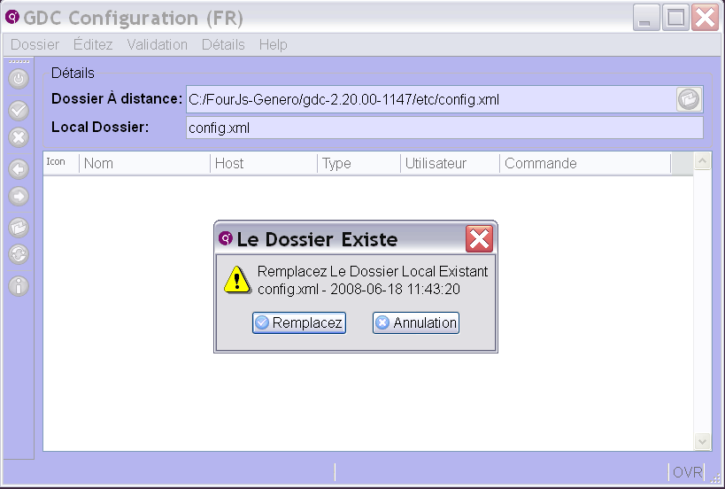
French version.
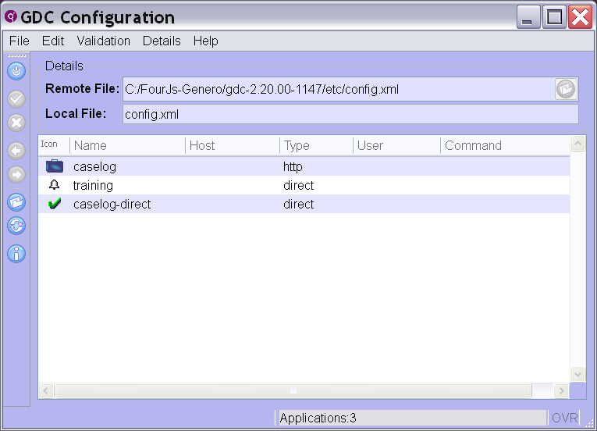
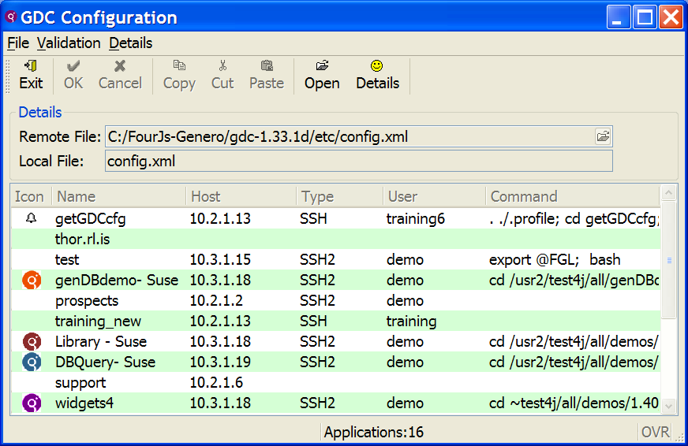

Without the custom style settings:

