**Heuristics Analysis for Build a Game-Playing Agent project (AIND)**

Neil Mistry

May 16, 2018

In this project, I have introduced three different types of heuristic functions for scoring the in the Game-Playing Agent project.

1. AB_Custom is a heuristic that calculates the number of open spaces available to the active player. It will then select the move that will maximize the number of open spaces available to the active player at the next node (# player open spaces).
2. AB_Custom_2 is a heuristic that calculates the difference between the number of open spaces that the active player will have vs. the number of open spaces the non-active player will have. It will select the move that will maximize the difference (# player open spaces - # opponent open spaces).
3. AB_Custom_3 is a heuristic that calculates the number of open spaces available to the active player. It will then select the move that will maximize the number of open spaces available to the active player at the next node.

Below we can see the performance of each of these heuristics given the opponent strategy.

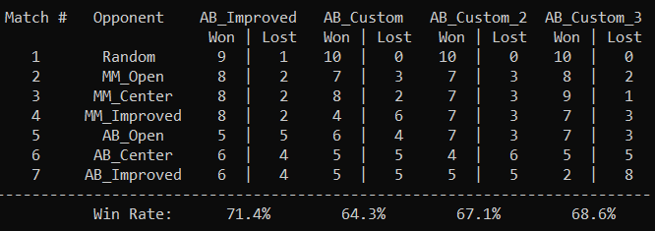

We can see that AB_Improved has the highest win rate given any of the opponent strategies. AB_Improved is the equivalent of AB_Custom_2 strategy even though they did return slightly different results. However, if we had an idea of the strategy used by the opponent, we could counter that opponent by using the appropriate strategy. For example, if we knew our opponent would use Random, MM_Open, MM_Center, our best counter strategy would be to use AB_Custom_3.

I have chosen AB_Custom_2 as my preferred strategy. Assuming that we do not know our opponents strategy, AB_Custom_2 will return a win >= 50% of the time in all but 1 of our opponents strategy (AB_Center).