**Documentation for the Grocery Item Frequency Tracking Program**

**Design and Functionality**

The Grocery Item Frequency Tracking Program is designed to analyze and display the purchase frequencies of grocery items based on a provided input file. The program utilizes a class called FrequencyTracker to handle the core functionality of reading the input file, counting item frequencies, and providing methods to retrieve and display the frequency information.

The FrequencyTracker class constructor (FrequencyTracker(const std::string& filename)) reads the input file specified by the provided filename. It parses the file line by line, storing each unique item in a std::map called frequencies, with the item as the key and the frequency count as the value. The constructor also creates an output file named “frequency.dat” and writes the item-frequency data to this file for backup purposes.

The class provides the following methods:

1. getFrequency(const std::string& item): This method takes an item name as input and returns the corresponding frequency count from the frequencies map. It converts the input item to lowercase for case-insensitive searching.
2. printFrequencies(): This method prints a list of all unique items and their respective frequency counts. The output is formatted with the item name left-aligned and padded to a width of 15 characters, followed by the frequency count.
3. printHistogram(): This method prints a text-based histogram representing the frequency of each item. The histogram displays the item name left-aligned and padded to a width of 15 characters, followed by a sequence of asterisks (*) where the number of asterisks corresponds to the frequency count.

The main() function creates an instance of the FrequencyTracker class, passing the filename of the input file ("CS210_Project_Three_Input_File.txt"). It then displays a menu with options to search for an item’s frequency, print all frequencies, print the histogram, or exit the program. The program incorporates input validation to ensure that the user’s choices and item input are valid.

When the user selects an option, the corresponding class method is called to perform the requested operation. The program continues to display the menu until the user chooses to exit.

**Screenshots**

1. Program Menu:

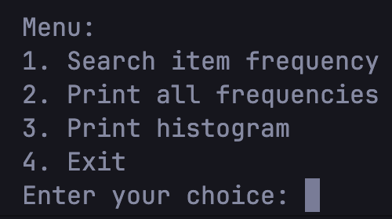

1. Searching for an Item Frequency:

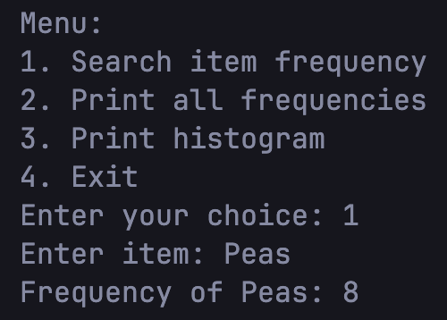

1. Printing All Frequencies:

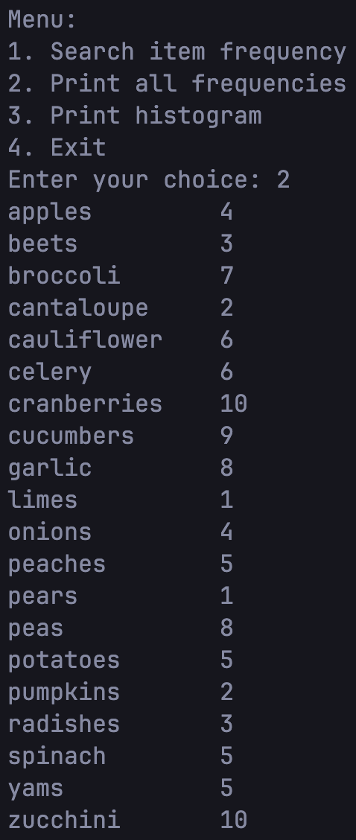

1. Printing the Histogram:

