Pokémon Index
Group 3
Aaron Darrah
Tyler Dewitt
Andrew Taylor
Neil Pirch

Purpose
This project will provide a look into the first generation gyms, trainers, and Pokémon.
It will provide a look into each Pokémon and what they are strong and weak against as well as what they evolve to and from if applicable.

Requirements
The pokémon will be represented with a name, type(s), description.
Trainers will have a name, gym they belong to, and pokémon they use..

Database Development

Entity Relationship Diagram

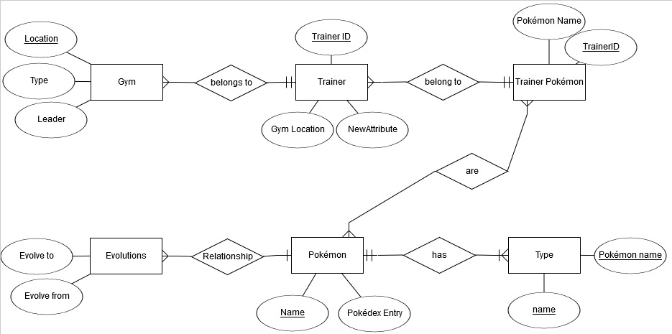Schema Diagram
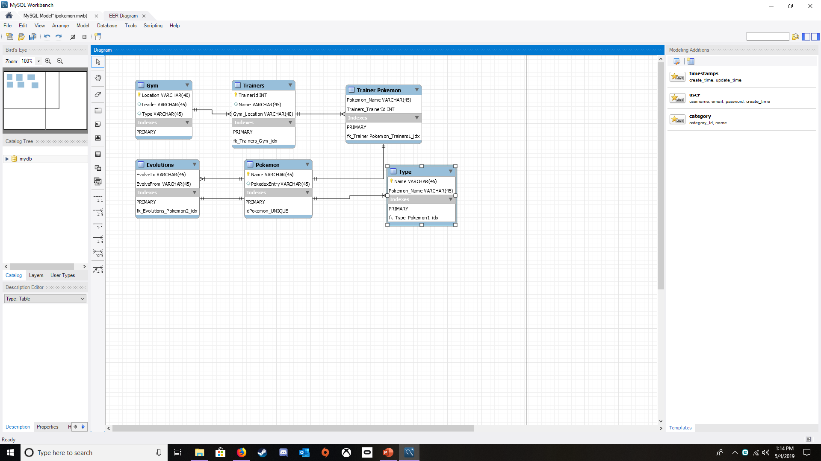

System Documentation

Introduction
The Pokémon Index application allows user to easily search a database of the original 151 Pokémon, as well as the gyms and trainers of the original game.
A user can find:
- Pokémon by type or name
- Trainers and their Pokémon by Gym
- Pokémon and level by trainer

System Installation
Pokémon Index is a web application that is developed to work in most modern web browsers.
The Pokémon Index project was developed using Microsoft Visual Studio 2017 platform, .NET 4.6.1. To begin the installation, Visual Studio 2017 must be installed on the computer being used as the first step. Visual Studio: Community Edition can be downloaded from the Visual Studio website at https://visualstudio.microsoft.com/downloads/. For students at the University of Missouri – Kansas City, a copy of Visual Studio 2017 is already installed on computers in the Flarshiem Hall labs.
lone or Download RepositoryNow that the Visual Studio 2017platform has been installed on your machine, the PokémonIndex application can be downloaded from thePokémon Database repository:
https://github.com/neilpirch/Pokémon-Database
After downloading the project and opening in Visual Studio, double-click the solution PokémonIndex.sln.

Initialize and Seed the Database
Open Package Manager Console through the Tools -> NuGet Package Manager option in the toolbar. In the package manager console, execute the command: update-database. The database migrations and seed methods will create and populate the database.
Once the database has been created and populated with data, the application can be run by clicking IIS Express (Microsoft Edge), or another browser.

Future direction
- Add more Pokémon and moves for each.
- Add more action links to navigate between views
- Add Pokémon and trainer images
- Update trainers for future generations
- Add badges when a gym is completed to provide access (views) to the next.

