1. **PCB**
   1. **Schematics**

To create the schematics and layout of the PCB shown in the images of this report, you need to use the software Altium. If you are a BU student, all the computer labs should have Altium installed on it. If you are not, talk to a representative of your IT department on how to get Altium since Altium requires a paid license to work.

The schematic files are called Sheet3.SchDoc and Sheet4.SchDoc and are int PCB Files folder. Figures 1.1.1 and 1.1.2 below show the schematic of the PCB used in the toy.

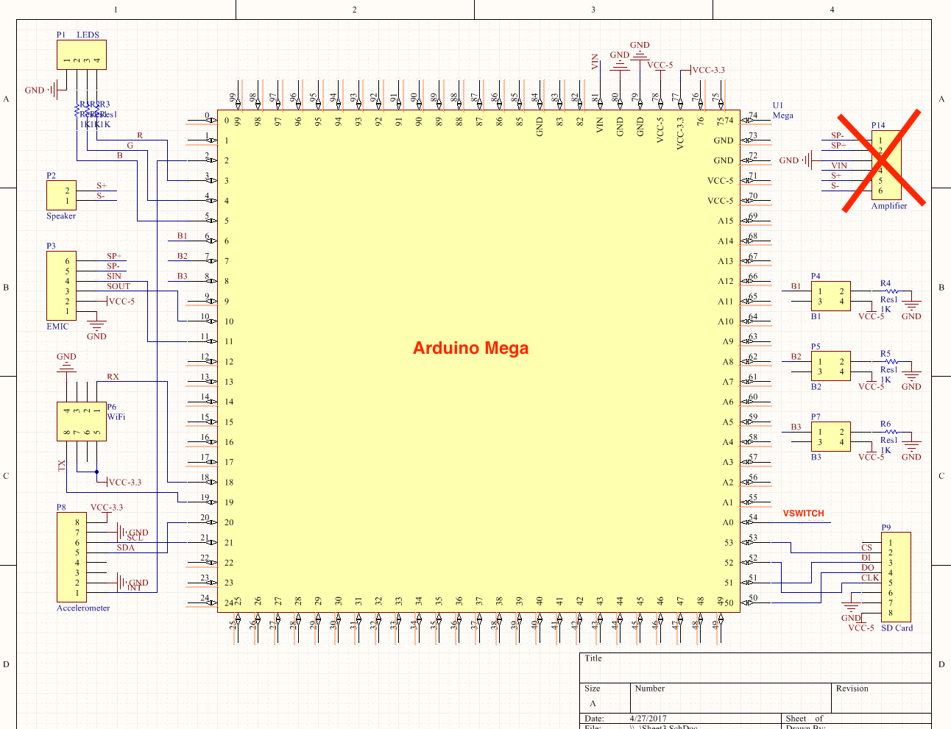

Figure 1.1.1: Schematic of PCB Part 1

In the Schematic above, the Arduino Mega is shown as a component with all its pin numbers labelled according to the board. All the modules and components used are shown on the side and labelled. The modules connect to various pins on the Arduino that are identified by both the pin number, as labelled on the Arduino, and the pin names as labelled on the modules. The amplifier was not used in the final product due to noise issues, so the “SP+” and “SP-” wires from the EMIC should connect to the “S+” and “S-” wires in the speaker respectively.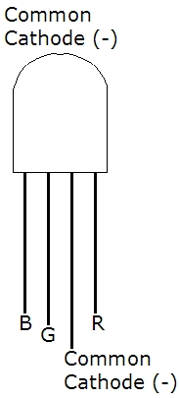

A common cathode RGB LED is used. The RGB pins connect to three pins on the Arduino through a resistor. The resistor used can range from 270 ohms to 1 kilo-ohms - we used 270 ohms. The fourth pin is the common cathode, which is connected to ground.

Three 4-prong buttons are used to allow the user to increase and decrease volume, as well as setup the WiFi management for the toy. Three out of the four prongs on the buttons are used. As shown in the schematic above, one prong connects to 5V, the other connects to ground through a resistor, and the third connects to the pin of the Arduino. The resistor value can range from 270 ohms to 1 kilo-ohms - we used a resistance of 270 ohms.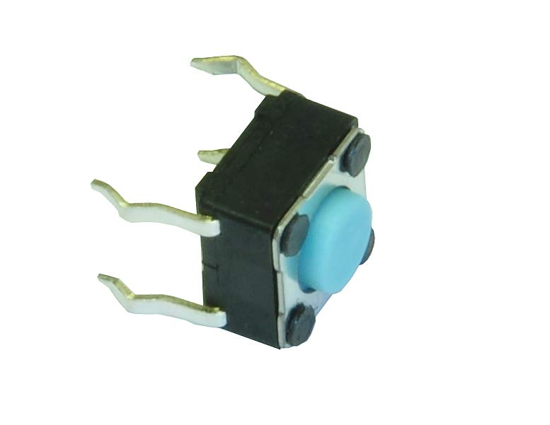

The modules are powered from the Arduino’s 3.3V and 5V pins, since all the modules used require one of these voltages as their input voltage. Pin 54(A0) on the Arduino has “VSWITCH” going in so that the Arduino can read the battery voltage and determine the percentage of battery left. “VSWITCH” is used instead of “VBAT” because the switch powers the toy on and off, so we only want the Arduino checking the battery voltage when the toy is on.

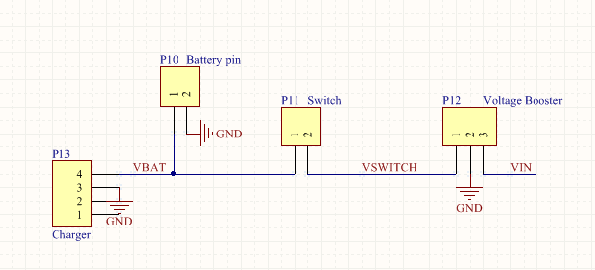

Figure 1.1.2: Schematic of PCB part 2

The charging module is connected to the battery before the switch so that the battery can be charged regardless of whether the switch is on or off. The switch used is a 2-pin switch where one side of the switch is connected to the positive rail of the battery and the other side is connected to the input of the voltage booster. Therefore, when the switch is flipped the connection is closed and the voltage from the battery flows into the voltage booster, which steps it up to 9V. The stepped up voltage is then sent to pin 81(Vin) on the Arduino, which powers the Arduino up causing all the other modules to power up as well. This link/connection is shown as “VIN” on both the schematics.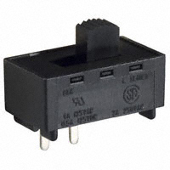

All the grounds are connected to the battery’s ground making it common between all modules and components.

* 1. **Layout**

The layout of the schematics above is shown in the PCB image in Figure 1.2.1 below. The Layout file is called PCB1.PcbDoc located in the PCB Files folder. The order the PCB, you need to generate the gerber files. To generate the Gerber Files follow the instructions in the video [here](https://www.youtube.com/watch?v=UlKPZ0K8mAM).

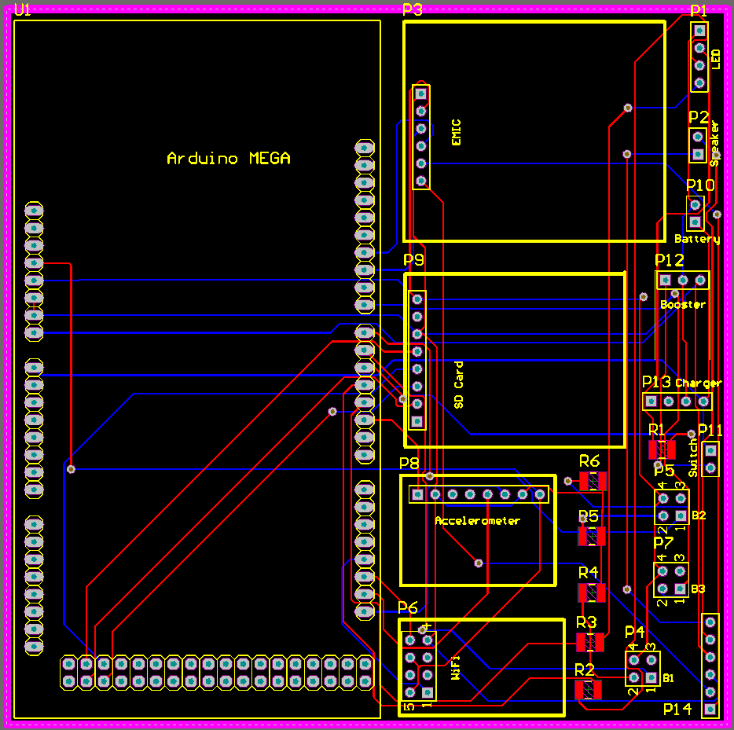

Figure 1.2.1: PCB Layout

As shown in the image above, all the modules are mounted onto the PCB. The yellow lines surrounding the various pin headers are the dimensions of each of the modules. R1 to R6 is the footprints of the six resistors used in the schematic. They are of type 1206 and are surface mounts. Pins P14 can be ignored since that was for the amplifier, which we took out of the final product. All the connections are made within the PCB so that external wires would not be needed. Only the LED, buttons, battery, switch, and charging module would need external wires as they are mounted onto the surface of the toy. 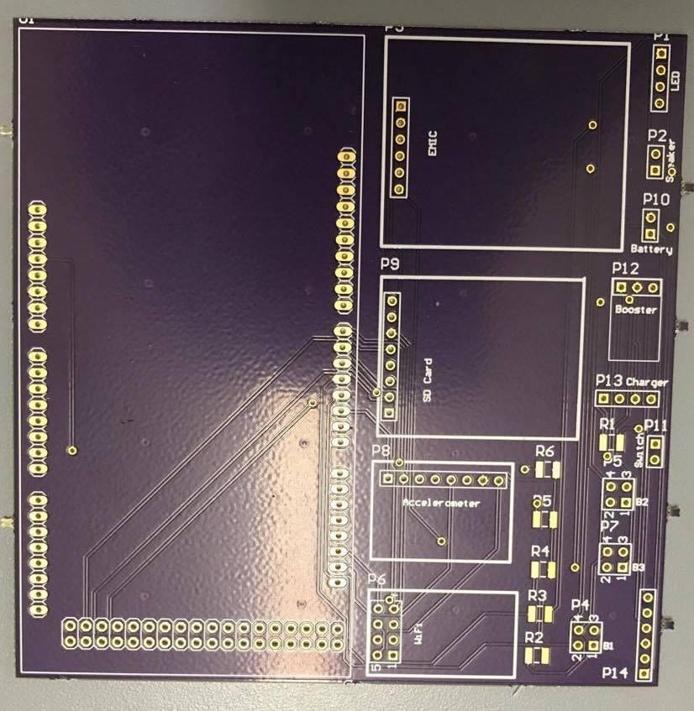

However, during the testing of the PCB, we realised that the voltage booster was not stepping up the voltage correctly. I checked the schematic and layout but everything was connected correctly. We decided to make the connections in Figure 1.1.2 externally using wires, instead of mounting the booster onto the PCB. If you are trying to replicate this, look into the PCB connections again otherwise you can redo the connections externally as well. Both the schematics are a 100% correct though. A picture of the final PCB is shown on the right.

1. **Modules and Components**

The part numbers of the modules and components used and where they were bought from are shown below.

* WiFi Module
  + ESP8266-01
  + Merchant: Amazon
  + Price: $14.99 (Pack of 4)
* Accelerometer
  + MPU6050
  + Merchant: Amazon
  + Price: $12 (Pack of 2)
* SD Card Reader
  + ADA254 (Adafruit)
  + Merchant: Amazon
  + Price: $12
* Text-to-Speech
  + EMIC2
  + Merchant: Microcenter
  + Price: $60
* Arduino Mega
  + Merchant: Microcenter
  + Price: $10
* Voltage Booster
  + U3V12F9 (9V Step-Up Voltage Regulator)
  + Merchant: Pololu
  + Price: $3.95
* LED
  + Common cathode RGB LED
  + Merchant: Amazon
  + Price: $5.64 (Pack of 50)
* Button
  + Four-pin buttons
  + Merchant: Amazon
  + Price: $6.80 (Pack of 100)
* Switch
  + L101011MS02Q (2 pin switch)
  + Merchant: DigiKey
  + Price: $1.74
* Resistor
  + Type 1206 Surface Mount (270 Ohms)
  + Merchant: DigiKey
  + Price: $0.016
* Header Pins
  + Male header pins
  + Merchant: Amazon
  + Price: $5.49 (Pack of 400)
* Battery
  + Samsung Galaxy S4
  + Merchant: Amazon
  + Price: $15
* Charging module

# Adafruit Micro Lipo w/MicroUSB Jack - USB LiIon/LiPoly charger

* + Merchant: Amazon
  + Price: $15 (pack of 3)
* Outside material

# Impact-absorbing EVA foam mat

* + Merchant: Amazon
  + Price: $ 17

These are the main modules and components used in building this toy. You will need a few male-to-male and male-to-female wires for the external connections.

1. **Connections**

For the connections, you will need to have a solder iron and experience soldering. The solder iron is very hot so be cautious. Follow these steps to replicate the electrical hardware of the toy.

* Solder header pins onto any of the modules that do not have them already soldered.
* Solder header pins onto the PCB for the Arduino part only.
  + The long side of the pins should be on the bottom of the PCB as shown in the image on the right. Assume the small board is the PCB.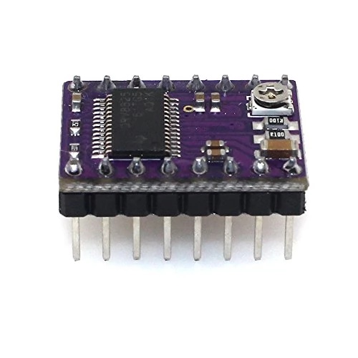
  + Since the Arduino has female pins, you can attach the Arduino to the PCB by sliding the soldered male pins into it.
  + The Arduino will sit below the entire PCB.
* Connect the Arduino to a power supply to ensure it powers on.
* Solder on the rest of the modules, except the voltage booster, one by one.
  + Line up the modules with their outlines on the PCB.
* Each time you solder on a module, power the Arduino to ensure that the other modules come on.
* Disconnect all power sources when soldering.
* Solder header pins onto the battery, switch, buttons, speaker and LED. Make sure the long side of the header pins is facing up now. Opposite of what you did for the Arduino.
* Solder the resistors into place.
* If you fixed the PCB connections for the voltage booster and are certain it works, you can solder on the voltage booster as well.
  + Solder header pins on the part labelled “Battery” and connect the battery.
* Otherwise, make those connections externally.
  + Take a thick long red wires and make cuts on 3 places for connections to be established.
    - Solder a wire from one cut to the positive terminal of the battery.
    - Solder a wire from the second cut to the positive terminal of the Charging Module.
    - Solder a wire from the third cut to one side of the Switch.
  + Take another red wire and make three cuts on it.
    - Solder a wire from one cut to the other side of the Switch.
    - Solder a wire from the second cut to pin A0 on the Arduino.
    - Solder a wire from the third cut to the input of the Voltage Booster.
  + Take a black wire and make three cuts on it. Connect the ground of the battery pin, Charging module, and Voltage Booster to this wire.
* Do not solder wires directly onto the battery pins!

The final soldered PCB and product are shown from different angles in the images below.



Figure 3.1: Images of the final PCB and toy

1. **Toy Shell**
   1. **Software Program**

You will need to download the program Solidworks to view the CAD files.

To do this, you will first need to create an account or login with Solidworks at <https://login.solidworks.com/nidp/idff/sso?id=cpenglish&sid=0&option=credential&sid=0&target=https://customerportal.solidworks.com/>.

Then you can go to <http://www.solidworks.com/sw/support/downloads.htm> to install the program. You must have a Windows operating system in order to install it.

Once downloaded from the website, you may double click on the file to launch the installer and accept all steps to download it with the default settings.

* 1. **CAD Files**

The files pcbmountshell.SLDPRT and speakermount2.SLDPRT are Solidworks files that can be edited in the program. If any dimension changes or feature changes need to be made, those two files can be opened up in Solidworks and edited accordingly. The file pcbmountshell.SLDPRT is the bottom half of the toy’s shell which includes a tray for the PCB and holes for the buttons, led, and power switch. The file speakermount2.SLDPRT is the top half of the shell which has the holes for the speaker.

You can refer to the “CAD Layout.pdf” for the layout of the files.

* 1. **Printing**

If the shell needs to be sent for 3D printing, the files pcbmountshell.STL and speakermount.STL can be used, which reflects the printable file for the bottom and top half of the shell respectively. However, if changes were made to the solidworks files, a new STL file needs to be created. This is done in Solidworks by going to File > Save As > .STL.

If you are a BU student, you have access to 3D printing at EPIC, in which case you can submit the STL files for printing at <http://people.bu.edu/karam/3D/>.

If you have your own 3D printing machine, you can use whatever software it comes with, depending on the manufacturer, and upload and print the file from there.

If you do not have access to these resources then you can use any 3D printing service you like, which you can pick by looking it up on the internet, and submit the file to print from there.