**cARscan Programming task for Computer Vision Engineer**

**Input Image:**

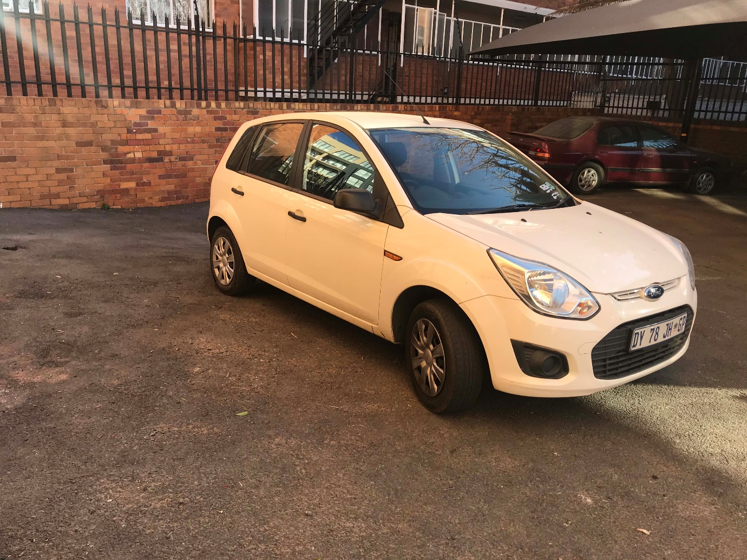

**Output Image:**

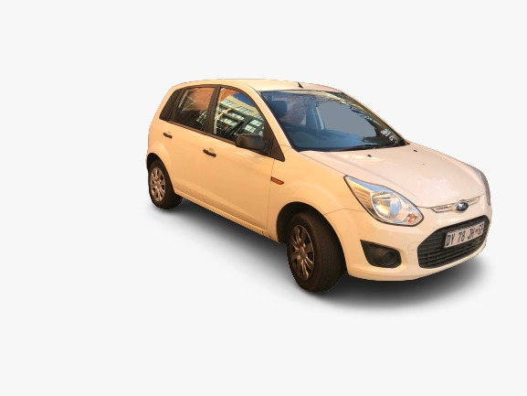

**Tasks:**

1. Process the image in the fastest way possible.
2. background removal
3. background replacement

**Please also send us the below data:**

1) Output images

2) No of the frames classified as a blur

3) 5) Time to process the images

6) How can we run this on mobile devices?

7) How could you further improve it? please describe.

8) Would you able to write or convert the same code into C++ if needed? Yes/No

9) Are you able to write custom code for blur/light models without OpenCV? Yes/No

**Note:**

1. Please send the solution through a git link or zip folder [**career@carscan.co.za**](mailto:career@carscan.co.za)
2. Once this task is completed, we will have a further technical discussion based on this.
3. For any queries, please write us back.