**Sensitivity Analysis of Internal Erosion Models for Dam Safety**

|  |  |  |
| --- | --- | --- |
|  |  |  |

|  |  |  |
| --- | --- | --- |
| Mitchell L. Neilsen and Chendi Cao  Department of Computer Science  Kansas State University  2184 Engineering Hall  Manhattan, KS, USA |  |  |

**Abstract**

*WindowsTM Dam Analysis Modules (WinDAM) is a set of modular software components used to analyze the erosion and peak discharges that results from the overtopping or internal erosion in earthen embankment dams. The initial computational modules address routing of floods through the reservoir with dam overtopping and evaluation of the potential for vegetation or riprap to delay or prevent failure of the embankment. Subsequent modules perform dam breach analysis. Current work is underway to include analysis of internal erosion, non-homogeneous, zoned embankments, and the analysis of various other forms of embankment protection. The focus of this paper is on sensitivity analysis of internal erosion models using Sandia National Laboratories’ Dakota software suite 6.10 to perform the analysis.*

## Keywords: Dam safety, hydraulic modeling, sensitivity analysis, simulation, uncertainty analysis.

**1. Introduction**

WindowsTM Dam Analysis Modules (WinDAM) is a set of modular software components that can be used to analyze overtopped earthen embankments and internal dam erosion. The development of WinDAM is staged. The initial computational model addresses routing of the flood through the reservoir with dam overtopping and evaluation of the potential for vegetation or riprap to delay or prevent failure of the embankment. The first module, WinDAM A, is extended to incorporate the auxiliary spillway erosion analysis used in SITES in WinDAM A+. However, unlike SITES, WinDAM A+ allows a user to analyze up to three auxiliary spillways and embankment erosion on the dam. The next module, WinDAM B, incorporates dam breach analysis; i.e., the breach failure of a homogeneous embankment through overtopping and drainage of stored water in the reservoir. The current module, WinDAM C, includes the analysis of internal erosion. Work is underway to include analysis of non-homogeneous embankments, and analysis of other forms of embankment protection. The two most common causes of earthen embankment and levee failure are overtopping and internal erosion [14].

WinDAM is designed to address the dam safety concerns facing the national legacy infrastructure of over 11,000 small watershed dams constructed with US Federal involvement over a seventy-year period. The US Department of Agriculture -Agricultural Research Service (USDA-ARS), US Department of Agriculture-Natural Resources Conservation Service (USDA-NRCS), and Kansas State University are working jointly to develop and refine this software. Public Law 78-534 – Flood Control Act of 1944 started the small watershed program, and it was followed by Public Law 83-566 – Watershed Protection and Flood Prevention Act of 1954. Starting in 1958, an average of one significantly large (TR-60) dam per day was constructed over a period of twenty years. In addition, thousands of small (378-farm pond) dams have been build. Below is an example of internal erosion in a typical dam.



**Figure 1.** Internal erosion of USDA-NRCS structure

Most flood routing of dams before the middle 1960’s was computed manually. Then, routing software on computers began to replace manual methods. In 1983, the USDA-SCS-ARS Emergency Spillway Flow Study Task Group (ESFSTG) was formed to develop better technology for earth spillway analysis. The ESFSTG collected data on dams that experienced either emergency spillway flow at least three feet deep or significant damage during a storm event. Approximately one hundred sites were selected for more in-depth evaluation and data collection, and data analysis began in 1990 from the field spillway data initially collected. Tests were conducted in the USDA-ARS outdoor Hydraulic Engineering Research Unit (HERU) Laboratory near Stillwater, Oklahoma, during this time to further understand spillway performance processes such as flow concentration, vegetal cover failure, surface detachment, and headcut migration. These findings were incorporated into the DAMS2 software, and then into Stability and Integrity Technology for Earth Spillways (SITES) software in 1994. The bulk length concept was replaced by SITES spillway erosion modeling technology in other USDA-NRCS references. Although SITES may be used to analyze existing dams and spillways, it was developed primarily for design and was developed over a period in which computational capability was much more limited than today. The legacy infrastructure of aging structures also means a transition from design of new structures to analysis of existing structures. For example, existing structures may overtop as a result of watershed changes or sediment deposition within the flood pool leading to inadequate spillway capacity. WinDAM builds on and extends the existing technology in SITES to provide the needed capability for these types of analyses.

WindowsTM Dam Analysis Modules (WinDAM) is a collection of modular software components that can be used to design and analyze the performance of earthen dams. The focus of the initial collection of computational modules is to evaluate earth dams subjected to flooding that may result in overtopping of the dam embankment and auxiliary spillway(s) [1]. The reservoir routing model incorporated into the software includes outflow from a principal spillway, up to three auxiliary spillways, and over the top of the dam embankment. For conditions where overtopping of the embankment is predicted, the hydraulic attack on the downstream face can also be evaluated using the initial software modules in WinDAM A+. The downstream face of a dam is typically protected using vegetation or riprap. WinDAM A+ has been extended to include erosion and breach computations for conditions where the hydraulic attack exceeds that which can be withstood by the vegetal or riprap lining, and the resulting modules are in WinDAM B. The next version, WinDAM C, will incorporate analysis of failures caused by internal erosion or piping failures. To evaluate erosion in each auxiliary spillway, the SITES Spillway Erosion Analysis module with Latin Hypercube Sampling (SSEA+LHS) is integrated with WinDAM A+. The Embankment Erosion Module is extended to include a Breach Analysis Module. The current model assumes the dam has a homogeneous embankment. It is most applicable for the analysis or design of embankments constructed from cohesive soil materials. It is anticipated that the model will be expanded to handle zoned embankments in WinDAM D. The breach technology enabling this expansion is currently under development. Inputs to WinDAM include a description of the reservoir inflow hydrograph, reservoir storage capacity, all spillway properties, the dam cross section and profile, properties of the embankment, and input parameters for the breach analysis module. Inflow hydrographs can also be obtained automatically from other reach routing software, such as SITES 2005.1.6, SSEA+LHS [2], HEC-HMS [3], HEC-RAS, or WinTR-20 as shown in Figure 2.

Outputs include a description of the reservoir water surface variation with time, the hydrographs associated with outflow through each of the spillways and over the top of the embankment, and a description of the attack on the dam embankment and downstream embankment face. Output hydrographs can be directed to external reach routing software. Output information is generated in both text and graphical format. The software generates ASCII text and/or XML control files for the model simulator which performs the model calculations. Output from the simulator is written to intermediate XML and/or fixed-format ASCII text files that can be read by a Graphical User Interface (GUI) to display results in both text and graphical format. Due to the well-defined interfaces that automatically convert data to and from different forms, it is easy for software developers to interface the system with existing analysis software and with software under development. Templates that can be used in conjunction with Dakota are also automatically generated.

In the Dakota system, a strategy is used to create and manage iterators and models [4]. A model contains a set of variables, an interface, and a set of responses, and an iterator operates on the model to map the variables into responses using the interface. The WinDAM system is used to automatically generate Dakota input files. For parameter studies, the user indirectly specifies these components through strategy, method, model, variables, interface, and responses keywords. Then, Dakota is invoked to iterate on the WinDAM simulation models, or vice versa, as needed to generate output.

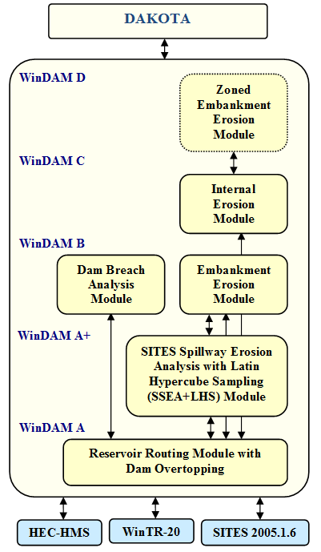

**Figure 2.** WinDAM software architecture

In what follows, Section 2 covers the WinDAM software which may be used to evaluate dams subjected to flooding that may result in overtopping of the embankment or flow through an existing pathway (conduit) through the embankment – up to WinDAM C. Then, Section 3 covers integration of WinDAM with Dakota to perform simple parameter studies and sensitivity analysis. Finally, Section 4 summarizes the results.

**2. Breach and Internal Erosion Analysis**

Flow is routed through the reservoir by balancing inflow, outflow, and storage under the assumptions of a level reservoir surface with all outflow being a function of reservoir water surface elevation. Stage-storage properties of the reservoir are entered in tabular format with elevation in feet and the corresponding surface area in acres or storage volume in acre-feet. Reservoir inflow hydrographs are entered into WinDAM as series of time-discharge pairs with time in hours and flow in cubic feet per second (cfs).

Inflow hydrographs are normally computed using other software that is capable of generating a rainfall-runoff hydrograph. The time increment used for entry of the hydrograph is normally used in performing the routing and erosive attack computations.

The computational model incorporated into the WinDAM software assumes stepwise steady-state flow and a level water surface in the reservoir. The mass balance equation governing flow through the reservoir for any given time step may be obtained by averaging conditions over the time step. The inflow to the reservoir is a known function of time only, and is obtained through application of appropriate hydrologic models such as SITES 2005.1.6, HEC-HMS [3], or WinTR-20. The outflow from the reservoir is the sum of the outflow from all spillways and the outflow over the top of the dam. Using the assumptions of a level water surface in the reservoir and stepwise steady flow, each of the individual outflows may be treated as a unique function of the reservoir water surface elevation. Likewise, the storage volume in the reservoir becomes a unique function of the reservoir water surface elevation.

**2.1 WinDAM B**

The primary purpose of WinDAM B is threefold:

* Hydraulically route one input hydrograph through, around, and over a single earthen dam.
* Estimate auxiliary spillway erosion in up to three earthen or vegetated auxiliary spillways.
* Estimate erosion of the earthen embankment caused by overtopping of the dam embankment.

Since WinDAM B does not include any specific hydrology component, the user must create the input hydrograph using other software. This allows the user the flexibility to choose the hydrologic software most suitable for analysis of site conditions; e.g., HEC-HMS, etc.

WinDAM B assumes the embankment of the dam is a homogenous earthen material. Many USDA-NRCS dams are homogenous earthen fill, so the WinDAM B model applies. Future versions of WinDAM will address zoned embankments where each zone exhibits different erosion resistance from other zones.

Most existing USDA-NRCS dams are built with a single earthen auxiliary spillway. In rehabilitation of old USDA-NRCS-designed dams, it is more common to also utilize additional auxiliary spillways. As a result, WinDAM B allows the user to input up to three auxiliary spillways, each spillway with a zoned embankment and different physical characteristics.

Computation of the discharge through the area of the breach, if any, is unit discharge based on the effective width. If breach is to be evaluated, the associated erosion is assumed to be initiated in an area corresponding to maximum unit discharge over the top of the dam.

Following breach initiation, the unit discharge is computed assuming negligible energy loss from the reservoir to the hydraulic control and critical flow conditions with hydrostatic pressure at the hydraulic control. The processes that determine the erosion during embankment breach are dependent on the breach geometry and the breach area discharge.

The way in which the erosion will progress depends on the local geometry and discharge. Initially, the headcut (local vertical) may not be sufficiently high to generate the plunging action that is associated with typical headcut advance. Likewise, during latter stages of the process, the headcut may become submerged.

The headcut is considered to be submerged for purposes of computing erosion whenever the downstream tailwater elevation is greater than the elevation of the crest of the headcut, or the height of the headcut is less than the critical depth of the flow in the breach area. The latter implies that the minimum depth of water at the base of the headcut is the critical flow depth based on the breach area unit discharge. When the headcut is submerged, the headcut is considered not to advance or deepen from plunging action of the flow over the crest of the headcut. If elevation of the downstream tailwater computed from total flow through the reservoir is below the elevation of the base of the headcut and the base of the headcut is within the embankment, the headcut may continue to deepen as a result of flow on the face of the dam downstream of the headcut. The rate of deepening that is associated with this flow is approximated using a normal flow depth model consistent with that used in evaluating surface protection. The erosion rate resulting in deepening of the headcut is computed by:

 (1)

where

*εr* = the soil detachment rate in volume per unit area per unit time,

*kd*= a detachment rate coefficient that is a property of the embankment material,

*τe =* the erosionally effective stress (in 1b/ft2), and

*τc =* the critical soil stress (in 1b/ft2).

As applied in WinDAM, *kd* is expressed in (ft/h)/(lb/ft2) and is provided as input to the model (see Figure 3). The appropriate value for input may be obtained from soil tests as described by Hanson and Cook [11].

When the tailwater is below the crest of the headcut and the height of the headcut is greater than the critical depth of flow, the flow will tend to plunge over the crest of the headcut. Stresses associated with this plunging flow may govern the rate of downward erosion at the base of the headcut, the rate of headcut advance, or both.

Tw

Kd

Us

Tc

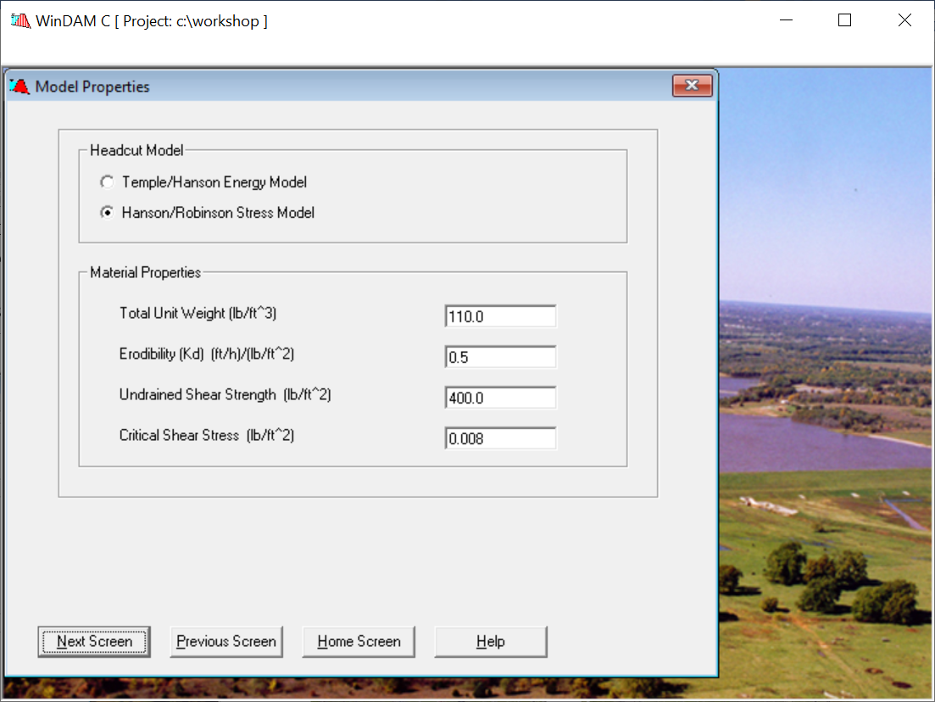

**Figure 3.** Breach model input

In WinDAM, users may select an energy-based or a stress-based advance rate model. The energy-based model, designated the Temple/Hanson model, is described by Temple et al. [5]. The model is a variation on the semi-empirical model used in the SITES spillway erosion computations [2]. The stress-based model, designated the Hanson/Robinson model, is an adaptation of the model described by Hanson, et al. [10], These advance rate models reflect different degrees of simplification of the complex process and have different input requirements.

**2.2 WinDAM C**

For WinDAM C, in addition to overtopping breach computations, calculations may alternatively be executed to evaluate breach through internal erosion along an existing flow path through the embankment. Several tests were conducted at the USDA-ARS Hydraulic Engineering Research Unit (HERU) near Stillwater, Oklahoma, to evaluate the impact that different material properties have on the rate of internal erosion, as shown in Figure 4. The internal erosion module assumes a homogeneous embankment with a simple cross section and is most directly applicable to embankments constructed from cohesive soil materials. The initial flow path (conduit) through the embankment is assumed to be horizontal with a rectangular cross section and a constant width and height over its entire length. The initial dimensions and location are specified by the user. The conduit is allowed to expand uniformly vertically and horizontally until a boundary is reached or the upper surface becomes unstable and collapses (as shown in Figure 4 d-e). In addition to expansion of the conduit due to hydraulic stress along the conduit boundary, a headcut may form at the outlet of the conduit and to progress upstream. Once erosion of the conduit results in removal of the conduit roof, erosion processes and computations are similar to the overtopping breach computation in WinDAM B.



**Figure 4.** Internal erosion analysis at USDA-ARS HERU

Internal erosion calculations represent a simplified approach and are considered a first effort at identifying the dominant processes and incorporating them into an integrated breach model for cohesive embankments. This model will be refined and modified as the overall process becomes better understood and more validation data becomes available. To that end, it becomes important to perform sensitivity and uncertainty analysis to better understand the model and which parameters are most important.

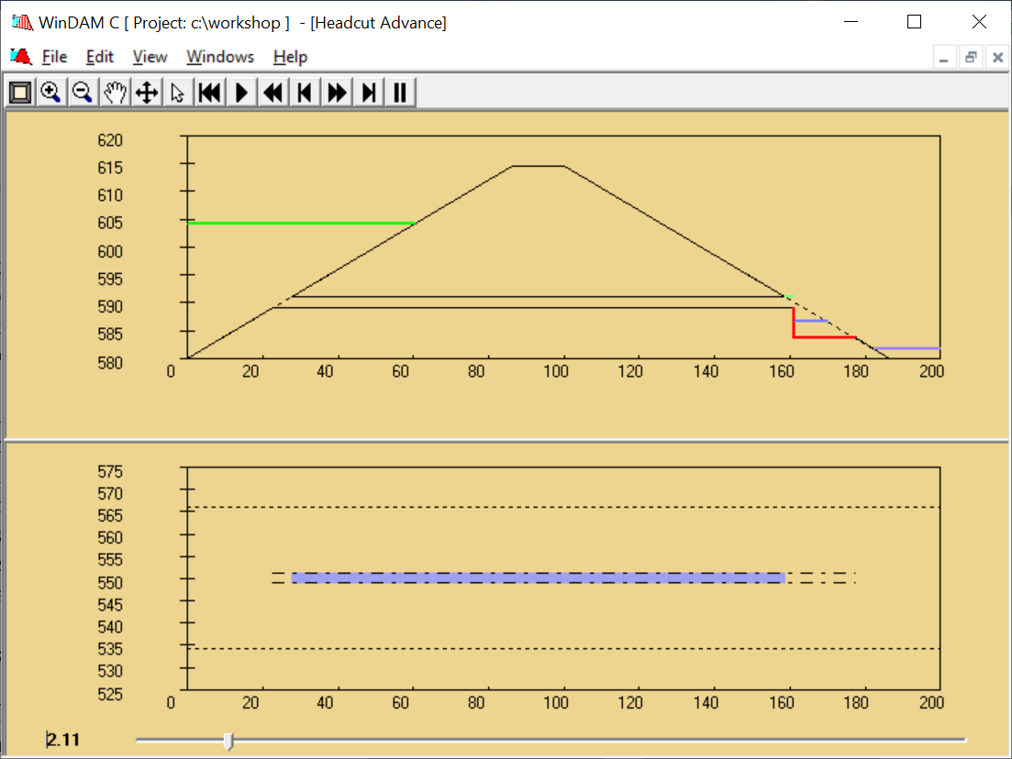

**Figure 5.** WinDAM C output

There are four alternate conditions which may control the discharge through the breach area for the internal erosion path as shown below in Figure 6: a) full conduit flow over the entire length of the conduit; b) mixed full conduit and free surface flow; c) free surface flow through the breach area with energy loss between the reservoir and the point of hydraulic control (critical flow section); and d) free surface flow without energy loss between the reservoir and the hydraulic control. Hydrostatic pressure conditions are assumed for all alternatives and the boundary roughness is assumed to be represented by a Manning’s coefficient of 0.02 for the purpose of computing frictional energy loss.

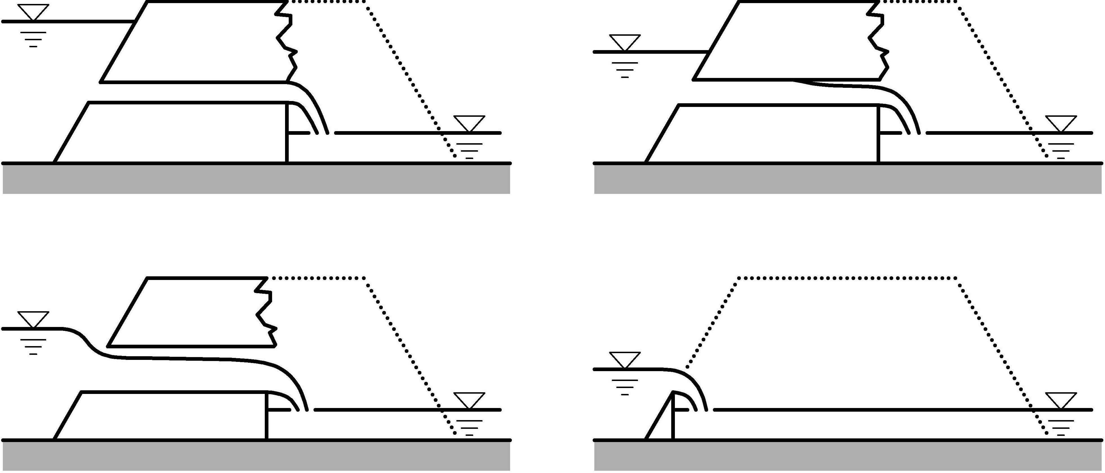

(b)

(a)

(d)

(c)

**Figure 6.** Internal erosion flow conditions

**3. Sensitivity Analysis**

The goal of sensitivity analysis is to obtain a better understanding of how the code output varies as input factors vary, and to identify the most important variables and their interaction with the model code. These most-important variables can be analyzed in more detail In particular, based on uncertain inputs, determine the distribution function (uncertainty) of the outputs and probabilities of failure (reliability metrics); identify the statistical measures (mean, variance, etc.) of the outputs; and identify the inputs whose variance contribute most to variance in the outputs (global sensitivity analysis) [4]. In the early model development work, it was also used to identify code and model issues; e.g., where small changes in a single input led to instability in model output, etc. This is beneficial in correcting model and code issues previously undetected. For simplicity, we will focus on the analysis of spillway designs, but the same analysis can be used to evaluate a wide range of properties, including the model inputs as shown in Figure 3 for breach or internal erosion analysis.

Sites and WinDAM rely on the Dakota libraries to generate Latin-Hypercube Samples (LHS) for simple parameter studies. For example, for Material Properties in the Auxiliary Spillway, users can specify a range of different input parameters. Twenty-five different types of distributions can be specified [2]. For example, a user could specify a Normal Distribution for hydrograph peak discharge with a mean of 50,000 cfs and a standard deviation of 10,000 cfs, or a user could specify a Uniform Distribution for a material property such as headcut index, Kh, for multiple materials or a single material as shown in Figure 7.

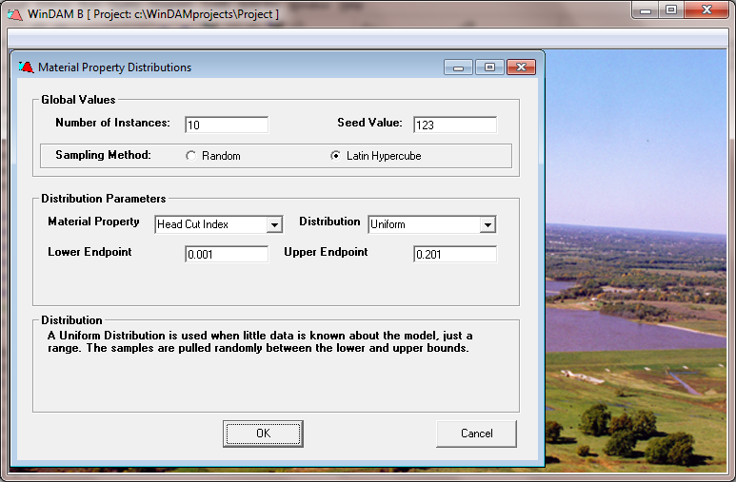

**Figure 7.** Uniform distribution input

Random samples are generated using the Latin Hypercube Sampling (LHS) library routines found in Dakota. In addition to specifying the types of distributions to be used to generate samples, the user can also specify the number of instances to be generated and the algorithm to be used to generate those samples. In particular, the user can select between Monte Carlo and Latin Hypercube Sampling. With Monte Carlo Sampling, the samples are generated at random. The user can specify a random number seed to generate the same sequence of random samples. With Latin Hypercube Sampling, the samples are more evenly distributed across the search space, resulting in better coverage and fewer samples required [13]. As shown in Figure 7, a user could request 10 instances (samples) to be generated for a given material's headcut index using a Uniform Distribution from 0.001 to 0.201. Then, one sample would be randomly generated for each interval of length 0.02 from 0.001 to 0.201. For this input, the generated samples are shown in Figure 8.

**@UNCERTAINTY**

**@OBSERVATIONS 10**

**@VARIABLES 1**

**KH(1):**

**@SAMPLEDATA**

**1 1 0.178143860112386**

**2 1 0.114162037013804**

**3 1 0.153554977141378**

**4 1 0.184678807170631 <- min erosion**

**5 1 0.140484162236030**

**6 1 7.696084019646307E-003 <- max erosion**

**7 1 6.790786373412117E-002 <- mean erosion**

**8 1 2.112528697716014E-002**

**9 1 5.711419140612775E-002**

**10 1 9.154328306156087E-002**

**Figure 8.** Random samples generated

The *Build Interface* is used to generate instances for a given run based on the random variables generated, and then to invoke the simulator for each instance. The Build Interface also parses output to extract summary data. The summary data is presented in a two-level table. The top-level table, shown in Figure 9, only displays instances resulting in maximum, mean (actually the run closest to the mean), and minimum erosion, whereas the second-level table, see Figure 10, displays all instances. After one or more related runs have been processed, they can be analyzed by using the *Output Interface.* The user can quickly compare differences between runs and instances by viewing the Summary Tables and Summary Graphs.

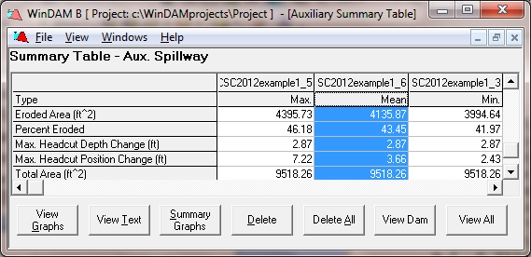

**Figure 9.** Aux. spillway summary table

By varying these input parameters, a user can quickly determine how changes in each will potentially impact erosion.

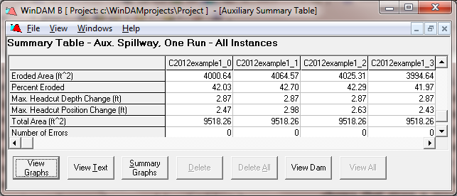

**Figure 10.** View All runs

The output graph for Spillway Erosion includes the option to display the currently selected run with the maximum erosion (shown in orange), the mean erosion (shown in red), and the minimum erosion (shown in green). The erosion for the current run is shown in blue, in Figure 11.

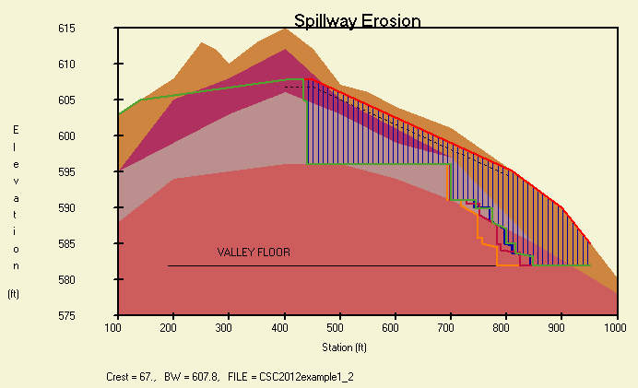

**Figure 11.** Spillway erosion graph

Finally, the output can be used for a simple parameter study to determine how changing the value of an input parameter, in our example the headcut index, Kh, will impact the amount of erosion that results. A scatter plot of the results is shown in Figure 12. As expected, the stronger materials result in less erosion. Note that one sample is selected from each interval due to Latin Hypercube Sampling. A sometime more important factor is the peak discharge that may result when a dam fails. It is important to have this information to determine potential inundation for adequate disaster management response.



**Figure 12.** Scatter plot for all runs

Instead of having WinDAM drive the analysis, we can also allow Dakota to be used to drive the analysis in an iterative fashion. Previously, we had developed our own GUI for such analysis, but since version 6.10, Dakota has a much improved GUI.

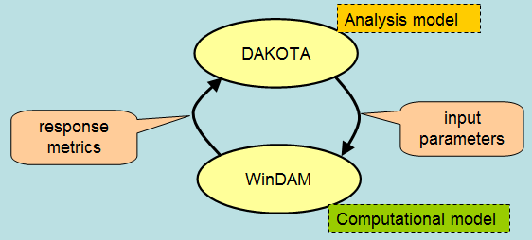

**Figure 13.** Iterative analysis

For the example presented in Section 2, we might want to determine which erosion model parameter is most influential in predicting the peak outflow. We could start with a centered-parameter study defined by the Dakota Input File in Figure 14.

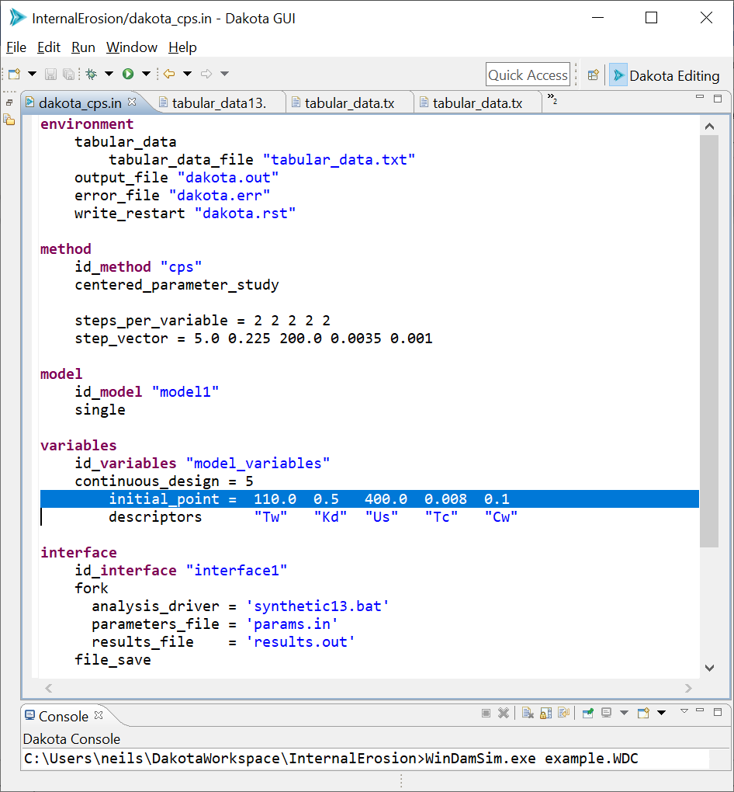

**Figure 14.** Dakota centered-parameter study input file

Note that the initial point is the center point, and we take two steps in each direction using the step vector to determine step size. For example, Tw, total unit weight, has an initial value of 110 with a step size of 5, so the values used in the analysis of Tw are 100, 105, 110, 115, and 120, while holding all other variables at their initial value. Unfortunately, we don’t obtain very much good information from this analysis, only that Kd (soil erodibility) impacts maximum flow and the other parameters appear to have much less impact.

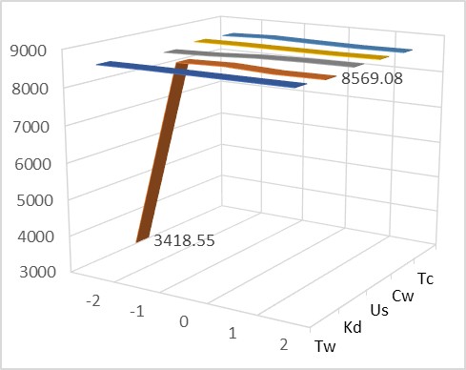

**Figure 15.** Centered-parameter study results

If we run a more detailed variance-based on the same range of points with 100 samples, as shown in Figure 16, we discover that other parameters are important as well.

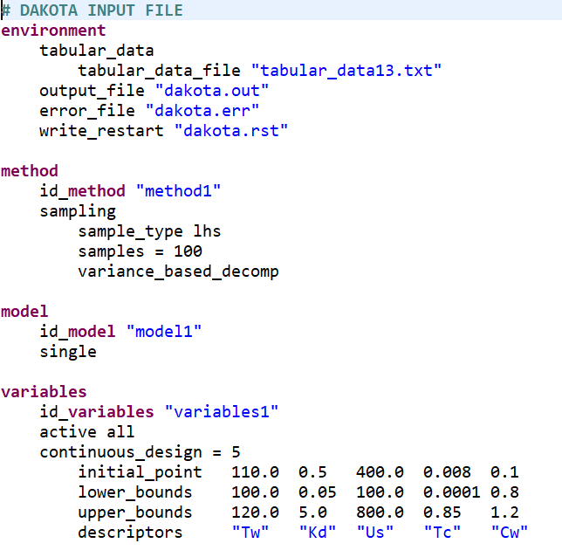

**Figure 16.** Variance-based decomposition study input

The Peak Flow Sobel indices for main and total effects are computed as shown in Figure 17. This indicates that Kd and Tc are the most influential, and the other parameters have a small effect.

If we take a closer look at Tc, as shown in Figure 18, we find that for dams with a critical shear stress threshold below 0.16, the material will erode rapidly resulting in a peak outflow around 8600 cfs, but if the material is stronger and the threshold is between 0.16 and 0.24, then the dam will fill some before failing, resulting in a larger peak flow, up to 22,000 cfs.

**Main Total Variable**

3.6583120264e-04 6.1933580748e-04 Tw

**7.9733886725e-01 8.1438160208e-01 Kd**

7.5951019306e-03 2.0226039927e-03 Us

**2.8293990703e-01 4.0351278028e-01 Tc**

-1.7264200992e-04 2.1209241177e-03 Cw

**Figure 17.** Sobel indices for peak flow

Finally, if Tc is greater than 0.24, the dam will not fail and the flow will be controlled based on only flows through the principal and auxiliary spillways.

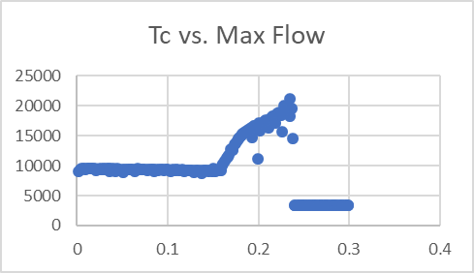

**Figure 18.** Tc vs. Peak Flow

**4. Conclusions**

WinDAM is being developed in stages to evaluate the performance of earth dams. Existing modules with well-defined interfaces enable efficient integration of existing legacy software and future enhancements. The system provides tools that can be used to better understand the structure, function, and dynamics of such structures. This paper describes how sensitivity analysis can be used to enhance model development and analysis of dam designs using the new Dakota User Interface and tools. The paper also provides simple examples to show how the system can be used to conduct a parameter study both from WinDAM and directly from Dakota. Finally, variance-based decomposition provides a powerful tool for the hydraulic analysts toolbox.

**Acknowledgements**

I would like to thank the USDA-ARS and USDA-NRCS for use of the photographic images used in this paper. I would also like to thank Sandia National Laboratories for updating Dakota to incorporate a highly usable user interface which has now been available since version 6.10 in May 2019.

**References**

[1] D.M. Temple, G.J. Hanson, and M.L. Neilsen, "WinDAM -- Analysis of overtopped earth embankment dams", In *Proc. of the ASABE Annual Conference,* Paper Number 062105, 2006.

[2] M.L. Neilsen, D.M. Temple, and J.L. Wibowo, "A distributed hydrologic simulation environment with latin hypercube sampling", In *Proc. of the Intl. Conf. on Env. Modelling and Simulation*, No. 432-032, St. Thomas, USVI, Nov. 22-24, 2004.

[3] United States Army Corps of Engineers, "Hydrologic modeling system HEC-HMS User’s Manual", CPD-74A, Ver. 3.5, USACE, HEC, 2010.

[4] B.M. Adams, W.J. Bohnhoff, K.R.Dalbey, M.S. Ebeida, J.P. Eddy, M.S. Eldred, G. Geraci, R.W. Hooper, P.D. Hough, K.T. Hu, J.D., Jakeman, M. Khalil, K.A. Maupin, J.A. Monschke, E.M. Ridgway, A. Rushdi, J.A. Stephens, L.P. Swiler, D.M. Vigil, and T.M. Wildey, "Dakota Reference Manual, Version 6.10”, May 15, 2019. Downloaded from URL: https://dakota.sandia.gov/content/610-reference-manual.

[5] D.M. Temple and G. J. Hanson, "Earth dam overtopping and breach outflow", In *Proc. of the World Water and Environmental Resources Congress*, Anchorage, Alaska, ASCE, 8 pp., 2005.

[6] V.T. Chow, "*Open-channel hydraulics*", McGraw Hill Book Company, New York, 680 pgs., 1959.

[7] United States Department of Agriculture, Natural Resources Conservation Service, "Earth spillway erosion model", Ch. 51, Part 628, Dams, *National Engineering Handbook*, 210-VI-NEH, 1997.

[8] D.M. Temple, J. Wibowo, M.L. Neilsen, "Erosion of earth spillways", In *Proc. of 23rd United States Society on Dams (USSD) Annual Meeting and Conference*, pp. 331-339, 2003.

[9] M.L. Neilsen and D.M. Temple, "A concurrent simulation model for analysis of water control structures at the watershed scale", In *Proc. of the Intl. Conf. on Par. and Dist. Proc. Tech. and Apps.*, (PDPTA 2010), pp. 1565-1570, June 26-29, 2000.

[10] G.J. Hanson, K.M. Robinson, and K.R. Cook, “Prediction of headcut migration using a deterministic approach. Trans. ASAE, 44(3): pp. 525-531, 2001.

[11] G.J. Hanson and K.R. Cook, “Apparatus, test procedures, and analytical methods to measure soil erodibility in-situ”, in Applied Engineering in Agriculture, ASABE, 20(4):455-462, 2004.

[13] M. D. McKay, W.J. Conover, and R. J. Beckman, "A comparison of three methods for selecting values in the analysis of output from a computer code", *Technometrics*, 21(2):239-245, 1979.

[14] R. Fell, C.F. Wan, J. Cyganiewicz, and M. Foster, “Time for Development of Internal Erosion and Piping in Embankment Dams”, in *Journal of Geotechnical and Geoenvironmental Engineering,* ASCE Vol. 129(4):307-314, 2003.