WinDAM C Dam Overtopping and Internal Erosion Model
March 2016

INTRODUCTION
The Windows Dam Analysis Modules (WinDAM) computer program is being developed for use in evaluating the performance of earth dams. The focus of the computational model described herein is evaluation of dams subjected to flooding that may result in overtopping of the embankment or flow through an existing pathway (conduit) through the embankment. The reservoir routing model incorporated into the software includes outflow from
- a principal spillway,
- up to three auxiliary spillways,
- over the embankment, and
- through the embankment (internal erosion).
For conditions where overtopping of the embankment or flow through the embankment is predicted, embankment breach may be evaluated. This initial software (WinDAM C) and the associated computational models are capable of evaluating the ability of vegetation or riprap on the downstream face of the dam to withstand the predicted hydraulic attack. When the hydraulic attack exceeds that which can be withstood by the vegetal or riprap lining, erosion computations may be performed to evaluate breach conditions. Calculations may alternatively be performed to evaluate breach through internal erosion along an existing flow path through the embankment. Overtopping may occur during evaluation of erosion associated with an internal flow path, but internal and overtopping erosion cannot be evaluated simultaneously. The current model as described herein assumes a homogeneous embankment of simple cross section and is most directly applicable to embankments constructed from cohesive soil materials. It is anticipated that the model will be expanded to evaluate breaches of zoned embankments and more complex downstream slope features.
The computational model represents a simplified approach to reservoir routing and earth embankment performance evaluation that requires minimal data input and computational resources. The simplifications include the assumptions of stepwise steady state conditions and a level reservoir water surface for routing computations. The model and associated software may be used for either design of new structures or analysis of existing structures, but the conditions selected for inclusion and the structure of the computations reflect the needs of analysis of existing dams that may experience floods sufficient to overtop the dam or to cause internal erosion along an existing flow path through the dam. The model includes the capability to consider the flow resistance effects of vegetation in the auxiliary spillway and on the crest of the dam as well as the protective value of the vegetation in the spillway exit channel or on the downstream face of the dam. Computation of flow over the dam does not require the elevation of the dam crest to be constant over the length of the dam. The inclusion of conditions related to vegetal flow resistance and a non-uniform dam crest elevation will generally have a greater impact when considering relatively low levels of earth dam overtopping. The focus in development of the software has been on dams such as the flood control dams constructed with the assistance of the USDA during the last half of the 20th century, but the model is applicable to a wide range of conditions. As the underlying breach processes become better understood, it may be appropriate to replace portions of the simplified model with more refined models and software.
The WinDAM software does not include hydrologic modeling of rainfall and runoff, nor routing of reservoir inflow or outflow through upstream or downstream channels. Other software such as SITES (USDA NRCS, 2007), WinTR-20 (USDA NRCS, 2015), or HEC-HMS (USACE, 2005) may be used to generate the inflow hydrograph to the reservoir. Output from the WINDAM computations may be transferred to stream routing software as appropriate.

RESERVOIR ROUTING

Mass Balance
The computational model incorporated into the WINDAM software assumes stepwise steady state flow and a level water surface in the reservoir. The mass balance equation governing flow through the reservoir for any given time step may be obtained by averaging conditions over the time step and written as:
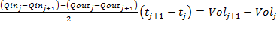 (1)
Where:
Qin = the total inflow into the reservoir,
Qout = the total outflow from the reservoir,
Vol = the storage volume in the reservoir,
t = time,
and the subscripts j and j+1 indicate the computational nodes representing the beginning and end of the time step respectively.
In applying Equation 1, the inflow to the reservoir is a known function of time only, and is obtained through application of appropriate hydrologic models such as SITES (USDA NRCS, 2007), WinTR-20 (USDA NRCS, 2015), or HEC-HMS (USACE, 2005). The outflow from the reservoir is the sum of the outflow from all spillways, the outflow over the top of the dam, and flow through the breach area of the dam. Using the assumptions of a level water surface in the reservoir and stepwise steady flow, each of the individual outflows may be treated as a unique function of the reservoir water surface elevation and the spillway, dam, and breach geometry associated with the time node. Likewise, the storage volume in the reservoir becomes a unique function of the reservoir water surface elevation. With these functions known along with the initial elevation of the reservoir water surface, Equation 1 may be solved for the reservoir water surface elevation at the end of each time step. As with all equations within WinDAM, Equation 1 is applied in English (USCS) units with appropriate factors added for unit consistency.
Because Equation 1 represents an averaging of conditions over the time step and variations in inflow and outflow may not be linear, the selected time step must be small enough to allow this type of averaging. Provision is also made for preventing this averaging from introducing numerical instability into the computations. In the WinDAM C implementation, Equation 1 is solved iteratively for water surface elevation using interval halving convergence. Numerical instability is avoided by requiring that:
- When the reservoir water surface elevation is rising through the time step as computed by Equation 1, the outflow at the end of the time step (Qout_{j+1}) must be less than or equal to the maximum inflow for the time step (greater of Qin_{j} or Qin_{j+1}) unless there is potential for embankment erosion during the time step; and
- When the water surface elevation is decreasing through the time step, the outflow at the end of the time step (Qout_{j+1})) must be greater than or equal to the minimum inflow for the time step (lesser of Qin_{j} or Qin_{j+1}).
If either of these conditions is found to be violated by solution of Equation 1, the outflow is set to the bound value that would be violated and the corresponding reservoir water surface elevation determined from the outflow.
Reservoir volumes for use in Equation 1 are determined by linear interpolation of tabular stage storage information provided as input to the model. When this information is provided as an elevation-area table, the table is linearly interpolated to determine the area at a given elevation before integrating to determine the storage volume. When input is in the form of elevation-volume pairs, the volume is determined directly through linear interpolation. When both area and volume information are provided and are not in agreement with linear area interpolation, volume information is assumed correct and the area information is not used.

Principal Spillway Rating
The WinDAM software provides for inclusion of a single principal spillway. The rating for this spillway may be entered as a table of elevation discharge pairs or, for typical spillways used by the Natural Resources Conservation Service (USDA NRCS), it may be computed by the software from properties of the spillway. Principal spillways for which ratings may be computed are standard single- and two-stage risers with circular or rectangular conduits, and standard hood inlets on circular conduits. Risers may have multiple conduits. Inclusion of a principal spillway is optional.
When the principal spillway rating is entered into the computational routine in tabular form as a series of elevation-discharge pairs, linear interpolation of the table is used to determine the discharge associated with any given elevation during routing computations. For this form of entry, the spillway and inlet may be of any type, provided that the discharge is uniquely determined by the elevation of the water surface in the reservoir.
When the principal spillway rating is computed by the software, provision is made for including the influence of tailwater on the computed discharge. The relation of tailwater elevation to total reservoir outflow is entered in tabular form. If no relation is provided, a low tailwater condition is assumed. When tailwater information is provided, the table is interpolated linearly to determine the tailwater elevation at the computed total reservoir outflow and computations carried out iteratively as necessary to account for the influence of tailwater on the computed discharge.
For an inlet with a two-stage riser, the low stage inlet is represented as a single rectangular opening for which the length, width, and crest elevation (lower edge of the rectangular opening) are known. For conditions where the elevation of the reservoir water surface is above the elevation of the crest plus 1.5 times the orifice height, orifice flow is assumed as illustrated in Figure 1 and the discharge is computed as:
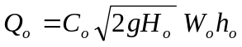 (2)
Where:
Q_{o} = the discharge through the orifice,
C_{o} = the discharge coefficient for the orifice provided as input,
H_{o} = the driving head defined as the difference in the elevation of the reservoir water surface and the greater of the center of the orifice (crest elevation plus ½ the orifice height) or the computed tailwater elevation,
h_{o} = the height of the orifice,
W_{o} = the width of the orifice, and
g = the gravitational constant.
When the elevation of the water surface is less than 1.5 times the height of the orifice above the crest, the low stage discharge is computed as the lesser of the discharge computed by Equation 2 and that computed with the orifice acting as a weir. In applying Equation 2 with the water surface below the elevation of the crest plus the height of the orifice (top of the orifice opening), the driving head is assumed to be the lesser of ½ the difference between the water surface and the crest elevation or the difference between the water surface and the computed tailwater elevation.
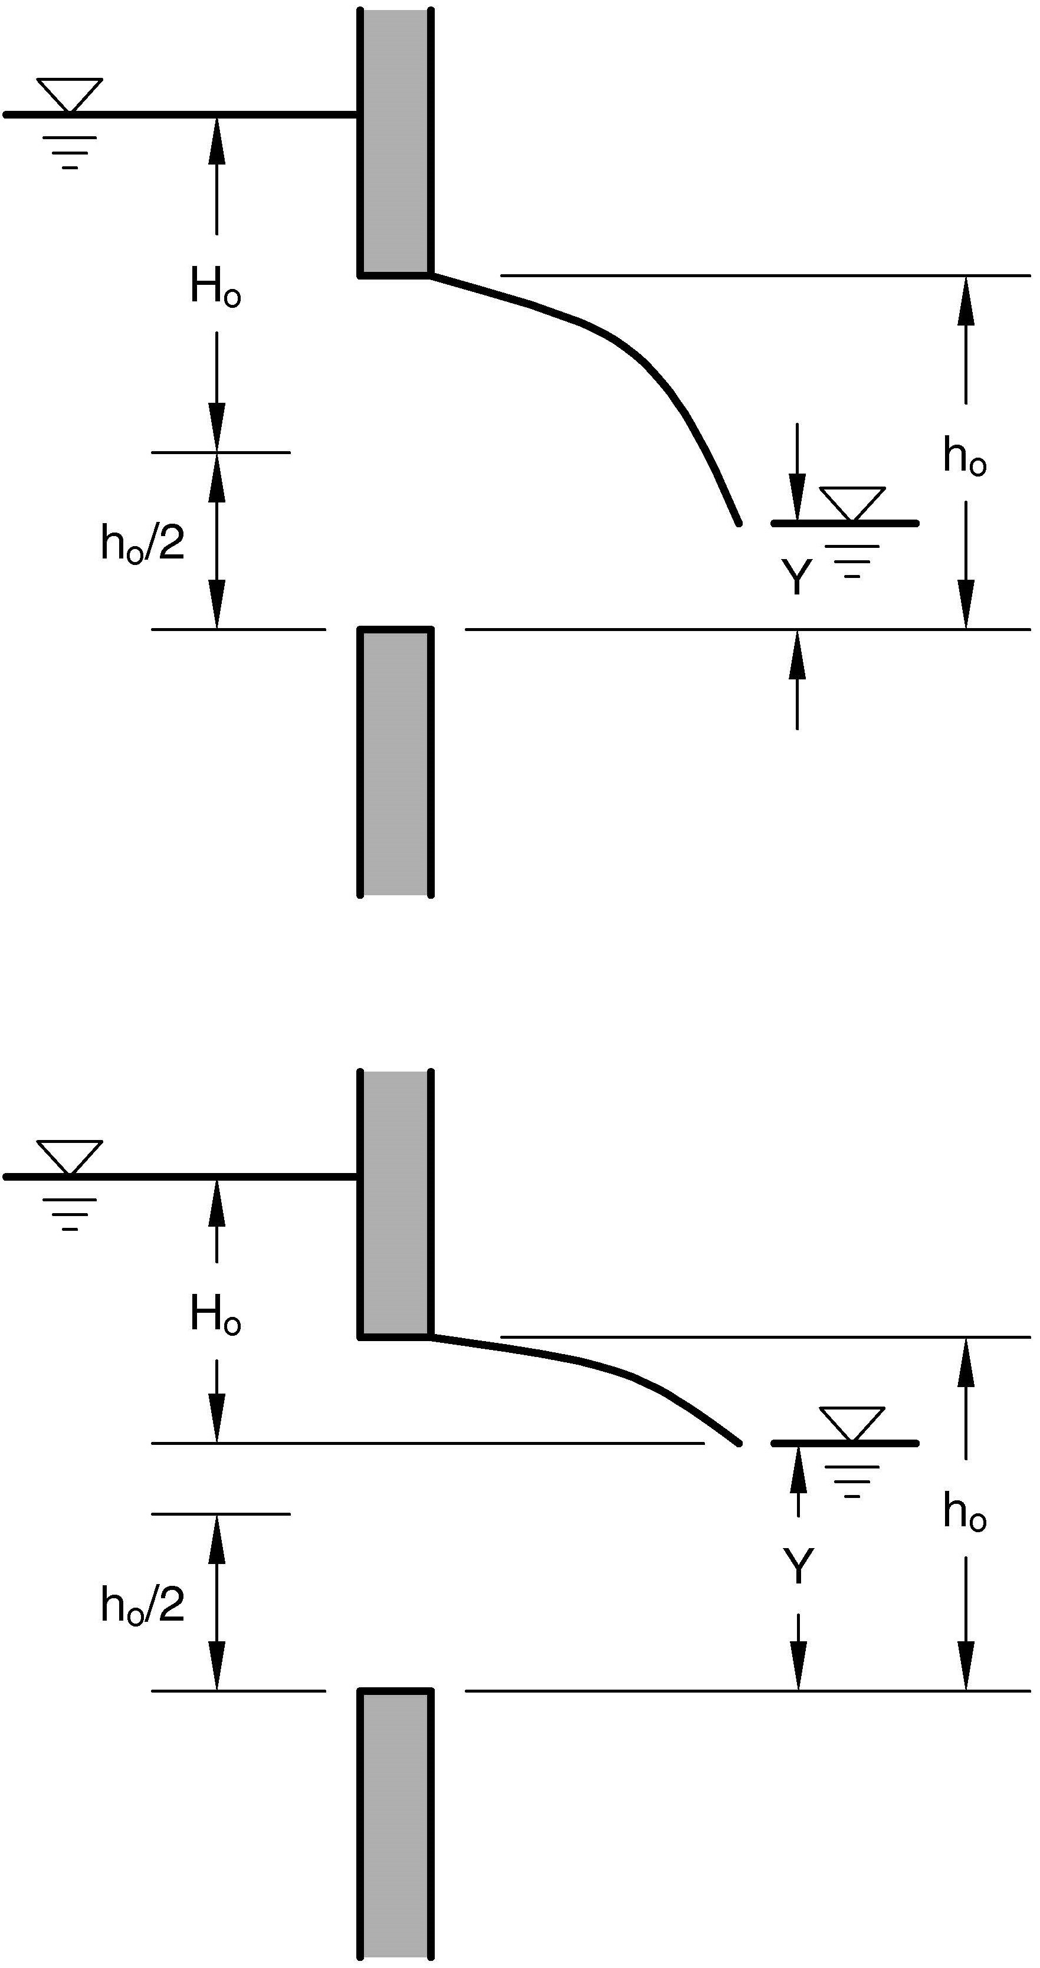

(a)

(a)
(b)

(b)

Figure 1. Sketches illustrating orifice flow conditions for (a) low tailwater with Y < h_{o}/2 and (b) high tailwater with Y > h_{o}/2 with Y representing the tailwater as shown.
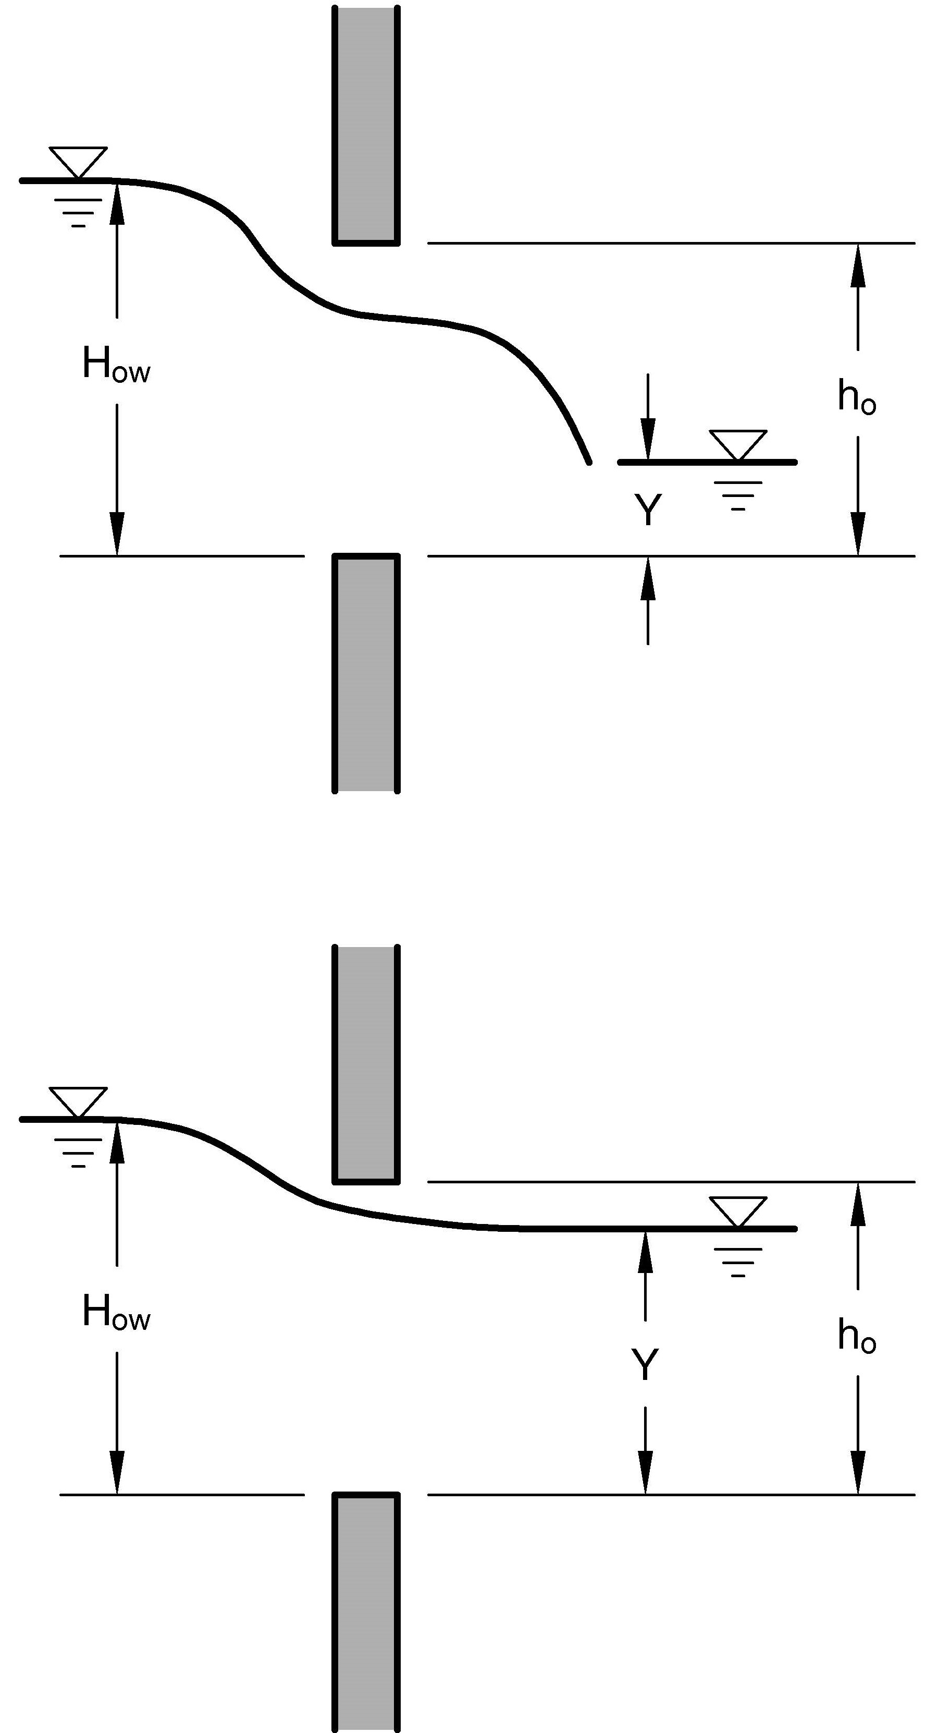

(a)

(b)

Figure 2. Sketches illustrating weir flow conditions for H_{ow}<1.5 h_{o} with (a) low tailwater where Y<2/3 H_{ow}, and (b) high tailwater where Y>2/3 H_{ow}.
When the computed tailwater elevation is below the elevation of the crest plus 2/3 the difference between the water surface elevation and the elevation of the crest, the weir discharge associated with the orifice is computed as (see Figure 2):
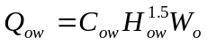 (3)
Where:
Q_{ow} = the discharge associated with weir flow through the orifice,
C_{ow} = the weir coefficient for the orifice provided as input,
H_{ow}= the driving head defined as the difference between the reservoir water surface
elevation and the crest elevation,
and W_{o} is as previously defined. For the condition where the tailwater is between the elevation of the reservoir water surface and limit specified for Equation 3 above, the weir discharge is computed by the approximating relation obtained by adjusting flow depth over the weir to match the water surface to the tailwater elevation:
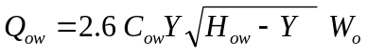 (4)
Where:
Y= the difference between the tailwater elevation and the elevation of crest of the orifice,
and the other variables are as previously defined.
For a single-stage riser or the upper stage of a two-stage riser, the inlet is assumed to be a weir and discharge is computed using either Equation 3 or 4 as applicable with the values of the weir coefficient, weir length, and crest elevation being those appropriate for the upper stage weir. Expressed in terms of these variables, Equation 3 becomes:
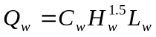 (5)
Where
Q_{w} = the discharge over the weir,
C_{w} = the weir coefficient provided as input,
H_{w} = the driving head defined as the difference between the reservoir water surface elevation and the elevation of the crest of the weir, and
L_{w} = the length of the weir provided as input.
Note that when considering the effect of tailwater on the discharge for either the upper or lower stage inlets, computations are simplified by the approximation of ignoring the energy losses associated with flow through the conduit. Similarly, any interaction between the upper and lower stage inlets is also ignored.
In computing the principal spillway rating, provision is also made for orifice control at the conduit entrance. The area of the orifice is considered a known input value less than or equal to the area of the conduit. Maximum discharge through the orifice is computed as:
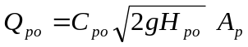 (6)
Where
Q_{po} = the discharge that would enter the pipe treating the entrance as an orifice,
C_{po} = the orifice coefficient for the conduit,
H_{po} = the head on the conduit with the entrance treated as an orifice, and
A_{p} = the cross sectional area of the conduit or orifice in conduit.
The head, H_{po}, is computed as the difference between the reservoir water surface and the greater of the conduit centerline at the entrance or the computed elevation of the tailwater. Application of Equation 6 is limited to conditions where the elevation of the reservoir water surface is above the top of the entrance to the conduit so no other provision is made for partially submerged orifice flow. As with the inlet computations, evaluation of the tailwater effects is simplified by ignoring the energy losses in the pipe downstream of the orifice.
The discharge associated with full conduit flow is computed using the relation:
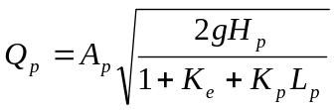 (7)
Where
K_{p} = a frictional energy loss coefficient for the conduit, 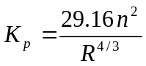 in English units,
H_{p} = total head on the spillway,
L_{p} = the length of the conduit,
R = the hydraulic radius of the conduit defined as the area divided by the wetted perimeter,
K_{e} = the entrance loss coefficient,
n = Manning’s n for the conduit,
and the other variables are as previously defined. If more than one conduit is indicated, the computed discharge is multiplied by the number of conduits. The total head on the spillway is the difference between the elevation of the reservoir water surface and the elevation of the hydraulic grade line at the outlet. The hydraulic grade line at the outlet is taken to be the greater of the computed tailwater elevation and the elevation of the conduit centerline at the outlet.
The principal spillway discharge for a given reservoir water surface and tailwater elevation is determined as the minimum of the discharge as computed for inlet control (both the orifice and weir for a two-stage inlet), conduit entrance orifice control, or full conduit control computed using the applicable relations from Equations 2 through 7.
When the hood inlet is used as a principal spillway, the circular conduit and inlet are considered as a unit with the discharge for multiple conduits being the product of the number of conduits and the discharge for a single conduit. Discharge computations are based on the work of Blaisdell and Donnelly (1958) which identified flow regimes as weir flow, slug flow, and pipe flow. For weir flow, the equation governing discharge is of the form:
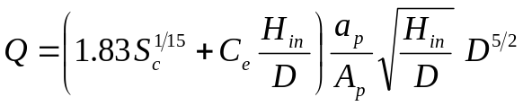 (8)
Where
Q = the computed discharge in cfs,
D = the conduit diameter in ft,
S_{c} = the conduit slope at the inlet in ft/ft,
C_{e} = a user specified weir coefficient ranging from 0.6 to 1.35,
H_{in} = the head in feet defined as the difference between the water surface elevation and the conduit invert at the inlet,
a_{p} = the wetted area of the conduit in square feet corresponding to a flow depth of H in a partially full conduit, and
A_{p} = the total area of the conduit in square feet.
For typical hood inlet configurations, there exists a slug flow region between weir control and full conduit flow. For this region, the equation governing discharge is:
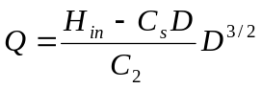 (9)
Where
C_{s} = the weir slug flow coefficient, and
C₂ = a coefficient found from tests to take on a value of approximately 0.025.
Blaisdell and Donnelly (1958) presented Equation 9 in a form with the coefficients C_{s} and C₂ treated as constants with values of 1.05 and 0.025, respectively. Rice (1967) confirmed these results for smooth pipe, but found that for rough pipe the transition from weir to pipe (full conduit) flow could take place suddenly and the point of transition could depend on whether the head was rising or falling. To the extent that Equation 9 was applicable, the data obtained by Rice (1967) appeared to indicate a larger value of C_{s} than was determined for smooth pipe conditions. For purposes of providing a consistent set of well-behaved equations representative of the available data over the full range of flow conditions and pipe roughness, C_{s} is assumed to vary with pipe roughness as:
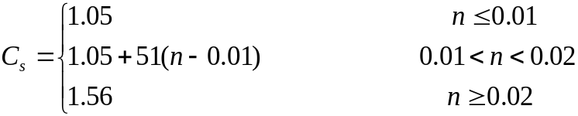 (10)
The equation governing full conduit flow is equivalent to Equation 7 with the head loss coefficients being those appropriate for the hood inlet configuration. The equation is then expressed as:
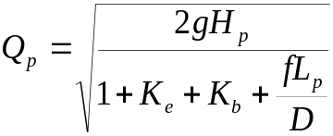 (11)
Where
K_{b} = the bend loss coefficient,
f = the Darcy-Weisbach friction coefficient for the conduit,
and the other variables are as previously defined. The bend loss coefficient applies only when the conduit is installed with a break in slope, and is computed by the relation from SCS Technical Release 3 (USDA SCS, 1956) as:
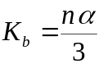 (12)
Where
α = the deflection angle of the bend in the conduit in radians,
and the other variables are as previously defined. Turbulent flow conditions are assumed allowing direct conversion between f and n.
To determine the discharge for given head and tailwater elevation, the points of intersection of Equations 8 and 11 with Equation 9 are first determined. For the usual condition where the head and discharge corresponding to the intersection of Equations 8 and 9 are less than those corresponding to the intersection of Equations 9 and 11, the flow is assumed to progress from weir flow (Equation 8), to slug flow (Equation 9), to pipe flow (Equation 11) with increasing head. For the condition where the head and discharge for the intersection of Equations 8 and 9 are greater than those corresponding to the intersection of Equations 9 and 11, relations 8 through 12 are inadequate to fully describe flow behavior and the low flow conditions are approximated for partially full pipe flow by assuming a linear head-discharge relation from zero head to the point of intersection of Equations 9 and 11. Therefore, the computational scheme used in WinDAM is inappropriate for use in developing rating curves for applications such as culverts where no slug flow transition would be indicated.

Auxiliary Spillway Rating
The WinDAM software provides for inclusion of up to three auxiliary spillways in addition to the principal spillway discussed in the previous section. As with the principal spillway, the rating for each auxiliary spillway may be entered directly in the form of a head-discharge table or computed at runtime by the software. When computed at run-time, the procedure used is that developed for use in the SITES software (USDA NRCS, 2007) with the exception that tailwater is accounted for in the WinDAM implementation. Only an overview of the procedure is described herein.
For the rating to be computed by the software, the spillway must be of constant width, have a trapezoidal cross section, and be adequately described by reaches having constant conditions within each reach. Stepwise steady state conditions are assumed with hydrostatic pressure and a uniform velocity distribution (energy coefficient of 1.0) at all computational nodes including the hydraulic control. The hydraulic control is determined as the upstream end of the first reach in the spillway for which normal flow conditions in the reach would be supercritical. The potential for downstream reaches to submerge the reach is not evaluated in determination of the hydraulic control. The potential for tailwater to submerge the hydraulic control is evaluated in a simplified fashion. If the computed tailwater elevation is greater than the water surface elevation associated with critical depth at the computed hydraulic control, the water surface elevation is set equal to the computed tailwater elevation and the associated flow depth and energy are computed and used as the beginning point for backwater computations. A mixed direct-step standard-step (Chow, 1959) procedure is used to compute frictional energy loss between the point of hydraulic control and the reservoir. Energy losses other than those associated with frictional flow resistance are not considered. The computations are carried out with discharge adjusted iteratively until an energy balance is achieved. Flow resistance within the spillway may be represented by either Manning’s n or a vegetal retardance curve index. When the resistance is represented by a retardance curve index, the relation of Manning’s n to the product of velocity and hydraulic radius given by Temple et al. (1987) is applied. That relation is discussed further in relation to hydraulic attack on a vegetated embankment slope and presented as Equation 21.

Dam Crest Rating
For purposes of determining the head-discharge relation for an overtopped dam, the dam crest may be represented by either a weir coefficient or by a simple cross-section template where the cross section represents the surface profile over which the flow occurs. In either case, the elevation of the dam crest representing the hydraulic control is allowed to vary along the length of the dam. The variation in elevation of the hydraulic control is specified by tabular input of station-elevation pairs that are then used as nodes for computation of discharge. Elevation is assumed to vary linearly between the nodes.
The head-discharge relation for any node is represented by the weir equation in the form:
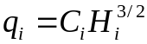 (13)
Where
q_{i} = unit discharge (discharge per unit width) at node i,
C_{i} = the weir coefficient at node i, and
H_{i} = the head defined as the difference in the elevation of the reservoir water surface and the elevation of the dam crest at node i.
The discharge over the dam is then computed by integrating Equation 13 over the length of the dam with the reservoir water surface elevation constant and the elevation of the dam crest assumed to vary linearly between nodes. When the resistance to flow across the dam crest is represented by a constant weir coefficient, the relation describing the discharge over the dam between nodes i and i+1 is given by:
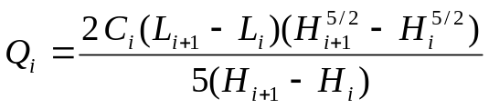 (14)
Where
L_{i+1}-L_{i} = the distance between the nodes (L representing the station along the crest),
and the other variables are as previously defined with the weir coefficient (C_{i}) the same for all i as noted above. As the difference in head (H_{i+1}-H_{i}) tends to zero, the unit discharge (Eq. 13) becomes constant also and the incremental discharge (Q_{i}) is computed as the product of that unit discharge and the distance between nodes. For computational purposes in WinDAM, the heads are considered equal when the absolute value of the difference is less than 0.001 ft.
When the flow path over the dam is represented by a cross-section template where the cross section represents the surface profile over which the flow occurs, the unit discharge at the node is computed using a mixed standard-step direct-step procedure similar to that used for computation of auxiliary spillway discharge. As for the auxiliary spillway computations, stepwise steady state conditions are assumed with hydrostatic pressure and a uniform velocity distribution (energy coefficient of 1.0) at all computational nodes including the hydraulic control. Flow resistance may be represented by either a vegetal retardance curve index (Temple et al., 1987) or Manning’s n. Energy losses other than those associated with frictional flow resistance are not considered. The computations are carried out with the unit discharge adjusted iteratively until an energy balance is achieved. Once the unit discharge for the node is determined, the weir coefficient for the node may be computed by solution of Equation 13 for C_{i}. Approximating the variation of the weir coefficient between nodes as linear, the relation describing the discharge over the embankment between nodes becomes:
(15)
In the case where there is no elevation variation between nodes, the head and the weir coefficient also become constant and the discharge becomes the product of the computed unit discharge and the distance between nodes as discussed in relation to Equation 14. The total discharge over the dam is obtained by summing the values of Q_{i} to include the entire length of the dam. Provision is made for conditions where only a portion of the dam is overtopped.
It may be noted that the variation in the weir coefficient and head will be most significant for low levels of overtopping where the variation in elevation across the length of the dam is of the same order as the head. For greater levels of overtopping where the energy loss between the reservoir and the hydraulic control is small relative to the overtopping head, the procedure used will result in the computed weir coefficient tending to a constant value of 3.09 ft^{1/2}/s.
The influence of high tailwater on discharge over the dam is accounted for when computing unit discharge at the nodes in the simplified fashion described for the principal and auxiliary spillway computation. When the weir coefficient is input directly, the appropriate variation of Equation 4 is applied in computing the unit discharge at the node, and when the unit discharge is determined with backwater computations, the flow depth at the hydraulic control is adjusted as described for the auxiliary spillway.

Breach Area Discharge (Overtopping)
When dam embankment breach due to overtopping is evaluated, discharge through the breach area is dependent on the extent of erosion as well as on the reservoir water surface elevation. A four stage breach model is used in performing these computations with the relations governing the erosion process described in subsequent sections. Stage one of the breach process is the development of a headcut on the downstream face of the embankment including the failure of any surface protection that is present; Stage two is the advance of the headcut through the crest of the dam to initiate breach; Stage three is the continued advance of the headcut into the reservoir to form the breach through local removal of the embankment, and; Stage four is the continued widening of the breach during release of the remaining stored water. The breach area is described by the location of the headcut (or developing headcut), the width of the breach area (headcut or developing headcut), and the elevation of the base of the headcut (maximum erosion depth). The location of the headcut or developing headcut in the cross section defines the elevation of the crest of the headcut, and therefore the hydraulic control for discharge computations.
Computation of the discharge through the area of the breach is unit discharge based with the effective width determined as described in other sections herein. When breach is not evaluated and prior to the failure of any surface protection, the width of the breach area, and therefore the associated discharge, is equal to zero. When breach is evaluated, the associated erosion is assumed to be initiated in an area corresponding to maximum unit discharge over the top of the dam. Therefore, for any time step, the breach area unit discharge must be greater than or equal to the maximum overtopping unit discharge. During stage one, the breach area unit discharge will be equal to the maximum overtopping unit discharge. As the headcut moves through the crest during stage two, the location of the headcut is tracked and used in determination of the breach area unit discharge. If the unit discharge over the dam is computed from backwater computations, the eroded geometry is used to determine the hydraulic control and the unit discharge in the breach area is computed using backwater computations in the same fashion as for other areas of the dam. If the discharge over the dam is computed from user input of a weir coefficient, the coefficient is assumed to vary linearly with position of the advancing headcut. The value of the coefficient when the headcut is at the downstream edge of the crest is that input by the user and the value at the upstream edge of the crest is that corresponding to critical flow with hydrostatic pressure and an energy coefficient of 1.0.
Following breach initiation (stages three and four), the unit discharge is computed assuming negligible energy loss from the reservoir to the hydraulic control and critical flow conditions with hydrostatic pressure at the hydraulic control. The equation describing unit discharge in the breach area is then:
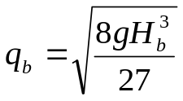 (16)
Where
q_{b} = the unit discharge in the breach area, and
H_{b} = the head on the breach area defined as the difference in elevation between the crest of the headcut and water surface in the reservoir.
This is equivalent to using a weir discharge coefficient of 3.09 ft^{1/2}/s. The restriction that the computed unit discharge in the breach area is greater than or equal to the maximum computed overtopping unit discharge remains in effect.
The total flow through the breach area is obtained by multiplying the unit discharge by the width of the breach area. The computed discharge over the dam outside of the breach area is obtained by reducing the computed flow over the top of dam without erosion by an amount equal to the product of the maximum unit discharge over the top of the dam without erosion times the breach area width with the restriction that the resulting flow over the top of the dam outside of the breach are must be greater than or equal to zero. This is an approximation for conditions where the original top of dam is not uniform over the entire width of the breach.

Breach Area Discharge (Internal Flow Path)
When embankment breach due to internal erosion is evaluated, the initial cross-sectional dimensions of a rectangular flow path (conduit) through the dam are specified by the user along with the initial elevation of the invert. The conduit is considered to have constant width and height over its entire length and to be horizontal through the embankment. Vertical and lateral expansion of the conduit are tracked as described in subsequent sections. A headcut is allowed to form at the outlet and to progress upstream. For purposes of computing discharge through the breach area, conditions downstream of the computed location of the headcut are ignored with the exception of the external tailwater resulting from total outflow.
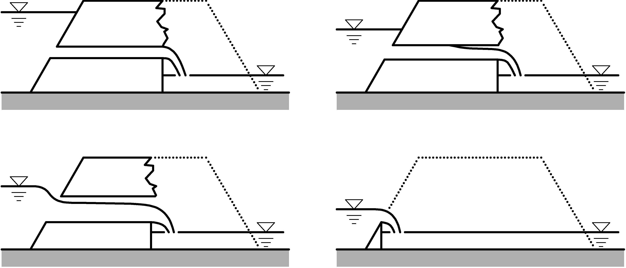
There are four alternate conditions which may control the discharge through the breach area for the internal erosion path. As illustrated in Figure 3, these are: a) full conduit flow over the entire length of the conduit; b) mixed full conduit and free surface flow; c) free surface flow through the breach area with energy loss between the reservoir and the point of hydraulic control (critical flow section); and d) free surface flow without energy loss between the reservoir and the hydraulic control. Hydrostatic pressure conditions are assumed for all alternatives and the boundary roughness is assumed to be represented by a Manning’s coefficient of 0.02 for the purpose of computing frictional energy loss.

(a)
(b)

(c)
(d)

Figure 3. Sketches illustrating internal erosion computation discharge control conditions of a) full conduit flow, b) mixed full conduit and free surface flow, c) free surface flow with energy loss, and d) free surface flow without energy loss.
For full conduit flow to control discharge, the upper surface of the conduit must be below the top of dam elevation, the reservoir water surface elevation must be above the upper surface of the conduit, the computed location of the headcut must be downstream of the intersection of the upper surface of the conduit with the upstream dam face, and the effective water surface elevation at the conduit outlet must be above the upper surface of conduit. The location of the conduit outlet is considered to be the lesser (most upstream) of the intersection of the upper surface of the conduit with the downstream face of the dam or the location of the headcut. The effective water surface elevation at the outlet is considered to be the lesser of the water surface elevation associated with critical flow conditions for the computed discharge or the top of the conduit; subject to a minimum value of the elevation of the external tailwater. When these conditions are satisfied, the discharge is computed by assuming uniform flow through the conduit with energy losses at the inlet ignored. The conduit length is considered to be the distance from the intersection of the upper surface of the conduit with the upstream dam face to the conduit outlet as defined above.
Mixed free surface and conduit flow occurs when the effective water surface elevation at the conduit outlet (defined above) is below the top of the conduit and water surface profile computations indicate an intersection of the water surface with the top of the conduit downstream of the entrance. For this condition, the discharge through the breach area is computed using the distance from this intersection point to the conduit entrance (defined above) as the effective length of the conduit and computing energy loss as for full conduit flow. The beginning point for the water surface profile computations is the location of the headcut with the water surface elevation at that point being the greater of that associated with critical flow conditions or external tailwater.
When the water surface profile computations carried out as described above indicate that the water surface does not intersect the upper surface of the conduit, the discharge is considered to be controlled by free surface flow through the rectangular channel formed by expansion of the original conduit. The point of intersection of the water surface profile with the upstream face of the embankment is determined and energy loss from the reservoir to this point is assumed negligible.
When free surface flow is determined to exist and the headcut has advanced upstream to the point where the effective water surface at the headcut (outlet) is at or above the surface of the original upstream slope of the embankment, frictional energy loss through the breach area is considered negligible for purposes of discharge computation. Discharge is controlled by the elevation of the remaining embankment material and the effective tailwater elevation (critical flow conditions or external tailwater). In terms of the conduit, the inlet and outlet are now represented by a common point.

DAM FACE SURFACE PROTECTION EVALUATION
When the dam experiences overtopping, the unit discharge associated with the lowest crest node(s) is used in evaluating the hydraulic attack on the downstream face of the dam. Areas of concentrated attack such as toe and berm areas are not evaluated. Erosion initiation due to hydraulic attack on the downstream slope may be delayed by grass or riprap protection of the surface.
Vegetation
For vegetation (grass), the basis for evaluation of the hydraulic attack is that applied to phase 1 (surface) failure of vegetated earth spillways (USDA NRCS, 1997). The computed attack is based on the assumptions of stepwise steady flow conditions and normal depth on the slope as computed by Manning’s equation in the form (English units):
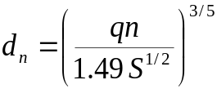 (17)
Where
d_{n} = the normal depth on the slope in feet,
n = Manning’s roughness coefficient,
S = the embankment slope expressed as the sine of the angle with the horizontal, and
q = the unit discharge on the slope in cfs/ft.
Two forms of hydraulic attack are evaluated. These are the gross stress and the time integral of the erosionally effective stress. For this purpose, the gross stress is computed as:
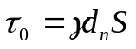 (18)
Where
τ₀ = the gross hydraulic stress,
γ = the unit weight of the water,
and the other variables are as previously defined.
The erosionally effective stress on the soil supporting the vegetation is computed from the relation:
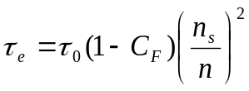 (19)
Where
τ_{e} = the erosionally effective stress,
C_{F} = the vegetal cover factor,
n_{s} = the soil grain roughness expressed as a Manning’s coefficient,
and the other variables are as previously defined. Guidelines for determining the vegetal cover factor for uniform grass covers are given by Temple et al. (1987). For covers with discontinuities such that erosion takes place within the discontinuity, Equation 19 is applied with C_{F} set to zero (USDA NRCS, 1997).
The soil grain roughness for use in Equation 19 is computed from representative particle diameter using the relation presented by Lane (1955) expressed in the form:
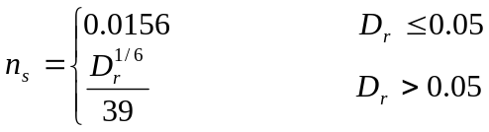 (20)
Where
D_{r} = the representative soil particle diameter in inches.
In application, the representative soil particle diameter for use in Equation 20 is normally taken to be the particle diameter for which 75% by weight of the material is finer.
For covers having major discontinuities such that the flow is concentrated in the discontinuity, Equation 19 is applied with C_{F} set to zero and the local effective value of Manning’s coefficient equal to the soil grain roughness thereby making the erosionally effective stress equal to the gross stress (USDA NRCS, 1997).
The value of Manning’s coefficient for the vegetated slope is computed from the relation (Temple et al., 1987):
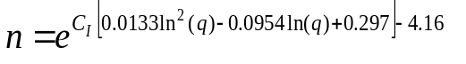 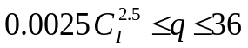 (21)
Where
= retardance curve index,
the other variables as previously defined, and q expressed in cfs/ft. When q is outside of the indicated bounds for Equation 21, the value of n is set to that computed for the nearest bound. The normal flow depth used in Equation 18 for computation of gross stress is that computed with Manning’s n from Equation 21 regardless of the type of discontinuities present.
In application, the uniformity of the vegetal cover is specified by a maintenance code having a value of 1 indicating uniform cover, 2 indicating minor discontinuities, or 3 indicating major discontinuities. Determination of the appropriate code is somewhat subjective and additional research and analysis is needed to better quantify the effects of various sizes and types of discontinuities. For present application, minor discontinuities are those which locally expose the soil to erosive attack over an area on the order of the stem length and/or flow depth without causing flow concentrations. Major discontinuities are those which cause the unit discharge to locally increase as well as locally exposing the soil to erosive attack. The ideal condition of uniform cover over the entire embankment face providing optimal protection from erosion would be unusual under field conditions.
Integration of the erosionally effective stress over time to determine the point of effective failure of the vegetative cover implies a failure mode of soil erosion through the vegetative cover. The value of the integral corresponding to cover failure is given by (USDA NRCS, 1997):
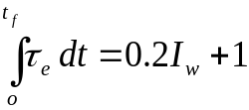 (22)
Where
t_{f} = the time corresponding to failure with time expressed in hours,
τ_{e} = the erosionally effective stress expressed in lb/ft², and
I_{w} = the plasticity index of the soil material being eroded.
Equation 22 was developed empirically using data from vegetated earth spillways and a relatively fine-grained soil material capable of supporting vegetation is implied. As implemented in WinDAM, the integration is carried out by treating the conditions computed for the beginning of the time step as constant through the time step. This approach is also used in computing changes in breach geometry due to erosion as described in subsequent sections.
For the erosionally driven failure mode implied by Equation 22 to be applicable, the vegetal cover must be adequately rooted in the soil and the total stress must be less than that required to directly remove the vegetal elements. Therefore, a limit is also placed on the gross stress computed by Equation 18. For application in the WINDAM model, this limit is set 13.5 lb/ft² corresponding to a rooting depth of approximately 1.5 ft in the relations developed for spillway application (USDA NRCS, 1997). As implemented, the vegetal protection evaluation portion of the model is not considered applicable to conditions where the potential rooting depth is less than 1.5 ft.
The limiting values described above may be used to determine conditions for which failure of the vegetal cover on the slope would not be expected or to determine the approximate time of failure for an embankment subjected to a given level of overtopping and flow down the slope. Once the allowable value of either the gross stress or the time integral of the erosionally effective stress is exceeded, the vegetal cover would be expected to fail and any remaining flow would tend to concentrate in the area of the failure. Output may expressed as a percentage of that expected to cause failure. If the evaluation of the vegetal protection is performed as a part of breach analysis, the vegetation is assumed to be locally removed to a depth of 0.5 ft (USDA NRCS, 1997) during the time step in which either stress value reaches 100% of allowable. This becomes the initial condition for breach erosion computations as described in subsequent sections.

Riprap
The potential for riprap to protect the downstream face of a dam is evaluated using the applicable relation from those developed by Abt and Johnson (1991), Robinson et al. (1998), or Mishra and Ruff (1998). Most dam face slopes fall into the range for which the relation developed by Robinson et al. (1998) is applicable. This relation may be expressed as:
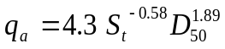 (23)
Where
q_{a} = the allowable unit discharge expressed in cfs/ft,
D₅₀ = the riprap diameter in ft for which 50% by weight of material is finer, and
S_{t} = the embankment slope expressed in rise over run (tangent of the angle with the horizontal).
For unusually flat embankment slopes of less than 10%, the relation developed by Abt and Johnson (1991) is applied. This relation may be expressed as:
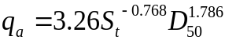 (24)
Where the variables are as previously defined.
Slopes between 10% and 17% are treated as transitional with the allowable unit discharge computed using both Equations 23 and 24 and weighted linearly such that Equation 24 is matched at the 10% slope and Equation 23 is matched at the 17% slope.
For slopes exceeding 40%, the flow tends to be through rather than over the riprap and the relations developed by Mishra and Ruff (1998) are used to compute the allowable (failure) discharge. The equation describing flow through the riprap may be written in the form:
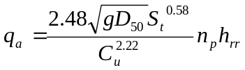 (25)
Where
n_{p} = the porosity of the riprap,
h_{rr} = the riprap thickness in ft,
C_{u} = the coefficient of uniformity defined as the ratio of D₆₀ to D₁₀,
and the other variables are as previously defined.
A maximum allowable discharge is also computed from the relation 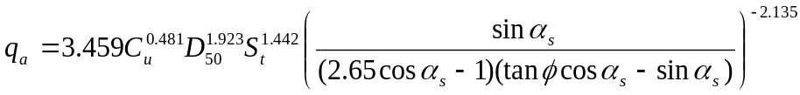 (26)
Where
φ = the angle of repose of the riprap,
α_{s} = the angle of the embankment slope with the horizontal, and
and the other variables are as previously defined. The allowable unit discharge for slopes exceeding 40% is the minimum of that computed using Equations 25 and 26.
Application of Equations 23 through 26 is limited to angular riprap with a thickness greater than or equal to twice D_{50,} and to D₅₀ values less than or equal to 2 ft (Temple et al., 2006). Slopes must be 50% (2H:1V) or less. Failure is expected whenever the maximum unit discharge on the slope exceeds the applicable allowable value. As with vegetation, it is the failure of the protection on the slope that is being evaluated, and regions of concentrated attack associated with the toe, berms, etc. may require additional evaluation. WinDAM output is expressed as the percentage of the allowable unit discharge with values exceeding 100% indicating failure is expected. If breach analysis is performed, the erosion depth at failure is assumed to be the greater of the thickness of the riprap or 0.5 ft.

Bare Soil
If no slope protection in the form of vegetation or riprap is present on the slope, the initial condition is assumed to be an exposed bare soil. For this condition, the critical shear stress of the soil material is considered to be a material property and is taken as the allowable value of gross stress as computed by Equation 18. Since the primary application of the breach model is cohesive soil materials, Manning’s n for computation of normal flow depth in Equation 17 is taken as 0.02. As with surface protection, output may be expressed as a percentage of allowable with values exceeding 100% indicating that erosion is expected. If breach analysis is performed, the erosion depth at the beginning of the time step for which stress exceeds 100% of allowable is assumed to be zero and erosion is computed for the time step.

OVERTOPPING BREACH EROSION
The processes dominating erosion during breach of an overtopped embankment are dependent on the breach geometry and the breach area discharge. The actual processes are complex, and their representation in a computational model is necessarily simplified. Simplifications are also introduced in the representation of the embankment and valley cross section. These simplifications will generally result in conservative predictions for failure time and breach outflow.
The four stage model described herein is a dominant process model of the progressive breach erosion as previously outlined in the discussion of breach area discharge. Once erosion is initiated on the downstream embankment slope, it is assumed to deepen and move upstream as a vertical or near vertical headcut. The current model is applicable to a homogeneous embankment, represented by a cross-section having a fore-slope, level crest section, and a back-slope. The cross section is assumed to be constant from one end of the dam to the other with only the elevation of the crest allowed to vary along the length of the dam. For purposes of the model computations, the elevation of the base of the dam is assumed constant and level implying an approximation of a rectangular valley cross section. The boundaries of this rectangular section are treated as non-erodible.
When the surface protection on the slope is failed as described in the preceding sections, the underlying material is exposed to erosive attack. The location of the surface failure is taken to be the upstream point on the slope. For the simple dam embankment cross section used, this also represents the downstream edge of the dam crest. The location of the surface failure along the length of the dam is taken to be the point of minimum crest elevation that is the maximum distance from either end of the embankment. This location represents the point where the resulting headcut must move a minimum distance to result in breach of the embankment and the breach area may experience a maximum amount of widening before encountering an abutment. Initial width of the eroded area is taken to be 1.4 times the initial depth as described in the preceding sections as the erosion depth corresponding to surface protection failure.
Erosive attack on the exposed embankment material following failure of any surface slope protection will result in the eroded area (referred to herein as the breach area) deepening, widening, and advancing upstream through the embankment. The way in which the erosion progresses will depend on the local geometry and discharge. Initially, the developing headcut may not be sufficiently high to generate the plunging action associated with typical headcut advance. Likewise, during latter stages of the process, the headcut may become submerged such that plunging action does not occur.

Submerged Headcut Erosion
The headcut is considered to be submerged for purposes of computing erosion whenever the downstream tailwater elevation is greater than the elevation of the crest of the headcut, or the height of the headcut is less than the computed flow depth for flow away from the headcut. The computed flow depth for flow away from the headcut is considered to be dependent on unit discharge over the headcut and the relative scale of the flow and erosion. During formation of the headcut following the initial failure of any surface protection, the depth associated with flow away from the headcut is taken to be critical depth for the unit discharge through the breach area. Once headcut movement has begun, the depth associated with flow away from the headcut is taken to be the lesser of critical depth or 90% of the headcut height with the limit that it cannot be less than the flow depth associated with no energy loss for flow over the headcut. Therefore, resubmergence of the headcut is predicted to occur only when the tailwater exceeds the elevation of the crest of the headcut or when flow over the headcut without energy loss would result in submergence.
When the headcut is submerged, the headcut is considered not to advance or deepen from plunging action of the flow over the crest of the headcut. If elevation of the downstream tailwater computed from total flow through the reservoir is below the elevation of the base of the headcut and the base of the headcut is within the embankment, the headcut may continue to deepen as a result of flow on the face of the dam downstream of the headcut. The rate of deepening associated with this flow is approximated using a normal flow depth model consistent with that used in evaluating surface protection. If the elevation of the tailwater is above elevation of the base of the headcut, the stress associated with flow on the downstream slope will be less than that associated with flow away from the headcut. In computing the stress associated with flow away from the headcut, the flow depth is computed as described in the previous paragraph but not less than the depth implied by the external tailwater elevation. Applied stress is computed using Equations 17 and 18 with a Manning’s n value of 0.02 representing the eroding soil surface. The entire gross stress is assumed effective in generating erosion which is consistent with application of Equation 19 with no vegetal cover and soil grain roughness equal to total roughness (τ_{e} = τ₀). The erosion rate resulting in deepening of the headcut is then computed by:
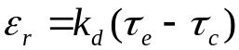 (27)
Where
ε_{r} = the soil detachment rate in volume per unit area per unit time,
k_{d} = a detachment rate coefficient that is a property of the embankment material,
τ_{c} = the critical stress for the material,
and the erosionally effective stress (τ_{e}) is as previously defined. For application, k_{d} may be expressed in (ft/h)/(lb/ft²) and is considered a material property. The appropriate value for input to the model may be obtained from soil tests as described by Hanson and Cook (2004) and Hanson and Hunt (2007). The detachment rate is taken as representing the rate of downward erosion of the headcut base. In recognition of the fact that the actual geometry in the area of the base is complex, no additional adjustment in rate is made for embankment slope.
When headcut is submerged and the downward erosion of the headcut base is due to flow on the slope or flow away from the headcut, the breach area is considered to widen due to the same flow conditions. The downstream channel is treated as rectangular and the rate of widening is taken to be 1.4 times the rate of downcutting of the base with 0.7 times the rate assigned to each side. This widening rate is an approximation based on the classic work of Lane (1955) on stress distribution in channels and the breach widening research reported by Hunt et al. (2005). Once the elevation of the base of the headcut reaches the elevation of the base of the dam, downcutting is stopped, but widening continues at the computed rate until an abutment is reached.
The WinDAM breach erosion model assumes the crest of the embankment to resist downward erosion due to the hydraulic stresses associated with flow across the crest. However, once headcut has advanced into the reservoir, the crest elevation of the headcut, which is also the hydraulic control within the breach area, is assumed to be exposed soil and is allowed to erode downward due to the critical or tailwater controlled flow over the crest of the headcut. The rate of this downward erosion of the crest is computed by using the critical or tailwater controlled flow conditions to compute flow depth and energy slope and applying Equations 18 and 27. This downward erosion of the crest is then treated as equivalent to the headcut advance required to cause the same change in the hydraulic control elevation. The rate of widening of the breach area for a submerged headcut is the greater of the rate associated with downward erosion of the crest or base using the same assumptions relative to stress distribution. If the elevation of the base of the headcut is within the embankment material, the headcut height is not allowed to decrease, meaning that the effective rate of downward erosion of the headcut base is also the maximum of that computed for the crest or the base.
For the simple embankment cross section of the model, the headcut is considered to have advanced into the reservoir when the computed location of the headcut is upstream of the upstream end of the level crest. The time that the headcut reaches this point is designated as the time of breach initiation (see Figure 4).

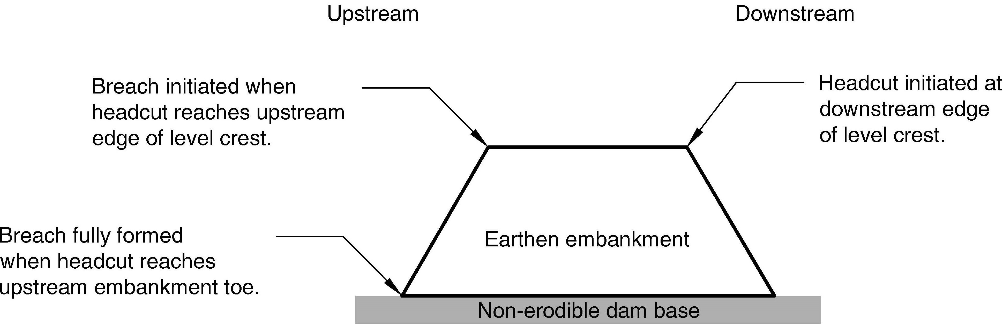

Figure 4. Headcut location during breach initiation and formation.
The breach formation time reported by the model is the time when the embankment is entirely removed within the breach area (headcut reaches the upstream toe of the dam). After this headcut location is reached, erosion can only widen the breach area. This special case of the submerged headcut condition is treated as described above for critical or tailwater controlled flow conditions necessarily governing the computed stress. As described in discussion of discharge computations, tailwater is considered to govern flow depth whenever the computed tailwater elevation is greater than the water surface elevation computed for critical depth over the hydraulic control.

Unsubmerged Headcut Erosion
When the tailwater is below the crest of the headcut and the height of the headcut is greater than the depth of flow away from the headcut, the flow will tend to plunge over the crest of the headcut. Stresses associated with this plunging flow may govern the rate of downward erosion at the base of the headcut, the rate of headcut advance, or both.
The relations used to compute the stress associated with this plunging action at the base of the headcut driving downward erosion deepening the headcut are those developed from laboratory tests of an idealized headcut with critical flow at the crest by Robinson (1992). The downcutting stress is taken to be the lesser of:
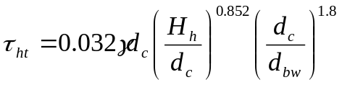 (28a)
or
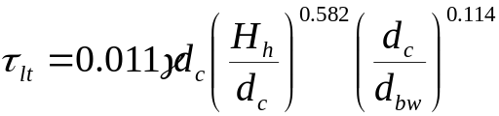 (28b)
Where
τ_{ht} = the computed stress for high tailwater conditions,
τ_{lt} = the computed stress for low tailwater conditions,
d_{c} = the critical flow depth associated with the unit discharge in the breach area,
H_{h} = the height of the headcut,
d_{bw} = downstream depth of tailwater relative to the base of the headcut,
and the other variables are as previously defined. In applying Equations 28 (unsubmerged conditions), the depth of the tailwater is the greater of the computed depth for flow away from the headcut or the external tailwater. However, if the depth implied by the elevation of the tailwater is between 0.9 and 1.0 times the headcut height, a value of 0.9 times the headcut height is used in Equations 28 for consistency with their initially specified limit of applicability.
The smaller of the stresses computed from Equations 28 is compared to the stresses associated with flow away from the headcut and flow on the downstream slope computed as described in the previous section, and the greater of the resulting stresses is used to compute the rate of downward erosion at the base of the headcut through application of Equation 27. Note that the elevation of the downstream tailwater may impact both the stress associated with the plunging action and that associated with flow away from the base.
Headcut advance rate is dependent on erosion taking place on the face of the headcut and on the material resistance to mass failure. As implemented in WinDAM, the user may select an energy-based or a stress-based advance rate model. The energy-based model, designated the Temple/Hanson model, is described by Temple et al. (2005). The model is a variation on the semi-empirical model used in the SITES spillway erosion computations (USDA NRCS, 1997). The stress-based model, designated the Hanson/Robinson model, is an adaptation of the model described by Hanson et al. (2001). These advance rate models reflect different degrees of simplification of the complex process and have different input requirements.
Energy driven headcut advance rate model: The Temple/Hanson headcut advance rate model computes headcut advance rate using the relation:
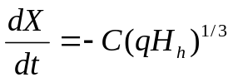 (29)
Where
dX/dt = the rate of headcut advance (negative value indicates upstream advance) ,
C = an advance rate coefficient,
and the other variables are as previously defined with q being the unit discharge over the headcut which, in WinDAM application, is equal to the unit discharge in the breach area. This may be shown to be a zero-threshold implementation of the headcut advance relation used for spillway erosion computations as described later in this report (Equation 39). Implicit in this formulation is the simplification that flow specific energy upstream and downstream of the headcut are approximately equal. As implemented in WinDAM, Equation 29 is not adjusted for tailwater for conditions insufficient to submerge the headcut. This is considered to be a conservative implementation in that maximum headcut advance rates are predicted.
The advance rate coefficient, C is considered a material property and must be determined external to the model. Data obtained from experience with earth spillways or other embankments may be used to obtain an estimate of this parameter. Evaluation of data from physical model tests in the outdoor laboratory as described by Hanson et al. (2005) suggests that an estimate of C may be obtained from the detachment rate coefficient using the relation:
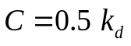 (30)
Where the variables are as previously defined, the detachment rate coefficient (k_{d}) is expressed in (ft/h)/(lb/ft²), and headcut advance rate coefficient (C) in (ft/h)/(ft/s^{1/3}).
Equation 29 does not differentiate between embankments for which the headcut would be stable in the absence of flow and conditions where a vertical face of height ( H_{h}) would be unstable in the absence of flow. Since the underlying data are very limited for high dams, more data are needed and the equation, and therefore the model, should be applied with appropriate caution.
Stress driven headcut advance rate model: The Hanson/Robinson headcut advance rate model has the advantage of being a more detailed representation of the physical processes governing headcut advance through a homogeneous soil material. However, the increased complexity makes it more difficult to utilize experience with similar conditions to calibrate the model for application to a specific site. The model is fundamentally that presented by Hanson et al. (2001). The headcut is assumed to advance through a series of mass failures driven by erosion at the base as indicated by the sketch presented as Figure 5.

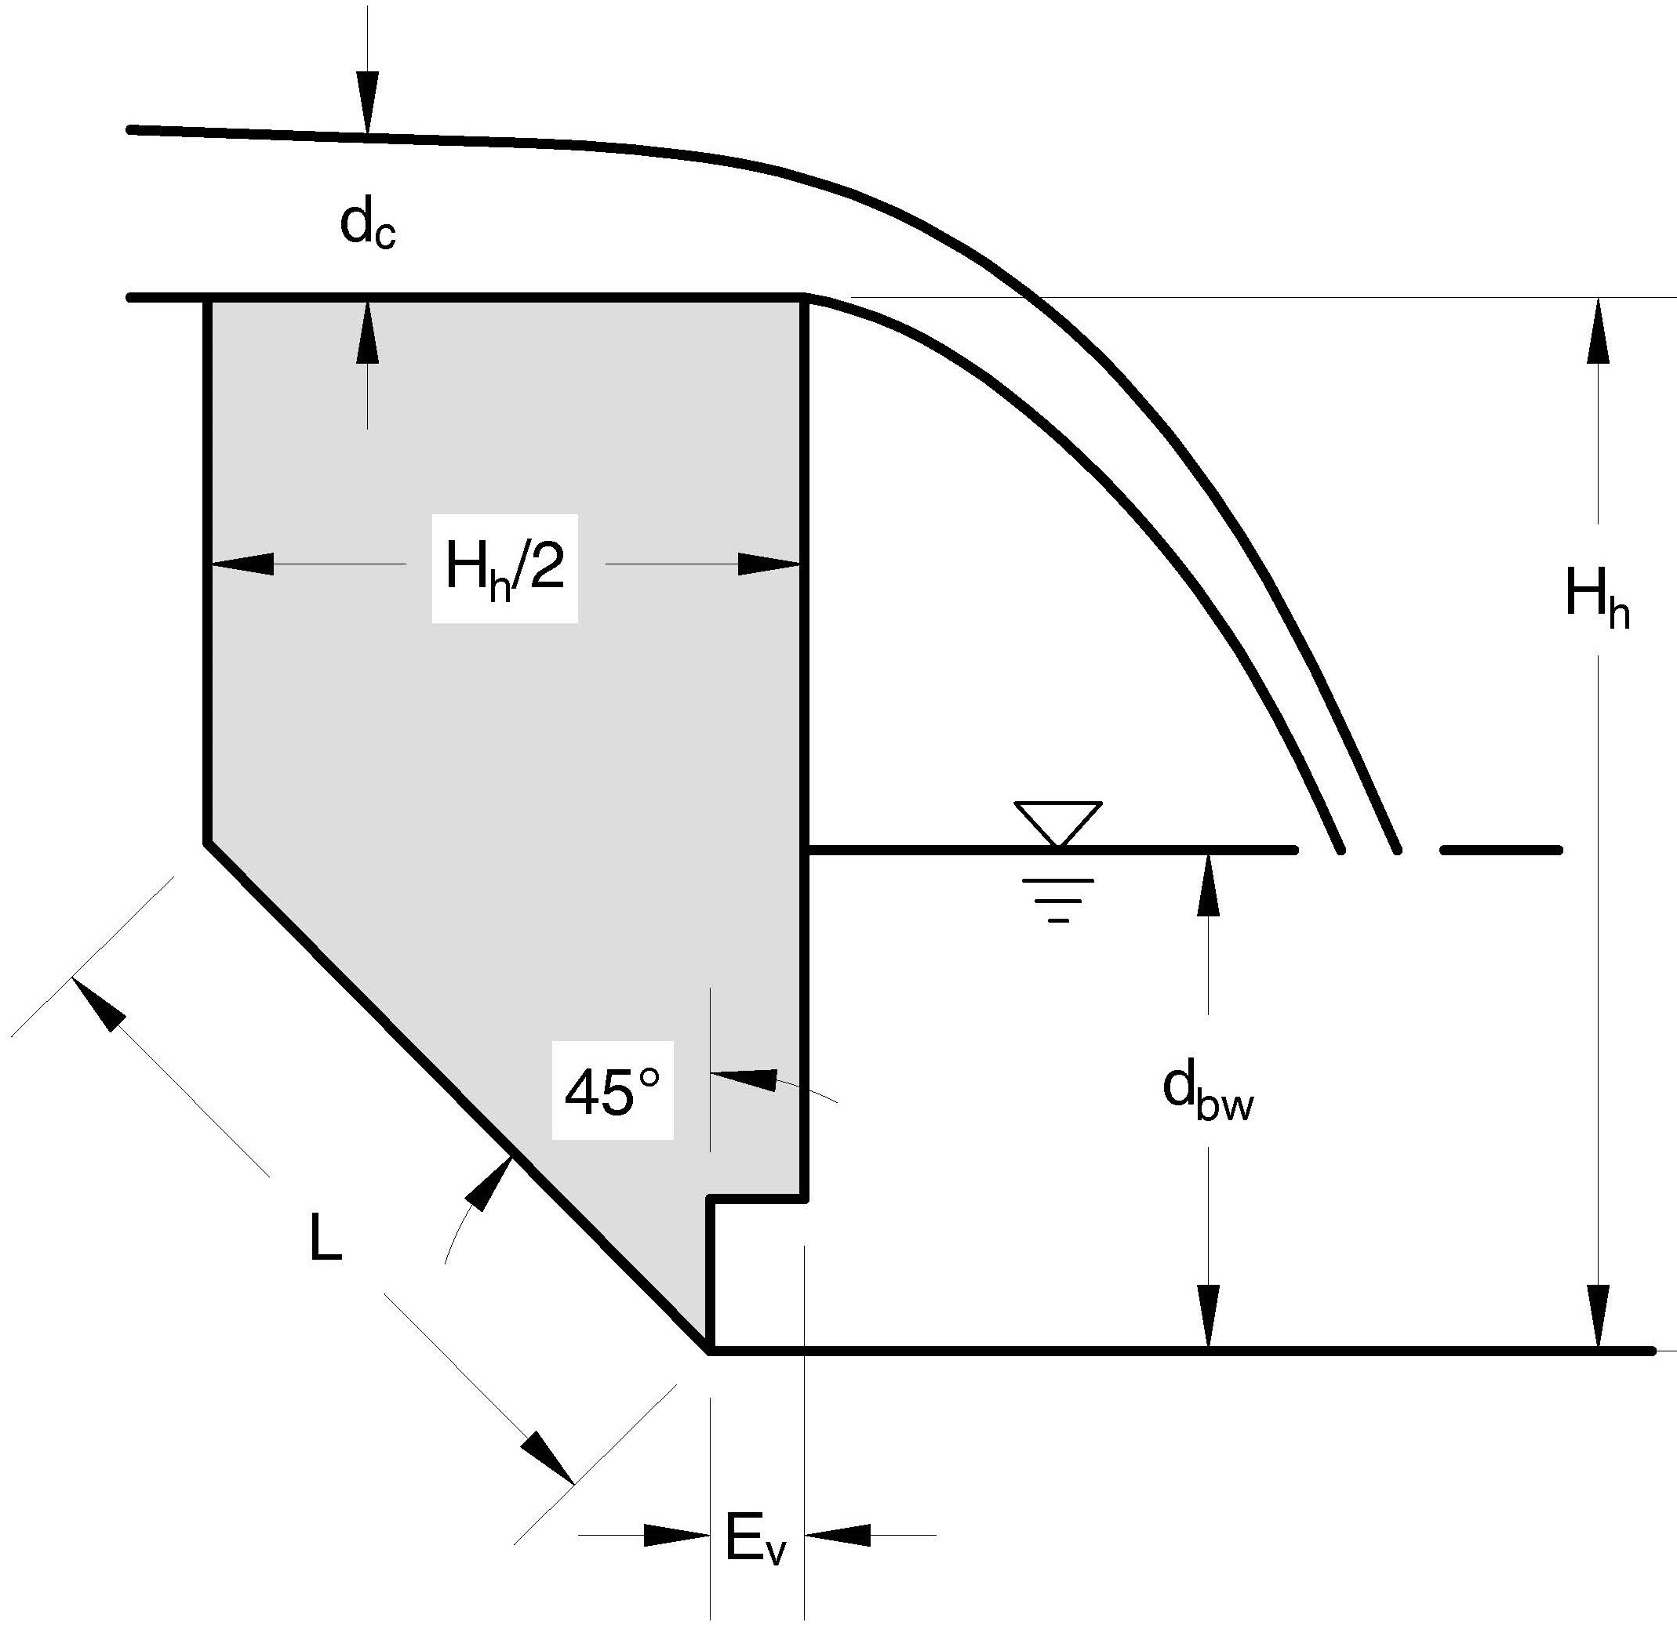

Figure 5. Sketch of headcut failure form used in formulation of Hanson/Robinson headcut advance model.
Hydraulic shear stresses are assumed to erode the base increasing the distance E_{v} and shortening distance L until gravitational forces exceed the soil strength resulting in failure. Soil tensile strength is assumed to be negligible. The hydraulic shear stress driving the erosion on the face of the headcut to increase E_{v} is computed by the relations developed by Robinson (1992). For the condition represented by Figure 5, these relations may be expressed as:
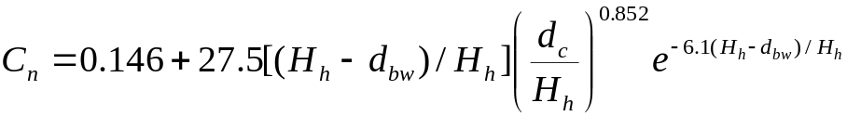 (31)
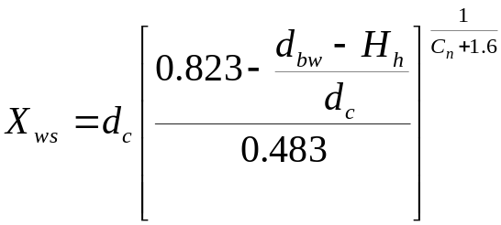 (32)
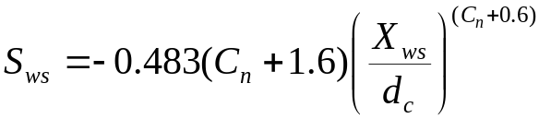 (33)
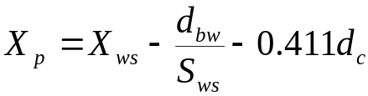 (34)
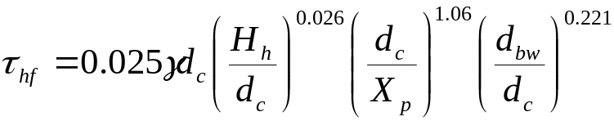 (35)
Where
C_{n} = a correction factor associated with the assumption of an incompletely vented nappe at the overfall,
X_{ws} = the relative horizontal position of the entry of the jet into the tailwater,
S_{ws} = the slope of the jet upon entry into the tailwater,
X_{p} = the approximate location of the maximum stagnation pressure of the jet at the headcut base with eccentricity and contraction of the jet ignored as secondary effects,
τ_{hf} = the stress on the headcut face driving the undercutting erosion at base of headcut,
and the other variables are as previously defined. τ_{hf} is used as the erosionally effective stress in Equation 27 to compute the rate of erosion associated with the increase in distance E_{v} with time. The assumption of an incompletely vented nappe implicit in the use of Equation 31 is conservative in that it tends to increase the computed value of τ_{hf} (Robinson, 1992). In application of Equations 31-35, tailwater is as previously defined.
The value of E_{v} corresponding to failure conditions may be computed for the condition shown in Figure 5 from the quadratic equation solution form (Hanson et al., 2001):
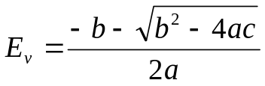 (36)
With
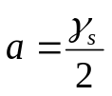 (36a)
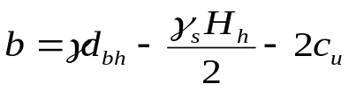 (36b)
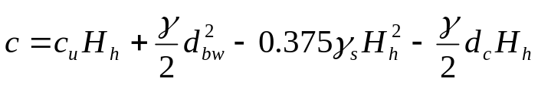 (36c)
Where
E_{v} = horizontal length of undercutting erosion at base of the vertical headcut face as illustrated in Figure 5,
γ_{s} = the total unit weight of the soil mass,
c_{u} = the undrained shear strength of the soil,
d_{bh} = the computed depth of flow away from the headcut in the absence of external tailwater computed as previously described.
a, b, and c are intermediate terms in the solution of the quadratic equation, and the other variables are as previously defined. Use of d_{bh} rather than d_{bw} in computation of the b term implies a conservative application ignoring the stabilizing effect of high tailwater on the force balance.
The implied average headcut advance rate may then be computed as:
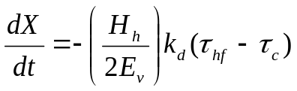 (37)
With rate equal to zero when the erosionally effective stress on the face,(τ_{hf}) is less than the critical stress for the soil (τ_{c}).
Equation 37 is applicable only to plunging flow with headcut height and soil strength such that the computed value of E_{v} is greater than zero. A value of E_{v} approaching zero implies an unstable vertical face. Physical observations of headcut advance under these conditions are extremely limited, but the expected mode would be cascading flow down the unstable near vertical. Therefore, the headcut advance model as implemented assumes an upper limit on the absolute value of the headcut advance rate computed by Equation 37 equal to the rate associated with normal depth flow erosion on a ½ to 1 slope (H:V). The ½ to 1 slope is based on the erosion feature created in the failure process described in Figure 5. This limiting erosion rate is computed using Equations 18 and 27 with erosionally effective stress assumed to be the gross stress and the flow depth computed as normal depth on the ½ to 1 slope with a Manning’s n value of 0.02 as is used for other eroding soil computations. The absolute value of headcut advance rate is then taken to be the lesser of the absolute value of dX/dt value computed by Equation 37 or the ε_{r} value computed by Equation 27 divided by the sine of the slope angle.
Breach area widening: When headcut advance is governed by the plunging action of unsubmerged flow, the widening of the breach (headcut) area is assumed to be governed by the same action and the widening rate is taken to be equal to the absolute value of the headcut advance rate computed by the selected model. As with all widening computations, if one edge of the headcut is determined to be at the abutment, only the side away from the abutment is considered to contribute to the widening resulting in the rate being ½ that computed for conditions with both sides being allowed to erode. If the headcut is within the dam crest, an additional check is made to determine if the elevation of the crest of the embankment is below the elevation of the reservoir water surface at the edge of the breach area. If not, the breach area widening is suppressed for that edge over the time step.
If the headcut has entered the reservoir, a check is made to determine whether erosion of the crest as described for submerged conditions would result in a greater decrease in the hydraulic control elevation than implied by the computed rate of headcut advance computed by the appropriate advance model. If the rate is greater, the implied equivalent headcut advance rate is applied in determining the position of the headcut. In this case, the greater of the computed widening rate for submerged headcut conditions or for plunging flow is used.

INTERNAL FLOW PATH BREACH EROSION
As with overtopping, the processes dominating erosion during breach as the result of a defined flow path through the embankment are dependent on the breach geometry and the breach area discharge. The actual processes are complex and their representation in a computational model is necessarily simplified. The simplifying assumptions of a homogeneous embankment, a simple embankment cross section, and a rectangular valley are applied for the expansion of an internal erosion flow path in the same form as for the overtopping erosion computations.
The initial flow path (conduit) through the embankment is assumed to be horizontal with a rectangular cross section having constant width and height over its entire length. The initial dimensions and location are specified by the user. The conduit is allowed to expand uniformly vertically and horizontally until a boundary is reached or the upper surface becomes unstable and collapses. The boundary of the rectangular valley is considered non-erodible.
The upper surface of the conduit is considered able to resist collapse so long as it is flowing full over a portion of its length and the upper surface of the conduit is below the top of dam. When the flow is detached from the top of the conduit (free surface flow within the conduit), the upper surface of the conduit is considered to collapse when the width becomes greater than or equal to twice the elevation difference between the upper surface of the conduit and the top of the embankment.
A headcut is allowed to form at the outlet of the conduit and to progress upstream. Erosion taking place downstream of the headcut location is not directly considered in computations except as described for conditions following headcut advance into the upstream face of the embankment.
The flow path (conduit) expansion erosion computations are based on the excess stress equation (eq. 27) with the applied stress, τ_{e}, being the average gross stress on the boundary. This approach is applied for full conduit, mixed free surface and full conduit, and free surface flow.
For full conduit flow computed as described in the discussion of discharge computations, the average stress on the conduit boundary is computed as:
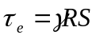 (38)
Where the variables are as previously defined.
The energy grade line slope is computed using Manning’s equation with a roughness, n, of 0.02. The conduit is considered to expand equally in all directions unless a valley boundary is encountered (see Figure 6).

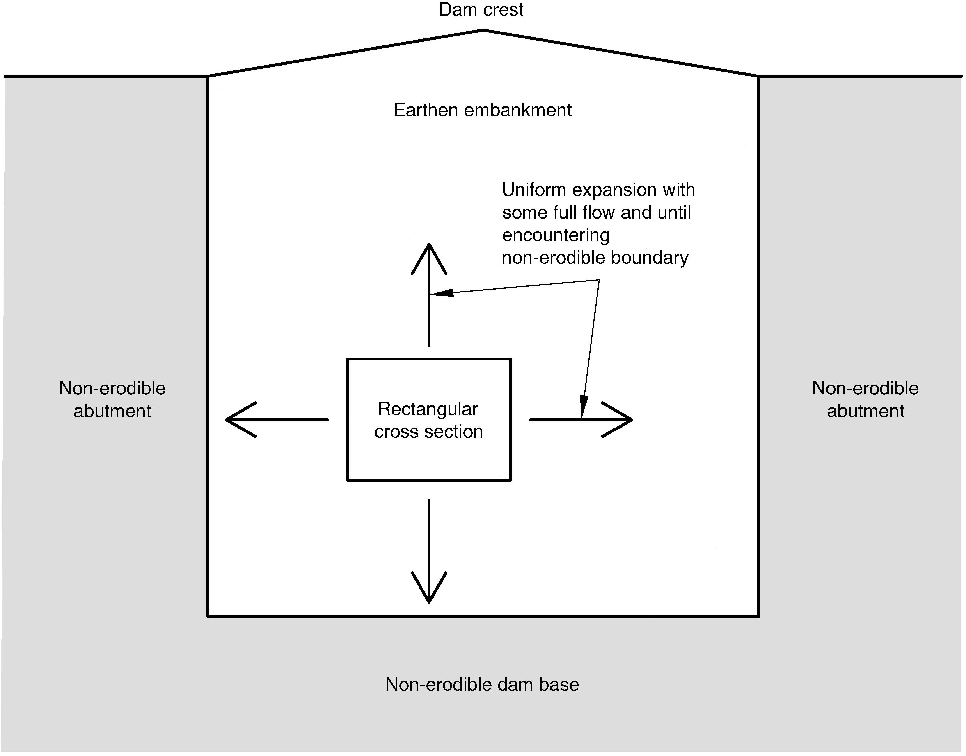

Figure 6. WinDAM internal erosion conduit looking upstream
For mixed conduit and free surface flow, the hydraulic radius and the energy slope, and therefore the stress as computed by eq. 38, varies with location in the area of free surface flow. The average stress for use in Equation 27 is computed as an area weighted average (summation of stress times area divided by total area) over the length of the conduit with inlet and outlet as defined in the discussion of discharge computations. As for full conduit flow, the conduit is considered to expand equally in all directions unless a valley boundary is encountered. This is recognized as an approximation.
For free surface flow with the headcut downstream of the intersection of the conduit invert with the face of the dam, the average stress for use in Equation 27 is computed as for the mixed free surface and conduit flow condition with the inlet and outlet of the rectangular channel over which averaging is done defined as for computation of discharge (distance between headcut location and intersection of water surface with the upstream face of the dam). The conduit boundaries are considered to expand downward and laterally at an equal rate unless a boundary of the rectangular valley is encountered. The upper surface may or may not have collapsed at this point, but does not impact discharge or erosion computations.
For conditions where the headcut has advanced into the upstream face of the embankment, the conduit has become an open breach for purposes of computation. Computations, including the rate of widening of the breach area, are performed as described for overtopping flow conditions.
If a headcut forms, it is considered to form at the intersection of the downstream embankment slope and the invert of the internal flow conduit with the potential of simultaneously deepening to the base of the embankment and moving upstream through the embankment (see figure 3). For computations related to headcut development, a bare soil condition is assumed on the slope at this location. Headcut formation and advance are calculated as described for overtopping conditions with the user allowed to select the headcut advance model. Equations representing the Hanson/Robinson model are modified as appropriate for the conditions of flow depth at the headcut crest being controlled by full conduit flow. As for overtopping computations, the headcut is considered to advance only for the unsubmerged condition except for the effective headcut advance associated with downward erosion lowering the hydraulic control when the headcut is in the upstream face of the embankment. The width of the breach area is considered to be controlled as described above. Therefore the widening associated with the headcut activity is not tracked except for conditions where the headcut is in the upstream embankment face. Conditions downstream of the headcut do not enter computations with the exception of the external tailwater which is a user input function of total reservoir outflow.

SPILLWAY EROSION EVALUATON
The WINDAM software utilizes an extended version of the earth spillway erosion model developed for the SITES 2005 software and described by USDA NRCS (1997). The original erosion model was extended through the joint efforts of the United States Department of Agriculture, the United States Army Corps of Engineers, and Kansas State University.
The resulting SITES Spillway Erosion Model (SSEA) incorporated into WINDAM is described by Temple et al. (2003), Neilsen et al. (2004), and Wibowo et al. (2005). The underlying erosion mechanics and mathematical relations are discussed in the report prepared by USSD (2006). The SSEA implementation of the SITES model allows the user additional flexibility in selecting the headcut advance relations to be used in computations and adds the capability of performing limited statistical analysis. It is anticipated that some details of implementation may be further modified as WinDAM continues to evolve. The spillway erosion model is similar to, but not identical with, the breach erosion model described in the preceding section. It is also important to note that, as implemented, the spillway erosion evaluation does not include interaction with the WinDAM routing routine and, therefore, does not include evaluation of spillway breach. In other words, the hydraulic routing is not coupled to auxiliary spillway erosion. As a result, auxiliary spillway capacity is not altered by erosion within the auxiliary spillway. However, the aforementioned embankment breach erosion is dynamically coupled to the hydraulic routing, such that progressive embankment erosion generally leads to greater flow through the eroded breach opening in the embankment.
For typical vegetated earth spillways of the type used by NRCS, the erosion process may be modeled as a three-phase process (USDA NRCS, 1997). Phase one of the spillway erosion process is the failure of the vegetal cover protection (if any) and the development of concentrated flow; Phase two is the downward and downstream erosion associated with the concentrated flow that leads to formation of a vertical or near-vertical headcut in the vicinity of initial failure, and; Phase 3 is the upstream advance and deepening of the headcut resulting from flow over the vertical or near vertical face. These phases are sequential with multiple points of erosion initiation evaluated to determine the condition that represents the greatest potential for spillway breach. Details of the governing relations and their implementation are described by USDA NRCS (1997).
The SSEA model extends the original spillway erosion model by providing additional options for specifying the relations used to describe the headcut advance during the third phase of the erosion process. Expanding the model in this fashion allows results of site-specific studies such as the work of Perlea et al. (1997) to be incorporated directly into the model. The extended model retains the original headcut advance relation in the form:
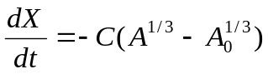 (39)
Where
A = the hydraulic attack,
A₀ = the attack threshold below which no advance occurs,
with the headcut advance rate (dX/dt) and the advance rate coefficient (C) as defined for Equation 29. It may be noted, however, that Equation 39 includes an attack threshold term not included in Equation 29 and that in application, the relations governing determination of the advance rate coefficient (C) also differ.
For application of Equation 39, hydraulic attack parameter is defined as:
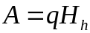 (40)
Where the variables are as previously defined with the unit discharge (q) and headcut height (H_{h}) referring to conditions in the spillway.
The advance rate threshold, A₀, and the advance rate coefficient, C, are material dependent with the properties of the material represented by a headcut erodibility index, K_{h}. Guidelines for determining this index are provided by USDA NRCS (2001). The relation of A₀ to the headcut erodibility index was developed empirically from available data and initially given by USDA NRCS (1997) in a form equivalent to:
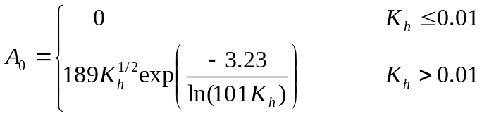 (41)
With A₀ expressed in ft³/s for consistency of applying Equations 39 and 40 with q in cfs/ft and H_{h} in ft. As implemented in the WinDAM/SSEA model, Equation 41 may be used or, at user discretion, replaced by the general relation:
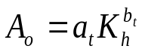 (42)
Where
a_{t} = a user determined coefficient expressed in ft³/s, and
b_{t} = a user determined exponent.
The advance rate coefficient, C, can be determined using the relation given by USDA NRCS (1997) as:
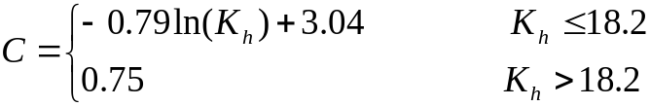 (43)
with C having the units of (ft/h)/(ft/s^{1/3}), or user specified in the form of either a log-log (power function) or the semi-log form of Equation 43. In semi-log form, the relation becomes:
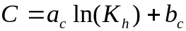 (44)
With C limited to being greater than or equal to c_{c}, and
a_{c} = a user specified coefficient,
b_{c} = a user specified intercept point, and
c_{c} = a user specified lower limit on C.
In log-log or power function form, the relation becomes,
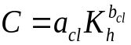 (45)
With C limited to being greater than or equal to c_{c}, and
a_{cl} = a user specified coefficient,
b_{cl} = a user- specified exponent, and
c_{c} = a user specified lower limit on C.
In application of these equations, C is expressed in English units for consistency with the other unit dependent relations.
The present (2015) state of the science is such that prediction of erosion rates in any form, including headcut advance rate and threshold, is less than exact. When appropriate information is available for use in estimating the user specified parameters, the increased flexibility represented by Equations 42, 44, and 45 may be used to refine prediction of earth spillway performance. These relations should, however, be applied with appropriate caution and judgment.
The addition of limited statistical analysis capability to the earth spillway erosion model also focuses on the variability of the geologic materials and the uncertainty in estimating geologic material properties. When utilizing this feature of the WinDAM/SSEA software, material parameters are entered in terms of a probability distribution rather than an explicit value. The erosion model is then applied multiple times to determine minimum, maximum, and mean values of erosion expected. The sampling for repeated model application may be by either Monte Carlo or Latin Hypercube procedures with the user controlling the number of samples and thereby the number of simulations. The output may be used to evaluate the sensitivity of the predicted performance to the material parameters. Neilsen et al. (2004) discuss the available distributions and statistical application.

SUMMARY
The WinDAM computer program is being developed for use in evaluating the performance of earth dams. The focus of the computational model described herein is evaluation of dams subjected to flooding that may result in overtopping of the embankment or flow through an existing pathway (conduit) through the embankment. The reservoir routing model incorporated into the software includes outflow from a principal spillway, up to three auxiliary spillways, over the embankment, and through the embankment. The model computations include discharge rating of vegetated spillways and dams and closed conduits of the type typically used by the NRCS on flood control reservoirs.
The expected performance of earth spillways may also be evaluated. The erosion model used for spillway erosion is extracted from the SITES software and does not include spillway breach computations.
The embankment overtopping breach computations as described herein are applicable to a homogeneous embankment with a simple cross section. Focus is on low levels of overtopping, but the model may be applied to a wide range of conditions. The model assumes erosion to begin on the downstream face of the embankment and includes evaluation of the effect of vegetation (grass) or riprap on the slope. Effects of concentrated attack due to other geometric features of the embankment are not evaluated in predicting erosion initiation. The breach failure mode represented in the model is headcut formation and advance as observed in large scale studies of the breach process for cohesive materials. Alternate headcut advance models may be used within the context of the overall breach model. The overall erosion process is seen to be complex with flow conditions changing as the breach progresses. As with other components of the WinDAM software, the breach computational model represents a simplified approach focusing on the dominant physical processes.
In addition to the overtopping breach computations, calculations may alternatively be performed to evaluate breach through internal erosion along an existing flow path through the embankment. Although overtopping may occur during evaluation of erosion associated with an internal flow path, overtopping erosion and internal erosion cannot be evaluated simultaneously. The current internal erosion model as described herein also assumes a homogeneous embankment of simple cross section and is most directly applicable to embankments constructed from cohesive soil materials. The initial flow path (conduit) through the embankment is assumed to be horizontal with a rectangular cross section having constant width and height over its entire length. The initial dimensions and location are specified by the user. The conduit is allowed to expand uniformly vertically and horizontally until a boundary is reached or the upper surface becomes unstable and collapses. In addition to expansion of the conduit due to hydraulic stress along the conduit boundary, a headcut is allowed to form at the outlet of the conduit and to progress upstream. As stated in the previous paragraph relative to overtopping, internal erosion calculations in this model represents a simplified approach focusing on the dominant physical processes.
This is considered a first effort at identifying the dominant processes and incorporating them in an integrated breach model for cohesive embankments. This model should be refined/modified as the overall process becomes better understood and more validation data become available.
The information needed for model application will depend on the specific situation and the computations to be performed. The discussion in this document describes the scope of the WinDAM C dam overtopping and internal erosion expansion models, the concepts applied, and the equations used in quantifying the various components of the models. Application of the models will require the user to also become familiar with the tools available for determining the required input variables, including those describing the natural materials governing spillway and embankment erosion. Cited reference materials contain additional discussion of these variables and guidance that may be used in estimating their value for specific conditions. Additional discussion related to determination of soil parameters for dam breach analysis is provided by Hanson et al. (2011). It is anticipated that the model will subsequently be expanded to allow evaluation a broader range of geometries and conditions including breach of zoned embankments. Additional research is needed to allow expansion and refinement of the model(s).

REFERENCES
Abt, S. R., and T. L. Johnson. 1991. Riprap design for overtopping flow. J. Hydr. Engr., ASCE 117(8):959-972.
Blaisdell, F. W., and C. A. Donnelly. 1958. Hydraulics of closed conduit spillways Part X. The hood inlet. University of Minnesota, St. Anthony Falls Hydraulic Laboratory, Technical Paper No. 20. Series B. 41p.
Chow, V. T. 1959. Open-channel hydraulics. McGraw Hill Book Company. New York. 680p.
Frizell, K. H., J. F. Ruff, and S. Mishra. 1998. Simplified design guidelines for riprap subjected to overtopping flow. Proceedings of the Annual Conference of the Assoc. of State Dam Safety Officials, Las Vegas, NV, pg 301-312. CD ROM.
Hanson, G. J., K. M. Robinson, and K. R. Cook. 2001. Prediction of headcut migration using a deterministic approach. Trans. ASAE, 44(3): 525-531.
Hanson, G. J. and K. R. Cook. 2004. Apparatus, test procedures, and analytical methods to measure soil erodibility in-situ. Applied Engineering in Agriculture, 20(4):455-462.
Hanson, G. J., D. M. Temple, M. Morris, M. Hassan, and K. Cook. 2005. Simplified breach analysis model for homogeneous embankments: Part II, Parameter inputs and variable scale model comparisons. Technologies to Enhance Dam Safety and the Environment. Proc. USSD Conf. pp 163-174.
Hanson, G. J., and S. L. Hunt. 2007. Lessons learned using laboratory JET method to measure soil erodibility of compacted soils. ASABE, Applied Engineering in Agriculture, 23(3):305-312.
Hanson, G. J., D. M. Temple, S. L. Hunt, and R. D. Tejral. 2011. Development and characterization of soil material parameters for embankment breach. ASABE, Applied Engineering in Agriculture. 27(4):587-595.
Hunt, S. L., G. J. Hanson, and D. M. Temple. 2005. Earthen embankment breach research: physical and simplified numerical modeling of breach widening. Proceedings of the Association of State Dam Safety Officials Annual Conference. 2005. (CD-ROM)
Lane, E. W. 1955. Design of stable channels. Trans. ASCE. 120: 1234-1260.
Mishra, S. K., and J. F. Ruff. 1998. Riprap design for overtopped embankments. Report prepared for the US Bureau of Reclamation.
Neilsen, M. L., D. M. Temple, and J. L. Wibowo. 2004. A distributed hydrologic simulation environment with Latin hypercube sampling. Proc. IASTED International Conference. Environmental Modeling and Simulation. Pp117-122.
Perlea, V. G., D. L, Mathews, and F. C. Walberg. 1997. Rock erosion of unlined spillway chute. 19th Congress on Large Dams, Florence, Italy.
Rice, C. E. 1967. Effect of pipe boundary on hood inlet performance. J. Hydraulics Div. ASCE. 92(4):146-167.
Robinson, K. M. 1992. Predicting Stress and Pressure at an Overfall. Trans. ASAE. 35(2): 561-569.
Robinson, K. M., C. E. Rice, and K. C. Kadavy. 1998. Design of Rock Chutes. Trans. ASAE 41(3):621-626.
Temple, D. M., K. M. Robinson, R. M. Ahring, and A. G. Davis. 1987. Stability design of grass-lined open channels. USDA Agriculture Handbook # 667. 167p.
Temple, D. M., J. L. Wibowo, and M. L. Neilsen. 2003. Erosion of earth spillways. Proc. United States Society on Dams. Reducing Risk from Extreme Events. pp331-339.
Temple, D. M., G. J. Hanson, M. L. Neilsen, and K. R. Cook. 2005. Simplified breach analysis model for homogeneous embankments: Part 1, background and model components. Technologies to enhance dam safety and the Environment, Proc. USSD Conf. pp151-161.
Temple, D. M., G. J. Hanson, and M. L. Neilsen. 2006. WINDAM – Analysis of overtopped earth embankment dams. Paper number 062101, 2006 ASABE Annual Meeting. 11p.
[USACE] United States Army Corps of Engineers. 2005. Hydrologic Modeling System HEC-HMS User’s manual. CPD-74A. USACE Hydrologic Engineering Center, Davis, CA.
[USDA SCS] United States Department of Agriculture, Soil Conservation Service. 1956. Hood inlets for culvert spillways. Technical Release No. 3. Design Section. June 27, 1956.
[USDA NRCS] United States Department of Agriculture, Natural Resources Conservation Service. 1997. Earth spillway erosion model. Chapter 51, Part 628, Dams, National Engineering Handbook. 210-VI-NEH
[USDA NRCS] United States Department of Agriculture, Natural Resources Conservation Service. 2001. Field procedures guide for the headcut erodibility index. Chapter 52, Part 628, Dams, National Engineering Handbook. 210-VI-NEH. Issued August 1997. Revised March 2001.
[USDA NRCS] United States Department of Agriculture, Natural Resources Conservation Service. 2015. WinTR-20 Version 3.10 User guide.
[USDA NRCS] United States Department of Agriculture, Natural Resources Conservation Service. 2007. SITES 2005 water resource site analysis computer program user guide. 210-728.5, SITES 2005.
[USSD] United States Society on Dams. 2006. Erosion of unlined spillways. Prepared by the USSD committee on Hydraulics of Dams. June 2006. 183p.

Wibowo, J. L., D. E. Yule, E. Villanueva, and D. M. Temple. 2005. Earth and rock spillway erosion risk assessment. Alaska Rocks 2005. The 40th U.S. Symposium on Rock Mechanics.

NOTATION
A = the hydraulic attack on a headcut,
A₀ = the attack threshold below which no headcut advance occurs
A_{p} = the cross sectional area of the conduit or an orifice in a conduit
C = a coefficient as locally defined: used with subscript i to represent the effective weir
coefficient at computational node i along the top of dam: also used to represent
context specific headcut advance rate coefficients for embankment breach and
spillway erosion computations.
C₂ = a coefficient used in hood inlet calculations
C_{e} = the weir coefficient for a hood inlet
C_{F} = the vegetal cover factor
C_{I} = the retardance curve index
C_{n} = a correction factor associated with the assumption of an incompletely vented nappe at the headcut overfall
C_{o} = discharge coefficient for an inlet orifice
C_{ow} = the weir coefficient for an inlet orifice
C_{po} = the orifice coefficient for the conduit entrance
C_{s} = the weir slug flow coefficient for a hood inlet
C_{u} = the coefficient of uniformity for riprap
C_{w} = the weir coefficient for an inlet weir
C₂ = a coefficient used in hood inlet calculations
D = the conduit diameter
D₅₀ = diameter for which 50% by weight of the material is finer
D₆₀ = diameter for which 60% by weight of the material is finer
D₁₀ = diameter for which 10% by weight of the material is finer
D_{r} = the representative particle diameter for a soil material
E_{v} = the horizontal length of undercutting erosion at the base of the headcut
H = head or height as locally defined: used with subscript i
to represent head at node i along top of dam: also used to designate headcut
height as noted for H_{h}
H_{b} = the head in the breach area
H_{h} = the height of the headcut
H_{in} = the head relative to inlet invert for a hood inlet
H_{o} = the head on the inlet orifice (when functioning as orifice)
H_{ow} = the head on an inlet orifice (when functioning as a weir)
H_{p} = the total head on the principal spillway
H_{po} = the head on the conduit with the entrance treated as an orifice
H_{w} = the driving head on the inlet weir
I_{w} = the plasticity index of a soil material
K_{b} = the pipe bend loss coefficient
K_{e} = the entrance loss coefficient for full conduit flow through the principal spillway
K_{h} = the headcut erodibility index
K_{p} = the frictional energy loss coefficient for the principal spillway conduit
L = distance (length) as locally defined: used with subscript i to represent distance
along top of dam such that (L_{i+1}-L_{i}) represents the distance between nodes
L_{p} = the length of the principal spillway conduit
L_{w} = the length of the inlet weir
Q = the total discharge as locally defined: used with subscript i
to represent discharge between nodes i and i+1 along top of dam

Qin = total inflow into the reservoir (a j subscript would indicate jth time node)
Q_{o} = discharge through inlet orifice
Qout = total outflow from the reservoir (a j subscript would indicate jth time node)
Q_{p} = the discharge associated with full conduit flow through the principal spillway
Q_{po} = the principal spillway discharge treating the conduit entrance as an orifice
Q_{w} = the discharge over an inlet weir
Q_{ow} = the discharge associated with weir flow through an inlet orifice
R = the hydraulic radius as locally defined
S = the surface or energy slope associated with flow as locally defined
S_{c} = the conduit slope at the inlet of a hood inlet
S_{t} = the embankment slope expressed as the tangent of the angle with the horizontal
S_{ws} = the slope of the headcut overfall jet upon entry into the tailwater
Vol = storage volume in the reservoir ((Vol_{j+1}-Vol_{j}) represents volume change over the
time step (t_{j+1}-t_{j}))
W_{o} = the width of inlet orifice
X = headcut position: dX/dt is the headcut advance rate
X_{p} = the approximate relative location maximum stagnation pressure of the overfall jet at the headcut base
X_{ws} = the relative horizontal position of the entry of the jet into the headcut tailwater
Y = difference between the tailwater elevation and the elevation of inlet orifice crest
a = a locally defined coefficient
a_{c} = a user specified coefficient
a_{cl} = a user specified coefficient
a_{p} = the wetted area of the conduit
a_{t} = a user specified coefficient
b_{t} = a user specified exponent
b = a locally defined coefficient
b_{c} = a user specified intercept point
b_{cl} = a user specified exponent
c = a locally defined coefficient
c_{c} = a user specified lower limit on the spillway headcut advance rate coefficient
c_{u} = the undrained shear strength of the embankment soil
d_{bh} = the computed depth for flow away from the headcut in the absence of external tailwater
d_{bw} = the downstream depth of tailwater relative to the base of the headcut
d_{c} = the critical flow depth
d_{n} = the normal depth on the slope
f = the Darcy-Weisbach friction coefficient for the conduit
g = gravitational constant
h_{o} = the height of inlet orifice
h_{rr} = the riprap thickness
k_{d} = the detachment rate coefficient
n = Manning’s roughness coefficient as locally defined
n_{p} = the porosity of the riprap
n_{s} =the soil grain roughness expressed as a Manning’s coefficient
q = unit discharge (discharge per unit width) as locally defined: used with subscript i
to represent unit discharge at node i along top of dam
q_{a} = the allowable unit discharge on the embankment slope
q_{b} = the unit discharge in the breach area
t = time: (t_{j+1}-t_{j}) represents a computational time step with the j subscript indicating a
computational node
t_{f} = time corresponding to failure of a vegetal cover
α = the deflection angle of the bend in the conduit in radians
α_{s} =the angle of the embankment slope with the horizontal
φ = the angle of repose of the riprap
γ = the unit weight of the water
γ_{s} = the total unit weight of the soil mass
ε_{r} = the soil detachment rate in volume per unit area per unit time
τ₀ = the gross hydraulic stress
τ_{c} = critical stress for the material
τ_{e} = the erosionally effective stress
τ_{ht} = the computed downcutting stress for high tailwater on the overfall
τ_{lt} = the computed downcutting stress for low tailwater on the overfall
τ_{hf} = the stress on the headcut face driving the undercutting erosion

APPENDIX A

Breach Model Assumptions
The embankment breach model incorporated into the WinDAM C software represents an initial effort to capture the dominant processes observed in overtopping and internal erosion breach of cohesive embankments in a predictive model. The overall breach process is complex and only imperfectly understood. Therefore, this model contains a number of simplifications and approximations. Validation data that may be used to verify the validity of these assumptions are extremely limited. It is, therefore, important for users to understand the nature of these approximations so that they may make informed judgments about the applicability of the model predictions to specific conditions. It is also important for researchers to recognize these so that model components may be refined and replaced as more data are identified and the processes become better understood. The purpose of this appendix is to clarify the nature of key simplifications and approximations and the basis for them. In development of the model, the attempt has been made to provide the best estimates of breach time and outflow, but to the extent that errors may be introduced through the simplifications, to avoid underprediction of time to breach or magnitude of breach outflow.

Embankment and Valley Cross Section
In its present form, the model addresses only a simple embankment cross section with homogeneous materials and a simple rectangular valley cross section. Boundaries of the rectangular valley cross section are assumed inerodible. Actual cross sections are generally more complex. Investigation of the impact of zones in the embankment, berms and other embankment cross section features, and the interaction of the flow with changing materials at the abutment is needed in order to better represent these features in predictive models. Because this model represents a first effort at quantifying the cohesive embankment breach process, only the simplified cross sections are addressed. Assuming the valley cross section to be rectangular means that the full height of the embankment may be eroded irrespective of where along the length of the embankment that the erosion is initiated. Widening of the breach into the abutment is restricted, however, making the location of erosion initiation a factor in computations.
The assumption of simple cross sections is consistent with the fact that points of concentrated hydraulic attack that may be created by the form of the valley cross section or the presence of berms are not considered in computations. The embankment toe is likewise considered to be submerged or otherwise protected. Additional study is needed to develop failure models that correctly reflect the flow behavior for these concentrated attack areas. Development of economical means of protecting these areas should be a part of that research.

Erosion Initiation Location
Erosion from embankment overtopping is assumed to be initiated at the downstream edge of the embankment crest due to flow down the embankment face. Erosion and failure of any surface protection would be expected to begin at a weak area somewhere on the slope. The description of conditions on the slope is seldom adequate to identify the specific location. The downstream edge of the crest is the location which allows the greatest initial deepening of the forming headcut and the least distance for the headcut to advance to initiate breach of the embankment. The point along the length of the embankment is taken to be the low point the furthest from an abutment. This is that point that allows maximum widening of the breach area prior to encountering an abutment.
The stress driving erosion initiation on the slope is taken to be that associated with normal depth flow conditions. The distance down the slope that would be required for the flow to accelerate to normal depth conditions is not computed and this maximum stress is assumed applied at the downstream edge of the crest as noted above. This is considered a conservative approximation consistent with the overall detail in the model.
The crest of the embankment is considered resistant to erosion such that direct downward erosion due to flow over the crest is not considered. Once the headcut has advanced into the reservoir, the potential for downward erosion of the crest of the headcut itself is considered.
The assumptions are considered consistent with information available from observed dam overtopping and laboratory tests. The work of Hanson et al. (2005) on overtopping erosion and breach formation of cohesive embankments yielded results consistent with these assumptions.
For internal erosion computations, the location of the initial flow path is user specified. The elevation of the initial flow path within the embankment may have significant impact on the headcut formation and advance predicted by the model. The proximity of the initial flow path to a boundary of the simplified valley cross section may impact expansion of the “conduit” as described in discussion of the computational model. As with other model components, validation is difficult and should be considered incomplete.

Grass Protection Failure
The basis for evaluating grass protection on the embankment slope is taken to be that originally developed for vegetated earth spillways utilizing field data from these spillways. Tests of grass-lined slopes in the outdoor laboratory (Temple and Hanson, 1998) suggested that high quality vegetal covers could withstand a higher level of attack than that implied by the spillway criteria (USDA 1997). However, data were considered insufficient to determine whether this increase was related to differences in flow conditions on the steep slopes or simply the result of the relative quality of the cover in the laboratory tests with the latter appearing the more likely. The spillway criteria represented the only available data for field conditions of the grasses and appeared consistent with the overall behavior observed. Therefore, these criteria were adopted for application in the model. It is noted that the limitation on maximum gross stress is primarily a limitation on available data (Temple and Hanson, 1994).
The characteristics of vegetal (grass) cover vary with climate, season, maintenance practices, soil conditions, and other factors. Quality of the cover may vary substantially with location on the embankment slope. The current model is capable of only crudely representing these properties. Refinement in this area should include refinement in the description of the cover and its spatial variability. Refinement could include improved prediction of size of the initial failure area as well as time and location of failure.

Breach Area Width
Conceptually, the overtopping breach model tracks the development of a single headcut from the initiation of erosion through breach of the embankment. For the case of no surface protection, the initial width and depth of the eroding area that may develop into headcut and breach is zero. As erosion develops on the slope, it is assumed to take the form of an approximately rectangular channel. The work of Lane (1955) on stress distribution in open channels suggests that the maximum stress on the banks of a rectangular channel should be on the order of three-fourths that which would exist on the bed of an infinitely wide channel with the same unit discharge. In development of the breach model, this was simplified to the form of the rate of widening being proportional to the computed rate of deepening for the material when conditions are such that the erosion is controlled by frictional stress. The constant of proportionality was taken to be 1.4 (0.7 assigned to each side) in recognition that it is the excess stress above critical that drives the erosion and the fact that the “banks” may deform somewhat during the erosion process. The work of Hunt et al. (2005) on breach widening after formation yielded results consistent with this assumption.
When the erosion is initiated by failure of vegetal or riprap protection, the initial width at failure is taken to be 1.4 times the depth associated with the surface protection failure for consistency with the unprotected erosion development. For vegetation, the initial depth is taken to be 0.5 ft from the spillway failure model (USDA, 1997), and for riprap, the depth is taken to be the depth of the riprap with a minimum of 0.5 ft. Removal to these depths and widths are computed to occur over the first time step in which the surface protection is predicted to fail.
When the flow is determined to be advancing the headcut through the embankment due to the plunging action of flow over the headcut, the model assumes a widening rate proportional to the headcut advance rate in recognition that the same processes are expected to govern both advance and width in the vicinity of the headcut. The constant of proportionality is taken to be 1.0 from observation of embankment breach tests reported by Hanson et al. (2003).
As noted by Temple et al. (2010), the concept of a single headcut forming on the slope and progressing through the embankment is itself a simplification of the processes observed. The actual size of the initial erosion area on the slope is likely to be variable based on a number of things including the formation discharge, the nature and uniformity of any protection, and the properties of the embankment material. However, observation suggests that as the headcut forms and progresses through the embankment crest, it widens and advances in a fashion consistent with the stated model assumptions. Additional study in this area is suggested. However, significant advances in this area may require improved description of the variation in materials and surface conditions.
The internal erosion path expansion model begins with a user specified width and height. The application of Manning’s equation implies that these initial conduit dimensions are sufficiently large to result in turbulent flow conditions. The computational model assumes the increase in width is governed by the average stress on the flow path (conduit) boundary. Although a headcut is allowed to form at the conduit outlet, the governing width of the breach is assumed to be controlled by flow conditions upstream of the headcut location except for conditions where the headcut is in the upstream face of the dam. The use of spatially averaged stress and uniform expansion of the flow path represents an approximation when free surface flow exists within the breach area.

Headcut Submergence
The breach model differentiates between conditions where the crest of the headcut is submerged by flow away from the headcut and conditions where a plunging action occurs due to flow over the headcut. The depth of water above the base of the headcut is therefore an important parameter in computations.
For conditions expected to develop during headcut formation and the relatively low head conditions observed in laboratory tests (Hanson and Temple, 2002), the expected mode of development would be a stepped condition where a plunge pool would develop at the base of the headcut and flow away from the base would be near critical unless submerged by external tailwater. Therefore, during headcut formation and for conditions where the headcut height is greater than 90% of the critical depth, the minimum depth at the headcut base associated with flow away from the the headcut is taken to be critical depth for the unit discharge through the breach area.
The research model SIMBA (Hanson et al. 2005; Temple et al. 2005) used the assumption of critical depth at the base of the headcut throughout. However, examination of the flow conditions implied for breach of some higher dams suggested the possibility that as the scale of the flow increased relative to the scale of erosion during breach, the velocity might exit the plunge pool area at supercritical flow depths. Therefore, the current model utilizes assumptions that reduce the possibility of headcut submergence by flow away from the headcut with the water surface above external tailwater. When critical depth associated with unit discharge through the breach area is greater than 90% of headcut height, the depth associated with flow away from the headcut in the absence of external tailwater is taken to be the greater of 90% of the headcut height or the flow depth associated with no energy loss for flow over the headcut. Therefore, once the headcut is formed, it becomes submerged only by external tailwater or by flow conditions associated with available energy. This set of assumptions will generally increase the predicted breach outflow over that predicted by the preliminary model. There is a strong need for validation data for the conditions where these assumptions impact results (primarily high dams with rapid headcut advance). Field observation and data from physical models are difficult to obtain. As previously noted, sufficiently detailed validation data from failure events are extremely limited. Future model refinements should be expected.

Unstable Headcut Conditions
Another condition associated with high dams that is difficult to physically model and for which there is very little information available is the potential for developing headcut heights that would be unstable in the absence of flow. When an unstable condition develops, it is likely that the erosion progresses in a complex interaction of mass failure with erosion. Neither of the headcut advance models incorporated into WinDAM C addresses this type of erosion in physical detail.
The Hanson/Robinson stress based model is directly applicable to conditions where a vertical headcut is made unstable by erosion of the base resulting in instability and mass failure. When the headcut height is sufficient to result in instability without erosion, the primary model does not directly predict an advance rate. The headcut advance model is extended in a fashion consistent with the primary model by assuming the unstable headcut reverts to a 0.5H:1V slope and the erosion due to flow down that slope governs the headcut advance rate. For purposes of computing the stress due to flow on the slope, a smooth slope (Manning n equal 0.02) and stress based on normal depth is assumed. In recognition of the fact that this is a significant simplification of complex flow conditions that may require less specific energy to develop the stress than that associated with normal depth on a smooth slope, no check of available total energy is made in the computations. It is believed by the developers that this approach results in predicted stresses that are of the proper order of magnitude and produces the correct response to material properties. However, it is also recognized that this is a relatively crude approximation that should be carefully examined through additional research and field data analysis.
The Temple/Hanson stress model does not directly address the condition of an unstable headcut. This model is semi-empirical and dependent on quality calibration data. It should be applied to conditions where unstable headcuts may develop only with appropriate caution, and preferably with calibration from experience with similar conditions.

Upper Surface Collapse (Internal Erosion Conduit)
The criterion for determining when the upper surface of the internal erosion conduit will collapse is relatively crude and based on limited observation. Additional study and refinement is needed. The upper surface of the conduit is considered able to resist collapse so long as it is flowing full over a portion of its length and the upper surface of the conduit is below the top of dam. When the flow is detached from the top of the conduit (free surface flow within the conduit), the upper surface of the conduit is considered to collapse when the width becomes greater than or equal to twice the elevation difference between the upper surface of the conduit and the top of the embankment
It may be noted that when applying the model to a constant inflow condition where the reservoir surface is dropping or constant, the actual time of the upper surface collapse is not significant so long as it occurs after flow has detached from the upper surface of the conduit. This is because free surface flow will exist for the remainder of the computations without regard as to whether the upper surface remains in place or collapses. If collapse occurs, removal of the material is assumed to be immediate and to not influence the erosion compuations.

Time Step Management and Adjustment
WinDAM was initially developed using a simple constant time step approach. The user controlled the time step through the time increment of the inflow hydrograph which was also expected to be in constant time increment format. The time increment associated with the inflow hydrograph was used in all computations. In the case of no inflow hydrograph, the user was required to enter a time increment to be used. This approach is retained in WinDAM C with the modifications described below.
The erosion process being simulated in both overtopping and internal erosion breach computations is a threshold-rate process. That is, there may be no erosion, a low rate of erosion, or little impact of erosion on attack level until a threshold of attack or geometry is reached. Once that threshold has been reached, the rate of change in discharge and breach geometry may begin to occur much more rapidly. For example, advance of a headcut through the crest of an embankment during breach formation due to overtopping may progress much more slowly and have less impact on computed discharge than headcut advance into the upstream face of the embankment during the breach development stage of the process. Since the computational model assumes constant erosion rates (including headcut advance) over any given time step, sensitivity of the results to time step would be expected to be greater through this portion of the computations. To address this issue (and only this issue) related to time step sensitivity, an adaptive time step is introduced in WinDAM C. This is done in a fashion consistent with the concept of the user retaining control of the overall (base) time step.
The parameter used in WinDAM C to determine whether local reduction in time step is appropriate is the relative change in breach area unit discharge over the time step if there were no change in reservoir water surface. This parameter, which may be replaced in future implementations, is selected as a measure of the expected impact of geometry changes on breach area discharge over the time step. This parameter is obtained by computing the erosion over the time step being used to obtain a new breach area geometry, and using that geometry to compute a new unit discharge assuming no change in reservoir water surface. If the unit discharge computed in this fashion indicates an increase of more than ten percent and less than fifty percent (based on average) then the time increment is divided by two. If the increase is greater than fifty percent, the original time increment is divided by four. This reduction is applied only to the current time step and no check is made on the reduced time step to determine if further reduction would be appropriate under the indicated criterion. Subsequent full time steps may be similarly reduced. The values of one-half and one-fourth are arbitrary, but are considered consistent with the concept of the user retaining control over the overall time step.
In addition to run time adjustment of the time step described above, the user is provided the option of letting the software adjust the base time step size (time step used for all computations except when adjusted for breach computations as described above). When this option is selected the user must specify the closure criterion desired. The criterion available is a percent change in computed peak outflow or an absolute change in computed reservoir water surface elevation. The change refers to the difference in computed value when the base time increment is divided by two and the entire simulation repeated. The smallest base time increment used in the computations is that for which output is reported.

Summary
The WinDAM C breach model is a first attempt to quantify the dominant erosion processes associated with cohesive embankment failure in a single breach prediction model. Although the overall breach erosion process is complex and only imperfectly understood, the current model appears to reproduce the observed behavior and available data with reasonable consistency. The preceding discussion of the simplifications and approximations is provided to assist users in interpreting output and to assist those who would refine or replace the model(s) in identifying weak areas and research needs. Not all of the simplifications and approximations are discussed directly in this appendix. Despite the extent of approximation required, it is believed by the developers of the model that the results represent the current state of the science in this area and that the model, properly applied, may be used to obtain quality estimates of embankment performance including timing and magnitude of breach outflows. Judgment is required in determining whether the model should be applied to specific conditions and in interpreting output.

REFERENCES
Hanson, G. J., and D. M. Temple. 2002. Performance of bare-earth and vegetated steep channels under long-duration flows. Trans. ASAE 45(3):695-701.
Hanson, K.R. Cook, and S. L. Hunt. 2005. Physical modeling of overtopping erosion and breach formation of cohesive embankments. Transactions of the ASAE 48(5):1783-1794.
Hanson, G. J., K. R. Cook, W. Hahn, and S. L. Britton. 2003. Evaluating erosion widening and headcut migration rates for embankment overtopping tests. ASAE Paper No. 032067.
Hanson, G. J., D. M. Temple, M. Morris, M. Hassan, and K. Cook. 2005. Simplified breach analysis model for homogeneous embankments: Part 2, Parameter inputs and variable scale model comparisons. In: Technologies to Enhance Dam Safety and the Environment. USSD annual conference. pp163-174.
Hunt, S. L., Hanson, G. J., and Temple, D. M. 2005. Earthen embankment breach research: physical and simplified numerical modeling of breach widening. In Proceedings of the Association of State Dam Safety Officials Annual Conference. 2005. CD-ROM. 12p.
Lane, E. W. 1955. Design of stable channels. Trans. ASCE. 120:1234-1260.
Temple, D. M., and G. J. Hanson. 1994. Headcut development in vegetated earth spillways. Applied Engineering in Agriculture. 10(5):677-682.
Temple, D. M., and G. J. Hanson. 1998. Overtopping of grassed embankments. Proc. of Dam Safety 1998. Association of State Dam Safety Officials. CD-ROM. 9p.
Temple, D. M., G. J. Hanson, M. L. Neilsen, and K. R. Cook. 2005. Simplified breach analysis model for homogeneous embankments: Part 1, Background and model components. Technologies to Enhance Dam Safety and the Environment. USSD annual conference. pp151-161.
Temple, D. M., G. J. Hanson, and S. L. Hunt. 2010. Observations on dam overtopping breach processes and prediction. The Journal of Dam Safety. 8(2):28-33.
United States Department of Agriculture, Natural Resources Conservation Service. 1997. Earth spillway erosion model. Chapter 51, Part 628, Dams, National Engineering Handbook. 210-VI-NEH.

This same approach is used in computing the stress associated with erosion on the embankment slope following failure of any surface protection.

