**A SARACENIC MATCH SAFE**

By Neil Shapiro

Shortly after the American Civil War, at the 1867 Paris Exposition, Edward C. Moore, [1827–1891] chief designer for the Tiffany Co., won an award for his “Moresque*” tea set.

The 1867 Paris exposition theme was Orientalism and Moore had an interest in images and ornamentation from Japan and the Middle East. His interest and the dissemination of non-Western art images altered Western design in both the fine and applied arts from that time on.

Moore continued to explore non-Western art until he led Tiffany’s production of Saracenic** wares in 1889.

Moore influence on silver design was shared by other manufacturers and designers of silver products, such as Gorham, Woods & Chatelier, Dominic & Haff, George W. Shiebler, and others.

One result of that exploration of non-Western art in silver design is an unusual match safe with no maker’s mark, but made with Middle Eastern ornamentation. 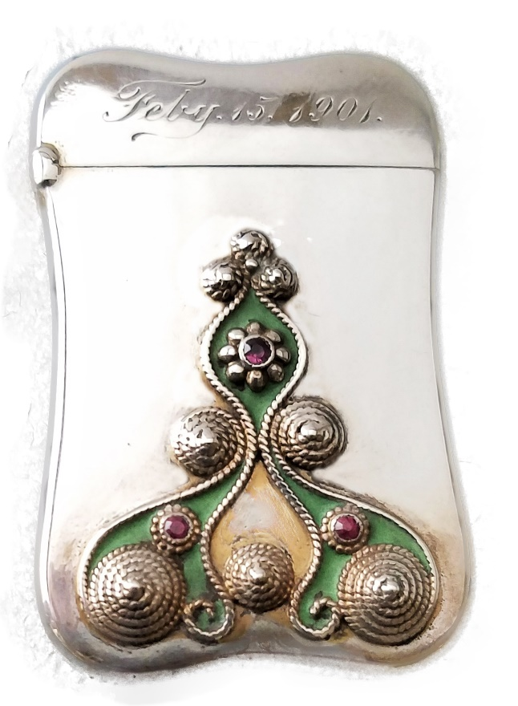 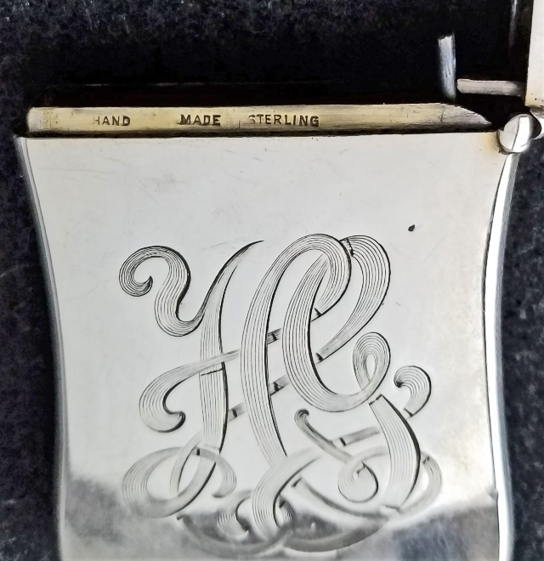

While the safe has no specific maker it does bear the words “hand made” and “sterling” on the bezel. It is 2 ½” x 1 ½” x 3/8” and the form of the safe’s body is exactly like the Gorham match safe form for production # B225.

Gorham often made safes in the style of other safes that it had already produced. These new safes had the same basic configuration but used different materials, motifs or designs.

Gorham frequently used the prefix “B” followed by a number in their production records to designate a form for the body of a match safe. The B225 form has four curved sides with indented edges. The Moresque/Sarascenic safe discussed in this essay has the same shape and dimensions of the Gorham B225.

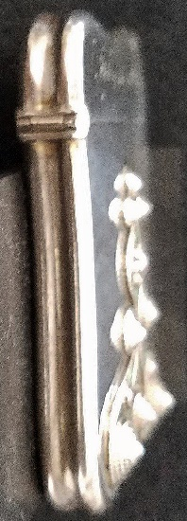 Indented edge Silver Smalls:Match Safes, A GORHAM SILVER MATCH SAFE . Gorham Manufacturing Co., Providence,
Rhode Island, circa 1880. Marks: (lion-anchor-G), STERL... Signed/hallmarked Gorham B225

The applied design on this safe has interlacing, intricate scrollwork found throughout the applied arts of the Islamic world. This early Moresque style was used only for surface decoration. Additionally, matte green enamel fills three interior areas with small rondels capped with red stones.

The coiled silver wire significantly rises above the surface of the safe. On the lid is an engraved date “Febry.15.1901.” The backside of the safe has an elaborate monogram.

Whether this safe was made by Gorham or made for Gorham is speculative. Gorham was quite careful to mark most of their products as they regularly advertised that their products were superior and all the consumer had to do was see the Gorham mark and know that they were buying a fine product.

There are a small number of match safes that have no maker’s mark but are marked “hand made.” To date, we have not established if that was a special order for a particular customer or an unknown maker’s mark. But this writer and a colleague have been able to handle several of these “hand made” safes and each one is of excellent quality.

Below are three more examples of “hand made” match safes. The center example with the surface application of golfing clubs, ball, and hole marker has the name *Gorham Mfg. Co.* marked on the bezel but it does not have the Gorham hallmark.

The other two safes do not have the Gorham name on the bezel. The shapes of the “hand made” safes match several of the Gorham “B” series.

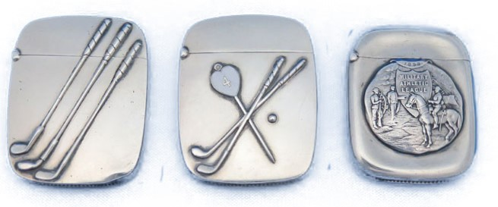 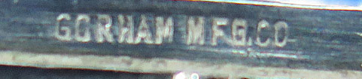

After discussing this with a knowledgeable colleague we think Gorham made the body of the safes from their own dies and sold the blank lids and bodies to another manufacturer or jeweler. The buyer then did the application of the ornamentation and the finish work on the striker, hinge and thumb lift since after careful scrutiny they differ in quality, craftsmanship, and kind from the Gorham safes. If this is so it follows a long established practice of a wholesale jeweler/silversmith making basic materials for other companies to finish and sell at retail.

____________________________________

* A term used to mean Persian design

**Saracens were primarily Arab Muslims, but also Turks or other who were Muslims as referred to by Christian writers in Europe during the Middle Ages. The term's meaning evolved during its history. The words *Muslim* and *Islam* were generally not used.

The colleague mentioned in this essay is George Sparacio and the three other “hand made” safes are from his personal collection.