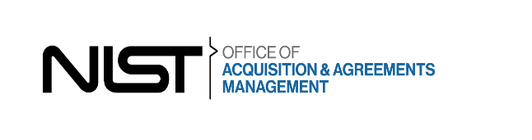

**NOTICE OF INTENT TO SOLE SOURCE**

The Acquisition Management Division (AMD) at the National Institute of Standards and Technology Physical Measurements Lab, Quantum Measurements Division (NIST PML) intends to procure repair services and a software upgrade for a quantity of one (1) Olympus LEXT OLS4100 microscope using Simplified Acquisition Procedures for Commercial Items (FAR Parts 12 and 13).

The NIST Quantum Measurements Division requires a service for a recently failed LEXT OLS4100 microscope which is an indispensable tool to select qualified epitaxial graphene material for fabrication of quantum Hall resistance standard. The Quantum Measurements group synthesizes graphene on a transparent silicon carbide substrate and uses the unique power of LEXT OLS4100 for fast and reliable characterization of large, homogeneous epitaxial graphene. An expedite repair of our LEXT OLS4100 microscope will allow us to reassume the interrupted research on developing graphene quantum Hall devices.

Market research findings demonstrated only Evident Scientific has the capability to meet all of the following requirements:

1. Provide OEM replacement parts.
2. Has the proprietary knowledge required to calibrate the microscope.
3. Has the proprietary knowledge of the laser and the LEXT OLS4100.
4. Provide the required upgraded software.

Evident Scientific does not have authorized 3rd party service providers.

The North American Industry Classification code for this acquisition is 334516, Analytical Laboratory Instrument Manufacturing, with a small business size standard of 750 employees.

A determination by the Government not to compete the proposed acquisition based upon responses to this notice is solely within the discretion of the Government. Information received will be considered solely for the purpose of determining whether to conduct a competitive procurement.

No solicitation package will be issued. This notice of intent is not a request for quotations; however, all responsible sources interested may identify their interest and capability to respond to this requirement. Interested parties that believe they can satisfy the requirements listed above must identify their capability in writing before the response date of this notice. Only responses received by 5:00 p.m. Eastern Standard Time on March 13, 2025, will be considered by the government. Responses shall be submitted via email to [ranae.armstrong@nist.gov](mailto:ranae.armstrong@nist.gov) with a cc to [Donald.collie@nist.gov](mailto:Donald.collie@nist.gov).

Contracting Office Address:

100 Bureau Drive

Bldg. 301, Mail Stop 1640

Gaithersburg, Maryland 20899-0001