Task Order

Scope / Statement of Work (SOW)

Contract: ________________



Table of Contents

1.0 Project Description / Summary
2.0 Objectives
3.0 Background
4.0 Specific Work / Tasks
5.0 Optional Work / Tasks
6.0 Government Furnished Equipment / Materials / Other
7.0 Special Conditions / Requirements
8.0 Place of Performance
9.0 Performance Period / Schedule Requirements

Scope / Statement of Work
Task Order /  Project Title: | Automate Gate at Gran Quivira Unit with Optional Automation of Gate at Quarai Unit
Park /  Park Unit: | SAP
Task Order#:
Prepared By: | Charles Vickrey
Date: | 30 April 2026

- Project Description / Summary:
The primary work of this project includes, but is not limited to, addition of motorized operators to the entrance gates and relocation and motorization of the Quarai gate (Optional). General tasks will include the following: modification of existing gates, installation of new gate motors, hardware, sensors, rolling assembly (if needed), solar panels, batteries, conduit, wiring, wireless transmitters, reflectors, signage, road markings (stop bar-swing indicator), warranty, operational training, and all necessary appurtenances for a turn-key gate system.
- Objectives:
This project is intended to provide reduced travel time for staff to open gates at Salinas Pueblo Missions National Monument many entrances. This project will add new powered gates which will increase security and safety for public and staff entering and leaving the grounds.

- Background:
The Salinas Pueblo Mission National Monument consists of three units and a headquarters/visitor center operation. The three units spread out from the HQ/VC in three different directions. GQ being the furthest from the HQ at approximately 25 miles. Abo is second furthest at over 11 miles from the HQ with Quarai the closest at over 7 miles. Having these gates operate on timer would reduce the number of hours spent driving to and from each area to unlock and lock gates each day.

- Specific Work / Tasks: Automate Solar Entrance gate at Gran Quivira
  - Setup roadside warning signage per approved highway permit.
  - Install concrete pads/posts for solar panels and battery compartments as well as gate operator mounting structures. Battery compartments shall be lockable, and solar components shall have tamper proof nuts/bolts.
  - Provide and install new automatic gate arm operators, conduit, wire, ground rods, and hardware on existing pipe gate arms.
  - Provide and install solar photovoltaic panels and batteries. Size system to provide a minimum of 50 cycles per day. Gate operators shall be programable so that the gates remains open during business hours.
  - Provide eight (8) programable wireless transmitters (two channel minimum).
  - Provide and install exist loop in pavement and seal pavement upon testing of loop readiness.
  - Grease fittings and ensure proper operation of the gate
  - Upon completion verify all systems are functioning as intended.
  - Provide and install a “Knox Box” model 3200. Box to be mounted on outside of gate or on gate posts in full view of the incoming traffic. Notify the local fire department for coordination of installation and key access.
  - Provide and install signage and painted stop bars on entrance and exist sides of the pavement that indicate the limit of the gate swing and exit loop.
  - Clean up area upon completion of construction portion of work.
  - Conduct training for park key-personnel. Video training and provide a copy of training on a flash-drive, operator’s manual, and any other documentation in a hard-bound folder.
  - Provide a two-year warranty on labor, parts, and materials in addition to any manufacture’s warranties.

- Optional Work / Tasks:
The reason for using options in construction projects is to obtain as much of the project scope as possible within the funds available. All optional work requirements must be within the scope of the primary proposal work requirements, and the PMIS statement. The work / tasks of the primary proposal must result in a complete and usable project without exercising of optional work requirements.
  - Option #1: New Quarai Entrance Swing Gate Location “A”
    - Grid tied electrical gate
    - Obtain permit for new underground power from existing power pole.
    - Setup roadside warning signage per approved highway permit.
    - Trench new underground line from power pole to new gate location.
    - Install concrete pads/posts for gate operator mounting structures.
    - Construct new pipe gate with new posts set in concrete.
    - Provide and install new gate operators, hardware, cable, grounding rods, wire and all items necessary to provide a turnkey entry gate system.
    - Provide six (6) programable wireless transmitters (two channel minimum).
    - Provide and install new magnetic loop on exit lane.
    - Provide and install a “Knox Box” model 3200. Box to be mounted on outside of gate or on gate posts in full view of the incoming traffic. Notify the local fire department for coordination of installation and key access.
    - Grease fittings and ensure proper operation of the gate
    - Upon completion verify all systems are functioning as intended.
    - Provide a two-year warranty on labor, parts, and materials in addition to any manufacture’s warranties.
  - Option #2: New Solar Powered Swing Gate at Quarai Location “B”
    - Install concrete pads/posts for solar panels and battery compartments as well as gate operator mounting structures. Battery compartments shall be lockable, and solar components shall have tamper proof nuts/bolts.
    - Provide and install new automatic gate arm operators, conduit, wire, ground rods, and hardware on existing pipe gate arms.
    - Provide and install solar photovoltaic panels and batteries. See Section 2.5. Gate operators shall be programable so that the gates remain open during business hours.
    - Setup roadside warning signage per approved highway permit.
    - Provide and swing gate and all necessary hardware for a complete turnkey system.Provide and install new magnetic loop on exit lane.
    - Provide six (6) programable wireless transmitters (two channel minimum).
    - Upon completion verify all systems are functioning as intended.
    - Provide and install a “Knox Box” model 3200. Box to be mounted on outside of gate or on gate posts in full view of the incoming traffic. Notify the local fire department for coordination of installation and key access.
    - Conduct training for park key-personnel. Video training and provide a copy of training on a flash-drive, operator’s manual, and any other documentation in a hard-bound folder.
    - Provide a two-year warranty on labor, parts, and materials in addition to any manufacture’s warranties.

- Government Furnished Equipment / Materials / Other:
  - Equipment:
    - N/A
  - Materials:
    - Existing swing gate
  - Other:
    - Basic design drawings with site plan of proposed gates
- Special Conditions / Requirements:
  - The work is adjacent to the highway right of way and therefore the contractor shall comply with state highway regulations regarding signage, safety procedures and permits.
  - Contractor shall provide all necessary documentation and approved state highway permits 30-days prior to start of construction on gate.
  - SECTION 323116 - WELDED WIRE FENCES AND GATES (Option #1 Site A Swing Gate)
- GENERAL
      - SUMMARY
        - Section Includes:
          - Metallic-coated-steel.
          - Swing gates.
          - Cantilever gates.
          - Gate operators, including controls.
      - PREINSTALLATION MEETINGS
        - Preinstallation Conference: Conduct conference at Project site.
      - ACTION SUBMITTALS
        - Product Data: For each type of product.
        - Shop Drawings: For fencing and gates.
          - Include plans, elevations, sections, and attachment details.
          - Include diagrams for power, signal, and control wiring.
        - Samples: For each fence material and for each color specified.
      - INFORMATIONAL SUBMITTALS
        - Field quality-control reports.
      - CLOSEOUT SUBMITTALS
        - Maintenance data.
      - QUALITY ASSURANCE
        - Installer Qualifications: Fabricator of products.
- PRODUCTS
      - PERFORMANCE REQUIREMENTS
        - Wind Loading: Comply with ASCE/SEI 7 requirements for fence height, wind exposure category, design wind speed, and design wind pressure.
        - Lightning-Protection System: Maximum grounding-resistance value of 25 ohms under normal dry conditions.
      - SWING GATES
        - Steel Frames and Bracing: Fabricate members from square tubes [1-1/2 by 1-1/2 inches (38 by 38 mm)] formed from 0.108-inch (2.74-mm) nominal-thickness, metallic-coated steel sheet or formed from 0.105-inch (2.66-mm) nominal-thickness steel sheet and powder-coating after fabrication.
        - Infill: Welded-wire fence fabric matching adjacent fence.
        - Hardware: Latches permitting operation from both sides of gate, hinges, and keepers for each gate leaf more than 5 feet (1.52 m) wide. Fabricate latches with integral eye openings for padlocking; padlock accessible from both sides of gate.
        - Metallic-Coated-Steel Finish: High-performance coating.
      - CANTILEVER GATES
        - Gate Frame:
            - The gate frame shall be constructed from 6061 aluminum alloy extrusions. The upper rail shall be a 52mm x 157mm weighing no less than 7.9 kg/m. The lower rail shall be a 51mm x 127mm aluminum structural extrusion weighing no less than 3kg/m.
        - Vertical Members:
            - The vertical members shall be 51mm x 51mm x 3.2mm structural aluminum extrusions weighing not less than 1.65kg /m.

            - All welding of gate frame to conform to CSA W55.3 (R2013
        - Gate Mounting:
            - The gate is to be supported from its track by two self-aligning, four wheeled bearing truck assemblies.
            - The lower rail shall be guided by a guide bracket on both posts. Each guide bracket will have a pair of 76mm phenolic guide wheels. Lower guide wheels to have protective covers as per UL325.
            - Gap protectors shall be provided and installed, compliant with ASTM F 2200. D. Diagonal Bracing: 1. Diagonal bracing of two 5mm galvanized steel cables installed in each bay throughout the entire gate frame.
        - The gate shall be completed by the installation of approved mesh as specified.
            - Chain Link: 2” x 2” x 9 gauge galvanized chain link mesh fabric to extend the entire length of the gate. Fabric attached at each end of the gate frame with standard fencing tension bars and tied at each vertical member with standard fencing ties. ASTM F 2200 requires attachment method that leaves no leading or bottom edge protrusions (cannot exceed 12.7mm).
        - Splicing:
            - When splicing of two or more panels is required, the following hardware requirements must be met. 2. Upper main splice bar to be machined from 6061 billet aluminum with final dimensions measuring 305mm x 63.5mm x 31.75mm. Upper main splice bar to be installed with a total of ten 3/8” Ø NC countersunk head fasteners. 3. Upper track alignment brace to be machined from 6061 billet aluminum with final dimensions measuring 152mm x 25.4mm x 25.4mm and secured in place with four ¼” Ø NC countersink fasteners. 4. Lower splice bar to be machined from 6061 billet aluminum dimensions measuring 203mm x 51mm x 12.7mm and be secured in place with four ¼” Ø NC button head fasteners.

        - Metallic-Coated-Steel Finish: High-performance coating.

      - POSTS: A. Support posts shall be a minimum of 88.9mm round SC40. Posts shall be galvanized or coated and supported in concrete footings as specified.
      - GATE OPERATORS
        - Gate Operators:
          - Manufacturers: Subject to compliance with requirements, provide products by one of the following:
            - Amazing Gates of America LLC.
            - AutoGate, Inc.
            - Begley Automated Gate Systems.
            - Byan Systems, Inc.
            - CAME Americas Automation LLC.
            - Chamberlain Group, Inc. (The).
            - DoorKing, Inc.
            - Eagle Access Control Systems, Inc.
            - FAAC USA.
            - Gates That Open, LLC.
            - Hy-Security Gate, Inc.; Nice North America; Nice group.
            - Nice USA; Nice North America; Nice group.
        - Provide factory-assembled automatic operating system designed for gate size, type, weight, and operation frequency. Provide operation control system with characteristics suitable for Project conditions, with remote-control stations, safety devices, and weatherproof enclosures; coordinate electrical requirements with building electrical system.
          - Provide operator with UL approved components.
        - Comply with NFPA 70.
        - UL Standard: Manufacturer and label gate operators to comply with UL 325.
        - Motor Characteristics: Sufficient to start, accelerate, and operate connected loads at designated speeds, within installed environment, with indicated operating sequence, and without exceeding nameplate rating or considering service factor. Comply with NEMA MG 1 and the following:
          - Voltage: NEMA standard voltage selected to operate on nominal circuit voltage to which motor is connected.
          - Duty: Continuous duty at ambient temperature of 105 deg F (40 deg C) and at altitude of 6500 feet above sea level.
          - Service Factor: 1.15 for open drip-proof motors; 1.0 for totally enclosed motors.
          - Phase: One.
        - Gate Operators: Post mounted and as follows:
          - Mechanical Gate Operators:
            - Duty: Medium duty, commercial/industrial.
            - Maximum Gate Weight: 800 lb (363 kg).
            - Frequency of Use: 10 cycles per hour.
        - Remote Controls: Electric controls separated from gate and motor and drive mechanism, UL 325 and UL 991 compliant C. Provide the following remote-control device(s):
          - Single and three-button control stations/remotes. Programable, multiple-code capability.
        - Vehicle Loop Detector: System includes automatic closing timer with adjustable time delay, timer cutoff switch, and loop detector designed to open and close gate, hold gate open until traffic clears.
        - Vehicle Presence Detector: System includes automatic closing timer with adjustable time delay, open and close gate.
        - Obstruction Detection Devices: Provide each motorized gate with automatic safety sensor(s). Activation of sensor(s) causes operator to immediately stop gate in opening cycle and reverse gate in closing cycle and hold until clear of obstruction.
        - Accessories:
          - Warning Module: Audio, strobe-light alarm sounding three to five seconds in advance of gate operation and continuing until gate stops moving; compliant with the United States Access Board's ADA-ABA Accessibility Guidelines.
          - Battery Backup System: Battery-powered drive and access-control system, independent of primary drive system.
          - Instructional, Safety, and Warning Labels and Signs: According to UL 325 .
      - GATE MATERIALS
        - Metallic-Coated-Steel Wire: Welded-wire fence fabric, hot-dip galvanized after fabrication. Weight of zinc coating shall be not less than 1.0 oz./sq. ft. (305 g/sq. m).
        - Uncoated Steel Sheet: Hot-rolled steel sheet, ASTM A1011/A1011M, Structural Steel, Grade 45 (Grade 310).
      - COATING MATERIALS
      - See 2.8 METALLIC-COATED-STEEL FINISHES

      - MISCELLANEOUS MATERIALS
        - Concrete: Normal-weight, air-entrained, ready-mix concrete complying with requirements in Section 033000 "Cast-in-Place Concrete" with a minimum 28-day compressive strength of 3000 psi (20 MPa), 3-inch (75-mm) slump, and 1-inch (25-mm) maximum aggregate size or dry, packaged, normal-weight concrete mix complying with ASTM C387/C387M mixed with potable water according to manufacturer's written instructions.
      - GROUNDING MATERIALS
        - Comply with requirements of Section 260526 "Grounding and Bonding for Electrical Systems."
        - Grounding Conductors: Size as indicated on Drawings. Bare, solid wire for No. 6 AWG and smaller; stranded wire for No. 4 AWG and larger.
          - Material above Finished Grade: Copper.
          - Material on or below Finished Grade: Copper.
          - Bonding Jumpers: Braided copper tape, 1-5/8 inch (41 mm) wide and 1/16 inch (1.6 mm) thick, woven of No. 30 AWG bare copper wire, terminated with copper ferrules.
        - Grounding Connectors and Grounding Rods: Comply with UL 467.
      - METALLIC-COATED-STEEL FINISHES
        - Surface Preparation: Clean surfaces of oil and other contaminants. Use cleaning methods that do not leave residue. After cleaning, apply a conversion coating compatible with the organic coating to be applied over it. Clean welds, mechanical connections, and abraded areas and apply galvanizing repair paint, complying with SSPC-Paint 20, to comply with ASTM A780/A780M.
        - Powder Coating: Epoxy prime coat and TGIC polyester topcoat to a minimum dry film thickness of 2 mils (0.05 mm). Comply with coating manufacturer's written instructions to achieve a minimum total dry film thickness of 4 mils (0.10 mm).
          - Color and Gloss: As selected by Park Official from manufacturer's full range.
          - Comply with surface finish testing requirements in ASTM F2408.
- EXECUTION
      - FENCE INSTALLATION
        - Install fences according to manufacturer's written instructions.
        - Install fences by setting posts as indicated and fastening rails to posts. Peen threads of bolts after assembly to prevent removal.
        - Post Excavation: Drill or hand-excavate holes for posts in firm, undisturbed soil. Excavate holes to a diameter of not less than 4 times post size and a depth of not less than 24 inches (600 mm) plus 3 inches (75 mm) for each foot (300 mm) or fraction of a foot (300 mm) that fence height exceeds 4 feet (1.2 m).
        - Post Setting: Set posts in concrete at indicated spacing into firm, undisturbed soil.
          - Verify that posts are set plumb, aligned, and at correct height and spacing, and hold in position during setting with concrete or mechanical devices.
          - Concrete Fill: Place concrete around posts and sleeves and vibrate or tamp for consolidation. Protect aboveground portion of posts from concrete splatter.
          - Posts Set in Concrete: Extend post to within 6 inches (150 mm) of specified excavation depth, but not closer than 3 inches (75 mm) to bottom of concrete.

      - GATE INSTALLATION
        - Install gates according to manufacturer's written instructions, level, plumb, and secure for full opening without interference. Attach hardware using tamper-resistant or concealed means. Install ground-set items in concrete for anchorage. Adjust hardware for smooth operation and lubricate where necessary.
      - GATE OPERATOR INSTALLATION
        - General: Install gate operators according to manufacturer's written instructions, aligned and true to fence line and grade.
        - Excavation for Support Posts, Pedestals, and Concrete Bases: Hand-excavate holes for bases in firm, undisturbed soil to dimensions and depths and at locations as required by gate operator component manufacturer's written instructions and as indicated.
        - Concrete Bases: Cast-in-place or precast concrete, [depth not less than 24 inches (600 mm). D Dimensioned and reinforced according to gate operator component manufacturer's written instructions and as indicated on Drawings.
        - Vehicle Loop Detector System: Cut grooves in pavement and bury and seal wire loop according to manufacturer's written instructions. Connect to equipment operated by detector.
        - Comply with NFPA 70 and manufacturer's written instructions for grounding of electric-powered motors, controls, and other devices.
END OF SECTION 323116

- Place Of Performance:
  - Salinas Pueblo Missions National Monument
  - Grand Quivira Unit and Quarai Unit
  - Mountainair, New Mexico

- Performance Period / Schedule Requirements:
  - All on-site work shall be completed 90 calendar days after Notice to Proceed (NTP) is issued by the Contracting Officer (CO).
  - No work scheduled for weekends or federal holidays unless a written request is accepted by the Contracting Officer 48 hours in advance of scheduling the work.
- Drawings/Plans
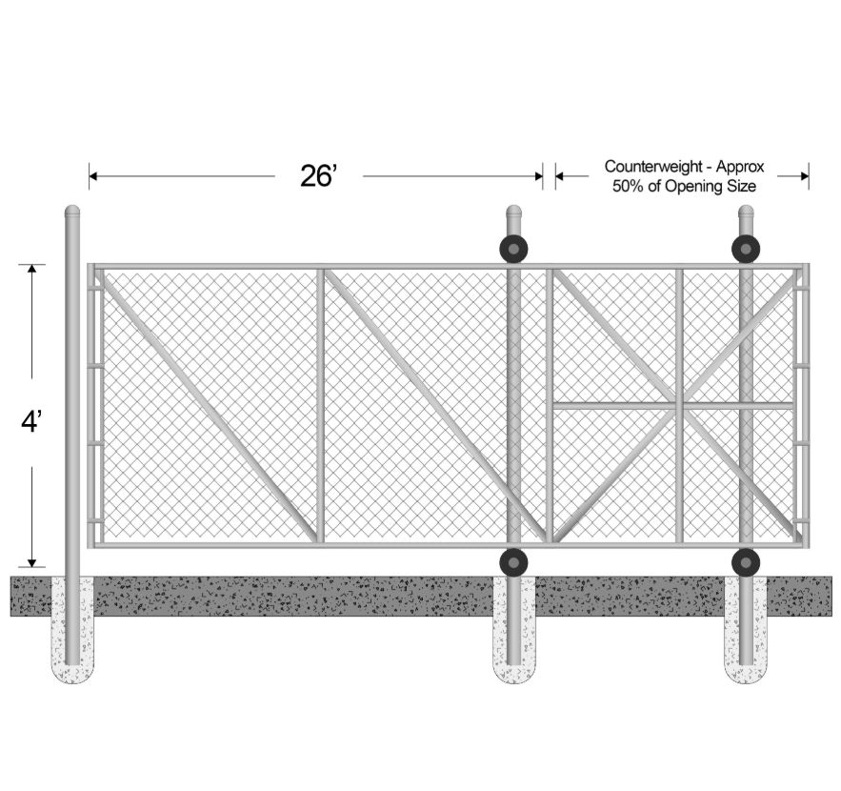
CANTILEVER DESIGN (OPTION B)
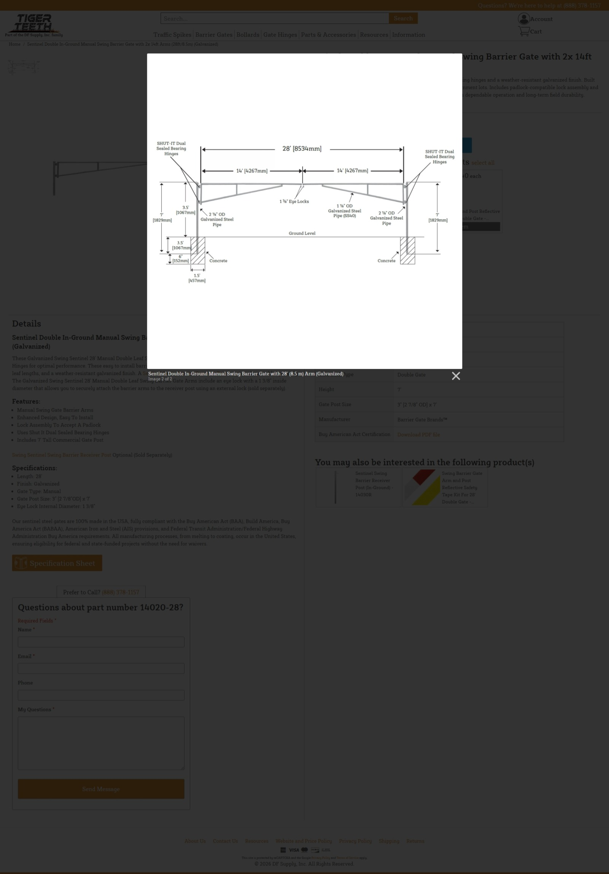
SWING ARM DESIGN

Attachment Maps Coordinates:

