FEDERAL BUREAU OF PRISONS
COMMUNITY TREATMENT SERVICES
TECHNICAL QUOTATION INFORMATION

Name of Company: Click or tap here to enter text.

Authorized Negotiator: Click or tap here to enter text.

Solicitation Number: Click or tap here to enter text.

Directions: Provide detailed and concise written responses to all of the areas below and submit all supplementary documentation as a complete technical quotation packet. Please limit your responses to what is requested in this document.

- Staffing Requirement: The Quoter must have key personnel to meet the solicitation requirements. The Quoter must ensure all personnel providing clinical services to Bureau offenders meet the experiential, educational, and appropriate licensure/certification as required by the state authority where the services will be rendered. [SOW 5.1]

  - Submit the Technical Personnel document that identifies the position and responsibility of all personnel proposed to meet or exceed the minimum staffing requirements of key personnel identified in the Decisional Rule Criteria (2.1 of SF 1449). All key personnel and administrative positions must be identified on this document. [SOW 5.2]

RESPONSE: Attach completed Technical Personnel List. ☐

  - Submit copies of current and valid professional licenses for key personnel who will provide direct clinical services to Bureau offenders. Clinical licenses submitted must be listed in the Decisional Rule Criteria (2.1 of SF 1449) and correspond to the respective clinical duties performed. [SOW 5.4]
          - Staff licenses for medical staff (e.g., medical doctor, physician assistant, nurse practitioner) must meet the standards of practice established by the applicable state’s professional regulatory board in the state where services will be rendered.
          - If submitting a non-medical license that is not listed on the table below, complete the Mental Health/Behavioral Health Professionals Scope of Practice Summary. Any licenses other than those listed below will be reviewed on a case-by-case basis.
          - If unable to produce an original license, provide a license verification sheet with a copy of a government-issued photo identification card for the staff member.

RESPONSE: Attach professional licenses for all clinical staff listed as key personnel on 1a. ☐

c. Submit the Clinical Experience document for all key personnel who will be providing direct clinical services and list total clinical experience working with a criminal justice population providing substance use disorder, mental health, or sex offender treatment services.

RESPONSE: Attach completed Clinical Experience List for all clinical staff identified as key personnel on 1a. ☐

d. Submit resumes for key personnel listed on the Clinical Experience document. Resumes must show documented experience working with a criminal justice population providing substance use disorder, mental health, or sex offender treatment services and must correspond to information submitted on the Clinical Experience document. Documented experience on a resume must include brief descriptions of the type of clinical services provided working with a criminal justice population. [SOW 5.3]

RESPONSE: Attach resumes for all key personnel listed on the Clinical Experience List for 1c. ☐

e. Psychiatric/Medication Monitoring: Submit a Drug Enforcement Agency Controlled Substance Registration Certificate for a qualified practitioner with prescriptive authority who meets the standards of practice established by the state’s professional regulatory board to provide psychiatric evaluations, medication monitoring, and if applicable, MAT services. [SOW 5.4.5]

RESPONSE: Attach DEA certificates for qualified practitioners listed on 3a. ☐

- Operational Requirement – Cognitive Behavioral Therapy (CBT): The Quoter must demonstrate adherence to the CBT model of treatment or other evidence-based programming compatible with CBT. [SOW 2.2]

  - Submit two (2) cognitive behavioral methods or techniques that will be used with Bureau inmates in the delivery of Community Treatment Services (CTS). Limit response to listing the methods or techniques that will be used; do not provide explanations or descriptions of the methods or techniques, unless not a widely known form of treatment. [SOW 2.2.1]

RESPONSE 1: Click or tap here to enter text.
RESPONSE 2: Click or tap here to enter text.

- Operational Requirement – Crisis Interventions: The Quoter must provide emergency crisis intervention assessments, when necessary. The Quoter must have the ability to provide a crisis intervention evaluation and submit a report, contract line item number (CLIN) 6000, within 24 hours of the request made by CTS staff. [SOW 4.3.9]

  - Identify on the Technical Personnel document which key personnel are able to conduct a comprehensive diagnostic interview and provide the written report within 24 hours of the referral for emergency crisis interventions.

RESPONSE: Attach completed Technical Personnel document listing the key personnel who will provide crisis intervention assessments. ☐

- Facility Requirement – Proposed Location(s): The Quoter must provide treatment at performance sites that meet the specified restrictions, space requirements, ADA compliance guidelines, and that do not present safety risks to the community. [SOW 7.1 & 7.2.1]

  - List addresses for all proposed performance sites, including subcontractors, where the required services will be provided within the solicitation’s restrictions in the Decisional Rule Criteria (2.1 of SF 1449).

RESPONSE: Click or tap here to enter text.

  - Submit a deed, lease, bill of sale, option or intent to lease, or option to buy in the name of the Quoter, or subcontractor, if applicable, for all addresses listed in 4a.

RESPONSE: Attach documents for all addresses listed in 4a. ☐

  - Provide the methods and means that will be used to ensure individual and group rooms are private and allow for confidentiality during treatment sessions. [SOW 7.1.1]

RESPONSE: Click or tap here to enter text.
  - Submit an office diagram (see attached example) for each proposed performance site listed in 4a. The diagram must identify all rooms that will be used as counseling space and services, i.e., individual, group, or psychiatric treatment rooms, as well as space used for a waiting, lobby, or reception area. The location of the restroom facilities should also be identified. [SOW 7.1.1]
          - Specify on the office diagram the number of people each group room can comfortably accommodate. Therapeutic group rooms must be primarily dedicated to treatment or reserved for outpatient community treatment services.

RESPONSE: Attach an office diagram for all addresses listed in 4a. ☐

  - Complete and submit the attached Americans with Disabilities Act (ADA) Checklist for each proposed performance site listed in 4a. [SOW 7.1.1]
RESPONSE: Attach completed ADA Checklist for all addresses listed in 4a. ☐
  - Complete and submit the Local Area of Concerns document. This document must identify the following areas of concern that are within the solicitation restrictions listed in the Decisional Rule Criteria (2.1 of SF 1449), to include the same space and/or same building, of each proposed performance site, and include a plan to mitigate risk to children and other vulnerable populations:
- Schools, day-care centers, playgrounds, developed or improved parks, athletic fields, churches, school bus stops, and any facilities/businesses that primarily care for/educate/entertain minors or other vulnerable populations. [SOW 7.2.1]
RESPONSE: Attach completed Local Area of Concern form for all addresses listed in 4a. ☐

Technical Personnel List – Table 1A
Name of Company: |  |  | Click or tap here to enter text.
Proposed Performance Site Address: |  |  | Click or tap here to enter text.
Solicitation Number: |  |  | Click or tap here to enter text.
 | Last Name, First Name | Required Key Personnel |  |  |  |  |  |  | Professional License and Numb. or Admin Position Title | License Expiration Date | Employee or Subcontractor? | EVALUATION  USE ONLY
 |  | AN | SU | MH | CRISIS INTERV | P  S  Y | SO | M  A  T
1 | Click or tap here to enter text. | ☐ | ☐ | ☐ | ☐ | ☐ | ☐ | ☐ | **** | Click or tap to enter a date. | Choose an item. | ☐ L ☐ PA
2 | Click or tap here to enter text. | ☐ | ☐ | ☐ | ☐ | ☐ | ☐ | ☐ | **** | Click or tap to enter a date. | Choose an item. | ☐ L ☐ PA
3 | Click or tap here to enter text. | ☐ | ☐ | ☐ | ☐ | ☐ | ☐ | ☐ | **** | Click or tap to enter a date. | Choose an item. | ☐ L ☐ PA
4 | Click or tap here to enter text. | ☐ | ☐ | ☐ | ☐ | ☐ | ☐ | ☐ | **** | Click or tap to enter a date. | Choose an item. | ☐ L ☐ PA
5 | Click or tap here to enter text. | ☐ | ☐ | ☐ | ☐ | ☐ | ☐ | ☐ | **** | Click or tap to enter a date. | Choose an item. | ☐ L ☐ PA
6 | Click or tap here to enter text. | ☐ | ☐ | ☐ | ☐ | ☐ | ☐ | ☐ | **** | Click or tap to enter a date. | Choose an item. | ☐ L ☐ PA
7 | Click or tap here to enter text. | ☐ | ☐ | ☐ | ☐ | ☐ | ☐ | ☐ | **** | Click or tap to enter a date. | Choose an item. | ☐ L ☐ PA
8 | Click or tap here to enter text. | ☐ | ☐ | ☐ | ☐ | ☐ | ☐ | ☐ | **** | Click or tap to enter a date. | Choose an item. | ☐ L ☐ PA
9 | Click or tap here to enter text. | ☐ | ☐ | ☐ | ☐ | ☐ | ☐ | ☐ | **** | Click or tap to enter a date. | Choose an item. | ☐ L ☐ PA
10 | Click or tap here to enter text. | ☐ | ☐ | ☐ | ☐ | ☐ | ☐ | ☐ | **** | Click or tap to enter a date. | Choose an item. | ☐ L ☐ PA

Professionals Scope of Practice Summary – Table 1B
State: | Click or tap here to enter text.
Profession | Licensing Board and Website | Scope of Practice | Scope of  License
Click or tap here to enter text. | Click or tap here to enter text. | Click or tap here to enter text. | Choose an item.
Click or tap here to enter text. | Click or tap here to enter text. | Click or tap here to enter text. | Choose an item.
Click or tap here to enter text. | Click or tap here to enter text. | Click or tap here to enter text. | Choose an item.
Click or tap here to enter text. | Click or tap here to enter text. | Click or tap here to enter text. | Choose an item.

Professionals Scope of Practice Summary ***EXAMPLE***
State: | Somewhere (SW), USA
Profession | Licensing Board and Website | Scope of Practice | Scope of  License
Licensed Professional Clinical Counselors (LPCC) | SW Board of Behavioral Health and Therapy  www.bbht.state.sw.us/Home/tabid/10 | The scope of practice of a licensed professional clinical counselor includes, but is not limited to:  - implementation of professional counseling treatment interventions including evaluation, treatment planning, assessment, and referral;  - direct counseling services to individuals, groups, and families;  - counseling strategies that effectively respond to multicultural populations;  - knowledge of relevant laws and ethics impacting practice;  - crisis intervention;  - consultation; and  - program evaluation and applied research.  (S.W. 148B.50) | Practice Independently
Licensed Independent Clinical Social Worker (LICSW) | SW Board of Social Work  www.socialwork.state.sw.us | May engage in clinical practice. Clinical practice is the diagnosis and treatment of psychosocial function, disability, or impairment, including addictions and emotional, mental, and behavioral disorders, including plans based on a differential diagnosis. Treatment may include psychotherapy.  (S.W. 148D.050) | Practice Independently
Licensed Social Worker (LSW) | SW Board of Social Work  http://www.socialwork.state.sw.us/ | Practices under supervision. May not engage in clinical practice.  Practice includes:  - assessment  - case management ‘  - client-centered advocacy  - client education and counseling  - crisis intervention  - referral  (S.W. 148D.050) | Requires Supervision

Clinical Experience List – Table 1C
Name of Company: | Click or tap here to enter text.
Proposed Performance Site Address: | Click or tap here to enter text.
Solicitation Number: | Click or tap here to enter text.
 | Required Key Personnel |  |  |  | Total Clinical Experience with  Criminal Justice Population Providing:
 | Last Name, First Name | SU | MH | SO | Substance Use  Disorder Treatment | Mental Health Treatment | Sex Offender Treatment | Evaluation Use Only
1 | Click or tap here to enter text. | ☐ | ☐ | ☐ | Choose an item. | Choose an item. | Choose an item. | ☐ R ☐ PA
2 | Click or tap here to enter text. | ☐ | ☐ | ☐ | Choose an item. | Choose an item. | Choose an item. | ☐ R ☐ PA
3 | Click or tap here to enter text. | ☐ | ☐ | ☐ | Choose an item. | Choose an item. | Choose an item. | ☐ R ☐ PA
4 | Click or tap here to enter text. | ☐ | ☐ | ☐ | Choose an item. | Choose an item. | Choose an item. | ☐ R ☐ PA
5 | Click or tap here to enter text. | ☐ | ☐ | ☐ | Choose an item. | Choose an item. | Choose an item. | ☐ R ☐ PA
6 | Click or tap here to enter text. | ☐ | ☐ | ☐ | Choose an item. | Choose an item. | Choose an item. | ☐ R ☐ PA
7 | Click or tap here to enter text. | ☐ | ☐ | ☐ | Choose an item. | Choose an item. | Choose an item. | ☐ R ☐ PA
8 | Click or tap here to enter text. | ☐ | ☐ | ☐ | Choose an item. | Choose an item. | Choose an item. | ☐ R ☐ PA
9 | Click or tap here to enter text. | ☐ | ☐ | ☐ | Choose an item. | Choose an item. | Choose an item. | ☐ R ☐ PA
10 | Click or tap here to enter text. | ☐ | ☐ | ☐ | Choose an item. | Choose an item. | Choose an item. | ☐ R ☐ PA

Example Office Diagram – 4D
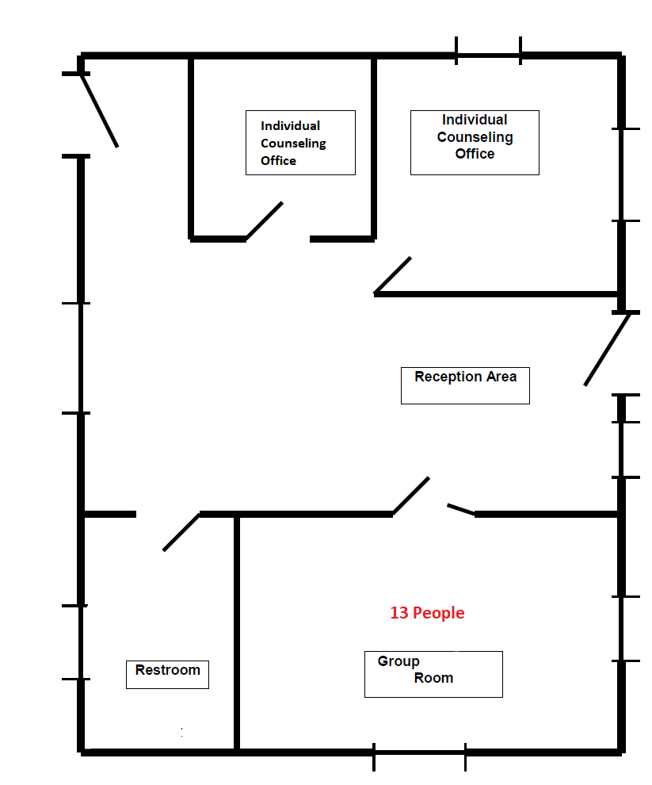
For each proposed performance site listed in 1a, submit an office diagram:
- Identify all rooms that will be used as counseling space.
- Include any areas used for a waiting, lobby, or reception area.
- Identify the location of the restroom facilities.
- Specify the number of people each group room can comfortably accommodate.

ADA Compliance Checklist – Table 4E
- Submit the following checklist to assess each proposed performance site for accessibility.
- Please note this is not a complete or detailed checklist for ADA compliance.
- More information can be found at: www.ada.gov

Name of Company: |  | Click or tap here to enter text.
Proposed Performance  Site Address: |  | Click or tap here to enter text.
Solicitation Number: |  | Click or tap here to enter text.
Existing Buildings and Facilities |  |  | Yes | No | NA
1 | Are accessible entrances clearly marked? |  | ☐ | ☐
2 | Is there an accessible route to an accessible entrance from parking, drop-off points, public transportation, and public sidewalks? |  | ☐ | ☐
3 | Is there at least one entrance that is accessible (e.g., with a level entrance or ramp)? |  | ☐ | ☐
4 | If there is more than one ﬂoor or level, is each connected by an elevator with accessible controls? |  | ☐ | ☐ | ☐
5 | Do doors have a 32-inch clearance and usable hardware (e.g., lever handles)? |  | ☐ | ☐
6 | Are signs accessible to people who are blind or have low vision? |  | ☐ | ☐
7 | Are accessible restrooms provided with accessible stalls and lavatories and directional signage? |  | ☐ | ☐
8 | If the site where services will be provided are not accessible, can the services be moved to accessible locations or can other modiﬁcations be made to ensure participation by those who have disabilities? |  | ☐ | ☐ | ☐

Provide a plan for ADA compliance and estimated completion date for any “NO” responses above:
Click or tap here to enter text.

Local Areas of Concern – Table 4F
- Identify any of the following areas of concern, including those in the same space and/or same building, that are within the restrictions of 2.1 of SF1449 for each proposed performance site and submit a plan to mitigate risk to children and other vulnerable populations: schools, day-care centers, playgrounds, developed or improved parks, athletic fields, churches, school bus stops, and any facilities/businesses that primarily care for/educate/entertain minors or other vulnerable populations.
- The plan to mitigate risk to children and other vulnerable populations must include details to limit or eliminate contact with the local areas of concern identified.
The following table must be completed fully with all appropriate information for each proposed performance site.
Name of Company: | Click or tap here to enter text.
Proposed Performance  Site Address: | Click or tap here to enter text.
Solicitation Number: | Click or tap here to enter text.
Area of concern:  (name and location/address) | Distance from proposed perfor-mance site: | Days & hours of operation: | Potential risk or negative impact of proposed site to area of concern. | Plan to mitigate potential risk or negative impact.
Click or tap here to enter text. | Click or tap here to enter text. | **** | Click or tap here to enter text. | Click or tap here to enter text.
Click or tap here to enter text. | Click or tap here to enter text. | **** | Click or tap here to enter text. | Click or tap here to enter text.
Click or tap here to enter text. | Click or tap here to enter text. | **** | Click or tap here to enter text. | Click or tap here to enter text.
Click or tap here to enter text. | Click or tap here to enter text. | **** | Click or tap here to enter text. | Click or tap here to enter text.
Click or tap here to enter text. | Click or tap here to enter text. | **** | Click or tap here to enter text. | Click or tap here to enter text.

 Technical Quotation Checklist

Check each response for correct and complete information submitted in technical quotation packet:

☐ Provide completed technical quotation packet. Absence of a completed technical quotation that addresses each Decisional Rule Criteria may result in no further evaluation of Quoter’s submitted response
☐ Submit Technical Personnel document listing all key personnel
☐ Provide clinical licenses for all key personnel
☐ Provide verification sheets & photo ID’s when unable to provide copy of original clinical license
☐ Submit Clinical Experience document for key personnel
☐ Provide resumes for all key personnel providing clinical services
☐ Submit DEA registration certificates for all qualified prescribing practitioners
☐ Identify on Technical Personnel document key personnel to conduct crisis intervention assessments
☐ Provide address and leases, deeds, etc for all performance sites listed
☐ Submit information for ensuring confidentiality and privacy of treatment rooms
☐ Submit office diagram(s) with all rooms identified as specified, with group room capacity listed
☐ Submit ADA checklist
☐ Submit Local Area of Concerns document
☐ Provide Facility License (if applicable)

