FEDERAL BUREAU OF PRISONS
COMMUNITY TREATMENT SERVICES
TECHNICAL PROPOSAL INFORMATION
DECISIONAL RULE CRITERIA MATRIX

Name of Company: Click or tap here to enter text.

Authorized Negotiator: Click or tap here to enter text.

Solicitation Number: Click or tap here to enter text.

Directions: Submit a detailed and comprehensive response to the areas below and include any supplementary documentation as a complete technical proposal packet. Please limit responses to what is requested in this document and adhere to the page limitations.

- This is a best value source selection in which a contract will be awarded based on the value of the services the Government will receive from the awarded contractor. Review the evaluation criteria carefully as it will be used to determine the quality of your technical proposal; responding to all elements requested is critical.
- Please note that technical proposals will be evaluated based on the Decisional Rule Criteria Matrix.
- Some factors will be evaluated on an acceptable/unacceptable basis while others will be evaluated to distinguish their relative quality by considering the degree to which the proposal exceeds the minimum solicitation requirements and will better satisfy the agency’s needs and bring the best value to the Government.
- Offerors must provide sufficient information to demonstrate their organization’s strengths, technical skills, personnel qualifications, experience, and capabilities beyond meeting the minimum requirements.

STAFFING EVALUATION AREA
- Factor: Key Personnel - Licensure

This factor evaluates Offeror’s key personnel proposed to meet the solicitation requirements. This includes evaluating all personnel providing clinical services meet the appropriate licensure/certification as required by the state authority where the services will be rendered, to practice independently, without supervision. [SOW 5.4]
The following information shall be submitted in the proposal and will be evaluated as meeting the minimum requirements below:

  - The Offeror shall submit the Technical Personnel document that identifies the position and responsibility of all personnel proposed to meet or exceed the minimum staffing requirements of key personnel identified in the Decisional Rule Criteria Matrix (2.1 of SF 1449). All key personnel and administrative positions must be identified on this document.

RESPONSE: Attach completed Technical Personnel List 1a. ☐

  - The Offeror shall submit copies of current and valid professional licenses for key personnel who will provide direct clinical services to Adults in Custody (AICs) while in community placement. Clinical licenses submitted must be listed in the Decisional Rule Criteria Matrix (2.1 of SF 1449) and must correspond to the respective clinical duties performed.
    - Staff licenses for medical staff (e.g., medical doctor, physician assistant, nurse practitioner) must meet the standards of practice established by the applicable state’s professional regulatory board in the state where services will be rendered.
    - If submitting a non-medical license that is not listed in the Decisional Rule Criteria Matrix (2.1 of SF 1449), complete the attached Mental Health/Behavioral Health Professionals Scope of Practice Summary (document 1b). Any licenses other than those listed will be reviewed on a case-by-case basis.
    - If unable to produce an original license, provide a license verification sheet with a copy of a government-issued photo identification card for the staff member.
RESPONSE: Attach professional licenses for all clinical staff listed as key personnel on 1a. ☐
  - Psychiatric/Medication Monitoring: The Offeror shall submit a Drug Enforcement Agency Controlled Substance Registration Certificate for a qualified practitioner with prescriptive authority who meets the standards of practice established by the state’s professional regulatory board to provide psychiatric evaluations and medication monitoring services. [SOW 5.4.5)
RESPONSE: Attach DEA certificates for qualified practitioners listed on 1a. ☐

STAFFING EVALUATION AREA
- Factor: Key Personnel – Experience

This factor evaluates Offeror’s key personnel and their experience. Clinical staff should have documented experience providing substance use disorder treatment and/or mental health services to a criminal justice population. For sex offender treatment, clinical staff must have experience working with a sex offender population. [SOW 5.3]

The following information shall be submitted in the proposal and will be evaluated on the degree to which the offeror meets the solicitation requirements and provides a benefit to the Government:

- The Offeror shall submit resumes for key personnel listed on the Technical Personnel document 1a. Resumes must show documented experience working with a criminal justice population providing substance use disorder, mental health, or sex offender treatment services and must correspond to their respective clinical duties as noted on the Technical Personnel document.

- Documented experience on a resume must include descriptions of the type of clinical services provided and show prior clinical experience working with AICs providing treatment services or with programs of a similar type or complexity.

Resumes shall not exceed three pages.

RESPONSE: Attach resumes showing documented experience for all key personnel listed on 1a. ☐

OPERATIONAL EVALUATION AREA
- Factor: Clinical Treatment Standards and Practices

This factor evaluates the quality, comprehensiveness, and innovativeness of the Offeror’s plan to implement and follow expectations for treatment services, which include elements of the following standards. [SOW 3.2]
- Treatment Services
- Assessments
- Clinician Engagement
- Frequency of Sessions
- Standard Session Length
- Session Breaks
- Schedules
- Individual Counseling
- Group Counseling
- Group Size Limitations
- Agency Rules
- Cell Phones
- Disruptive Behavior
- Favors and Items of Value
- Immediate Crisis Intervention Plan
- Continuing Contract Performance During a Government Shutdown, Pandemic, Influenza, or Other National Emergency

The following information shall be submitted in the proposal and will be evaluated on the degree to which the offeror meets the solicitation requirements and provides a benefit to the Government:

- The Offeror shall provide a plan which describes their model or approach for delivering Community Treatment Services. The Offeror shall describe the procedures and practices they will employ to meet the solicitation requirements.
- The Offeror shall ensure the plan is relevant to the requirements but must not merely restate or paraphrase the Statement of Work requirements, as this will be found unacceptable.
- The intent of this requirement is to evaluate Offeror’s delivery of services to AICs in the community according to elements of the standards in the SOW.
- It also provides an opportunity for Offeror to describe the capabilities of their organization in performance of the contract to offer a more comprehensive and supportive environment in the delivery of treatment services for AICs in the community.

The plan shall not exceed five pages.

RESPONSE: Submit an attachment labeled Factor 3 - Clinical Treatment Standards and Practices. ☐

FACILITY EVALUATION AREA
- Factor: Proposed Location(s)

This factor evaluates the Offeror’s performance site(s) meet the specified restrictions, space requirements, ADA compliance guidelines, and do not present safety risks to the community. [SOW 7.1 & 7.2.1]

The following information shall be submitted in the proposal and will be evaluated as meeting the minimum requirements below:
  - List addresses for all proposed performance sites, including subcontractors, who will provide the required services within the solicitation’s restrictions in the Decisional Rule Criteria Matrix (2.1 of SF 1449).
RESPONSE: Click or tap here to enter text.

  - Submit a deed, lease, bill of sale, option or intent to lease, or option to buy in the name of the Offeror, or subcontractor, if applicable, for all addresses listed in 4a.
    - Acceptable proof of intent to lease must address, at a minimum, the following provisions: names of the parties (landlord and prospective tenant), property details, including location, proposed terms of lease, desired start and end dates, condition of premises, i.e., space is being leased in “AS IS” condition or will require either party to build out the space, and signature of both parties.
RESPONSE: Attach documents for all addresses listed in 4a. ☐

  - Describe how individual and group rooms at the proposed performance site(s) will be private and allow for confidentiality during treatment sessions. [SOW 7.1.1]
RESPONSE: Provide response here or submit an attachment, labeled 4c. ☐

  - Submit an office diagram (see attached example) for each proposed performance site listed in 4a. The diagram must identify all rooms that will be used for counseling space and services, i.e., individual, group, or psychiatric treatment rooms, as well as space used for a waiting, lobby or reception area. The location of the restroom facilities should also be identified. [SOW 7.1.1]
    - Specify on the office diagram the number of individuals each group room can comfortably accommodate. Therapeutic group rooms must be primarily dedicated to treatment or reserved for outpatient community treatment services.

RESPONSE: Attach an office diagram for each address listed in 4a. ☐

  - Complete and submit the attached Americans with Disabilities Act (ADA) Checklist for each proposed performance site listed in 4a. [SOW 7.1.1]
RESPONSE: Attach completed ADA Checklist for each address listed in 4a. ☐
  - Complete and submit the attached Local Areas of Concern document for each proposed performance site listed in 4a. This document must identify the following areas of concern that are within the solicitation restrictions listed in the Decisional Rule Criteria Matrix (2.1 of SF 1449). This must include the same space and/or same building, of each proposed performance site, and include a plan to mitigate risk to children and other vulnerable populations:
    - Schools, day-care centers, playgrounds, developed or improved parks, athletic fields, churches, school bus stops, and any facilities/businesses that primarily care for/educate/entertain minors or other vulnerable populations. [SOW 7.2.1]

RESPONSE: Attach completed Local Area of Concern form for each address listed in 4a. ☐

FACILITY EVALUATION AREA
- Factor: Facility License

This factor evaluates the Offeror’s facility is appropriately licensed and/or certified to provide all required services on, or by, the contract effective date by the state authority where services will be rendered. [SOW 7.4]
The following information shall be submitted in the proposal and will be evaluated as meeting the minimum requirements below:
  - Submit the required state facility license and/or certification to provide all treatment services at the proposed performance site(s) listed in 4a.
          - If in the process of obtaining a valid license, submit the completed and signed application, provisional license, and/or other official documentation as proof. Providing only the email of submitting the application will not be acceptable. Documentation, such as official email correspondence, must show that the Offeror may begin services on, or by, the contract effective date.

RESPONSE: Attach facility documents for all addresses listed in 4a. ☐

Technical Personnel List – Factor 1a
Name of Company: |  |  | Click or tap here to enter text.
Proposed Performance Site Address: |  |  | Click or tap here to enter text.
Solicitation Number: |  |  | Click or tap here to enter text.
 | Last Name, First Name | Required Key Personnel |  |  |  |  |  | Professional License and Numb. or Admin Position Title | License Expiration Date | Employee or Subcontractor? | EVALUATION  USE ONLY
 |  | AN | SU | MH | CRISIS INTERV | P  S  Y | SO
1 | Click or tap here to enter text. | ☐ | ☐ | ☐ | ☐ | ☐ | ☐ | **** | Click or tap to enter a date. | Choose an item. | ☐ L ☐ R ☐ PA
2 | Click or tap here to enter text. | ☐ | ☐ | ☐ | ☐ | ☐ | ☐ | **** | Click or tap to enter a date. | Choose an item. | ☐ L ☐ R ☐ PA
3 | Click or tap here to enter text. | ☐ | ☐ | ☐ | ☐ | ☐ | ☐ | **** | Click or tap to enter a date. | Choose an item. | ☐ L ☐ R ☐ PA
4 | Click or tap here to enter text. | ☐ | ☐ | ☐ | ☐ | ☐ | ☐ | **** | Click or tap to enter a date. | Choose an item. | ☐ L ☐ R ☐ PA
5 | Click or tap here to enter text. | ☐ | ☐ | ☐ | ☐ | ☐ | ☐ | **** | Click or tap to enter a date. | Choose an item. | ☐ L ☐ R ☐ PA
6 | Click or tap here to enter text. | ☐ | ☐ | ☐ | ☐ | ☐ | ☐ | **** | Click or tap to enter a date. | Choose an item. | ☐ L ☐ R ☐ PA
7 | Click or tap here to enter text. | ☐ | ☐ | ☐ | ☐ | ☐ | ☐ | **** | Click or tap to enter a date. | Choose an item. | ☐ L ☐ R ☐ PA
8 | Click or tap here to enter text. | ☐ | ☐ | ☐ | ☐ | ☐ | ☐ | **** | Click or tap to enter a date. | Choose an item. | ☐ L ☐ R ☐ PA
9 | Click or tap here to enter text. | ☐ | ☐ | ☐ | ☐ | ☐ | ☐ | **** | Click or tap to enter a date. | Choose an item. | ☐ L ☐ R ☐ PA
10 | Click or tap here to enter text. | ☐ | ☐ | ☐ | ☐ | ☐ | ☐ | **** | Click or tap to enter a date. | Choose an item. | ☐ L ☐ R ☐ PA

Professionals Scope of Practice Summary – Factor 1b (only complete if submitting a non-medical license not listed in DRC)
State: | Click or tap here to enter text.
Profession | Licensing Board and Website | Scope of Practice | Scope of  License
Click or tap here to enter text. | Click or tap here to enter text. | Click or tap here to enter text. | Choose an item.
Click or tap here to enter text. | Click or tap here to enter text. | Click or tap here to enter text. | Choose an item.
Click or tap here to enter text. | Click or tap here to enter text. | Click or tap here to enter text. | Choose an item.
Click or tap here to enter text. | Click or tap here to enter text. | Click or tap here to enter text. | Choose an item.

Professionals Scope of Practice Summary ***EXAMPLE*** Factor 1b
State: | Somewhere (SW), USA
Profession | Licensing Board and Website | Scope of Practice | Scope of  License
Licensed Professional Clinical Counselors (LPCC) | SW Board of Behavioral Health and Therapy  www.bbht.state.sw.us/Home/tabid/10 | The scope of practice of a licensed professional clinical counselor includes, but is not limited to:  - implementation of professional counseling treatment interventions including evaluation, treatment planning, assessment, and referral;  - direct counseling services to individuals, groups, and families;  - counseling strategies that effectively respond to multicultural populations;  - knowledge of relevant laws and ethics impacting practice;  - crisis intervention;  - consultation; and  - program evaluation and applied research.  (S.W. 148B.50) | Practice Independently
Licensed Independent Clinical Social Worker (LICSW) | SW Board of Social Work  www.socialwork.state.sw.us | May engage in clinical practice. Clinical practice is the diagnosis and treatment of psychosocial function, disability, or impairment, including addictions and emotional, mental, and behavioral disorders, including plans based on a differential diagnosis. Treatment may include psychotherapy.  (S.W. 148D.050) | Practice Independently
Licensed Social Worker (LSW) | SW Board of Social Work  http://www.socialwork.state.sw.us/ | Practices under supervision. May not engage in clinical practice.  Practice includes:  - assessment  - case management ‘  - client-centered advocacy  - client education and counseling  - crisis intervention  - referral  (S.W. 148D.050) | Requires Supervision

Example Office Diagram – Factor 4d

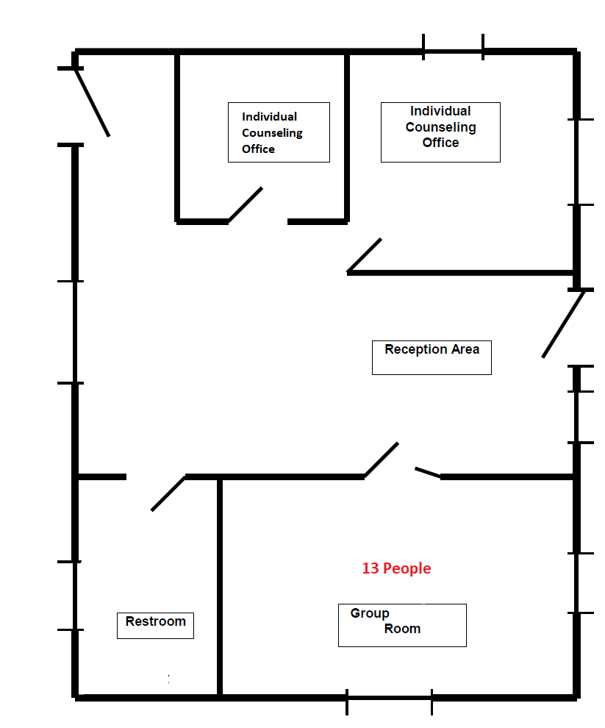

For each proposed performance site listed in 1a, submit an office diagram:
- Identify all rooms that will be used as counseling space.
- Include any areas used for a waiting, lobby, or reception area.
- Identify the location of the restroom facilities.
- Specify the number of people each group room can comfortably accommodate.

ADA Compliance Checklist – Factor 4e
- Submit the following checklist to assess each proposed performance site for accessibility.
- Please note this is not a complete or detailed checklist for ADA compliance.
- More information can be found at: www.ada.gov

Name of Company: |  | Click or tap here to enter text.
Proposed Performance  Site Address: |  | Click or tap here to enter text.
Solicitation Number: |  | Click or tap here to enter text.
Existing Buildings and Facilities |  |  | Yes | No | NA
1 | Are accessible entrances clearly marked? |  | ☐ | ☐
2 | Is there an accessible route to an accessible entrance from parking, drop-off points, public transportation, and public sidewalks? |  | ☐ | ☐
3 | Is there at least one entrance that is accessible (e.g., with a level entrance or ramp)? |  | ☐ | ☐
4 | If there is more than one ﬂoor or level, is each connected by an elevator with accessible controls? |  | ☐ | ☐ | ☐
5 | Do doors have a 32-inch clearance and usable hardware (e.g., lever handles)? |  | ☐ | ☐
6 | Are signs accessible to people who are blind or have low vision? |  | ☐ | ☐
7 | Are accessible restrooms provided with accessible stalls and lavatories and directional signage? |  | ☐ | ☐
8 | If the site where services will be provided is not accessible, can the services be moved to accessible locations or can other modiﬁcations be made to ensure participation by those who have disabilities? |  | ☐ | ☐ | ☐

Provide a plan for ADA compliance and estimated completion date for any “NO” responses above:
Click or tap here to enter text.

Local Areas of Concern – Factor 4f
- Identify any of the following areas of concern, including those in the same space and/or same building, that are within the restrictions of 2.1 of SF1449 for each proposed performance site and submit a plan to mitigate risk to children and other vulnerable populations: schools, day-care centers, playgrounds, developed or improved parks, athletic fields, churches, school bus stops, and any facilities/businesses that primarily care for/educate/entertain minors or other vulnerable populations.
- The plan to mitigate risk to children and other vulnerable populations must include details to limit or eliminate contact with the local areas of concern identified.
- The following table must be completed fully with all appropriate information for each proposed performance site.
Name of Company: | Click or tap here to enter text.
Proposed Performance  Site Address: | Click or tap here to enter text.
Solicitation Number: | Click or tap here to enter text.
Area of concern:  (name and location/address) | Distance from proposed perfor-mance site: | Days & hours of operation: | Potential risk or negative impact of proposed site to area of concern. | Plan to mitigate potential risk or negative impact.
Click or tap here to enter text. | Click or tap here to enter text. | **** | Click or tap here to enter text. | Click or tap here to enter text.
Click or tap here to enter text. | Click or tap here to enter text. | **** | Click or tap here to enter text. | Click or tap here to enter text.
Click or tap here to enter text. | Click or tap here to enter text. | **** | Click or tap here to enter text. | Click or tap here to enter text.
Click or tap here to enter text. | Click or tap here to enter text. | **** | Click or tap here to enter text. | Click or tap here to enter text.
Click or tap here to enter text. | Click or tap here to enter text. | **** | Click or tap here to enter text. | Click or tap here to enter text.

 Technical Proposal Checklist

☐ Submit completed technical proposal packet for all factors listed in the solicitation. Absence of a completed technical proposal which addresses each Decisional Rule Criteria may result in no further evaluation of Offeror’s submitted response.
☐ Submit Technical Personnel document listing all key personnel.
☐ Provide clinical licenses for all key personnel.
☐ Provide verification sheets & photo ID’s when unable to provide copy of original clinical license.
☐ Provide DEA registration certificates for all qualified prescribing practitioners.
☐ Provide resumes for all key personnel detailing experience providing treatment services.
☐ Submit plan for Clinical Treatment Standards & Practices.
☐ Provide address and leases, deeds, etc. for all performance sites listed.
☐ Provide office diagram, including number of people for group room size.
☐ Submit ADA checklist for all performance sites.
☐ Submit Local Area of Concerns document for all performance sites.
☐ Submit required state facility license or other official documentation.
☐ Ensure all documentation is complete, labeled, and well organized.
☐ Please note any size limitations when sending your completed technical proposal packet.

