DEPARTMENT OF HOMELAND SECURITY
UNITED STATES COAST GUARD



SECTOR HUMBOLDT BAY
McKinleyville, CA 95519

SPECIFICATIONS
FOR
Grounds Maintenance Service

LOCATED AT
U.S. Coast Guard
Sector Humboldt Bay
1001 Lycoming Ave.
McKinleyville, CA 95519

PART 1- GENERAL

BACKGROUND INFORMATION: The U.S. Coast Guard (USCG) is procuring Grounds Maintenance/Landscaping Services as described in this Statement of Work (SOW) for USCG Sector Humboldt Bay, CA. The area to be serviced is identified in Enclosure 1, “Site Layout”. This SOW is in compliance with the direction in which the USCG is procuring contracts to ensure consistent performance and be results-oriented.
- SCOPE OF WORK: USCG Sector Humboldt Bay is seeking a contract to provide personnel, management, supervision, materials, supplies, equipment, tools, transportation and other items or services (except as stated herein) necessary to perform grounds maintenance services to maintain a safe, clean, and healthy environment for all residents, military and civilian, and members of the general public. To accomplish this mission, it is essential that the properties and facilities of the area specified herein have qualified grounds maintenance service as required.
- WORK Requirements:
  - Service Area:
    - This Procurement consists of locations within boundaries of the USCG Sector Humboldt Bay, CA. The services required are all-inclusive for the properties shown in the attached Enclosure 1, “Site Layout”. USCG Sector Humboldt Bay is a developed 13-acre complex, however, approximately 8 acres will of lawns and grounds will need to be maintained. Grounds Maintenance to include: grass cutting/mowing, trimming along the roads, parking lots, buildings walkways and fence line, edging-turf, weeding, and weed eradication.
  - Mowing:
    - Specs: The contractor shall cut/mow grass areas in a manner that promotes proper health, growth, and a neat appearance. The Contractor shall keep lawn areas free of dead vegetation and debris. All surface disruptions (e.g., ground hog mounds, mole mounds, etc.) are to be raked level prior to mowing. Grass cutting shall be accomplished in a manner that is free of scalping, rutting. Bruising, and uneven or rough cutting. In no case is scalping or rutting of grass allowed, however, if this occurs, the Contractor may be asked to re-cut the area of concern. Mowing of area is to be cut no shorter than 1 ½ inches and to grow no longer than 4 inches. All grass clippings shall be removed immediately after each mowing. There shall never be visible rows of grass clippings allowed to remain on grass areas that have been cut. Prior to mowing, the Contractor shall remove all refuse, debris, leaves, rocks, paper and other portable objects within the maintenance area lodged in shrubs, hedges, fences and along foundation walls. All rubbish and debris shall be removed by the Contractor from the site and disposed of IAW federal, state and local regulations.
    - Frequency:
All mowing is to be accomplished in the span of two days. If weather or any unforeseen circumstances occur which prevent the contractor from completing the mowing in two days, the contractor must notify the Facilities Representative or the Contracting Officer.
January: Twice per month July: Twice per month
February: Twice per month August: Twice per month
March: Twice per month September: Twice per month
April: Twice per month October: Twice per month
May: Twice per month November: Twice per month
June: Twice per month December: Twice per month

(Mowing the required amounts per month in Humboldt County can often cause difficulties due to weather, specifically rain. It will be the responsibility of the contractor to monitor the weather and plan accordingly).
  - Edging:
    - Specs: The Contractor shall perform edging in a manner that is free of scalping, rutting, bruising, uneven and rough cutting. Edging shall be performed along all sidewalks, driveways, curbs, parking lots, slabs, pads, and other paved surfaces, and around all gardens, beds, and other cultivated areas. The Contractor shall perform edging in such a manner that there is no vegetation closer than 1/2 inch from pavement, curbs, and sidewalks. Care is to be employed where tree roots that are in close proximity to curbs and sidewalks. All debris resulting from edging shall be blown back into lawn area or swept and removed off streets, parking lots and sidewalks.

    - Frequency: Edging is to be conducted in conjunction with scheduled mowing on a once a month basis, and as needed during twice a month mowing schedules.

  - Trimming:
    - Specs: The Contractor shall trim around trees, shrubs, cultivated areas, fences, poles, walls, valves and other similar objects. Trimming shall be accomplished to match the height and appearance of surrounding vegetation. Trimming shall be done in such a way as to avoid damaging the trunk, bark or roots of trees or shrubs. After trimming , all cuttings and debris shall be removed; sidewalks and paved areas cleaned; and all trash and debris shall be removed from the site and disposed of off Sector Humboldt Bay by the Contractor.

    - Frequency: Trimming within any given area should be completed at the same time as each mowing.

  - Plant and Shrub Pruning:
    - Specs: The contractor shall prune all shrubs, bushes, hedges, and other cultivated plants according to their natural growth habit, for the proper health, attractive appearance and to prevent interference with pedestrian and vehicle traffic. Pruning is to be done in a manner that: prevents growth in front of windows, within 6 inches of building roofs, over entrance and walkways; prevents obstructing vision at street intersections; removes dead, damaged, or diseased wood; and naturally forms and balances the shrub, bush, or plant. With the exception of flowering plants, shrubs, and ornamentals, which shall be pruned to accommodate their flowering cycle, pruning of the entire plant or shrub shall be performed to maintain their established shape and appearance. Prune to maintain plants outward facing bud. Prune to prevent safety hazards, and to maintain pathways and walkways.

    - Frequency: Pruning shall be performed on an as needed basis. Inspection shall be completed in conjunction with each mowing to determine need.

  - Surface Drainage:
    - Specs: Whenever necessary, the Contractor shall remove obstructions (i.e., vegetation, debris, leaves, soil, etc.) to water flow in drainage ditches, gutters, catch basins, curb inlets, and gratings. Soil depressions resulting in accumulation of excavation or rutting caused by vehicles, tractors, and other mobile equipment shall be filled with topsoil, graded to conform to the surrounding area, and vegetation replaced.

    - Frequency: As needed. Some areas may be more easily identified during the winter rainy months in the local area.

  - Leaf Removal:
    - Specs: The Contractor shall remove fallen leaves, evergreen needles, and other fallen vegetation so as to prevent an unsanitary, unsightly, or unkempt appearance. The Contractor shall collect and dispose of the removed leaves and other debris in accordance with federal, state and local regulations.

    - Frequency: To be completed in conjunction with each mowing cycle.

  - Surfaced Area Sweeping:
    - Specs: The Contactor shall sweep all sidewalks, roadways, areas designated for vehicle parking, and other paved areas to remove grass clippings.

    - Frequency: Shall be completed the same day as mowing adjacent grass areas.

  - Clean-Up, Waste and Disposal of Debris:
    - Specs: All cuttings and debris (i.e., grass clippings, evergreen needles, pinecones, pine needles, fallen branches, trash, stones/dirt, cut weeds, dead carcasses, and other debris) incident to mowing, trimming and edging, shrubbery/hedge trimming/pruning, and etc. shall be removed from Government property and disposed of in compliance with all federal, state and local laws and regulations at the Contractor’s expense regularly and properly with each service. This is to include used trimming line and other debris caused by equipment maintenance, and removal of debris from catch basins, drain openings, and culverts. Debris shall not be permitted to accumulate in open spaces. The Contractor shall not use Government compactors, dumpsters or containers for disposal. The Contractor can dispose of litter picked up during the course of trimming and cutting turf (paper, plastics, glass, cigarette butts, etc.) into the USCG containers.

    - Frequency: To be completed in conjunction with every mowing cycle.

  - Contractor Equipment Storage:
    - Specs: There will be no storage of equipment at USCG Sector Humboldt Bay. If the need arises to temporarily store equipment the Facilities Representative or Contracting Officer must be notified. The Government will take no responsibility for any damage or occurrences that affect any Contractor property, supplies, materials, and equipment. Any equipment found to be leaking fluids will be immediately repaired or removed from the site by the Contractor.

  - Weed Control:
    - Specs: The Contractor shall perform wee control to prevent the encroachment of weeds into established landscapes, including lawn areas and around trees, shrubs, flower beds, etc. Plant beds and special landscaped areas shall receive weed control to eliminate unsightly and/or noxious weeds. Weed control in all plant beds shall be performed by pulling the weeds by hand or use of EPA approved chemicals and in areas of limited growth to prevent the encroachment or vegetation into perimeter fences or roads. The Contractor shall submit data concerning proposed chemical use prior to utilization to the Facilities Representative. Weed control shall be performed to eliminate grass and weeds in cracks and joints within or along sidewalks, curbs, and roads within or adjacent to the maintenance area. All manufacturers’ instructions and recommendations for the preparation and application of chemicals shall be strictly followed.

    - Frequency: As needed during each mowing cycle.

  - Required Licenses:
    - In addition to the work stated above, the contractor must provide the following licenses. All required licenses and permits must be current upon acceptance of contract and is the contractor’s responsibility to ensure that the required licenses and permits remain current for the entire duration of the contract.
      - Landscaping (C-27) and Tree Service (C-61/D-49) California State Contractor License.
      - State of California Qualified Applicator License.
      - Humboldt County Agriculture Department Chemical Applicator License. (Contractor must be present when any herbicide or insecticide application is done).

  - Inspections:

    - Walk through inspections with the contractor and the Coast Guard Housing Representative will be required once each month.

  - Safety:
    - All mowing and edging equipment shall be maintained and used in a safe and effective manner, including effective safety shielding. The Contractor shall ensure that all employees have been properly trained, certified, and/or licensed to operate equipment (ex. Trucks, lawn mowers, tractors, weed eaters, etc.). Record of all Contractor employee training, qualifications and certifications shall be made available for Government review upon request. At no time shall the safety guards on lawn mowers, edgers, weed eaters or any other power equipment (with safety measures) be up or used improperly. All safety guards must be always in place and operational.

    - All power operating equipment shall be carefully maintained and operated with proper safety guards and devices and with discretion with near pedestrians or building residents. All operators shall wear safety protection equipment to include protective goggles (ex. Safety glasses) and clothing (i.e., gloves, hearing protection, helmets, etc.) as required by the equipment manufacturer, OSHA and local safety requirements when on-site.

  - Damages:
    - All operations, including mowing, edging, tree trimming and weed control performed by the Contractor, will be conducted in a manner that ensures trees, shrubs, buildings and vehicles in the area being worked, are not damaged. If damage should occur, the Contractor shall contact the Coast Guard Facility Representative or the Contracting Officer immediately for determining repair and or replacement.

  - Subcontracting:
    - Considerations for any subcontracting shall first be reviewed by the Coast Guard Facilities Representative and the Contracting Officer. All potential subcontractors must possess current licenses as required by law in their trade and be able to meet all other requirements within this statement of work.

  - Objective:
    - The objective of this effort is to acquire continuous, safe, and efficient operation of grounds maintenance services as described herein. This work includes all labor, experienced personnel, equipment, tools, materials, transportation, supervision, and management and any other items necessary to perform the services required in order to maintain healthy grass, trees, shrubs, hedges, and plants. The services shall be performed in accordance with (IAW) all terms and conditions of the contract but not limited to:
      - Planning and scheduling of all services
      - Lawn maintenance
      - Edging
      - Trimming
      - Weed control and re-seeding
      - Tree and shrub care
      - Leaf and debris removal
      - Compliance with all record and reporting requirements

****In order for a contractor to receive award, they must have an active registration in the System for Award Management (SAM), www.sam.gov.
- LOCATION: Project site is located at U.S. Coast Guard Sector Humboldt Bay, 1001 Lycoming Ave., McKinleyville, CA 95519.
- PERIOD OF PERFOMANCE:
The period of performance for this contract is an initial 6-month Base Period of Performance (POP) contract with four option periods (OP) of twelve months each.
Base Period: Oct 1, 2026 through March 31, 2027 Option Period One: 01Apr2027 through 31Mar2028 Option Period Two: 01Apr2028 through 31Mar2029 Option Period Three: 01Apr2029 through 31Mar2030 Option Period Four: 01Apr2030 through 31Mar2031
- SITE INVESTIGATION: Investigate the site per FAR 52.236-3 to ascertain the general and local conditions which can affect the work or its cost. Contact DCC Chris Ybarra, at (707)839-6137 to arrange site visit.
- CONTRACTING OFFICER’S REPRESENTATIVE (COR): The COR will ensure that the Government’s technical objectives are met. To this end, the COR will provide necessary information, direction, coordination, etcetera, within the contractual work description. The COR is not authorized to change any of the terms and conditions of this contract, nor authorize any additional work beyond the scope of work originally contracted, Changes in the scope of work will be made by the Contracting Officer (KO), only by properly written modifications to the contract.

COR: DCC Chris Ybarra
U.S. Coast Guard Sector Humboldt Bay
David.C.Ybarra@uscg.mil
(707) 839-6137

- CONTRACTOR SECURITY REQUIREMENTS: The Contractor shall provide a list of all on-site personnel, including sub-contractors (including second and third-tier subcontractors) and suppliers, to the Contracting Officer. The contractor shall update this list when changes occur. Contractor personnel not listed will be denied access to the Coast Guard facility. Contractor personnel will be restricted to designated working areas. Any personnel violating this policy may lose access to the Coast Guard facility. Contractor personnel shall have photo identification at all times while working on Coast Guard facilities.
Contractor and delivery personnel may be required to present personal photo identification to gain access to a Coast Guard installation. If identification does not indicate United States citizenship, Coast Guard Security may require proof of the legal right to work in the United States. Contractor and delivery personnel also may be subjected to an immigration status and outstanding criminal warrants check.
Contractors shall provide the Contracting Officer's Technical Representative with 24 hours of advance notice of every delivery to the site (e.g., concrete, lumber, parts, etc.) and provide the company name, delivery person, and phone number of the firm(s) making deliveries. All vehicle access to government property requires vehicle registration and proof of liability insurance. Otherwise access to the Coast Guard facility may be denied.
- CONTINUITY OF FACILITIES OPERATION: Work Hours: the Contractor shall generally work during the normal unit operational hours, Monday through Friday, 7:30 am to 3:30pm. The Contracting Officer’s Representative (COR), DCC Chris Ybarra, must approve any deviation from these hours.
  - Saturday, Sunday and Holidays: The Contractor shall provide the On-Site Representative at least forty-eight hours advance notice prior to working on weekends of federal holidays. The Contracting Officer and COR reserves the right of refusal with no impact to the contract.
  - Schedule work to minimize interference with tenants residing in the vicinity. Notify the Contracting Officer’s Representative, DCC Chris Ybarra, immediately if any required shutdowns of work site is necessary.
- NOTIFICATION OF START AND COMPLETION OF WORK: The Contractor shall notify the Contracting Officer’s Representative (COR), DCC Chris Ybarra, two (2) business days in advance of the date intended work will commence each month.
- MATERIAL SAFETY DATA SHEETS AND MATERIAL HANDLING PROCEDURE: Data Sheets: The Contractor shall provide Material Safety Data Sheets (MSDS) for all material to be used in the execution of the contract work that contains hazardous constituents. The MSDS shall meet all requirements of 29 CFR 1910.1200 and shall be submitted to the COTR prior to bringing these materials to the work site.

  - Material Storage: The storage of these materials at the work site shall be strictly limited to that quantity needed for the execution of the current day contract work. The Contractor shall ensure that storage of the material complies with all applicable federal, state, and local laws and regulations.

  - The Contractor shall ensure that adequate protective measures are taken to minimize Coast Guard and Contractor personnel exposure to harmful substances. If protective measures are required, the Contractor shall include them in the Safety Plan and they shall be reviewed by the COTR prior to the start of any contract work involving use of the harmful substance.

- RECYCLING AND DISPOSAL OF REFUSE: Refuse, excess or waste materials resulting from operations shall become the property of the Contractor and shall be recycled and/or disposed of off Government property. All disposals shall be done in accordance with federal, state, and local laws and regulations.
  - Construction Waste Management: Develop and implement a Construction Waste Management Plan quantifying material diversion in order to recycle and reuse and/or salvage to the maximum extent feasible of construction and demolition materials.
- REGIONAL MATERIALS: The contractor shall make all attempts to maximize the procurement of materials within a 500-mile radius of the project site.
- SAFETY: During the execution of this contract, the Contractor shall conform to the rules and regulations as set forth by Safety and Health Regulations for Construction and California Code of Regulations, Title 8, Div. 1, Ch 4, Subchapter 4, Construction Safety Orders. When the standards differ, the more restrictive standard shall apply. The contractor shall provide barriers, temporary fencing, trench covers, etc. wherever work could cause injury to workers, visitors, Coast Guard personnel, or dependents.
- TEMPORARY FACILITIES:
  - STORAGE: Contractor is to remove all materials and equipment at the completion of each day’s work. No storage area will be provided.
  - SANITARY FACILITIES: There are limited toilet facilities available for Contractor use at the job site. The Contractor may provide their own facilities in accordance with 29 CFR 1926, Chapter XVII, Subpart D, paragraph 1926.51 (c) (1).
  - WATER AND ELECTRICITY: Water and 120V electricity are available on site for the Contractor.
  - TELEPHONE: No telephone service is available for contractor use.
- UNFORSEEN HAZARDOUS MATERIAL: If, during the course of work, material is found that may be hazardous to human health upon disturbance during construction operations, stop that portion of work and notify the Contracting Officer Representative (COR), DCC Chris Ybarra, immediately.
- NOISE: Make the maximum use of "low-noise-emission products" as certified by EPA and described at 40 CFR Part 204. No blasting or use of explosives is permitted. Comply with applicable portions of the Noise Control Act (NCA). The Contractor is responsible for complying with all other federal, state, and local noise control laws and regulations.
- Unsafe and/or unforeseen interferences or hazards: If any interference or hazards is discovered that prevent continuation of work, the contractor shall notify the Contracting Officer Representative (COR), DCC Chris Ybarra, immediately. This includes but is not limited to insects (Hornets, bees,) and other wildlife.

- Enclosure: See below enclosure 1, “Site Layout” which defines areas of contractor responsibility. Additional maps and pictures may be requested and/or obtained during a scheduled site visit. Contact DCC Chris Ybarra @ (707)839-6137.

ENCLOSURE 1
SITE LAYOUT
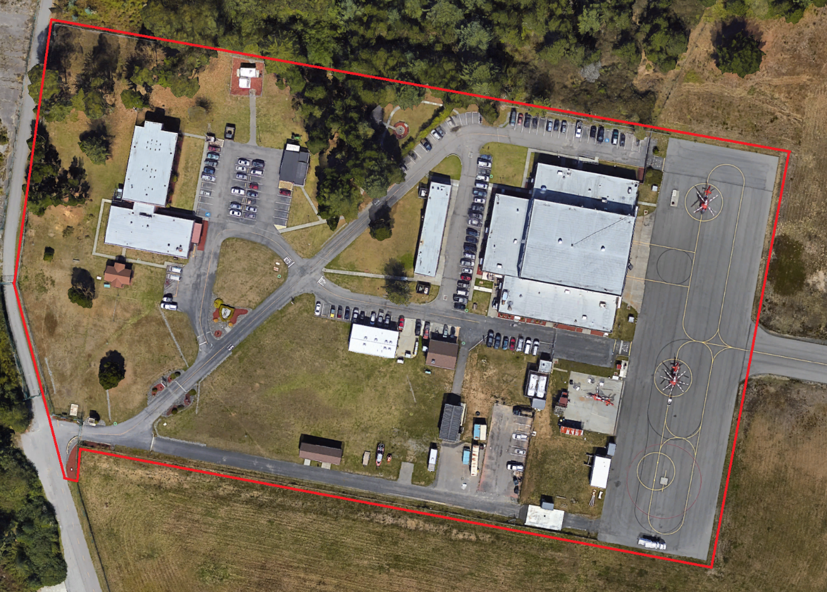
Enclosure 1: Site map; All areas inside the red marked area are to which the contractor is responisble to mow, edge, and spray as outlined in the scope of work.
***END OF SECTION***

