

NATIONAL AERONAUTICS AND SPACE ADMINISTRATION (NASA) AGENCY
ANNOUNCEMENT FOR PROPOSALS (AFP)
FOR LEASE OF NON-EXCESS UNDEVELOPED LAND AND BUILDING
Located at Launch Complex 48 (LC-48)

AFP-KSC-LC48-2026

Table of Contents

I. INTRODUCTION 3
Initiating Installation 3
Description 3
Purpose and Objectives 5
Attachments 5
II. GUIDELINES 6
Security 6
Infrastructure 6
Environmental 6
Financial and Legal 7
Eligibility 7
Historic Preservation 8
Construction 9
Follow-on-Agreements 9
III. PROPOSAL CONTENT 9
Proposal Content and Format 10
AFP Question and Answer Period 11
IV. EVALUATION FACTORS FOR PROPOSAL 14
V. ADDITIONAL INFORMATION 19
Ombudsman 20
NASA Points of Contact 20
VI. EXHIBITS 21
Exhibit A: Maps and Photos 21

I. INTRODUCTION

This selection process is not bound by the procedures set forth in the Federal Acquisition Regulation (FAR) or the NASA FAR Supplement. This AFP will not result in the award of a contract using federally appropriated funds.

Initiating Installation

NASA John F. Kennedy Space Center, FL 32899

Description

This Announcement for Proposals (AFP) solicits proposals for lease of available Federal property at NASA John F. Kennedy Space Center (KSC or Center) consisting of underutilized, non-excess property at Launch Complex 48 (LC-48) for a site operator (defined below) to operate the entire multi-user site with responsibility for coordination of all activities on LC-48 with NASA and U. S. Space Force operations at KSC and CCSFS.

LC-48 is situated between Launch Complexes 39A and 41. LC-48 is a multi-user launch complex built to encourage and support growth of the emerging small class launch vehicle industry and capable of housing multiple users performing concurrent activities. It may also be able to accommodate landings based on vehicle- and mission-specific parameters provided as part of launch and re-entry licensing and safety assessments. The total proposed area available to be leased is approximately 127.66 acres. The site will be available at selection in “as is”, “where is” condition for up to 50 years, including all renewal periods.

LC-48 is ready for development and is mostly vacant, with an existing pad located on the north side. The site is accessible only through KSC’s secured perimeter. Accordingly, NASA procedures and policies regarding badging, background investigation requirements, foreign national access, and unescorted access to controlled areas apply. Pad users may have the opportunity to obtain on a reimbursable basis certain specialized KSC services and resources for operating the launch site not reasonably available from the private sector which are unique to the nation’s premier spaceport.

Definitions:

“Days” – Days are listed in calendar days.

“LC-48” – The property being offered for lease comprising LC-48 North together with LC-48 Undeveloped.

“LC-48 North” – The developed launch site at Launch Complex 48, encompassing approximately 10.85 acres (see Exhibit A, LC-48 North Legal Description).

“LC-48 Undeveloped” – The undeveloped land at Launch Complex 48, encompassing approximately 116.8 acres (see Exhibit A, LC-48 Site Boundary).

“Launch Service Provider” – The entity that will perform launch and/or landing.
“Multi-user Operations” – Actual launch or landing by at least two discrete users, which are not part of the same corporate entity.

“Site operator” – Refers to the tenant, and is defined as the entity that will manage the day-to-day operations of a launch pad. A site operator may, but does not necessarily have to, be a launch service provider.

Background

LC-48 North – This site is currently intended to be operated as a multiuser launch site. LC-48 North has been used to accommodate a variety of small class launch vehicles, including associated ground support equipment and could be used for launch or testing operations.

NASA designed LC-48 North as a “clean pad,” offering approximately 30,000 square feet of paved area available for the launch system, ground support equipment and fuel and oxidizer placement. NASA envisioned launch service providers would transport and configure their equipment, and would be required to remove said equipment upon expiration of the lease or when otherwise deemed appropriate by the site manager during the life of the lease.

The existing pad, with an associated Quantity Distance (QD) arc, is more specifically described below in “LC-48 North Legal Description” in Appendix A. LC-48 North is expected to be capable of supporting vehicles with a maximum gross liftoff weight of 300,000 pounds, a maximum of 500,000 pounds of vehicle thrust, and a maximum Net Explosive Weight of 30,000 pounds TNT equivalent. If tenant were at any point to consider scenarios where the maximum Net Explosive Weight for a particular proposed launch vehicle exceeds 30,000 pounds, then tenant would need to conduct additional analysis to determine if such a vehicle could safely launch from LC-48, and additional permission from NASA would be required.

LC-48 Undeveloped – Consists of any portions of the area identified below as “LC-48 Boundary Map” in Appendix A that are not contained within LC-48 North. This parcel is vacant, undeveloped land that could potentially support launch processing operations for small class launch vehicles, provided that they meet similar weight and thrust constraints identified for LC-48 North to avoid exceeding QD limits so as to avoid adverse impacts to NASA and other users of Kennedy Space Center (KSC) and Cape Canaveral Space Force Station (CCSFS).

The KSC Master Plan (https://masterplan.ksc.nasa.gov/) guides KSC’s mission to provide continuous access to space by supporting government, commercial, and other space launch users and providers. KSC’s Center Planning and Development (CPD) is responsible for implementing and administering the KSC Master Plan and conducts AFPs periodically to solicit proposals from industry for the utilization of non-excess, underutilized property at KSC.

LC-48 may be used to provide space launch services, landings, payload processing, integration, and testing. The Tenant would assume financial and technical responsibility for its operations and maintenance in accordance with the terms and conditions in the attached LC-48 Model Enhanced Use Lease (EUL) Agreement.

Additional information on LC-48 is available at the following link(s):
https://kscpartnerships.ksc.nasa.gov/Partnering-Opportunities/Capabilities-and-Testing/Physical-Assets/Launch-Complex-48

https://www.nasa.gov/feature/kennedy-s-newest-launch-complex-ready-to-serve-smaller-class-of-rockets

KSC has additional launch and processing assets, not included in this AFP. Use of these capabilities will require additional negotiated agreements and are not a part of this Announcement for Proposals. Interested parties may obtain information on KSC facility and equipment capabilities by contacting CPD at: http://kscpartnerships.ksc.nasa.gov.

Purpose and Objectives

NASA seeks to further leverage KSC’s unique location, developable land, and infrastructure to support NASA’s statutory mandate (51 U.S.C. § 20112(a)(4)) to encourage, to the maximum extent possible, the fullest commercial use of space.

NASA’s goals and objectives for leasing the LC-48 through this AFP are to:
- Publicize the availability of delineated land and facilities, and identify federal, specific industry and public entities interested in leasing;
- Increase commercial access to space;
- Enhance U. S. commercial competitiveness in the space launch industry;
- Diversify the user base and operations at KSC;
- Promote uses of KSC’s underutilized, non-excess property and facilities that will build, expand, and modernize aerospace-related capabilities for the United States.

NASA will not consider proposals for use of KSC real property that do not contribute to enabling the commercial use of space, specifically:
- Proposed uses that NASA deems incompatible with the current KSC Master Plan, NASA or KSC facility use policies, or existing environmental conditions;
- Proposed uses that could negatively impact any NASA mission;
- Proposed non-aerospace uses of KSC real property;
- Proposed transfer of title of NASA-owned land;
- Proposed residential uses; or
- Proposed uses that NASA, in its sole discretion, determines not to be in the best interest of the U.S. Government.

Attachments

The following attachments are included with this AFP, are critical elements, and considered part of Proposers’ submissions:

Attachment A: LC-48 Model Enhanced Use Lease (EUL) Agreement
Attachment B.1: LC-48 Environmental Assessment (EA), May 30, 2019
Attachment B.2: LC-48 Environmental Baseline Survey (EBS)
Attachment C: LC-48 Model Reimbursable Space Act Agreement (RSAA)

II. GUIDELINES

The following items must be addressed in the proposal by the proposer (Proposer) in accordance with Section II Guidelines and the content outlined in Section III, Proposal Content. Development of LC-48 is at Proposer’s expense and must be approved by NASA and completed without interfering with NASA operations as more specifically set out in the Model Enhanced Use Lease Agreement.

Security

The land intended for lease is inside KSC, a Government-owned and Government-operated facility. The site does not currently have access controls in place to prevent unauthorized entry to the site from other areas on Center. The Tenant may choose to further restrict access to their leased area by means of their own choosing. For use of Center Capabilities, see Follow-on-Agreements section below.

Infrastructure

Based on Tenant’s requirements, NASA may have the ability to provide Tenant access to certain utilities under a separate RSAA (defined below), as set out in the Model Enhanced Use Lease Agreement. If NASA does not have the ability to provide Tenant access, utilities for existing and tenant constructed facilities and equipment are the responsibility of the Tenant and will be coordinated with local providers. Tenant will be responsible for restoring the property to its original condition at the conclusion of the lease term and any renewal options as further set out in the Model Enhanced Use Lease Agreement. For use of Center Capabilities, see Follow-on-Agreements section below.

Environmental

In the Environmental Assessment (EA) for LC-48, NASA considered small to medium class launch vehicles at a rate of 52 launches per year per pad, totaling 104 launches a year, to be the maximum constraint for this site. If the number of launches at LC-48 were to exceed these limits, NASA would require tenant to perform an additional Environmental Assessment in a form acceptable to NASA. Tenant may be required to perform additional assessments for operations not addressed in the existing EA (e.g., proposed landings). While the EA for LC-48 considered up to 52 launches per year per pad, such a launch cadence is not guaranteed by NASA.

As a Federal agency, NASA is required to comply with the National Environmental Policy Act (NEPA) (42 U.S.C. §4321 et seq.), including applicable guidance and regulations published by the Council on Environmental Quality and NASA’s implementing regulations, 14 CFR 1216.300 et. seq. Should the Tenant’s proposed site activities trigger the need for new or supplemental NEPA documentation, Tenant will be responsible for any costs associated with NASA’s NEPA compliance. Please see the EUL for specific Environmental requirements and conditions.

Financial and Legal
NASA has determined the base rent of the available land based on an appraisal conducted by a State Certified Appraiser. The fair market value (FMV) of leased property, as defined in the EUL, is comprised of (i) the Base Rent amount as more specifically defined and described in the Model EUL, (ii) a Support Amount for Support Services NASA will provide under the lease which are associated with being located on NASA property as more specifically defined and described in the Model EUL, and (iii) an amount of Participating Rent as more specifically defined and described in the Model EUL. Proposers should identify which portions of the LC-48 complex they wish to lease and how many acres they are desiring in their proposal. Maps & legal descriptions should be included that delineate requested property from available acreage. LC-48 North, which encompasses all improvements and the underlying 10.85 acres, has a proposed base rent between $79,384.95 and $100,554.27 annually. The remaining acreage, LC-48 Undeveloped, has a proposed base rent between $487.50 and $617.50 per acre annually. Include in your proposal your acceptable escalation rate between 3-4% annually.

Eligibility

NASA has determined that “United States Commercial Providers,” as defined in 51 U.S.C. § 50101(7), may respond to this AFP. Proposer shall identify and disclose whether the immediate or highest-level owner of the entity, including an entity involved in any related financing thereof, is a foreign person or a foreign entity, including the country associated with the ownership entity.

The following persons (including entities) are ineligible to be a Proposer or otherwise participate in the project (including as a contractor, subcontractor, or professional):

- Any person/entity that has been debarred or suspended from doing business with the Federal government.
- Any person/entity or its partners, members, or principal stockholders listed on any non-procurement or reciprocal lists on the most current “System for Award Management” published by the U.S. General Services Administration at www.sam.gov, as updated from time to time, or any replacement thereof.
- Any person or entity or its partners, members, directors, officers, or principal stockholders that is included in the most current “Country Reports on Terrorism” report, issued by the Secretary of State in compliance with 22 U.S.C. § 2656f(a), available from the Superintendent of Documents, U.S. Government Printing Office, Washington, DC 20402 and at https://www.state.gov/country-reports-on- terrorism-2/; or
- Any person or entity or its partners, members, directors, officers, or principal stockholders that is, or is acting on behalf of, a department, agency, or instrumentality of the government of the People’s Republic of China or any governmental subdivision thereof, or any company, university, or similar institution incorporated under the laws of the People’s Republic of China;
- Any person or entity or its partners, members. directors, officers, or principal stockholders subject to a criminal indictment or information for a felony in any court in the United States.; or
- Any other person or entity who is prohibited from entering into contracts with the US Government.
For purposes of this AFP, the term “principal stockholder” shall mean any person who is directly or indirectly the beneficial owner (as defined for purposes of Rule 13d-3 of the Securities Exchange Act of 1934, as amended, and promulgated by the Securities and Exchange Commission) of more than five percent (5%) of the outstanding stock or other equity of the entity in question.

Responses to this AFP are limited to two classes: (1) United States Commercial Providers as used in the Space Commerce Act (51 U.S.C. § 50101(7)), and (2) U.S. Persons as defined in the International Traffic in Arms Regulations (22 C.F.R. § 120.15), including State and Federal Agencies. NASA will apply and pursue a negotiated agreement with a prospective Proposer only if its proposal meets the intent of this AFP and it is deemed in the Government’s best interests. NASA reserves the right to proceed with development and negotiation of one or more agreements for the use of real property with Proposers responding to this AFP, without further notice, if NASA determines the purposes, intent, and objectives identified in this AFP have been met.

Historic Preservation

NASA intends to lease the real property for a specified term through an EUL, which will provide the selected Tenant the right to operate, modify, and maintain the available land to support the permitted uses.

Tenant shall not remove or disturb, or cause or permit to be removed or disturbed, any historical, archaeological, architectural, or other cultural artifacts, relics, vestiges, remains, or objects of antiquity. In the event such items are discovered at the leased property, Tenant shall cease its activities, promptly notify the NASA KSC Environmental Management Branch (EMB), NASA KSC Cultural Resources Manager, and protect the site from further disturbance until the NASA KSC EMB gives clearance to proceed. Any costs resulting from this delay shall be the responsibility of Tenant.

Tenant and NASA acknowledge that certain activities proposed under this Lease may have the potential to affect historic properties (as defined under 36 C.F.R. Part 800), including archaeological sites, and may be subject to National Historic Preservation Act (NHPA) Section 106 review. NASA, in coordination with Tenant, will consult with the State Historic Preservation Officer (SHPO) on all activities proposed by Tenant that constitute an “undertaking” under 36
C.F.R. Part 800. Tenant shall be required to survey any land per Section 106 of the NHPA prior to ground disturbing activities.

Construction

The development of the Land shall be in accordance with the provisions included in the EUL, Article 5, Improvements.

Follow-on-Agreements

The Tenant will be required to enter into a separate Umbrella Reimbursable Space Act Agreement (RSAA) in accordance with NASA’s standard terms and conditions for use of any Center capabilities (unique services not available from commercial sources), and any and all associated Annexes to deliver services beyond those provided under the EUL, all on a reimbursable basis. The Umbrella RSAA outlines the general terms and conditions, while the first Annex outlines Integration Manager support. Integration Manager support will be required for this follow-on RSAA due to the complexity of the agreement and the required effort to provide the requested services. Integration Manager support may be provided on a per hour basis, reimbursable to NASA. Additional annexes may be ordered as additional services are needed. A draft Umbrella RSAA, with an Annex 1, is attached to this AFP.

In some instances, prior to agreement execution, an RSAA may be required for unique services not available from commercial sources, such as site investigations or environmental assessments. All services provided by NASA at LC-48 except for Support Services provided under the EUL will be provided under Tenant’s Umbrella RSAA.

Tenant is responsible for costs to install utility metering for applicable utilities under the RSAA.

Connections to utilities that fall outside of the leased area may require a utility easement.

III. PROPOSAL CONTENT

Aside from completing blanks and attaching finalized exhibits, NASA expects to enter with the selected Proposer into the Model EUL, and further modifications are not anticipated. If there is a particular reason the Proposer is not able or willing to agree to any of the provisions of the Model EUL, the Proposer must notify NASA in writing of such Proposer-required modifications to the Model EUL during the Question-and-Answer Period (defined herein). Each Proposer-required modification will be assessed by NASA to determine if NASA is willing to accommodate the required modifications. NASA may choose to accept the required modifications, may choose to reach out to Proposer to discuss the required modifications further, or may choose to reject the required modifications, and will so notify Proposer. In the event a Proposer is selected to be the Tenant, the fill in sections (e.g., LC-48 North FMV, LC-48 Undeveloped base rent, annual escalation rate) will be finalized at that time by NASA as noted herein.

Proposers are requested to provide information responsive to the items set forth below. This information is considered essential for the Government to conduct a fair and uniform evaluation of proposals in accordance with the evaluation factors provided. The items listed are not, however, all-inclusive, and Proposers may therefore include in their proposals any further discussion that they believe to be necessary or useful in demonstrating their plan.

Proposal Content and Format

Proposals must comply with the following format and page limit requirements. Proposals must be submitted as one searchable, unlocked Portable Document Format (PDF) file with the edit permission enabled. Font must be Times New Roman, size 12. Page size must be 8.5”x11” with one-inch margins. Text must be single-spaced with double-spacing between paragraphs.

Proposals are limited to forty-five (45) total pages. NASA will remove pages exceeding the forty-five (45) page limit and will not evaluate any information from the excess pages. All pages must reference “AFP-KSC-LC48-2026.” Letters of Intent, maps, and drawings attached to the Proposal will not be counted towards the total page limit. Additionally, financial documentation, consisting solely of information prepared by independent third parties, as described in Section III C(2)(F) below, will not count against the total page limit.

The Proposer must include in the Proposal a proposed lease term, not to exceed 50 years (including all renewal options). Maps and/or drawings should be included that delineate requested property from available acreage.

NASA reserves the right, at any time, without notice, at its sole and absolute discretion, to extend any deadline set forth in this AFP or reject all proposals and terminate the AFP process, in whole or in part. If any proposal does not comply with Proposal Content and Format requirements, NASA may refuse to evaluate the proposal.

Proposals must be submitted electronically in PDF format via email to: hq-realestate@mail.nasa.gov, and are due no later than 5:00 PM ET, April 10, 2026.

If the size of a proposal file is too large to submit, alternative methods to submit will be provided. Submit an email to hq-realestate@mail.nasa.gov to request an alternative submission method. If a Proposer uses an alternative submission method, the proposal must still be submitted by the time listed above, regardless of any government delay in responding to Proposer with an alternative submission method.

To ensure timely delivery, the Proposer is encouraged to submit its proposal at least 24 hours prior to the due date specified; however, the earliness of the proposal submission will not factor into the evaluation of said proposal. The electronic submission of the proposal must contain all information required by this AFP to be determined responsive. All proposals received on time will be acknowledged. Proposals received by NASA after the due date and time will not be accepted. Proposals that do not meet the eligibility, page limit, line spacing, font size, and other administrative requirements as listed in this Announcement may be eliminated without review. Hard copies will not be accepted.

Proposers are encouraged to limit the amount of Proprietary Data (defined below) included in their proposal, and only include such information that is necessary to satisfactorily respond to the evaluation criteria listed in this Announcement. Proposers must clearly mark any Proprietary Data in their proposal. For purposes of this Announcement, “Proprietary data” means data embodying trade secrets developed at private expense or commercial or financial information that is privileged or confidential, and that includes a restrictive notice, unless the data is: known or available from other sources without restriction; known, possessed, or developed independently, and without reference to the proprietary data; made available by the owners to others without restriction; or required by law or court order to be disclosed. With respect to such Proprietary Data, NASA will:

a. Use, disclose, or reproduce such Proprietary Data only as necessary to evaluate the proposal;
b. Safeguard such Proprietary Data from unauthorized use and disclosure;
c. Allow access to such Proprietary Data only to its employees requiring access for purposes of evaluating the proposal;
d. Preclude disclosure outside NASA; and
e. Notify its employees with access about their obligations under this AFP and ensure their compliance.

NASA may retain proposals as needed to fulfill legal or administrative requirements in connection with the AFP and selection. Participation in the AFP is voluntary. NASA will not reimburse any costs associated with proposal development.

AFP Question and Answer Period
During the Question-and-Answer Period, potential Proposers are free to submit questions seeking clarification on any terms of the AFP or the Model EUL to hq-realestate@mail.nasa.gov. The subject line for all questions must reference “AFP-KSC-LC48-2026.” NASA will only respond to questions submitted by 5:00 PM ET on February 6, 2026. Such questions should be limited to the scope of the AFP and should not include any proprietary information. Answers to the submitted questions will be posted to this announcement prior to the closing of the AFP. NASA may extend the closing date of the AFP as needed. Questions received after the due date will not be addressed.

Proposals must be divided into four sections: Business Approach, Technical Approach, Base Rent, and Financial Capability/Viability.

- Business Approach – Proposers will describe the concept of operations for LC-48 which must include commercial launch and/or landing services or opportunities. For each launch service provider, if any, the Proposer must submit a letter of intent from that launch service provider and it must be on their letterhead.

- Technical Approach – Proposers will describe their approach to successfully modify, operate, and maintain LC-48 in order to increase commercial access to space and enhance U.S. commercial competitiveness in the space launch industry. The proposal will address the following:

- Maximization and Immediacy of Planned LC-48 Usage

  - Proposers will describe the concept of operations (e.g., proposed operations, processing schedules, planned periods of inactivity, proposed launch/use manifest) that shows how they will maximize the launch and/or landing rate from LC-48.
  - Proposers will describe how they will expeditiously commence launch and/or landing operations from LC-48.
  - Proposers will provide the implementation schedule for conversion from the current LC-48 configuration to the proposed configuration that supports the concept of operations.

- Plans for LC-48 Launch Pad Development (Ground Systems Architecture Approach):

- Proposers will provide their approach to ground systems (additions, alterations, and modifications) for all proposed operations and explain how they will support launch and landing operations.
.
- Proposers will provide infrastructure requirements for IT Comm, power, water, wastewater, stormwater, natural gas, propellants, and additional road upgrades.

- Plans for LC-48 Prevention and Mitigation of Potential Adverse Effects:

  - Proposers will describe their approach to ensuring safe and environmentally sustainable operations. The proposal must include:
    - The approach to ensure the safety and health of personnel and the public and protect property from damage. This should address the Proposer’s process for risk assessment, hazard identification and mitigation, roles and responsibilities, etc.
    - List of currently known hazards and the intended controls/mitigations for each hazard.
    - Identify bulk hazardous chemicals to be stored and used in the Leased area.

  - Proposers will describe details on prevention, control, and countermeasures for potential environmental and safety hazards, which may affect other operations and users at KSC or the Cape Canaveral Space Force Station (CCSFS).

- Base Rent – Proposers shall provide their proposed first year Base Rent.
- Base Rent – NASA will accept a Base Rent between $79,384.95 and $100,554.27 annually for LC-48 North, which encompasses all improvements and the underlying 10.85 acres. NASA will accept a Base Rent between $487.50 and $617.50 per acre for LC-48 Undeveloped. NASA will accept an escalation rate between 3-4% annually. Support Service amount will be in addition to the Base Rent. It is currently 15.9% of the Base Rent and is subject to change.

a. Proposers will identify their proposed Base Rent for Year 1, annual
escalation percentage and desired acreage of LC-48 Undeveloped land in addition to LC-48 North, within the ranges identified herein.

- Financial Capability/Viability – Proposers will describe their financial capability to successfully achieve and sustain operations as proposed. With reference to the concept of operations and plans described in the Technical Approach, Proposers will provide the following business and financial information, as applicable:

- Financial Capability/Viability
Describe the financial capability and viability to ensure successful achievement and sustainment of operations as proposed. With reference to the concept of operations and plans described in the Technical Approach, Proposers will provide the following business and financial information, as applicable:

- A demonstrated business proposal including proposed development/improvements, operations, economic impact, and any secured contracts or agreements, and/or market analysis including any current or future arrangements with the government that the proposer’s use of the available property would be used to support or be reliant upon the use of the Proposers’ development/operations of the property to fulfill the requirements under these arrangement(s).

- Proposer’s organization structure and history of company, including date company established, lines of business, locations, size, number of employees etc.

- Current or prior history with the Federal Government including other lease arrangements, contracts, or agreements. Unique Entity ID (UEI) for Sam.gov, Cage Code, or DUNS number and Arrangement #, if available.

- Planned capital and operational budget, including capital phasing plans (for developing/improving LC-48) for the Lease Term by year; and phases, including conceptual design, construction, execution, operations/maintenance, and deactivation/decontamination/disposition provided as a rough order of magnitude (ROM); and all other planned or expected costs to develop and operate LC-48. The budget must distinguish between all planned or expected costs to develop the land to the point of occupancy and the expected operating budget after occupancy.

- Sources of capital to meet budget requirements for all planned or expected costs to develop and operate LC-48. Proposer will provide a capital investment proposal for the proposed project and any pre-approvals, Letters of Credit, or Credit Ratings/Guarantees sufficient to meet the expected development and operations costs.

- Proposers will provide documentation demonstrating financial viability of the proposed development and operations of the proposed project. This may include (a) recent company financial statement(s) (e.g., Balance Sheet, Statement of Net Cost, Income Statement, Statement of Cash Flows), annual reports, etc., demonstrating the overall financial capabilities and health of the company. At a minimum, the Proposer will provide the most recent Audit Opinion or Statement from the Proposer’s CPA/IPA and the Statement of Assurance from the Proposer’s Chief Financial Officer confirming the planned capital investment and ability of the Proposer to meet the proposed project development and operation costs.

The Proposer will identify its proposed approach to mitigating risks to NASA during the term of the lease, including information on how it will fulfill the requirements identified in the Model EUL relating to maintaining liability insurance, obtaining a Bond (as defined in the Model EUL), and other financial assurance mechanisms, should the proposer be unable to meet its obligations at the end of the lease period.

NASA may consider and evaluate any other data obtained from other sources and use the obtained information in the evaluation of the Proposer’s financial capability.

IV. EVALUATION FACTORS FOR PROPOSAL

Following proposal receipt, the Government will pre-screen all timely-received proposals for completeness, as well as adherence to the requirements of Sections II and III of this AFP. NASA reserves the right to reject, without further evaluation, proposals found to be incomplete or irrelevant or which fail to adhere to the requirements of Sections II & III of this AFP. NASA technical reviewers will evaluate and rank the proposals according to an overall rating for each of the individual proposals. NASA will evaluate the proposal or proposals in accordance with the Evaluation Factors and the Relative Importance of those factors described below:

LC-48 Evaluation Factors:

For Factor 1: Business Approach – NASA will rely solely on that information provided in the section of the proposal that corresponds to Section III (A), above.

- Business Approach
The following sub-factors will be evaluated. Please see Section I of this AFP for the definitions of “multi-user operations,” “LC-48 North,” and “LC-48 Undeveloped.”

1. NASA will evaluate the Proposer’s concept of operations for LC-48 for launch and landing activities. Each proposal will be evaluated based on the order of preference stated below:

  - First preference will be given to a Site Operator that proposes multi-user operations at both:
    - LC-48 North, and
    - LC-48 Undeveloped
  - Second preference will be given to a Site Operator that proposes:
    - Multi-user operations at either LC-48North or LC-48 Undeveloped, and
    - Single-user operations at the other site
  - Third preference will be given to a Site Operator that only proposes multi-user operations at either:
    - LC-48 North, or
    - LC-48 Undeveloped
  - Fourth preference will be given to a Site Operator that proposes single-user operations at both:
    - LC-48 North, and
    - LC-48 Undeveloped
  - Fifth preference will be given to a Site Operator that only proposes single-user operations at either:
    - LC-48 North, or
    - LC-48 Undeveloped

Note: Proposer need not be a launch service provider. The government will not more heavily favor a proposal in which the site operator is also a launch service provider. Use of LC-48 for activities such as first-time static fire tests may be permitted at the site, but such use does not count as a user for purposes of this evaluation criteria.

For Factor 2: Technical Approach – NASA will use data provided in the sections of the proposal that correspond to Section III (B).

- Technical Approach
The following sub-factors will be evaluated.

1. Assessment of Maximization and Immediacy of Planned LC-48 Usage

- NASA will evaluate the Proposer’s approach to maximize the use of LC-48 by assessing its anticipated launch and/or landing rate based on the concept of operations.
- NASA will evaluate the Proposer’s ability to expeditiously commence launch and/or landing operations from LC-48.
- NASA will evaluate the Proposer’s implementation schedule for conversion from the current LC-48 configuration to the Proposer’s proposed configuration that supports the concept of operations.

2. Assessment of LC-48 Launch Pad Development (Ground Systems Architecture Approach)

- NASA will evaluate the Proposer’s approach to construct, operate, and maintain ground systems for all proposed operations.
- NASA will evaluate the extent to which Proposer’s planned additions, alterations, and modifications to LC-48 will support launch and landing operations.
- NASA will evaluate the proposed concept of operations, manifest, ground systems architecture, infrastructure requirements, and construction for compatibility with the operations at KSC and CCSFS.

3. Assessment of Prevention and Mitigation of Potential Adverse Effects

- NASA will evaluate the Proposer’s ability to mitigate potential impacts to all operations at KSC and CCSFS.
- NASA will evaluate the Proposer’s capability related to the prevention of potential LC-48 environmental and safety hazards.

For Factor 3: Base Rent – NASA will rely solely on the information provided in the section of the proposal that corresponds to Section III (C), above.

- Base Rent

  - Base Rent
Base Rent and the associated escalation rate will be evaluated in accordance with the factors outlined in section III (C) of this AFP based on information provided in the proposal and based on benefit to NASA. The government will more heavily favor a proposal offering higher Base Rent.

For Factor 4: Financial Capability – NASA will use data provided in the section of the proposal that correspond to Section III (D), and in addition, may use data independently obtained from other sources in its evaluation.

- Financial Capability/Viability

  - Financial Capability/Viability
Financial Capability/Viability will be evaluated based on the factors outlined in Section III (D) of this AFP, specifically Proposer’s financial ability to meet the proposed activities and potential risks.

Upon NASA request, but not more than annually, the proposer must demonstrate its financial capabilities to NASA to meet the life cycle requirements stipulated within the lease.

NASA may consider and evaluate any other data obtained from other sources and use the obtained information in the evaluation of the Proposer’s financial capability.

Factor Ratings:

Factor 1: Business Approach will be ranked on a five-point scale, based on the concept of operations proposed and the highest corresponding level of preference as laid out in Section III (A), above, thus a proposal outlining the first preference will receive five points, and the proposal outlining the fifth preference will receive one point, with higher points ranking higher than lower points.

Factor 2: Technical Approach will be ranked by how it best fits the evaluation criteria and is in the best interest of NASA KSC. NASA evaluators will review the proposal and, based upon their reasonable technical opinion, will rate proposals and assign a Level of Effectiveness for the Technical Approach Factor according to the Criteria listed in Figure A-1 below. NASA will not assign Levels of Effectiveness ratings to the Financial Capability and Business Approach Factors.

The sub-factors within Technical Approach will not be individually rated but will be used by the evaluators in their overall assessment.
Figure A-1
Color | Level of Effectiveness Criteria
B | Very High Level of Effectiveness: The reviewer(s) technical assessment determines the proposal demonstrates a very highly effective technical approach.
G | High Level of Effectiveness: The reviewer(s) technical assessment determines the proposal demonstrates a highly effective technical approach.
W | Moderate Level of Effectiveness: The reviewer(s) technical assessment determines the proposal demonstrates a moderately effective technical approach.
Y | Low Level of Effectiveness: The reviewer(s) technical assessment determines the proposal demonstrates a less effective technical approach.
R | Very Low Level of Effectiveness: The reviewer(s) technical assessment determines the proposal demonstrates an ineffective technical approach.

Factor 3: Base Rent and the associated escalation rate will be ranked based on the information provided in the proposal and assessed based on the impact and benefit to NASA. Higher proposed values will be preferred over lower proposed values.

Factor 4: Financial Capability will be evaluated for Level of Confidence, where NASA will assign a rating of High, Medium, or Low based on the likelihood of successful performance of the proposal according to the criteria in Figure A-2 below:

Figure A-2
 | Level of Confidence/Risk Criteria
High | The reviewer(s) technical assessment finds a high level of confidence that the Proposer has the [financial capability] to perform as proposed with minimal risk to NASA.
Medium | The reviewer(s) technical assessment finds a medium level of confidence that the Proposer has the [financial capability] to perform as proposed with medium risk to NASA.
Low | The reviewer(s) technical assessment finds a low level of confidence that the Proposer has the [financial capability] to perform as proposed with high risk to NASA.

Relative Importance of Evaluation Factors:
All factors are of approximately equal importance. No one factor has more importance or significance than another factor. Notwithstanding, any one factor may be the distinguishing factor.
- Business Approach
- Technical Approach
- Fair Market Value Rent (FMV)
- Financial Capability/Viability

If NASA determines in its discretion that additional clarification is needed, on information within the scope of the information requested by the AFP, NASA will contact Proposer in writing with a list of questions for written response to the specific questions only. Clarifications will not permit the Proposer to update their proposal. Final proposal ratings may be updated, if deemed necessary, based on the information provided.

After completing the evaluation of proposal(s), NASA will present the results of the proposal evaluation to a designated Selection Official. The Selection Official will consider the results of the evaluation, as well as NASA programmatic considerations, and select (a) proposal(s). All Proposers will be notified of their selection status.

Upon selecting (a) potential proposal(s), NASA will send the selected Proposer(s) a draft Lease in the form attached as the EUL with blanks completed and exhibits finalized by NASA in reference to the particulars identified in the proposal and Proposer-required modifications submitted during the Question-and-Answer period, if any, which NASA accepted. If there are clerical corrections needed, then the Proposer will notify NASA timely, but NASA will not accept any further modifications to the EUL. At this time, the candidate Proposer may either sign and return the Lease or return it to NASA unsigned in which case the candidate Proposer will no longer be considered. At any point, NASA may choose to forego any further discussions with a Proposer, and the Proposer will no longer be considered. If candidate Proposer signs the Lease in a form agreed by NASA, then NASA will countersign. Selection of a proposal will only be considered final upon signing of the EUL by both parties. Public announcement by any party of a selection, if any, will occur only after the EUL is executed, and any announcement by the potential selectee prior to such time may result in NASA withdrawing the selection. NASA, in its sole discretion, reserves the right to withdraw a selection if the selected Proposer is not able to sign the EUL within fourteen (14) days following receipt of the Lease.

Following the execution of the EUL, the selected Proposer(s) will be required to execute a RSAA in accordance with NASA’s standard terms and conditions in the event the selected Tenant will wish to obtain demand services from NASA as more specifically set out in the Model EULA.

NASA reserves the right to select a Proposer based on the proposals received and may or may not conduct due diligence. Therefore, Proposers should submit complete content in their proposals.

V. ADDITIONAL INFORMATION

NASA reserves the right to select none, one, or more of the proposals received in response to this Announcement and will only do so if it is in NASA’s best interest.

It is the Proposers’ responsibility to monitor SAM.gov for release of AFP documents and amendments, if any, and are responsible for downloading their own copy.

This AFP is not to be construed as a commitment by the Government to enter into any contract or agreement, or into the negotiation of any contract or agreement.

NASA will not pay for any information provided. NASA will not be obligated to respond or provide the results of any evaluations.

Proposers are reminded that this process does not involve the procedures set forth in the Federal Acquisition Regulation (FAR) or the NASA FAR Supplement. This AFP will not result in the award of a contract using federally appropriated funds.

Ombudsman

A KSC ombudsman has been appointed to hear and facilitate the resolution of concerns from Proposers, potential Proposers, and third parties during the pre-selection and post-selection phases of this activity. When requested, and to the extent permitted by law, the ombudsman will maintain strict confidentiality as to the source of the concern. The existence of the ombudsman is not to diminish the authority of the Partnership Agreements Officer, the Proposal Evaluation Team, or the Selection Authority. Further, the ombudsman does not participate in the evaluation of proposals, the selection process, or the adjudication of formal disputes. Therefore, before consulting with the ombudsman, interested parties must first address their concerns, issues, disagreements, and/or recommendations to the Partnership Agreements Officer for resolution.

If resolution cannot be made by the Partnership Agreements Officer, interested parties may contact the appointed ombudsman, Mr. Burt Summerfield, Associate Director, Management, at 321.867.4598 / or via email: Burton.R.Summerfield@nasa.gov. Concerns, issues, disagreements, and recommendations which cannot be resolved by the Partnership Agreements Officer may be referred to the KSC Ombudsman identified above. Please do not contact the ombudsman to request copies of the announcement, verify the proposal due date, or clarify technical objectives. Such inquiries must be directed to the Partnership Agreements Officer.

NASA Points of Contact
AFP/Partnership Agreements Officer: | EUL/Partnership Development Manager:
Christina Williams | Steven Vandercook
hq-realestate@mail.nasa.gov | hq-realestate@mail.nasa.gov
John F. Kennedy Space Center | John F. Kennedy Space Center
Center Planning and Development Directorate | Center Planning and Development Directorate
Spaceport Planning Office (AD-A) | Partnership Development Office (AD-C)

Real Property Accountable Officer: | Real Estate Contracting Officer:
Richard Griffin | Hope Marini
hq-realestate@mail.nasa.gov
 | hq-realestate@mail.nasa.gov
NASA Headquarters | NASA Headquarters
Facility and Real Estate Division | Facility and Real Estate Division

VI. EXHIBITS

Exhibit A: Maps and Photos

LC-48 Legal Description

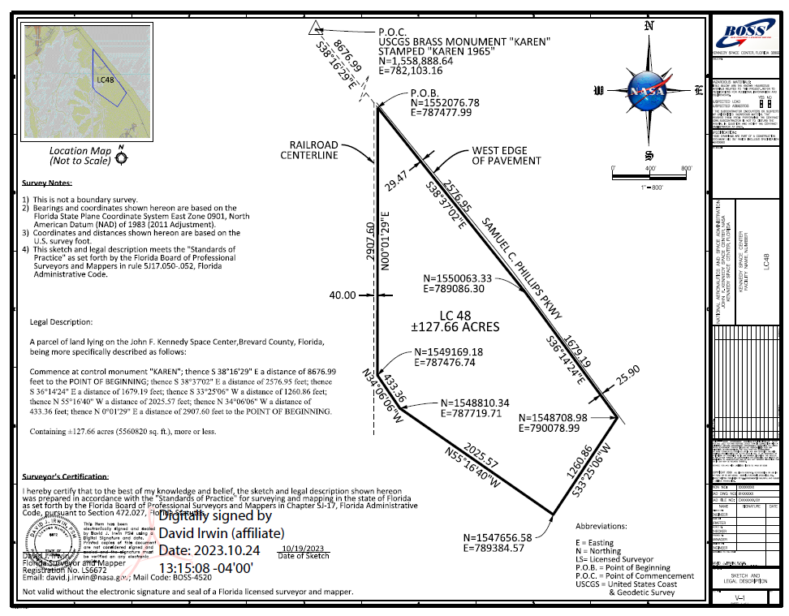

LC-48 North Legal Description

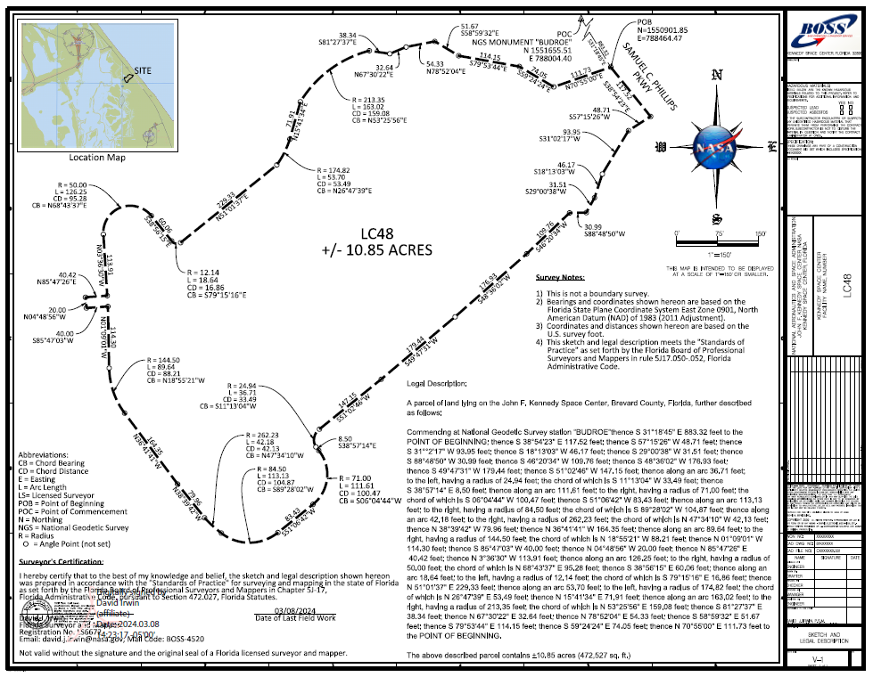

LC-48 Site Boundary Parcels

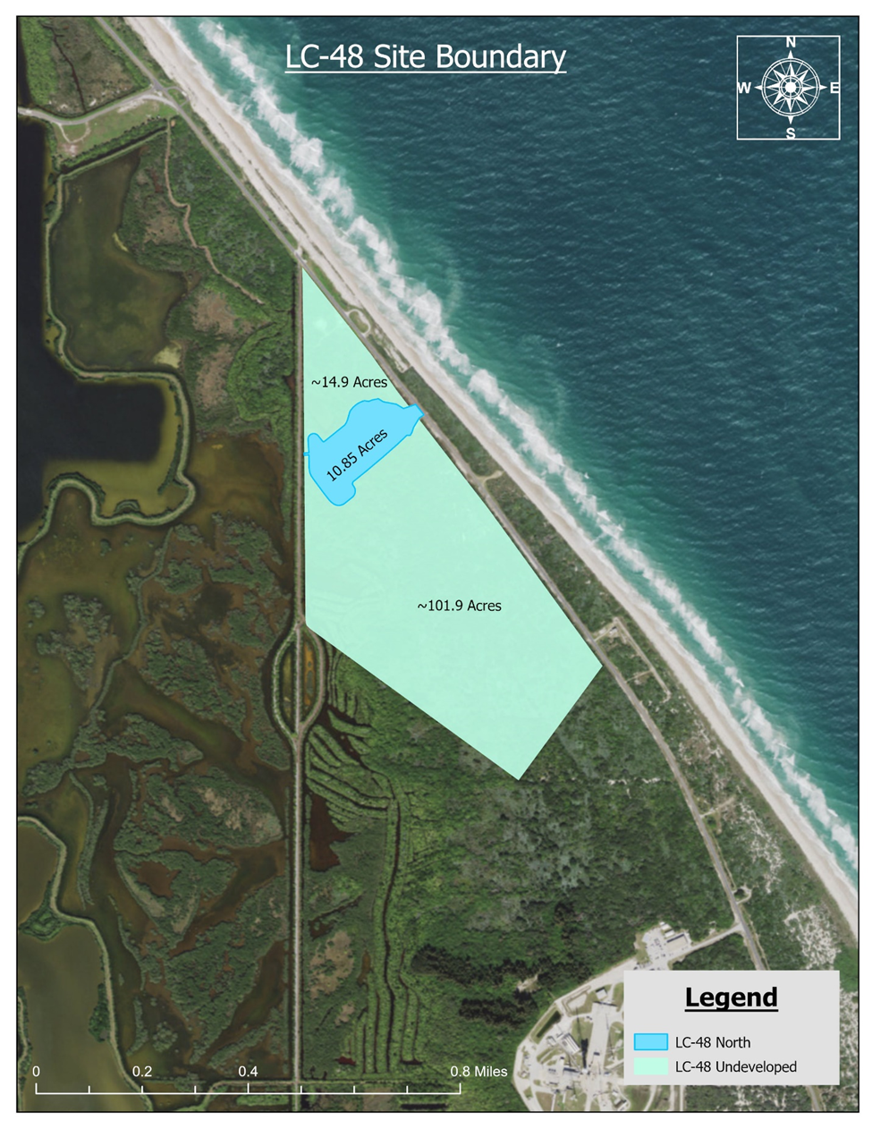

LC-48 North Existing Infrastructure (scale drawing)

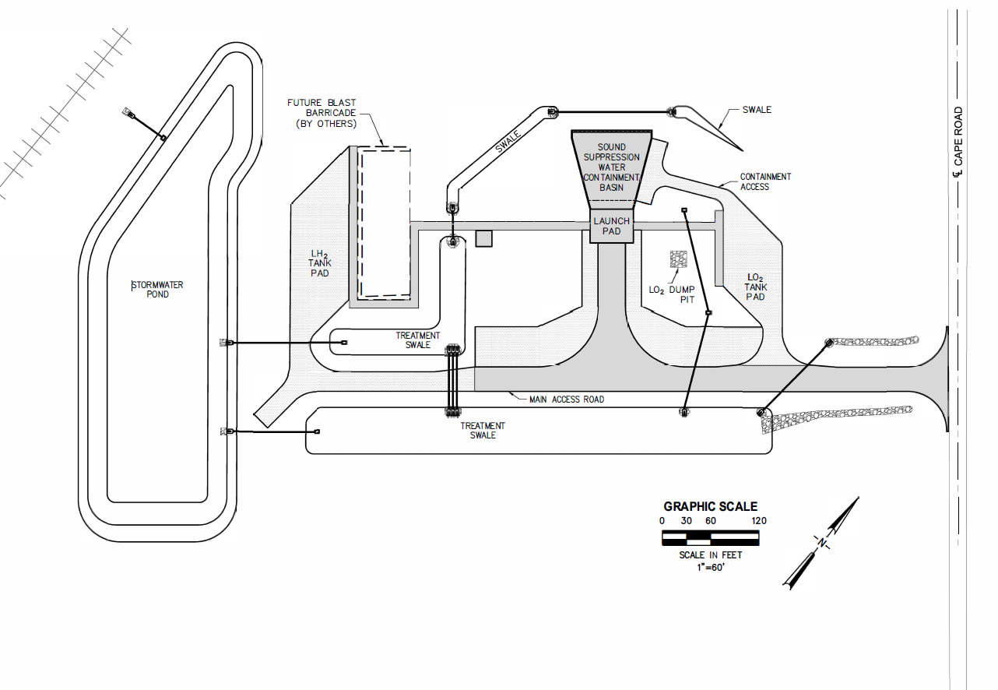

Refer to page 8, Table 2-1 of Attachment B.1-Environmental Assessment.
Support Amount will be in addition to the Base Rent. It is currently 15.9% of the Base Rent and Participating Rent and is subject to change. This amount is used to maintain Center infrastructure that is used by all tenants. Finally, any changes or demand services may be provided through an RSAA as described herein upon request.

