STATEMENT OF WORK

OMAHA AND FORT MCPHERSON NATIONAL CEMETERIES
INTERMENT, GROUNDS MAINTENANCE

DESCRIPTION OF SERVICES

The Contractor will provide all management, manpower, supervision, equipment, materials and supplies necessary to provide interment of casketed remains into pre-placed crypts (PPCs), conduct traditional casketed interments, interment of cremated remains in-ground, interment of cremated remains into columbaria, grounds maintenance, facility cleaning and maintenance, and headstone and monument cleaning and alignment services as described herein. The Contractor will comply with all applicable Veterans Affairs, National Cemetery Administration, Omaha National Cemetery Complex (ONCC) Directives, Handbooks, Policies and Standing Operating Procedures (SOP) for all work performed including applicable OSHA safety requirements and NCA Operational Standards and Measures. The Contractor will also adjust/modify work procedures, as required, to comply with updates, changes or additions to Policies, Procedures, Directives, Handbooks, etc., from the VA, NCA, ONCC and or OSHA. The contractor is responsible for maintaining hearing conservation program within OSHA Standards, conducting safety training monthly and providing supporting documentation as requested by the Contracting Officer’s Representative (COR). Work on this indefinite delivery indefinite quantity contract will be performed at Omaha and Fort McPherson National Cemeteries and includes all current and future expansions that may be performed during the contract period. All acreage measurements throughout this Statement of Work (SOW) are estimates and it is incumbent upon the Contractor to conduct a site survey or walk through to determine work to be performed and in either case Contractor is responsible for performing the complete task within the area described therein. The contractor is responsible for committing sufficient resources to maintain operational pace and workload increases throughout the work period. Work under this solicitation is expected to commence on or about September 1, 2025.

BACKGROUND

National Cemeteries are National Shrines that honor our Veterans with a final resting place and lasting memorials that commemorate their service to our Nation. The cemeteries conduct both casketed and cremation burials, receiving many visitors, therefore, standards of maintenance & appearance must reflect the Nation’s concern for those interred there. Because of the special significance and attention each national cemetery receives from the public, strict adherence to contract specifications, terms and condition is essential.

Every action by contractor personnel at a national cemetery must be performed with the special care, reverence, dignity, and respect that acknowledges the cemetery as the final resting place that commemorates the service and sacrifice that service members, Veterans and their families made for our Nation. Critically important is the awareness required of the Contractor employees of the remains buried in the grounds where the work is performed. The utmost care must be given to these remains and the headstones and grave markers that mark those gravesites and memorialize the service of individuals.

General Requirements

- All work will be performed during normal cemetery hours of operation, 8:00am - 4:30pm local time Monday through Friday. Work performed outside of normal work hours may be required for interments or ceremonies on Federal Holidays or weekends at the discretion and approval of the VA Contracting Officer’s Representative (COR). The contractor may make a written request to the COR to work outside of the normal work hours when needed to carry out the specifications of this contract. The contractor must conduct services outlined below and according to the contract during all interment and operational days when the cemetery is open regardless of weather conditions. Contractor must maintain a minimum of 2 personnel (one supervisory such as a foreman or work leader) capable of performing statement of work tasks at each site during cemetery operating hours.

- The contractor will ensure that all personnel performing the application of fertilizers, pesticides, and herbicides maintain applicable Nebraska State licenses throughout the performance of the contract. Certifications will be provided to the government prior to start of contract.

- Contractor will provide resumes of foremen that are providing daily oversight of work crews performing work under the contract at both Fort McPherson National Cemetery and Omaha National Cemetery showing a minimum of five (5) years work experience in cemetery operations. Work experience must show five (5) years of work experience in casketed and cremation burials and headstone setting operations in National Cemeteries.

- Contractor will ensure the foreman listed above in paragraph (c) is present at each cemetery whenever the contractor is performing work.

- The contractor will submit all invoices to the government for payment prior to the 5th day of the month following work performance.

- Federal Holidays: All work required under this contract will be performed during normal cemetery hours of operation, which may include Federal Holidays and Weekends. The following is a list of all Federal holidays:

New Year's Day  Martin Luther King's Birthday  President's Day  Memorial Day  Juneteenth  Fourth of July | Labor Day  Columbus Day  Veterans Day  Thanksgiving Day  Christmas Day

- Place(s) of Performance: Omaha and Fort McPherson National Cemeteries.

Cemetery | Location
Omaha National Cemetery (hereafter called “ONC;” 49 developed acres, with active interments and approximately 5,600 burial sites with headstones and columbarium niches). | 14250 Schram Road  Omaha, Nebraska 68123  (402) 253-3949
Fort McPherson National Cemetery (hereafter called “FMNC”; approximately 23 developed acres, with active interments and approximately 9,700 burial sites with headstones and columbarium niches) | 12004 South Spur 56A  Maxwell, NE 69151

SECTION a: Technical Specifications

The following list, with subsequent corresponding descriptions of services, describe the contract requirements.

Section | Description
A.1 | Transport Urn and Floral Arrangements, tagging of floral arrangements, completion of "chain of custody documents, Place Urn into Columbarium, gather and submit GIS/GPS data and replace niche cover and temporary tag, for all interment days including weekend and Holiday burials, includes first and subsequent interments/ reinterments and dis-interments. (FMNC CLIN 0029)
A.2 | Transport Casket and Floral Arrangements from Committal Shelter, completion of "chain of custody documents, and Place Casket onto lowering device over gravesite for all Casket interments including weekend and Holiday burials, includes first and subsequent interments/ reinterments and dis-interments. (ONC CLIN 0001)
A.3 | Remove Sod, excavate assigned casket and cremation gravesite, place and lower casket/urn, gather and submit GIS/GPS data, backfill grave, tamp grave, place Temporary Marker on gravesite, and properly dress gravesite with approved materials to cover exposed soil and or sod replacement. Transport Casket and Floral Arrangements from Committal Shelter, and Place Casket onto lowering device over gravesite. Tag floral arrangement with grave number and completion of "chain of custody" documents, includes first and subsequent interments/ reinterments/ dis-interments, weekend and Holiday burials: (FMNC CLIN 0030, 0031; ONC CLIN 0004 - Sod remove and replace; no excavation)
A.4 | Headstones – receiving shipments, storage, initial setting within 10 calendar days, replacing within 10 calendar days (setting R2’s) replaced headstones (ONC CLIN 0002and FMNC CLIN 0032) DAVIS BACON ACT WAGES APPLY
A.5 | Headstone Destruction (ONC CLIN 0003 FMNC CLIN 0033)
A.6 | Committal Shelter/Flag – Daily Set-up and Cleaning, and Lowering and Raising U.S. Flag for all interment days including weekend and Holiday burials as required: (FMNC CLIN 0034, ONC CLIN 0006 - Committal shelter clean only)
A.7 | Committal Shelter Glass Wind-wall Cleaning (ONC 0007 FMNC 0033
A.8 | Mow and Trim ALL turfgrass areas including headstones; edge all sidewalks, roads, tree rings, beds, and flat markers; blow/sweep/remove debris. (ONC CLIN 0008 and FMNC CLIN 0036)
A.9 | Mow Native (Prairie) Grass and Unimproved Native Turf Areas around perimeter of FMNC (ONC CLIN 0009 and FMNC CLIN 0037)
A.10 | Fertilizer: Provide and Apply ALL turfgrass areas (OCT, JUNE, SEP.) (ONC 0010 and FMNC 0038)
A.11 | Pre/Post-emergence Herbicide: Provide and Apply All turfgrass areas (APR, MAY, JUN, OCT) (ONC CLIN 0011 FMNC CLIN 0039)
A.12 | Prairies Grass Thistle Herbicide: Provide and apply. (ONC 0012 FMNC 0040)
A.13 | Core Aeration of all turfgrass areas: (ONC CLIN 0013 and FMNC CLIN 0041)
A.14 | Overseed all turfgrass areas: (ONC CLIN 0014 and FMNC CLIN 0042)
A.15 | Planting Beds and Tree Rings - 100% weed-free all planting beds and tree rings (ONC CLIN 0015 and FMNC CLIN 0043)
A.16 | Shrub and tree Maintenance - trim, prune/shape: (ONC CLIN 0016 and FMNC CLIN 0044)
A.17 | Japanese Beetle Control on Trees and Shrubs: (ONC CLIN 0017 and FMNC CLIN 0045)
A.18 | Grub Insecticide: Provide and Apply to All Turfgrass Areas: (ONC CLIN 0018, FMNC CLIN 0046)
A.19 | Turfgrass Renovation: (ONC CLIN 0019 and FMNC CLIN 0047)
A.20 | Cleaning All Paved Areas (road, sidewalks, parking lots, staging areas, etc.), including weekends and Holidays (FMNC CLIN 0048 and ONC CLIN 0020)
A.21 | Trash and Debris Removal from any/all cemetery grounds: (ONC CLIN 0021 and FMNC 0049)
A.22 | Fall Leaf Removal (ONC CLIN 0022 and FMNC CLIN 0050)
A.23 | Pressure Wash Committal Shelter, Columbaria, hardscapes, administrative building and window cleaning for all buildings. (ONC 0023 and FMNC CLIN 0051)
A.24 | Snow Removal (ONC CLIN 0024 and FMNC CLIN 0052)
A.25 | Salt (Magnesium Chloride) application for Ice removal and prevention (ONC CLIN 0025 and FMNC CLIN 0053)
A.26 | Headstone Cleaning: (ONC CLIN 0026 and FMNC CLIN 0054)
A.27 | Headstone Fine Tune Alignment (ONC CLIN 0027 and FMNC CLIN 0055)
A.28 | Headstone Raise & Realignment (ONC CLIN 0028 and FMNC CLIN 0056) DAVIS BACON ACT WAGES APPLY
A.29 | Sunken Grave Repair (FMNC CLIN 0057)
A.30 | Irrigation System – Full operation and maintenance, including repairs to maintain operation and adjustments as necessary, Fall Shut-Down, Spring Start-Up, Backflow Testing (FMNC CLIN 0058)

A.1 Transport Urn and Floral Arrangements, tagging of floral arrangements, completion of "chain of custody documents, Place Urn into Columbarium, gather and submit GIS/GPS data and replace niche cover and temporary tag, for all interment days including weekend and Holiday burials, includes first and subsequent interments/ reinterments and dis-interments. (FMNC ONLY)

Work consists of verification, transfer of remains and opening and closing the niche under the direction of the Contracting Officer’s Representative (COR). The National Scheduling Office will schedule committal services (i.e., services held at the committal service area) Monday through Friday and some weekends where Federal Holidays require Saturday burials. The Contractor will provide interment services described herein, with preparation services performed before these times and interment services accomplished after the committal service is complete.

The Contractor will be responsible for the opening and closing of graves/columbarium niche and transfer of the remains in a dignified manner according to ONCC Standard Operating Procedures (SOP) from the committal service area and into the proper gravesite/niche following all NCA policies including verification processes. Contractors will also comply with all safety measures set forth by NCA and ONC policy and Standards and Measures in addition to current applicable OSHA standards for all procedures conducted on Cemetery grounds. The contractor will communicate with the Contracting Officer’s Representative (COR) to allow for 2nd verifications to be made, ensuring the proper niche covers are removed. Only upon request by the COR will the Contractor move remains. Remains must be accounted for once they have entered the cemetery until they are properly placed in the columbarium niche. Upon proper notification by COR, the Contractor will be required to transport and place the remains into niche in a safe and efficient manner, with dignity, and without damage to urn. Contractor will also properly document location and take photos using the GPS/GIS system along with chain of custody documents provided in compliance with NCA policy and directives.

The contractor will verify decedent information using cemetery gravesite verification and accounting for remains SOP. This is a critical step for ensuring the remains are placed in the correct gravesite.

All floral bouquets and arrangements left by the funeral party will be tagged with the appropriate niche number, then moved to and neatly arranged below the niche beside the columbarium wall. Stands for floral arrangements will be removed prior to placement at the columbarium. Floral arrangements will be removed by the contractor when they become unsightly. After the committal service, COR will notify Contractor if any items are to be removed after verifying with funeral party.

A.2 Transport Casket and Floral Arrangements from Committal Shelter, completion of "chain of custody documents, and Place Casket onto lowering device over gravesite for all Casket interments including weekend and Holiday burials, includes first and subsequent interments/ reinterments and dis-interments. (ONC and FMNC)

Work consists of transporting the casket and floral arrangements from the committal shelter to the burial section.

The Contractor will provide a minimum of four (4) employees and a clean, serviceable, and safe vehicle, equipped with casket rollers, to remove the casket and or urn from the committal shelter and transport the remains to the burial section in a dignified and respectful manner.

For ONC – the Contractor will make an audible confirmation of remains identification with government employee and then place the casket onto the lowering device and complete chain of custody form and then depart the burial section. The Government will then complete the interment process.

For FMNC – the Contractor will maintain custody but will make an audible confirmation of remains identification with government employee and then sign the proper chain of custody form and complete the interment process.

The Contractor is responsible for transporting the floral arrangements from the committal shelter to the burial site and will tag floral arrangements to identify which grave/decedent they belong with for both cemeteries.

The driver of the vehicle must possess a valid state driver’s license.

Contractor will be provided with a cemetery radio and a daily interment schedule to prevent delays. The Contractor personnel will report to the committal shelter for remains transportation as discreetly as possible and no more than 10 minutes after the committal service concludes. Contractor personnel must be in clean, presentable uniforms.

A.3 Remove Sod, excavate assigned casket and cremation gravesite, place, and lower casket/urn, gather and submit GIS/GPS data, backfill grave, tamp grave, place Temporary Marker on gravesite, and properly dress gravesite with approved materials to cover exposed soil and or sod replacement. Transport Casket and Floral Arrangements from Committal Shelter, and Place Casket onto lowering device over gravesite. Tag floral arrangement with grave number and completion of "chain of custody" documents, includes first and subsequent interments/ reinterments/ dis-interments, weekend, and Holiday burials: (FMNC; ONC Sod remove and replace only; no excavation)

Turfgrass sod over cremains and casket burial sites will be removed by the Contractor, then later placed on the gravesite to conclude the backfill operation. Contractor will provide new sod in cases where the existing sod/turfgrass is not suitable to be replaced on the gravesite. Care must be taken to keep the final grass surface smooth and graded with the surrounding area, and to best facilitate re-establishment of the turfgrass. The Contractor will prepare the gravesite with topsoil (tamp, level, and rake). Contractor will remove sod prior to opening gravesites in both FMNC and ONC and set aside (in growing season) for replacement back on gravesite upon closing and dressing of gravesite. The contractor is responsible for taking necessary steps to re-establish sod on gravesites. Sod will be hand-watered daily until sod is fully established; the irrigation system will not be used for the purpose of establishing sod on individual gravesites. If sod fails to take and blend with adjacent turf within three weeks (21 days), the contractor is responsible for providing and replacing sod and ensuring gravesite has well maintained appearance that blends with adjacent turf. No gravesite will have bare areas. An exception to the sod requirement is during winter/non-growing season; during this time, the contractor will maintain the appearance of the gravesites by placing mulch to reduce mud and an unkept appearance. When the growing season begins, the contractor will remove the mulch and will provide and replace sod on all winter graves within 30 days on the gravesites where there has not been any sod placed and will replace sod that fails to re-establish.

All gravesite excavations for casketed and cremated remains (cremains) will be completed no less than one and one-half (1 ½) hours prior to the committal service. Gravesite excavations will not be performed prior to the duty day without prior approval from the COR/Site Manager. If a private concrete vault is to be used, the gravesite excavation will be completed to allow the vault to be pre-set in the grave one (1) hour prior to the service. Each new gravesite will be finished and ready for viewing by the next of kin (NOK) no later than one and one-half (1 ½) hours after the committal service.

It will be the COR’s responsibility to notify the Contractor of any underground utilities in the vicinity of gravesite excavation. In turfgrass areas, prior to permitting excavation equipment in the burial section, the Contractor will provide and place turf protection mats/panels along the path of entry to the gravesite and on the turf area surrounding the gravesite to protect the turf from damage from the equipment used to excavate the graves, exceptions will be requested through the COR/Site Manager on a case-by-case basis.

Gravesites measure 3’ x 8’ for preplaced crypts and 4’ x 10’ for traditional and oversized preplaced crypts, 3’ x 3’ and 4’ x 4’ for in-ground cremation. Older sections of FMNC have gravesites of varying sizes. The COR will advise the Contractor on the required type (See below), depth, and position prior to any excavation or niche opening operation. The contractor should probe all full interments prior to excavation to assure adequate depth for 2nd interment. COR will be notified immediately of insufficient depth to accomplish interment.

- Caskets, Traditional: The graves will be excavated to five (5) feet in width by ten (10) feet in length and to a depth of eight (8) feet (first interment) or to five (5) feet (second interment), to be determined by the COR.

- Caskets, Crypts (Pre-Placed Crypts -PPCs): The graves will be excavated to three (3) feet in width by eight (8) feet in length and to a depth sufficient to expose and allow the lifting of the crypt lid.

- Cremains, In-Ground (IGC): The graves will be excavated to approximately 18 inches square and three (3) feet deep, or to a depth to ensure there is at least 18 inches of fill on top of the Urn.

- Cremains, Columbarium: The niche cover will be removed momentarily in preparation to receive the cremation urn.

When a grave is opened to receive a second interment and is found to be of insufficient depth to permit interment due to an existing vault, poly or concrete liner, or casket not being deep enough, the Contractor will notify the COR or Cemetery Director immediately. After notification to the COR and or Cemetery Director and with their approval, the remains of the first interment will be removed and the grave excavated to a depth to accommodate both interments.

All excavated soil will be removed from the gravesite area prior to the scheduled interment and brought back in to backfill the grave. Excess backfill may be stored in the cemetery spoils area; however, once this area becomes full, it is the Contractor’s responsibility to remove excess backfill and spoils from the Cemetery and properly disposed of at the Contractor’s expense.

For burials in pre-placed crypts (PPCs), the Contractor will excavate down to the crypt lid and remove the crypt lid using appropriate and safe techniques. All lifting and lowering straps/devices will be provided by the Contractor and must be inspected and properly tagged/marked according to NCA safety and OSHA regulations. The contractor is responsible for providing a lift capable of lifting vault lids with side slots and must be rated at 3,000-pound capacity total. Chains and other components within the assembly must not reduce the capacity total. A spotter MUST be always present during the operation of an excavator or similar heavy equipment within any burial section on cemetery grounds. At least one person with proper Personal Protective Equipment (PPE) will assist the equipment operator with the lid lifting device and spotting the operation. The spotter will ensure the strap or chain hooks/vault lid lifting device is/are seated safely to the four attachment points. At that time the spotter will move safely out of the grave and assist with guiding the lid as the equipment operator carefully lifts the lid off the crypt and to the side of the excavation. The operator will lift the lid straight up and ensure the lid does not swing excessively while moving it to the side.

When the grave is opened, the Contractor will be responsible for removing any headstone(s) needed to ensure access for the vault and the remains and subsequently reinstalling headstone(s) removed. All open excavated graves, including pre-placed crypts, will be properly protected, and secured to prevent unauthorized access to the excavation by visitors, NCA staff, or contractor employees.

The Contractor will transfer the remains in a dignified manner from the committal service area to the proper gravesite following all NCA policies. The Contractor will be required to lower casketed remains into the gravesite with a mechanical lowering device (Contractor furnished) in a safe and efficient manner, with dignity, and without damage to the casket. For burials in pre-placed crypts, the Contractor will lower casketed remains directly down into the open crypt, place the provided inside shelf (divider) and position the concrete lid bevel along the entire perimeter.

The Contractor will be required to place the government-furnished poly or concrete liner around the casket for a traditional gravesite. Backfill material immediately between the government-furnished poly or concrete liner and the excavation will be sufficiently non-compressive to allow for more solid compaction without the aid of equipment to reduce subsequent ground settlement. The material should be relatively uniform in size to aid in self-compaction and large enough to avoid migration into surrounding soils, for example, sand.

Backfill material on top of the government-furnished poly or concrete liner and or on top of the concrete lid will be sufficiently pliable to allow voids to be filled for more solid compaction to reduce subsequent ground settlement. Backfill will be brought to an established grade in one (1) foot lifts, maximum. Each lift will be thoroughly compacted by means of an approved mechanical or hand tamper. Backfill should not be mounded but should conform to existing grades. The Contractor will remove all unusable dirt, rocks, roots, and other types of objects from the cemetery grounds.

If the excavation is five (5) feet or deeper, a worker is prohibited from entering the gravesite until the sides of the grave are stored in a safe manner in accordance with OSHA standards.

If the grave has an existing headstone, it will be removed and carefully placed in an area near the gravesite on a stand such as 4” x 4” blocks and covered with proper protection. If the gravesite is a casket, then the headstone may be placed on top of the PPC and covered when backfilled. If the site is an IGC, then the headstone will be removed from the site and destroyed so as to no longer be recognized or legible in any way (to the satisfaction of the COR) and then the fragments disposed of properly. The Contractor must place a new temporary marker with both names (first and second interment in accordance with proper NCA policy), centered and level in place of the previous headstone.

As backfilling is completed and compacted, the remaining three (3) inches will be filled with topsoil and then place the sod and ensure level and with grade.

The Contractor will place the temporary marker on the grave so that it is in alignment with other temporary markers and other headstones ensuring an aligned, dignified, and uniform appearance.

All floral arrangements left at the gravesite by the funeral party will be neatly arranged upon the grave and removed when they become unsightly. All stands from floral wreaths will be removed prior to placing the wreath flat on the grave.

See below for gravesite diagram and handling of multiple interments. The conditions in diagram “D” will occur only rarely, usually when the minor dependents predecease their parents or in extremely rare cases when an accident takes the lives of a family group. When the remains are in a small casket (diagram “E”), they will be placed in the lower corner of the gravesite, at a depth of eight (8) feet, permitting room for an additional like burial at the head of the first at a depth of eight (8) and the second at five (5) feet.

When it is necessary to make side-by-side burials in a single gravesite, extreme care will be exercised to accurately locate the sideline of the site. Where a burial vault or poly or concrete liner is used in such cases, it may be necessary to encroach several inches on adjacent site(s). This is permissible provided the site encroached upon has been or will be utilized as shown in diagram “A” or “B” below.

Unusual conditions may require occasional deviations from the methods indicated. For cases not covered herein, the Contractor will consult with the COR for advice on determination of action to be taken. The contractor is responsible for performing the movement of caskets and or vaults and urns where necessary for second/subsequent interments and for the opening and closing of gravesites for the facilitation of dis-interments when requested.

Casket or cremated remains may on occasion be removed from the national cemetery upon request of the next of kin. When this is allowed, the Contractor will be notified of the name, gravesite number, date, time, and the entity removing the remains.

Special care will be shown to adjacent graves and headstones to avoid or minimize damage. The contractor will reopen the grave to one (1) foot above the top of the casket or casket container. Family-contracted personnel (e.g., Funeral Home), will complete the disinterment, including removal of liner/vault, removal of casket and or remains. Cemetery contracted staff are prohibited from any activities other than the opening of the grave other than to close the grave in accordance with proper procedures outlined above as when interring remains.

Cremated remains that are inurned may be fully uncovered. Contractor will not remove urn/liner or otherwise participate in any other aspects of the disinterment operation. Only family contract personnel and or family members are authorized to remove the container. Following the disinterment, the Contractor will return the gravesite to normal by backfilling and removing the headstone or marker and conducting proper disposition of the headstone or marker in accordance with NCA and Cemetery Policy.

Damaged urns/containers will be reported immediately to the COR and or Cemetery Director.

The contractor will also properly document location and take photo using the GPS/GIS system provided in compliance with NCA policy and directives.
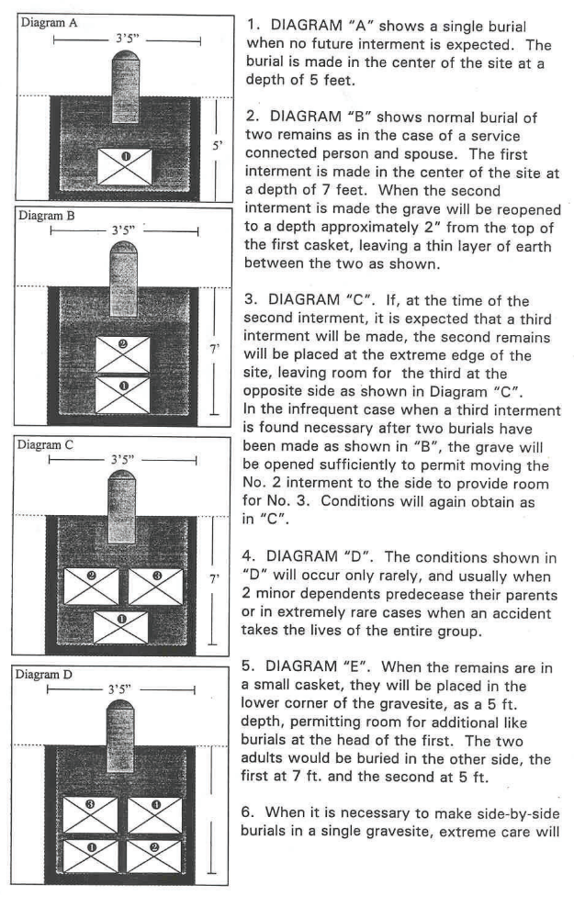

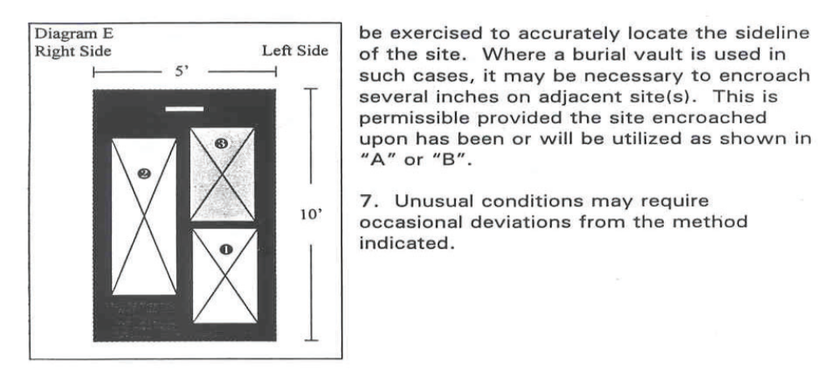

A.4 Headstones – receiving shipments, storage, initial setting within 7 calendar days, replacing within 7 calendar days (setting R2’s) replaced headstones (ONC and FMNC)

Work consists of setting new or replacement headstones on gravesites and realigning those already in place that have shifted out of vertical or horizontal alignment. It includes reporting physical defects to the COR. Approximately 750 (ONC) and 250 (FMNC) headstones will require setting annually and approximately 200 will require removal and replacement annually between both Cemeteries. The contractor will make every effort to ensure proper square, location, and alignment of all headstones installed. When headstones are set that are determined to not be in compliance with the standards below by the COR, the Contractor will make the necessary adjustments at no additional cost to the Government to ensure compliance within 14 Calendar Days.

Upright white marble headstones (provided by NCA/Cemetery) are to be used at both Cemeteries as determined through direction of the National Cemetery Administration, Central Office (in accordance with the general plan of the cemeteries). Headstones will be installed within seven (7) calendar days of delivery or within the sixty (60) day period from date of order, whichever comes first. Standard upright marble headstones are approximately 42 inches long x 13 inches wide x 4 inches thick and weigh approximately 230 pounds.

The Procedure for Headstone Setting and the replacement of Headstones is as follows:

- The responsibility for ordering headstones, checking for proper wording and initial inspection for damages will be that of the Government.

- Headstones/niche covers are received at each cemetery (ONC and FMNC) and unloaded by the contractor via forklift provided and operated by the contractor. Contractor personnel are responsible for the unloading of headstones from the delivery truck, inspecting the headstones for damage (documenting any damage and reporting to the COR immediately) and breaking down the pallet of headstones onto staging area racks and will remove glue, cardboard or crating material from the headstones that has adhered to the surface for COR quality and inscription inspection. Contractor is responsible for removal of all packing material and pallets from Cemetery property at Contractor cost using Contractor’s disposal containers. Headstones identified by the COR as damaged or after inspection of inscription as incorrect will be moved by the contractor to a designated area determined by the COR.

- Headstones will be properly set on the correct gravesites (gravesite location will be verified with the government prior to beginning installation) within seven (7) calendar days of delivery to the cemetery. In transporting or storage of headstones, they will be protected from the weather to avoid damage or staining from crating materials. Where there is a shortage of storage space and there is a wall or other substantial support at the storage area, the headstones may be stored by resting them on their bottom edge and leaning them against the wall at a safe angle. Several stones may be stacked against the first stone to conserve space with proper separation in all cases. If there is any breakage or damage in any form due to the Contractor’s handling or negligence, the cost of replacement will be borne by the Contractor. The COR will designate a suitable area for storage of stones at both ONC and FMNC. An inscription and quality inspection will be accomplished by the COR upon receipt. Defective headstones will not be set. Replacement headstones will be ordered by Cemetery staff.

- Headstones will be lifted and transported or set by at least two (2) people.

- Headstones will be properly set on the centerline of the grave, twelve (12) inches in from the head of the grave, with the inscription facing the grave or at a distance designated by the COR. Headstones will be set vertically plumb in all directions in all cases – in line vertically (top line), and laterally as well as diagonally with headstones of adjacent graves using top string line, front of headstone string line, and a side of headstone string line. Maximum vertical, lateral and diagonal (traverse) tolerance of any headstone off the alignment string lines and or marks will be less than 1/8”. All measurements and string line set ups and row layouts will be taken from established burial section layout control point grid monuments, not from previously set headstones.

- In irregular terrain where sloping and uneven ground conditions exist, all headstones and markers will be set at proper heights and levels to provide a flowing transition through uneven terrain unless otherwise specified by the COR. Headstones will be anchored firmly in place so that they are rigid with no give or play.

- If there are cases where headstone sockets need to be realigned/shifted, and or re-dug, the headstone sockets to receive headstones will be dug by hand and or mechanical devices to a sufficient depth so that 24-26 inches of the headstone is extending from the grade level to the top of the arc of the headstone. The Contractor will not dig a headstone socket wider than twelve (12) inches x twenty (20) inches in length or deeper than twenty (20) inches with aggregate that may cause the headstone to settle below height requirements.

- The alignment of the headstones should be checked frequently during this process because the tamping may move the headstone out of level or off the mark on the line. Upright headstones in all section will be firmly set and anchored in place with no movement from forces subjected by the COR.

- Headstones are to be set in the following manner:

  - On PPCs, sockets for headstones are to be dug down to the crypt lid, then, if needed to achieve the correct height, moistened, crushed limestone base material supplied by the contractor (graded aggregate sizes ranging from crushed powder fines up to 3/8 inch maximum) is to be added and tamped to full compaction in the bottom of each socket to the proper depth needed for the headstone to set on and extend 24-26 inches from the top of grade to the top of the arc on the headstone. After each headstone is placed into its socket and its correct height confirmed, moistened crushed limestone base material (same grading as above) is to be placed around all sides of the headstone and heavily tamped to full compaction at each three (3) inch interval, leaving the last four (4) inches at the top to have tamped topsoil and sod applied. During this process it is critical that proper plumb, alignment, and height be frequently checked, corrected, and ultimately achieved with each headstone rigidly set.

  - If a headstone is to be installed where there is no PPC or headstone containment box, the depth of the socket will be dug to a maximum depth of twenty (20) inches and then a minimum of three (3) inches of crushed limestone base material (graded aggregate sizes ranging from crushed powder fines up to 3/8 inch maximum) supplied by the contractor is to be heavily tamped to full compaction in the bottom of the socket to provide a footing for the headstone to set on, and to the proper depth so that 24-26 inches of the headstone extends from top of grade to the top of the arc of the headstone. After the headstone is placed in the socket and its correct height confirmed, moistened crushed limestone base material (same grading as above) is to be placed around all sides of the headstone and heavily tamped to full compaction at each three (3) inch interval, leaving the last four (4) inches at the top to have tamped topsoil and sod applied. During this process it is critical that proper plumb, alignment, and height be frequently checked, corrected and ultimately achieved with each headstone rigidly set.

  - On a precast concrete urn crypt, the precast headstone containment box is to be uncovered, and lid removed. The filter fabric lining within the containment box will be kept in place to cover the weepholes in the bottom. Ice (if present) will be removed by and at the contractor’s expense with either heat or de-icer, but not damage the containment box (hammer, chisels, such tools not to be used to remove ice considering the damage they may cause to the containment box). Moistened Crushed Limestone Base Material supplied by the contractor (graded aggregate sizes ranging from crushed powder fines up to 3/8 inches maximum) is to be added and compacted at the bottom, if needed for proper headstone height. After the headstone is placed into the socket and its correct height confirmed, Moistened Crushed Limestone Base Material supplied by the contractor (graded aggregate sizes ranging from crushed powder fines up to 3/8 inches maximum) is to be placed around all sides of the headstone and tamped to full compaction at each three (3) inch vertical interval to the top of the containment box. Care must be taken during installation or compaction to not break or crack the containment box. During this process it is critical that proper plumb, alignment, and height be frequently checked, corrected for, and ultimately achieved, with each headstone rigidly set.

  - Contractor will replace sod around the headstone so that the sod matches the grading of the surrounding area. Contractor will provide sod where the sod was damaged during removal or in the case of winter operations, the contractor will place mulch around the headstone to cover the area where the sod was removed. Contractor will remove the mulch and replace the sod once the growing season resumes.

  - The Contractor will report at the end of the day, no later than 3:30pm CST, on their daily headstone settings in writing to the COR.

  - Any headstones broken or damaged by the Contractor will be reported to the COR at time of discovery each working day to allow time for ONCC staff to make correction and to ensure the grave is properly marked. The Contractor will be responsible for the cost of the headstone replacement. All headstone replacements must be coordinated with the COR. Any grid or sectional monuments disturbed, displaced, or broken will be replaced by the Contractor at the Contractor’s expense. All grid or sectional monuments disturbed, etc., will be properly reset by a licensed land surveyor at Contractor’s expense. Curbs, roads, walks, turf, trees, utilities, etc. existing above and below the ground that are damaged or disturbed by the contractor during performance of contract work will be repaired at the expense of the contractor. Repairs to the above will be corrected by the Contractor within fourteen (14) workdays, unless otherwise agreed to with the COR.

  - Headstones will be removed from their sockets by using wooden, and or metal clamps. If metal clamps are used the area that contacts the headstone must be protected with a rigid fabric that will prevent damage and marking of the headstone. Clamps may be attached to a Bob Cat or similar Machine to extract headstone from socket. Use care not to scratch or damage headstones in any manner. The contractor is responsible for the correction and restoration to original condition all areas where damages were caused to turf and headstones during performance of this work.

  - Adjustment (raising, lowering, or otherwise realigning newly set headstones due to initial settling, improper compaction or contractor error will be the responsibility of the Contractor, and will be at the Contractor’s expense.

  - If there is a problem with realigning a specific marker, a report will be sent to the COR providing a detailed explanation, the reasons the marker was not realigned.

  - All headstones set by the Contractor will maintain the proper height and alignment for a period of 365 days from the date of install and compliance by the COR; any adjustment, raise, lower or realignment of headstones during this warranty period will be at the Contractor’s expense. Adjustment, raising, lowering and/or realigning newly set headstones due to initial settling, improper compaction or Contractor error will not constitute Headstone Raise, Lower, Realign, Reset, backfill as described in the Price/Cost Schedule and will be at the Contractor’s expense.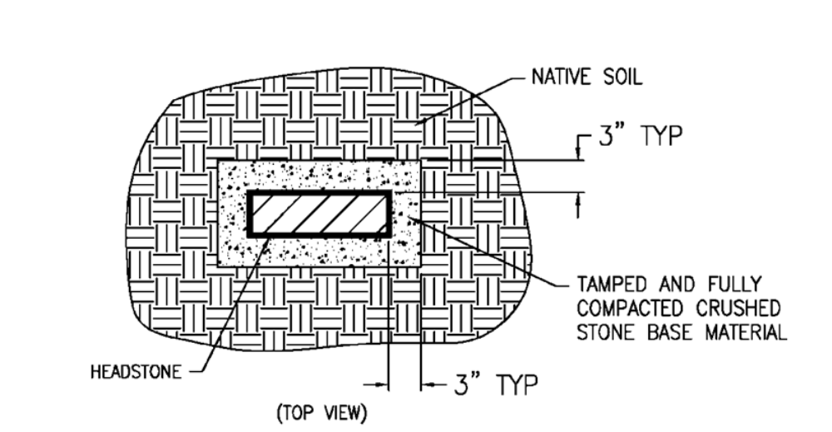

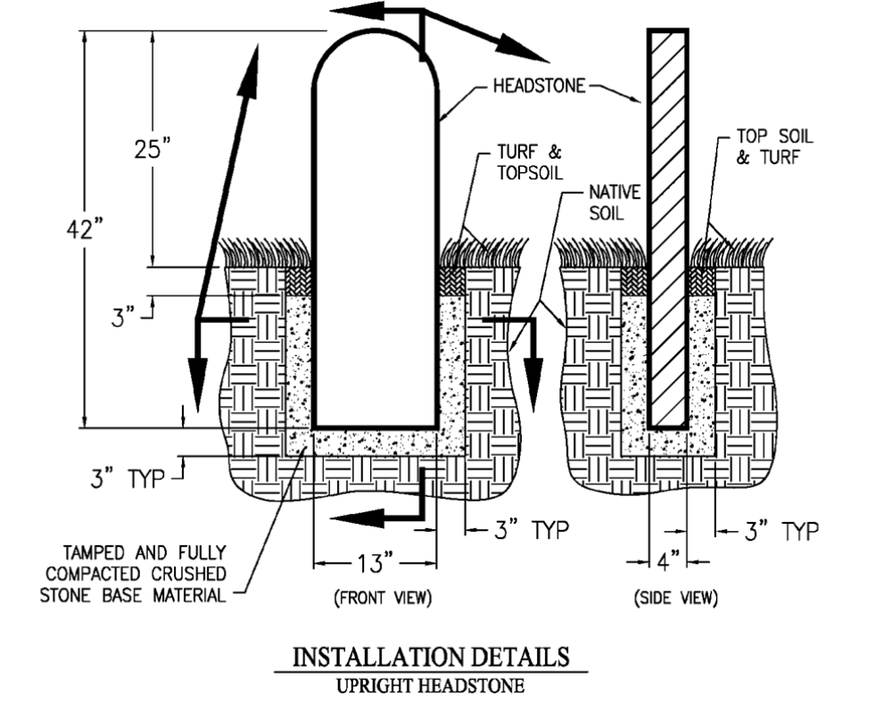

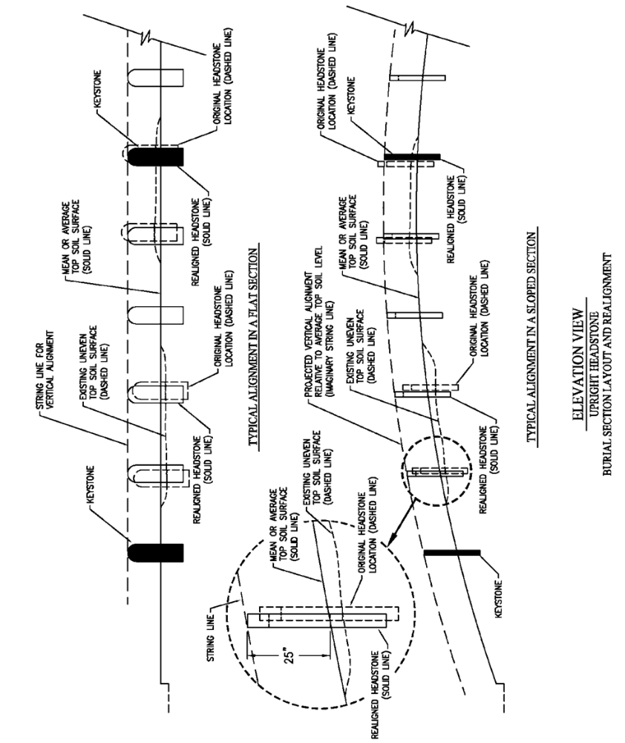

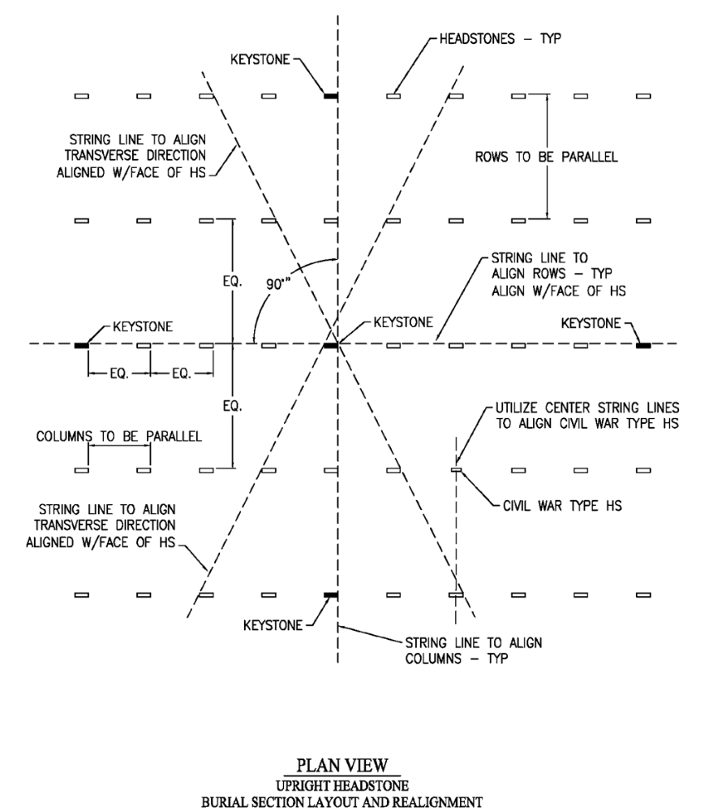

A.5 Headstone Destruction

Once the COR or his/her designee has identified a headstone for disposal (due to damage, inscription change, or second interment) the Contractor will take the following actions: Move the headstone to an area designated by the COR and out of the view of the public. Break the headstone into pieces using a maul or sledgehammer so that no part of the inscriptions are legible (no part of the identifying information will be legible, i.e. names, date of birth, death). Dispose of the broken headstone pieces at the contractor’s expense as coordinated with the COR. Headstones will not be used for any purpose other than their intended use. The Contractor will maintain a log of all disposed headstones. This log will track the Name, date of disposal and the location of disposed headstone and a copy will be provided to the COR on the last day of each month. The contractor is responsible for the removal and disposal of all headstone debris associated with the destruction of headstones (proving necessary receptacles and transportation off site to appropriate recycling center or dump); at a minimum, this waste will be removed monthly.

A.6 Committal Shelter/Flag – Daily Set-up and Cleaning, and Lowering and Raising U.S. Flag for all interment days including weekend and Holiday burials as required: (FMNC, ONC Committal shelter clean only)

The Contractor will maintain the committal service area clean and free of webs, nests (bird, insect, etc.) and other dirt or debris and will check and ensure cleanliness and proper setup/order before each committal service day or as required when debris is left by the prior party for both ONC and FMNC. Where there are glass doors/ wind-walls that have sliding tracks, the contractor will inspect and remove any buildup of dirt or debris in the tracks or path of doors to ensure smooth and proper function of sliding glass or other door types and movement. The contractor will initial the committal shelter checklist after each cleaning.

The Contractor will bring the flag of the United States of America (FMNC Only) to half-staff each day one-half (½) hour before the start of the first committal service and raise it to full-staff one-half (½) hour after the conclusion of the last committal service and all family members have departed the committal service area each day. The Contractor will also bring the US flag at FMNC to half-staff within one hour of notice by the COR, as authorized by a Presidential proclamation to commemorate the death of distinguished individuals, and the US flag will be returned to full staff when notified by the COR. The US flag will be flown during the hours of daylight and will be flown during non-daylight hours so long as at least two flagpole lights are functional between the hours of sunset and sunrise.

A.7 Committal Shelter Glass Wind-wall Cleaning

The Contractor will provide daily cleaning of all committal shelter glass windows/wind-walls. The cleaning will be completed one hour prior to the first service for each day. On days where there are no interments, the cleaning will be conducted at the direction and timing provided by the COR. The Contractor will ensure there are no water marks, streaking and other residue or buildup remaining on any of the windows/glass.

A.8 Mow and Trim ALL turfgrass areas including headstones; edge all sidewalks, roads, tree rings, beds, flat markers; blow/sweep/remove debris. (ONC and FMNC)

The Contractor will mow, which includes string trimming and edging in conjunction with each mowing - all turfgrass areas to present a well-manicured, neat, professional appearance always, in the same manner as a high-quality residential lawn under contract from a professional lawn maintenance service and in accordance with NCA Operational Standards and Measures Guidebook. A complete mow/trim/edge cycle is usually required each week during the growing season and to be considered a complete mow/trim/edge event, all turfgrass areas must be completely mowed/trimmed/edged and removed of debris within a one-week (Monday-Friday) period. Each burial section will be mowed/trimmed/edged and cleared of debris prior to moving to the next section. Mowed areas will be uniform in appearance, free of skips, gaps, scalping, rutting, bruising, and uneven and rough cutting.

Mowing:

- Mowing height will be as specified by the COR, generally 3.5-3.75 inches.

- Mowing frequency will be often enough that:

1) Excessive clippings are not generated, and
2) No more than one third of the grass height is removed per mowing.

If mowing is delayed by weather or some other reason and grass height becomes excessive, then mowing height will be increased so no more than one third of the grass height is removed, and it will then be mowed twice per week at a slightly lower height each time till the COR-specified target height is again achieved.

- Clippings will normally be left on the turf if they are well dispersed and don’t inhibit grass growth or detract from the appearance of the cemetery, but excessive quantities or accumulations of clippings will be dispersed or removed. Windrows or clumps will not remain after mowing but will be promptly dispersed or removed. Any grass clippings on headstones, flat markers, monuments, mulch beds, or impervious surfaces such as walks and roads will be blown or swept onto adjacent turf, or collected and disposed of, before workers leave the section being mowed. Any clippings or edgings deposited on sidewalks or at public visitor areas including the Committal Shelter areas will be removed (by sweeping or mechanical blower) at same time mowing work is occurring.

- Contractor is responsible for collection and disposal of all unsightly flowers, debris, and trash before and after each mowing and trimming event within the Cemetery. Debris and Trash is any item, material, or foreign object not permanently attached to or planted within the Cemetery grounds and boundaries. Items include, but are not limited to, fallen twigs and branches that are under ten (10) inches (25.40 cm) in diameter, paper products, cigarette butts, gum, glass and metal products, plastic and any other synthetic items, loose rock and stone over three (3) inches (7.62 cm) in diameter that are not the apparent result of an interment.

- Mowers will be commercial grade and designed to produce a professional, high-quality cut, and they will be properly maintained and adjusted. Rear or Mulching decks are required on all mowers to assist in keeping headstones free from debris.

- Mulching blades will be used and will be kept sharp (sharpened and balanced prior to each mowing cycle), so grass is cut cleanly, not torn, or shredded. Push mowers will be used in selected locations designated by the COR where there are numerous monuments or other obstacles.

- Mowing direction will be changed or reversed from one mowing cycle to the next, wherever doing so is practical. Mowers will not be operated within 12 inches of monuments, tree trunks, or other vertical surfaces.

- Mowing patterns in open areas will be deliberate, precise (straight lines), and attractive to enhance the cemetery’s appearance. Mowing direction will be alternated between mowing events to prevent rutting/grooving.

- Mower ground speed (and turning) will be slow enough to provide a complete, clean cut, without turf damage. At turning areas, such as at ends of grave rows and around trees and other objects, mower operators will reduce ground speed and exercise care to prevent tearing or otherwise damaging turfgrass or creating turn or ring patterns in turf from the mower tires. This is especially critical when soils are wet. Any damage to turf from mower tires at these turn points will be repaired within 1/2 day of identification by COR.

- Floral and commemorative items on grave sites will be removed prior to mowing and trimming, and then replaced afterward in their same locations by the Contractor.

- Cleaning of mowing equipment will NOT be done on Cemetery property, and only clean equipment will be brought to the Cemetery to reduce the risk of introducing contaminant weed seeds in the cemetery turf.

- Newly repaired turf areas (newly sodded or seeded) will be mowed with a push mower until the turfgrass is well enough established that it will not be damaged by riding mowers per the COR’s guidance.

- Unsuitable mowing conditions are likely at times due to heavy rain, lightning, or other extreme conditions. The COR, Cemetery Foreman, or Cemetery Director has authority to stop work if conditions are such that work that day will do more damage than good to the Cemetery grounds or is dangerous to workers.

- The Contractor will take the utmost care not to damage headstones, markers, floral or commemorative items, structures, survey monuments, and irrigation equipment while performing mowing and trimming services.

- Contractor is responsible for removal and replacement of all lawn, shrubs, and trees due to damage by the Contractor. Contractor will provide replacement plants and will be of the same type and size. The Cemetery is responsible for plants damaged by the Cemetery or third parties, storms, flood or frost damage and trees beyond their normal life span.

- The Government will not be held responsible for any damage to the Contractor’s equipment, materials, supplies or the like which may result from vandalism, theft, etc. while on site.

String Trimming:

The Contractor will trim grass and vegetation around headstones and other upright surfaces and along planting beds and other edges and spots that mowers miss. Streaks or irregularities, uneven cutting, plowing, or gouging of the soil is unacceptable. Objects and areas to be trimmed around include headstones, section markers, monuments, trees, planting beds, shrubs, buildings, curbs/curbing, fences, walls, poles, signs, fire hydrants, parking lot bumper blocks, boulders, utility/valve boxes and covers. Where donor trees or ‘suckers’ have grown up from the base of trees, the trimming will be performed by the Contractor to remove them from the base of the trees without injuring or harming the trees or removing the bark, if the Contractor is unable to do so without causing damage, then another method will be used, such as by hand removal using pruners.

- Trimming height will be the same as mowing height, and no shorter. There will be no scalping.

- Trimming frequency is the same as mowing, and trimming will be considered a part of mowing, but mowing will be done first so trimming height can be matched to the mowed height.

- Clippings will be dispersed, removed, or mulched with mowers if visually objectionable after trimming, and before proceeding with work in other sections.

- All fuel cans must be kept, stored, carried, or used outside of turf sections and on hardtop or concrete surfaces.

- Caution will be exercised to avoid any damage to headstones, markers, monuments, building walls, trees, other desirable plant materials, or any other assets. Any damage will be promptly reported to COR.

- Equipment - commercial grade string trimmers will be used.

- String Litter - Trimmer string pieces (longer than short pieces of perhaps an inch or two long that break off with regular wear) will not remain on the grounds.

Edging:

The Contractor will blade edge all streets, roads, curbs, walkways, tree rings/wells, permanent building/structure lines, flat markers, and planting beds. Edging will provide a clear zone ½” wide by 2” to 3” deep with all vegetation removed from joints and cracks. Damage to asphalt/concrete will be avoided.

A.9 Mow Native (Prairie) Grass and Unimproved Native Turf Areas around perimeter (ONC and FMNC)

The Contractor will mow prairie grass areas as coordinated the COR using a flail or rotary mower to prevent musk and Canadian thistle from producing seed by removing flowering stocks (but not mowing off the lower leaves) and chop other overgrowth which may intercept herbicide spray. Mowing height may vary, but generally 6” – 8” or as coordinated with the COR. Native turf areas around the perimeter of FMNC will be mowed in conjunction with regular mowing of turfgrass at the direction of the COR.

A.10 Fertilizer: Provide and Apply ALL turfgrass areas (ONC and FMNC)

Fertilizer will be applied to all turfgrass areas at a rate of one pound of nitrogen per 1,000 square feet three times each year:

- Late May/early June,
- Early September, and
- Mid to Late October (or about the time of the final mowing for the season).

- Fertilizer will be applied with a properly adjusted and calibrated spreader. Overlap of spread pattern from adjacent passes will be adequate to ensure uniform application. Streaks appearing in turf any time during the year because of non-uniform application are not acceptable. Fertilizer deposited on impervious surfaces (walks/pavement) will be removed or blown onto the turf immediately following application. If weather conditions warrant, such as severe drought or extended wet conditions, applications can be delayed until conditions are suitable, with concurrence of the COR, but may not be made to frozen soil. The first seasonal application is near Memorial Day. Care will need to be taken to not interfere with Memorial Day preparations or events. Application could possibly be made prior to the week before Memorial Day, or soon after Memorial Day. Options for applying the May/early June fertilizer with pre-emergence herbicide or grub insecticide are mentioned below in those respective sections.

- The fertilizer will have the following properties:
- The nitrogen (N) content will be at least 18%.
- 50% or more of the nitrogen in the fertilizer will be in a slow or controlled-release form (e.g., sulfur coated, polymer coated, urea-form, isobutylidene diurea, etc.).
- Phosphate (P) percentage will be at least one fourth of the nitrogen percentage (examples below).
- Potash (K) content percentage will be one third or more of the N percentage (e.g., 16-4-8, 21-6-7, 20-5-10, 30-8-12 would all be acceptable).
- It will contain no iron (to prevent headstone staining).

- Variations of this regime may be approved by the COR, in consultation with the District Agronomist, if needed, based on soil test results or extreme weather conditions.

A.11 Pre/Post-emergence Herbicide: Provide and Apply All turfgrass areas (ONC and FMNC)

Pre-emergence herbicide (herbicide product will not be older than 1 year from date of manufacture, unless written approval is provided prior to application by the COR) will be uniformly applied to turfgrass areas twice per year for annual grassy weed control. Applications will be in April when soil temperature approaches that necessary for crabgrass germination, and again approximately seven weeks later in June. Either dithiopyr (e.g., Dimension) or prodiamine (e.g., Barricade) will be used at the maximum label rate allowed for the site.

- If approved by the COR, and the product is properly formulated, the spring fertilizer application may be combined with the pre-emergence herbicide applications if no more than one half of the spring fertilizer is applied at the early (March/April) time, and then the remainder applied at the regular time.

Post-emergence herbicide (herbicide product will not be older than 1 year from date of manufacture, unless written approval is provided prior to application by the COR) will be uniformly applied to turfgrass areas twice per year for annual grassy weed control in May and October or as coordinated by the COR. Post-Emergence weeds will be controlled by spraying turfgrass areas with the proper type and rate of herbicides that will control the weeds present (typically clover, dandelion, plantain, oxalis, chickweed, henbit, etc.). The spray mixture or herbicide product used will contain three or more ingredients effective in controlling broadleaf weeds.

- Spraying of all turfgrass areas will be done twice each year: in early-mid May to clean up weeds prior to Memorial Day, and in October to have maximum effect on perennial weeds and reduce winter-annual weed establishment. Weather and field conditions at the time of application must be favorable for herbicide efficacy, as well as for minimal risk of damage such as herbicide injury to off-target plants, or of equipment making ruts. Preparation of the spray mixture may be done on site but water availability at the cemetery is unknown at the time of the writing of this contract. Any re-treatment needed because of the Contractor’s failure to follow manufacturer’s instructions will be done at the Contractor’s expense.

A.12 Prairie Grass Thistle Herbicide: Provide and apply.

The Contractor will spray herbicide to control thistles in prairie grass areas as coordinated by the COR in mid- May. The contractor will coordinate with COR to confirm acreage, locations, and to confirm application prior to and after application. Use the maximum rate of Chaparral or Opensight herbicide (or approved equal) for Canada thistle control in non-crop or natural areas, which is 3.3 ounces of product per acre (equal to 2.046 oz of aminopyralid plus 0.312 oz metsulfuron methyl per acre). Spray volume must be 10 gallons per acre or more, and a crop oil concentrate or non-ionic surfactant must be included as prescribed by the label. Follow all label directions. Do not broadcast spray within 10 feet of trees to prevent non-target injury, though patches of thistles near trees may be carefully spot treated.

A.13 Core Aeration of Turfgrass: (ONC and FMNC)

Twice a year during the spring (usually April) fall (usually September) at the direction of the COR, the contractor will perform core aeration of all accessible turfgrass areas. A rotary, pull-behind core aerator may be used, but two or more passes may be required to achieve 12 holes per square foot. In all sections between and along adjacent headstones, extreme care must be taken to reduce the risk of damage to the headstones and markers. It is imperative that headstones, grave markers, and section markers not be chipped, scratched, or otherwise damaged in any way. Irrigation heads and other irrigation components in the cemeteries will be flagged prior to aeration and not damaged. Aeration cores are to be left on the turf surface. Contractor will clean any soil or other debris resulting from this operation off all roads and sidewalks immediately following the work. In addition, to prevent the importation of weeds or other pests, the equipment will be cleaned prior to bringing it to the cemetery.

Core depth – 3” or more
Dore diameter – 5/8 to 1.0 inch
Density – 12 or more cores per square foot

A.14 Overseed Turfgrass: (ONC and FMNC)

Contractor will uniformly overseed turfgrass areas to increase the density and overall health of the turf. This is generally done immediately after core aeration. The COR will notify the Contractor which sections of the cemetery and the number of acres that will be overseeded in a particular year. The Contractor will be responsible for obtaining the required seed in sufficient time for application.

- The contractor will use an approved RTF type tall fescue at a rate of 4 pounds per 1,000 sq. feet. The contractor will provide sufficient evidence that this rate has been achieved (bags used per section of turf is acceptable.)

- Care will be taken to ensure that seed lost to areas such as roadways and any other areas where turf is not intended will be kept to a minimum. Any seed on hard surfaces will be blown back into the turf before moving on to the next area.

A.15 Planting Beds and Tree Rings – 100% weed-free all planting beds and tree rings (ONC and FMNC)

Shredded hardwood, single ground, natural color mulch (not dyed) will be applied as needed but not less than all planting beds and rings one time each year (within a two week period prior to Memorial Day) to freshen the appearance of beds and maintain mulch depth at approximately 3 inches, with depth in tree rings diminishing up to the tree so as to not be piled against the base (trunks) of trees (i.e., mulch should lightly cover the soil near the trunk, but not be in contact with it). Existing mulch will be substantially removed to eliminate hardened and moldy mulch. If mulch builds up to greater than 4-inch depth remove enough old mulch to bring the depth to about 3 inches after adding new. Edge beds in conjunction with mowing to maintain clean/crisp and well-defined bed edges and remove encroachment of turfgrass and weeds. The contractor is responsible for maintaining all mulch and planting beds and tree rings supplied with mulch and 100% weed free.

A.16 Shrub and Tree Maintenance/Pruning/Shaping: (ONC and FMNC)

Maintain shrubs and trees in a healthy, attractive condition with hand pruning, shearing, and branch removal as necessary. Dead, diseased, crossing, and other problem branches will be removed by a properly trained employee. Natural shape and appropriate size of the species will be maintained. Trees will be trimmed in such a way as to keep the roadways free of overhanging branches which may impede traffic/cause damage to vehicles that may pass under the overhanging branches; however, the trees will not be cut back in such a way as to make them look unsightly or unnatural in their shape and appearance. Any issues/concerns on branch removal should be addressed through the COR for coordination and approval of the trimming plan. Non-flowering shrubs will be evaluated in early spring prior to growth and trimmed as coordinated by the COR to maintain healthy, uniform growth and appearance. Flowering shrubs will be trimmed/pruned as coordinated by the COR to maintain healthy, uniform growth, and appearance. Shrub areas will be kept free of shrub trimmings or any other debris. Shrubs will be properly fertilized two (2) times per year with proper slow-release type shrub fertilizer; one (1) application in Spring, and one (1) application in Fall.

A.17 Japanese Beetle Control on Trees and Shrubs: (ONC and FMNC)

If Japanese beetles become problematic, and with approval of the COR, spray shrubs or young trees on which they feed with an effective insecticide to prevent excessive damage by the beetles. Plant species likely to need treating in an outbreak are crabapple, ornamental cherry, dawn redwood and others.

A.18 Grub Control: (ONC and FMNC)

Granular Trichlorfon 6.2% (Dylox) will be provided and applied by the Contractor as a separate application from any other product at the direction of the COR, typically in June.

A.19 Turfgrass Renovation: (ONC and FMNC)

For areas where turfgrass has been damaged or died, or the smoothness of surface disrupted such as by a sunken grave, the Contractor will restore that area to match the surrounding grade and type and quality of turfgrass, which will be free of weeds or non-matching grass. Quality topsoil will be used for any fill that is needed, and the soil will be appropriately compacted to prevent additional settling. Starter fertilizer will be used to help re-establish the grass. Generally, new sod will be used in reestablishing the turfgrass, but the COR will provide guidance if seed should be used instead, or if existing sod may be cut and reused. Contractor will ensure adequate irrigation is provided to the area to maintain the new turfgrass in good health to match the surrounding turfgrass through the growing season. The establishment period for turf will begin immediately after installation, with the approval of the COR. Maintenance will be done by the Contractor for at least 60 days with proper mowing, fertilization, pest control, and irrigation as needed until final acceptance is made by the Government. In addition, sod installed during the spring and summer will be maintained after the 60-day period to at least the same quality (greenness) of established, nearby turf through the rest of the growing season with proper fertilization, pest control, and irrigation as needed. If the sod, all, or part, dies during the growing season the contractor is responsible for replacing the dead sod and the maintenance process begins anew. Any sod laid after September 1 that dies before or is obviously in poorer condition than the surrounding turf, established turf by the following May 1 will be repaired or replaced by the Contractor and the maintenance process begins anew.

A.20 Cleaning All Paved Areas - road, sidewalks, parking lots, staging areas, etc. (FMNC and ONC)

Contractor will maintain all Cemetery roadways, cortege lanes, sidewalks, walkways, and parking areas free of trash, debris, dirt build up, daily by cleaning/clearing or as needed/ deemed necessary by the COR, which may include weekends and Holidays when burials or events occur. All debris will be removed off site by the Contractor using Contractor provided disposal containers and transportation.

- Work consists of removing all debris, such as, but not limited to fallen leaves, seed pods, pinecones, acorns, mud, dirt, rocks, and branches from all cemetery roads/sidewalks/walkways.

A.21 Trash and Debris Removal: (ONC and FMNC)

Contractor will maintain all the cemetery grounds and burial sections free of trash and debris.

- The Contractor will provide the necessary labor and suitable conveyance each workday for pickup of debris and emptying trash receptacles from the Cemetery grounds. All debris will be removed off site by the Contractor using Contractor provided disposal containers and transportation.

- Work consists of collecting and removing all trash, debris, and branches, dead and unsightly flowers from the cemetery grounds, driveways, parking areas, and areas within the public right-of-way between the cemetery proper.

- Contractor will maintain the cemetery free of all trash throughout each day during cemetery operation.

- Debris piles, equipment, tools, and supplies will be removed at the conclusion of each task each day during cemetery operation.

- All roads, driveways, walkways, shelters, and burial sections are free of grounds maintenance debris by the end of the workday.

- All floral decorations will be removed as needed and in accordance with Cemetery floral regulations.

- Storm Clean-Up: Cemetery grounds will be checked and cleaned up following storms, generally the next working day following afternoon or nighttime storms unless the extent of the storm prompts civil defense authorities to declare emergency movement only. Should this occur, clean-up should be done as soon as emergency restrictions are lifted. Large branches or felled trees requiring breakdown by chainsaw or ax are not within the scope of this requirement.

A.22 Fall Leaf removal (ONC and FMNC)

Contractor will remove all leaves, branches, seed pods, acorns, pinecones, and any other similar debris dropped by trees during the fall leaf cycle to the satisfaction of the COR. All debris will be raked/vacuumed, collected, and disposed of using Contractor provided disposal containers and transportation. Leaves may be mowed/mulched when approved and authorized by the COR. The entire turf area, including around all cemetery buildings, but not including prairie grass areas, must be cleared within one business week. Contractor may be coordinated with the COR to remove leaf build-up in designated areas on certain days of the week and then progress throughout the cemetery until the grounds are clear from leaves each week during the season.

A.23 Pressure Wash Committal Shelter, Columbaria, Public Information Center (PIC) and Administrative Building(s): (ONC and FMNC)

Prior to Memorial Day and Veteran’s Day, and at other times as determined by the COR, the Contractor will pressure wash the columbarium, committal shelter, sidewalks, curbs, fencing as necessary, PIC, and Administrative Buildings of the cemeteries. The natural surfaces will be retained. Contractor is to remove objectionable material and discoloration, such as environmental deposits, accumulations of bird droppings or dirt/mud, tire and hose markings, grass stains, residue from trees, mold, mildew, moss, algae, lichen, fungus, and so forth.

Spray pressure will not exceed 500 psi while cleaning niche covers. Excessive soil, staining and/or discoloration may be removed with plain water and a stiff brush (no wire brushes, bleach, solvents, or abrasive cleaners/blasting will be permitted), followed by rinsing with clear water.

Protect plants, shrubs, trees, and grass from damage.

A.24 Snow Removal (ONC and FMNC)

- Contractor will begin snow/ice removal processes as soon as the snow or ice begins to accumulate, regardless of the day of the week, during daylight hours or at the direction of the COR. All staff parking areas and entrances to all building on both ONC and FMNC must be clear and safely accessible to staff prior to the start of business (8:00AM during most business days). The intent of this task is to ensure the utmost safety for visitors and staff and to ensure clear and safe access to all buildings and interment areas. Preventing slips, trips, and falls to visitors and all staff is paramount to the execution of this task. The COR will be notified during the day to ensure there are no conflicts with operations. The tractor or self-propelled unit will be restricted to paved areas. This is a weekly task, the Contractor will be responsible for maintaining clear roads, curbs, walkways, steps, paved areas, entrances, and parking areas throughout the entire cemetery throughout the week, including Holidays and weekends, Monday through Sunday, dawn until dusk.

- All snow will be plowed away from the buildings and committal service area and pushed to the farthest end of the parking lot. No snow will be piled up and stacked around light posts, or onto islands or landscaping. All fire hydrants must be kept free from snow and easily accessible in case of emergencies. Snow along interment areas will be blown into the sections to not create a large pile or bank of snow, to maintain access to the sections as much as possible. The COR may direct alternate methods and locations of snow placement as necessary during higher accumulations. The Contractor will take measures to not damage turf, shrubbery, trees, walkways, and driveways. Damaged turf and shrubbery will be replaced as soon as the growing season starts.

A.25 Salt (Magnesium Chloride) Application for Ice removal and prevention (ONC and FMNC)

Contractor will maintain all roadways, curbs, walkways, and parking lots free from ice throughout the week, including Holidays and weekends, Monday through Sunday, dawn until dusk or at the direction of the COR. Contractor will use magnesium chloride to prevent damage to concrete and asphalt surfaces. The COR may approve other products that are proven to not cause corrosion or destruction to concrete and asphalt surfaces. Contractor will take measures to not damage turf, shrubbery, trees, walkways, and driveways. Damaged turf and shrubbery will be replaced as soon as the growing season starts.

A.26 Headstone Cleaning: (ONC and FMNC)

Government-approved cleaning agent (D2, Weatherzyme) and clean water will be used to clean headstones. Cleaning techniques with water will include high pressure spraying, scrubbing, and rinsing. “Clean” under this contract means the headstones will contain NO discoloration, environmental deposits, mold, mildew, moss, algae, lichen, dirt/mud, grass clippings, grass marks, bird droppings, etc.

- When pressure washing is utilized, the pressure will not exceed 500 psi at a minimum distance of 12 inches between nozzle and headstone. The older the headstone or marker the more likely that power washing can cause damage, lower psi (up to 200 psi) is recommended on older headstones. Excessive soil will be removed with plain water and a stiff brush (no wire brushes), followed by rinsing with clear water.

- Use a cleaning product specifically designed to clean headstones each year. Acceptable Products: D/2 Biological Solution by D/2 Biological Solutions, Inc.; or COR-approved equal. Follow the manufacturer’s printed instructions for product mixing and application. Protect turf from injury. Avoid contact between cleaning agent and turf exposed to direct sunlight. Initially clean two headstones using the approved cleaning agent as a test area to determine efficacy of cleaning and to observe for damage done to turf. COR will inspect and track results. Discontinue use of cleaning agents that are not producing satisfactory results and/or are damaging turf. Continue with cleaning of headstones when coordinated with the COR.

- Every attempt should be made by the contractor to protect turf around headstone from contacting a cleaning agent in the form of plywood or similar.

A.27 Headstone Fine Tune Alignment: (ONC and FMNC)

Work will consist of adjusting the alignment of headstones already in place that have shifted out of vertical or horizontal alignment. Fine tuning of headstone alignment, or “Bump and run,” will be ongoing to keep stones plumb and aligned, and those headstones that are below or above allowable grade will be fixed to proper height. Contractor will bring the headstone back to within one (1.0) degree of plumb (vertical). This may be accomplished by one person by hand or with a wooden tamping/pry stick and a stringline but is usually more efficient with one or two others to sight along headstone rows and columns to guide the adjustment.

- Upright headstones in current active burial sections are installed to be uniform in height (24”-26” above ground); horizontally, vertically, and diagonally aligned; and inscription visible. A deviation from the height requirement is acceptable to ensure a Pleasing Top Line is achieved to compensate for ground contours. In areas where smaller than standard size headstones occur (Civil War type), coordinate the measurements, dimensions, and layout of these headstones with COR. Typically the Civil War type headstones are set at 18-20 inches above grade and located by aligning the faces of the headstones along the rows and aligning the centerline of the headstones down the columns. Minor deviations in less than nominal height is permissible to provide a uniform appearance in the top line to compensate for slight ground rises or depression within a burial section. Where a considerable number of adjacent stones are set or reset in a section, and ground conditions are known to require an allowance for vertical settlement, an extra inch may be permissible in the above ground projection when the stone is initially set.

- If a headstone needs to be removed from its socket to adjust its height, it will not be removed from the gravesite and will not be left unattended. It will be removed only briefly so an adequate amount of moistened, crushed limestone can be added to and compacted, or removed from, the bottom of the socket for proper height adjustment, then the headstone will be replaced. No more than one headstone will be removed from its socket at one time in a section.

- Headstones will not be removed from their respective gravesites.

A.28 Headstone Raise & Realignment: (ONC and FMNC)

This section outlines Upright Headstone realignment requirements. Raise, Lower, Realignment, Reset, and Backfill services consist of extracting, resetting, aligning backfilling, and tamping/compacting upright headstones that are already in place which have shifted out of vertical and/or horizontal alignment and plumb, as well as inventorying and assuring accurate placement of gravesites. (See ATTACHMENT C, HEADSTONE RAISE AND REALIGNMENT for drawing diagrams and layout diagrams.) HEADSTONES WILL NOT BE REMOVED FROM THEIR RESPECTIVE GRAVESITES. The approved performance of this task will be determined by an accepted and approved action plan that outlines the procedures the Contractor will take to ensure headstones are removed and replaced on the correct gravesite and the Government’s inspections to verify the correct placement during that process.

- Removal/Handling/Storage of Headstones: If headstones are to be removed, prior to their removal they will be verified by the contractor using grave plot maps provided by the COR. Verify the accuracy of these maps with COR prior to removing any headstones. Headstones will not be removed from their gravesites. Place headstone flat side down on supports when necessary. Do not lean headstones against any object. Headstones will be handled and stored in a dignified manner.

- Headstones will be removed from their sockets by using wooden and/or metal clamps. If metal clamps are used the area that contacts the headstone will be protected with a rigid fabric that will prevent damage to, and marking of, the headstone. Clamps will be attached to a Bob Cat or similar machine to extract headstone from the socket. Use care not to scratch or damage headstones in any manner. The contractor is responsible for restoring all damages caused to turf and headstones during performance of this work. Headstones are to be raised and/or lowered in the following manner: (Note: In areas where smaller than standard size headstones will occur, coordinate specified measurements and dimensions of required work with COR)

- Shallow and Correct Depth Headstones Set in Earth: Earthen sockets are to be dug to a depth of 21 inches below finished grade. Place minimum 3-inch-deep base of 3/4-inch minus crushed aggregate material and compact to 95 percent relative density such that 24-26 inches of the headstone will extend from the finish grade to the top of the arc on the headstone. Place aggregate base material around all sides of the headstones in 3-inch lifts and compact to 95 percent relative density, leaving the last 6 inches for placement of topsoil. Compact topsoil to 85 percent relative density and seed per “Turf Maintenance”.

- Deep Headstones Set in Earth: Earthen sockets are to be filled to a depth of 18 inches below finished grade. Place minimum 3-inch-deep base of 3/4-inch minus crushed aggregate material and compact to 95 percent relative density such that 24-26 inches of the headstone will extend from the finish grade to the top of the arc on the headstone. Place aggregate base material around all sides of the headstones in 3-inch lifts and compact to 95 percent relative density, leaving the last 6 inches for placement of topsoil. Compact topsoil to 85 percent relative density and seed per “Turf Maintenance”.

- For Straight Rows: Headstones will be set vertically plumb in all directions, in all cases in a line vertically and laterally, and where possible transversely (coordinate with COR), with headstones of other graves using a top string, a back of headstone string line, and a side of headstone string line. Maximum vertical, lateral, and transverse tolerance of any headstone off the alignment string lines and/or marks will be 1/8-inch or less. All measurements and string line set ups will be taken from established section layout control points, not from previously set headstones or keystones, in irregular terrain where sloping and uneven ground conditions exist, all headstones will be set at proper heights and levels to provide a flowing transition through uneven terrain. Raised and realigned headstones in all soil and terrain conditions will be firmly in place so that the headstones are rigid with no give or play.

- In cases where headstone sockets need to be realigned/shifted, and/or re-dug, the headstone sockets (holes) to receive headstones will be dug by hand and/or mechanical devices to a sufficient depth so that 24-26 inches of the headstone is extending from the soil level to the top of the arc on the headstone. Contractor will not dig a headstone socket wider than twelve (12) inches, twenty (20) inches in length, or exceed a depth of twenty-one (21) inches that will cause the headstone to settle below height requirement.

- The measurements between rows of headstones and headstones within each row will differ from one section to the next due to the use of differing burial patterns; discuss with COR where this is found to occur. These measurements will be adhered to as closely as possible. Headstones will be accurately and precisely reinstalled on the correct gravesites with the utilization of grave plot maps.

- Headstones are chosen to be “key” stones. All headstones determined to be keystones are stones identified by the COR that are set off the burial section’s permanent control markers. All keystones are to be identified at beginning, middle, and the end of 72-feet grids. These keystones are to be aligned by leveling front and back and side-to-side, and raised or lowered to a height of 24-26 inches above topsoil level. Constant quality control is to be maintained and is required on all keys.

- At the start of work in each burial section, the first row of reset/realigned headstones in each burial section is to be inspected by COR for appearance, spacing, depth, alignment, plumbness, height, accuracy, and smoothness in grade transition. No further setting of headstones will be done until this first row has been inspected and accepted by the COR. If the first row is rejected by the COR, the contractor will at no additional cost to the Government reset the rejected stones before proceeding in that section. It is the Contractors responsibility to notify the COR 24 hours in advance of when each of these inspections will be needed.

- Heavy strings or lines must run along the backs, sides, and tops of these keystones. The string or line is required to be provided by the contractor. These lines are to be marked with the proper measurements (size of section) for the section being aligned. All remaining headstones in the row are then aligned along the strings front to back and side-to-side even with the measured marks on the line. Each headstone is leveled and plumbed front to back and side-to-side keeping the back of the headstone along the string and the side of the headstone along the measured mark. Maximum vertical, lateral, and transverse tolerance of any headstone off the alignment string lines and/or marks will be 1/8 inch, or less. Each headstone is also raised or lowered as necessary to ensure a uniform measurement of 24-26 inches above topsoil level. The headstone is then aligned along the string front to back and side-to-side even with the measured mark on the line. The headstone is leveled and plumbed front to back and side-to-side keeping the back of headstone along the string and the side of the headstone along the measured mark.

- The alignment of the headstones will be checked frequently during this process because the tamping will move the headstone out of level or off the mark on the line. This process of raising and realigning is repeated for each row of headstones. Upright headstones in all completed work areas will be firmly set and anchored in place with no movement from forces subjected by the COR. The Government reserves the right to require the contractor to pull suspect stones to verify that the correct base material and specified depths have been achieved. Any stone pulled under this requirement will be pulled and reset at no additional cost to the Government.

A.29 Sunken Grave Repair

At the direction of the COR, the Contractor will repair gravesites identified as sunken gravesites within 24 hours. Once the repair work is started, it must be finished the same day. If at any stage during this process remains are exposed, the Contractor will immediately cease work and notify the COR or Cemetery Representative. Contractor will remove any sod possible to reduce resettling. If the headstone on the gravesite will require removal and resetting, the Contractor will first inform the COR to ensure proper verification of gravesite marking and it will be the Contractor’s responsibility to remove and reset the headstone as part of this task. Contractor will use a hand operated tamper to ensure complete compaction, apply suitable Contractor provided fill, re-tamping in 10-inch lifts until even grading is achieved. The last 2-4 inches will consist of topsoil and then matching sod replaced in the same manner as if backfilling a gravesite.

A.30 Irrigation System – Full operation and maintenance, including repairs to maintain operation and adjustments as necessary, Fall Shut-Down, Spring Start-Up, Backflow Testing (FMNC)

The Contractor will coordinate with the COR prior to the Contractor charging up the irrigation system. The Contractor will commence charging of systems (weather permitting) no earlier than April 1, with all irrigation lines charged by April 30.

The Contractor will coordinate with the COR prior to the Contractor winterizing the irrigation system. The Contractor will commence winterizing systems (weather permitting) no later than October 31, with all irrigation lines and pump station winterized according to manufacturer’s recommendations.

This work includes any State or local testing such as backflow prevention devices. The contractor will be responsible for ensuring the backflow testing results are properly reported to requesting agencies within the requested time. This is generally an annual inspection.

The Contractor will exercise all manual control and shut-off valves at least twice per year according to American Water Works Association (AWWA) guidelines. Exercising the valve is operating the valve at least on full cycle until the valve operates freely with little resistance; this may take several full cycles and should be done slowly to avoid damage due to water hammer.

The Cemetery is an improved area requiring irrigation and will receive enough water as necessary to present turf with a uniform green color without browning, no barren areas (where there is supposed to be turf) resulting from lack of water, and healthy foliage for trees, bushes, and plants. The Contractor is responsible for maintaining the irrigation system in full working order and providing adequate coverage to maintain turf with a uniform green color without browning or barren areas, and adequate flow for trees, bushes, and plants.

The Contractor will inspect the irrigation system for proper operation each operational day throughout the irrigation season (typically April 1 through October 31 annually).

The Government does not guarantee 100 percent coverage by irrigation systems. The Contractor will ensure all improved areas receive water and will further prevent excessive accumulation of water, except where unpreventable due to unforeseen excessive natural precipitation. The Government retains the right to operate all irrigation systems, to include the timers or main valves. The Contractor will adjust watering times such that all systems have adequate pressure to function properly and do not reduce pressure in water mains such as causing operational problems. The irrigation schedule set at the main controller will be adjusted by the contractor as necessary and reported to the COR.

The Contractor will seek to improve the efficiency of the irrigation system. Irrigation heads will be adjusted whenever their coverage or volume is inadequate, too plentiful, or misdirected. The Contractor will abide by any local, state, or other water agency regulations or controls in force at the time of this contract.

Due to certain functions, events and practices, special requests for timers and irrigation systems adjustments may be required to meet these activities.

The Contractor will provide all labor supervision, equipment, parts, replacement parts, materials, etc. to maintain irrigation heads, bubblers, sprayers, and riser connections as necessary to eliminate obstructions, leaks, and other defects which would prevent proper operation of the irrigation system, including unexpected breaks, leaks, and failures at no additional cost to the Government. Irrigation heads, bubblers and sprayers will be maintained clear of dirt and other debris for approximately 1 inch around their outside circumference. Contractor will notify the COR when a head cannot be repaired or maintained to functional condition and a replacement head is necessary. Replacement irrigation heads, bubblers, and sprayers will be of the same make, manufacturer, model, flow rate, and spray pattern as existing, except where approved by the COR. The Contractor will plan for replacing approximately 10% of the irrigation heads annually.

The Contractor will provide all labor supervision, equipment, parts, replacement parts, materials, etc. to maintain the irrigation pump station, including unexpected breaks, leaks, and failures, at no additional cost to the Government. The Contractor will inspect the pump station for proper operation at least once per week during irrigation operation, checking all gaskets under pressure and checking the flow meter to ensure proper flow rate. The Contractor will perform all weekly, monthly, quarterly, and seasonal maintenance according to the manufacturer’s preventative maintenance schedule.

The Contractor will provide all required labor, supervision, equipment, parts, replacement parts, materials, etc. to maintain the installed irrigation system, to include, but not limited to, valve systems, underground piping, irrigation heads, bubblers, sprayers, and riser connections including unexpected breaks, leaks, and failures. The Contractor will promptly report damage to or malfunction of any irrigation system to the COR. The Contractor will always operate and maintain the irrigation systems in good working order and repairable condition.

Hoses, portable irrigations, portable pipe, and similar irrigation equipment will be removed from areas at the end of each workday or when not actually in use, except where approved by the COR. All valves, covers, and valve box covers will be kept always closed except when in actual use. Any open excavations must be covered and marked with warning signs and roped/chained off to prevent anyone from falling into the opening when contractor or staff is not present.

The Contractor will repair the irrigation system by locating and repairing defective and broken electric and manual valves, valve control boxes, irrigation valve pit covers, controller, controller boxes, electrical wiring (between timer and valves), controller pedestals, irrigation heads, bubblers, sprayers, risers, water lines, automatic and manual drains, backflow preventers, air vacuum breakers, all types of fittings (tees, unions, ells, nipples, clamps, etc.), and pipes. Irrigation heads and valve control boxes will be flush with the ground and level. The Contractor will clean out irrigation heads, bubblers, sprayers, and nozzles when plugged with debris. The Contractor will regularly clean out or replace irrigation head/sprayer filters. The Contractor will regularly clean accumulated sediment from the valve boxes.

The Contractor will respond within thirty (30) minutes during business hours and within two (2) hours during non-duty hours, after notification, for repairing leaks, breaks, faulty controllers, valves not completely shut off or controllers identified as being stuck in the "on" position. When it is determined that there is a leak, break or stuck "on" situation, the Contractor will immediately isolate the irrigation line using the nearest isolation gate valve at no additional cost to the Government. The Contractor may be required to flush out the systems with either water pressure, air pressure, or both to remove accumulation of debris from the water lines because of water line breaks.

The government reserves the right to contract out or repair using government resources emergency repairs where contractor is deemed to be not responsive within the timeline guidance described above.

SECTION B: ROLES AND RESPONSIBILITIES

B.1 USE OF CEMETERY FACILITIES AND UTILITIES

- Contractor will be responsible for acceptable standards of housekeeping and custodial maintenance of Department of Veterans Affair’s facilities used by contractor's employees.

- The Government may provide limited storage, shop area and utilities, if available. Space offered will be in “as-is" condition. Prior to making any modifications or alterations to the space, Contractor will obtain written approval from the COR. Any such modifications or alterations will be at the expense of the Contractor. Upon completion of the contract, the facility will be returned to the government in the same condition as received at the expense of the Contractor, except for reasonable wear and tear.

- The Government will not provide the Contractor with any fuel storage, equipment, or telephones. If available, electric and gas utilities at the designated work and storage areas will be provided for purposes of contract performance only. The contractor will be responsible for the cleaning and maintaining of any Government spaces provided for their use. The Contractor will also be responsible for the cost of any utilities, such as sewer, water, electricity, heat(gas), internet services, and trash removal, associated with their use of the Government facility. The Contractor will take adequate safety precautions to prevent hazardous product spills, fire hazards, odors, and unsanitary conditions.

- The Contractor is responsible for safely handling and disposition of all fluids, oil, cleaning solutions, used parts, etc. in accordance with manufacturers recommendations.

- Contractor employees may park privately owned vehicles in the area designated for parking by the COR.

- The administration building is off limits except for necessary work such, snow, ice, and other debris removal.

B.2 OPERATIONS AND STORAGE AREAS

- The Contractor will store all supplies and equipment at their own off-site facilities unless the Government provides and designates appropriate area(s) on site. Contractor is responsible for maintaining any buildings or areas to the satisfaction of the COR in compliance with facility COR inspections, daily inspection checklists, and maintaining facilities occupied within cemetery, NCA, All Employee Workplace, and Facility Condition Assessment standards will result in the facilities or areas being returned to the Government.

- The Contractor will use only established roadways or use temporary roadways constructed by the Contractor when and as authorized by the COR or designee.

- When materials are transported in performance of work, vehicles will not be loaded beyond the loading capacity recommended by the manufacturer of the vehicle or prescribed by any Federal, State, or local law or regulation. When it is necessary to cross curbs or sidewalks, the Contractor will protect them from damage. The Contractor will repair or pay for the repair of any damaged curbs, sidewalks, or roads.

- Contract personnel are subject to the Cemetery rules of conduct. In addition to items listed elsewhere in this contract, the Contractor is responsible for ensuring that no contract work causes any committal service, ceremony, procession, or visitation to be delayed, altered, or otherwise impacted in such a way that the dignity, security, or safety of the event or visit is compromised.

- Contractor will execute work in such a manner as to interfere as little as possible with work being done by other contractors. Keep roads clear of materials, debris, stationary equipment, and vehicles at all times.

B.3 UTILITY INTERRUPTIONS

    - No utility services such as water, gas, steam, sewers or electricity, or fire protection systems and communications systems may be interrupted without prior approval of the COR.

    - The contractor will submit a request to interrupt any such services to COR, in writing, 48 hours in advance of proposed interruption. The request will state reason, date, exact time of, and approximate duration of such interruption.

    - The contractor will be advised (in writing) of approval of request, or of which other date and/or time such interruption will cause least inconvenience to operations of Cemetery. Interruption time approved by the cemetery may occur at other than Contractor's normal working hours.

    - To minimize interference of daily operational activities with flow of Cemetery traffic, the Contractor is to keep roads, walks and entrances to grounds, to parking and to occupied areas of buildings clear of materials, debris and standing equipment and vehicles. At least one lane must be open to traffic at all times.

B.4 PROTECTION & DAMAGE

            - The Contractor will preserve and protect all structures, equipment, and vegetation (such as trees, shrubs, and grass) within the cemeteries which are not to be removed, and which do not interfere with the work required under this contract. The Contractor will only remove trees when specifically authorized to do so by the COR and will avoid damaging vegetation that will remain in place. If any limbs or branches of trees are broken during contract performance or by the careless operation of equipment by workmen, the Contractor will trim those limbs or branches with a clean cut, remove, and properly dispose of from the site as defined herein.

            - The Contractor will protect from damage all existing improvements and utilities at or near the work site and on adjacent property of a third party. The Contractor will immediately notify the COR of any such occurrence and repair any damage to those facilities, including those that are the property of a third party, resulting from failure to comply with the requirements of this contract or failure to exercise reasonable care in performing the work. If the Contractor fails or refuses to repair the damage promptly, the Contracting Officer may have the necessary work performed and charge the cost to the Contractor.

B.5 RESTORATION

  - Contractor will remove, cut, alter, replace, patch and repair existing work as necessary. Except as otherwise shown or specified, will not disturb any water, steam, gas, or electric services without prior approval of the COR or designee. Existing work to be altered or extended that is found to be defective in any way, will be reported to the COR before it is disturbed. Materials and workmanship used in restoring work will conform in type and quality to that of original construction, except as otherwise shown or specified.

  - Upon completion of contract, existing work (lawns, paving, roads, walks, buildings, utilities, facilities, etc.) disturbed, removed or damaged as a result of performing required services, will be patched, repaired, reinstalled, or replaced as determined necessary by the COR. Lawns, paving, roads, walks, buildings, utilities, facilities, etc. will be repaired / refinished and left in as good condition as existed before contract commencement. All restoration work will be accomplished without undue delay and jointly inspected by the COR and Contractor thirty (30) days prior to contract completion.

  - The Contractor, at its own expense, will immediately restore to service and repair any damage caused by Contractor's workmen/sub-contractors to existing piping, conduits, wires, cables, etc., of utility services or of fire protection systems and communications systems (including telephone - if applicable), to the work performed under this agreement, which are not scheduled for discontinuance or abandonment.

B.6 Contract ADMINISTRATION

- Representatives of the Contracting Officer: The VA Contracting Officer will designate one (or more) representatives to serve as the Contracting Officer’s Representative (COR) to act for him/her in furnishing technical guidance and advice or generally directing the work to be performed under the contract. Such a designation will be in writing and will define the scope and limitations of the COR’s authority. A copy of the designation(s) will be furnished to the Contractor at the time of award.

- Contractor’s work schedule will account for daily cemetery activities and operations and minimize any disruptions. Duties and responsibilities of the COR include day-to-day monitoring of the contract as follows:

- Providing contract oversight and technical guidance to the Contractor.
- Schedule services
- Verification / certification of payments to the Contractor for services rendered.

- All administrative contract functions are the responsibility of the VA Contracting Officer. Any modifications to the contract, including those involving no-cost changes, increases, and decreases in cost or level of services provided, termination or extension of the contract (in part or in whole) and decisions concerning claims or disputes, must be authorized in writing by the Government Contracting Officer.

- Notwithstanding the Contractors responsibility for total management during the performance of this contract, the administration of the contract will require maximum coordination between the Government and the Contractor. The Government will provide a list of Government personnel authorized to act as COR.

B.7 CONTRACTOR RESPONSIBILITIES

- The Contractor will be aware of the intensive labor and equipment requirements needed to meet contract specifications. Inclement weather - other than extreme snow cover, will not be considered an excusable delay in meeting specifications. The government expects the Contractor to work throughout all weather conditions and to apply additional labor and equipment as necessary to meet deadlines. The Contractor will maintain at least two (2) personnel on-site during cemetery business hours (8:00am – 4:30pm CST) every working day, including weekends and holidays when services are being performed (during holiday and weekend burials, the business hours may be reduced to match the period of time the government staff is on site).

- The Contractor is responsible for taking all precautions to prevent damage to the cemetery, in any manner, including headstones, markers, monuments, flower bases, trees and other structures during maintenance operations. The Contractor will be charged current replacement costs for headstones, markers and other cemetery structures or property damaged because of actions by the Contractor and/or its personnel.

- Use of Cemetery Facilities: The Government will not be responsible for any loss, damage, or theft of Contractor items, nor will free telephone service be provided. The Contractor will also be responsible for any utilities such as sewer, water, heat(gas), electric, internet services, and trash removal associated with their use. Contractor will be responsible for acceptable standards of housekeeping and custodial maintenance of any Department of Veterans Affair’s facilities used by Contractor's employees. The Contractor will take adequate safety precautions to prevent hazardous product spills, fire hazards, odors, and unsanitary conditions.

- The Contractor is responsible for safely handling any chemicals, pesticides, herbicides, cleaning solutions, etc. in accordance with manufacturers recommendations. An accessible SDS (Safety Data Sheet) is required for all chemicals, pesticides, herbicides, and cleaning solutions.

- No maintenance or repair of Contractor equipment will be done on cemetery property without the COR’s approval. The contractor is responsible for maintaining ALL equipment, vehicles, machinery, tools, etc., used, owned, leased, borrowed, etc., by the contractor on cemetery ground within safe operational status, clean and presentable.

- Cooperation with other Contractors: The Government may undertake or award other contracts for additional work at or near the site of work for this contract. The Contractor will fully cooperate with other Contractors and with Government employees.

- The Government is not responsible for any costs associated with repairing or replacing Contractor(s) property while on cemetery property.

- The Contractor will not operate trucks, tractors, or other heavy equipment on any turf areas except as provided in this contract or as authorized by the COR. The Contractor will be responsible for repairing turf damage caused by the Contractor regardless of weather conditions, and at no additional cost to the government.

- The Contractor will provide adequate safety warning devices, barricades, and cover boards, etc., at all work sites to eliminate hazards from public visitors and cemetery employees at no cost to the government.

- At the end of each day, the Contractor will remove all debris from the cemetery site. At all times rubbish and trash generated by the Contractor will be kept clear of vehicular and pedestrian traffic throughout the site. The government will not provide receptacles for the disposal of debris related to this contract.

- The Contractor or any sub-contractors hired by the contractor under this contract will possess and maintain all necessary insurance, licenses and permits required for contract performance in the state of Nebraska, including required certifications for application of herbicides and pesticides. Contractor is responsible for any injury to himself/herself, his/her employees, as well as for any damage to personal or public property that occurs during the performance of this contract that is caused by his/her employees’ fault or negligence and will maintain personal liability and property damage insurance having coverage for a limit as required by the laws of the State of Nebraska.

- Reporting "on-the-job" Injuries: The Contractor is required to report all "on-the-job" injuries incurred by the Contractor, its agents or employees, resulting from performance of this contract. The contractor will notify the COR (either orally or via telephone) within twenty-four (24) hours of the injury and provide details and exact location of the incident. This will be followed up by a written notice to the COR. Any Contractor (including its agents and employees) that knowingly files a false claim may be criminally prosecuted.

B.8 STANDARDS OF EMPLOYEE CONDUCT

Contractor and Contractor personnel are required to adhere to the following standards of dress and conduct while performing work in the National Cemetery. These standards and regulations are enforceable under Title 38, U.S.C. Section 218. Contractor and Contractor Personnel --

- Will be fully clothed in contractor provided uniforms at all times, to include long slacks or pants and shirt, buttoned up from neck to waist. Clothing will be clean each day. Any soiled clothing should be cemetery work-related that day. T-shirts and/or tank tops as outer garments are prohibited. Shoes/boots will have no holes or loose soles. Steel-toed shoes will be required in accordance with OSHA. Contractor employees will maintain personal hygiene. Uniforms for contractor employees will be provided within 30 days of hire by the contractor.

- Will not engage in loud or boisterous behavior or use profane or abusive language and show proper reverence during committal service.

- Will not eat or drink beverages except water or non-alcoholic drinks while in the work area or within sight of committal shelter during a committal service. Use of intoxicating beverages and/or drugs is strictly prohibited.

- Contractor personnel will not lean, sit or stand on or against headstones or monuments. No tools, equipment or other items will be placed or leaned on headstones or monuments.

- SMOKING is not permitted in any buildings with the National Cemetery. This restriction includes offices, restrooms, stairwells, entrances, exits or any other public area. The COR will designate an area for smoking.

B.9 ROLES & RESPONSIBILITIES OF KEY PERSONNEL

      - Foreman: The Contractor will provide an English-speaking Foreman who will be on-site at all times during contract performance. The Foreman will be responsible for the following:
  - Directing, overseeing and coordinating the work involved.
  - Staying abreast of all upcoming cemetery functions including special holiday events and interment activities
  - Ensuring that contract work does not cause any committal service, ceremony, procession or visitation to be delayed, altered, or otherwise impacted in such a way that the dignity, security, or safety of the event or visit is compromised.
  - The Foreman will re-direct work throughout the rest of the Cemetery – so that productive use of labor and equipment is assured, and downtime is avoided.

Communication & Coordination of Work with COR: Communication with the COR (or designee) is strongly encouraged. Burial activities at NCA will take precedence over contract work activities. Work activity and noise cannot disturb Burial Services. Trucks and workmen are prohibited from passing through the service area during this period.

Note: To cause the least possible interference with cemetery activities, contract personnel will stop (cease) all work in areas where burials are taking place. As a general "rule-of-thumb", work should not take place within 1,000 feet of an ongoing committal service or ceremony.

- The Contractor Foreman will be responsible for maintaining satisfactory standards of contractor personnel conduct and work performance and will administer disciplinary action as required.

B10. QUALITY CONTROL PLAN (QCP)
A COMPLETE QUALITY CONTROL PLAN (QCP) WILL BE ACCEPTED BY THE CONTRACTING OFFICER (CO) PRIOR TO AWARD OF A CONTRACT.

The contractor will prepare and implement a written quality control plan as described below. The Contractor must maintain continuity of services, without interruption, throughout the entire term of the contract. To maintain these critical services, the Contractor will execute specific, detailed plans how this service continuity will be maintained. Plans (deliverables) are described as follows:

This paragraph establishes the minimum requirements for a quality control system to be provided and maintained by the Contractor. The Contractor will ensure that the required services specified in this contract, meet the quality standards outlined in the contract. All work performed under this contract will be of the highest quality, consistent with the best industry practices, to assure timely provision of services, optimum tenant agency satisfaction, and adequate protection of Government assets. The Contractor is responsible for the day-to-day inspection and monitoring of all Contractor work performed to ensure compliance with contract requirements. The results of all quality control inspections conducted by the Contractor will be documented on inspection reports (warranted as presented) and provided to the COR as required or on the last workday of each week. It is also applicable for subcontractors where Government inspection is required. In such cases, it is the contractor’s responsibility to include in writing in each subcontract the use of this standard by his/her subcontractor. The Contractor must revise the plan at no additional cost to the Government during the life of the contract as necessary to ensure that contract objectives are met. All revisions must be accepted by the COR. The Quality Control Plan will include, but not be limited to:

(1) Task and Frequencies: A plan which indicates tasks to be performed, and the frequency associated with each task, including all daily and periodic tasks.

(2) Inspection Methods and Frequencies: An inspection system, which will include all requirements listed in the Performance Work Statement and inspection procedures such as some or all of the following methods: type of inspection, frequency of inspection, acceptance/rejection criteria, disposition of rejected services, corrective action, error rate, and procedure for recording results of inspections. Specify areas to be inspected when inspections occur and titles of individuals performing inspections. The QCP must identify how the Contractor will correct noted deficiencies immediately. Any changes to the inspection systems during the course of the contract must be accepted by the COR. The administrative methods the Contractor will use for identifying, correcting, and preventing defects in the quality of service performed before such level of performance becomes unacceptable to the COR. The contractor should include plans for revising job schedules as new and better ways are found to perform given tasks.

(3) Roles and Responsibilities of Key Personnel: This must include the Contractor’s staffing levels (including supervision) depicting various job classifications. A roster by name and job title must also be provided. Roles and responsibilities of key personnel must be clearly identified as well as addressing responsibilities for oversight of the QCP and functions associated with such oversight as well as authority in dealing with Government contracts must be identified. Job descriptions including tasks are also required.

(4) Records and Files: A description and/or samples of the forms, records, reports, and files the Contractor intends to utilize and keep on-site, which will indicate both the inspections conducted by the Contractor and necessary corrective action taken (as appropriate). Copies of all QCP related inspection reports and other documents will be made available to the COR when requested. All such documents will be maintained at the service location for the life of the contract, unless this requirement is waived in writing by the COR.

(5) Employee Training: The Contractor must identify how quality training of his employees at the facilities specified in this contract will take place. The Contractor must specify when and where training will take place, as well as the proposed content of training classes.

(6) The Contractor is responsible for safety / precaution training of Contractor employees performing work under the contact. OSHA standards will be observed by the Contractor in all work performed. Appropriate safety equipment will be furnished by the Contractor-to-Contractor personnel and will be used as prescribed by OSHA standards, including hard hats, safety shoes, safety glasses, hearing protection devices, and other required Personal protective equipment (PPE), as designated by the COR.

B.11 QUALITY ASSURANCE PLAN

- General: The procedures and methods established in this Quality Assurance Plan will serve as a guide for all parties involved to ensure that the VA/NCA receives the services paid for and specified in this contract.

- A record keeping system of Contractor work performance will be established and implemented by the VA COR for the services involved. The COR will inspect all work performed and submitted by the Contractor for acceptance. The Government reserves the right to reject any work that does not meet contract specifications. Work rejected by the COR will be re-performed without cost to the Government.

- Weekly Progress Report: On a weekly basis, the Contractor will provide a written progress report to the COR of all work completed at Omaha and Fort McPherson National Cemeteries. If there are problems or issues adversely affecting the progress of the contract, a detailed explanation will be given in the report.

- Payment: The Contractor will submit a monthly invoice in arrears for all services rendered. Prior to certification of payment, invoices will be verified by the COR for accuracy against all Weekly Progress Reports submitted by the Contractor for the billing period.

- Partnering: In order to have an effective contract administration program that also ensures a successful business relationship between VA/NCA and the contractor, all parties involved in the service delivery process must work as a team and always foster open and honest communication. Close coordination and active cooperation on a continuous basis between the contractor and those representing the Contracting Officer are necessary to ensure a clean, safe, and healthy working environment, and a well-maintained national cemetery.

- NCA/Contractor Meetings: An initial step in avoiding disputes and claims is to settle minor problems and misunderstandings at the lowest possible level. Accordingly, the contractor or the contractor's on-site representative will meet at the discretion of the COR. A mutual effort will be made to resolve all the problems identified during these meetings.

- Performance Evaluation: Both the contractor and the Government, at the time of the contract award, have agreed upon all terms and conditions as stated in the contract. During the life of the contract, contractor performance will be documented by means of written inspections, minutes of meetings, visitor surveys and records which will be retained as part of the official contract file.

- Effectiveness of Quality Control: The COR will assess the effectiveness of the contractor's Quality Control Program through review of reports required of the contractor, service delivery information, customer interaction, and by means of visual inspections.

- Service Delivery: The quality and timeliness of the contractor's performance of the scheduled program will be used to assess the overall service delivery. If the contractor's performance remains less than satisfactory or fails to adhere to the contract specifications, the Government may contract for the services and charge the contractor for all costs incurred, including administrative costs.

- Performance Objectives/Inspection Methods and Frequencies: NCA representatives will make tours and inspections through the building and other areas covered by this contract with the contractor's representative, to ascertain the level of services being performed. The contractor will be informed of less than satisfactory performance. The inspections will be carried out in the following manner:

- Random Sampling: The COR will inspect daily/weekly progress thru random inspections of a section or job.

(b) Periodic Work: All areas identified for periodic work will be inspected by the COR upon completion.

B.11 INSPECTION AND ACCEPTANCE

CRITERIA FOR EVALUATIVE PERFORMANCE
(1) If Government inspection reports indicate performance deficiencies, the CO or COR may require the Contractor to explain, in writing, why performance was unacceptable, how performance will be returned to acceptable levels, and how recurrence of the problem(s) will be prevented in the future. The CO and/or COR will evaluate the Contractor's explanation.

(2) At the sole election of the Government, and upon notification of the Contractor, the Contractor may be required to re-perform or perform late any or all defective work disclosed by Government inspection, including incomplete performance. Where the Government so elects, the Contractor will be notified promptly after inspection that specified defective services must be re-performed or performed late, and completed within a reasonable time, as specified by the Government. In such cases, the Government will re-inspect the work designated for re-performance or late performance, and the Contractor may be liable for any damage sustained by the Government including, for example, the costs associated with re-inspection. All re-performance by the Contractor will not be a reimbursable cost.

(3) Re-performance, and the acceptance of re-performance (or late performance), will be determined by the CO or COR on an individual service work item basis.

(4) The Government reserves the right to have any or all of the existing deficiencies corrected by other means. The Contractor will have the full amount of the cost for having these deficiencies corrected deducted from the monthly payment.

(5) Payment may be withheld for failure to comply with any terms and conditions of the contract.

DEDUCTION RATE
It is the objective of the Government to obtain complete and satisfactory performance in accordance with the terms of the specifications and requirements in this contract. To this end, the Government is contracting for the complete performance of each task identified in the specifications, and deductions may, therefore, be made as stipulated in this Section. Deductions for work performed improperly may be made as though the work has not been performed. Inadequate performance is just as undesirable as nonperformance, and the cost of correcting inadequate performance may equal or exceed the cost of initial performance.

Withholding Monies for Non-submission of Reports. If the contractor fails to prepare and/or submit acceptable reports as called for in Section C, DESCRIPTION/SPECIFICATION, within the required time frame, this may be construed to mean that the contract work has not been performed, and the Government will withhold all payment until the required reports are satisfactorily completed and/or submitted to the COR.

B.12 DEFINITIONS

- Contracting Officer (CO): The CO has the overall responsibility for administering this contract. He/she alone, without delegation, is authorized to take actions on behalf of the Government to amend, modify, or deviate from the contract terms, conditions, requirements, specifications, details and delivery schedules; make final decisions on disputed deductions from contract payments for nonperformance or unsatisfactory performance; terminate the contract for convenience or default; and issue final decisions regarding contract questions or matters under dispute. Additionally, he/she may delegate certain other responsibilities to his/her authorized representatives.

- Contracting Officer’s Representative (COR): The COR is designated by the CO at time of award and if necessary revised by letter during the contract period to assist him/her in discharging his/her responsibilities. The responsibilities of the COR include but are not limited to: Evaluating Contractor performance with the Government's representative at the work site; advising the Contractor of proposed deductions for nonperformance or unsatisfactory performance; compliance with contract requirements insofar as the work is concerned; and advising the CO of any factors which may cause delay in work performance. The COR will assist in the discharge of the Contracting Officer's responsibilities when the Contracting Officer is unable to be directly in touch with the contract work.

- Cemetery Director (Administrator / Management Official): The Cemetery Director is the VA Official responsible for day-to-day oversight of a National Cemetery, including burying veterans and eligible family members, and maintaining cemetery grounds as a national shrine. The Cemetery Director and/or designee (hereon referred to as COR) are responsible for contract oversight.

- Contractor: The term “Contractor” as used herein refers to the prime Contractor, his/her employees, and any subcontractors and their employees. The Contractor is responsible for assuring its employees and subcontractors comply with all contract terms, conditions and provisions.

- National Cemetery Administration (NCA) Operational Standards & Measures: Provides standards for performance in the key cemetery operational areas of Interments, Grounds Maintenance, Headstones, Markers and Equipment & Facilities Maintenance. A copy of NCA Operational Standards will be provided to the Contractor by the COR.

- NCA Turf & Landscape Handbook 3420: Outlines procedures for the proper establishment and care of turf-grass in VA National Cemeteries. A copy of the handbook will be provided to the Contractor by the COR.

- Applicable Publications: Every contractor and subcontractor will comply with the Occupational Safety & Health Administration (OSHA) safety and health standards published in 29 CFR Part 1925 (Safety & Health Regulations for Federal Service Contracts). OSHA Safety & Health Regulations and any other publication referenced in this contract will be with the same force and effect as if they were given in full text.

List of Attachments

ATTACHMENT A: CONTRACT DISCREPANCY REPORT
ATTACHMENT B: INITIAL HEADSTONE/MARKER RAISE & REALIGN SURVEY
ATTACHMENT C: HEADSTONE RAISE AND REALIGNMENT

ATTACHMENT A

CONTRACT DISCREPANCY REPORT
Contract Number: |  |  |  | Report No. for this Discrepancy:
To: (Contractor/Manager’s Name) |  |  |  | From: (Name of COR)
5. Dates
5a. Prepared: |  | 5b. Returned by Contractor: |  |  |  |  | 5c. Action Complete:
Discrepancy or Problem: (Describe in detail. Include reference to PWS Directive; attach additional sheet if necessary.)
Signature of Contracting Officer or COR:
8a. To: (Contracting Officer and/or COR) |  |  |  |  | 8b. From: (Contractor)
9. Contractor Response as to Cause, Corrective Action and Actions to Prevent Recurrence: (attach additional sheet if necessary.)
10a. Signature of Contractor Representative: |  |  |  |  |  |  |  | 10b. Date:
11. Government Evaluation: (Acceptance, partial acceptance, reflection; attach additional sheet if necessary.)
12. Government Actions: (Reduced payment, cure notice, show cause, other)
13. Close Out
 | Name |  | Title |  |  | Signature |  |  | Date
Contractor
Notified
b. COR
c. CO

ATTACHMENT – B

Initial Headstone / Marker Raise & Realign Survey

Station Number: __________ Date: __________

Cemetery: _______________ Cemetery Director: __________________

Contracting Officers Representative: _____________________

Instructions: The Contracting Officer’s Representative (COR) / Cemetery Director / Cemetery Foreman / Work Leader / designee MUST conduct an initial survey of ALL headstones/markers included in the scope of work (SOW) before any work is performed. The COR / Cemetery Director / Cemetery Foreman / Cemetery Work Leader / designee will use the Burial Register Report and the Gravesite Layout Map(s) for the initial survey.

Discrepancy/Issue Identified: Y/N _________ Date: ___________________

____________________________________________________________________
____________________________________________________________________
____________________________________________________________________
____________________________________________________________________

All discrepancies/issues resolved Y/N__________ Date: ___________________

I certify that the Initial Headstone/Marker verification survey was completed by the COR/Cemetery Director/Foreman or Work Leader/designee. The Burial Register Report and the Gravesite Layout Map for the cemetery and sections listed in the SOW were used to complete the survey.

COR/Director/Foreman/Work Leader/designee Signature: _______________________
Date: ________

Prior to the completion of the workday, a Daily Headstone/Marker R&R Verification Survey MUST be completed by the COR / Cemetery Director /Cemetery Foreman / Work Leader / designee utilizing the same Burial Register Report and Gravesite Layout Map as used in the initial survey for ALL completed work.

ATTACHMENT C

HEADSTONE RAISE AND REALIGNMENT

The Contractor will meet or exceed the requirements of this Guidance Specification in its proposed technical approach. The successful Offeror’s technical approach will be incorporated into the resulting contract.
Phasing and Work Sequencing: All work is to be accomplished in a sequential manner, with the raise and realign work limited to no more than one (1) row of headstones at any given time in order to minimize overall disruption to the cemetery. Work cannot begin in subsequent burial rows until such time that work has been completed in prior burial rows. The Contractor will submit a proposed project work schedule sequence for COR review and approval prior to start of project.
- UPRIGHT HEADSTONE RAISE, LOWER, REALIGN, LEVEL, BACKFILL

  - WORK OVERVIEW

    - Raise, lower, realignment, reset, and backfill services, defined as work consisting of extracting, resetting, aligning, backfilling, and compacting upright headstones that are identified in this contract. The process includes inventorying and assuring accurate placement on each gravesite at the cemetery. The contractor will provide all supervision, professional advice/guidance, professional land surveys, labor, parts, materials, equipment, and personnel, to provide the services defined herein.
    - The COR will determine the beginning point and ending points in each gravesite section.

    - The contractor will limit headstone raise and realignment activities to one section at a time. Upon satisfactory completion of the headstone raise & realignment in that section and with approval of the COR/Cemetery Director, the contractor may proceed to the next section scheduled for headstone raise & realignment activities. After satisfactory headstone raise & realignment of a section and with the approval of the COR/Cemetery Director, turf renovation activities may commence in that section. Headstone raise & realignment activities will not be permitted simultaneously in two or more sections of the cemetery unless the contractor receives prior approval from the Cemetery Director or Cemetery Foreman/COR in writing.

    - Upright headstone descriptions:

      - Standard upright marble headstones are approximately 42 inches long, 13 inches wide, 4 inches thick, and weigh approximately 230 pounds.
      - Civil War type (older) upright marble headstones are typically around 35 to 39 inches long, 9-1/2 to 12 inches wide, 3 to 4 inches thick, and weigh approximately 130 to 160 pounds.
      - Other headstone types may exist and are not included in the contract scope of work unless otherwise specified.
    - All in-ground vases, temporary markers, floral, commemorative, or other types of decorations (arrangements) causing interference with the raise and realignment of upright headstone operation will be carefully, and in an orderly manner, moved from and after completion of the work, moved back to all gravesites by the Contractor. Prior to removal, the contractor will verify the numbering sequence and location of the headstone and associated decorations or vases. If the vases are in poor condition their replacement back to the gravesites can be waived at the approval of the COR.
    - Do not remove headstones from the burial section as part of this project. Headstones are to remain on their respective gravesites at all times. Headstones must be handled and stored on each gravesite in a dignified manner. The Contractor will coordinate with COR the appropriate method for temporary storage for unique situations and site conditions. Typically, this requires laying each headstone onto 4x4 lumber supports directly on each gravesite. Attachment U will be used to record the names/locations of each specific marker on each specific gravesite before start of any work. The contractor and cemetery will verify the locations of headstones prior to renovation work and after renovation work and will sign the spreadsheet where indicated. All headstones will be properly placed in their sockets prior to the end of each workday.
    - Headstones will be removed from their sockets using wooden and/or metal clamps. If metal clamps are used, the area that contacts the headstone must be protected with a rigid fabric that will prevent damage to and marking of the headstone. Clamps may be attached to a skid steer loader (i.e. Bobcat®) or similar machine to extract the headstone from the socket. When headstones are removed from their sockets, they will be carefully stored on each associated gravesite. Use care not to scratch or damage headstones in any manner. The headstones will be laid with front inscription side up while the headstone is lying horizontally on the ground. The headstone will be protected from direct ground contact while lying horizontally. The protection method will be as approved by the COR and will be free of deterioration in weather. An approved method is to support each headstone with two (2) wood 4X4’s. Alternate methods can be approved. Cardboard will not be used. Wood or other suitable appropriate and attractive material will be used to keep the headstones from contact with the soil while lying horizontally during the construction period. Contractor will be responsible for replacing damaged headstones and restoring all damage caused to turf during performance of this work.
    - Crushed Rock Base Material Specifications:

      - Crushed Rock will be composed of limestone, granite, dolomite, or any other hard, sound rock that is produced by blasting and then crushing.
      - Crushed Rock will be clean, hard, tough, and durable fragments (excluding schist, shale or slate) of uniform quality throughout and free of any detrimental quantities of soft, friable, thin, elongated or laminated pieces, disintegrated material, dirt, organic matter, oil, alkali, or other deleterious substances.
      - Crushed Rock will consist of hard durable fragments of particles of rock, free of stripping dirt, vegetation, and other foreign substances. Hardness: Resistant to breaking, crushing or crumbling

      - Shape: Sharp and angular (Do not use rounded pea gravel.)

      - Gravel or Crushed Gravel mixed with filler, sand, crushed rock, or crushed stone is NOT an acceptable substitute.
      - Crushed Rock will consist of the product obtained by crushing rock or stone so that it meets the following graduation requirements:

Sieve Size % Passing
Particle Size | % of Passing
1/2 inch | 100
3/8 inch | 70 – 90
No. 4 | 50 – 72
No. 8 | 35 – 55
No. 40 | 14 – 32
No. 200 | 4.0- 10.0

      - The gradation of crushed rock will comply with ASTM D-448. Sampling and sieve analysis will be performed in accordance with ASTM D-75 and ASTM C- 136.
    - Compaction of Crushed Rock Base Material:

      - The Crushed Rock Base Material will be compacted in lifts not exceeding 1-1/2” in thickness. Before compaction, moisten or aerate each layer as necessary to provide optimum moisture content. If the fines are dry at the time of compaction, use a very fine mist type hose and spray the Base Material sparingly. The moisture content of the material during placing operations will be within ± 2% of the optimum moisture content as determined by ASTM D 1557. Compact each layer to 90% to 95% relative density. Do not perform compaction operations on excessively wet soils.
      - Tamping Tools: Will be approved by COR prior to use. Tamping tools will have sufficient impact area and weight to achieve 90% to 95% compaction of the Crushed Rock Base Material. Tamping tools made of wood or containing wood (such as wood handles) are not acceptable.
      - The use of a backhoe to tamp as the sole means of compaction is prohibited.

  - UPRIGHT HEADSTONE SETTING.

    - The headstones will be removed from their sockets as per paragraph 1.1.5. and 1.1.6. All headstone sockets will be dug with a three (3) inch clearance at the front, back, sides and underneath the headstone. Headstone sockets will be dug to the required depth to meet the height and alignment requirements. All headstone sockets will be clean and free of loose dirt and debris prior to adding Crushed Rock Base Material. Moistened Crushed Rock Base Material will be added and heavily tamped to 90% to 95% compaction in the bottom of the sockets to provide a minimum three (3) inch footing under the base of the headstone prior to the re-installation of the headstones. Moistened Crushed Rock Base Material will be placed around all four sides of the headstones and compacted per the requirements of paragraph 1.1.8, providing for a minimum fourteen (14) inches depth of Crushed Rock Base Material along the sides of the headstone as measured from the bottom of the headstone. Typically, there should be three (3) inches of space remaining from the top of the compacted Crushed Rock Base Material to the ground surface to allow tamped topsoil and grass seed to be applied. The actual measurement will vary depending on how much the headstone was raised or lowered and will be approved by the COR. See Exhibits (A) and (B).
    - Existing headstone sockets that exceed the correct depth requirements will be filled with sufficient Moistened Crushed Rock Base Material and compacted per the requirements of paragraph 1.1.8 to achieve the correct final depth. All headstone sockets will be clean and free of loose dirt and debris prior to adding Crushed Rock Base Material. After filling in the deep sockets in this manner, proceed with requirements in paragraph 1.4 for completing the headstone realignment.
    - In cases where headstone sockets need to be realigned/shifted, and/or re-dug, apply the following procedures:
      - After removal of the headstone(s), backfill and compact the existing socket prior to digging the new socket. Backfill the existing socket with Moistened Crushed Rock Base Material. Thoroughly tamp to 90% to 95% compaction at each 1-1/2” inch vertical intervals (1-1/2” inch lifts), leaving the last three (3) inches at the top to have tamped topsoil and grass seed applied.
      - The contractor will dig/excavate the new socket in accordance with the requirements in paragraph 1.2.1.
      - All headstone sockets will be clean and free of loose dirt and debris prior to adding Crushed Rock Base Material.
    - The completed raised and realigned headstones will be anchored firmly in place such that the headstones are rigid with no give or play in any direction regardless of the soil and terrain conditions. All headstones will be firmly set and anchored in place with no movement from forces subjected by the COR.
  - UPRIGHT HEADSTONE RAISE AND REALIGNMENT PROCESS:

    - Prior to starting work in each burial section, the location of the existing permanent gravesite control markers and the required gravesite row/gravesite spacing layout dimensions will be verified and certified by a licensed surveyor and coordinated with the COR.
      - The Contractor will use a licensed surveyor to validate and/or relocate any existing permanent control markers that do not conform to the section layout.
      - The Contractor will use a licensed surveyor to install temporary control markers where any existing permanent control markers cannot be located or are missing.
      - The Contractor will use a licensed surveyor to accurately and precisely install temporary control markers at the ends of each gravesite row.
    - Headstones will be accurately adjusted and precisely reinstalled on the correct gravesites by utilizing temporary grave plotting maps, existing permanent gravesite control markers, temporary contractor installed gravesite control markers, and temporary contractor installed control markers at the ends of each gravesite row. All measurements, setting of string lines, and the layout of rows/columns will be taken from existing or temporary gravesite control markers, and NOT from previously set headstones, unless otherwise coordinated with the COR.
    - The mean (or average) topsoil level will be determined for the entire section to be aligned in all directions with assistance from a licensed surveyor and the COR, with approval by the COR. The Contractor will use the mean (or average) topsoil level to allow all of the headstones in the section to be aligned vertically without having drastic changes in headstone heights (several inches) between the rows and columns of headstones in ALL directions. In irregular terrain where sloping and uneven ground conditions exist, all headstones and markers will be set at the proper height and overall level necessary to provide a smooth, flowing transition between ALL headstones in ALL directions through uneven terrain. The Contractor will take the adjoining sections and/or terrain into consideration when determining the mean top-soil levels. IMPORTANT: To meet the requirement of a smooth, flowing transition, the Contractor may be required to set the headstones at a height other than at the required 24-26 inches above grade (or 20 inches for Civil War type headstones) with approval by the COR. See Exhibit (A) and (B).
    - Keystone Placement and Installation

      - The headstone realignment process starts by the selection of specific headstones throughout the gravesite section to be designated as “Key” stones (or “Keystones”) for use throughout the remainder of the realignment process. Keystones will be chosen and utilized throughout the section at a maximum spacing of every 10th headstone or at a more frequent spacing as necessary in areas of sloped or rolling terrain in order to achieve a smooth, flowing transition between the rows and columns. See Exhibits (C) and (D).
1.4. Each of the Keystones will be permanently set.

      - “at the proper location and at the proper height using a licensed surveyor with the approval of the COR. The Keystones will be laid out to the correct dimensions to match the required measurements for the section such that the rows and columns are evenly spaced. The vertical height of the Keystones will be adjusted to accommodate the mean (average) topsoil levels throughout the entire section in order to achieve a smooth, flowing transition between all the rows and columns. See Exhibit (D).
      - All Keystones will be vertically plumbed and aligned by leveling the front, back, and sides while raising or lowering the headstone as necessary to achieve a height of 24-26 inches above the mean (average) topsoil level. IMPORTANT: To meet the requirement of a smooth, flowing transition, the Contractor may be required to set the Keystones at a height other than at the required 24-26 inches above grade (or 20 inches for Civil War type headstones) with approval by the COR.
      - The COR will approve of the quantity, location, height, and installation of the Keystones prior to the Contractor continuing with the realignment process.
    - The next step in the headstone realignment process is the Contractor selects a row and a column of headstones at the center or close to the center of the section to be realigned with approval from the COR. See Exhibit (C).
    - Install heavy string lines along the back, sides, tops, and transversely of all applicable Keystones. The string lines will be laid out to the correct dimensions as determined by Keystones such that the rows and columns are evenly spaced. All headstones will be vertically plumbed and aligned by leveling the front, back, and sides while raising or lowering the headstone as required to achieve a height of 24-26 inches above the mean (average) topsoil level. IMPORTANT: To meet the requirement of a smooth, flowing transition, the Contractor may be required to set the headstone at a height other than at the required 24-26 inches above grade with approval by the COR. These measurements will be adhered to as closely as possible and may be adjusted to suit unique site conditions with approval by the COR. See Exhibit (C).
    - At the start of work in each burial section, the first row of reset/realigned headstones in each burial section will be inspected by COR for appearance, spacing, depth, alignment, plumb, height, accuracy, and smoothness in grade transition. No further setting of headstones will be done until this first row has been inspected and accepted by the COR. It is the Contractors responsibility to notify the COR 24 hours in advance of when each of these inspections will be needed.
    - All remaining headstones in all rows, columns, and transverse directions are then aligned. The installation, adjusting, and setting of the remaining headstones will meet the requirements of section 1.3. See Exhibits (C) and (D).
    - A plus/minus (+/-) 1/8-inch maximum tolerance will be maintained in the vertical, lateral, and transverse directions. The alignment of the headstones should be checked frequently during this process because the tamping of the headstones may move the headstone out of level or off the mark on the line.
    - The measurements between rows or columns of headstones and between the headstones within each row or column may differ from one gravesite section to the next. This condition will be discussed with COR where this is found to occur. Some variances may be allowed by the COR in order to keep a uniform appearance of headstones being aligned.
    - Any upright headstones broken or damaged by the Contractor will be reported to the COR or the Cemetery Director by close of business each working day in order that the grave can be properly marked. The Contractor will be responsible for the cost of the headstone replacement. The cost of the replacement headstones will be deducted from Contractor’s invoice(s). All headstone replacements must be coordinated with the COR. Any existing permanent gravesite control markers, temporary contractor installed control markers, grid or sectional monuments that are disturbed, displaced, or broken will be replaced and properly reset by a licensed surveyor at the Contractor’s expense. Curbs, roads, walks, turf, trees, utilities, etc. existing above and below the ground that are damaged or disturbed by the Contractor during performance of contract work will be repaired at the Contractor’s expense. The requirements of this paragraph will be completed by the Contractor within fourteen (14) workdays, unless otherwise agreed to by the COR.
    - In areas where smaller than standard size headstones occur (Civil War type), coordinate the measurements, dimensions, and layout of these headstones with COR. Typically, the Civil War type headstones are set at 20 inches above grade and located by aligning the faces of the headstones along the rows and aligning the centerline of the headstones down the columns.
    - In the event a headstone is obstructed by a tree, roots or other foreign object(s), under the direction of the Cemetery Director or COR, the contractor will modify the headstone socket by removal of the obstruction or modification of the headstone up to cutting the headstone at the contractor’s expense. Pre-approval of the modification with the Cemetery Director or COR will be required. Modifications will be documented on the Attachment U: Daily Headstone/Marker R&R Verification Survey.
    - The Contractor will remove all unusable dirt, rocks, roots and other types of objects from the cemetery grounds at the contractor’s expense

GUIDANCE SPECIFICATION EXHIBITS for ATTACHMENT E
EXHIBIT NUMBER | EXHIBIT TITLE
A | Upright Headstone Installation Details
B | Upright Headstone (Civil War Type) Installation Details
C | Plan View – Upright Headstone Burial Section Layout and Realignment
D | Elevation View – Upright Headstone Burial Section Vertical Alignment

