SUBJECT* | Window Tinting – Financial Services Center, Austin, TX

GENERAL INFORMATION
CONTRACTING OFFICE’S ZIP CODE* | 21703
SOLICITATION NUMBER* | 36C10X26Q0154
RESPONSE DATE/TIME/ZONE | 05-18-2026 13:00 EASTERN TIME, NEW YORK, USA
ARCHIVE | 7 DAYS AFTER THE RESPONSE DATE
RECOVERY ACT FUNDS | N
SET-ASIDE
PRODUCT SERVICE CODE* | Z1AA
NAICS CODE* | 238150
CONTRACTING OFFICE ADDRESS | Strategic Acquisition Center - Frederick  Department of Veterans Affairs  5202 Presidents Court, Suite 103  Frederick MD 21703
POINT OF CONTACT* | Contract Specialist  Brian Tedesco  Brian.Tedesco@va.gov  (503) 560-5788

PLACE OF PERFORMANCE
ADDRESS | VA Financial Services Center  8000 Metropolis Dr., Bldg. B  Austin, TX 78744
POSTAL CODE | 78744
COUNTRY | USA
DESCRIPTION
DISCLAIMER
This Sources Sought is issued solely for market research and planning purposes. It does not constitute a Request for Quotation (RFQ) or Request for Proposal (RFP), and is not to be construed as a commitment by the Government to issue a solicitation or ultimately award a contract. No reimbursement will be made for any costs associated with providing information in response to this notice.
The Government reserves the right to cancel this notice at any time and is not obligated to provide feedback to respondents. Information received in response to this notice may be used to shape the acquisition strategy, including the set-aside determination, for any resulting solicitation.
All responses must be submitted electronically to the Point of Contact listed above by the response deadline. Telephone inquiries will not be accepted.
SOURCES SOUGHT DESCRIPTION
This is NOT a solicitation announcement. This is a Sources Sought only. The purpose of this Source Sought is to gain knowledge of potential qualified sources and their size classification relative to NAICS 238150 (size standard of $19 million). Responses to this Sources Sought will be used by the Government to make appropriate acquisition decisions. After review of the responses to this Sources Sought, a solicitation announcement may be published. Responses to this Sources Sought synopsis are not considered adequate responses for a solicitation announcement.
REQUESTED INFORMATION
Interested firms are requested to submit the following information via email to the Point of Contact listed above, no later than 5/18/2026, 1:00 PM EST:
- Company Name, Address, and Point of Contact (name, phone, email)
- Business Size and Socioeconomic Status — Indicate all that apply:
  - Large Business
  - Small Business
  - Service-Disabled Veteran-Owned Small Business (SDVOSB)
  - Veteran-Owned Small Business (VOSB)
  - Woman-Owned Small Business (WOSB)
  - HUBZone Small Business
  - 8(a) Certified Small Business
- SAM.gov Registration Status — Confirm whether your firm is currently registered and active in SAM.gov (www.sam.gov) under NAICS code 238150.
- SBA Certification Status — If claiming SDVOSB or VOSB status, confirm whether your firm is currently certified in the SBA Certification Database (www.certify.sba.gov).
- Capability Statement — Provide a brief statement (no more than two pages) describing your firm's ability to perform the requirement described above, to include:
  - Experience performing commercial window film installation on government or commercial facilities of similar size and scope
  - Geographic capability to perform work in the Austin, TX area
  - Identification of window film product(s) your firm typically installs and whether those products meet the minimum performance specifications listed above
  - Current workforce capacity to complete the work within a 90-calendar-day period of performance

The following Statement of Work describes the minimum technical requirements for this effort. Interested vendors should review these requirements when preparing their capability statements.

STATEMENT OF WORK (SOW)

PART 1 — GENERAL INFORMATION
1.1 General
This is a non-personal services contract to procure and install window tint material at the Department of Veterans Affairs (VA) facility located at 8000 Metropolis Dr., Bldg. B, Austin, TX 78744 (hereinafter referred to as the "VA Facility").
1.2 Description of Services/Introduction
The Contractor shall provide all personnel, equipment, supplies, facilities, transportation, tools, materials, supervision, and other items and nonpersonal services necessary to furnish and install commercial-grade dual-reflective window tint at the above-referenced VA facility, as defined in this Performance Work Statement (PWS), except for those items specified as Government-furnished property and services. The Contractor shall perform to the standards set forth in this contract.
1.3 Background
The VA Facility requires the installation of high-performance window tint across multiple building zones. Window tint is essential for enhancing occupant comfort, energy efficiency, and safety. It reduces solar glare, minimizes heat buildup, and blocks harmful UV rays, thereby protecting both occupants and interior furnishings from prolonged sun exposure. Additionally, window tint improves privacy and security by limiting visibility into the facility from the exterior. This acquisition is required because the current windows provide inadequate solar and UV protection.
1.4 Objectives
The objective of this contract is to furnish and install dual-reflective window tint on all applicable windows at the VA Facility, in accordance with the specifications contained herein.
1.5 Scope
Services include the procurement and installation of commercial dual-reflective window tint material on all windows identified in Section 4.2 of this PWS. The total scope encompasses three building zones: roof windows, the corner of the building, and the front of the building, totaling approximately 216 windowpanes and approximately 2,334 square feet of tint coverage.
1.6 Period of Performance
The Contractor shall complete all work within 90 calendar days after receipt of the contract award. The Contractor shall submit a proposed installation schedule to the Contracting Officer Representative (COR) within 10 business days of award for Government review and approval
prior to commencing work.

1.7 General Contract Information
1.7.1 Quality Control
Quality control is the responsibility of the Contractor. The Contractor is responsible for the delivery of quality services and supplies to the Government (see FAR 52.246-1, Contractor Inspection Requirements). The Contractor shall develop, implement, and maintain an effective quality control system that includes a written Quality Control Plan (QCP). The QCP shall be submitted to the COR within 30 days of contract award and shall address, at a minimum: continuous process improvement; scheduling, conducting, and documentation of inspections; discrepancy identification and correction; corrective action procedures; root cause analysis; trend analysis; and collection and resolution of customer feedback.
1.7.2 Quality Assurance
The Government will evaluate the Contractor's performance in accordance with the Quality Assurance Surveillance Plan (QASP). The QASP is a government-only document focused on ensuring the Contractor has performed in accordance with the requirements of the contract.
1.7.3 Federal Government Holidays
The Contractor is not required to perform services on Federal holidays. Observed Federal holidays include New Year's Day, Martin Luther King Jr. Day, Presidents' Day, Memorial Day, Juneteenth National Independence Day, Independence Day, Labor Day, Columbus Day, Veterans Day, Thanksgiving Day, and Christmas Day.
1.7.4 Hours of Operation
The Contractor shall conduct business between the hours of 8:00 AM and 5:00 PM, Monday through Friday, except on Federal holidays or when the Government facility is closed due to local or national emergencies, administrative closings, or similar Government-directed facility closings. The Contractor must maintain an adequate workforce for the uninterrupted performance of all tasks when the Government facility is open.
1.7.5 Place of Performance
Work shall be performed at the VA facility located at 8000 Metropolis Dr., Bldg. B, Austin, TX 78744.
1.7.6 Type of Contract
The Government will award a firm-fixed-price (FFP) contract.
1.7.7 Physical Security
The Contractor shall be responsible for safeguarding all Government equipment, information, and property provided for Contractor use. At the close of each work period, all Government facilities, equipment, and materials shall be secured. The Contractor shall coordinate facility access with the COR and the Physical Security Officer of the facility, and shall ensure all contractor employees follow VA physical security protocols, including badging requirements.
1.7.8 Key Control
The Contractor shall establish and implement methods to ensure all keys or access cards issued by the Government are not lost or misplaced and are not used by unauthorized persons. No keys issued to the Contractor may be duplicated. The Contractor shall immediately report any lost or duplicated keys to the Contracting Officer (CO). In the event keys are lost or duplicated, the cost of rekeying or lock replacement shall be deducted from the payment due the Contractor.
1.7.9 Personal Identity Verification (PIV)
All Contractor employees requiring recurring access to VA facilities shall comply with the VA PIV credentialing requirements per VA Handbook 0735, Identity and Access Management. The Contractor shall coordinate with the COR to initiate the VA credentialing process for all assigned personnel prior to commencing on-site work.
1.7.10 Contractor Identification
All Contractor and Subcontractor employees shall wear an identification (ID) badge that includes, at a minimum, the company name, employee name, and a color photo. ID badges shall always be worn visibly during the performance of work. The Contractor shall provide a listing of issued identification to the COR prior to the contract performance date and shall update the list as personnel changes occur.
1.7.11 COR
The COR will be identified by a separate letter. The COR monitors all technical aspects of the contract and assists in contract administration. The COR is authorized to provide technical direction within the scope of the contract, but is NOT authorized to change any terms, conditions, cost, or delivery dates of the contract. Only the CO has the authority to modify the contract.
1.7.12 Contract Manager/Point of Contact
The Contractor shall designate a contract manager in writing to the CO. This person shall serve as the primary point of contact for all matters related to daily contract operations and shall be available during business hours, Monday through Friday, excluding Federal holidays. An alternate shall also be designated to act during the contract manager's absence.

PART 2 — GOVERNMENT-FURNISHED PROPERTY, EQUIPMENT, AND SERVICES
2.1 Services
N/A. The Government will not provide any services under this contract.
2.2 Facilities
The Government will provide access to the VA Facility as coordinated with the COR.
2.3 Utilities
The Government will provide standard utilities (electrical, water) available within the facility for use during installation. The Contractor shall instruct employees in utility conservation practices and avoid waste.

PART 3 — CONTRACTOR-FURNISHED ITEMS AND SERVICES
3.1 General
The Contractor shall furnish all personnel, supplies, equipment, and services required to perform work under this contract not listed under Part 2 of this PWS.
3.2 Materials
The Contractor shall provide all window-tint material, primers, adhesives, cleaning solutions, and associated consumables required to complete installation, per the specifications in Section 4.3 of this PWS.
3.3 Equipment
The Contractor shall provide all tools, ladders, scaffolding, protective sheeting, and other equipment necessary to safely and effectively install window tint on all windows identified in Section 4.2 of this PWS.
3.4 Liability/Damage
The Contractor shall be fully responsible for any damage to Government property, facility surfaces, or windows resulting from the Contractor's installation activities. Any damage shall be reported to the COR immediately and repaired or replaced at the Contractor's expense.

PART 4 — SPECIFIC TASKS
4.1 Basic Services
The Contractor shall furnish all labor, materials, and equipment to install dual-reflective window tint on all windows at the VA Facility. The installation shall cover three building zones: (1) roof windows, (2) the corner of the building, and (3) the front of the building.
4.2 Window Specifications and Site Details
The breakdown of windows by zone is as follows:
Building Zone | Approximate Units (#) | Approximate Area (inches)
Roof Windows | 4 | 36 x 6
Roof Windows | 52 | 58 x 26
Roof Windows | 4 | 55.5 x 26
Corner | 2 | 52.5 x 20.5
Corner | 2 | 52.5 x 22.5
Corner | 1 | 51.5 x 20.5
Corner | 1 | 51.5 x 22.5
Corner | 1 | 55 x 20.5
Corner | 1 | 55 x 22.5
Corner | 3 | 26 x 20.5
Corner | 3 | 56 x 22.5
Corner | 1 | 48 x 20.5
Corner | 1 | 48 x 22.5
Front | 52 | 61 x 26.7
Front | 2 | 55 x 27
Front | 84 | 60.5 x 27.2
Front | 2 | 55.5 x 27
TOTALS | Approximate Units (#) | Total Sqft
Roof Totals | 60 | 612
Corner Totals | 16 | 132
Front Totals | 140 | 1,590
TOTAL | 216 | 2,334

The Contractor shall verify all measurements on-site before ordering or cutting tint materials and shall ensure all window tint is properly fitted and trimmed to each window's specific dimensions. Discrepancies between quoted measurements and actual field conditions shall be reported to the COR before installation.
See Appendix A for images of windows requiring tinting.
4.3 Window Tint Product Requirements
The Contractor shall furnish and install a high-performance dual-reflective window tint suitable for architectural applications. The product proposed must meet or exceed the following minimum performance criteria:
Performance Criterion | Minimum Requirement
Solar Heat Rejection | ≥70%
UV Rejection | ≥99%
Glare Reduction | ≥70%
Visible Light Transmission | 10%–20%
Interior Reflectivity | ≤25%
Exterior Reflectivity | ≥40% (Highly Reflective/Silver Appearance)
Manufacturer Warranty* | Minimum 10 years
Certification | NFRC-certified and compliant with ANSI standards
Definitions: ANSI = American National Standards Institute; NFRC = National Fenestration Ratings Council.
*Warranty shall cover bubbling, peeling, cracking, discoloration, and adhesive failure. Contractor shall remedy warranty claims at no cost to the VA during the warranty period.
All proposed alternate products must be accompanied by technical data sheets and test results demonstrating compliance with these specifications. Final product approval is subject to Government review and written acceptance by the COR before purchase and installation.
4.4 Installation Requirements
The Contractor shall perform all installations in accordance with the manufacturer's instructions and applicable industry standards. Specific requirements include:
- All glass surfaces shall be thoroughly cleaned and free of dust, debris, and contaminants before tint application.
- Tint shall be applied bubble-free, with no visible lifting, peeling, creasing, or distortion.
- All edges shall be trimmed cleanly within 1/16 inch of the window frame.
- The Contractor shall protect surrounding surfaces (floors, walls, furniture) from moisture and adhesive during installation.
- Any windows where tint installation causes damage to the glass seal or frame shall be reported to the COR immediately.
- Safety Requirements: OSHA fall protection compliance, PPE requirements, and ladder/scaffold safety standards must be adhered to.
- Disposal Requirements: Contractor shall remove all debris daily. Disposal must comply with local environmental regulations. No adhesive/wastewater may enter storm drains.
- A post-installation inspection shall be conducted with the COR before contract closeout. Any tint found to be defective, improperly applied, or out of spec shall be removed and replaced at the Contractor's expense.
4.5 Deliverables
Deliverable | Due Date | Recipient
Quality Control Plan | Within 30 days of award | COR/CO
Installation Schedule | Within 10 business days of award | COR and PM
Manufacturer Product Data Sheets | Prior to product purchase | COR and PM
Post-Installation Inspection Report | Upon completion of installation | COR and PM
Manufacturer Warranty Documentation | Within 15 days of project completion | COR and PM
Definitions: PM = program manager.

PART 5 — TECHNICAL EXHIBIT: PERFORMANCE REQUIREMENTS SUMMARY (PRS)
The contractor service requirements are summarized into performance objectives that relate directly to mission success. The performance threshold briefly describes the minimum acceptable service levels required for each requirement.
Performance Objective | Standard | Performance Threshold | Incentive/Disincentive
PRS #1: Install dual-reflective window tint on all designated windows at the VA Facility. | Contractor shall provide all labor, materials, and equipment to install window tint meeting all specifications in Section 4.3, in all zones identified in Section 4.2. | 100% of windows installed per spec, with zero unresolved deficiencies at final inspection. | Results will be documented and used for CPARS reporting. Deficiencies not corrected within 5 business days may result in a negative CPARS rating.
PRS #2: Submit all required deliverables per Section 4.5. | All deliverables must be submitted by the due dates specified in Section 4.5. | 100% on-time submission. Late deliverables without COR approval constitute a performance deficiency. | Documented and used in CPARS reporting.
PRS #3: Conduct on-site work within approved hours and in compliance with VA security requirements. | All work must be performed between 8:00 AM and 5:00 PM Monday–Friday (excluding Federal holidays). All personnel must comply with PIV and ID badge requirements. | Zero unauthorized access incidents. Zero violations of VA security protocols. | Security violations may result in immediate removal of personnel from the facility and potential contract termination.
Definitions: CPARS = Contractor Performance Assessment Reporting System.

PART 6 — SPECIAL REQUIREMENTS

Contractor personnel performing work under this contract will have physical access to the VA Facility, located at 8000 Metropolis Dr., Bldg. B, Austin, TX 78744, for the purpose of window tint installation only. Contractor personnel will not have access to VA information systems, VA networks, or sensitive VA data, and are not required to handle Personally Identifiable Information (PII) or Sensitive Personal Information (SPI) in the performance of this contract. In accordance with VA Directive 0710 and the policy exceptions outlined therein, Contractor personnel in this category—performing facility installation services with no access to VA information resources—are exempt from VA information security investigative requirements.
All Contractor personnel shall comply with the physical security and access requirements set forth in Sections 1.7.7 through 1.7.10 of this PWS, including facility badging, key control, PIV credentialing coordination, and contractor identification requirements. The Contractor shall coordinate all site access with the COR prior to commencing work.

Appendix A – Window Images

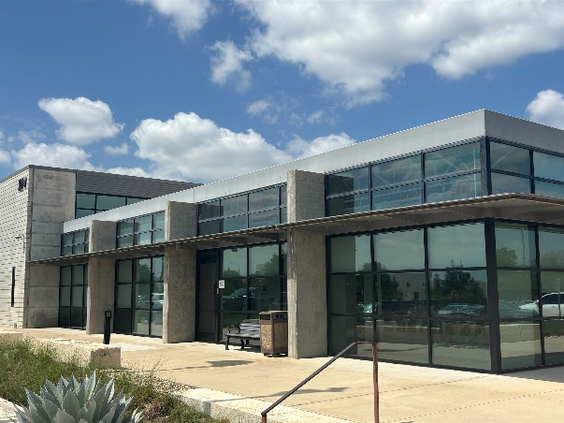 | 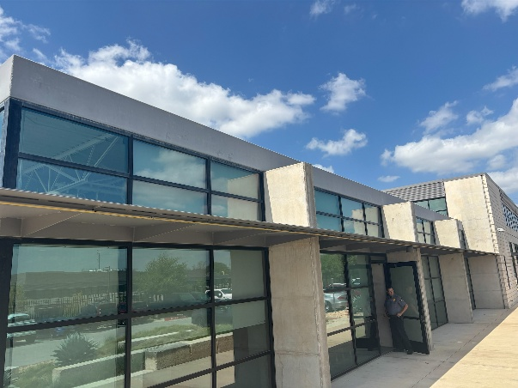
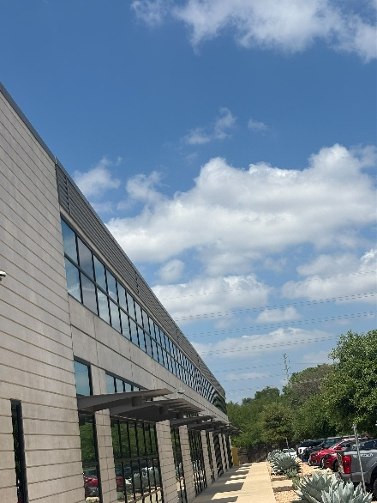 | 
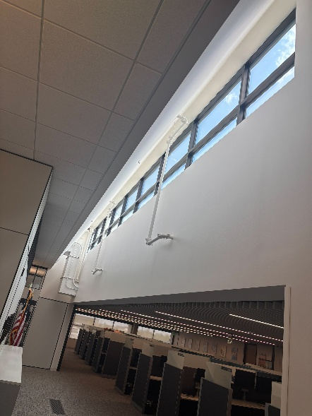 | 