STATEMENT OF WORK (SOW)
4-Year Software Maintenance and System Calibration and Repair Contract

- Scope

This SOW encompasses the services necessary for Perception software maintenance and calibration and repair services of the Genesis data acquisition system and its associated hardware.

- Technical Requirements

2.1 Annual Calibration – Accredited or Traceable Calibration with Priority Service
The calibration shall be performed using standards and instruments whose accuracies are traceable to the National Institute of Standards and Technology (NIST). The calibration system instruments supporting these standards shall meet the requirements of MIL-STD-45662A and ANSI/NCSL Z540-1-1994.

2.2 Extended Warranty Coverage on modules less than 10 years of age for the contract duration period.

Covers the 96 modules listed in Appendix A.

Modules that are out of manufacturer’s warranty can be covered by an HBK Assured Contract, but they will need to successfully pass the first calibration before they are eligible for the Extended Warranty Coverage portion.

The 1-Year Software Maintenance (provided each of the four years) provides 15 Perception Software Maintenance Licenses under ENT_MAIN_02 (PERC-OP-MTP-02 Maintenance Ent) Perception Package.

Covers the 15 Software License Serial Numbers listed in Appendix B.

- Acceptance
The service shall be performed at the contractor’s facility and inspected/accepted at NAWCWD China Lake, CA.

- Security Requirements
In the case of an unclassified contract that requires no access to Classified Military Information (CMI), but that does require access to Controlled Unclassified Information (CUI), NAWCWD Restricted Areas, and/or Government information technology (IT) systems, contractors are required to comply with non-NISP processing requirements before local access to CUI, Restricted Areas, and IT can be granted. This process shall be coordinated by the Contracting Officer’s Representative (COR) or Technical Point of Contact (TPOC) through the NAWCWD Industrial Security office.
CUI information generated and/or provided under this contract shall be marked and safeguarded as specified in DoDI 5200.48, Controlled Unclassified Information (CUI). Contractor shall not store or transmit CUI on personal information technology systems or via personal e-mail. Unclassified e-mail containing any DoD CUI shall be encrypted. Prior to sending CUI to any non-Navy Marine Corps Internet (NMCI) addressees, the sender must first positively verify all recipients are authorized access to CUI and have need-to-know. Non-NMCI recipients must have a DoD compliant Private Key Infrastructure (PKI) certificate that enables electronic transmission via unclassified networks while protecting the CUI with a digital signature and encryption.

Public Release. Disclosure of information is covered by DFARS 252.204-7000 Disclosure of Information, incorporated in Section I of the contract. Concerning subsection (a)(2), “information otherwise in the public domain” is information officially released into the public domain, e.g. via Distribution Statement A, and does not include information in the public domain that has not been officially released. For disclosure of unclassified information that has not been officially released, the contractor must seek specific approval from the Contracting Officer, with approval from the NAWCWD Public Affairs Office (PAO).
Appendix A: Genesis Mainframe and Card Coverage

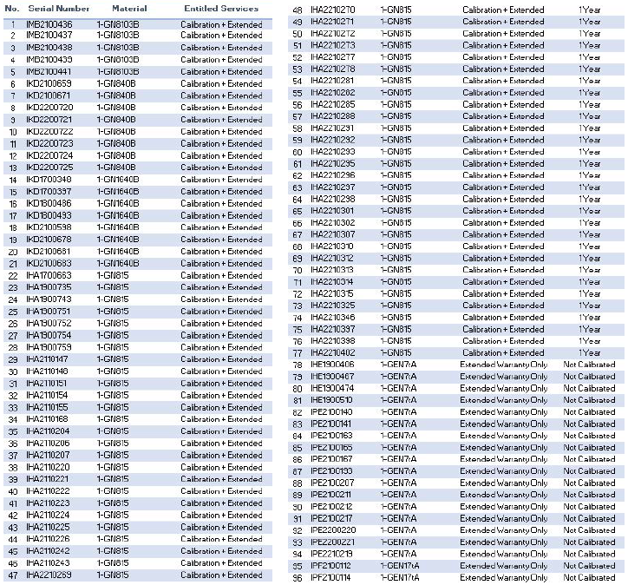

Appendix B: Perception Software License Key Serial Numbers
1. 3244683
2. 220462206
3. 613266062
4. 782513115
5. 2060664448
6. 59741295
7. 184276941
8. 314883398
9. 2094976500
10. 317858065
11. 1099746423
12. 1657745451
13. 1832256012
14. 391827521
15. 1828229443

