Arizona & New Mexico
Tree Cooler Project

STATEMENT OF WORK


U.S. FOREST SERVICE
February 2026

TABLE OF CONTENTS

1.0 GENERAL INFORMATION 3
1.1 WORK SUMMARY 3
1.2 LOCATIONS 3
1.3 PERFORMANCE PERIOD 9
1.4 POINTS OF CONTACT 9
2.0 PROJECT SCOPE 10
2.1 SCOPE 10
2.2 REQUIRED ITEMS 10
2.3 SUBMITTALS 10

1.0 GENERAL INFORMATION

1.1 WORK SUMMARY
This requisition is for nine (9) new 40-foot refrigerated ISO containers with a new 220 volt, 50-amp power transformer for tree seedling cooling and storage. Each site will have a specific need for the phase of the power transformer and will be noted below. The standard size of the ISO container is 40ft x 8ft x 9ft 6 inches. The supplier shall deliver the units and all required blocking, dunnage and other supplies needed to place and level each unit at each location. Site locations will be prepared and ready for delivery prior to scheduled delivery date by the local units by the local units. Some locations will require special permitting for transport, which will be the responsibility of the contractor.

The Carson National Forest, Gila National Forest, Coconino National Forest, Tonto National Forest, Kaibab National Forest, Santa Fe National Forest, and Coronado National Forest are each in need of at least one refrigerated container to set up permanently on forest for the respective reforestation program. All placements on units will be finalized onsite by the COR prior to delivery being scheduled.

1.2 LOCATIONS

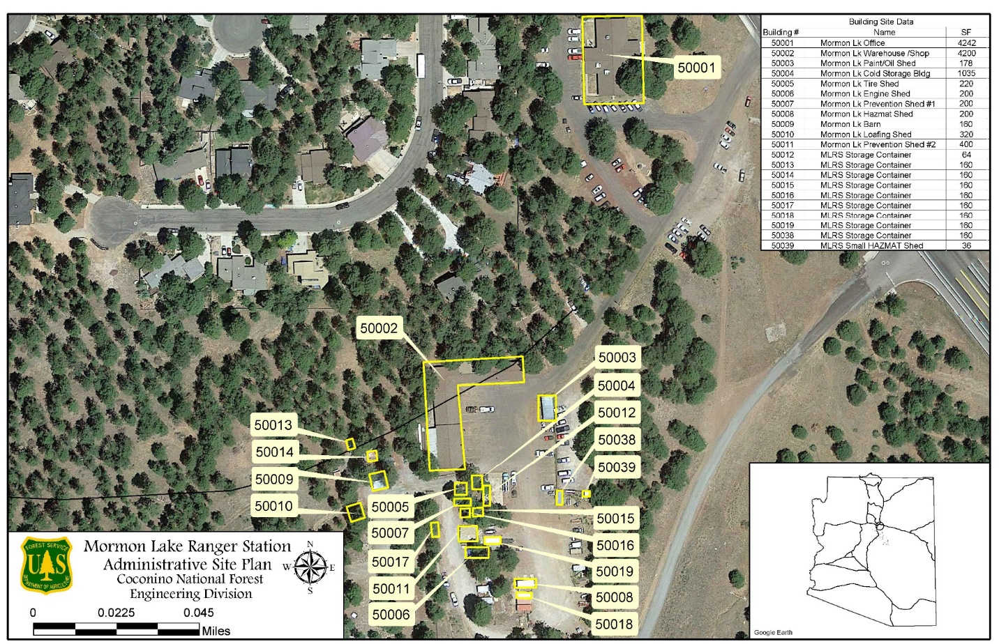
The delivery location for the Coconino National Forest is the Mormon Lake Ranger Station. It is located at 4373 Lake Mary Road, Flagstaff, AZ 86001. The box is planned to be placed east of buildings 50004 and 50012 on the map below.
The delivery location for the Tonto National Forest is the Payson Ranger Station. The box will be located near the engineering building. The address is 1009 AZ-260, Payson, AZ.

The delivery location for the Kaibab National Forest is the Jacob Lake workcenter. The box will be located is the spot shown. The site address is hc64, Fredonia, AZ 86022.
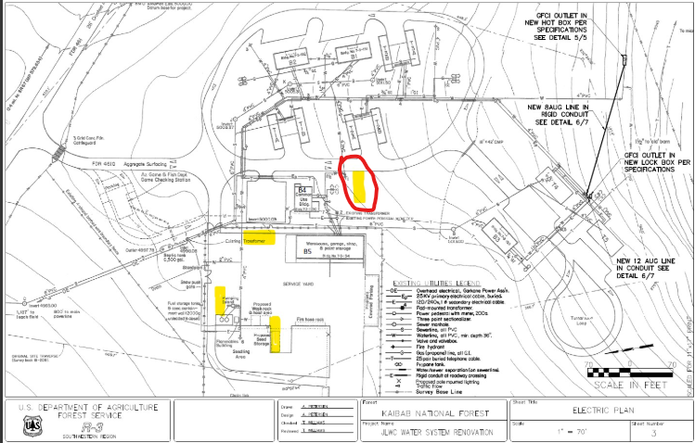
The delivery location for the Coronado National Forest is at the Columbine Work Center on Mt. Graham near Safford, Arizona. There are existing RV “pads” and a gravel roundabout. The tree cooler would be placed on the roundabout. Site is located at 32.70343, -109.91225.

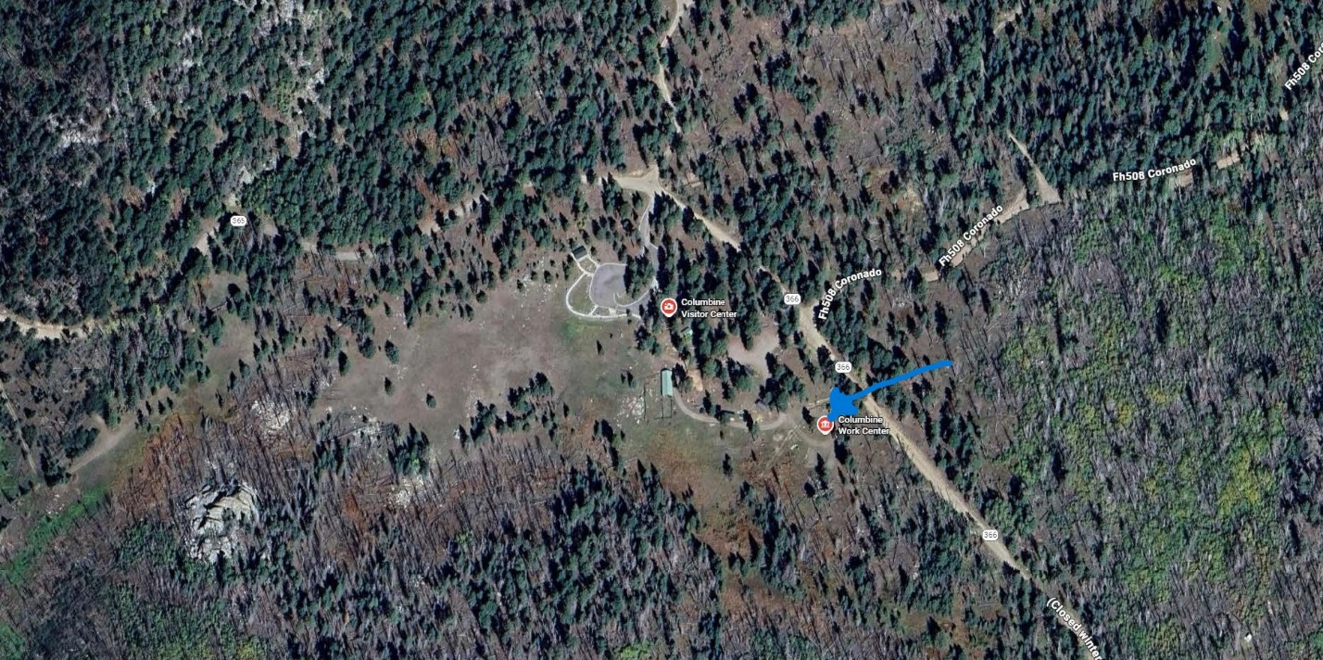

The first delivery location for the Santa Fe National Forest is at the Pecos Ranger Station in Pecos, New Mexico. Site is located at 35.57207, -105.67573. The preferred location is indicated in red below.

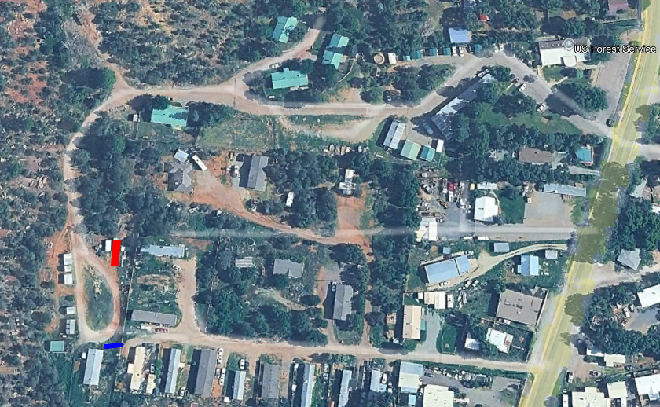
The second delivery location for the Santa Fe National Forest is at the Canon Administrative Site located at 36.398168, -105.549036. The specific site location will be determined prior to delivery being scheduled.
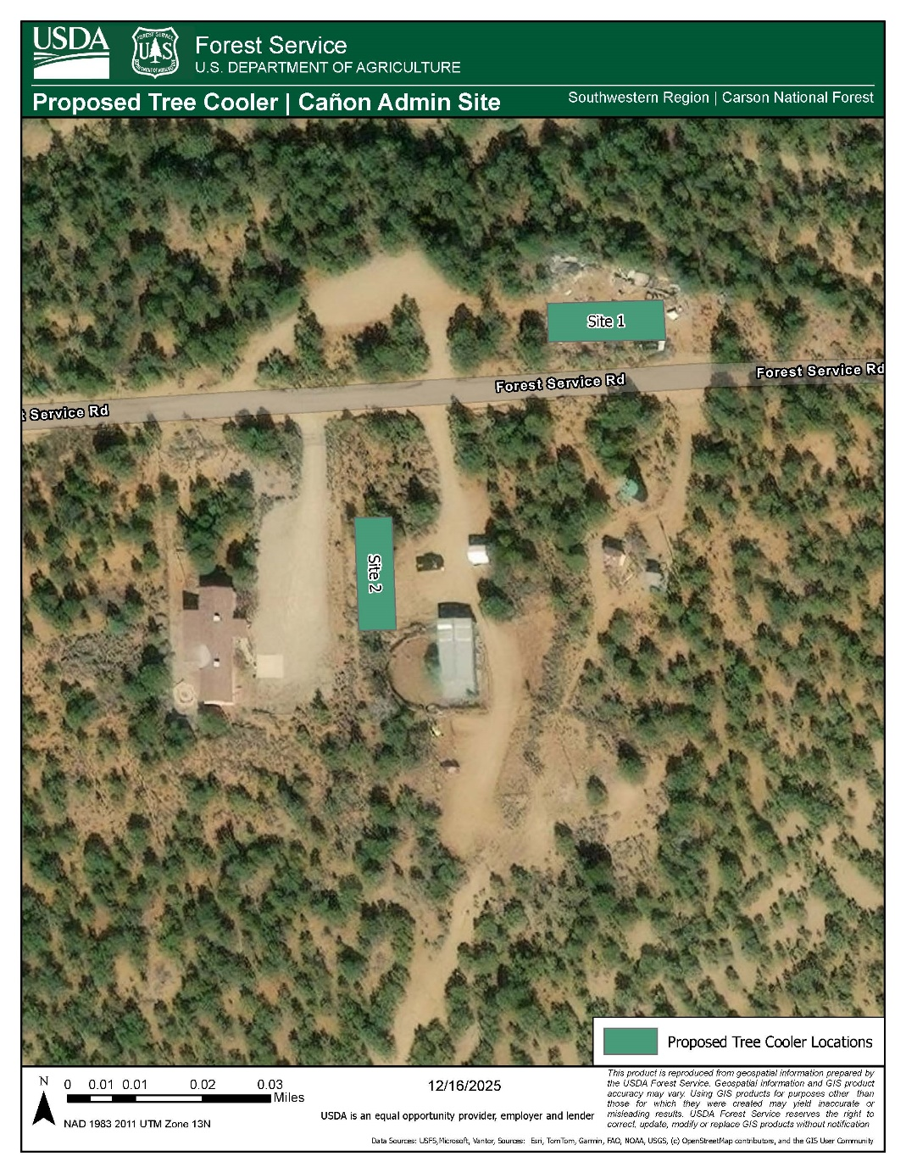
The third delivery location for the Santa Fe National Forest is at the Jemez Boneyard Site located at 35.666766, -106.741554. The specific site location will be determined prior to delivery being scheduled.

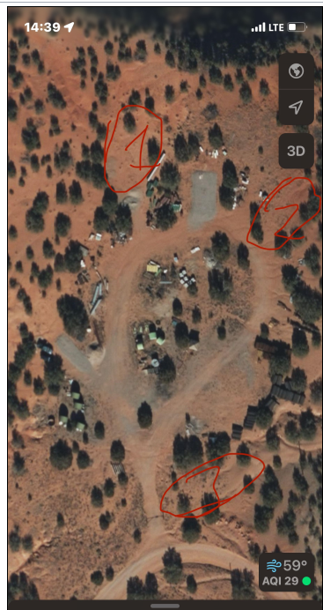

The delivery location for the Gila National Forest is the Luna work center near Luna, New Mexico. The box will be located is the spot shown. The site is located at 33.82312, -108.94232.
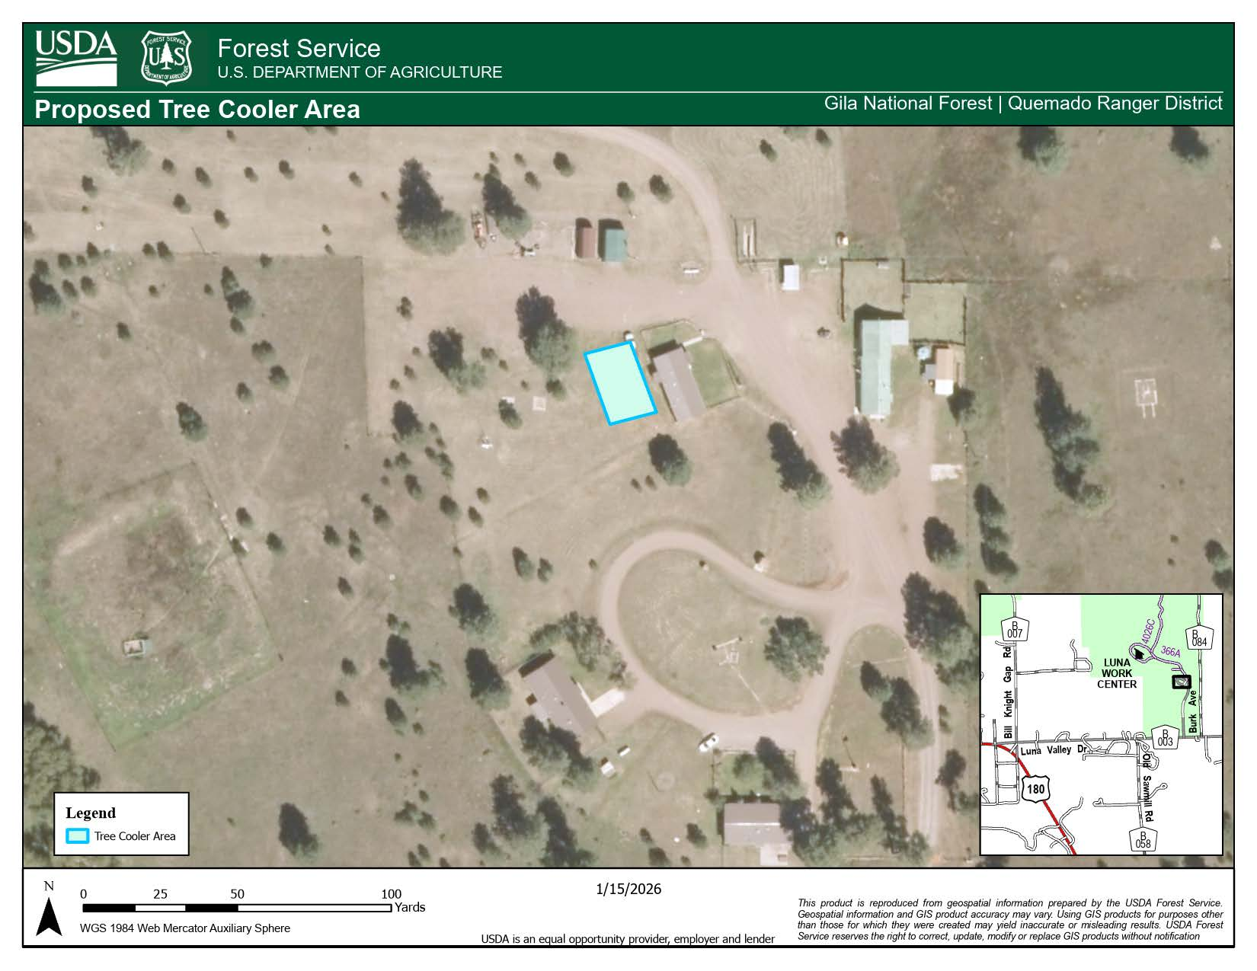

The delivery location for the Carson National Forest is the Boneyard at the Shot Base near Taos, New Mexico. The box will be located is the spot shown. The site is located at 36.398225, -105.548894.
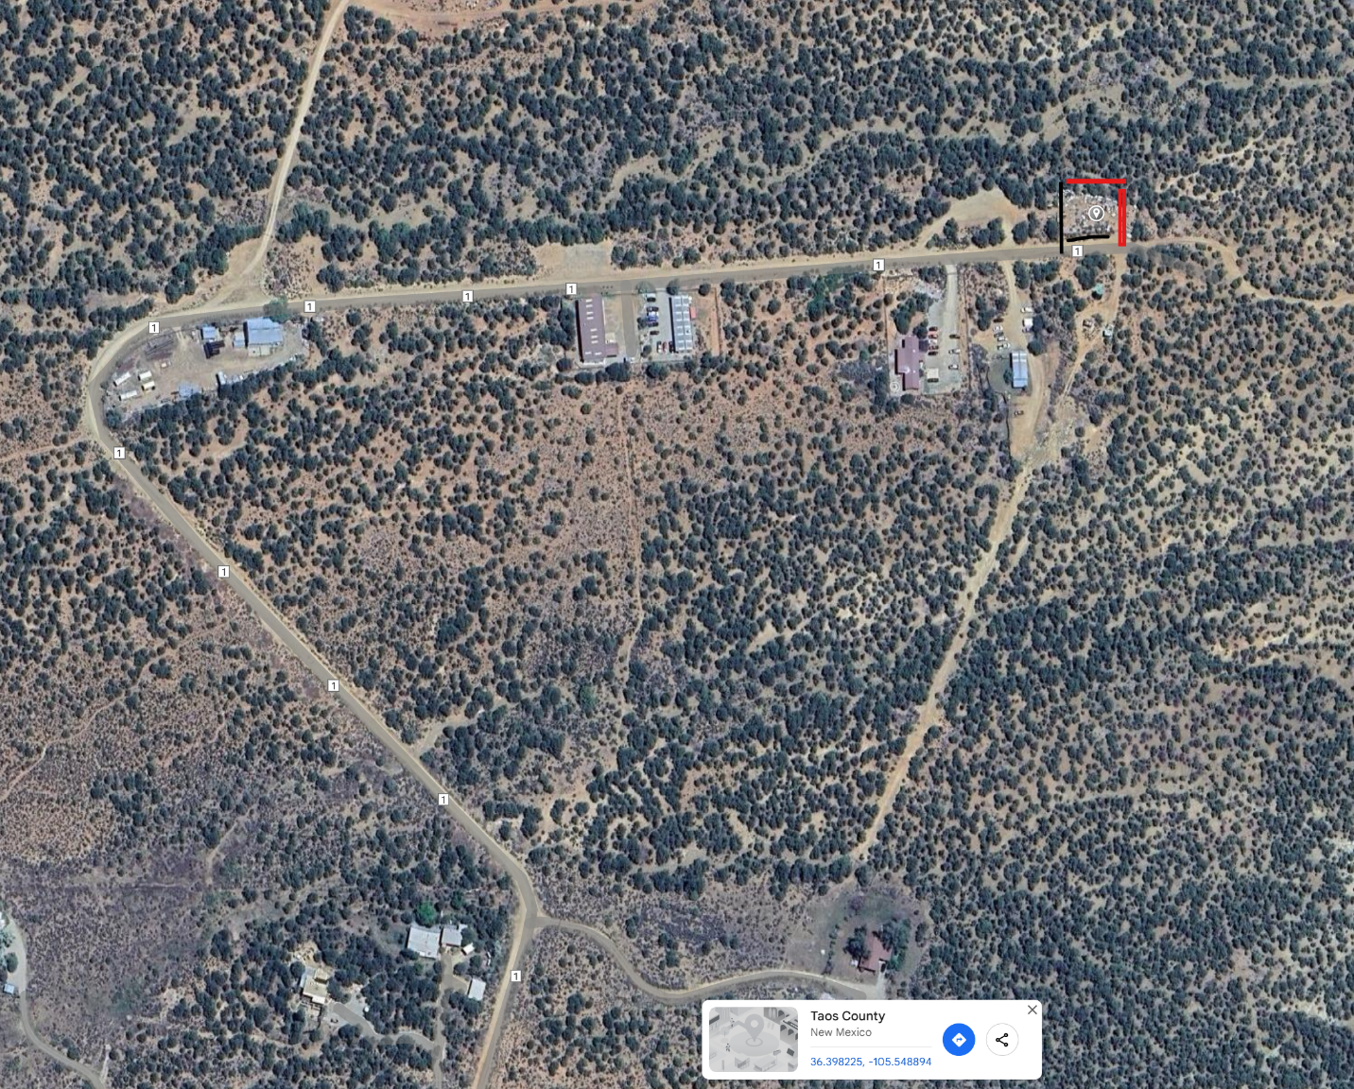

1.3 PERFORMANCE PERIOD

The project is expected to take 180 days to complete all nine locations.

POINTS OF CONTACT

Contracting Officer: To Be Determined
Contracting Officer’s Representative (COR): Lonny Rollins, P.E., Lonny.rollins@usda.gov
Forest Contact: List to be provided as project gets underway

2.0 PROJECT SCOPE

2.1 SCOPE

The contractor will provide nine (9) 40-foot new high cube refrigerated certified ISO containers delivered to the site and placed as directed by the COR. The containers will have new transformers to connect to either three-phase or single phase as indicated through this contract. The containers will need to maintain between 35-45 degrees Fahrenheit constantly during use.

Contractor will provide all listed submittal in section 2.3 prior to commencing any ordering to the COR for approval. It is expected that the contractor will have one point of contact to coordinate all deliveries and convey the logistics required to complete the project. There will be a meeting (virtual) to discuss the overall project prior to the deliveries commencing.

2.2 REQUIRED ITEMS

- 9 count 40ft New High Cube Refrigerated Certified ISO Container
- 1 count Transformer New 220V 3 Phase 50 Amp – at Columbine
- 1 count Transformer New 220V Single Phase 50 Amp – at Payson
- 1 count Transformer New 220V Single Phase 50 Amp – at Luna
- 1 count Transformer New 220V Single Phase 50 Amp – at Pecos Ranger Station
- 1 count Transformer New 220V Single Phase 50 Amp – at Canon Administrative Site
- 1 count Transformer New 220V Single Phase 50 Amp – at Jemez Boneyard
- 1 count Transformer New 220V Single Phase 50 Amp – at Mormon Lake Work Center
- 1 count Transformer New 220V Single Phase 50 Amp – at Jacob Lake Work Center
- 1 count Transformer New 220V Single Phase 50 Amp – at Boneyard at the Shot Base
- 1 count Shipping, Delivery, leveling and offloading at Carson NF
- 1 count Shipping, Delivery, leveling and offloading at Coconino NF
- 1 count Shipping, Delivery, leveling and offloading at Coronado NF
- 1 count Shipping, Delivery, leveling and offloading at Gila NF
- 3 count Shipping, Delivery, leveling and offloading at Santa Fe NF
- 1 count Shipping, Delivery, leveling and offloading at Tonto NF
- 1 count Shipping, Delivery, leveling and offloading at Kaibab NF

2.3 SUBMITTALS

The contractor to provide the following submittals for the following items prior to commencing the order and delivery of the containers:
- 40-foot containers matching the requirements in the scope.
- Three-phase transformer compatible with containers to be purchased
- Single-phase transformer compatible with containers to be purchased
- Schedule for delivery of each of the nine containers
- Logistics plan for delivery including any special permits required and type of vehicle planned to be used to deliver the containers
- Contact list for contractor’s representative which will be coordinating all nine deliveries.

