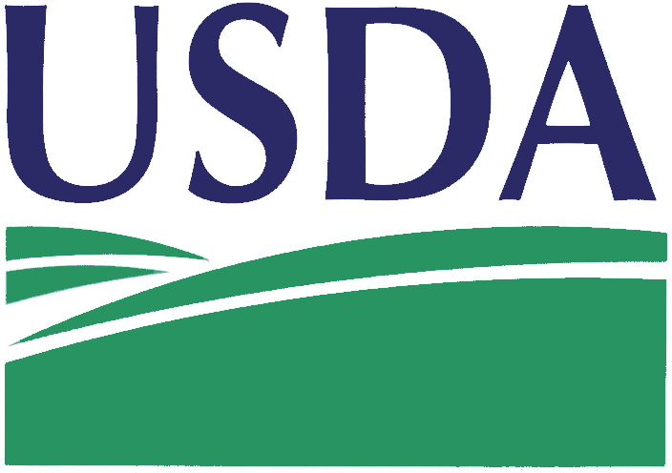
US Department of Agriculture (USDA)

12639526Q0134, Attachment 1
Statement of Work

Contents
Project 3
General Information 3
1.0 Scope of Work 3
2.0 Background 3
Contractor Requirements 3
1.0 Government Furnished 3
2.0 Deliverables / Schedule 3
3.0 Security Requirements 3

Project

Repair eleven fume hoods to good working order and to prevent future failures due to age and rust and ensure proper performance for the safety of users.

General Information

1.0 Scope of Work

Contractor will travel to the work site. For each of eleven hoods the contractor shall disconnect existing 115V electrical to the exhaust fan, remove existing exhaust fan and zero pressure cap, install new PVC flex connector, set new exhaust fan, install new PVC exhaust stack with guy wire, complete new electrical connection to exhaust fan motor, remove and replace existing fume hood alarm, test fume hood per OSHA requirements and calibrate alarm and replace fume hood light and remove all debris to jobsite dumpster and leave a clean safe working environment.

2.0 Background

National Science Laboratory-Blakely (NSL-B) is the reference USDA laboratory for aflatoxin levels in nuts and nut products. It is essential that the laboratory maintain scientific support capabilities for nuts that are covered under AMS Marketing Agreements and Orders (MA&O). Additionally, the NSL-Blakely provides AMS Commodity Procurement with scientific support and testing of USDA purchased nut and nut products that include aflatoxin level requirements. Nuts and nut products analyzed include pistachios, almonds, peanuts, walnuts, hazelnuts (filberts), pecans and peanut butter.
The laboratory must maintain fume hoods that work properly to complete these analyses.

Contractor Requirements

1.0 Government Furnished

Relocating items from work area as required by contractor.

2.0 Deliverables / Schedule

Key Deliverables
1. | Proper Hood Performance | All 11 hoods operating and tested against OSHA specified parameters.
2. | Functioning Alarms | All hood alarms properly functioning.
3. | Site Clean Up | Cleaning up all debris so work areas are safe.

Work should be completed in as short a timeframe as possible to minimize disruption to the laboratory workflow.

3.0 Security Requirements

The Contractor’s employees must not enter the project site without appropriate badge. They may also be subjected to inspection of their personal effects when entering or leaving the project site. Possession of weapons are prohibited. No photography of the SRTD premises is allowed without written permission of the Contracting Officer or Contractor Officer Representative. SRTD reserves the right to close or shut down the project site and order contractor’s employees off the premises in the event of a national emergency or violation of safety policy. Smoking is prohibited inside the facility, mechanical rooms, warehouse area, roofs, etc.

