ATTACHMENT 2

Figure 1 provides the overall AN/BQQ-10 A-RCI TI/APB Build Schedule for TI-28 and TI-next. The anticipated period of performance for the A-RCI procurement of TI-28 and TI-next is from 31 October 2028 to 31 October 2039.

Figure 1: AN/BQQ-10 A-RCI System TI/APB Cycles (FY)

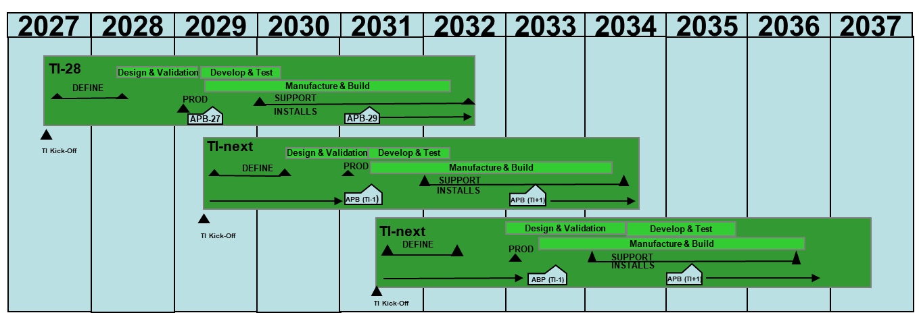

Note:
**TI-28 will have the same infrastructure and common shipboard integrated baselines with TI-26.
**TI-32 will have the same infrastructure and common shipboard integrated baseline with TI-30.

