Fort Donelson National Battlefield
Dover, TN

STATEMENT OF WORK
Fabricate and Ship ID Signs for Fort Donelson
DATED:
December 12th, 2025

NATIONAL PARK SERVICE
Interior Region 2 South Atlantic Gulf

Statement of Work
Fabricate and Ship ID Signs for FODO
Fort Donelson National Battlefield

I. GENERAL. The National Park Service, Fort Donelson National Battlefield has a need for replacement of deteriorated identification signs in Stewart County, TN and Calloway County KY.

II. REQUIREMENTS. The Contractor shall provide all necessary services and supporting activities for design, shop drawing submittal and resubmittal, fabrication and delivery of the following signs.
Signs shall be delivered to 205 Fort Donelson Shores Drive Dover TN 37058. Contractor shall notify park in advance at least 24 hours to when they will be delivered to the park. If a tracking number is available to be shared, contractor shall supply that number to the COR for the project.
Contractor shall include installation/mounting instructions
A. CLIN 0010: Contractor shall complete shop drawings, fabricate and ship ID (2) signs for Fort Donelson National Battlefield
i. Contractor shall use attached designs from Harpers Ferry Center to complete the fabrication of these signs
ii. Single Sided signs made of HDPE Plastic (or COR Approved Equal) with Routed Graphics, Dado.
iii. Park requests mounting hardware be included with this project
a. This sign will be mounted on existing brick base (see photos below)
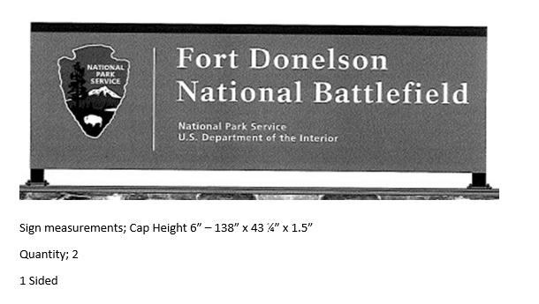
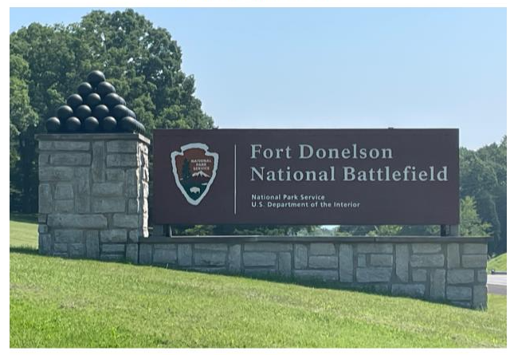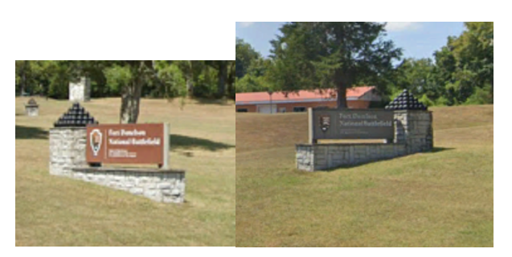
B. CLIN 0020: Contractor shall complete shop drawings, fabricate and ship ID (3) signs for Fort Heiman and one blank back panel
i. Contractor shall use attached designs from Harpers Ferry Center to complete the fabrication of these signs
ii. Single Sided signs made of HDPE Plastic (or COR Approved Equal) with Routed Graphics, Dado, and comes with an embedded full color Routed HDPE Plastic Arrowhead (or COR Approved Equal)
iii. Park requests mounting hardware be included with this project
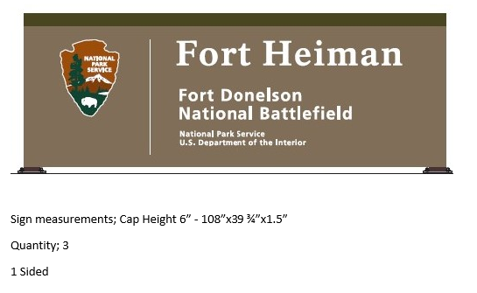
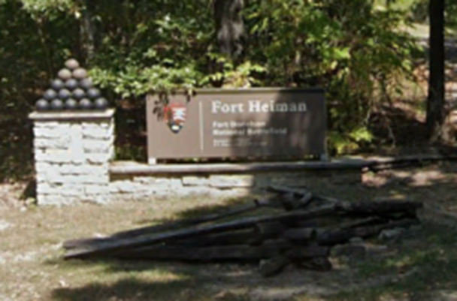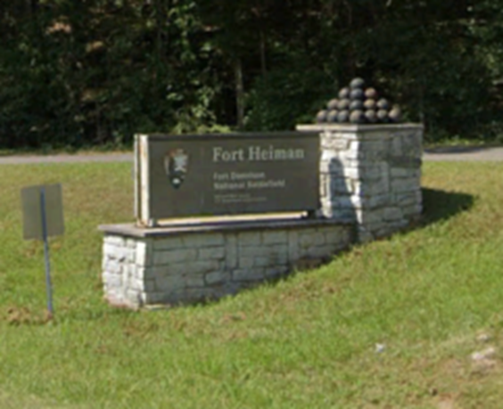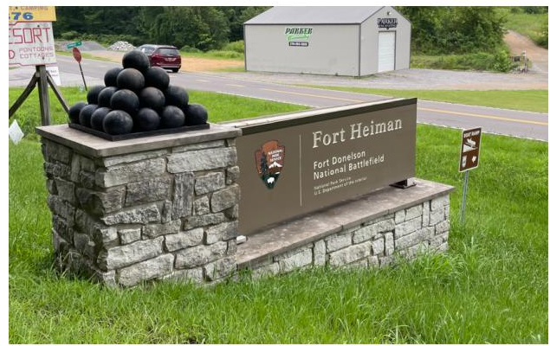
C. CLIN 0030: Contractor shall complete shop drawings, fabricate and ship ID (1) signs for Dover Hotel and one blank back panel
***Park Requests slight modification to have this sign say Dover Hotel – “Surrender House” ***
i. Contractor shall use attached designs from Harpers Ferry Center to complete the fabrication of these signs
ii. Single Sided signs made out of HDPE Plastic (or COR Approved Equal) with Routed Graphics, Dado, and comes with an with an embedded full color Routed HDPE Plastic Arrowhead (or COR Approved Equal)
iii. Park requests mounting hardware be included with this project
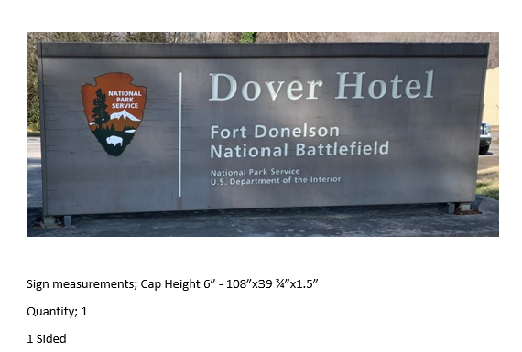
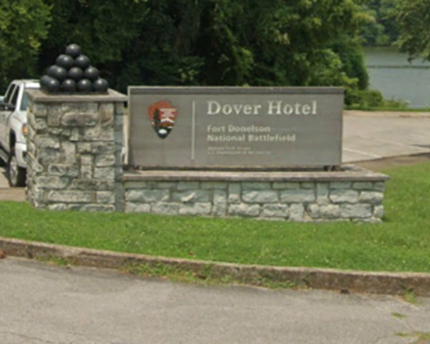
C. CLIN 0040: Contractor shall complete shop drawings, fabricate and ship ID (1) signs for Fort Donelson National Cemetery and one blank back panel
i. Contractor shall use attached designs from Harpers Ferry Center to complete the fabrication of these signs
ii. Single Sided signs made out of HDPE Plastic (or COR Approved Equal) with Routed Graphics, Dado, and comes with an with an embedded full color Routed HDPE Plastic Arrowhead (or COR Approved Equal)
iii. Park requests mounting hardware be included with this project
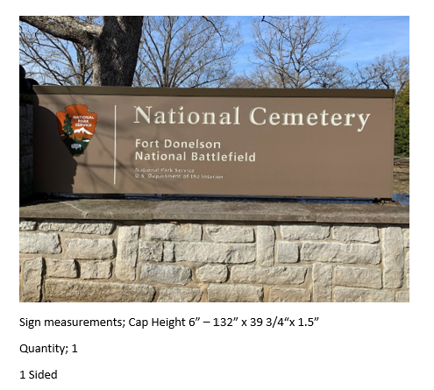
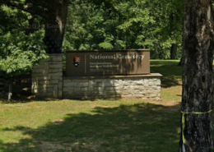

III. BACKGROUND DOCUMENTS. The following will be made available to the contractor in support of work on this project.
Color Guide
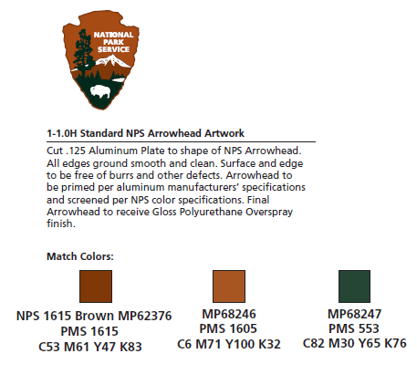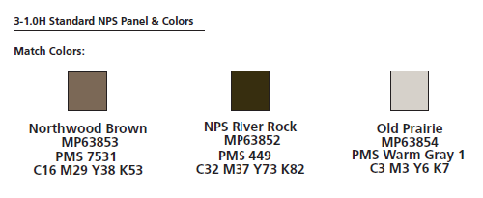
Shop Drawing Requirements
Fabrication Shop Drawings
The contractor shall provide fabrication shop drawings for review and approval by the COR. Shop drawings shall be in accordance with the fabrication specifications and design-intent drawings provided in attached drawings and shall describe in detail the techniques, methods, and materials (including brand names) for building all sign components and for all finishes.
The shop drawings shall be submitted electronically to the COR via email. Shop drawings shall be approved via PDF electronic stamp approval and shall include embedded notes for requested changes and additions. Shop drawings shall not be stamped final by the COR until all fabrication issues have been resolved.
As specified, the contractor shall prepare and submit revised shop drawings incorporating all corrections or revisions required by the COR. Each revision shall be marked with a revision number and a date.
Before any alteration to the NPS standards for fabrication the contractor shall submit proposed changes, in writing to the COR for approval. The proposed changes shall include at a minimum drawings, specifications, and product cut sheet (when applicable) and must detail the techniques, methods, and materials (including brand names) proposed for building all sign components and for all finishes.
The contractor shall prepare the shop drawings so they can be printed at 11" x 17" or 8.5" x 11" and remain clear and legible. Each drawing shall be identified with the park name, contractor’s name, sign project number, drawing number, page number, and date of submittal. The shop drawings shall include elevations, plan views, and sections; or other views to help describe the fabrication method; details on connections of materials; material descriptions; hardware details; complete dimensions; paint and finish descriptions; engineering and specifications.
Additionally, the shop drawings shall include the following:
- Details and Dimensions
The contractor shall include all sign dimensions, materials, hardware, instructions, finishes, manufacturer's name and associated color, and any other detail associated with the fabrication of the signs.
- Sign Panel Design and Layout
The contractor shall include all sign panel designs and layouts in the shop drawings. Sign panel drawings furnished in attached files The contractor shall check enlarge panel art to full size for fabrication.
- Product Listing
List brand names of off-the-shelf products that will be used in the sign structures and panels (paints, etc.).
Fabrication
Sign fabrication shall not begin until all samples have been approved by the COR. The sign shall be fabricated in accordance with the specifications in the approved fabrication shop drawings and using the same materials, techniques, and finishes as the approved samples.
The contractor shall fabricate all signs and supporting components to achieve a lasting durability in an exterior, high traffic environment. Sign materials used in fabrication shall provide for ease of maintenance and vandal resistance.
All materials shall be new and of first quality. Materials shall meet or exceed the standards and specifications herein or by reference. Factory seconds shall not be accepted. All materials shall comply with this specification or approved equal.
Fit and finish of all signs shall meet or exceed industry standards for architectural grade sign fabrication. All components shall be cut square and true, and pre-assembled prior to painting to ensure all parts fit together. All sign panels shall be cut square, and all edges cleaned and finished, free of sharp and rough edges, burrs, and other surface imperfections. Exposed fasteners shall be counter-sunk. All exposed weld joints shall be clean and ground prior to primer and paint application. Weld slag shall be ground clean and removed from exposed metal surfaces.
All metal surfaces, structural metal components, sign structures, signs and sign panels, panel backs and edges shall be primed and painted. The contractor shall prime and paint all exposed material surfaces in accordance with the paint manufacturer’s specific recommendations.
Digital Shop Inspection
Prior to packing and shipping all signs and components, the contractor shall provide the COR with digital photographs of all the fabricated sign panels and mounting structures for review. Photographs shall be provided to the COR digitally via email or NPS-approved FTP site. The photographic reference shall include a full front view, side view, and rear view of each component. Detail views shall also include details of sign back, corners, mounting hardware, routed details, and paint.
The COR will submit any negative findings to the contractor in writing. The COR may request additional photographs if details or quality are unclear. The contractor will be responsible for correcting any deficiencies discovered during the digital shop inspection prior to shipping and installing the sign.
IV. BID FORMAT
A. Schedule:
Task | Target Due Dates (calendar days after prior review comments) | Target Due Date | Target NPS Review Date | Target Meeting Place or Method | Special Submission Requirements
Task 1  Telephone conference call to answer contractor questions about sign designs prior to starting shop drawings  a) Review Attached SOW and Attached Design file  b) General project review.  c) Review of design intent drawings.  d) Review of basic project schedule. | Coordinate with project manager | Propose date | 1 weeks | Phone Call | PDF
Task 2  Submittal of initial Shop Drawings | 2 weeks | Propose date | 1 weeks | Email | PDF to Project Manager
Task 3  Submittal of final Shop Drawings for approval | 2 weeks | Propose date | 1 weeks | Email | PDF to Project Manager
Task 4  Fabrication and Final Delivery of Fabricated Signs | 12 weeks | Propose date | 2 weeks | Email | Ship to Fort Donelson NB - 205 Fort Donelson Shores Drive Dover TN 37058
**Note | The Proposed dates will be decided at the Task 1 Conference Call as one of the discussion topics to keep this project progressing with agreed upon dates

B. Submittals:
Coordinate all contractor and subcontractor submittals and review them for legibility, accuracy, completeness, and compliance with contract requirements prior to submitting to the COR for distribution. Forward all submittals to the COR for distribution, review and approval. Receive all reviewed submittals and take appropriate action according to the approval or rejection by the COR.
- Approved Submittals
Ensure that all changes, revisions, or additions are noted, and shop drawings and instructions are revised, updated, and forwarded to the COR.
- Rejected Submittals
When submittals are rejected, the COR shall notify the Project Manager, in writing, identifying the reasons for rejection. The Project Manager shall revise and/or correct and resubmit, identifying changes.
Submittal List:
1. Submittal of initial Shop Drawings. Format shall be electronic, full size or half size at contractor’s option, two copies for each sign.
2. Submittal of final Shop Drawings, format same as for initial signs.
3. Assembling and Access Instructions - Provide visuals clearly and sufficiently illustrating access to sign structures and graphic panels. The illustrations shall include step-by-step instructions, and any other information relevant to assembling, opening and/or dismantling the structures. The illustrations shall include isometric and exploded view drawings and/or photographs combined with text showing a person following the step-by-step instructions.
4. Cleaning Instructions - Provide instructions for cleaning all sign structures including metal and stone components, finishes, and graphic panels. Provide instructions for removing graffiti from sign structures and graphic panels. Include brand names of recommended cleaning materials. Listed cleaning products shall correspond with supplies included in the maintenance kit furnished by the contractor. "Not to be used" materials and techniques shall be identified.
5. Repair Instructions - Describe specific techniques for repairing damage to sign fabrication materials including repair and or refinishing.
C. Proposal format:
1. Contractor shall organize costs by each sign.
2. Contractor shall submit anticipated schedule with proposal.
V. PROJECT SCHEDULE
A. The anticipated start date and anticipated end date of this project will be determined after award.
VI. INSPECTIONS
A. The Government will conduct inspection upon completion of project work. Final payment will not be made until all noted discrepancies are corrected by the contractor.
VII. CONTRACTOR PAYMENT SCHEDULE.
- Single invoice based on completion and acceptance of the work.
- INVOICING
  - Electronic Invoicing and Payment Requirements - Invoice Processing Platform (IPP) (April 2013)
  - Payment requests must be submitted electronically through the U. S. Department of the Treasury's Invoice Processing Platform System (IPP).
  - "Payment request" means any request for contract financing payment or invoice payment by the Contractor. To constitute a proper invoice, the payment request must comply with the requirements identified in the applicable Prompt Payment clause included in the contract, or the clause 52.212-4 Contract Terms and Conditions - Commercial Items included in commercial item contracts. The IPP website address is: https://www.ipp.gov.
  - Under this contract, the following documents are required to be submitted as an attachment to the IPP invoice: none
  - The Contractor must use the IPP website to register access and use IPP for submitting requests for payment. The Contractor Government Business Point of Contact (as listed in SAM) will receive enrollment instructions via email from the Federal Reserve Bank of Boston (FRBB) within 3 - 5 business days of the contract award date. Contractor assistance with enrollment can be obtained by contacting the IPP Production Helpdesk via email ippgroup@bos.frb.org or phone (866) 973-3131.
  - If the Contractor is unable to comply with the requirement to use IPP for submitting invoices for payment, the Contractor must submit a waiver request in writing to the Contracting Officer with its proposal or quotation.
VIII. PROJECT COORDINATION. The NPS Contractor Officer’s Representative for this action is:
Craig K Davis, FMP
Chief of Facilities, Fort Donelson National Battlefield
174 National Cemetery Drive
Dover, TN 37058
931-627-0569
Craig_K_Davis@nps.gov

A. Note: All communication shall be routed through the above names, unless other people are authorized by the COR for the project. If additional staff are authorized by the COR, they will send out an email announcing such action to all parties involved. COR shall be included in all communications, preferably from the beginning of the conversation. Nothing is approved or changed without the KO or CORs approval.

I. If any actions are done without KO or COR prior approval the park employee and contractor are putting themselves at risk

XIV. ADDRESS FOR INVOICES. Provided in the contract award documents.
End of Statement of Work

