QUESTIONS AND ANSWERS NO. 2 – SOLICITATION 19SP5026Q0012

QUESTION 1: If work is to be done in phases, please include performance period for each phase.
ANSWER: The project is proposed to be completed in two phases: the first phase will take place in late June for the installation of the magnetic filter and heat water collector; the second phase will be conducted in September for the flooring installation.
- Phase 1: Magnetic filter and heat water collector: 35 days
- Phase 2: Floor: 25 days
This change will be incorporated to Amendment 1 of the solicitation.

QUESTION 2: Please confirm estimated performance period.
ANSWER: 60 days

QUESTION 3Please provide photos of conduits by hot water tanks.
ANWSWER: See pictures below This will be included in Amendment 1 to the solicitation as Attachment ·7
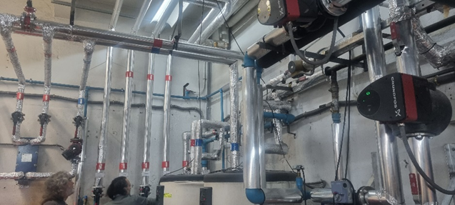
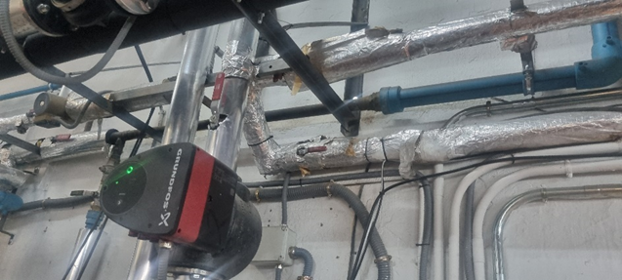

QUESTION 4: Please provide drawing of sub-basement area.
ANSWER: Attachment #6 – DRAWINGS has been incorporated into Amendment 1 to the solicitation.

QUESTION 5: How many filters are required for DHW return pump? Prospective offerors recommend that one filter per boiler is installed.
ANSWER Two filters (one per boiler) will be required. Statement of work will be modified to reflect this change. This will be part of Amendment 1 to the solicitation.

QUESTION 6: Does the floor area under hot water deposits need to be repaired/refinished?
ANSWER Yes, we must install the flooring underneath the tanks.

QUESTION 7: Is the filter only magnetic or also a sludge separator?
ANSWER The filter is only magnetic.

QUESTION 8: Can you define the floor resin replacement zone?
ANSWER The attached plan shows the marked area.

QUESTION 9: Can you confirm that everything is stainless steel?
ANSWER Yes, as stated in the SOW, stainless steel components are required. (See below excerpt of SOW: "Reconnection of DHW System Circuit - Unit for reconnection and installation of new piping and the existing DHW heat exchanger, including shut-off valves, fittings, and insulation. Executed in AISI 316L stainless steel, including bypass between tanks.")

QUESTION 10: From which zone should the piping be dismantled?
ANSWER From the 40 mm PPR piping.

QUESTION11 Is it necessary to perform the bypass?
ANSWER Yes, this is stated in the SOW (see below excerpt: "Temporary Domestic Hot Water (DHW) Production Heat Pump: Rental and installation of a heat pump system for temporary DHW production during the remodeling works in the room. Installed indoors and near the storage tanks, complete with piping, valves, and temporary electrical connection.")

QUESTION 12 Is it necessary to maintain service?
ANSWER Yes, service must be maintained at all times.

