SUBJECT* | Bronx Vet Center Emergency Relocation - Veterans Admin VHA needs 1,000-4624 ABOA SF for a short term 12 month lease. 3 months firm and 9 months soft. VHA is currently in the buildout phase of a new lease.
GENERAL INFORMATION
CONTRACTING OFFICE’S ZIP CODE* | 25405
SOLICITATION NUMBER* | 36C24526Q0495
RESPONSE DATE/TIME/ZONE | 05-08-2026 12:00 EASTERN TIME, NEW YORK, USA
ARCHIVE | 15 DAYS AFTER THE RESPONSE DATE
PRODUCT SERVICE CODE* | X1AA
NAICS CODE* | 531120
PLACE OF PERFORMANCE | Bronx NY
POSTAL CODE
COUNTRY | USA
CONTACT INFORMATION
CONTRACTING OFFICE ADDRESS | Department of Veterans Affairs  VAMC (613)  VISN 5 Contract Satellite Office  510 Butler Avenue, Building 306A  Martinsburg WV 25405
POINT OF CONTACT* | Lease Contract Specialist  Tammy Buckwalter  tammy.buckwalter@va.gov  304-263-0811 x 7613
ADDITIONAL INFORMATION
AGENCY’S URL | https://www.va.gov/
URL DESCRIPTION | VA Homepage
AGENCY CONTACT’S EMAIL ADDRESS
EMAIL DESCRIPTION

DESCRIPTION

U.S. GOVERNMENT

Veterans’ Health Administration (VHA) seeks to lease the following space:
State: | NY
City: | Bronx
Delineated Area: | N: E. Gun Hill Rd; S: E. Tremont Ave; E: I-95; W-Bronx River PKWY
Minimum Sq. Ft. (ABOA): | 1,000
Maximum Sq. Ft. (ABOA): | 4,624
Space Type: | Office
Parking Spaces (Total): | 0
Full Term: | 12 months
Firm Term: | 3 months
Additional Requirements: | Must be move in ready

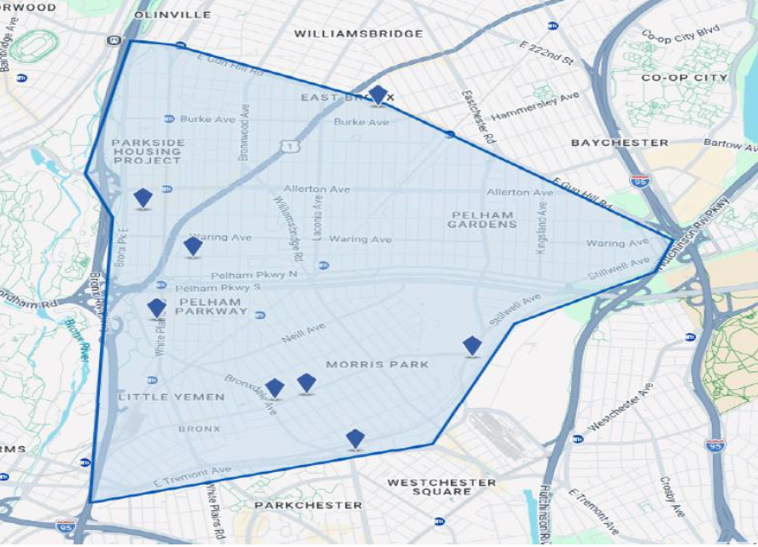

Offered space must meet Government requirements for fire safety, accessibility, and sustainability standards per the terms of the Lease. A fully serviced lease is required. Offered space must not be in the 1-percent-annual chance floodplain (formerly referred to as “100-year” floodplain).
This procurement is being conducted in accordance with FAR 6.302-1-Only one responsible source and no other supplies or services will satisfy agency requirements. NAICS Code 531120 applies to this procurement

Expressions of Interest Due: | 5/8/2026
Occupancy (Estimated): | 6/1/2026

Send Expressions of Interest to:
Name/Title: | Tammy Buckwalter
 | Lease Contracting Specialist
 | Tammy.buckwalter@va.gov

