Description
This is a combined synopsis/solicitation amendment 0001 for commercial products and commercial services prepared in accordance with the format Revolutionary FAR Overhaul (RFO) in Federal Acquisition Regulation (FAR) subpart 12.202, “Streamlined Procedures for Evaluation and Solicitation for Commercial Products and Commercial Services,” as supplemented with additional information included in this notice. This announcement constitutes the only solicitation; quotes are being requested, and a written solicitation document will not be issued.

This solicitation amendment 0001 is issued as an RFQ. The solicitation amendment document and incorporated provisions and clauses are those in effect through Federal Acquisition Circular 2025-06.

This solicitation is set-aside for 100% SDVOSB/VOSB.

The associated North American Industrial Classification System (NAICS) code for this procurement is 492110, with a small business size standard of 1,500 Employees.
The FSC/PSC is R602.

The Network Contracting Office (NCO) 1- New England is seeking to purchase Reusable Medical Devises (RMD) Transportation Services as a Firm-Fixed Price contract with a one year period of performance.

If you have any questions or concerns regarding this solicitation should be forwarded in writing via email to the Point of Contact listed below:

Jessica Martin Jessica.Martin11@va.gov

All interested companies shall provide quotations for the following:

Supplies/Services

Line Item | Description | Quantity | Unit of Measure | Unit Price | Total Price
0001 | Monday – Friday Schedule (In accordance with SOW)  Time: 0700 EST - Pick up at VA West Roxbury at Building 2, Basement AB05. Drop off at Lowell CBOC at Podiatry clinic, Bay 135.  Time: 1530 EST - Pick up at VA Lowell CBOC at Podiatry clinic, Bay 135. Drop off at VA West Roxbury at Building 2, Basement AB05. | 260 | EA
0002 | As Needed Schedule/Contingency (In accordance with SOW)  Round Trip #1: Pick up at VA West Roxbury. Drop off at VA Brockton.  Pick up at VA Brockton. Drop off at VA West Roxbury. | 30 | EA
0003 | As Needed Schedule/Contingency (In accordance with SOW)  Round Trip #2: Pick up at VA West Roxbury. Drop off at VA Jamaica Plain. Pick up at VA Jamaica Plain. Drop off at VA West Roxbury. | 30 | EA
0004 | As Needed Schedule/Contingency (In accordance with SOW)  Round Trip #3: Pick up at VA Brockton. Drop off at VA West Roxbury. Pick up at VA West Roxbury. Drop off at VA Brockton. | 30 | EA
0005 | As Needed Schedule/Contingency (In accordance with SOW)  Round Trip #4: Pick up at VA Brockton. Drop off at VA Jamaica Plain. Pick up at VA Jamaica Plain. Drop off at VA Brockton. | 30 | EA
0006 | As Needed Schedule/Contingency (In accordance with SOW)  Round Trip #5: Pick up at VA Jamaica Plain. Drop off at VA Brockton. Pick up at VA Brockton. Drop off at VA Jamaica Plain. | 30 | EA
0007 | As Needed Schedule/Contingency (In accordance with SOW)  Round Trip #6: Pick up at VA Jamaica Plain. Drop off at VA West Roxbury. Pick up at VA West Roxbury. Drop off at VA Jamaica Plain. | 30 | EA

(STATEMENT OF WORK)

Department of Veterans Affairs
VA Boston Healthcare System
Statement of Work (SOW)
Reusable Medical Device (RMD) Transport Services

Table of Contents
1. Purpose
2. Scope
3. Performance Requirements
4. Vehicle & Equipment Standards
5. Personnel Requirements
6. Regulatory Compliance
7. Documentation & Chain of Custody
8. Quality Assurance
9. Safety & Security
10. Environmental & Emergency Preparedness
11. Additional Requirements
12. Contractor Compliance Checklist

1. Purpose

To obtain non-personal, ground transportation services for the safe, secure, and compliant transport of Reusable Medical Devices (RMDs), laboratory specimens, mail totes, general supplies, and laundry between VA Boston Healthcare System (VABHS) campuses: Jamaica Plain, West Roxbury, Brockton, and Lowell CBOC. Transportation of VA personnel and patients is prohibited in the performance of this effort.

2. Scope
The Contractor shall provide all labor, supervision, vehicles, equipment, fuel, insurance, and materials necessary to transport clean and soiled RMDs, and other designated items in accordance with applicable:
- Federal regulations
- State regulations
- Local regulations

Vendor must have access to:
- ANSI/AAMIST79:2017 https://webstore.ansi.org/standards/aami/ANSIAAMIST792017

- AAMI TIR109:2025 https://aami.org/standard/aami-tir1092025-pdf/\

- OSHA Bloodborne Pathogen Standard (29 CFR 1910.1030)
https://www.osha.gov/laws-regs/regulations/standardnumber/1910/1910.1030/

- DOT Hazardous Materials Regulations (49 CFR Parts 171–180) https://www.ecfr.gov/current/title-49/subtitle-B/chapter-I/subchapter-C/part-171

VABHS staff will be providing the cargo to the contractor in bins and labeled accordingly.

3. Performance Requirements
All RMD must be transported in accordance with all local, state, and federal regulations, including and specified regulations for bio-hazardous materials. All efforts shall be made to ensure the integrity of all items delivered will not be compromised due to improper temperature conditions, rough handling, shift damage during transport and/or negligence.
Scheduled deliveries will be one round trip per day, Monday through Friday (excluding federal holidays) between VA West Roxbury and VA Lowell CBOC. Additional trips will be on an as needed basis. Prompt pickup and delivery. Chain of custody shall be maintained. Temperature control between 66–72°F shall be maintained. Humidity control between 30% -60% RH shall be maintained. Physical separation of clean and contaminated items shall be maintained. The dimensions of the bins for the scheduled deliveries are approximately 19 inches wide, 12 inches tall, 24 inches long with a quantity range between 1 to 3 bins.

Schedule of Pick-Ups and Drop-offs:
Monday – Friday Schedule (Qty 260)
Time | General Description | Building/Room | Notes
0700 EST | Pick up at VA West Roxbury | Building 2, Basement AB05 | Clean, sterilize RMD
 | Drop off at Lowell CBOC | Lowell CBOC, Podiatry clinic, Bay 135 | Drop off clean RMD
1530 EST | Pick up at VA Lowell CBOC | Lowell CBOC, Podiatry clinic, Bay 135 | Pick up soiled RMD
 | Drop off at VA West Roxbury | Building 2, Basement AB05 | Drop off soiled RMD

All other transport trips will be on an as needed schedule. As needed schedule (Contingencies) are not planned, and VA will notify the contractor when the pickup and drop off is needed. The Contractor will be notified the same day and be expected to provide the service within a 4-hour timeframe. The dimensions of the bins for the contingencies are approximately 16 inches tall, 30 inches long, 20 inches wide with a quantity range between 1 to 6 bins. Case carts may need to be transported, and the dimensions of the case carts will be approximately 46” W x33” D x57”H with a quantity range between 1 to 3 case carts.

As Needed Schedule (Contingencies)
Time | Pick up Location | Drop off Location | Notes
Round Trip #1 | Pick up at VA West Roxbury | Drop off at VA Brockton | Qty 30
 | Pick up at VA Brockton | Drop off at VA West Roxbury
Round Trip #2 | Pick up at VA West Roxbury | Drop off at VA Jamaica Plain | Qty 30
 | Pick up at VA Jamaica Plain | Drop off at VA West Roxbury
Round Trip #3 | Pick up at VA Brockton | Drop off at VA West Roxbury | Qty 30
 | Pick up at VA West Roxbury | Drop off at VA Brockton
Round Trip #4 | Pick up at VA Brockton | Drop off at VA Jamaica Plain | Qty 30
 | Pick up at VA Jamaica Plain | Drop off at VA Brockton
Round Trip #5 | Pick up at VA Jamaica Plain | Drop off at VA Brockton | Qty 30
 | Pick up at VA Brockton | Drop off at VA Jamaica Plain
Round Trip #6 | Pick up at VA Jamaica Plain | Drop off at VA West Roxbury | Qty 30
 | Pick up at VA West Roxbury | Drop off at VA Jamaica Plain

In the event, the CONTRACTOR is unable to perform services or have services performed as required, the CONTRACTOR shall immediately notify the COR and CO and provide an explanation for non-performance.

The CONTRACTOR shall notify the COR at the earliest time available, but no later than the next business day of the CONTRACTOR knowledge of any conditions which may adversely affect the CONTRACTOR’s ability to perform under the terms and conditions as stated in the specifications of this SOW (e.g., union strikes, vehicle problems and/or licensure issues)
The CONTRACTOR shall notify the COR if the scheduled pick-up time cannot be met for any reason; to include inclement weather.

4. Vehicle & Equipment Standards
Vehicles must have partitioned cargo areas labeled CLEAN and DIRTY/BIOHAZARD, non-porous disinfectable surfaces, spill kits, PPE, first aid kits, and securement systems. Transport carriers must be leak-proof, rigid, sealable, labeled, and cleaned after each use. All vehicles used in performance of this contract shall be registered, licensed and meet the minimum vehicle requirements as mandated by the Department of Transportation. The Government reserves the right to inspect the vehicles and investigate the responsibility of contractor to perform the work outlined in this contract and reject any offer should contractor be lacking.
To avoid cross contamination, vehicles used to transport RMD between health care facilities shall provide for the physical separation of clean sterile items from biologically dirty/soiled items, per ANSI/AAMI ST79, Section 6.5. The vehicle cargo compartment must be partitioned, and each section labeled with placards designating as “CLEAN” and/or “DIRTY /BIOHAZARD.” All surfaces of the interior vehicle that encounter deliverable items during transport must be wipeable non-porous surfaces that can be intermediate level disinfected. RMD shall not be transported in the trunk of a car as temperature and humidity levels cannot be controlled.

Physical separation and signage examples:
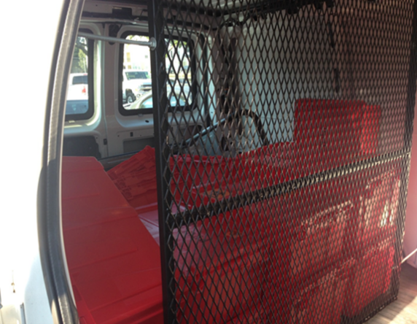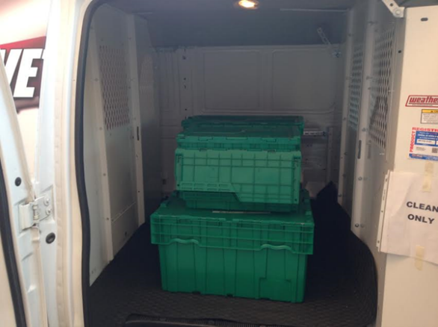

Firstly, RMD will be containerized in a medical grade, rigid, puncture proof, red biohazard marked transport container with a secure latching lid.
RMD transport container example:
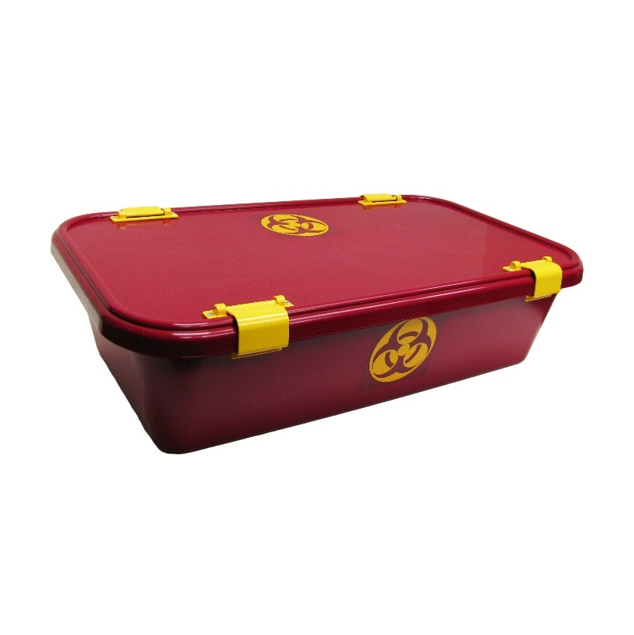
Red Storage tote and dirty transportation sticker example:
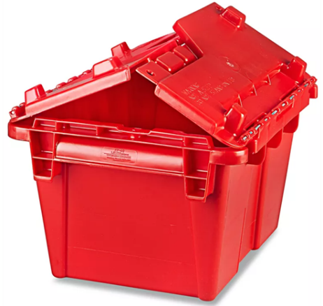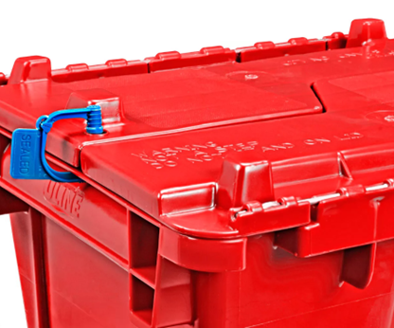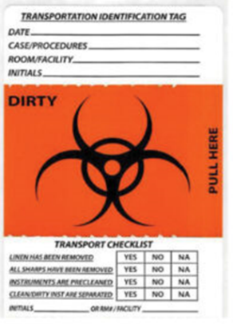
Clean RMD cargo will be packaged individually in peel packs or as sets placed inside a cassette and wrapped in a blue drape; then transported in a green/blue storage tote affixed with a clean tag or sticker.
Peel pack and cassette examples:


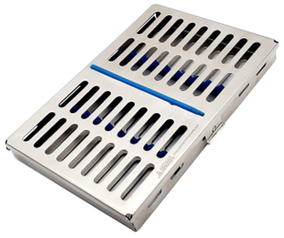

Clean transportation sticker example:
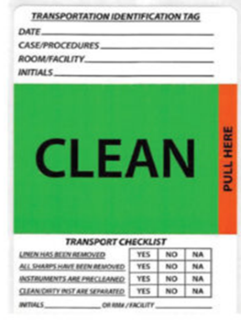

Case Cart Example:

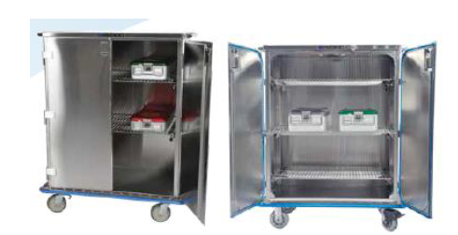

The ground transport vehicle shall be stocked with a shelf life current, “SPILL KIT” for bio-hazard spill cleanup. CONTRACTOR will ensure that the driver has been trained in proper use of spill kits to collect, contain, and dispose of spilled biomatter and chemicals. The CONTRACTOR will ensure the vehicle is outfitted with the necessary personal protective equipment (PPE) and first aid kit. Signage will be posted to identify the location of the spill kit and first aid kit.
First aid kit and spill kit signage examples:
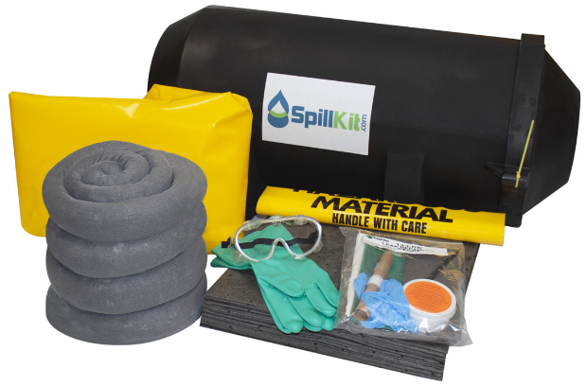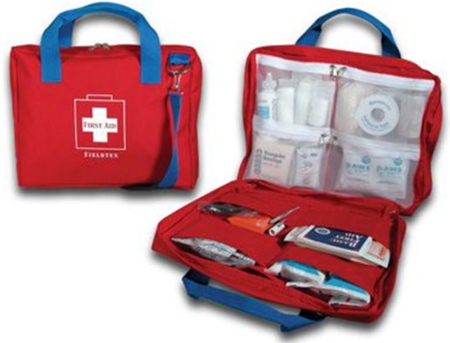

The RMD cargo will be loaded in a manner that protects the devices from shift damage during transportation. Bio-hazard transport bins with latching lids will be placed within a storage tote with securable closure lid. Totes will be secured in place using straps and anchor points.
Cargo anchor point and cargo strap example:
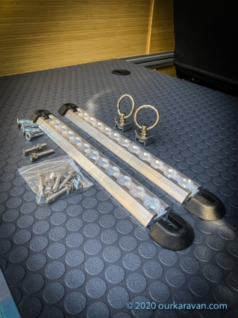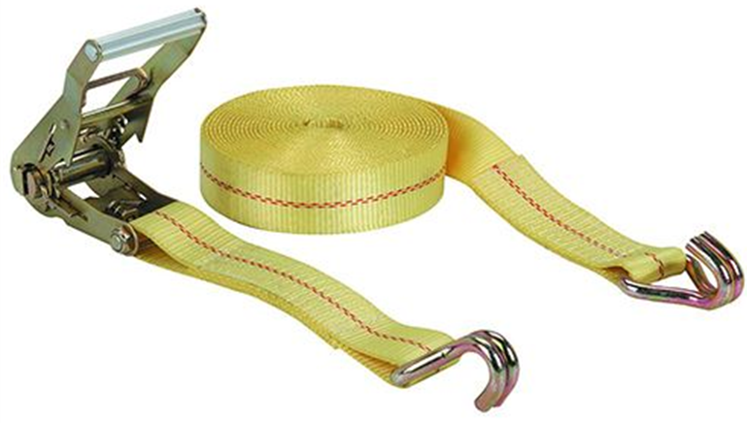

Any sterile items that are dropped should be considered contaminated and reprocessed, even if no damage to packaging is evident.
Direct contact with sterile packages shall be avoided. This includes any touching or excessive handling of packages.
The storage tote will be provided to the CONTRACTOR driver to be placed in a vehicle that maintains temperature compliance.
At any time that RMD cargo is in the vehicle, the air conditioning will remain in operation. The cargo area will have a dedicated air conditioning system independent of the passenger area environmental controls.
Cargo compartment dedicated air conditioner example:
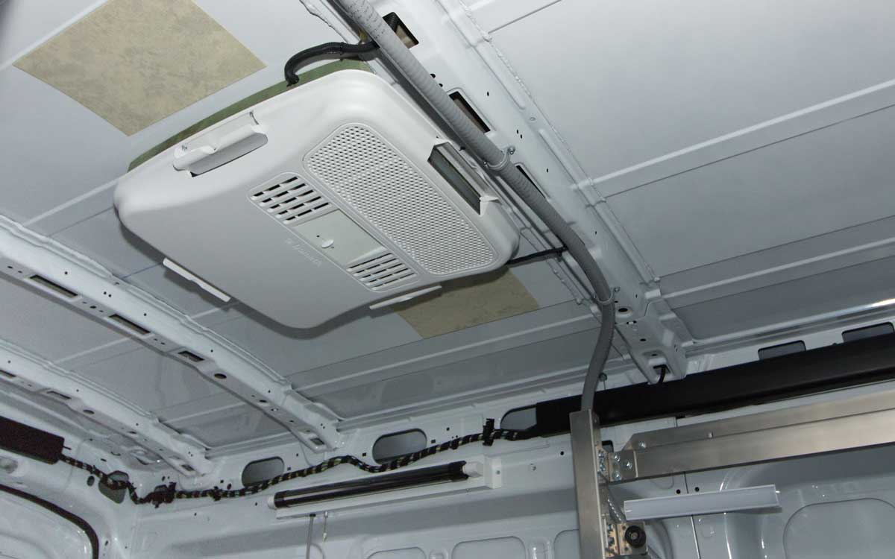
Temperature shall be maintained in accordance with AAMI/ANSI ST79 regulations for sterile RMD.
Temperature
66 – 72ºF
Humidity
30%-60%

The CONTRACTOR driver shall ensure that the vehicle meets the temperature requirements prior to loading RMD, throughout transit, and upon and during delivery.
The temperature of the ground transport cargo area will be recorded on the vehicle transportation checklist (attachment A) prior to departure and upon arrival at the receiving facility. The transportation checklist will be initialized by the CONTRACTOR driver and VABHS employee. All transportation manifests will be retained as a permanent record.
The vehicle interior must be terminally cleaned (i.e., intermediate level disinfected) after each RMD delivery. Suitable intermediate level disinfectants are hospital grade quaternary ammonia and isopropyl blends. The disinfectant will be applied per the manufacturer’s instructions for use (IFU).

5. Personnel Requirements
Drivers must be 18+, hold a valid commercial license, pass background checks and drug screening, and be trained in OSHA, DOT, AAMI TIR109, and IAHCSMM standards. Uniforms and visible ID badges are required. Drivers shall wear distinctive clothing items to identify them as employees of the courier company. Drivers shall be able to speak, understand and write English. Drivers shall possess VA Boston Security Officer approved picture identification showing driver name and company name. Contractor is responsible for the actions and conduct of its employees and shall assure that they are consistently compliant with all VA building and parking regulations, policies and guidelines while conducting business on Government property and for the VA. Drivers shall observe the smoking and tobacco policies of the VA. Employees working for the Contractor shall not be considered Government employees. The Contractor shall provide Workers Compensation, Professional Liability insurance, health examinations, Income Tax Withholding and Social Security Payments for all W2 employees. Alternatively, contractor may also utilize the services of “similarly situated” independent contractors who are of the same socio-economic category as the prime. Utilizing the services of an independent contractor who is not “similarly situated” will be designated as a subcontractor and not count towards the Limitations of Subcontracting requirement that contractor personnel perform at least 50% of the work. Contractors shall confirm compliance with the Limitations of Subcontracting FAR Clause 52.219-14.

6. Regulatory Compliance
Contaminated RMDs must be collected in leak-proof containers, kept moist, and transported promptly. Clean RMDs must be packaged and labeled. Documentation includes manifests, temperature logs, and cleaning records.

7. Documentation & Chain of Custody
Transportation manifests must include date/time, origin/destination, temperature logs, driver and receiver initials. Weekly cleaning logs and monthly reports to COR. Incident reports within 24 hours.

8. Quality Assurance
Contractor must implement a Quality Control Plan (QCP). VA COR will conduct inspections and reviews. Contractors must maintain training and performance records and resolve complaints.
The COR will periodically evaluate the contractor’s performance in accordance with the following Quality Assurance Plan.
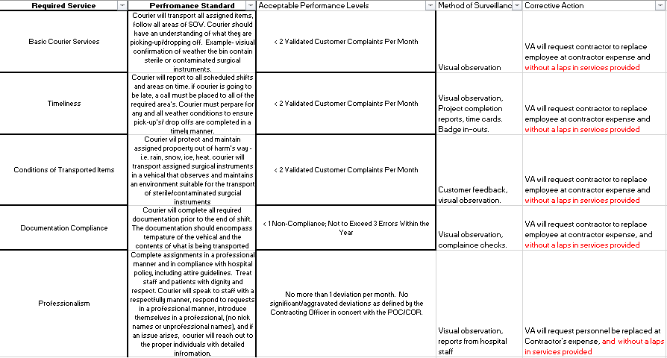

9. Safety & Security
Vehicles must remain locked when unattended. RMDs must not be abandoned. No transport of VA personnel or access to VA systems. Contractor is liable for loss or damage.

10. Environmental & Emergency Preparedness
Vehicles must operate safely in inclement weather. Spill kits and PPE must be available. Contractor must notify COR/CO of disruptions.

11. Additional Requirements
Contractors must comply with COVID-19 protocols, insurance requirements, and provide evidence of licensure, insurance, and training prior to contract initiation.
VABHS reserves the right to inspect contractor's equipment and vehicles or require documentation of compliance with contract specifications, and State laws, rules, regulations and guidelines governing transportation vehicles. The CONTRACTOR shall submit to and participate in any periodic review of service practice requests. VABHS inspections of contractor equipment will not constitute a warranty that the contractor's vehicles and equipment are properly maintained.

VABHS reserves the right to restrict the use of CONTRACTOR equipment and vehicles that are not in compliance with contract requirements. The restriction on such equipment and vehicles should not relieve the contractor from performing in accordance with the contract and without additional cost to VABHS.

Throughout the performance periods of the contract, it shall be the contractor’s responsibility to ensure that vehicles meet all current applicable Federal, State and local specifications and regulations including, but not limited to, licensing, registration, and safety standards. The vehicle must have alarm system that indicates when vehicle is backing up; back up lights with a built-in alarm constitute a backup alarm system.

The CONTRACTOR shall make all reasonable provisions to protect items being transported against loss. Should RMD be lost or stolen while in the CONTRACTOR possession they shall reimburse VABHS for the replacement value. The vehicle will not be left unattended while conducting delivery. The cargo area air conditioner must remain on during the entirety of the delivery to maintain specified environmental conditions.

Should any RMD be lost, damaged, or stolen while in the CONTRACTOR possession, they shall submit a written report to the COR within twenty-four (24) hours, explaining the circumstances.

The CONTRACTOR staff are required to interrupt their work at any time so as not to interfere with the normal functioning of the medical facility, including utility services, fire protection systems, and passage of facility patients, personnel, equipment and emergency and/or service carts. These interruptions should only be occasional. Any interruptions considered to be excessive should be brought to the attention of the CO and COR.

12. Contractor Compliance Checklist
To be completed and verified for each transport trip. Must be retained and submitted weekly. Includes checks for vehicle configuration, temperature control, documentation, PPE, training, and chain of custody.
Attachment A:
Requirement | Compliant (✔) | Notes
Vehicles have partitioned cargo areas labeled CLEAN/DIRTY | ☐
Cargo area temperature maintained at 66–72°F and Humidity maintained at 30%-60% RH  Attached Temp and Humidity Log filled each trip | ☐
Transport carriers are leak-proof, rigid, and labeled | ☐
Drivers trained in OSHA, DOT, AAMI TIR109 | ☐
Daily manifests include temperature logs and signatures | ☐
Weekly cleaning logs submitted | ☐
Spill kits and PPE stocked in vehicles | ☐
Chain of custody maintained | ☐
Clean and soiled items physically separated | ☐
Transport carriers cleaned after each use | ☐
Personnel wear uniforms and visible ID | ☐
Quality Control Plan implemented | ☐

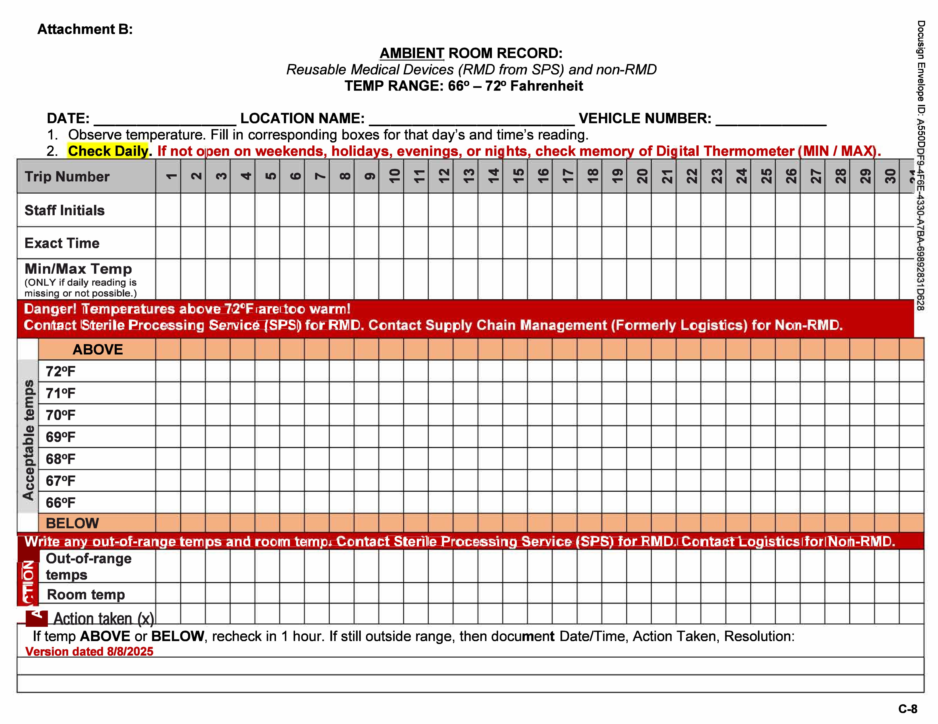
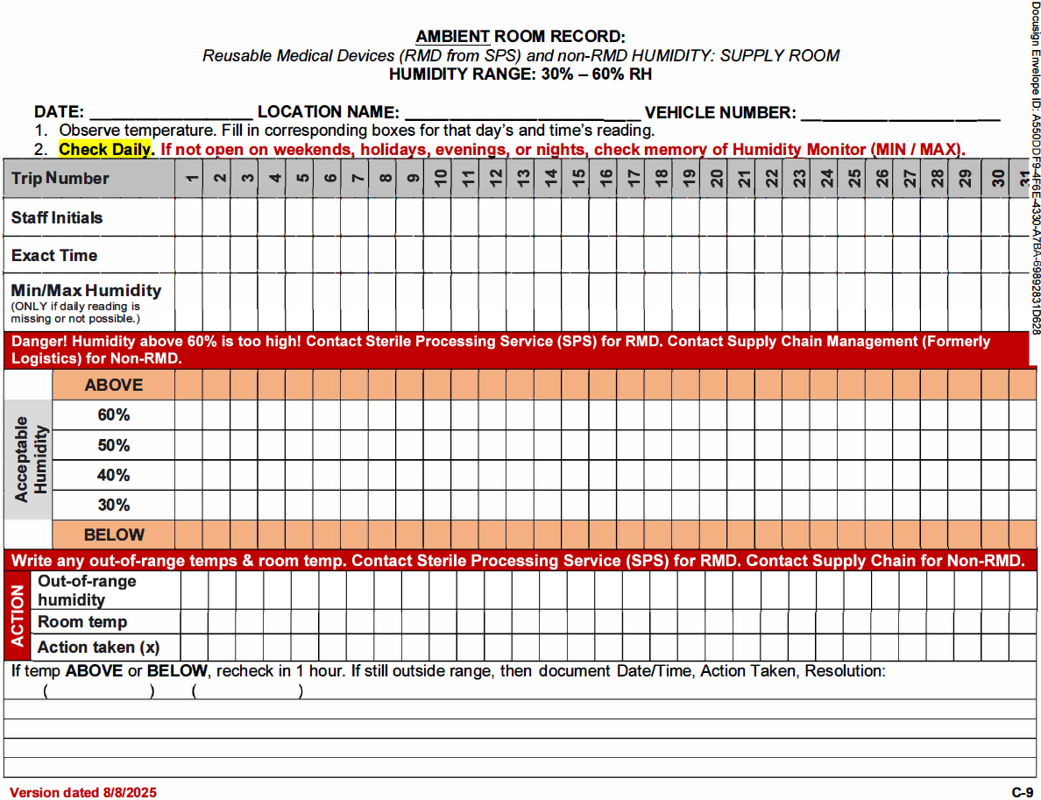

(END OF STATEMENT OF WORK)

The purchase order/contract period of performance is for one year.
Place of Performance/Place of Delivery
Address: | VA Boston Healthcare  1400 VFW Parkway  Boston MA
Postal Code: | 02132
Country: | UNITED STATES
(START OF CLAUSES AND PROVISIONS)

The full text of FAR provisions or clauses may be accessed electronically at https://www.acquisition.gov/browse/index/far.

The following solicitation provisions and clauses apply to this acquisition:
- FAR 52.212-1, Instructions to Offerors-Commercial Products and Commercial Services (SEP 2023) (DEVIATION OCT 2025)
All quoters shall submit the following: Price, Technical, and Past Performance
All quotes shall be sent to the Contract Specialist, Jessica Martin, Jessica.Martin11@va.gov

Award will be based upon a comparative evaluation of quotes in accordance with the Simplified Acquisition Procedures of RFO FAR 12. Comparative evaluation is the side by side pairwise comparison of quotes based on factors resulting in a Contracting Officer decision for the quote most favorable to the Government.

- www.sam.gov registration is required to be complete at time of submission of response. Offerors must complete annual representations and certifications electronically via the System for Award Management (SAM) website located at https://sam.gov/.

- FAR 52.212-4, Contract Terms and Conditions-Commercial Products and Commercial Services (NOV 2023) (DEVIATION OCT 2025)

- FAR 52.252-1, Solicitation Provisions Incorporated by Reference (FEB 1998) - This solicitation incorporates one or more solicitation provisions by reference, with the same force and effect as if they were given in full text. Upon request, the Contracting Officer will make their full text available. The offeror is cautioned that the listed provisions may include blocks that must be completed by the offeror and submitted with its quotation or offer. In lieu of submitting the full text of those provisions, the offeror may identify the provision by paragraph identifier and provide the appropriate information with its quotation or offer. Also, the full text of a solicitation provision may be accessed electronically at this/these address(es): https://www.acquisition.gov/far-overhaul/far-part-deviation-guide/far-overhaul-part-52#FAR_52_252_1 (FAR) and http://www.va.gov/oal/library/vaar/index.asp (VAAR)
- ADDENDUM to FAR 52.212-2 EVALUATION—COMMERCIAL PRODUCTS AND COMMERCIAL SERVICES (DEVIATION AUG 2025)
- The following factors shall be used to evaluate quotations:
- Technical or Quality: The offeror’s quote shall be evaluated to determine if the contractor has the experience and capabilities to provide quality services in a timely and efficient manner.
- Contractor shall demonstrate their corporate experience and approach to meet all requirements stated in the Performance Work Statement.
- Contractor will provide a quality control plan, which explains the offerors approach to quality control and methodologies
- If you are planning to sub-contract some or all of this work, please provide the name and address(s) of all subcontractor(s) (if applicable) and a description of their planned subcontracting effort.
- Past Performance:
- Provide (3) references of work, similar in scope and size with the requirement detailed in the Performance Work Statement. Refer to Past Performance sheet in section D. References must include contact information, brief description of the work completed, and contract # (if relevant). References may be checked by the Contracting Officer to ensure your company is has complied with prior requirements, responded to issues and performed in accordance with the PWS.
- Past performance information may also be obtained from other sources available to the Government to include, but not limited to, Past Performance Retrieval System (PPIRS), Federal Awardee Performance and Integrity Information System (FAPIIS), Electronic Subcontracting Reporting System (eSRS), or other databases.
- Veterans Involvement:
- SDVOSBs and VOSBs must be registered and certified in the Vendor Information Pages (VIP) database (http://www.VetBiz.gov).
- Price: Complete line items on Page 2 of this combined synopsis/solicitation, which will be completed by the offeror.
- Evaluation Approach. The Government will evaluate quotations using the comparative evaluation process outlined in FAR 13.106-2 (b) (3), where quotations will be compared to one another to determine which provides the best benefit to the Government. The Government reserves the right to consider a quotation other than the lowest price that provides additional benefit(s). Quotations may exceed minimum requirements of the solicitation. The Government reserves the right to select a quotation that provides benefit to the Government that exceeds the minimum requirements of the solicitation but is not required to do so. Each response must meet the minimum requirements of the solicitation. The Government is not requesting or accepting alternate quotations. The evaluation will consider the following:
- Technical or Quality: The quotation will be evaluated to the extent to which it can meet and/or exceed the Government’s requirements as outlined in the solicitation and based on the information requested in the instructions to quoters section of the solicitation.
- Past Performance: The past performance evaluation will assess the relative risks associated with a quoter’s likelihood of success in fulfilling the solicitation’s requirements as indicated by the quoter’s record of past performance. The past performance evaluation may be based on the contracting officer’s knowledge of and previous experience with the supply or service being acquired; Customer surveys, and past performance questionnaire replies; Contractor Performance Assessment Reporting System (CPARS) at http://www.cpars.gov/; or any other reasonable basis.
- Veterans Involvement: In accordance with Veterans Affairs Acquisition Regulation (VAAR) 852.215-70 (DEVIATION), Service-Disabled Veteran-Owned and Veteran-Owned Small Business (VOSB) Evaluation Factors, the Government will assign evaluation credit for a Quoter (i.e., prime contractor) which is a Service-Disabled Veteran-Owned Small Business (SDVOSB) or a VOSB. To receive credit, an offeror must be registered and verified in Vendor Information Pages (VIP) database at time of quotation submission and at time of award ( https://www.vip.vetbiz.va.gov/) and must meet federal small business size standards for the North American Industry Classification System (NAICS) code assigned to this solicitation. Non-SDVOSB/VOSB quotations that use SDVOSBs or VOSBs as subcontractors will receive some consideration under this evaluation Factor. Quoters must state in their quotations the names of the SDVOSBs and VOSBs with whom they intend to subcontract and provide a brief description of the proposed subcontracts and the approximate dollar values of the proposed subcontracts. In addition, the proposed subcontractors must be registered and verified in the VetBiz.gov VIP database ( https://www.vip.vetbiz.va.gov/) and must meet federal small business size standards for the NAICS code assigned to this solicitation at time of both quotation submission and at time of award.
- Price: The Government will evaluate the price by adding the total of all line-item prices. The Total Evaluated Price will be that sum.
- FAR 52.203-18, Prohibition on Contracting with Entities that Require Certain Internal Confidentiality Agreements or Statements-Representation. (JAN 2017)
- FAR 52.204-7, System for Award Management—Registration (NOV 2024) (DEVIATION NOV 2025)
- FAR 52.222-18, Certification Regarding Knowledge of Child Labor for Listed End Products.(FEB 2021)
- FAR 52.252-2, Clauses Incorporated by Reference (FEB 1998) - This contract incorporates one or more clauses by reference, with eh same force and effect as if they were given in full text. Upon request, the Contracting Officer will make their full
- text available. Also, the full text of a clause may be accessed electronically at this/these address(es):
http://www.acquisition.gov/far/index.html (FAR) and
http://www.va.gov/oal/library/vaar/index.asp (VAAR)
- FAR 52.203-17, Contractor Employee Whistleblower Rights. (NOV 2023)
- FAR 52.203-19, Prohibition on Requiring Certain Internal Confidentiality Agreements or Statements. (JAN 2017)
- FAR 52.204-9, Personal Identity Verification of Contractor Personnel (JAN 2011)
- FAR 52.204-13, System for Award Management-Maintenance (OCT 2018) (DEVIATION NOV 2025)
- FAR 52.209-6, Protecting the Government's Interest When Subcontracting With Contractors Debarred, Suspended, Proposed for Debarment, or Voluntarily Excluded. (JAN 2025) (DEVIATION NOV 2025)
- FAR 52.209-10, Prohibition on Contracting With Inverted Domestic Corporations. (NOV 2015) (DEVIATION NOV 2025)
- FAR 52.219-14, Limitations on Subcontracting. (OCT 2022) (DEVIATION NOV 2025)
- FAR 52.222-3, Convict Labor. (JUN 2003) (DEVIATION NOV 2025)
- FAR 52.222-19, Child Labor-Cooperation with Authorities and Remedies. (JAN 2025) (DEVIATION NOV 2025)
- FAR 52.222-36, Equal Opportunity for Workers with Disabilities. (JUN 2020) (DEVIATION NOV 2025)
- FAR 52.222-41, Service Contract Labor Standards. (AUG 2018) (DEVIATION NOV 2025)
- FAR 52.222-42, Statement of Equivalent Rates for Federal Hires. (MAY 2014)
- FAR 52.222-43, Fair Labor Standards Act and Service Contract Labor Standards-Price Adjustment (Multiple Year and Option Contracts). (AUG 2018) (DEVIATION NOV 2025)
- FAR 52.222-50, Combating Trafficking in Persons. (NOV 2021) (DEVIATION NOV 2025)
- FAR 52.222-62, Paid Sick Leave Under Executive Order 13706. (JAN 2022) (DEVIATION NOV 2025)
- FAR 52.223-23, Sustainable Products. (MAY 2024) (DEVIATION NOV 2025)
- FAR 52.226-8, Encouraging Contractor Policies to Ban Text Messaging While Driving. (MAY 2024)
- FAR 52.232-33, Payment by Electronic Funds Transfer-System for Award Management. (OCT 2018)
- FAR 52.233-3, Protest after Award. (AUG 1996) (DEVIATION NOV 2025)
- FAR 52.233-4, Applicable Law for Breach of Contract Claim. (OCT 2004) (DEVIATION NOV 2025)
- FAR 52.240-91, Security Prohibitions and Exclusions. (DEVIATION NOV 2025)
- FAR 52.244-6, Subcontracts for Commercial Products and Commercial Services. (JAN 2025) (DEVIATION OCT 2025)
- FAR 52.222-14, Disputes Concerning Labor Standards (FEB 1988) (DEVIATION NOV 2025)
- FAR 52.222-15, Certification of Eligibility (MAY 2014)
- FAR 52.222-55, Minimum Wages for Contractor Workers Under Executive Order 14026 (JAN 2022) (DEVIATION NOV 2025)
- FAR 52.223-5, Pollution Prevention and Right-to-Know Information (MAY 2024)
- FAR 52.252-6, Authorized Deviations in Clauses (NOV 2020) - (b) The use in this solicitation or contract of any VA Acquisition Regulation (VAAR) and 48 CFR Chapter 8 clause with an authorized deviation is indicated by the addition of "(DEVIATION)" after the name of the regulation.
- VAAR 852.209-70, Organizational Conflicts of Interest (OCT 2020)
- VAAR 852.203-70, Commercial Advertising (MAY 2018)
- VAAR 852.204-70, Personal Identity Verification of Contractor Personnel (MAY 2020)
- VAAR 852.219-73, VA Notice to Total Set-Aside for Certified Service-Disabled Veteran-Owned Small Businesses (JAN 2023) (DEVIATION)
- VAAR 852.219-74, VA Notice to Total Set-Aside for Certified Veteran-Owned Small Businesses (JAN 2023) (DEVIATION)
- VAAR 852.232-72, Electronic Submission of Payment Requests (NOV 2018)
- VAAR 852.242-71, Administrative Contracting Officer (OCT 2020)

(END OF CLAUSES AND PROVISIONS)

To facilitate the award process, all quotes must include a statement regarding the terms and conditions herein as follows:
"The terms and conditions in the solicitation are acceptable to be included in the award document without modification, deletion, or addition."
Quoters shall list exception(s) and rationale for the exception(s), if any.

Submission of your response shall be received not later than 05/18/2026 at 9:00AM EST. and email sent to Jessica.Martin11@va.gov. Any questions shall be received no later than 05/12/2026 at 4:00PM EST.

Late submissions shall be treated in accordance with the solicitation provision at FAR 52.212-1(f). Not Accepted.

Any questions or concerns regarding this solicitation should be forwarded in writing via e-mail to the Point of Contact listed below:

Jessica Martin Jessica.Martin11@va.gov

