SUBJECT* | Newington Boiler Plant Steam Header Valves

GENERAL INFORMATION
CONTRACTING OFFICE’S ZIP CODE* | 03104
SOLICITATION NUMBER* | 36C24126Q0475
RESPONSE DATE/TIME/ZONE | 05-20-2026 17:00 EASTERN TIME, NEW YORK, USA
ARCHIVE | 15 DAYS AFTER THE RESPONSE DATE
RECOVERY ACT FUNDS | N
SET-ASIDE | SDVOSBC
PRODUCT SERVICE CODE* | J045
NAICS CODE* | 238220
CONTRACTING OFFICE ADDRESS | Department of Veterans Affairs  VAMC Manchester  718 Smyth Road  Manchester NH 03104
POINT OF CONTACT* | Contract Specialist  Nathan Langone  Nathan.Langone@va.gov

PLACE OF PERFORMANCE
ADDRESS | VAMC West Haven
 | 950 Campbell Ave
 | West Haven CT
POSTAL CODE | 06516
COUNTRY | USA

ADDITIONAL INFORMATION
AGENCY’S URL
URL DESCRIPTION
AGENCY CONTACT’S EMAIL ADDRESS
EMAIL DESCRIPTION

DESCRIPTION
Combined Synopsis Solicitation – Newington VAMC - Boiler Plant Steam Header Valves
(i) This is a combined synopsis/solicitation for commercial items prepared in accordance with the format in Subpart 12.6, as supplemented with additional information included in this notice. This announcement constitutes the only solicitation; proposals are being requested and a written solicitation will not be issued.
(ii) The solicitation number is 36C24126Q0475 and the solicitation is issued as a request for quotation (RFQ).
(iii) A statement that the solicitation document and incorporated provisions and clauses are those in effect through Federal Acquisition Circular 2026-01.
(iv) This requirement is being issued as a SDVOSB set-aside. The associated NAICS 238220 and small business size standard is $19 million.
(v) The Government intends to award a firm-fixed price award for Newington Boiler Plant Steam Header Valves. Please see the attached Statement of Work for full requirement details. Please complete the Price Schedule below and submit with the quote submission.
(vi) The Contractor shall provide all resources necessary to provide Backflow Repairs IAW the attached (Statement of Work). Please see the attached SOW for full requirement details.
(vii) The Place of Performance is West Haven VAMC as described per the (Statement of Work).
(viii) Provision at 52.212-1, Instructions to Offerors -- Commercial, applies to this acquisition in addition to the following addenda’s to the provision: 52.252-1 Solicitation Provisions Incorporated by Reference (FEB 1998); 52.204-7 System for Award Management (OCT 2018); 52.204-16 Commercial and Government Entity Code Reporting (JUL 2016); 52.217-5 Evaluation of Options (JUL 1990); 852.252-70 Solicitation Provisions or Clauses Incorporated by Reference (JAN 2008)
(ix) Provision at 52.212-2, Evaluation -- Commercial Items, applies to this requirement.
Site Visit: A mandatory pre-bid site visit is required. Bidders shall perform a pre-bid walkthrough at 8:30 a.m. on 05/13/2026 VACHS Newington CT. The meeting starts in the FMS Building/ Office for sign-in and for temporary day badge issuance, etc. Newington Campus - E Building 3, 3rd Floor

Submission of Quotes:
(1) Quotes shall be received on or before the date and time specified in Section (xv) of this solicitation. Note: Offers received after the due date and time shall not be considered.
(2) Offerors shall submit their quotes electronically via email to Nathan.Langone@va.gov.
(3) Questions: Questions shall be submitted to the Contracting Officer in writing via e-mail. Oral questions are not acceptable due to the possibility of misunderstanding or misinterpretation. The cut-off date and time for receipt of questions is May 15th, 2026 by 12:00 PM EST. Questions received after this date and time may not be answered. Questions shall be answered in a formal amendment to the solicitation so all interested parties can see the answers.
(4) Quote Format: The submission should be clearly indexed and logically assembled in order of the evaluation criteria below. All pages of the quote shall be appropriately numbered and identified by the complete company name, date and solicitation number in the header and/or footer.
Evaluation Process:
Award shall be made to the best value, as determined to be the most beneficial to the Government. Please read each section below carefully for the submittals and information required as part of the evaluation. Failure to provide the requested information below shall be considered non-compliant and your quote could be removed from the evaluation process.
Offeror quotes shall be evaluated under FAR Part 13.106-2(b) -- Evaluation of Quotations or Offers. Therefore, the Government is not obligated to determine a competitive range, conduct discussions with all contractors, solicit final revised quotes, and use other techniques associated with FAR Part 15.
The Government shall award a contract resulting from this solicitation to the responsible offeror whose offer conforming to the solicitation shall be most advantageous to the Government, price and other factors considered. The following factors shall be used to evaluate offers:
- Price (Follow these instructions):
  - Offeror shall complete Attachment 1 - Price Schedule, with offerors proposed contract line item prices inserted in appropriate spaces.
- Past Performance:
  - Offeror shall utilize Attachment 2 – Past Performance Worksheet to provide at least one (1) but no more than (3) references of work, similar in scope and size with the requirement detailed in the (Performance Work Statement). References may be checked by the Contracting Officer to ensure your company is capable of performing the Statement of Work. The Government also reserves the right to obtain information for use in the evaluation of past performance from any and all sources.
- Technical: The offeror’s quote shall be evaluated to determine if the organization has the experience and capabilities to provide the requested services IAW the (Performance Work Statement) in a timely efficient manner.
  - Contractor shall demonstrate their corporate experience and approach to meet all requirements stated in the (Performance Work Statement).
  - Contractor shall demonstrate that their technicians meet the qualification standards stated in the (Performance Work Statement).
  - If you are planning to sub-contract some or all of this work, please provide the name and address(s) of all subcontractor(s) (if applicable) and a description of their planned subcontracting effort.
SAM: Interested parties shall be registered in System for Award Management (SAM) as prescribed in FAR Clause 52.232-33. SAM information can be obtained by accessing the internet at www.sam.gov or by calling 1-866-606-8220. Interested parties not registered in SAM in sufficient time to meet the VA’s requirement will be ineligible to receive a government contract. This determination will be at the discretion of the Contracting Officer.
VISTA: The VA utilizes VISTA to issue a purchase order and liquidate invoices. Failure to register in VISTA may result in exclusion from the issuance of a VA contract. This determination will be at the discretion of the Contracting Officer. Interested parties with no prior VA contracts can request a Form 10091 at any time.
(x) Please include a completed copy of the provision at 52.212-3, Offeror Representations and Certifications -- Commercial Items, with your offer via the SAM.gov website or a written copy.
(xi) Clause 52.212-4, Contract Terms and Conditions -- Commercial Items (OCT 2018), applies to this acquisition in addition to the following addenda’s to the clause: 52.204-16 Commercial and Government Entity Code Maintenance (JUL 2016); 52.219-6 Notice of Total Small Business Set-Aside; 52.232-40 Providing Accelerated Payments to Small Business Subcontractors (DEC 2013); 852.203-70 Commercial Advertising (MAY 2008); 852.232-72 Electronic Submission of Payment Requests (NOV 2018)
Subcontracting Commitments - Monitoring and Compliance
This solicitation includes VAAR 852.215-70, Service-Disabled Veteran-Owned and Veteran-Owned Small Business Evaluation Factors, and VAAR 852.215-71, Evaluation Factor Commitments. Accordingly, any contract resulting from this solicitation will include these clauses. The contractor is advised in performing contract administration functions, the CO may use the services of a support contractor(s) to assist in assessing contractor compliance with the subcontracting commitments incorporated into the “Information Protection and Non-Disclosure and Disclosure of Conflicts of Interest Agreement” to ensure the contractor's business records or other proprietary data reviewed or obtained in the course of assisting the CO in assessing the contractor for compliance are protected to ensure information or data is not improperly disclosed or other impropriety occurs. Furthermore, if VA determines any services the support contractor(s) will perform in assessing compliance are advisory and assistance services as defined in FAR 2.101, Definitions, the support contractor(s) must also enter into an agreement with the contractor to protect proprietary information as required by FAR 9.505-4, Obtaining access to proprietary information, paragraph (b). The contractor is required to cooperate fully and make available any records as may be required to enable the CO to assess the contractor compliance with the subcontracting commitments.
(xii) Clause at 52.212-5, Contract Terms and Conditions Required To Implement Statutes Or Executive Orders -- Commercial Items, applies to this acquisition and in addition to the following FAR clauses cited, which are also applicable to the acquisition: 52.204-10, 52.209-6, 52.219-6, 52.219-28, 52.222-3, 52.222-21, 52.222-26, 52.222-36, 52.222-50, 52.223-18, 52.232-33, 52.222-41, 52.222-43 (Wage Determination Applicable (Manchester 2015-4019 Rev 23 posted on beta.sam.gov)
(xiii) All contract requirement(s) and/or terms and conditions are stated above.
(xiv) The Defense Priorities and Allocations System (DPAS) and assigned rating are not applicable to this requirement.
(xv) RFQ responses are due May 20, 2026 by 10:00 AM EST. RFQ responses must be submitted via email to: Nathan.Langone@va.gov, Hand deliveries shall not be accepted.
(xvi) The POC of this solicitation is Nathan.Langone@va.gov

ATTACHMENT 1
PRICE SCHEDULE
ITEM NUMBER | DESCRIPTION OF SERVICES | QUANTITY | UNIT | UNIT PRICE | AMOUNT
Base | Boiler Plant Steam Header Valves | 1.00 | JB | __________________ | __________________
 |  |  |  | GRAND TOTAL | __________________

ATTACHMENT 2
PAST PERFORMANCE WORKSHEET
1. Name of Contracting Activity, Government Agency, Commercial Firm or other Organization:
2. Contracting Activity Address:
3. Contract Number: | 4. Date of Contract Award:
5. Beginning Date of Contract: | 6. Completion Date of Contract:
7. Contract Value: | 8. Type of Contract:
9a. Technical Point of Contact: | 9b. Contracting Point of Contact:
Name: | Name:
Title: | Title:
Address: | Address:
Telephone: | Telephone:
Email: | Email:
10. Place of Performance:
11. Description of Work (Use a continuation sheet if necessary):
12. List any commendations or awards received:
13. List of Major Subcontractors:

ATTACHMENT 3
STATEMENT OF WORK
NEWINGTON BOILER PLANT
HEADER DEFICIENCIES CORRECTION
BACKGROUND
VA manages and maintains the operation and condition of facility level boiler to set standards and does so through Directive 1810 as well as compliance to all applicable codes, regulation and guidance. It is the intent of this project to support and maintain the condition and operation of the facility level boilers in compliance through ongoing inspections, cleaning, service, proper operation, etc.

JUSTIFICATION
VA Connecticut Healthcare System Newington Campus operates a high-pressure steam Boiler Plant System. The current header system and its associated valves need assessment and replacements so that it can be assured to operate most effectively. These items and their corrections ensure that the boilers are operating to standard and in compliance with VA Directive 1810, codes, regulations, etc..

PLACE OF PERFORMANCE
The place of performance for this contract is VA Connecticut Healthcare System, located at Newington Campus, 555 Willard Avenue, Newington, CT 06111.

PERIOD OF PERFORMANCE
The Contract Time Period of Performance is 45 days from the contract award and Notice to Proceed (NTP).

QUALIFICATIONS
To be considered eligible for consideration, potential bidders shall have a field service representative located within 100 miles of the Newington Campus of the VA Connecticut Healthcare System. The Service Provider acting as a Prime with subcontracted labor shall meet this requirement.

The Bidders shall provide, upon request, documentation of certification/training on the specific equipment under the terms of this contract.

The Bidders shall be qualified to perform work on steam distribution systems to include industrial boiler plant equipment and have completed prior steam distribution work and/or inspection projects for VA Connecticut Healthcare System.

The Service Provider shall have a minimum of three (3) years of related scope and work experience with commercial and industrial steam boiler and steam boiler component installation and repairs as well as all aspects of inspections, cleaning, calibration, and testing in compliance with and clear understanding of relevant codes and regulations.

The Service Provider and/or assigned project staff members shall have industry standard certifications and qualifications to include but not limited to current OSHA certification (10 hours minimum/ 30 hours preferred) and equivalent qualifications associated with requirements herein.

The Service Provider shall submit documentation of technical training and certifications for personnel performing all work under the terms of this contract for review and acceptance prior to the start of work on site.

The Service Provider/ welders shall be certified and possess R-stamp certification.

The Service Provider will be responsible for complying with the VA Connecticut Healthcare System policies for confined space, Lock Out Tag Out, all equipment, supplies, and external support to safely enter the confined space to document and investigate existing conditions, determine quantities, and confirm scope of work.

The Service Provider shall submit documentation on technical training and certifications for personnel performing all work. The Contracting Officer (CO) and/or Contracting Officer’s Representative (COR) specifically reserve the right to reject any of the Service Provider’s personnel and refuse permission to work on the equipment outlined herein, based upon credentials provided.

A mandatory pre-bid site visit is required. Bidders shall perform a pre-bid walkthrough at 8:30 a.m. on 05/13/2026 VACHS Newington CT. The meeting starts in the FMS Building/ Office for sign-in and for temporary day badge issuance, etc. Newington Campus - E Building 3, 3rd Floor

SCOPE OF WORK
The Service Provider shall furnish all labor, materials, equipment, tools, supervision, Safety considerations, LOTO procedures, clean up (daily and at the end of work with proper disposal of waste) and all incidentals to complete work for the services described in this document.

The Service Provider shall submit a project schedule, work procedures, inspection procedures, testing procedures, all safety documentation, weld procedures, welders’ certifications, etc. for review and approval by VA Contracting Officer Representative (COR) and Safety Office before the start of work on site.

If applicable, the Service Provider shall develop and submit an abatement plan including all personnel certifications and training records before the start of work on site.

Normal scheduled work shall occur between the hours of; 7:00 a.m. and 5:00 p.m. Monday – Friday as coordinated with COR. All off-normal scheduled work shall be communicated and coordinated with CO and COR a minimum of ten (10) working days prior to need. No work shall be performed on Federal Holidays unless an emergency status has been indicated and/or authorized by the Contracting Officer.

US Federal Holidays:

New Year’s Day
Martin Luther King Jr. Day
President’s Day
Memorial Day
Juneteenth
Independence Day
Labor Day
Columbus Day
Veterans Day
Thanksgiving Day
Christmas Day
Description of Services:
The project will include but not be limited to the following:

  - Remove and replace valves as indicated in snip clips and per field review with Plant Supervisor and COR to verify count (x11), locations and setup. All Valves indicated to be replaced with new, Boiler #3 header valve to be replaced with new, blanked and LOTO.
  - 9 valves only shall be provided by the facility. Contractor to procure x2 - 4” valves and all required hardware – nuts, bolts, gaskets, etc. and install accordingly per code, regs. etc.

- General Site Information (valve locations):
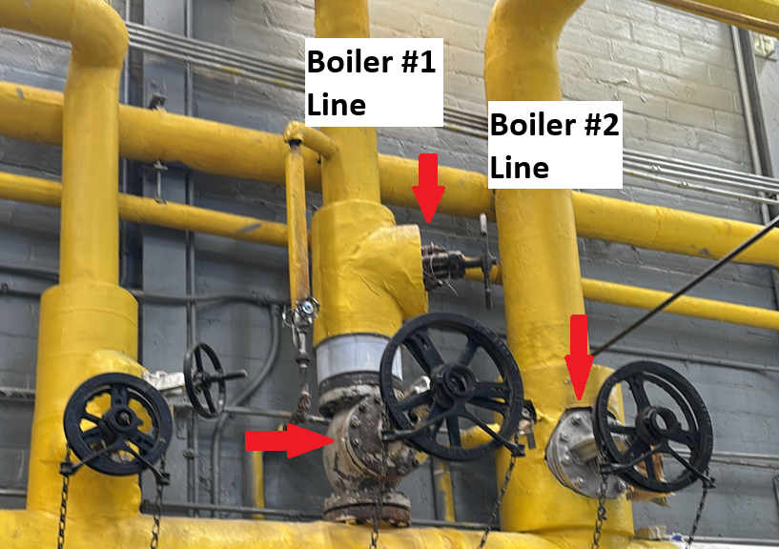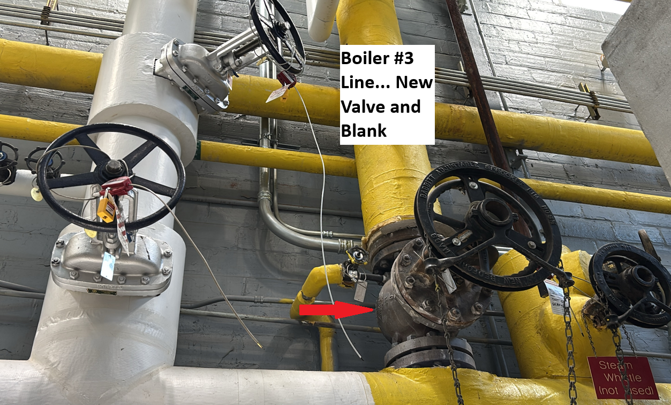
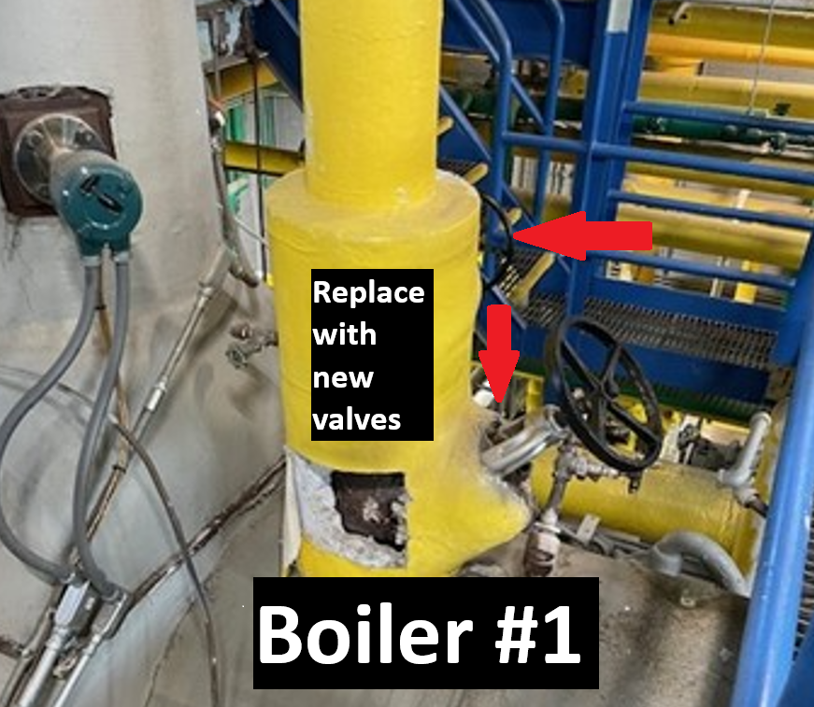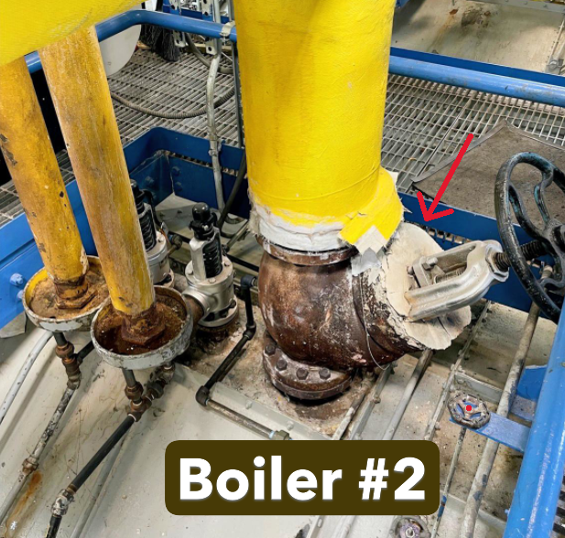
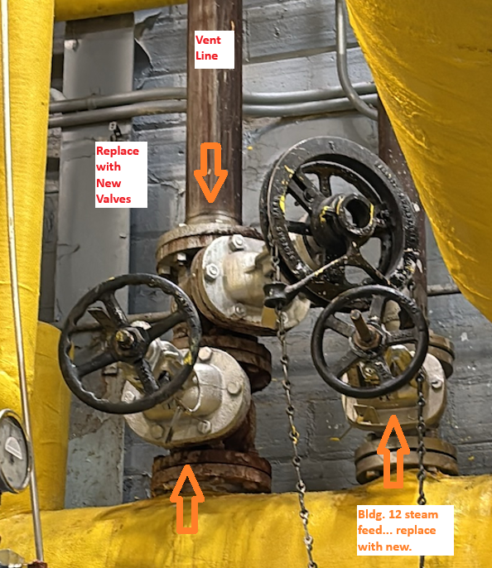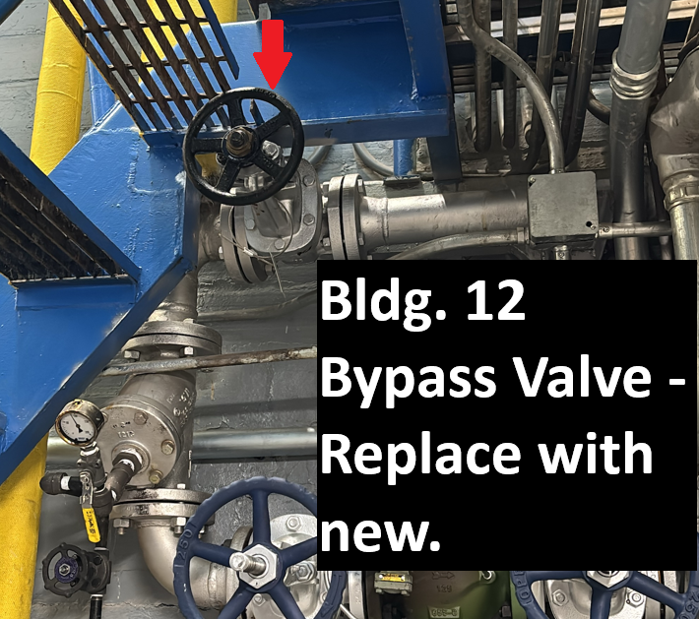

  - All elevated valves will be installed and set up with chain wheels and pull chains where access to valves are required from grade. Hammer blow chain wheels shall be installed to aid in opening and closing stuck valves. Chains shall be made safe for passage and will be set up, so they do not interfere with one another.

  - All isolation of high-pressure steam lines required double inline valve installation (where only 1 may exist at this time). Review with Plant Supervisor and COR required locations.

  - Insulation, flow indicators, labeling, color coding, tags, etc.

    - Insulations for valve bodies with be serviceable type insulation that can be installed and removed with Velcro straps.

- In addition, the contractor shall:

  - Check-in with the VACT Boiler Plant Supervisor at the start of each workday.

  - Provide a final comprehensive report on repairs and testing of deficient devices.

  - Performed and complete work per schedule that is approved in advance. Dates and times of work shall be coordinated between the Contractor and VA Contracting Officer to minimize impact on boiler plant operations. The Contract shall be completed within indicated days of the award. If any portion of the Contract cannot be completed within this period, the Contractor and VA Contracting Officer shall determine a reasonable period of performance for the specified portion within ten (10) Calander Days of award to modify for full compliance.

  - The Service Provider shall schedule and coordinate all work with VA COR, Utilities Supervisor, and Boiler Plant Supervisor.

  - All LOTO requests and procedures shall follow the VA Connecticut Healthcare System Medical Center Policy 138-075.

  - Coordinate Hot Work permit requests with VA Connecticut Healthcare System Safety Office.

  - Coordinate all placement and removal of Lock Out Tag Out devices for any energy sources with the VA COR/Maintenance & Operations.

  - All Confined Space entries shall follow the VA Connecticut Healthcare System Standard Operating Procedure Confined Space SOP-SO-010.

  - The VACHS confined space acknowledgement and permit is required to be completed by qualified individuals identified to perform entry into any confined space and will be coordinated with the VACHS Safety & Outage Coordinator and VACHS Safety Representative on site.

  - Protect all equipment in place during replacement activities.

  - Equipment considered necessary to accomplish all the work required by this contract includes but is not limited to equipment required for metal work, welding, inspection, testing, rigging & handling, de-watering, containment, and cleaning of any debris resulting from this work.

  - In accordance with VHA Operational Alert and Guidance, NO cast iron fittings and pipe components (valves, steam traps, etc.) shall be used. Reference VHA Directive 1810(1) as amended on September 11, 2018: 5.a(1) and 5.b(1).

  - ASTM A193 bolts shall be utilized and replace any ASTM A307 Bolts at locations of steam piping, flanges, gaskets, and other hardware where piping replacements are included within this scope of work. Reference Veterans Health Administration (VHA) Master Specifications for Hydronic Piping (Specification 23 22 13) and Steam and Condensate Heating Piping (Specification 23 22 13) where applicable.

  - The repair of existing cast iron fittings or pipe components is permissible in specific instances but must be reported and coordinated with the CO and COR for approval before starting the work through submittal process with justification as necessary.

  - All new steam and condensate lines shall be Schedule 80. All new steam and condensate lines that utilize valves to isolate or divert a medium shall be installed new as a double in series valve system (except for a drain line valve). Where the option exists to utilize welded vs threaded distribution, welded is the required option with connection to weld neck flanges and per use of metal jacketed gaskets. Alternate may be considered but not allowed unless authorized by the COR.

  - Repairs and any modifications shall be in full compliance with American Society of Mechanical Engineers (ASME) and National Board Inspection Code (NBIC).

  - The Service Provider shall perform an inspection report of all repairs, corrections, and testing with photographs and other documentation necessary to confirm information within the report.

  - All welding work shall be completed by certified welders (submit certifications for review and acceptance to the COR prior to any work) and must possess R-stamp certification. All weld tests shall meet standard per code specifications – ASME Section V requirements for nondestructive examination and ASME Section VIIII rules for construction of pressure vessel.

  - Finish work shall include new insulation with R-factor and type to match existing, fiberglass with white paper wrap on lines, removable Velcro type fitting booths, color coded for medium, brass tags valves, medium labels on insulation and flow indicators.

- SUBMITTALS/DELIVERABLES

  - The Service Provider shall furnish all submittal item documentations (with final dispositions) and final documentation report with all tests, photos, corrections made within fourteen (14) business days after work is completed. All submittals shall be provided to the VA O&M Section for Information Sharing Only and courtesy review. Proper equipment selection and timely procurement shall remain the responsibility of the Service Provider.

  - The Service Provider shall furnish all material certifications for any replacement parts used.

  - The Service Provider shall furnish a waste manifest as required.

- SPECIAL INSTRUCTIONS

  - Service Provider Check-in: All employees of the Service Provider shall comply with VA Security Management Program and obtain permission from the VA Police for access to restricted and unauthorized access areas. Upon arrival, the Service Provider shall sign-in at FMS Office and receive a temporary identification badge prior to performing services at VA Connecticut Healthcare System. The Service Provider shall wear visible identification always displaying the name and company ID while on site. All site visits shall be coordinated with the VA COR or assigned POC.

  - Per Directive 1805, smoking, vaping, and smokeless tobacco are prohibited on the grounds of VA facilities, including in vehicles. This Directive applies to all Service providers and their employees.

  - No photography of VA premises is allowed without the written permission of the contracting officer. Patients and staff are not to be photographed at any time.

  - Parking for Service Provider and employees shall be in designated areas only. The Service Provider shall coordinate with VA COR.

  - The Service Provider shall confine all operations (including storage of materials) on government premises to areas authorized or approved by the VA Contracting Officer. The Service provider shall confine all operations (including storage of materials) on government premises to areas authorized or approved by the VA Contracting Officer. The Service provider shall hold and save the government, its officers, and agents, free and harmless from liability of any nature occasioned by the Service provider’s performance. Working space and space available for storing materials shall be as determined by the COR. Workers are subject to the rules of the Medical Center applicable to their conduct. Execute work in such a manner as to reduce impacts with work being done by others.

  - Billing: Provide COR with a report or statement of work completed and include statements with request for payment. The statement should include service completed and the date each service item was completed. Labor charges shall be billed hurly, and any unused labor totals will be credited back to the VA Medical Center on the next billing cycle, upon receipt of the service report.

- Safety Codes / Certification / Licensing:

  - Environmental abatement work, if necessary and required per SOW, is to be performed by Service Provider under supervision and monitoring for the VA by a Certified Industrial Hygienist. If suspected ACM is discovered, reach out immediately to the VA Contracting Officer and Contracting Officer Representative.

  - The Service Provider shall comply with all codes as described above, as well as codes customarily applied in VA construction jobs such as NFPA fire code, OSHA, VA Design Guides, etc. Labs used by the Service Provider shall be licensed as required by any applicable governing agencies, and their certifications and licenses shall be included in the reports.

- Travel:
  - Service Provider and/or subcontractors will travel from their place of business to the VA Connecticut Healthcare System and park, access and/or work in authorized areas only.

- NARA Records Management Requirements

  - The following standard items relate to records generated in executing this contract:

  - Citations to pertinent laws, codes and regulations such as 44 U.S.C. Chapter 21, 29, 31, and 33; Freedom of Information Act (5 U.S.C. 552); Privacy Act (5 U.S.C. 552a); 36 CFR Part 1222 and Part 1228.

  - The Contractor shall treat all deliverables under the contract as the property of the U.S. Government for which the Government Agency shall have unlimited rights to use, dispose of, or disclose such data contained therein as it determines to be in the public interest.

  - The Contractor shall not create or maintain any records that are not specifically tied to or authorized by the contract using Government ‘IT’ equipment and/or Government records.

  - The Contractor shall not retain, use, sell, or disseminate copies of any deliverable that contains information covered by the Privacy Act of 1974 or that which is generally protected by the Freedom of Information Act.

  - The Contractor shall not create or maintain any records containing any Government Agency records that are not specifically tied to or authorized by the contract.

  - The Government Agency owns the rights to all data/records produced as part of this contract.

  - The Government Agency owns the rights to all electronic information (electronic data, electronic information systems, electronic databases, etc.) and all supporting documentation created as part of this contract. The Contractor must deliver sufficient technical documentation with all data deliverables to permit the agency to use the data.

  - The Contractor agrees to comply with Federal and Agency records management policies, including those policies associated with the safeguarding of records covered by the Privacy Act of 1974. These policies include the preservation of all records created or received regardless of format [paper, electronic, etc.] or mode of transmission [e-mail, fax, etc.] or state of completion [draft, final, etc.].

  - No disposition of documents will be allowed without the prior written consent of the Contracting Officer. The Agency and its contractors are responsible for preventing the alienation or unauthorized destruction of records, including all forms of mutilation. Willful and unlawful destruction, damage, or alienation of Federal records is subject to the fines and penalties imposed by 18 U.S.C. 2701. Records may not be removed from the legal custody of the Agency or destroyed without regard to the provisions of the agency records schedules.

  - The Contractor is required to obtain the Contracting Officer’s approval prior to engaging in any contractual relationship (sub-contractor) in support of this contract requiring the disclosure of information, documentary material and/or records generated under or relating to this contract. The Contractor (and any sub-contractor) is required to abide by Government and Agency guidance for protecting sensitive and proprietary information.

