Coconino Lookout Tower Cistern Demolition
Flagstaff and Mogollon Ranger District
Coconino National Forest
April 10,2026

STATEMENT OF WORK
Project:
This Statement of Work (SOW) outlines the tasks to properly abandon eight (8) concrete cisterns and one steel tank throughout the Coconino National Forest. The cisterns are located within the Flagstaff Ranger District and the Mogollon Ranger District of the Coconino National Forest.

Location:
Baker Butte Lookout Cistern- Baker Butte Lookout is approximately 71 miles Southeast of Flagstaff. To get to Baker Butte Lookout head southeast on Lake Mary Road for 60 miles to Junction with AZ-87. Turn south (right) on AZ-87, continue for 9.2 miles to junction with Rim Road (Forest Service Road (FSR) 300). Turn left onto FSR 300 continue for 1.3 miles to FSR 300B. Turn right on 300B for 1.3 miles to Lookout Tower. 34°27’28” N, 111°22’46” W

Buck Mountain Lookout Cistern – Head southeast on Lake Mary Road for approximately 50 miles take a right onto FSR 229. Travel 4.2 miles to junction with FSR 229B. Take a left and follow FSR 229B to Lookout Tower. 34°40’03” N, 111°25’04” W

East Pocket Lookout Cistern- From Historic Route 66 take Woody Mountain Road (FSR 231) south for approximately 28.1 miles to Lookout Tower. 34°59’09” N, 111°46’10” W

Hutch Mountain Cistern- Head southeast on Lake Mary Road for approximately 33 miles take a left onto FSR 135. Travel 2.7 miles to junction with FSR 135E. Take a left and follow FSR 135E, which turns into FSR 135B, to Lookout Tower. 34°48’09” N, 111°23’24” W

Lee Butte Lookout Cistern and Storage Tank- Head south on I-17 for 25 miles take a left onto FSR 127. At approximately 5.7 miles take a right onto FSR 127D for 1 mile to Lookout Tower. 34°50’06” N, 111°32’14” W

Mt. Elden Cistern- This location is approximately 10 miles north of Flagstaff. From Humphrey take Highway180 northwest for 2.7 miles, then turn north on N. Shultz Pass Road for about one mile, then take W. Mt. Elden Road (FSR 557) for 6.8 miles to the Lookout Tower. 35°14’27” N, 111°35’51” W

Turkey Butte Lookout Cistern- From Historic Route 66 take Woody Mountain Road (FSR 231) south for approximately 16 miles. Take a right onto FSR 231A to intersection with 538D. Take a left and travel approximately 1 mile. Take a left on FSR 6146 travel 0.3 miles to Lookout Tower. 35°01’28” N, 111°52’48” W

Woody Mountain Lookout Cistern- From Historic Route 66 take Woody Mountain Road (FSR 231) south for approximately 5 miles then turn left onto FSR 231C. Follow 231C for approximately 1.6 miles to Lookout Tower. 35°08’33” N, 111°45’03” W

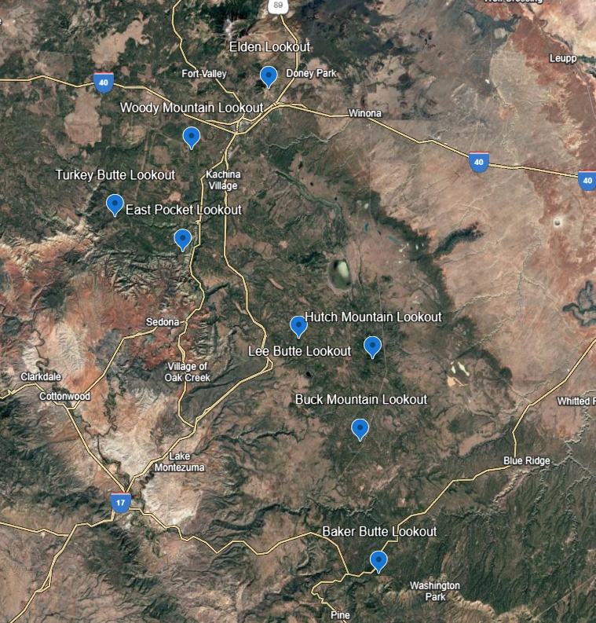

Background Information:
There are eight cisterns and one steel tank located at various sites around the Coconino National Forest. The cistern various sizes from approximately 880 gallons to 5,000 gallons. Most of the cisterns are 1,600 gallons.
The following is a list of the Cisterns that are scheduled for decommission.

- Baker Butte Lookout Cistern ~1,600 gallons
- Buck Mountain Lookout Cistern ~1,600 gallons
- East Pocket Lookout Cistern ~1,600 gallons
- Hutch Mountain Lookout Cistern ~2,500 gallons
- Lee Butte Lookout Cistern ~2,000 gallons
- Lee Butte Storage Tank ~5,000 gallons
- Mt. Elden Lookout Cistern ~1,600 gallons
- Turkey Butte Lookout Cistern ~880 gallons
- Woody Mountain Lookout Cistern ~1,025 gallons

The contractor shall use methods of abandonment in such a way as to create as little impact on the surrounding area as possible.

Sanitary Facilities:
There are no sanitary services available at these sites. Contractor is responsible for providing their own sanitary facilities.
Period of Performance:
The abandonment of the eight (8) concrete cisterns and one steel tank must be completed within 120 days of the issued notice to proceed.

Work at the following locations cannot be conducted from March 1st through August 31st:

Lee Butte
Woody Mountain
Hutch Mountain

Contract Time:
The contractor is permitted to perform work on weekends.

Utilities:
There is not electricity available at the sites.

There is no water available at these sites. Contractor is responsible for providing their own source of water and electricity.

Inspections:
Inspections will be performed by the government by the COR or designated inspector.

Tasks
The Contractor shall provide all labor, materials, tools, testing, supervision, incidentals and permits necessary to properly abandon eight (8) concrete cisterns and one steel tank. The contractor must be a licensed contractor.

All work is to be performed in accordance with applicable Federal, State, and local regulations including requirements of OSHA, EPA, ADEQ, ADWR and Coconino County.

The contractor shall adequately protect the work sites, surrounding lands, employees and general public during the entire length of the project. The contractor shall protect all guy wires at lookouts, and existing potable water and grey water systems that should not be removed and/or damaged. The contractor shall be responsible for all damages or injury caused due to their actions or negligence.

Tasks are Pay Items outlined in the Bid Schedule.

All tasks shall be completed per specifications listed in Division 2 Section 02071- Removal of Structures and Obstructions.

Mobilization is defined in the specification listed in Division 1 section 01601- Mobilization.

Task 1a: Cistern Abandonment-Fully Decommissioned
The abandonment of the cisterns shall be completed as follows:

- Empty the Cistern- remove all liquids from the cistern and dispose in a lawful manner.
- Remove or collapse the top of the cistern.
- Punch a hole in the bottom of the cistern if the bottom is below the seasonal high groundwater table.
- Fully collapse the cistern.
- Fill the cistern and any cavity resulting from the collapsed cistern with sand, gravel, concrete or other approved materials. Materials shall be provided by the contractor from an off-site source.
- Regrade the surface to provide drainage away from collapsed cistern. Grading shall match existing grades.
- Dispose of any excess material (metal, plastic, etc) at landfill.

Task 1b: Cistern Abandonment-Fill and Seal
The abandonment of the cisterns shall be completed as follows:

- Empty the Cistern- remove all liquids from the cistern and dispose in a lawful manner.
- Punch a hole in the bottom of the cistern if the bottom is below the seasonal high groundwater table.
- Fill the cistern with sand, gravel, concrete or other approved materials. Materials shall be provided by the contractor from an off-site source.
- Completely seal all opening on top of the cistern.
- Dispose of any excess material (metal, plastic, etc) at landfill.

Task 2: Tank Removal
Th removal of the storage tank at Lee Butte shall be completed as follows:
- Empty the Tank- remove all liquids from the tank and dispose in a lawful manner.
- Remove and dispose of tank.

Task 3: Mobilization
Task 3 consists of all activities associated with mobilization and demobilization to perform the tasks associated with the specifications. The sites are in remote locations and access is generally down rough dirt roads. Activities include transportation of labor, material, and equipment. Weather normally starts impacting the road conditions in mid-November, which can prevent access to the lookout tower sites. Access to the lookout sites during bad road conditions is prohibited due to vehicles causing resource damage. Road conditions generally improve after winter in late March – early April to allow access to the lookout tower.

Contacts
COR:
Kristina Brown, P.E., Civil Engineer
(928) 522-3332
Kristina.brown2@usda.gov

Project Inspector:
Kaitlyn Tighe, Civil Engineer
(928) 527-3622
Kaitlyn.tighe@usda.gov
Attachment 1: Photos

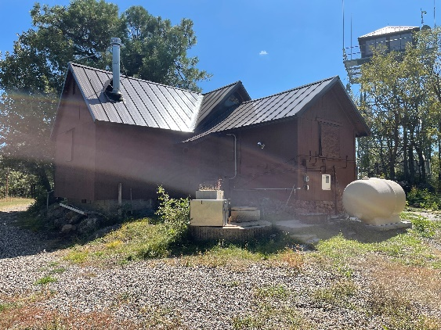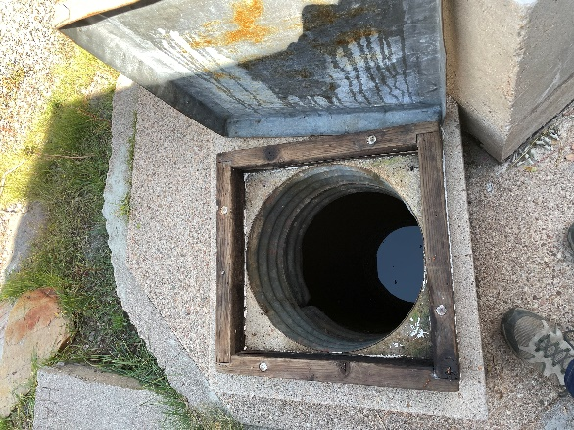

Figure 1. Baker Butte Cistern Figure 2. Baker Butte Cistern
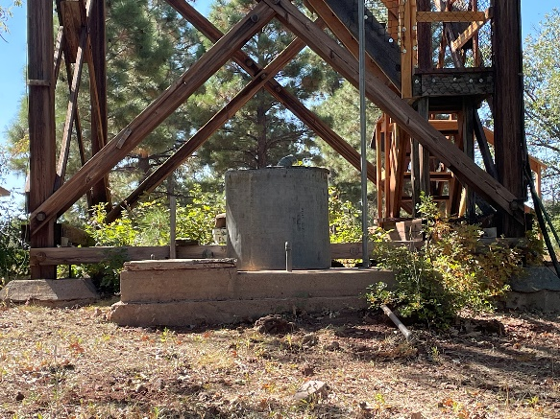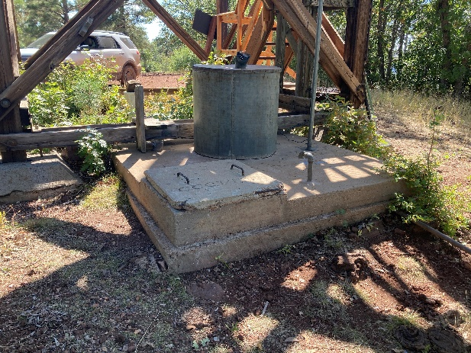

Figure 3. Buck Mountain Lookout cistern Figure 4. Buck Mountain Lookout cistern

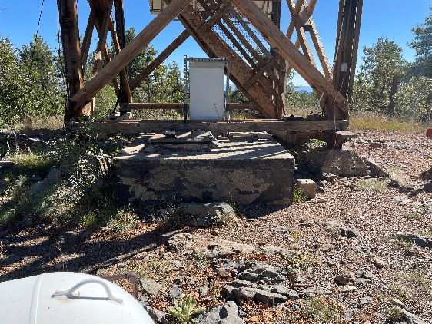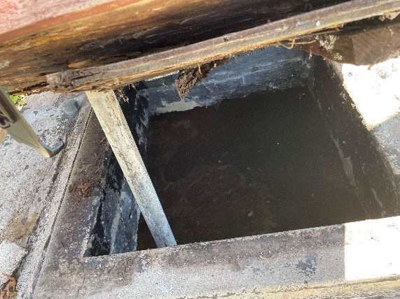

Figure 5. East Pocket Lookout Cistern Figure 6. East Pocket Lookout Cistern

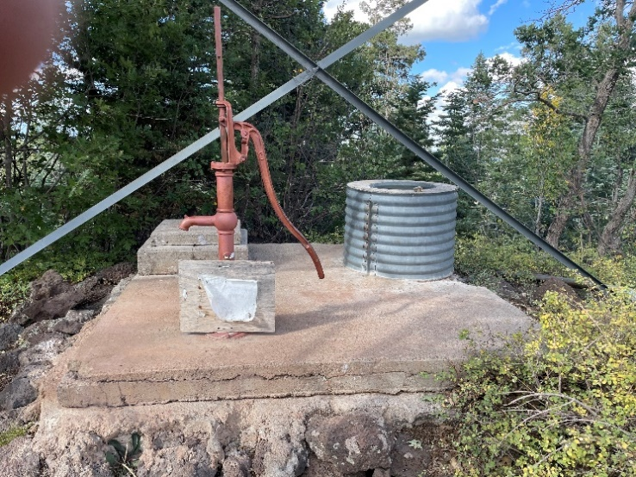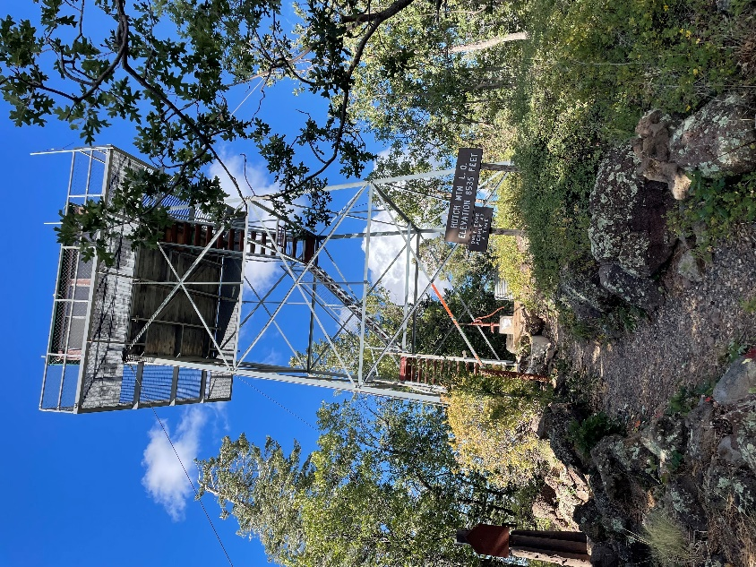

Figure 7. Hutch Mountain Lookout Cistern Figure 8. Hutch Mountain Lookout Cistern

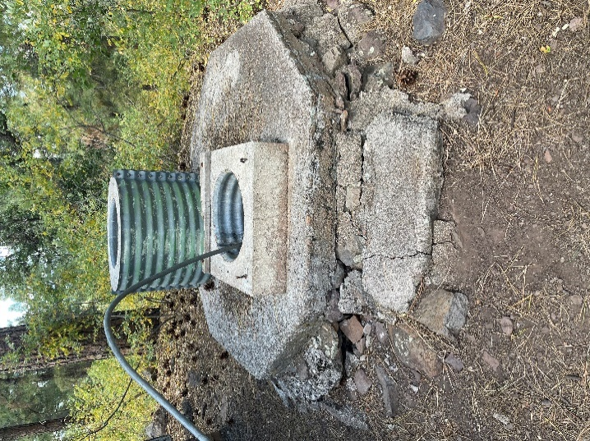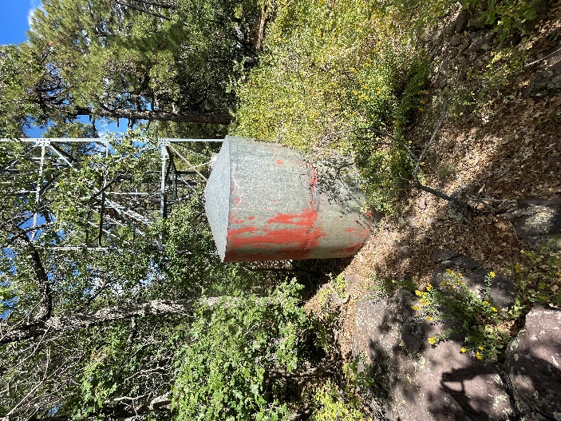

Figure 9. Lee Butte Cistern Figure 10. Lee Butte Tank
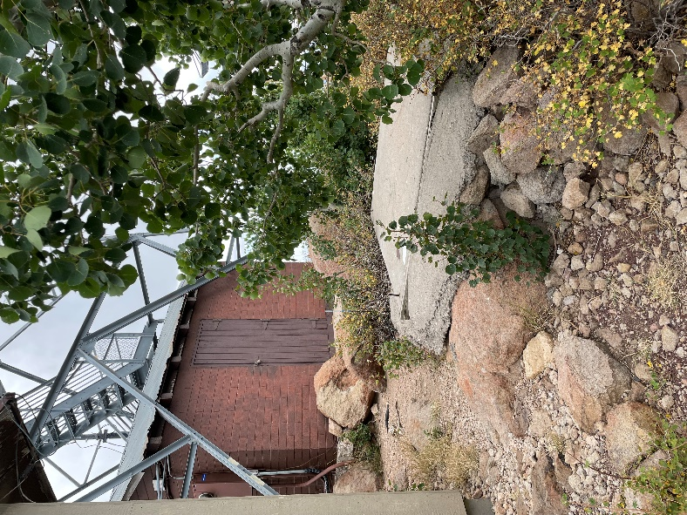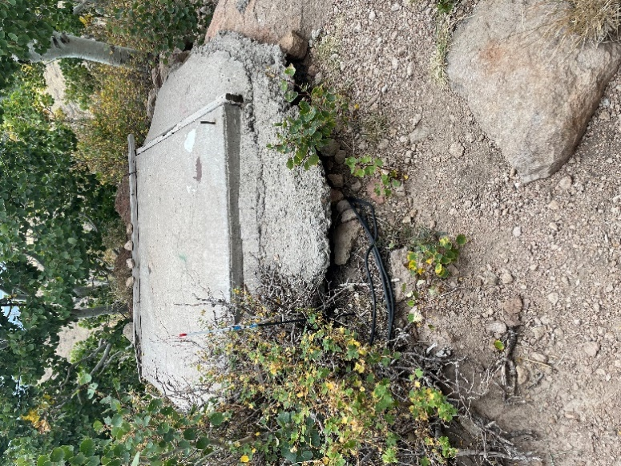

Figure 11. Elden Lookout Cistern Figure 12. Elden Lookout Cistern

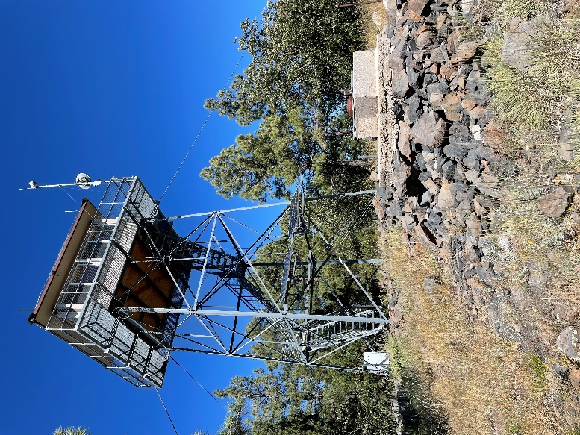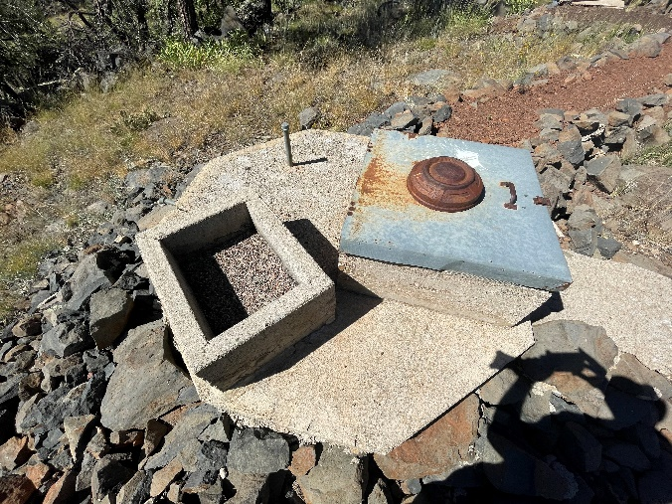

Figure 13. Turkey Butte Lookout Cistern Figure 14. Turkey Butte Lookout Cistern

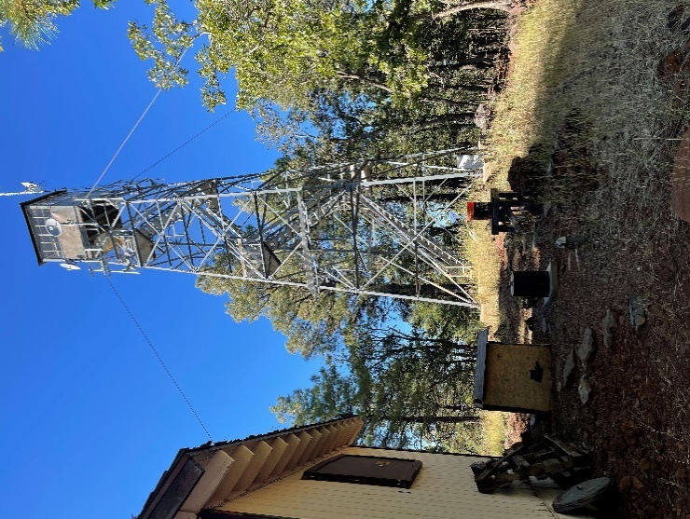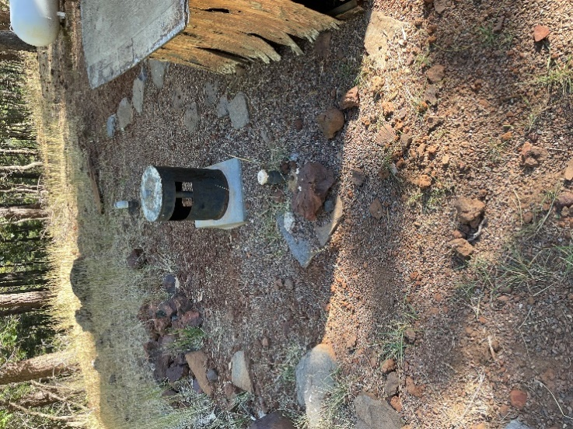

Figure 15. Woody Mountain Cistern Figure 16. Woody Mountain Cistern

