Statement of Work: Bulk Delivery of Liquefied Propane
  - Conte Research Laboratory, Turners Falls, MA
- Introduction: The Conte Research Lab (CRL) has a requirement for a delivery of liquified propane (LP) at the facility in Turners Falls MA. The Technical Liaison (TL) for this project will be Marty Garcia, the Facility Manager for the lab.
- Background: CRL has one 18,000 gallon above-ground tank located on their campus, which is used for heating the buildings and for heating potable water. The average yearly usage of LP is 18-20K gallons, though that amount varies greatly depending on the severity of the winter, and some years the usage has been as high as 30K gallons.
- Scope of Work: The contractor will provide propane through a Blanket Purchase Order (BPA) in response to delivery requests from TL.
All deliveries for this contract are at CRL, located at 1 Migratory Way, Turners Falls, Massachusetts.
4. Applicable Documents:
- Contractor and all site personnel will be licensed to perform fuel delivery services in the Commonwealth of Massachusetts.
- All vehicles and equipment will have necessary inspections and permits for interstate fuel delivery.
- Contractor will provide delivery reports and bill of lading to TL at the completion of the delivery.

- Technical Requirements:
- Contractor must have the capability to deliver the fuel within 7 days of the request by TL. The equipment on the delivery vehicle must be compatible with the liquid and vapor fittings on the storage tank. The deliveries will be approximately 9,000 gallons, or 50% of the tank’s overall capacity. Any delays in the delivery schedule must be clearly communicated via email to TL.
- The infrastructure supports delivery via tractor trailer. Smaller “bobtail” trucks may be used but the filling equipment may need to be modified, and numerous trips will be required to fill the order.
- Delivery personnel will perform a visual inspection of the tank before filling, to ensure that all the valves and fittings are sound and that there are no leaks or damage to the tank or piping. Tank levels will be checked and recorded before and after offloading and will be provided in the delivery report.
- Any concerns about the tank and fittings, roadway or protective fencing or any cause of interruption of service will be communicated to the TL.
- Bridge Ratings: There are two bridges that may be crossed to access the facility. The weight ratings and pictures of the bridges can be seen below. For more information contact Montague DPW at (413) 863-2054.

- Deliverables:
The period of performance for this project is 10 days from Notice to Proceed.
The contractor will provide a contact person for routine delivery reports and emergency contact information for any urgent matters.

All materials and equipment are to be provided by the contractor. No tools, equipment or manpower will be provided by the facility. Materials will not be unloaded or moved by facility staff. Equipment may not be stored at the facility unless an emergency or breakdown warrants them, and only after being authorized by TL.

The service will be staged to allow access to the facility throughout the offloading period. Delivery vehicles will not restrict access to facility. Signage and barriers will be provided by facility staff to restrict vehicle and pedestrian access to work areas during the performance of the service if deemed necessary and no hazardous conditions should be present in unguarded areas.

All services are to be performed between the hours of 7am and 3pm, Monday through Friday unless previous arrangements have been made with the Facility Manager. No services will be performed on Federal holidays without exceptions.

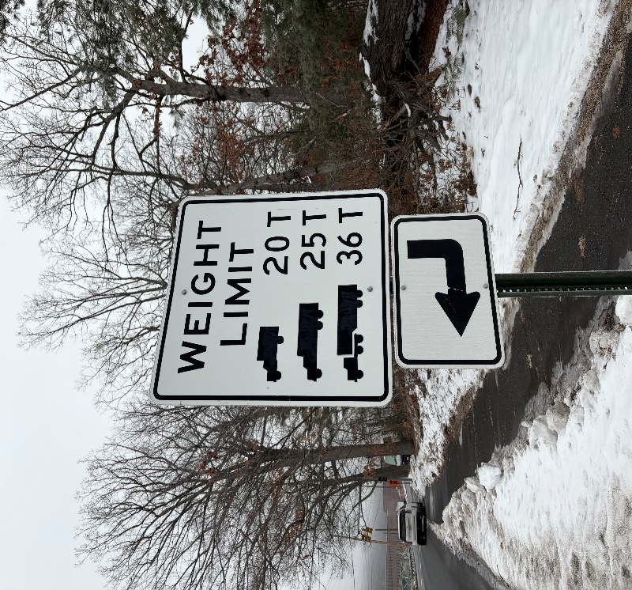
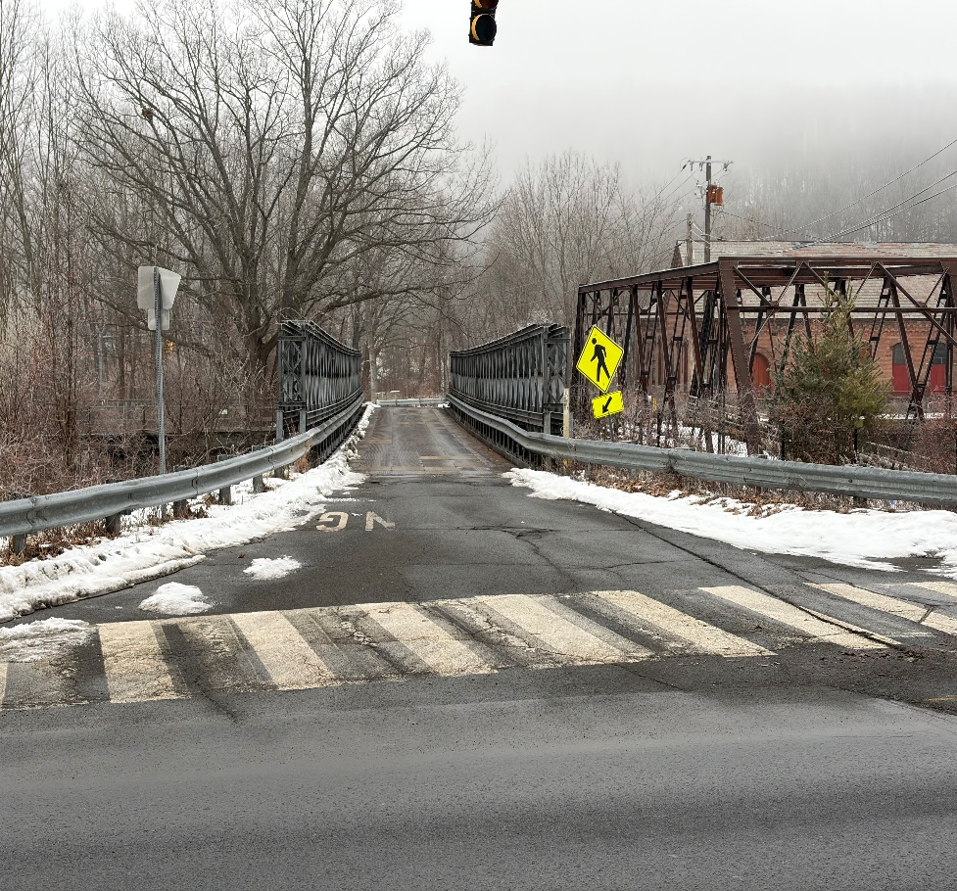
Canal Street Bridge
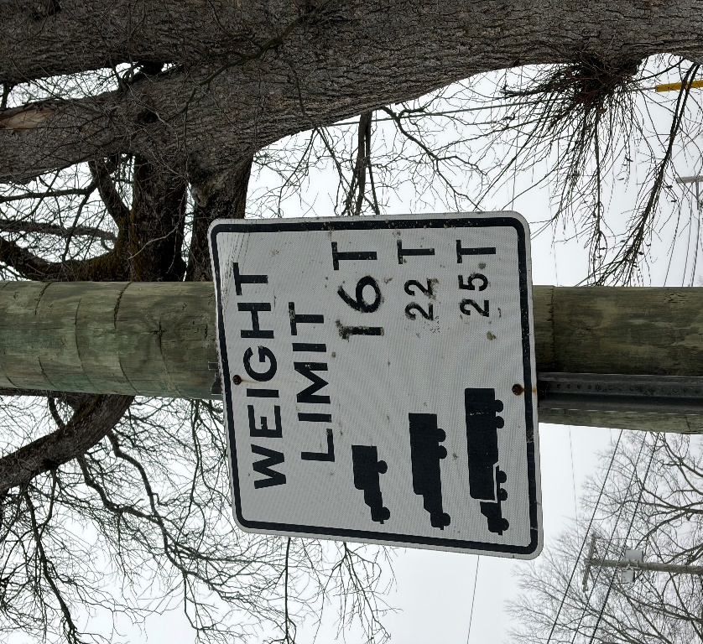
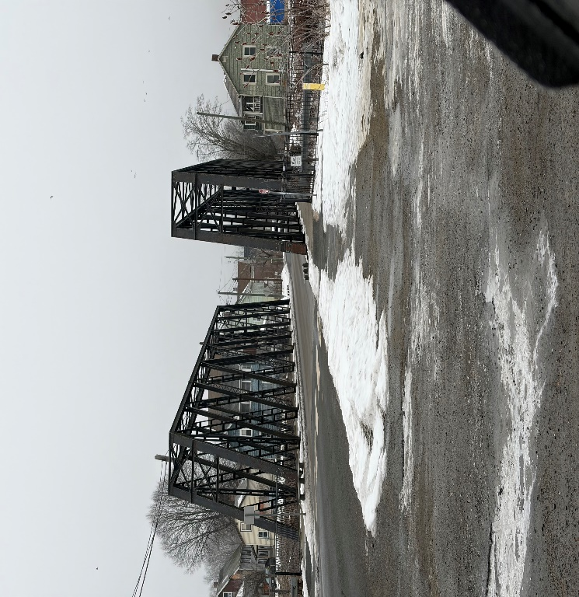
11th Street Bridge

