This is a combined synopsis/solicitation for commercial items prepared in accordance with the format in Federal Acquisition Regulation (FAR) Subpart 12.6, as supplemented with additional information included in this notice. This announcement constitutes the only solicitation; quotes are being requested in response to this notice and a written solicitation will NOT be issued. This solicitation is being issued as a Request for Quote (RFQ)# 246-26-Q-0017. Submit only written quotes for. This solicitation is a 100% BUY INDIAN SET-ASIDE. The associated NAICS code is 811210.

This RFQ contains the following Line Items:

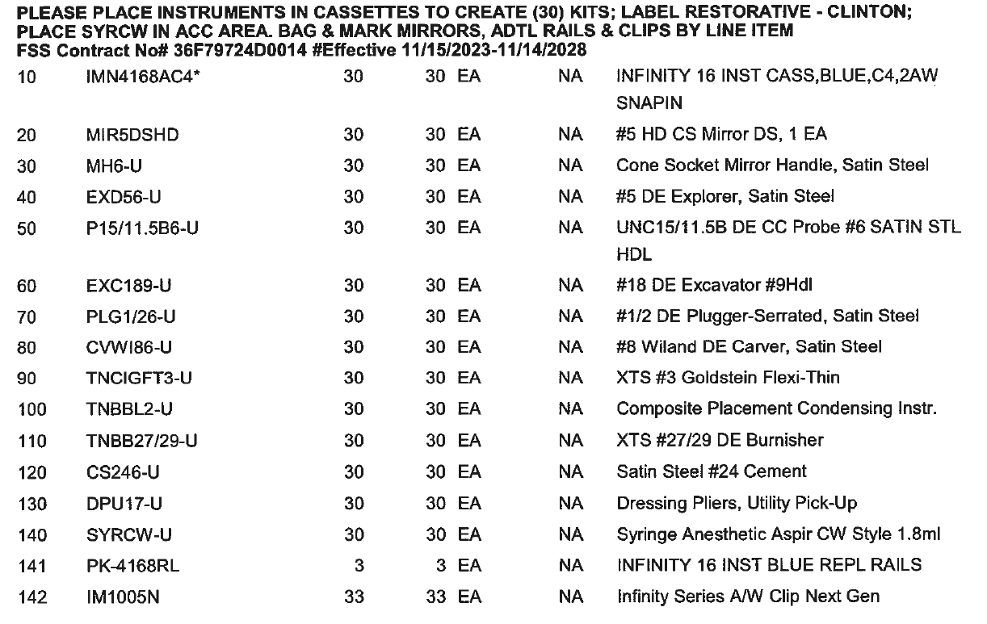
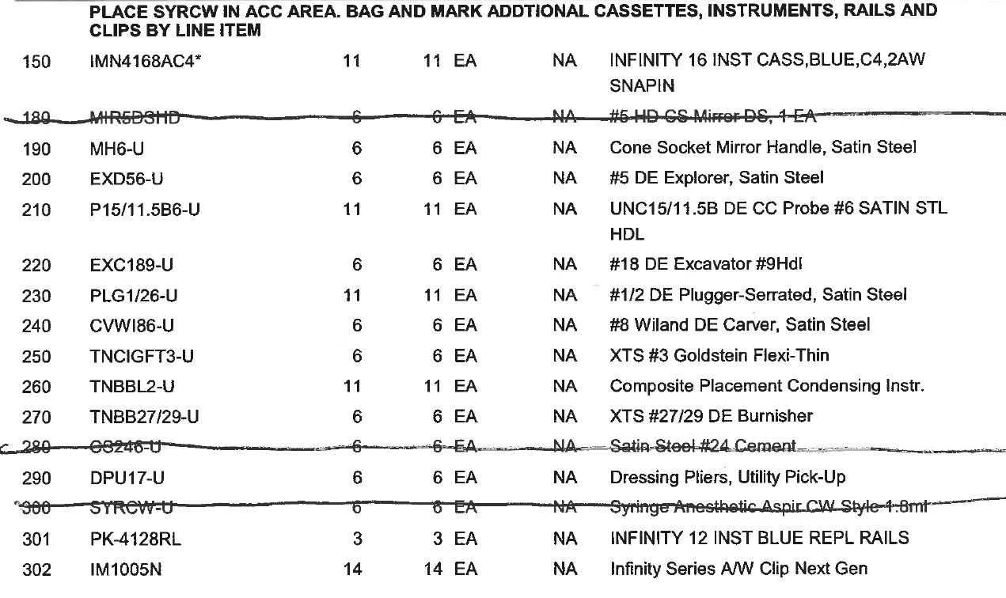
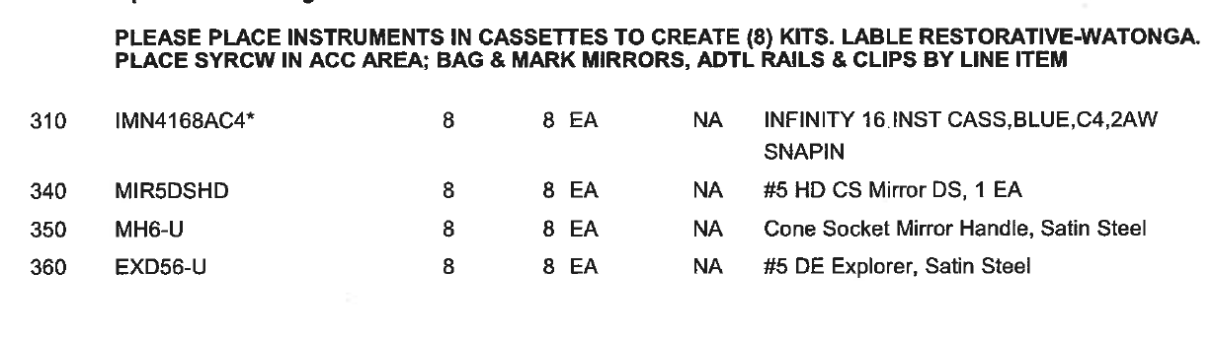

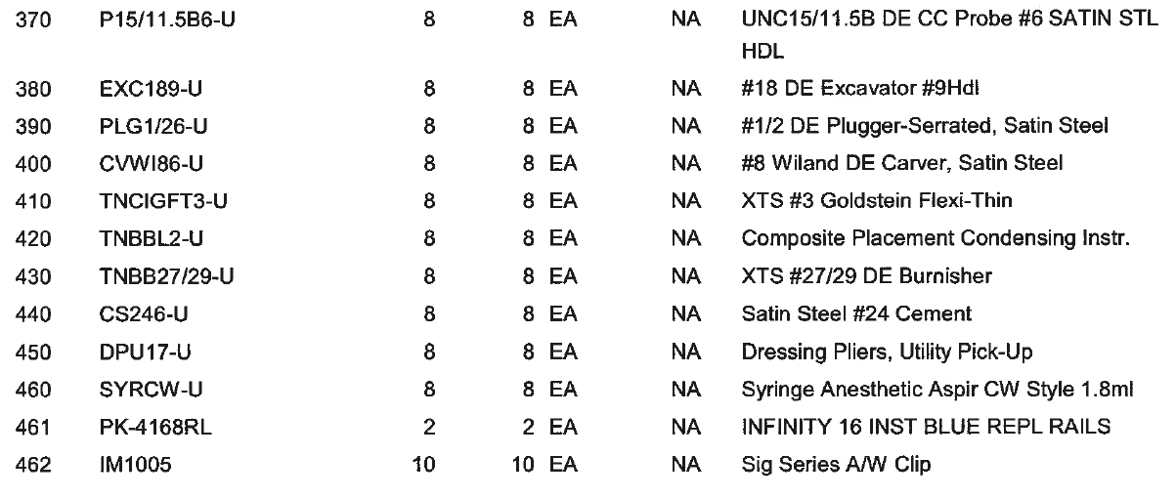
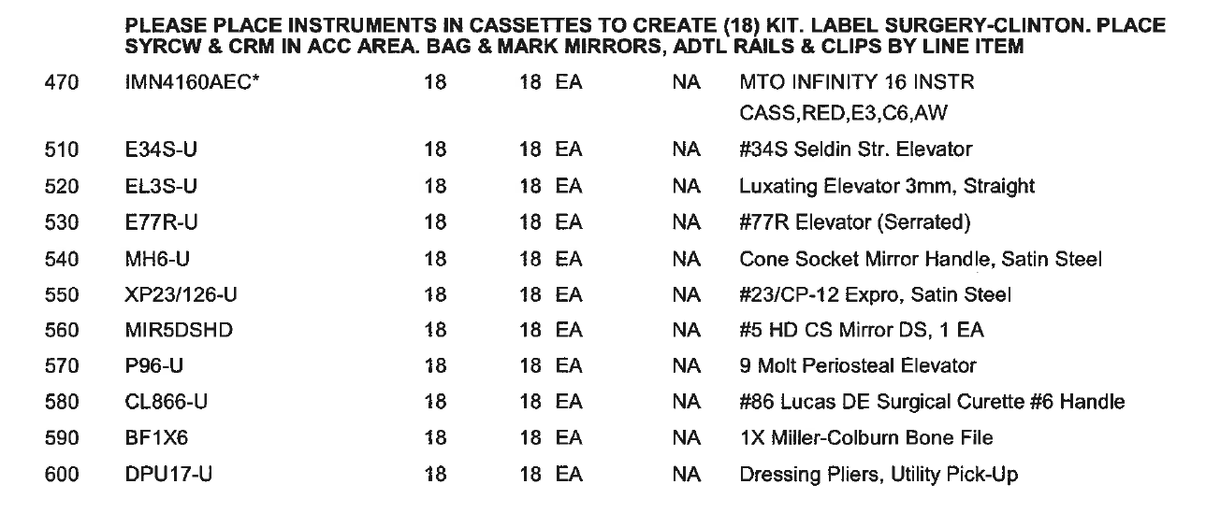
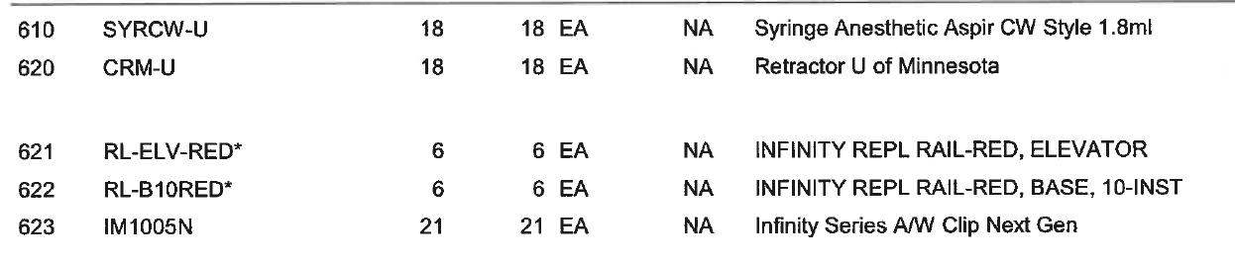
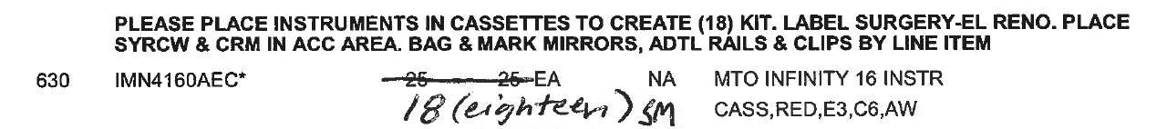
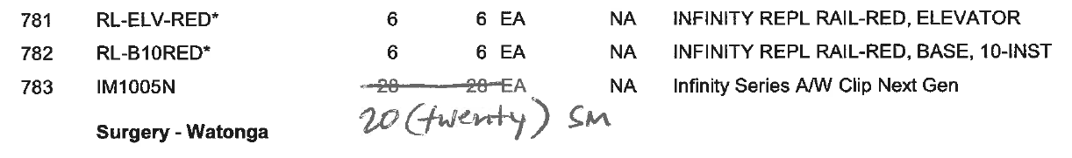

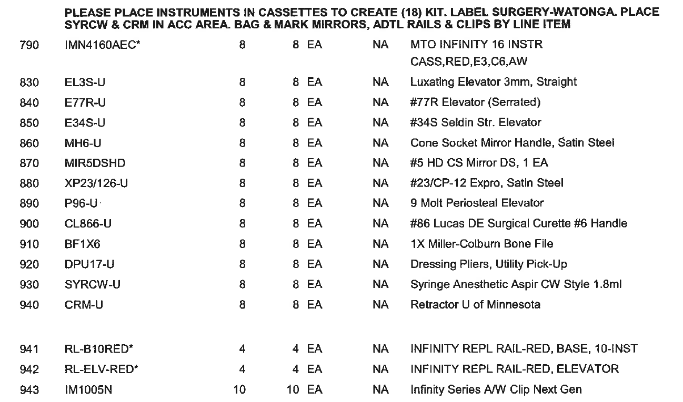
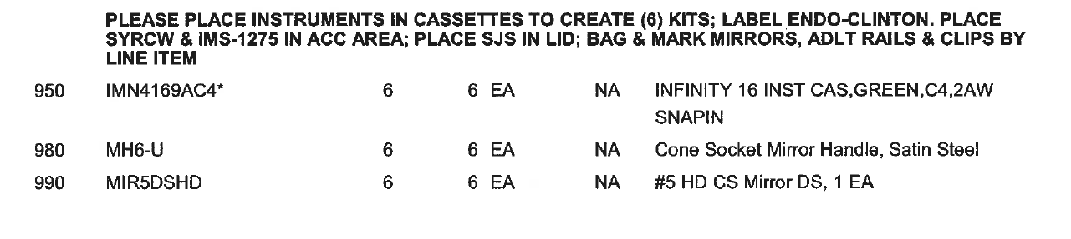
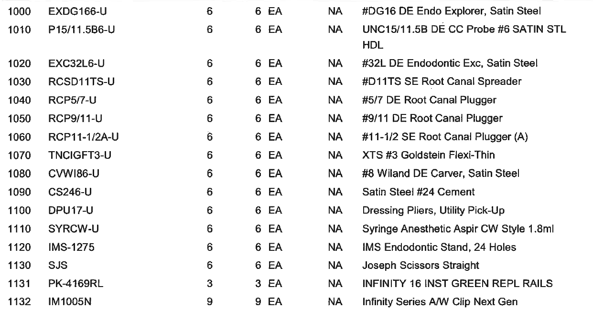
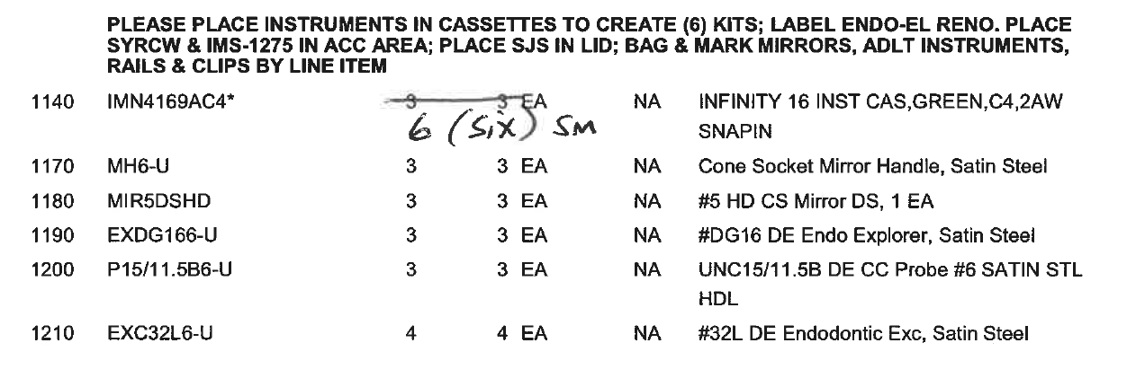
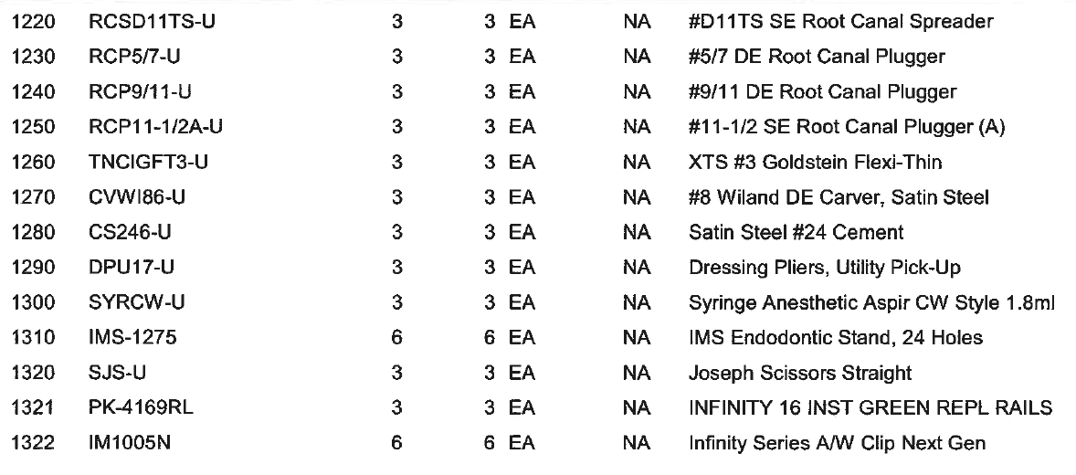
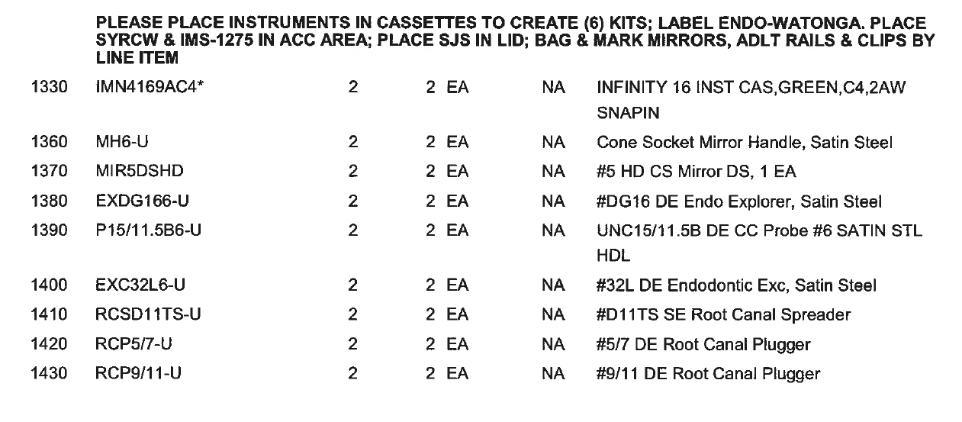
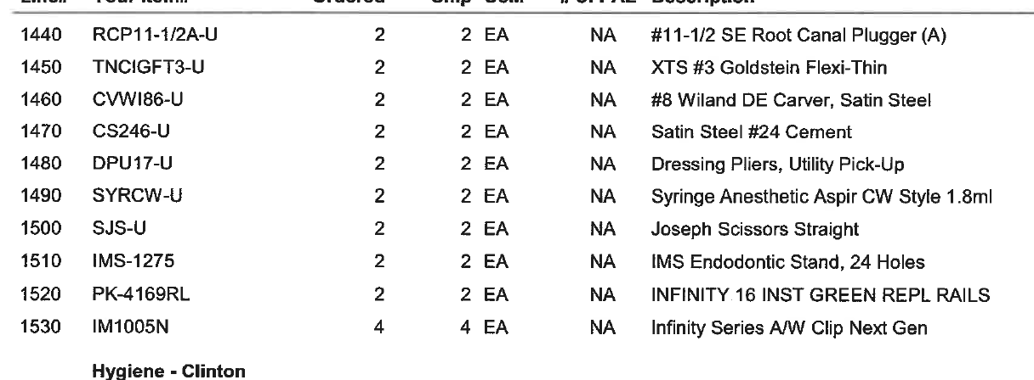
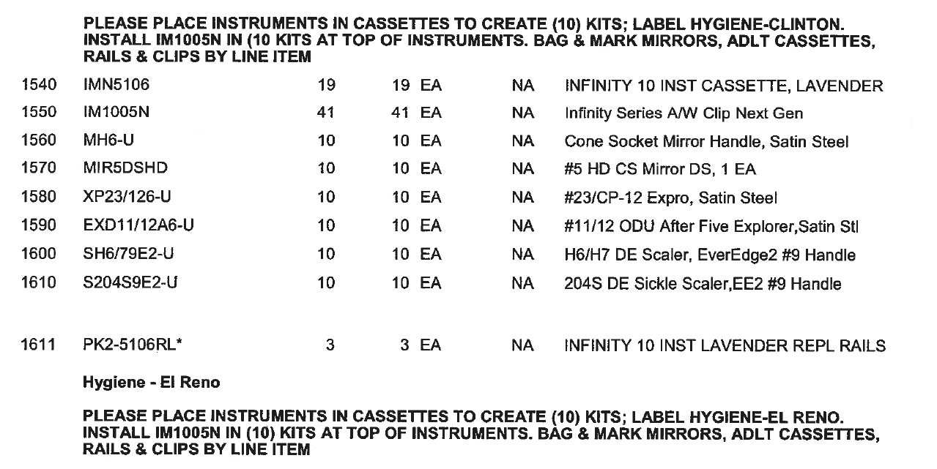
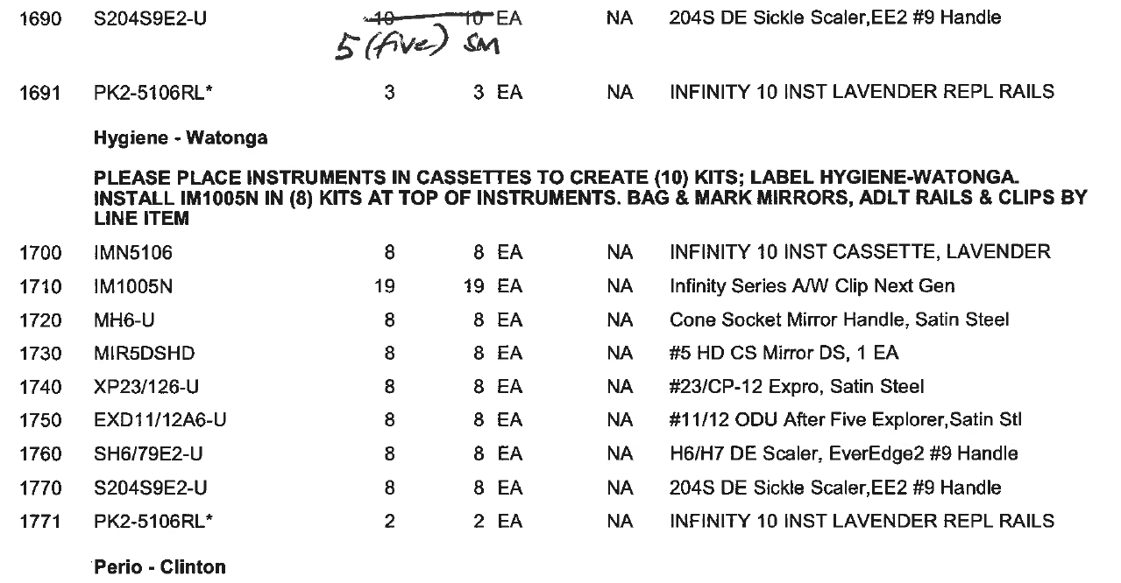
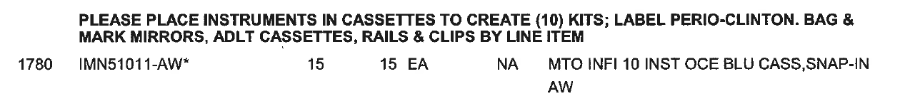
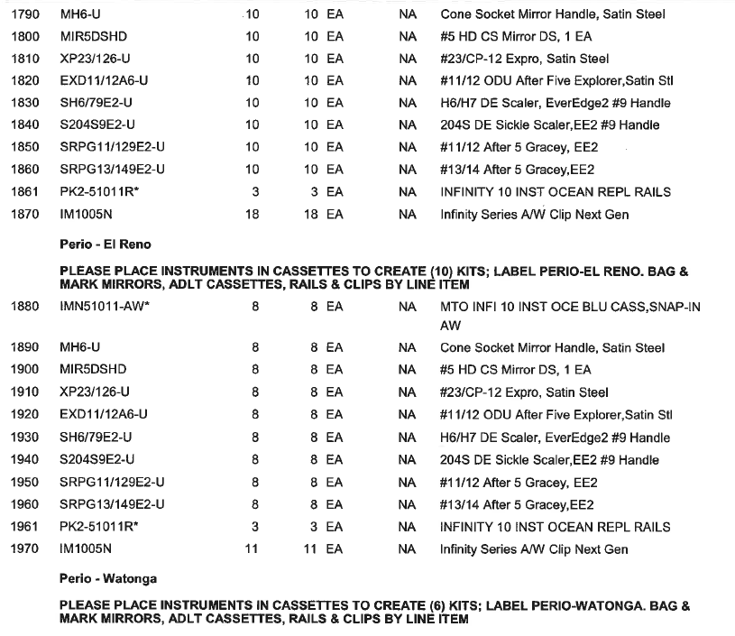
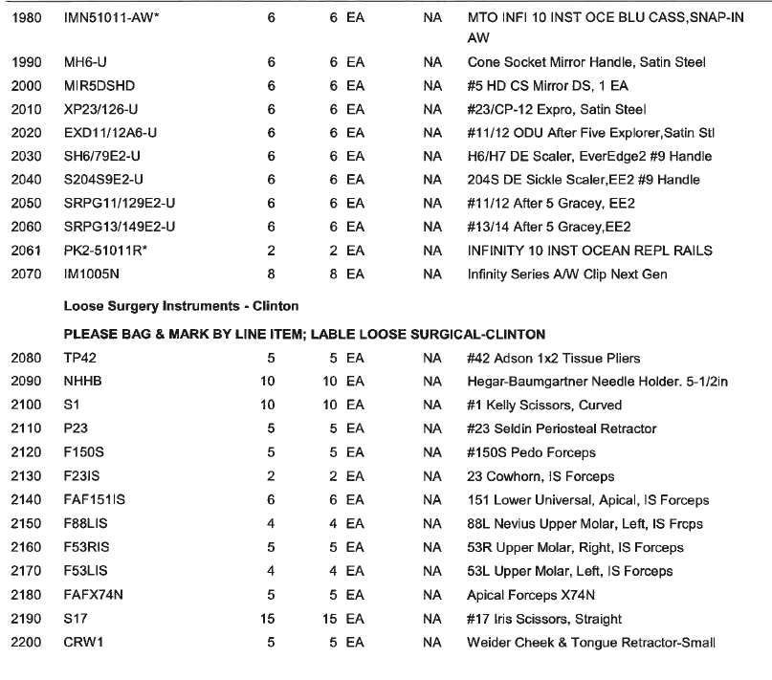
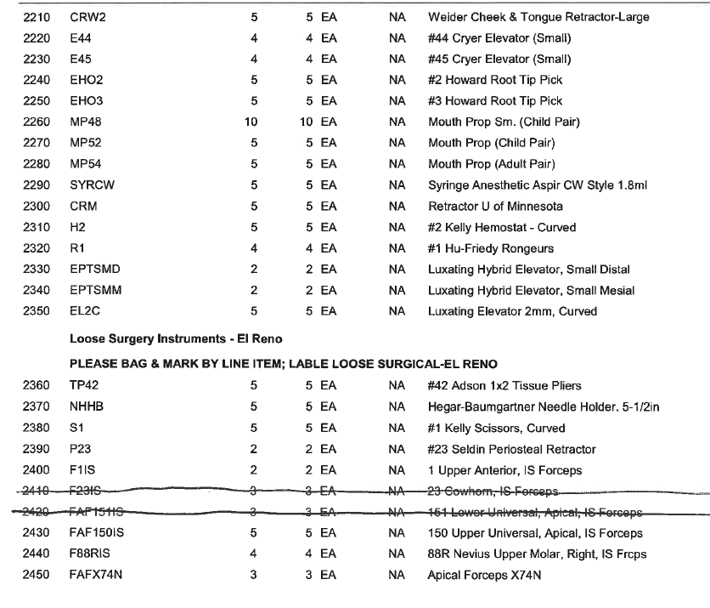
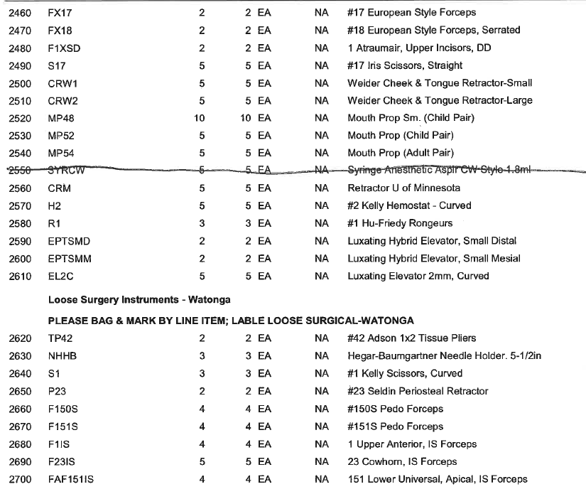
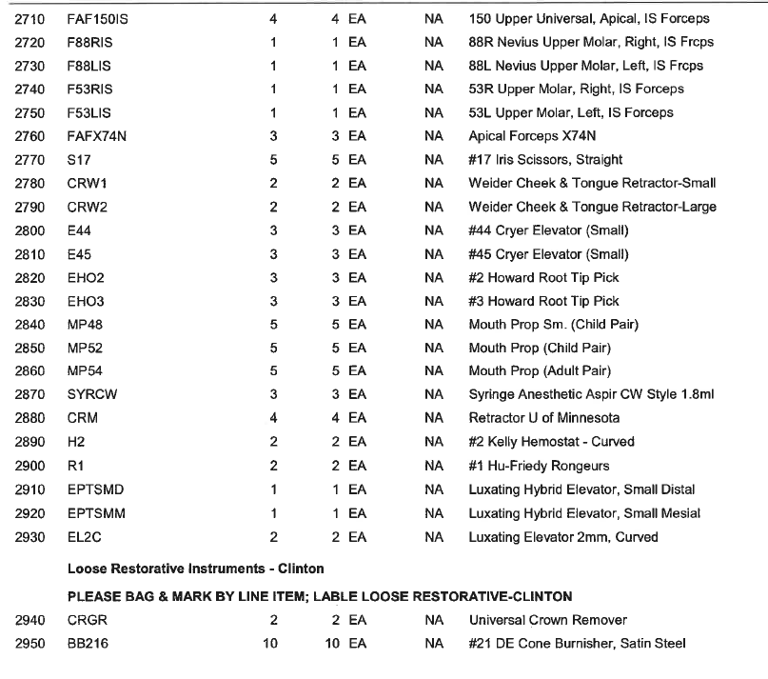
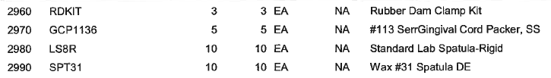
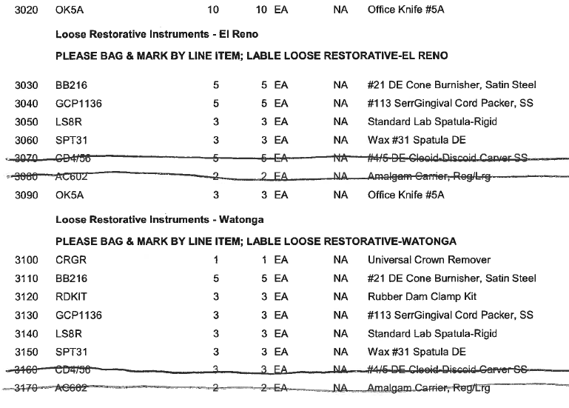
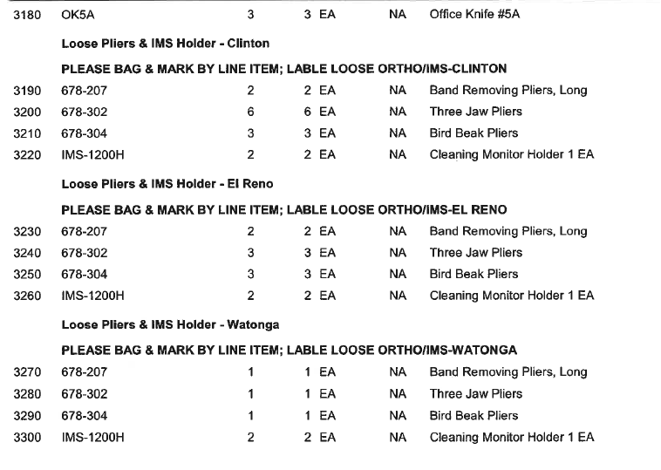
PERIOD OF PERFORMANCE: 90 DAYS ARO

Vendor Requirements: NA

Submit Quotes no later than: 05/21/2026 @ 10AM CST to the Following Point of Contact: Misti Bussell, Contract Specialist via Email: misti.bussell@ihs.gov

Evaluation: FAR 52.212-2 Evaluation -- Commercial Items (completed as follows):
(a) The Government will award a firm fixed price contract resulting from this solicitation to the responsible offeror whose offer conforming to the solicitation will be most advantageous to the Government, price and other factors considered. The following factors shall be used to evaluate offers:

Lowest Price Technically Acceptable
The following factors shall be used to evaluate quotes:
1) Pricing
2) Technical

Pricing – The government will add all items for a cumulative total. Pricing will be
compared to the government’s independent government cost estimate. A baseline for a
Satisfactory rating shall be utilized from the government’s IGCE.

Technical Capabilities shall be evaluated based on understanding of the labeling of each bag,
and by the planned execution of the project.

CLAUSES AND HHSAR: The following FAR clauses and HHSAR apply to this solicitation:
SECTION C CONTRACT CLAUSES
52.212-4, Terms and Conditions—Commercial Products and Commercial Services (Deviation Date)
52.203-17, Contractor Employee Whistleblower Rights (Nov 2023)
52.204-13, System for Award Management Maintenance (Deviation Date)
52.209-6, Protecting the Government's Interest When Subcontracting With Contractors Debarred, Suspended, Proposed for Debarment, or Voluntarily Excluded (Deviation Date)
52.209-10, Prohibition on Contracting with Inverted Domestic Corporations (Deviation Date)
52.217-8, Option to Extend Services (Nov 1999)
52.219-6, Notice of Total Small Business Set-Aside (Deviation Date)
52.219-28, Postaward Small Business Program Rerepresentation (Deviation Date)
52.222-3, Convict Labor (Deviation Date)
52.222-19, Child Labor-Cooperation with Authorities and Remedies (Deviation Date)
52.222-40, Notification of Employee Rights Under the National Labor Relations Act (Dec 2010)
52.222-50, Combating Trafficking in Persons (Deviation Date)
52.222-90 Addressing DEI Discrimination by Federal Contractors
52.223-5, Pollution Prevention and Right-to-Know Information (May 2024)
52.223-23, Sustainable Products and Services (DEVIATION DATE)
52.225-1, Buy American-Supplies (DEVIATION DATE)
52.226-1, Utilization of Indian Organizations and Indian-Owned Economic Enterprises (Deviation Date)
52.226-8, Encouraging Contractor Policies to Ban Text Messaging While Driving (MAY 2024)
52.232-40, Providing Accelerated Payments to Small Business Subcontractors (Mar 2023)
52.233-3, Protest after Award (Deviation Date)
52.233-4, Applicable Law for Breach of Contract Claim (Deviation Date)
52.237-2, Protection of Government Buildings, Equipment, and Vegetation (Apr 1984)
52.240-91, Security Prohibitions and Exclusions (Deviation Date)
52.244-6, Subcontracts for Commercial Products and Commercial Services (Deviation Date)
352.226-1, Indian Preference (Mar 2025 Deviation)
352.226-6, Indian Economic Enterprise Subcontracting Limitations (Mar 2022)
352.237-71, Crime Control Act—Reporting of Child Abuse (Dec 2015)
352.237-73, Indian Child Protection and Family Violence Act (Dec 2015)

Miscellaneous:
NO FAX QUOTATIONS
ELECTRONIC SUBMISSIONS – SUBMISSION VIA EMAIL IS THE ONLY ACCEPTABLE
ELECTRONIC SUBMISSION. (misti.bussell@ihs.gov)
All contractors must be registered in the System for Award Management database located
at https://www.sam.gov/sam/ prior to any contract award. Please submit the following
information with each quote: Vendor Name, Cage Code, DUNS number, Tax Identification
Number, Prompt Payment Terms, Delivery Time, GSA Contract Number (if applicable), Date
quote expires, warranty, total price for each line item, total quote price, and technical
documentation in sufficient detail to determine technical acceptability. Failure to provide
sufficient technical detail may result in rejection of your quote.

