Rock Creek Park (ROCR)
Hazardous Tree Mitigation
Performance Work Statement

Hazard Tree Mitigation FY26
Removals, Pruning and Emergency Tree Mitigation

May 05, 2026

- Background

The National Park Service (NPS) owns and operates Rock Creek Park (ROCR), which encompasses almost 3,000 acres of urban forests and includes more than 90 miles of boundaries within the city of Washington, DC.

This project will mitigate hazardous tree and vegetation conditions and support overall landscape management objectives by pruning and removing dead and diseased trees, as well as removing woody vegetation along roadsides, in park landscapes, around park facilities and adjacent to private homes and businesses.

This work will supplement the efforts of the ROCR tree crew and support public safety for all who utilize public lands within ROCR boundaries.

This is a firm-fixed-price contract, with all work to be completed within 12 calendar months after award. The contractor shall provide all management, supervision, labor, materials, supplies, tools, equipment, and all other items necessary to coordinate and ensure quality, professional and safe workmanship.

- Project Description
Rock Creek Park (ROCR) has limited internal resources to perform the full scope of hazardous tree removal and maintenance required to manage approximately 3,000 acres of urban forest. The majority of parkland is heavily forested and located within a highly urbanized environment, resulting in elevated risk due to proximity to visitor use areas, adjacent roadways, and neighboring residential and commercial properties, including homes, businesses, schools, and places of worship.
Tree management in these areas is complex and time-consuming, often requiring specialized equipment and technical expertise to safely perform large-scale removals and maintenance activities.
The contractor shall assist with hazardous tree removal, storm damage response, pruning, removal of hazardous vegetation, and general tree maintenance activities to protect and preserve park resources and support a safe environment for visitors and staff.
- Scope
The contractor shall mitigate hazardous trees, tree maintenance needs, and vegetation hazards identified by the Tree Crew Supervisor, the Contracting Officer’s Representative (COR), and/or a designated ROCR representative.
The contractor shall provide all labor, supervision, materials, tools, supplies, transportation, traffic control devices, signs and equipment necessary and incidental to execute safe and professional full-spectrum tree services.
For the purposes of this contract, full-spectrum tree services means the complete range of arboricultural and vegetation management work necessary to access, remove, prune, process, haul, and properly dispose of hazardous trees, limbs, storm-damaged trees, and hazardous vegetation. These services may include, but are not limited to, large tree removal, technical rigging, climbing operations, tracked aerial lift operations, crane-assisted removals, tree pruning maintenance, hazard reduction, storm response, stump grinding when directed, debris removal, chipping, hauling, traffic and pedestrian control, site cleanup, and related work necessary to restore the area to a safe and acceptable condition.
The contractor shall deliver the required services and provide an itemized cost breakdown that includes materials and equipment, labor, administrative costs, insurance, disposal fees, transportation, traffic control, and any other associated fees.

- Work to be Performed
The contractor shall mitigate all identified tree and vegetation hazards as designated by the Tree Crew Supervisor, the COR, and/or an authorized representative of ROCR, in accordance with the Park’s established order of precedence for remediation, as provided by the COR.
Mitigation shall include all aspects of tree care, including, but not limited to, tree removal, tree pruning, brush chipping, log removal, storm damage mitigation, and emergency tree removal response. The contractor may also be required to remove hazardous vegetation to create clear zones along roads and parkways, as directed by ROCR.
The contractor shall report to a location designated by the COR at a scheduled time with sufficient personnel, equipment, and materials necessary to perform a full eight (8)-hour workday. Work may include, but is not limited to, hazardous tree mitigation, pruning, vegetation removal, and emergency response operations, as required.
The contractor shall provide a minimum of two (2) working days’ advance notice prior to commencing scheduled work, unless otherwise directed by the COR for emergency situations.
The COR or designated ROCR representative will issue work assignments via email. Each assignment will include mapped tree locations with GPS coordinates and a corresponding spreadsheet with detailed tree data and specific scope requirements. Refer to Attachment C and Attachment D for a sample of a typical assignment package.

4.1 Task 1: Full-Spectrum Tree Services
The contractor shall provide five (5) eight-hour workdays per month of full-spectrum tree services throughout the period of performance.
Each workday shall include sufficient personnel and equipment to safely and efficiently complete assigned tasks. At a minimum, the contractor shall provide the following:
- One (1) chip truck and chipper with operator
- One (1) bucket truck with operator
- One (1) log truck with operator
- Two (2) climbers
- Two (2) ground workers
- Crane and/or tracked aerial lift with operator(s), as required by the assigned work
Workdays may be reallocated between months with prior approval from the COR or designated ROCR representative.
Application for payment may be on a monthly, bimonthly, or quarterly basis. and will be based on the actual number of workdays performed and accepted by the Government during the reporting period.
The contractor shall provide all tools, fuel, equipment, and all required ANSI and OSHA-compliant safety equipment necessary to perform an eight-hour workday of tree removal, brush chipping, tree climbing, tracked aerial lift operation, crane operation, log removal, and vegetation management.

Performance Requirements

    - All resulting brush and logs shall be removed from park boundaries or chipped and broadcast onto the natural forest floor in accordance with COR direction.
    - Wood chips may be broadcast beyond mowed grass areas into the wood line, maintaining a minimum of 20 feet clearance from roadways. Chip depth shall not exceed 2 inches, and chips shall not remain in mowed grass areas.
    - All stumps shall be cut flush with grade whenever possible. When flush cutting is not feasible and with COR approval, stumps shall not exceed 3 inches above grade. The top of the stump shall be cut flat with no protruding wood remaining.
    - All contractor-generated refuse and waste shall be hauled from the work site daily, unless otherwise authorized by the COR on a case-by-case basis. Refuse and waste material shall be hauled in trucks with tight fitting covers to prevent spillage on roadways.
    - All motorized equipment used in off-road areas shall be operated on ground protection mats (e.g., Alterna mats). Equipment shall not be operated directly on turf or within critical root zones without protection.
    - The contractor shall repair all ground disturbance resulting from operations to the satisfaction of the COR, including ruts and depressions. Disturbed areas and ruts shall be raked smooth. Seeding and straw shall only be applied in turf areas, not within natural forest areas
    - All tree pruning throughout the period of performance must be conducted in accordance with the most recent version of the ANSI A300 Pruning Standards and ISA Best Management Practices.

  - Task 2: Haul and Dispose of Stockpiled Logs

The contractor shall provide all labor, supervision, equipment, materials, and transportation necessary to remove, haul, and properly dispose of stockpiled logs and accumulated woody materials located at the designated ROCR wood dump site. Work shall include loading, transporting, chipping (if applicable), and disposal of all materials in accordance with Task 2 requirements and as directed by the COR or designated

Performance Requirements

    - Contractors shall remove all stockpiled logs and woody material from the designated ROCR wood dump site.
    - The contractor shall provide all necessary equipment to load, transport, and remove logs and accumulated wood materials from the site.
    - The contractor shall submit a disposal plan for all logs and wood materials, subject to COR approval.
    - Refuse and waste material shall be hauled in trucks with tight fitting covers to prevent spillage on roadways.
    - Chipping of stockpiled woody materials is permitted, on-site. Wood chips shall be broadcast into a designated chip pile, as directed by the COR.

- Location of Work
The tasks under this contract will occur at multiple Government-owned or managed locations within Washington, DC, under the jurisdiction of ROCR. Work may involve accessing trees from adjacent public and private properties and roadways.
The exact locations of trees designated for removal or pruning will be specified by the COR or an authorized ROCR representative.
If at any time the contractor is uncertain of a specific tree or location, the contractor shall contact the COR or designated ROCR representative for clarification prior to proceeding. The contractor shall be responsible for any damage resulting from failure to obtain such clarification.
- Period of Performance
Tasks under this contract shall begin within 10 days after award. All work shall be completed within 365 calendar days after award.
The period of performance includes all work activities, including permitting, reporting, and compliance with quality assurance requirements as outlined in the Quality Assurance Surveillance Plan (QASP).
- Performance or Delivery Schedule

The Performance or Delivery Schedule is identified in the QASP attachment.

- Performance Standards

The Contractor will be required to document completed work with accurate dates provided for all work completed and submit to the COR. prior to invoicing. The Acceptable Quality Level (AQL) for each task is outlined in the QASP.

- Special Requirements

9.1 Personnel Requirements

    - The contractor shall provide a current International Society of Arboriculture (ISA) Certified Arborist who shall serve as the primary point of contact for the COR and Designated Park Representative regarding technical aspects and quality of work. The contractor shall provide the arborist’s certification ID for verification prior to the start of work and upon any change in assigned personnel. Certification status is subject to verification by the Government through the ISA database.
    - The contractor shall provide a minimum of one on-site supervisor responsible for directing all contract personnel and operations. The supervisor shall be available during working hours and fluent in English to effectively communicate with the Designated Park Representative, the COR, and other Government personnel.
    - If the on-site supervisor is absent due to illness or other reasons, the contractor shall designate an alternate supervisor with equivalent qualifications. The contractor shall provide contact information for the alternate supervisor, who shall be responsible for managing all contract personnel and operations during the supervisor’s absence.

  - Permits and Responsibilities

    - The contractor shall, without additional expense to the Government, obtain and maintain all required permits and licenses necessary to perform the work.
    - The contractor shall be responsible for all damages to persons or property resulting from the contractor’s negligence and shall take appropriate safety and health precautions to protect the work, workers, the public, and surrounding property.
    - The contractor shall be responsible for all materials delivered and work performed until completion and acceptance of the entire work.

  - Traffic Control

    - All lane closures or disruptions to traffic shall be coordinated with the COR, U.S. Park Police (USPP), and/or the District Department of Transportation (DDOT), as applicable. Single lane closures are permitted only during non-rush hours, Monday through Friday, from 0900 to 1430, and require a minimum of one (1) week advance notification.
    - The contractor shall provide and install all advance warning signage and traffic control devices necessary for roadside operations and lane closures. All traffic control measures shall comply with the Manual on Uniform Traffic Control Devices (MUTCD).
    - The contractor shall be responsible for the cost, coordination, and permitting of any lane closures or traffic disruptions on roadways not owned by the National Park Service (NPS). The contractor shall also be responsible for reimbursing the USPP for any overtime expenses incurred for lane closures on NPS-owned and operated roadways.
    - The work area is open to public vehicular traffic. The contractor shall clearly identify and delineate all work zones using appropriate signage, barriers, and traffic control devices to protect park operations, motorists, pedestrians, and contractor personnel. All work zones shall comply with applicable AASHTO, MUTCD, and MDOT/DDOT requirements.

  - Safety Standards

    - The contractor and its employees shall comply with all applicable ANSI Z133, OSHA, federal, state, and local safety standards and regulations.
    - The contractor shall take all necessary safety precautions and ensure that all personnel at the work site always use appropriate Personal Protective Equipment (PPE) while performing work, in accordance with current OSHA regulations and ANSI standards.
    - The contractor shall be responsible for pedestrian and vehicular traffic management and shall utilize appropriate signage and traffic control devices in accordance with DDOT standards.
    - In the event of an emergency, the contractor shall immediately call 911, followed by notification to the USPP Communications Center at the 24-hour emergency dispatch number: (202) 610-7500. For non-emergency situations requiring law enforcement assistance, the U.S. Park Police District 3 may be contacted at (202) 426-7716.

  - Conduct
The contractor’s employees shall, at all times while on the job site or performing work under this contract, conduct themselves in a professional, orderly, and safe manner.
The following behaviors are prohibited on the job site: rudeness, fighting, being under the influence of alcohol and/or drugs, possession or consumption of alcohol and/or illegal drugs, gambling, soliciting, theft, or other conduct that may disrupt operations or pose a safety risk.
Any employee engaging in such conduct may be removed from the job site at the direction of the COR.
  - Site Maintenance

    - The contractor shall maintain the work site in a safe, neat, and orderly manner. All supplies and equipment on the project site shall be stored in a manner that prevents damage.
    - Limited space may be provided for the storage of materials or equipment. All items shall be stored in a clean and orderly condition and must be approved by the COR. Storage space is not guaranteed; if necessary, the contractor shall transport all materials and equipment to and from the site daily.
    - The contractor shall be responsible for protecting Government assets and shall perform work in a manner that minimizes disruption to ongoing operations in occupied areas.
    - The contractor shall be responsible for loss or damage to Government-furnished property (GFP) resulting from the contractor’s operations.
    - All mud, dirt, debris foreign objects or spills of any kind from the contractor’s operations shall be cleaned up daily or as directed by the COR.

  - Travel

The contractor shall be responsible for all travel related expenses for this project, including mobilization of equipment, staging, tools, materials, manpower, lodging, meals, and per diem. Parking for personal vehicles is limited to public street parking and is subject to local traffic enforcement regulations; contract personnel will park at their own risk. Parking of personal vehicles within the park boundaries will be determined on a case-by-case basis and must be authorized by the COR in advance of work being performed.

  - Business Hours

The contractor is responsible for conducting routine services, between the hours of 6:00 a.m. – 3:30 p.m. Monday thru Friday, except when the Government facility is closed due to local or national emergencies, administrative closings, or similar Government directed facility closings. Work on Federal Holidays is prohibited unless approved in writing by the COR. The contractor will not be reimbursed when the government facility is closed for the above reasons unless emergency services are requested.

  - Security

The Park is accessible 24/7 by the public and there is no on-site security. The contractor shall be responsible for security of any equipment left on-site and shall not leave any tools, supplies or equipment items unattended in the public area at any time while performing work.

  - Protection of Property

    - The contractor shall be fully responsible for any loss of or damage to Government and private property caused during contract operations and for all claims arising from injury to persons, property, or equipment resulting from services performed under this contract.
9.10.2 The contractor shall be responsible for the repair or replacement of any damage to Government or private property resulting from the contractor’s operations. All damage shall be repaired or replaced to the satisfaction of the Government at no additional cost. The Government may, at its sole discretion, repair or replace damaged property and deduct the cost from payments due to the contractor.

  - Vehicle Operations

Contractor personnel operating motor vehicles in the performance of this contract shall possess a valid state driver’s license and shall operate all vehicles in accordance with applicable federal, state, and local laws. Contractor vehicles shall display a clearly visible identification tag while on the job site.
- Submittals

Contractor shall submit the following documents on the outlined schedule.

End Result/Deliverable(s) | Schedule/Milestone(s) | Delivery Location
Safety Plan | 10-calendar days after award | Via email to COR and CO
Certificate of Insurance | 10-calendar days after award
Update Report (status) | Daily, once work begins | Via email to COR & CO
List of credentialed personnel with copies of ISA/State Tree Expert certifications and full equipment manifest. | 10-calendar days after award. | Via email to COR and CO
Log and wood removal hauling plan. | 10-calendar days after award | Via email to COR and CO
Work Log denoting trees completed and date completed. | Monthly and at completion of Work. | Via email to COR and CO

ATTACHMENT A:
Map of all ROCR park units (in green)
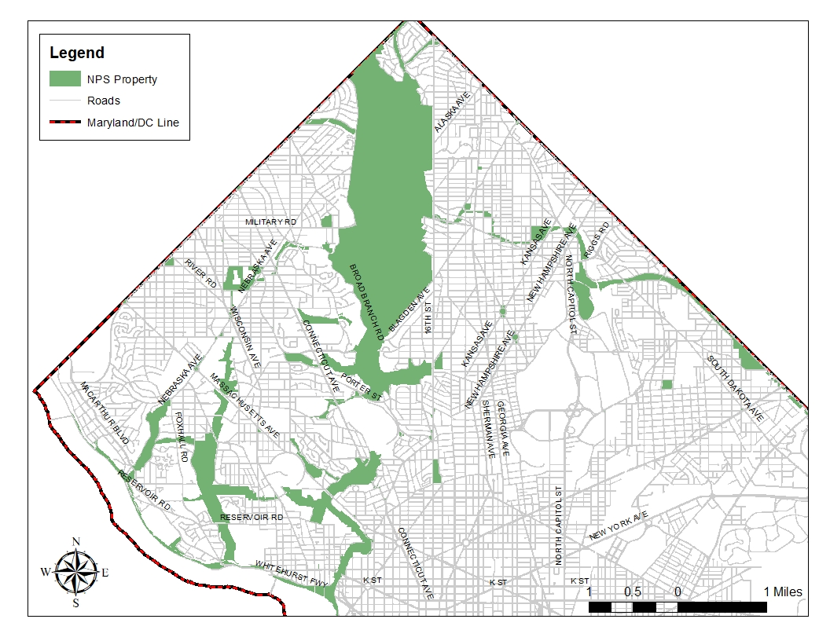

ATTACHMENT B: Administrative map of Rock Creek Park
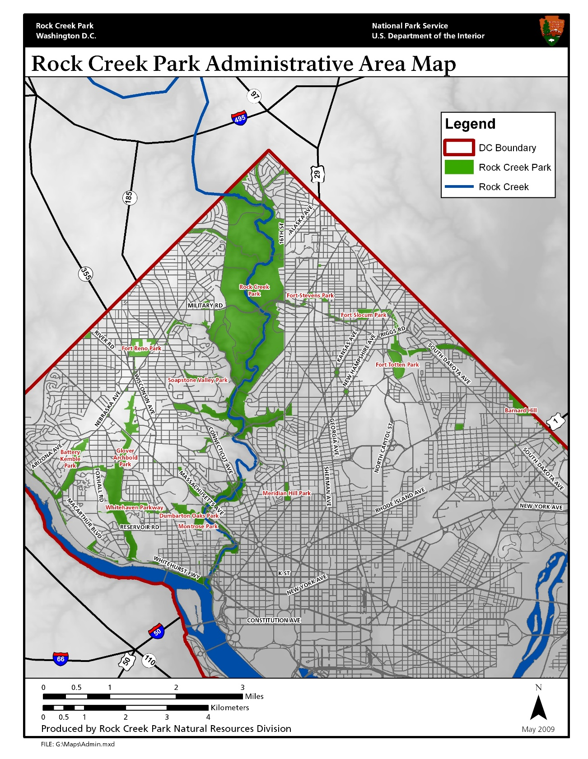

ATTACHMENT C: Sample Assignment Map.

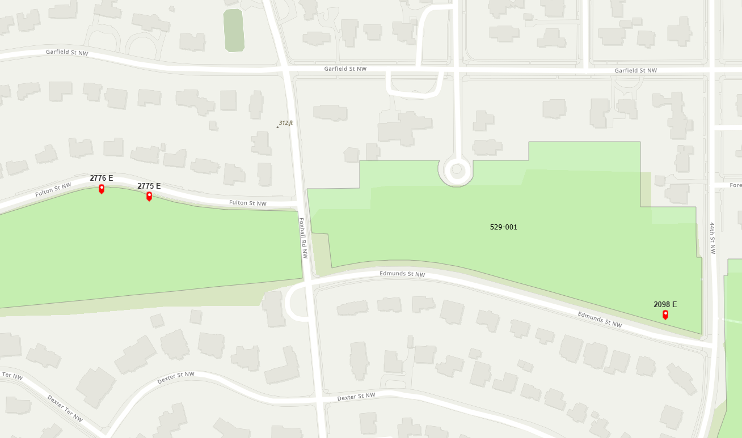

ATTACHMENT D: Sample Assignment Spreadsheet.

