Templates for Volume I: Technical Proposal

Appendix A1: Cover Sheet Template for Volume I: Technical Proposal
(1) ETA Program Announcement Number | DOI-ETA-FY26-30
(2) Program Name (Reference Attachment 1 – ETA Programs)
(3) Lead Organization Submitting Proposal: Address, Unique Entity ID, CAGE Code
(4) Type of Business. Is the Lead Organization a NDC?
(5) Contractor’s Reference Number (if any)
(6) Other Team Members and Type of Business. Identify the NDC, if other than the Lead Organization.
(7) Proposal Title
(8) Technical Point of Contact to Include: Title, First Name, Last Name, Street Address, City, State, Zip Code, Telephone, E-Mail Address
(9) Administrative Point of Contact to Include: Title, First Name, Last Name, Street Address, City, State, Zip Code, Telephone, E-Mail Address
(10) Volume I no more than the specified page limit | Yes/No
(11) Restrictions on IP rights details provided in Appendix A format? | Yes/No
(12) Research Data Management Plan included? | Yes/No
(13) OCI Waiver Determination, Notification or Certification Included? | Yes/No
(13a) If No, is written certification included (Appendix A)? | Yes/No
(14) Are one or more U.S. Academic Institutions part of your team? | Yes/No
(14a) If Yes, are you including an Academic Institution Acknowledgment Statement with your proposal for each U.S. Academic Institution that is part of your team (Appendix A)? | Yes/No
(15) Total Funds Requested from IARPA and the Amount of Cost Share (if any) | $
(16) Date of Proposal Submission

Appendix A2: Academic Institution Acknowledgment Letter
Proposers must use this template.
-Please Place on Official Letterhead –
<Insert date>

To: Agreements Officer Department of the Interior
Interior Business Center
Acquisition Services Directorate
Herndon, VA 20170

Subject: Academic Institution Acknowledgment Letter Reference: Executive Order 12333, As Amended, Para 2.7

This letter is to acknowledge that the undersigned is the responsible official of <insert name of academic institution>, authorized to approve the contractual relationship in support of the Office of the Director of National Intelligence’s Intelligence Advanced Research Projects Activity and this academic institution.

The undersigned further acknowledges that he/she is aware of the Intelligence Advanced Research Projects Activity’s proposed contractual relationship with insert name of institution through DOI-ETA-FY26-30 and is hereby approved by the undersigned official, serving as the president, vice president, chancellor, vice-chancellor, or provost of the institution.

Date

Appendix A3: IP Rights
The use of this Template is optional; however, any other format used must include the same content as that in the template below.
[Please provide your good faith representation of ownership or possession of appropriate licensing rights to all IP that shall be utilized under the Program.]
PATENTS
Patent number (or application number) | Patent name | Inventor name(s) | Patent owner(s) or assignee | Incorporation into deliverable
(List) | (List) | (List) | (List) | (Yes/No; applicable deliverable)
- Intended use of the patented invention(s) listed above in the conduct of the proposed research:
- Description of license rights to make, use, offer to sell, or sell, that are being offered to the Government in patented inventions listed above:
- How the offered rights will permit the Government to reach its program goals (including transition) with the rights offered:
- Cost to the Government to acquire additional or alternative rights.
- Alternatives, if any, that would permit IARPA to achieve program goals.
NON-COMMERCIAL ITEMS
Technical Data, Computer Software To be Furnished with Restrictions | Basis for Assertion | Asserted Rights Category | Name of Person Asserting Restrictions
(List) | (List) | (List) | (List)

COMMERCIAL ITEMS
Technical Data, Computer Software To be Furnished with Restrictions | Basis for Assertion | Asserted Rights Category | Name of Person Asserting Restrictions
(List) | (List) | (List) | (List)

- Intended use of the data, including technical data and computer software, listed above in the conduct of the proposed research:
- Description of Asserted Rights Categories, specifying restrictions.
- Government’s ability to use, modify, reproduce, release, perform, display, or disclose technical data, computer software, and deliverables incorporating technical data and computer software listed above: (3) How the offered rights will permit the Government to reach its program goals (including transition) with the rights offered:
- Cost to the Government to acquire additional or alternative rights.
- Alternatives, if any, that would permit IARPA to achieve program goals.

Appendix A4: Organizational Conflicts of Interest Certification Letter
The use of this template is required
(Month DD, YYYY)
Department of the Interior
Interior Business Center/Acquisition Services Directorate
Emerging Technology Accelerator
ATTN: William Galvin Jr. and Kevin Woody
Herndon, VA 20170
Subject: OCI Certification
Reference: DOI-ETA-FY26-30, (Insert assigned proposal ID #)
Dear ,
IAW ETA Program Announcement DOI-ETA-FY26-30, Section 3.A.1 Organizational Conflicts of Interest (OCI), and on behalf of (Proposer’s Name), I certify that neither (Proposer’s Name) nor any of our subcontractor teammates have as a potential conflict of interest, real or perceived, as it pertains to the ____________ Program.
Please note the following subcontractors and their proposed roles:
[Please list all proposed contractors by name with a brief description of their proposed involvement.]
If you have any questions, or need any additional information, please contact (Insert name of contact) at (Insert phone number and e-mail address).
Sincerely,

(Insert organization name) (Shall be signed by an official that has the authority to bind the organization)

(Insert signature)

(Insert name of signatory) (Insert title of signatory)

Appendix A5: Three Chart Summary of the Proposal
The use of this Template is required in PowerPoint format.
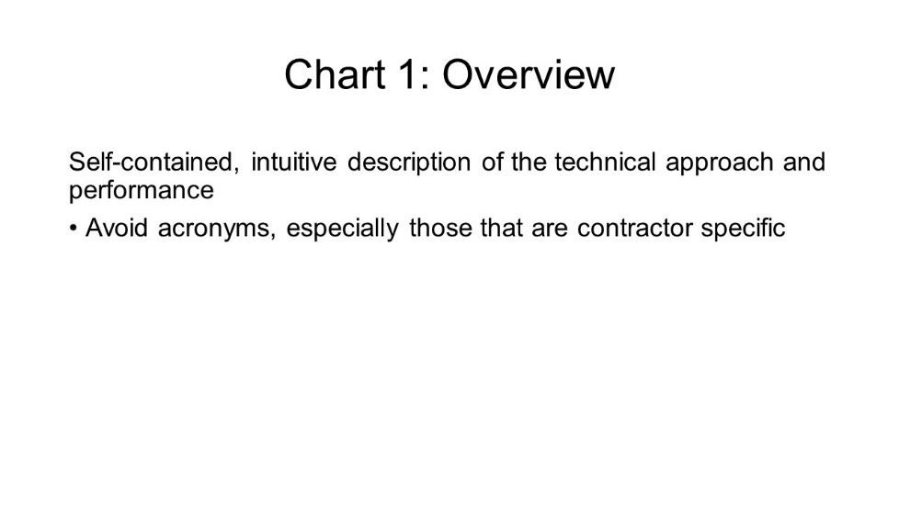
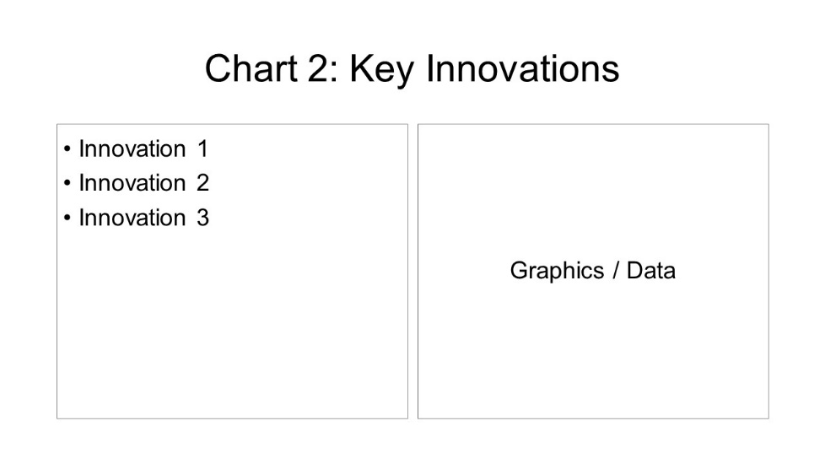
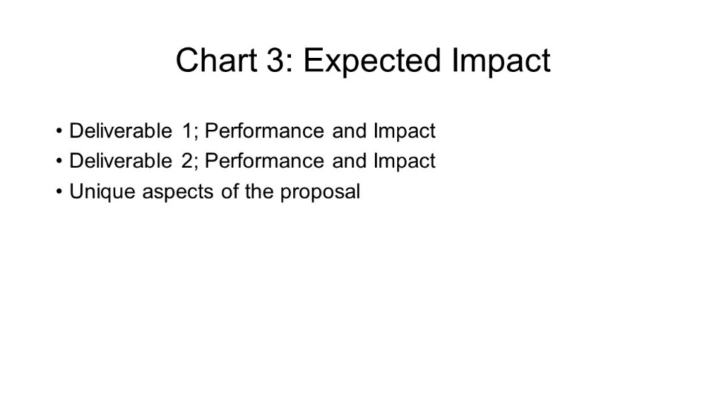

Appendix A6: Research Data Management Plan (RDMP)
The use of this template is required.
The Proposer must address each of the elements noted below.
The RDMP shall comply with the requirements stated in Section 4. In doing so, it will support the objectives of the ODNI Public Access Plan at www.iarpa.gov
Sponsoring IARPA Program (required) (Reference Attachment 1 – ETA Programs):
- Proposer (i.e., lead organization) (required):
- Proposer point of contact (required): The point of contact is the proposed PI or his/her Designee.
- Name and Position:
- Organization:
- E-mail:
- Phone:
- Research data types (required): Provide a brief, high-level description of the types of data to be collected or produced in the course of the project.
- Standards for research data and meta data content and format (required): Use standards reflecting the best practices of the relevant scientific discipline and research community whenever possible.
- Plans for making the research data that underlie the results in peer-reviewed journal articles and conference papers digitally accessible to the public at the time of publication/conference or within a reasonable time thereafter (required): The requirement could be met by including the data as supplementary information to a peer reviewed journal article or conference paper or by depositing the data in suitable repositories available to the public.
- Anticipated method(s) of making research data publicly accessible:
Provide dataset(s) to publisher as supplementary information (if publishers allow public access)
Deposit dataset(s) in Data Repository
Other (specify)________________________________________________
- Proposed research data repository or repositories (for dataset(s) not provided as supplementary information): Suitable repositories could be discipline-specific repositories, general purpose research data repositories, or institutional repositories, as long as they are publicly accessible.
- Retention period, at least three years after publication of associated research results: State the minimum length of time the data will remain publicly accessible.
- Submittal of metadata to IARPA: Proposers are required to make datasets underlying the results published in peer-reviewed journal or conferences digitally accessible to the public to the extent feasible. Here, the Proposer shall state a commitment to submit metadata on such datasets to IARPA in a timely manner.
Note: This does not supersede any requirements for deliverable data, as the award document may include metadata as a deliverable item.
- Policies and provisions for sharing and preservation (as applicable):
- Policies and provisions for appropriate protection of privacy, confidentiality, security, and IP:
- Descriptions of tools, including software, which may be needed to access and interpret the data:
- Policies and provisions for re-use, re-distribution, and production of derivative works:
- Justification for not sharing and/or preserving data underlying the results of peer reviewed publications (as applicable): If, for legitimate reasons, the data cannot be shared and preserved, the plan must include a justification detailing such reasons. Potential reasons may include privacy, confidentiality, security, IP rights considerations; size of data sets; cost of sharing and preservation; time required to prepare the dataset(s) for sharing and preservation.

Templates for Volume II, Section 1: Cost Proposal

Appendix B1: Cover Sheet for Volume II: Cost Proposal
(1) ETA Program Announcement Number | DOI-ETA-FY26-30
(2) Program Name (Reference Attachment 1 – ETA Programs)
(3) Lead organization submitting proposal
(4) Type of Business. Is the Lead Organization a NDC?
(5) Contractor’s Reference Number (if any)
(6) Other Team Members (if applicable) and Type of Business for Each. Identify the NDC, if other than the Lead Organization
(7) Proposal Title
(8) Technical Point of Contact to Include: Title, First Name, Last Name, Street Address, City, State, Zip Code, Telephone, E-Mail Address
(9) Administrative Point of Contact to Include: Title, First Name, Last Name, Street Address, City, State, Zip Code, Telephone, E-Mail Address
(10) OT Type Requested (i.e. Cost Reimbursement, FFP):
(11) Place(s) and Period(s) of Performance
(12) Total Proposed Cost Separated by Base Award, Phases, and Option(s) (if any)
(13) Name, Address, Telephone Number of the Proposer’s Defense Contract Management Agency (DCMA) Administration Office or Equivalent Cognizant Contract Administration Entity (If Applicable)
(14) Name, Address, Telephone Number of the Proposer’s Defense Contract Audit Agency (DCAA) Audit Office or Equivalent Cognizant Contract Audit Entity (If Applicable).
(15) Date Proposal was Prepared
(16) Unique Entity ID
(17) TIN Number
(18) CAGE Code
(19) Proposal Validity Period [Minimum of 180 days]
(20) Cost Summaries Provided (Appendix B)
(21) Size of Business IAW NAICS Code 541715

Appendix B2: Cost Proposal Template.

Excel Format will be provided to those Proposers invited to submit Volume II.
Prime Proposer/Subcontractor Cost Element Sheet for Volume II: Cost Proposal

Complete a Cost Element Sheet for the Base Period, each Phase, and each Option Period
COST ELEMENT |  |  | BASE |  | RATE |  | AMT
DIRECT LABOR (List each labor category separately. Identify all Key Personnel by name.) |  |  | # of Hours |  | $ |  | $
TOTAL DIRECT LABOR |  |  |  |  |  |  | $
FRINGE BENEFITS |  |  | $ |  | % |  | $
TOTAL LABOR OVERHEAD |  |  | $ |  | % |  | $
SUBCONTRACTORS, CONSULTANTS  (List separately. Reference table below) |  |  |  |  |  |  | $
MATERIALS & EQUIPMENT (List each material and equipment item separately.) |  |  | Quantity |  | $ unit price |  | $
SOFTWARE & IP (List separately. Reference table below) |  |  | $ |  | $ |  | $
TOTAL MATERIALS & EQUIPMENT |  |  |  |  |  |  | $
MATERIAL OVERHEAD |  |  | $ |  | % |  | $
TRAVEL (List each trip separately.) |  |  | # of travelers |  | $ price per traveler |  | $
TOTAL TRAVEL |  |  |  |  |  |  | $
OTHER DIRECT COSTS (List each item separately.) |  |  | Quantity |  | $ unit price |  | $
TOTAL ODCs |  |  |  |  |  |  | $
G&A |  |  | $ |  | % |  | $
SUBTOTAL COSTS |  |  |  |  |  |  | $
COST OF MONEY |  |  | $ |  | % |  | $
TOTAL COST |  |  |  |  |  |  | $
PROFIT/FEE |  |  | $ |  | % |  | $
TOTAL PRICE/COST |  |  |  |  |  |  | $
GOVERNMENT SHARE, IF APPLICABLE |  |  |  |  |  |  | $
RECIPIENT SHARE, IF APPLICABLE |  |  |  |  |  |  | $
SUBCONTRACTORS/IOTs) & CONSULTANTS PRICE SUMMARY

A | B | C |  | D |  | E |  | F
SUB-CONTRACTOR IOT & CONSULTANT NAME | SOW TASKS PERFORMED* | TYPE OF AWARD |  | SUB- CONTRACTOR, IOT & CONSULTANT QUOTED PRICE |  | COST PROPOSED BY PRIME FOR SUBCONTRACTOR, IOT & CONSULTANT |  | DIFFERENCE  (Column D - Column E) IF APPLICABLE
TOTALS
*Identify TDD, Milestone or Work Breakdown Structure paragraph, or provide a narrative explanation as an addendum to this Table that describes the effort to be performed.

Appendix B3: Software and IP Costs
Software and IP Costs
Item | Cost | Date of Expiration

NOTE: Educational institutions and non-profit organizations, at the prime and subcontractor level, may deviate from the cost template in Appendix B when estimating the direct labor portion of the proposal to allow for OMB guided accounting methods (2 C.F.R. 220) that are used by their institutions. The methodology shall be clear and provide sufficient detail to substantiate proposed labor costs. For example, each labor category shall be listed separately; identify all Key Personnel and significant contributors provide hours/rates or salaries and percentage of time allocated to the project.

Appendix B4: Travel Costs and Trip Breakdown
Base - Phase 1 as applicable
Trip # | Month of Trip | # of Travelers | Name of Traveler/Company | # of Days | Location | Purpose of Travel | Estimated Cost
Option Period - Phase 2 as applicable
Trip # | Month of Trip | # of Travelers | Name of Traveler/Company | # of Days | Location | Purpose of Travel | Estimated Cost
Option Period - Phase 3 as applicable
Trip # | Month of Trip | # of Travelers | Name of Traveler/Company | # of Days | Location | Purpose of Travel | Estimated Cost

Appendix B5: Deliverables Table
Reference Attachment 1 – ETA Programs

