SALIENT CHARACTERISTICS
Northern Arizona VA Health Care System—Vocera
450 communication devices and supported software with the following:
  - Badge
  - Badge must be lightweight. Badge may not exceed 4 ounces.
  - Badge must be hands-free to give hospital staff increased mobility and greater practicality to complete multiple tasks at the same time.
  - Badge must have a button to push to talk to contact other hospital staff without knowing what number to call.
  - Dedicated panic button to request immediate assistance for rapid response such as code blue.
  - Badge must have a universal clip to attach badge to clothing for optimal speech recognition which is no more than six inches under the chin.
  - Badge battery must last a minimum of 35 hours without being charged.
  - Badge must be an antimicrobial material to inhibit the growth of bacteria for hospital Safety.
  - Badge must have the ability to interrupt a busy signal to call a Code Blue or a Rapid Response call.
  - Badge must have the ability to leave a voice message for staff or group of users that can be retrieved when staff or users log back into the system.
  - Badge must be staff centered so that when staff log in to the system, it pulls up staff’s profile and privileges because this information is maintained on the server, and limits sharing of the devices among staff.
  - Badge must be FIPS compliant to operate in VA wireless system.
  - Capability to align with one integrated system throughout NAVAHCS.
  - Network/Server compatibility with hosting at NAVAHCS.

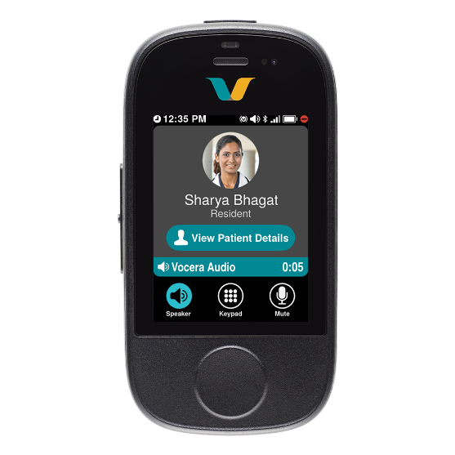
Picture is to provide guidance to the vendor only
  - Battery
  - Battery must be durable to be worn throughout various shifts.
  - Battery must have approximately a minimum of 4 hours talk time.
  - Must have a minimum of 40 hours standby time.
  - Under care and usage, batteries should be replaced at a minimum of 18 months.

  - 8-Bay Chargers
  - 8-Bay charger must have a minimum of 8 connected bays to charge 8 batteries at the same time.
  - 8-Bay charge must charge all 8 charges at once and this should take up to 6 hours or less.

  - Clips
  - Must provide clips that attach the badge to clothing.
  - The clips can be adjusted, and length cannot exceed 6 inches from the chin for speech recognition.

  - Standard Warranty for all equipment
  - Must replace or repair all broken equipment.
  - Badge comes with a minimum 1 year warranty from the shipment date to the original end user.

  - Extended Warranty for Badges
  - Must be a minimum of 2-year warranty for the badges beyond the initial year included with device purchase.
  - Must replace or repair broken badges damaged by normal use.

  - Extended Warranty for 8-Bay Chargers
  - Must be a minimum 2-year warranty for 8-bay chargers
  - Must replace broken 8-bay chargers.

  - LICENSE
  - Badges must be FIPS compliant.
  - Badge must be validated for effective hardware-based encryption in the VA wireless network.

  - OTHER REQUIRED DOCUMENTATION
  - Vendor must provide approved VA Directive 6550 for the Vocera Supplies.
  - Vendor must be in compliance with VA Directive 6500.
  - Vendor must provide a letter that they are the approved Original Equipment Manufacturer and/or distributor.
  - Vendor must demonstrate that their product will have compatibility with existing services and equipment currently in use within NAVAHCS.

