Delineated Area for Cleveland, OH
https://www.google.com/maps/d/edit?mid=1ZPtAZ8ImtTW8vvycgR-H6EHXpRPnLgE&usp=sharing

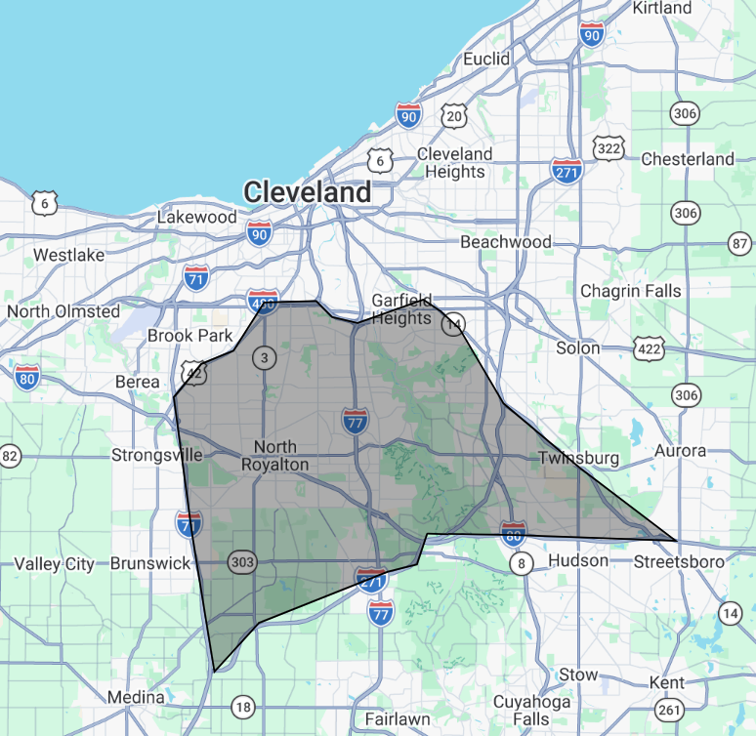
Delineated area for Cleveland, OH is defined by:
- Starting from intersection of SR-14 and I-480, west on I-480
- Southwest on US-42
- South on I-71
- East on I-271
- East on I-80
- Northwest on I-480
- Northwest on SR-14 to origin

