Broad Agency Announcement Tool (BAAT) Submission Portal Guide
The DARPA Broad Agency Announcement Tool (BAAT) Submission Portal Guide contains instructions and guidance for first time and returning users of this system.
Proposers using the BAAT may encounter heavy traffic on the submission deadline date; proposers are advised to begin their submission process as early as possible to avoid missing their submission deadline due to technical issues. For more guidance, see General Tips and Guidance.
Technical support for the DARPA BAAT Submission website is available during regular business hours, Monday – Friday, 9:00 a.m. – 5:00 p.m. Eastern Time. Requests for technical support must be emailed to BAAT_Support@darpa.mil with a copy to the solicitation coordinator email address identified in the solicitation. Questions regarding submission contents, format, deadlines, etc. should be emailed to the solicitation coordinator email address identified in the solicitation. Questions or requests for support sent to any other email address may result in delayed/no response.

Contents
BAA Submitter Account Creation Steps 2
First access to the BAAT application 4
Begin Your First Submission 8
General Tips and Guidance 12

BAA Submitter Account Creation Steps
- Access https://baa.darpa.mil
- Select the “Create New Account” button on the “DoD Notice and Consent Banner” page.
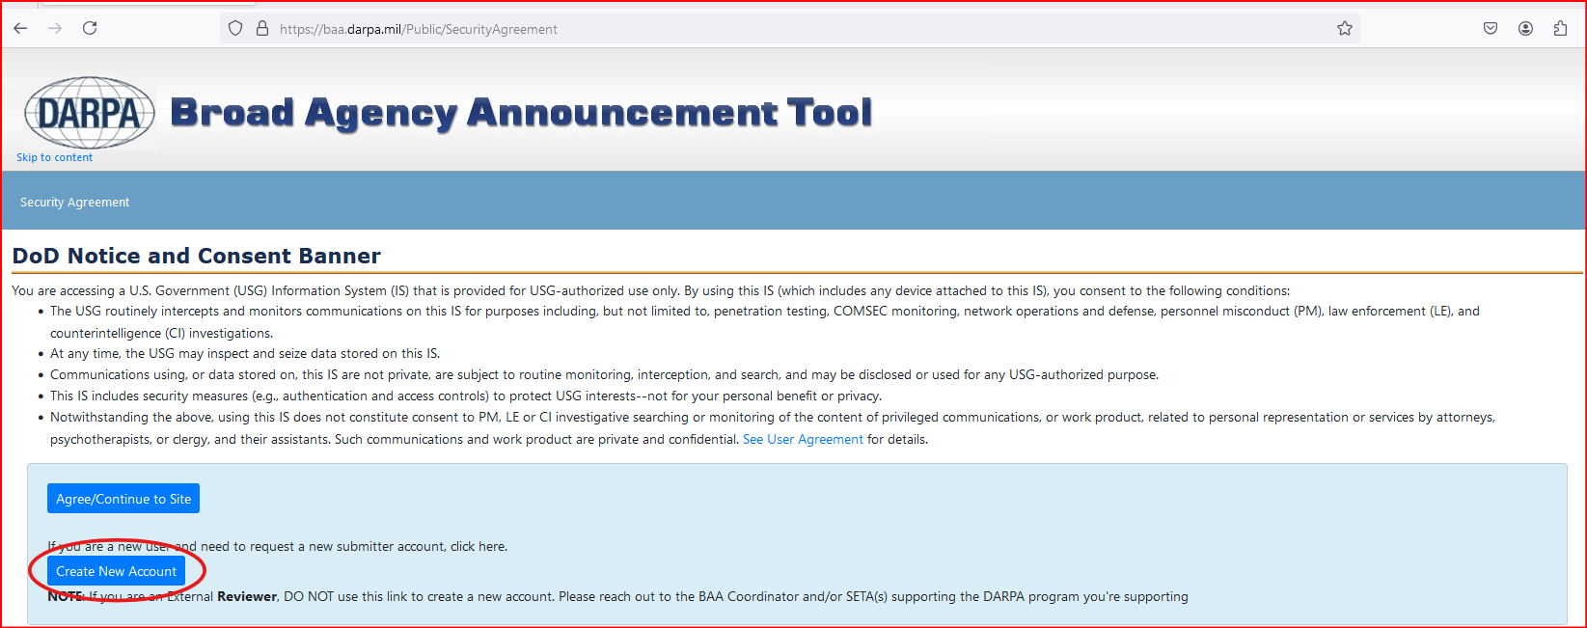
Image 1. BAAT DoD Notice and Consent Banner page
- The “DoD Notice and Consent Banner” pop up dialog box is displayed.
- Select the “PROCEED” button to dismiss the dialog box.
- The “Submitter Registration” form is displayed (https://baa-registration.darpa.mil/).
- Complete the “Submitter Registration” form and submit it.
  - Enter the “First Name”
  - Enter the “Last Name”
  - Enter the Organization (note – refrain from entering punctuation in the Organization field)
  - Enter the “Phone” number
  - Enter the “Email” address
  - Select the “Submit” button
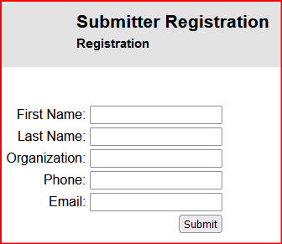
Image 2. Submitter Registration form
- Upon submission of the “Submitter Registration” form the “Registration Data Received” page will be displayed.
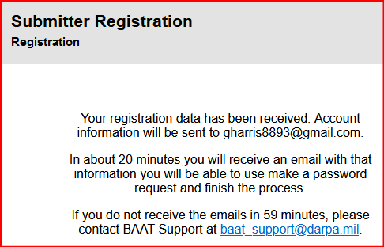
Image 3. Registration Data Received page
- Upon submission of the “Submitter Registration” form, two emails will be received.
  - The first email will come from “NoReply@darpa.mil”.
  - The second email will be delivered around 70 minutes later and come from “NoReply@okta.com” and will most likely be found in the Junk email folder.
- Upon receipt of the second email from Okta described in step 7.a., take note of the Username created for your account.
- The Okta email will contain an “Account Activation” button. Select the “Account Activation” button.
- You will be prompted to create a Password, Security Question, and select an “MFA” (multi factor authentication) method.
- When completed the “Okta” dashboard be displayed containing the “DARPA BAAT” tile.
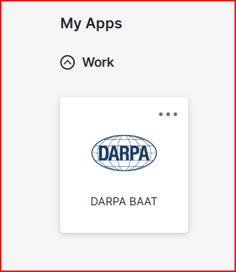
Image 4. Okta dashboard DARPA BAAT tile
- Select the “DARPA BAAT” tile to access the BAAT application.
- The “DoD Notice and Consent Banner” page will be displayed.

First access to the BAAT application
Upon access to the BAAT application, select the “Agree/Continue to Site” button on the “DoD Notice and Consent Banner” page.

Image 5. Agree/Continue to Site button
After selecting the “Agree/Continue to Site” button has been selected, the Submitter will be presented with the “New Unregistered User” pop up dialog box.
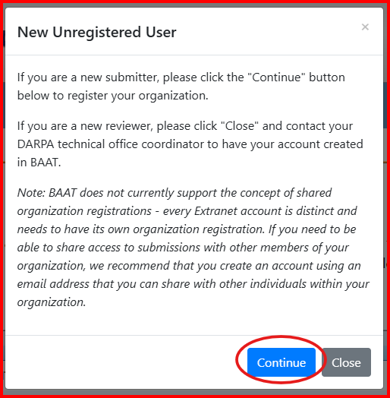
Image 6. New Unregistered User dialog box
Select the “Continue” button. The “New Unregistered User” dialog box will be dismissed and the “Register Your Organization” form will be displayed.
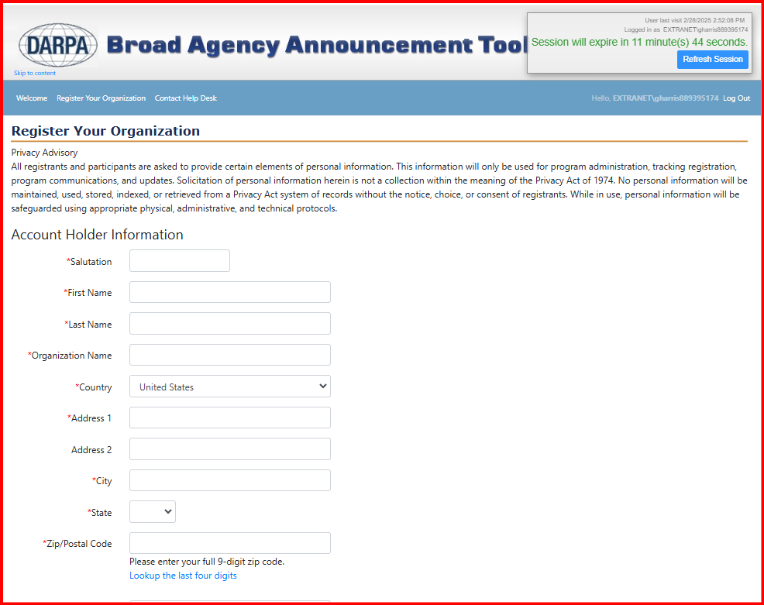
Image 7. Organization Information form
(Note: not all fields are displayed in this image)
Upon the first access of the BAAT application, the Submitter will be required to complete and submit the “Register Your Organization” form.
(Note – each account holder is required to fill out and submit the “Register Your Organization” form regardless of whether account holders in the Submitter’s organization have submitted the information before.)
The “Register Your Organization” form contains the following sections and fields:
- Account Holder Information Section (Note, required fields are marked with a *)
  - Salutation
  - First Name
  - Last Name
  - Organization Name
  - Country
  - Address 1
  - Address 2
  - City
  - State
  - Zip/Postal Code
  - Phone
  - Fax Email
- Organization Information Section (Note, required fields are marked with a *)
The “Organization Information” section contains a “Copy From Account Holder” button. When selected, the data entered in the “Account Holder Information” section will copy to the applicable fields in the “Organization Information” fields.

Image 8. Copy From Account Holder button
Organization Information Section Fields
- Organization Name
- Organization Division
- Organization Type
- Country
- Address 1
- Address 2
- City
- State
- Zip/Postal Code
- Questions About Your Organization Section
(Note, the Questions About Your Organization fields are not required at Organization Registration, but if an award is granted, this information will need to be entered. The Register Your Organization form can be accessed by selecting the “Organization Information” link.
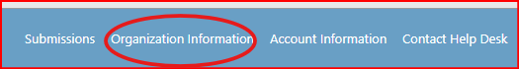
Image 9. Organization Information link
Questions About Your Organization section fields
- Number of Employees
- UEI Number
- Taxpayer/Employer Identification Number
- CAGE Code
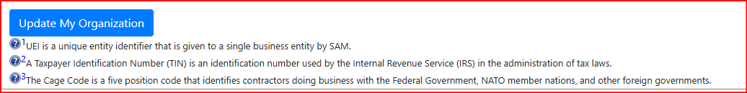
Image 10. Save/Update My Organization button
(Note, below the “Save/Update My Organization” button in image 10. There is informational text about the UEI Number, Taxpayer Identification Number, and the CAGE code field content.)
- After Completing all required fields on the “Register Your Organization” form select the “Save/Update My Organization” button.
Upon saving the Organization data the Submitter is presented with the “Begin Your First Submission” page.

Begin Your First Submission
After the BAAT application Organization Registration is completed, the “Begin Your First Submission” page will apppear.
Select the “Let’s Get Started” button on the “Begin Your First Submission” page. The “Begin Your First Submission” page will be dismissed and the “Begin a New Submission” page is displayed.
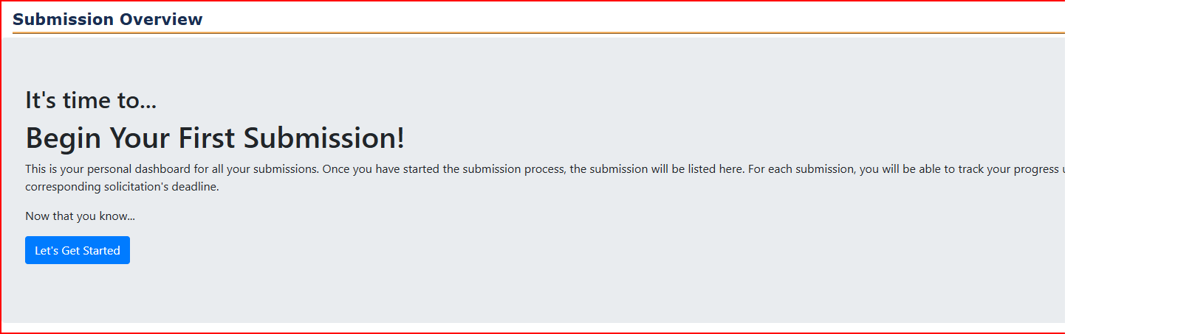
Image 11. Begin Your First Submission page
The “Begin a New Submission” page displays a list of all open DARPA announcements that Organizations can submit proposals for. The page also contains a “Filter by Office” picklist; the default filter by office value is “All”.
Submitters can filter the open DARPA announcements listed to a specific DARPA Technical Office.
Each Announcement listed will contain a “Submit…” button for the type of submissions accepted per Announcement, e.g., “Submit Executive Summary,” “Submit Proposal Abstract,” “Submit Full Proposal.”
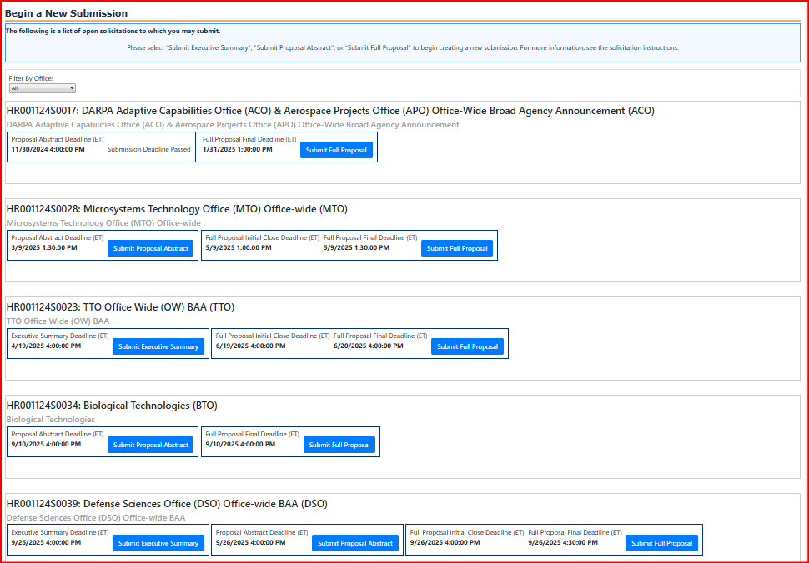
Image 12. Begin a New Submission page
To Submit a Proposal, follow the steps below.
- Select the “Submit…” button for the ‘Executive Summary,’ ‘Proposal Abstract,’ or ‘Full Proposal’ for the Announcement being submitted to.

- The “Create” submission form will be displayed.
(Note, the Submission forms’ fields will vary depending on the submission type and solicitation requirements.)

- Enter data in all required fields of the “Create” submission form. The Full Proposal Submission form will be used as the example in image 13. (Note, required fields are marked with a *)
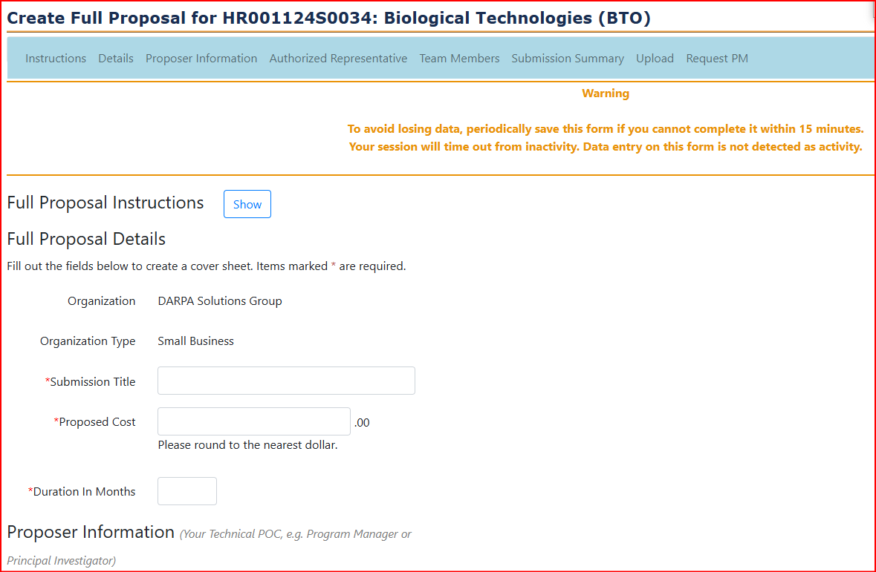
Image 13. Full Proposal Submission form (note, not all fields are sections of the form are included in the image.
- Full Proposal Details section and fields.
  - Organization (data is auto filled)
  - Organization Type (data is auto filled)
  - Submission Title
  - Proposed Cost
  - Duration in Months
- Proposer Information section and fields. (Your Technical POC, e.g., Program Manager or Principal Investigator data)
  - Salutation
  - First Name
  - Last Name
  - Organization Name
  - Country
  - Address 1
  - Address 2
  - City
  - State
  - Zip/Postal Code
  - Phone
  - Fax
  - Email
- Authorized Representative section (Your Contracting Officer or Grant Officer data)
The “Authorized Representative” section includes a “Copy From Proposer Information” button. Select the button to copy the Proposer Information data to the Authorized Representative fields when appliable.

Authorized Representative section fields
  - Salutation
  - First Name
  - Last Name
  - Organization Name
  - Country
  - Address 1
  - Address 2
  - City
  - State
  - Zip/Postal Code
  - Phone
  - Fax
  - Email
- Team Members Section
The “Team Members” section is used to identify any teams/subcontractor organizations contributing to the submitter’s proposal.
The “Team Members” section contains a “I do not have any team members” check box and fields to capture each team’s data.
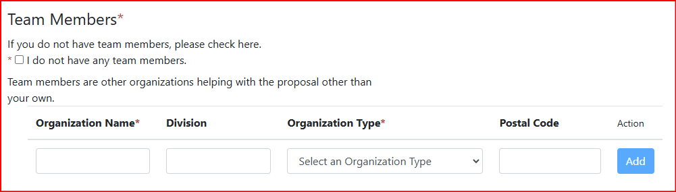
Image 14. Submission Form Team Members section
If the submission contains an additional team/subcontractor organization, enter the team/subcontractor organization’s “Organization Name,” “Division,” “Organization Type,” and “Postal Code,” then click “Add” to save.
Note, after entering each team/subcontractor organization’s data, select the “Add” button to save the Team data. Selecting the “Add” button will display additional Team data fields to use if needed.
- Submission Summary Section (if applicable)
Provide a summary of the proposal Technical and Management approach in the Submission Summary text field. The following rules apply to the Submission Summary field:
Maximum of 500 words. Limit use of special characters - accepted characters are & ( ) \ - : ` ' , . / _ # ;

- Submission File Upload Section
All Submission types (Executive Summary, Proposal Abstract, Full Proposal) require that a .zip or .zipx file containing the submission document(s) is uploaded for the submission. Password Protected files cannot be uploaded.
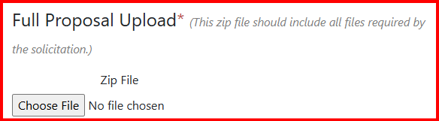
Image 15. Submission Document Upload section
Select the “Choose File” button, navigate to the location of the .zip or .zipx file and select it.
- Save and Finalize the Submission
While completing the Submission form, it is a good idea to save the form data periodically.
When the Submission form data is completed and the .zip or .zipx file has been uploaded, select the “Finalize” button to submit the proposal to DARPA.
The submission can only be accepted if it is finalized before the advertised Announcement closing time on the advertised closing date.
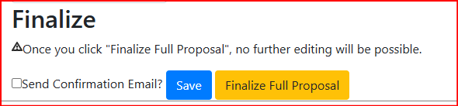
Image 16. Submission Form, Save and Finalize button
After finalizing the submission, an email containing the submission control number will be sent from BAAT-NO-REPLY@darpa.mil. Retain this control number for your records.

General Tips and Best Practices
- Proposers using the BAAT may encounter heavy traffic on the submission deadline date. In order to avoid any unforeseen technical issues, proposers should begin their submission process as early as possible.
- BAAT accounts will be disabled after 30 days of inactivity (i.e., no login activity) and deleted after 90 days of inactivity. It is recommended that you regularly login to your BAAT account to ensure it does not become disabled or deleted. Pay particular attention to the timing of submissions for the same solicitation (e.g., abstract and proposal due dates) to ensure your account is not inactivated between submissions.
- Contact BAAT_Support@darpa.mil as soon as you learn that your account has been disabled.
- At the top right of your screen is a countdown to when your session will expire due to inactivity. Only clicking on the page or navigating between pages counts as activity. Keystrokes, i.e., typing, do NOT count as activity. As you fill out a submission form, ensure you frequently click on the page or click the “Refresh Session” button to refresh the timer to avoid your account being logged out and losing your submission progress. A countdown timer is displayed in the top right of the website for your reference.
- Red validation error messages indicating improperly filled out fields on the Submission Form may appear when you attempt to save or submit the form. It is recommended that you build in time to address any such errors prior to submission, as these errors will block the submission from being finalized.
- A valid Commercial and Government Entity (CAGE) Code is required in order to submit via the BAAT.
- If you want to make changes to your submission after you have finalized it, and the submission deadline has not yet passed, contact BAAT_Support@darpa.mil and the solicitation coordinator email found in the solicitation to request that your submission be unfinalized. Once a submission has been unfinalized, it must be re-finalized prior to the submission deadline. Submissions cannot be unfinalized for edits after the submission deadline has passed.
- If you finalize multiple submissions for the same Announcement opportunity—whether intentionally or through error (e.g., clicking the Finalize button multiple times)—it is recommended that you notify the solicitation coordinator email found in the solicitation and indicate which submission(s) you would like reviewed or withdrawn.
- The Submission Form page may become slow as you enter data into it. If it becomes too slow to navigate, save and exit the Submission Form, then reenter it to refresh the page.
- Technical support for the DARPA BAAT Submission website is available during regular business hours, Monday – Friday, 9:00 a.m. – 5:00 p.m. Eastern Time. Requests for technical support must be emailed to BAAT_Support@darpa.mil with a copy to the solicitation coordinator email address identified in the solicitation.

