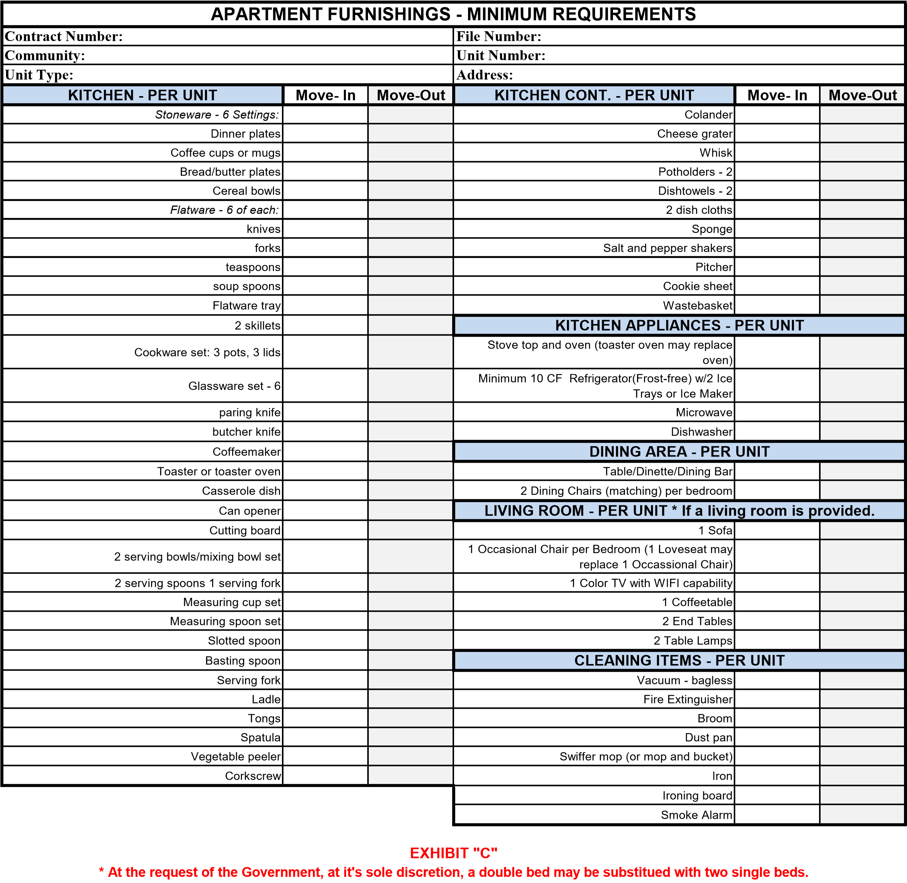
*At the request of the Government, at its sole discretion, a double bed may be substituted with two single beds.
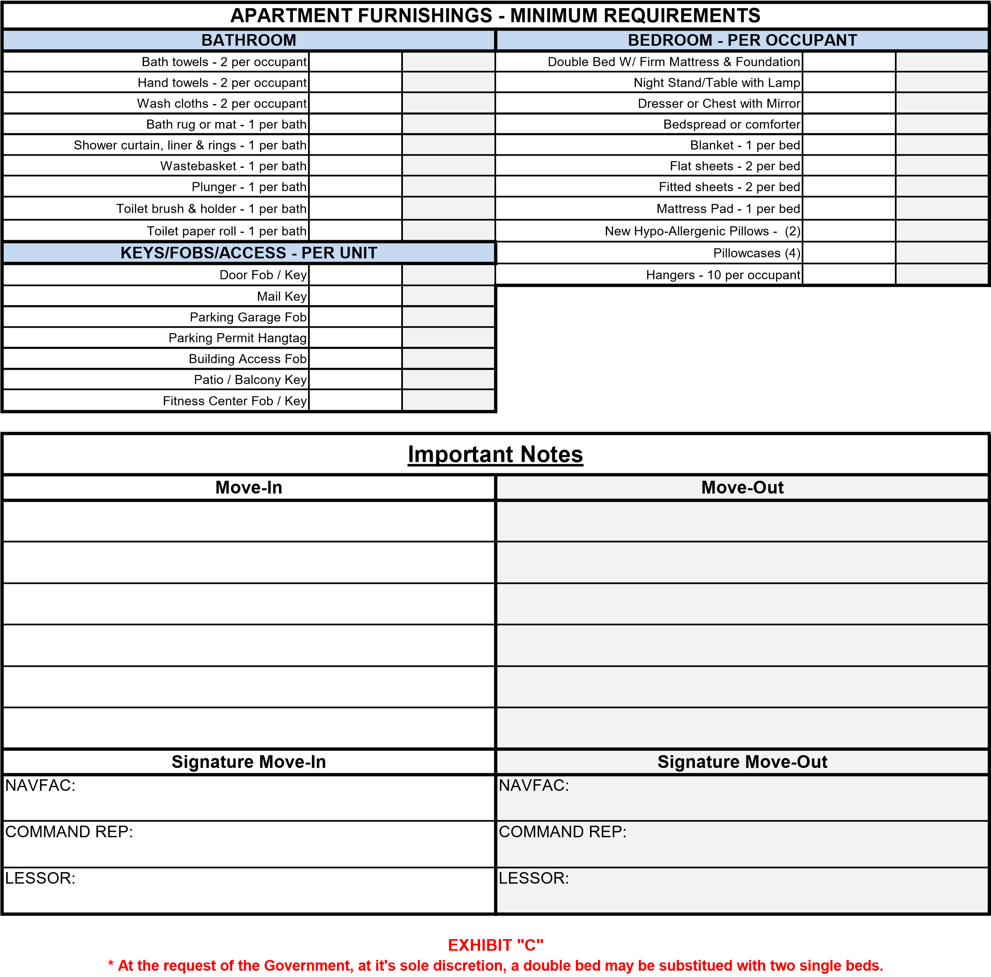
*At the request of the Government, at its sole discretion, a double bed may be substituted with two single beds.

