Defense Counterintelligence and Security Agency
Office of Small Business and Industry Engagement
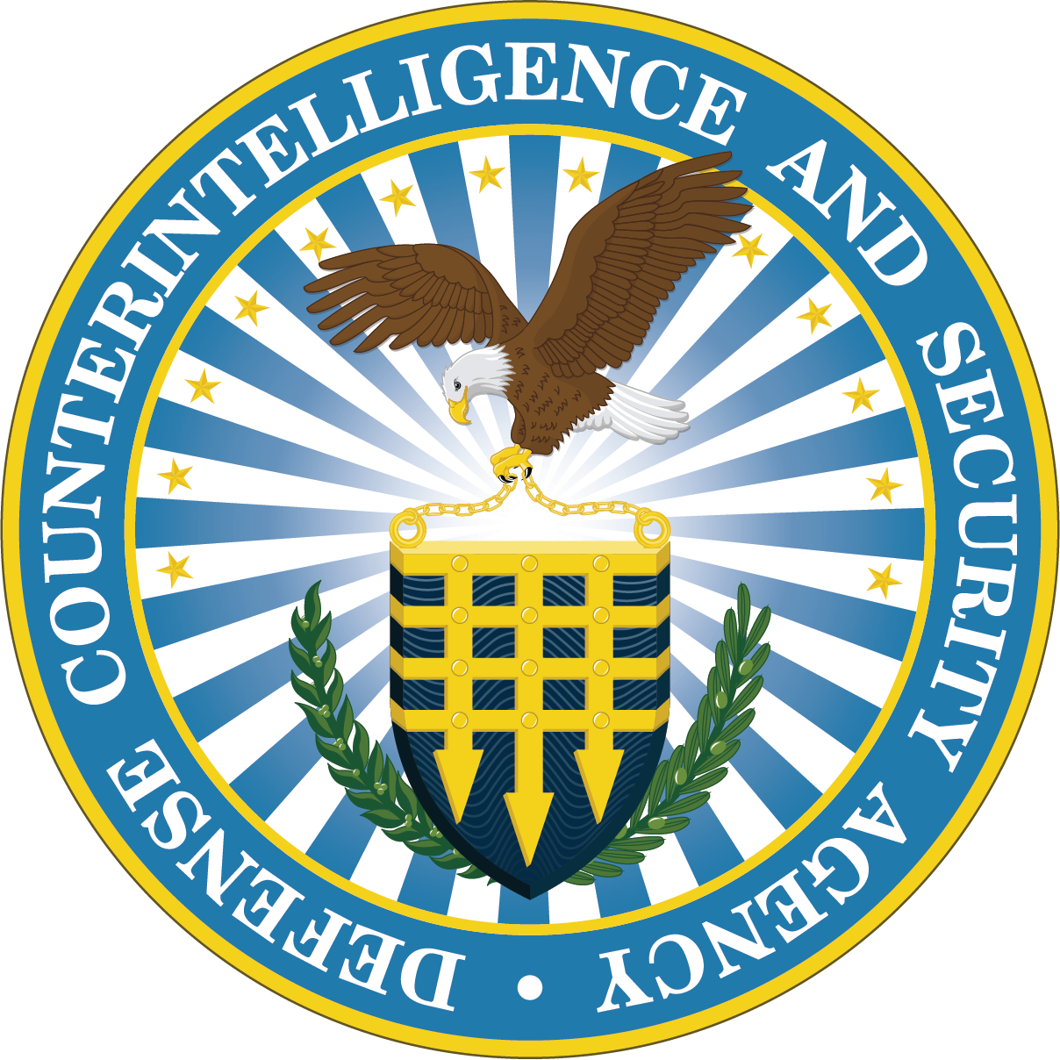

Mentor-Protégé Program

OPEN CALL
Fiscal Year 2026

1.0 Introduction & Program Overview

The Defense Counterintelligence and Security Agency (DCSA):
DCSA safeguards America’s trusted workforce, workspaces, and classified information. Through its mission areas of personnel vetting, industrial security, counterintelligence, insider threat, and education, DCSA plays a central role in protecting national security.

Mentor-Protégé Program:
The Department of War (DOW) Mentor-Protégé Program (MPP) is a premier business development initiative designed to incentivize large prime contractors to provide developmental assistance to small businesses. The primary goal is to enhance the capabilities of Protégés, enabling them to become more competitive and expand their presence in the Defense Industrial Base (DIB). Through this mutually beneficial partnership, Protégés gain valuable technical and business expertise, while the DoD cultivates a broader, more resilient supplier network to support its mission.

2.0 DCSA MPP Broad Agency Announcement (BAA)

BAA Management and Agreement Execution: The DCSA Office of Small Business Programs & Industry Engagement (OSBP&IE) manages this Broad Agency Announcement (BAA) and is the primary point of contact for submissions and review. The administration of agreements will be executed by Move America, Inc., through the DOW Office of Small Business Programs (OSBP) Mentor-Protégé Program Intermediary (MPP-I) Cooperative Agreement. Move America, Inc., will manage all subawards and reimbursements to participating firms. DCSA will continue to evaluate white papers for award selection, and the entire cooperative agreement will be administered by the ACC/APG Grants Officer.

Opportunity Description:
- Opportunity Name: FY26 DCSA Mentor-Protégé Program (MPP) Agreement Call
- Opportunity Number: TBD
- Opportunity Type: This is a 2-phase submission.
- Phase 1: White Paper submissions must be received no later than 5 p.m. Eastern Time (ET), 30 days after the announcement date.
- Phase 2: Final Proposal requests will only be issued to selected White Paper submissions based on the evaluation criteria. Selected submitters will receive a Request for Proposal (RFP) for their Phase 2 response.
- Dates: White Paper submissions must be submitted via email to the DCSA MPP Program Manager and the MPP Intermediary no later than 5:00 p.m. Eastern Time (ET), 30 calendar days from the BAA announcement date. Submissions received after this deadline will not be considered until a subsequent evaluation cycle.

- The Broad Agency Announcement (BAA) remains open, and White Papers are accepted on a rolling basis throughout the year. However, submissions are reviewed according to the following quarterly review cycles:
- Review Cycle I – March 29:
White Papers submitted on or before March 29 will be reviewed immediately following this date.
- Review Cycle II – June 30:
White Papers submitted after March 29 and on or before June 30 will be reviewed after June 30.
- Review Cycle III – September 30:
White Papers submitted after June 30 and on or before September 30 will be reviewed after September 30.
- Review Cycle IV – December 31:
White Papers submitted after September 30 and on or before December 31 will be reviewed after December 31.
- Review Cycle V – March 31:
White Papers submitted after December 31 and on or before March 31 will be reviewed after March 31

Submission Address: All White Papers are to be submitted by email to the DCSA Program Manager (dcsa.quantico.hq.mbx.dcsa-mpp@mail.mil) and the MPP Intermediary (mpp-src-i_contracts@moveamerica.org), (Subject: DCSA MPP Mentor-Protégé Agreement – (Insert Mentor & Protégé Name). All submissions will be acknowledged with an email confirmation within 24 hours of receipt. If a confirmation email is not received within 48 hours, please follow up to ensure delivery. DCSA is not responsible for email system malfunctions or undeliverable email.

BAA Submission Process:
- Phase I. White Paper Submission (Attachment 1): Firms respond to this Open Call by submitting a white paper summarizing technical and cost information.
- Phase II. Final Proposal Submission: After successful evaluation of white papers, selected firms provide a full Technical Proposal, Cost Proposal (Attachment 2), and Letters of Endorsement. The proposal will be reviewed for allowability, allocability, and reasonableness.
- Protégé Pilot Initiative (PPI) Application (Attachment 3): The Department of War (DOW) Pilot Protégé Initiative (PPI) was established under Pub. L. 117-63, div. A, title VIII, §856 (d), Dec. 23, 2022, 136 Stat, 2726. This pilot initiative provides Proteges in DOW reimbursable agreements an opportunity to propose projects supporting the advancement of engineering, software development, or manufacturing customization in support of the War Fighter. Proposals are limited to a maximum of up to 25% of the annual budget of the respective reimbursable agreement. The proposed amount will be used exclusively by Protégé for the project. PPI applications are due in Phase II with the final proposal.

3.0 DCSA Mentor-Protégé Program

MPP Objective & Benefits:
DCSA seeks to leverage Mentor-Protégé Agreements (MPAs) to mature Protégé firms for its critical mission spaces. By incentivizing Mentors to provide technical assistance, the agency aims to integrate high-capability small businesses into the Defense Industrial Base. This expansion directly strengthens national security by ensuring a resilient, value-added supply chain capable of safeguarding sensitive defense assets.

4.0 Participation Requirements

Protégé Firm Eligibility:
- Small business concerns eligible for federal contracts.
- Meet SBA size standards.
- Must satisfy one of the following: HUBZone, Women-Owned, Service-Disabled Veteran-Owned, Native American/Hawaiian controlled, socially/economically disadvantaged, employing severely disabled individuals, nontraditional defense contractors, or contributing to national security priorities.
Mentor Firm Eligibility:
- Prime contractors with $25M or more in DOW contracts in the last fiscal year.
- Active DOW subcontracting plan.
- Financially sound, good character, not debarred/suspended or under investigation.
- Approved by DOW OSBP as a Mentor.
Note: Active SAM.gov registration is mandatory for all vendors, mentors, protégés, and subcontractors at the time of package submission.

5.0 DCSA Technical Priorities
The core technical priorities for DCSA are structured around modernizing technology, integrating data, and securing IT infrastructure:
- Modernizing IT Infrastructure and Cloud Optimization
- National Background Investigation Services (NBIS): A primary focus is accelerating the delivery of NBIS to transform personnel vetting, including full transition to NBIS for Personnel Vetting operations including background investigations.
- Cloud Migration: Transitioning systems, such as the Defense Information System for Security (DISS), to a secure, self-hosted cloud environment and transforming it to enhance scalability and agility.
- System Modernization: Replacing legacy, slow-performing and siloed systems with modern, high performing components based on the DoW mandated Modular Open Systems Architecture (MOSA) approach.
- Data Integration and Advanced Analytics
- Data-Driven Decision Making: Enhancing data understanding, delivery, and management to enable faster, more accurate risk determinations in personnel and industrial security.
- AI and Machine Learning: Implementing a variety of Artificial Intelligence (AI) capabilities to analyze large volumes of data, identify anomalies, and calculate potential risks while keeping human judgment at the center of trust decisions.
- Automated Data Ingestion: Developing tools to automatically ingest data, improving the speed and quality of background investigations.
- Cyber and Industrial Security
- Securing the Defense Industrial Base: Protecting cleared facilities and IT systems from cyber-attacks, foreign insider threats, and vulnerabilities.
- Behavioral Threat Analysis Capability (BTAC): Enhancing capabilities to detect insider threats through advanced behavioral monitoring.
- Zero Trust Architecture: Strengthening cyber posture through modern, secure IT solutions that protect sensitive national security information.
- Digital Workforce and Governance
- Digital Skills Training: Empowering a skilled digital workforce, including expanding AI experience and cybersecurity awareness.
- IT Governance: Establishing enterprise-wide IT, data, and cybersecurity governance to ensure compliance and efficiency.

6.0 Scope of Work

Allowable Developmental Assistance:
Refer to DFARS Appendix I, paragraph I-106 for specific guidelines regarding allowable developmental assistance. Mentors can use authorized subcontractors to provide developmental assistance to proteges. Authorized subcontractors include Historically Black Colleges and Universities (HBCUs), Minority Serving Institutions (MSIs), APEX Accelerators (formerly Procurement Technical Assistance Centers (PTACs), Manufacturing Innovation Institutes (MIIs), and Small Business Development Centers (SBDCs).

Types of developmental assistance include, but are not limited to:
- Technical/Engineering Assistance: Technology transfer, certifications, quality processes, manufacturing improvements.
- Business Development Assistance: HR, accounting, marketing, safety, and company policies.
- Federal Contract Language Training: FAR/DFARS compliance assessment and workshops.
- Facility Clearance (FCL) Sponsorship & Guidance: Establish a formal process to assist the protégé in obtaining and maintaining a facility clearance to be eligible for classified contracts.
- Personnel Security & FSO Training: Provide templates, policies, and coaching for running a compliant Facility Security Officer (FSO) program and managing cleared staff.
- Cybersecurity Compliance (DFARS/NIST/CMMC): Train the protégé to build a secure IT/cyber program, share assessment tools, and prepare them for audits.
- Insider Threat & Counterintelligence Program Setup: Provide insider threat program templates, reporting procedures, and exercises on recognizing suspicious activities.
- Defense Contract Audit Agency (DCAA) Compliant Accounting & Contracting Knowledge: Help the protégé set up a compliant accounting system, understand cost/pricing rules, and manage contracts.
- Proposal Development Support: Share sample proposals, compliance checklists, and proposal writing strategies tailored to DCSA/DOW opportunities.
- Foreign Ownership Control and Influence (FOCI): To work with DCSA U.S. companies must identify and implement FOCI mitigation strategies, which are evaluated before final proposals are submitted.
- Information Technology Systems Enhancement: Upgrading hardware, software, and network infrastructure to improve performance, security, and scalability.

Note: Cybersecurity compliance (NIST SP 800 / CMMC Level I) is not reimbursable. However, DOW OSBP encourages companies to seek the services of Project Spectrum (https://www.projectspectrum.io) for CMMC Level 1 at no cost.

7.0 Proposal & Evaluation Process

Phase I. White Paper Submission:
- Requirements: Complete the white paper template (Attachment 1) including a White Paper Submission (Attachment 1): Firms respond to this Open Call by submitting a white paper summarizing technical and cost information.
- Formatting: 15 pages max, 12-pt font, Word/Excel/PDF formats (Letters of endorsement excluded).
Note: Email is for unclassified use only. For assistance with classified communications, please reach out to the contact above through an unclassified email first.

Evaluation Criteria:
- Alignment with National Security and DOW priorities
- Alignment with DCSA strategic plan and mission
- Technical approach and developmental assistance
- Cost reasonableness
- Letters of Endorsement from CEOs (Pass/Fail)
- FOCI Questionnaire (Pass/Fail)
- Statement of Mentor and Protégé eligibility
- Engineering and Technical Assistance is 50% or more of the overall proposed costs (Pass/Fail)
- HBCU/MSI/APEX/SBDC/WBC/MEP Involvement (Pass/Fail)

Selection Notification for Phase II:
The MPP-I will notify offerors of their white paper evaluation results. Please note that debriefs or feedback regarding Step-One submissions will not be provided. Selected participants will receive an official invitation via email to proceed to Phase II. However, this invitation does not guarantee an award, as all selections are contingent upon successful negotiations and the availability of funds. Do not submit formal proposal materials until a specific request is received.

8.0 Phase II. Final Proposal Submission & Award

Final Proposal Requirements:
Invited offerors must submit a final proposal (updated white paper) within 30 calendar days of notification, unless an extension is granted. This submission must include a Statement of Work, a comprehensive technical approach for technology transfer, and a fully disclosed cost proposal aligned to a work breakdown structure. The proposal must demonstrate alignment with DCSA strategic objectives and detail the involvement of HBCU/MSI/SBDC/APEX/MII organizations. Additionally, signed Letters of Endorsement and Commitment from both Mentor and Protégé leadership are required. Final agreements will be issued as subawards under the DOW OSBP MPP-I Cooperative Agreement.

Optional: Protégé Pilot Initiative (PPI) Application:
The PPI application (Attachment 3) provides an opportunity for Protégés to propose projects supporting the War Fighter. Proposals are limited to a maximum of 25% of the annual budget of the reimbursable agreement. Applications are due with the final proposal.

Evaluation and Award Notification:
The evaluation criteria for the formal proposal are the same as for the Phase I white paper. Following the evaluation of submissions, selected organizations will be notified of their acceptance into the Mentor-Protégé Program via both a phone call and an official email.

Note: Specific requirements of the proposal will be outlined in the request for proposal.

9.0 Agreement Administration & Terms

Award Details and Period of Performance:
Reimbursable Mentor-Protégé Agreement contracts will follow a structured invoice and payment schedule. Instructions will be provided upon Agreement Award. The total Period of Performance for any proposal is capped at three (3) years/36 months. Typically, standard agreements entail a 12-month base Period of Performance with the option for two (2) additional 12-month periods, subject to the discretion of DCSA.

Note: This BAA is soliciting Reimbursable agreements only, no Credit or Hybrid agreements will be accepted.

Cost, Reimbursement, and Liability:
All costs associated with preparing and submitting white papers, draft proposals, or final agreement proposals are the sole responsibility of the Mentor and Protégé. The Government will not reimburse or be liable for any expenses incurred.

Government Rights and Termination Clauses:
The Government reserves the right to review an MPA at any time. DCSA may modify, suspend, or terminate an MPA for reasons including, but not limited to, lack of progress, non-compliance, or if it is no longer in the Government's best interest. Mentors and protégés may also initiate termination per DFARS Appendix I. Termination, suspension, or modification will not give rise to any claim for damages. Written notice will be provided; however, the Government reserves the right to withhold specific details related to the reason(s) stated. Instructions for termination by the Mentor or Protégé will be included in the MPA contract.

10.0 Resources:
- DCSA Website
- DoW OSBP Mentor-Protégé Program
- DFARS Appendix I
- DCSA Strategic Plan
- DOW Small Business Strategy
- DOW Software Modernization Strategy
- DOW Cyber Strategy Summary

11.0 Attachments (3):
- White Paper Template
- Detailed Cost Estimate Template
- PPI Application Template

12.0 List of Acronyms

Acronym | Meaning
AI | Artificial Intelligence
CDSE | Center for Development of Security Excellence
CI | Counterintelligence
CMMC | Cybersecurity Maturity Model Certification
CUI | Controlled Unclassified Information
DCSA | Defense Counterintelligence and Security Agency
DIB | Defense Industrial Base
DISA | Defense Information Systems Agency
DOD | Department of Defense
DMDC | Defense Manpower Data Center
DOW | Department of War
ESC | Executive Steering Council
FOCI | Foreign Ownership, Control, or Influence
HBCU | Historically Black Colleges and Universities
IT | Information Technology
MEP | Manufacturing Extension Partnership
MII | Manufacturing Innovation Institutes
MPA | Mentor Protégé Agreement
MPP | Mentor Protégé Program
MPP – I | Mentor Protégé Program Intermediary
MSI | Minority Serving Institutions
NBIS | National Background Investigation Services
NISP | National Industrial Security Program
OSBP | Office of Small Business Programs
PPI | Protégé Pilot Initiative
SBDC | Small Business Development Center
TW | Trusted Workforce
USG | United States Government
WBC | Women’s Business Centers

Notice of Government Rights: The Government reserves the right to amend, modify, suspend, or cancel this Broad Agency Announcement, in whole or in part, at any time and at its sole discretion.

