SERVICE PERFORMANCE WORK STATEMENT

Potable Water Delivery and Testing Owl Canyon/Afton Canyon/El Mirage Visitor Center

Contents
PWS 1.0 Background on the Government’s Requirement 2
PWS 2.0 General Scope of Work 2
PWS 3.0 Overall Objective(s) 3
PWS 4.0 Specific Tasks 3
PWS 5.0 Delivery / Performance Schedule 4
PWS 6.0 Government-Furnished Property, Materials, Services 4
PWS 7.0 Security and Administrative Matters 5
PWS 8.0 Technical Exhibits and Definitions 6

PWS 1.0 Background on the Government’s Requirement

The Barstow Field Office requires a new potable water delivery and testing contract. This contract will cover filling and testing 2,000 gallon in-ground water tanks located at the Owl Canyon and Afton Canyon campground during the anticipated time. This contract will also cover refilling and testing of 1000 gallons of above ground water tank located at the El Mirage Visitor Center during the anticipated time.

PWS 2.0 General Scope of Work

Delivery and testing of potable water at Owl Canyon campground, Afton Canyon Campground, and El Mirage Visitor center. Contractors must have ability and proper equipment to deliver and fill each 2,000 gallon in-ground water tank at Owl Canyon and Afton Canyon campgrounds with potable water. Contractors must also have the ability and proper equipment to deliver and refill a 1000-gallon above ground water tank at El Mirage Visitor center. Contractors must have the ability, equipment and certified technicians to provide testing and results of quarterly chemical and bacteriological water analysis. Water analysis samples must be collected by a technician approved by California Department of Health. Water Analysis must be performed by laboratory approved by California Department of Health. Proper transportation of potable water and testing materials to and from location site is required. (Potable water tanks and collection points may be in areas in which a 4-wheel drive or off-road vehicle is needed). Contractors must have the ability, equipment, and certified technicians to remedy positive chemical or bacteriological water analysis results.

Place of Performance:

Barstow Field Office potable water tanks and analysis sample collection points located at Owl Canyon campground, Afton Canyon Campground, and El Mirage Visitor Center. All the services described will be provided in the previously mentioned locations. Maps of potable water tanks and water testing sample collection points locations attached.

Location:
- Owl Canyon Campground: Owl Canyon Rd., City of Barstow, San Bernardino County, California.
GPS Coordinates: 35.025215, -117.022192
(2,000 Gallon in-ground potable water tank)
- Afton Canyon Campground: Afton Rd, Baker, CA 92309
GPS Coordinates: 35.039729, -116.388742
(2,000 Gallon in-ground potable water tank)
- El Mirage Visitor Center: 20471 Mountain View Rd, Adelanto, CA 92301
GPS Coordinates: 34.622842, -117.542613
Inside water closet at Visitor Center
(500-Gallon above ground potable water tank)

Period of Performance:

The period of performance shall be for one (1) Base Year of 12 months and (3) 12-month option years.

PWS 3.0 Overall Objective(s)

The objective is to provide delivery, transfer, and testing of potable water for small water systems at developed campgrounds and visitor center: Owl canyon Campground, Afton Canyon Campground, and El Mirage Visitor Center.

PWS 4.0 Specific Tasks

Furnish equipment, labor, and supplies to provide potable water and water analysis during the anticipated time at the developed campgrounds and visitor center: Owl Canyon Campground, Afton Canyon Campground, and El Mirage Visitor Center. As depicted on attached map.

Task 1: Furnish potable water truck with offroad (4WD) capabilities. Water trucks must have capacity to pump minimum of 2,000 gallons of potable water into in-ground and above ground potable water tanks. Water truck must be certified by California Department of Health for transportation of potable water. Water must come from California Department of Public Health certified clean water sources.

Task 2: Transfer or pump potable water into potable water tank at place of performance no more than 6 times at each location during period of performance. Water delivery service must be completed within 2 hours of arriving at place of performance. Delivery and transfer of potable water to BLM COR requested place of performance must be completed within 2 business days.

Task 3: Retain records of each water delivery and transfer service including date, time, and amount of water delivered. Contractors must be able to provide these records upon request of BLM COR.

Task 4: Provide quarterly water testing, analysis, and results confirming water is potable according to California Department of Public Health. Water samples must be collected by a technician approved by The California Department of Public Health. Water analysis must be completed by a laboratory approved for chemical and bacteriological analysis by The California Department of Public Health.

Task 5: Provide results of water testing and analysis along with chain of custody documentation to the BLM COR within 24 hours of receipt.

Task 6: Notify COR immediately upon receipt of positive chemical or bacteriological water analysis result causing water to be non-potable.

Task 6: Provide proper remediation upon receipt of positive chemical or bacteriological water analysis result.

PWS 5.0 Delivery / Performance Schedule

Contractor must Furnish certified equipment, certified potable water, labor, certified technician, and supplies to provide potable water, water testing, and water analysis results at Owl Canyon Campground, Afton Canyon Campground, And El Mirage Visitor Center during the anticipated time period at as depicted on attached maps.

These services will be scheduled during the service contract dates. The delivery and transfer of potable water will be scheduled no more than 6 times at each place of performance. The scheduling and decision to service which locations will be decided and agreed upon by both the government COR and awarded contractor.

PWS 6.0 Government-Furnished Property, Materials, Services

General:
The Contractor shall furnish all personnel, materials, equipment, supplies, facilities, transportation, tools, materials, supervision, and other items and non-personal services necessary to perform the work tasks defined in this Performance Work Statement.

Materials:
The Government shall furnish do not duplicate key to access water tank fill points after DI-105 is completed by awarded contractor.

Equipment:
The Government shall not furnish any materials.

Utilities
The Contractor shall instruct employees in utilities conservation practices. The contractor shall be responsible for operating under conditions that preclude the waste of utilities, which include turning off the water faucets or valves after using the required amount to accomplish the work.

PWS 7.0 Security and Administrative Matters

Regular Work Hours:
The performance period established for this contract is based upon all work being conducted during regular working hours between 7:00am and 4:00pm, Monday through Friday, excluding government holidays. If the Contractor desires to carry on work outside regular hours, including Saturdays, Sundays, and government holidays, a request must be submitted to the Contracting Officer in sufficient time to allow satisfactory arrangements to be made for access to the work site.

Communications:
“Time” for communications received after 3:00pm, after 12:00 pm locally on Fridays, or after 12:00 pm locally prior to a holiday will not start until the next business day. All times are local Pacific Standard Time.

Federal Holidays:
The following Federal Legal Holidays are observed:
New Year’s Day Martin Luther King, Jr. Day
President’s Day Memorial Day
Juneteenth Independence Day
Labor Day Columbus Day
Veterans Day Thanksgiving Day
Christmas Day

Fire Danger Season:
If the Contracting Officer Representative (COR) allows the Contractor to continue work during periods of declared fire danger or season, the Contractor shall comply with all applicable state laws relating to fire prevention and with all special conditions of work as directed by the COR.

PWS 8.0 Technical Exhibits and Definitions

Standard Definitions:
Physical Condition
The Physical appearance of Federal equipment or facilities that considers cracks, chips, dents, abrasions, rust, corrosion, general cleanliness, vibration, operating temperature, and discoloration and other items as identified by the COR. Physical condition may be determined by visual as well as diagnostic means.

Contracting Officer (CO)
The Secretary of the Interior or designated authorized representative who is the only agent capable of signing a federal award or obligating funds.

Contracting Officer’s Representative (COR)
The Contracting Officer’s designated representative as indicated in a delegation of authority letter.

Quality Assurance (QA)
Surveillance of Contractor performance to determine performance requirements are met.

Performance Requirements Summary (PRS) (see Technical Exhibit below)
The PRS identifies the key performance indicators of the Contract that will be evaluated by the Government to assure Contract performance standards are met by the Contractor.

Quality Control
Those actions taken by the Contractor to control the production of goods or services so that they meet the requirements of the performance work statement.

Technical Exhibits:
EX 1: Owl Canyon 2,000 gallon in-ground tank and fill connection.
GPS Coordinates: 35.025215, -117.022192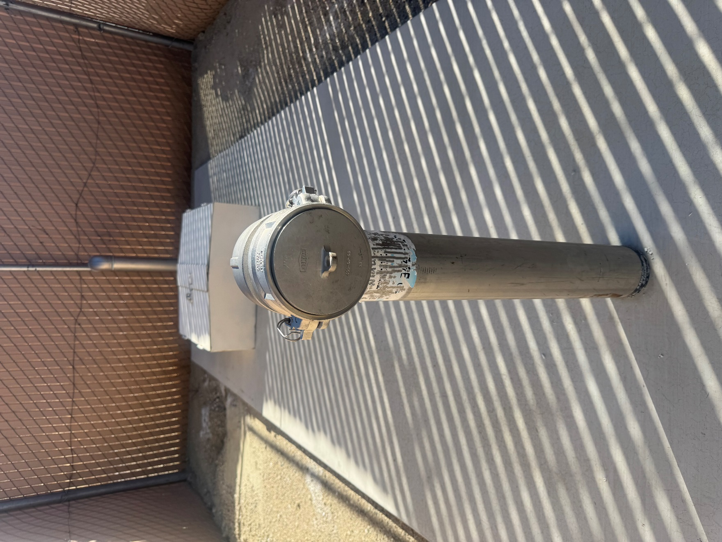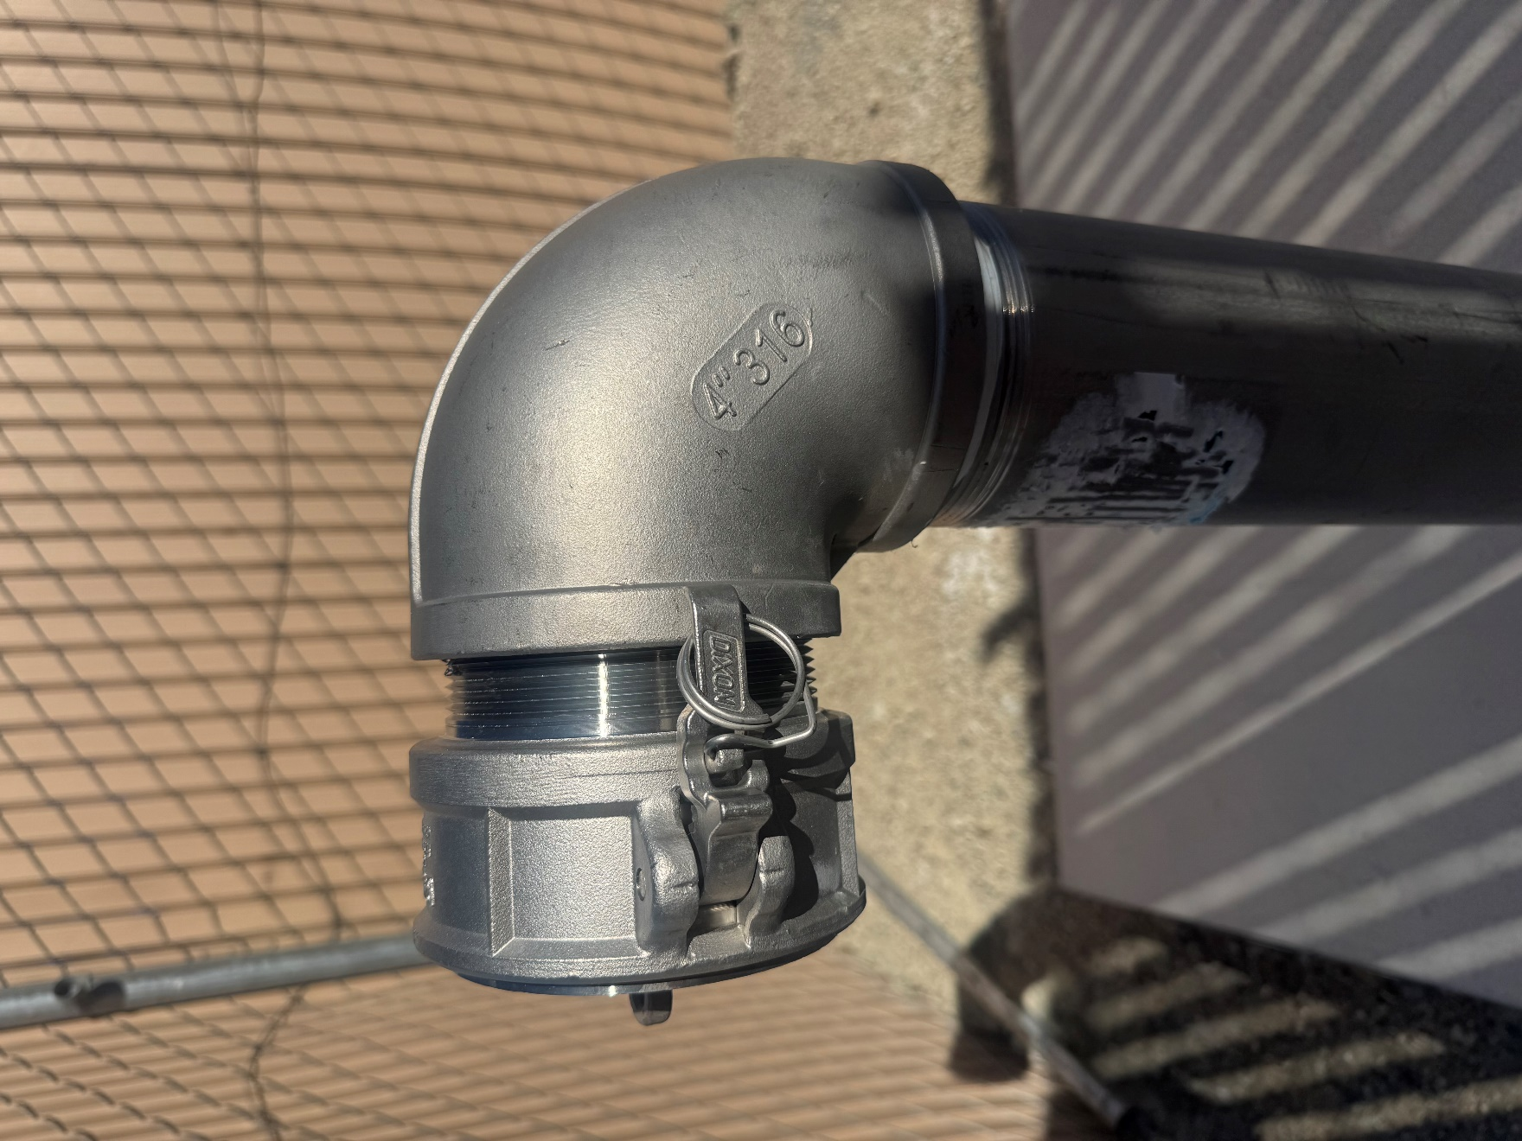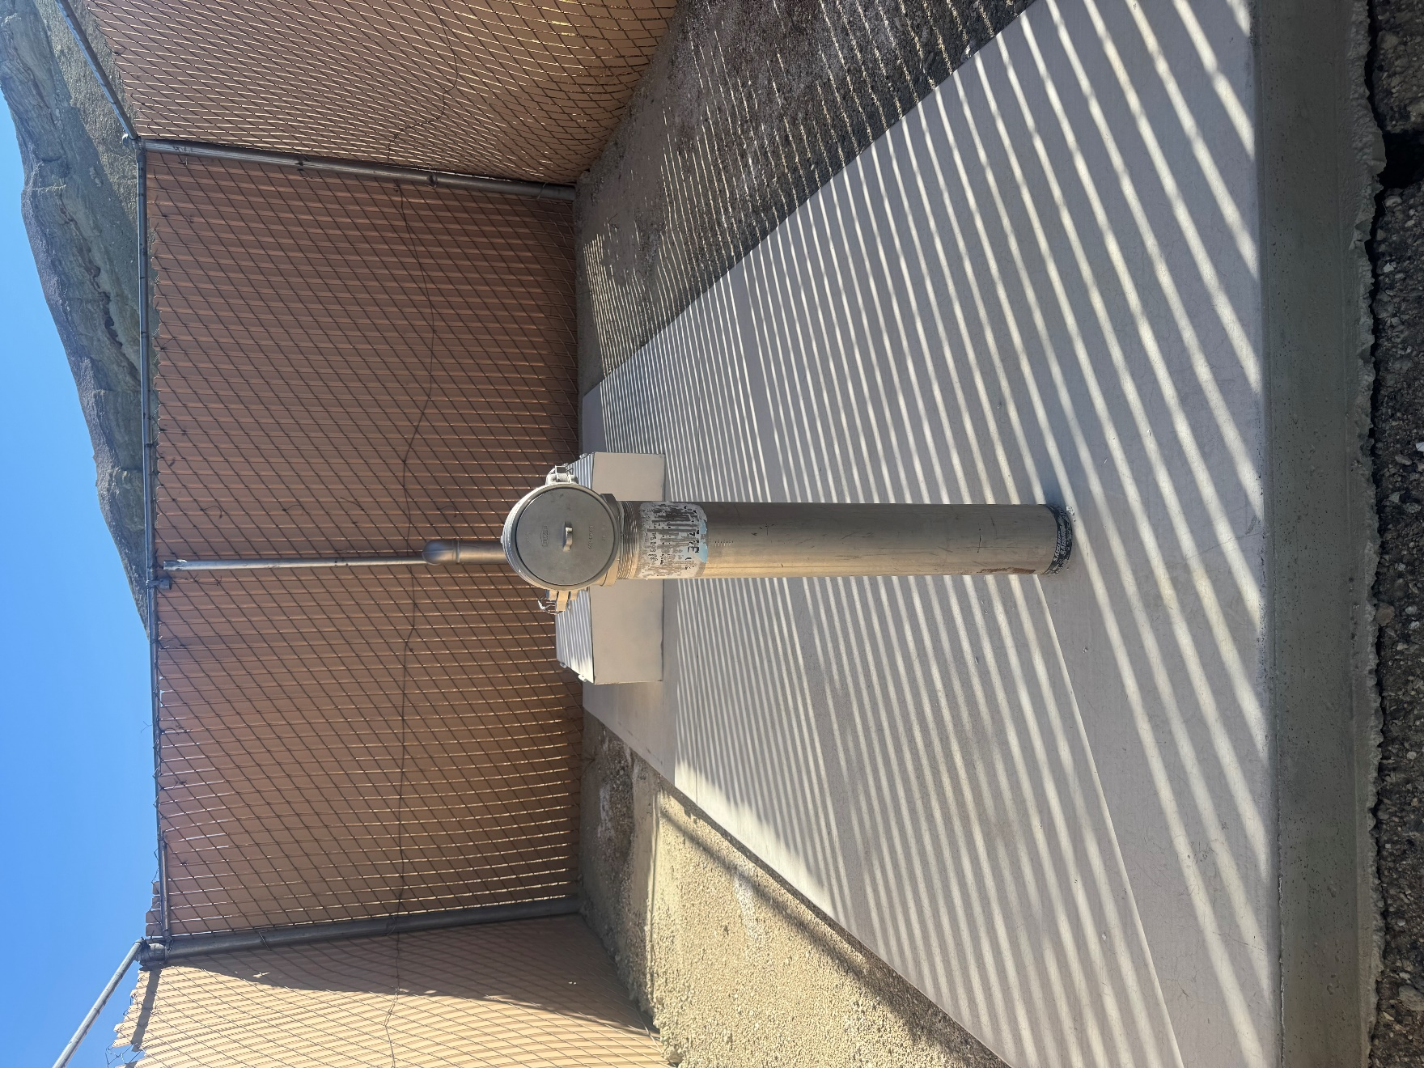

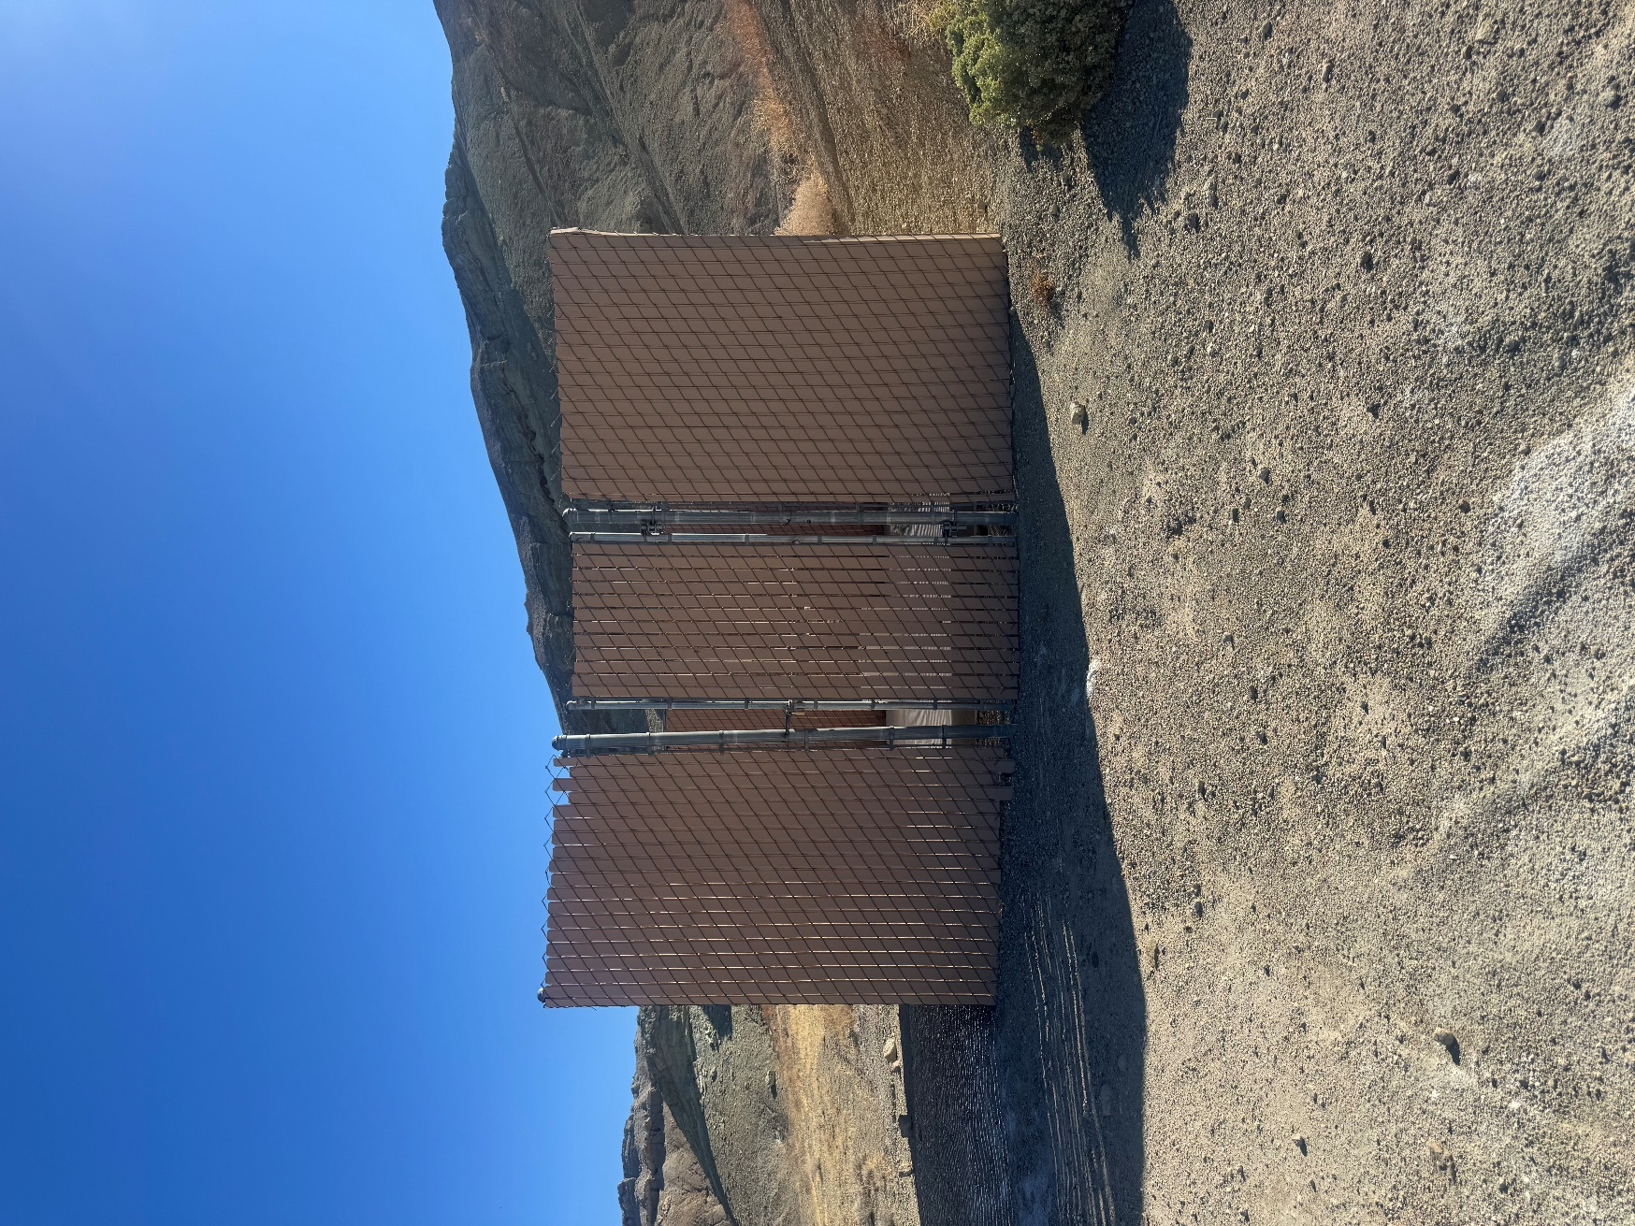

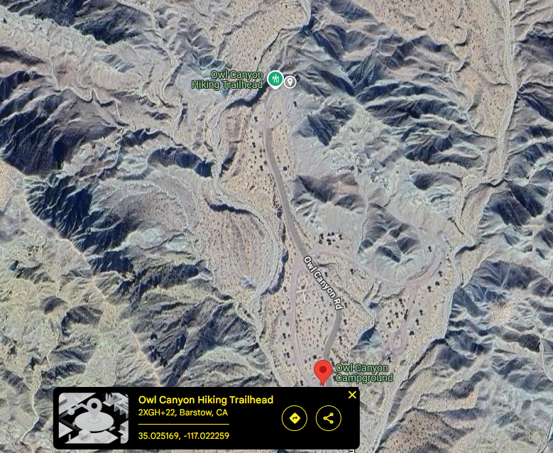

EX 2: Owl Canyon water testing sample collection point location and map.
GPS Coordinates: 35.024442, -117.022764

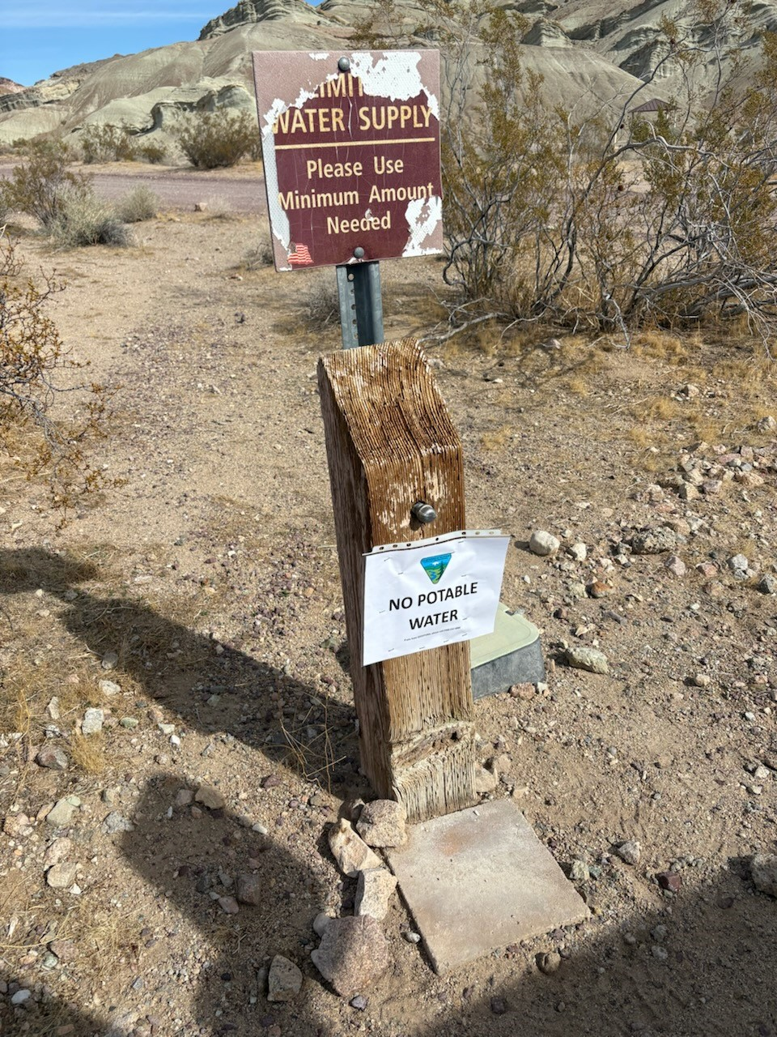

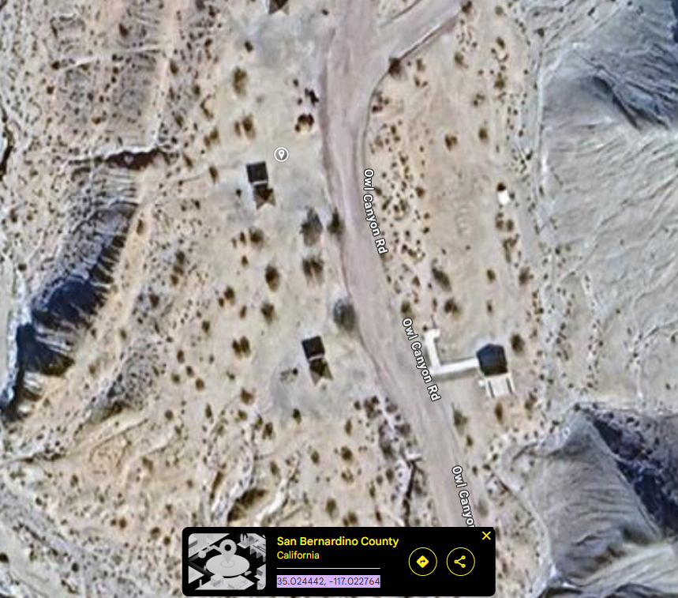

EX 3: Afton Canyon 2,000 Gallon in-ground potable water tank approach, tank, and fill location and map.
GPS Coordinates: 35.039729, -116.388742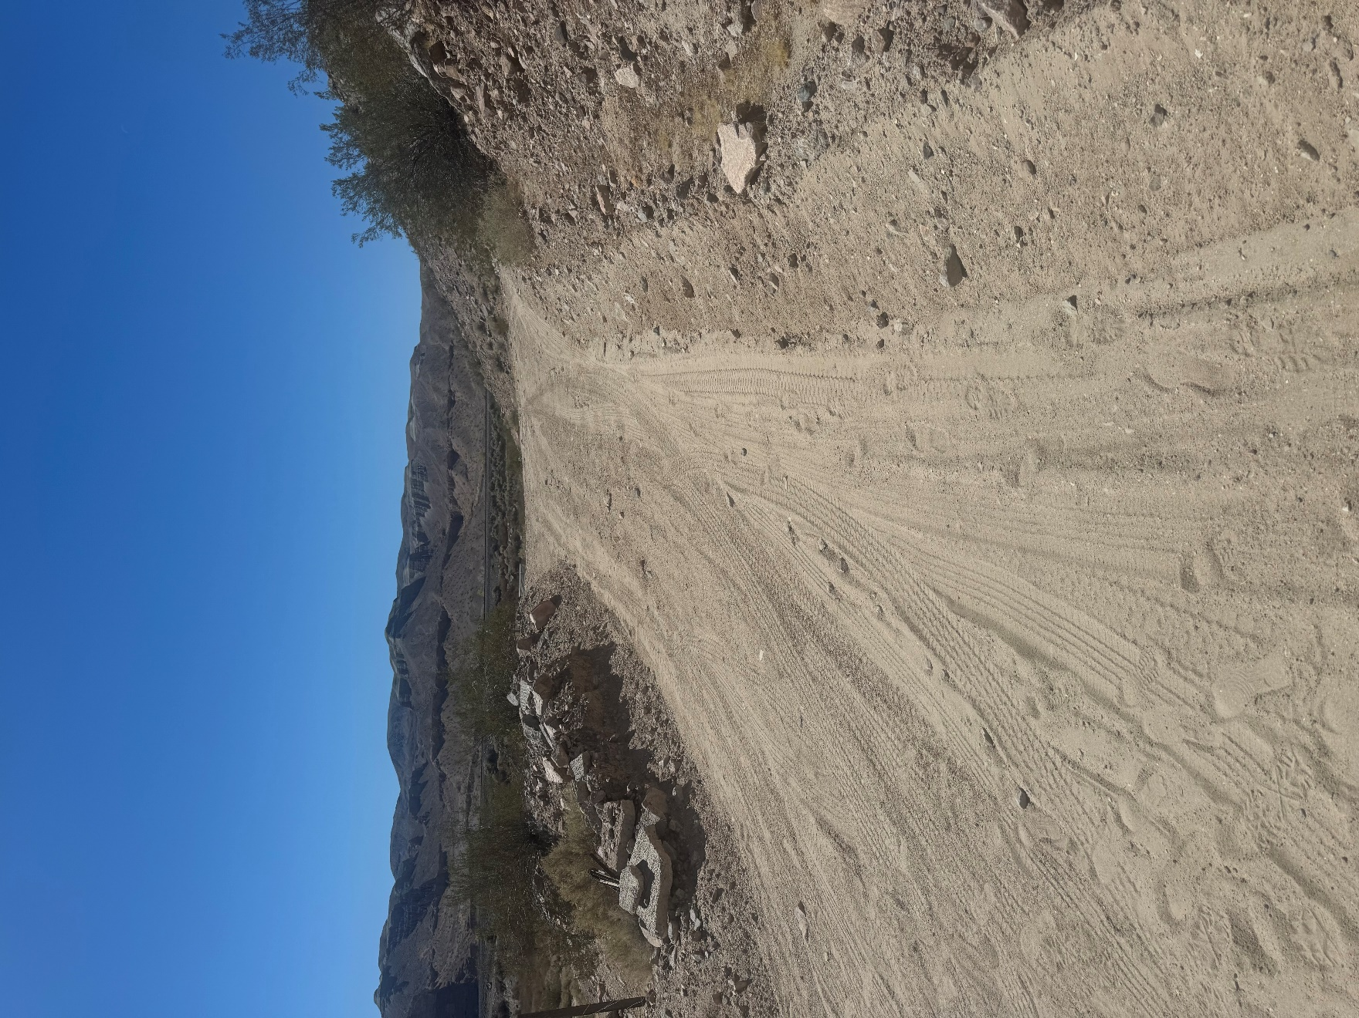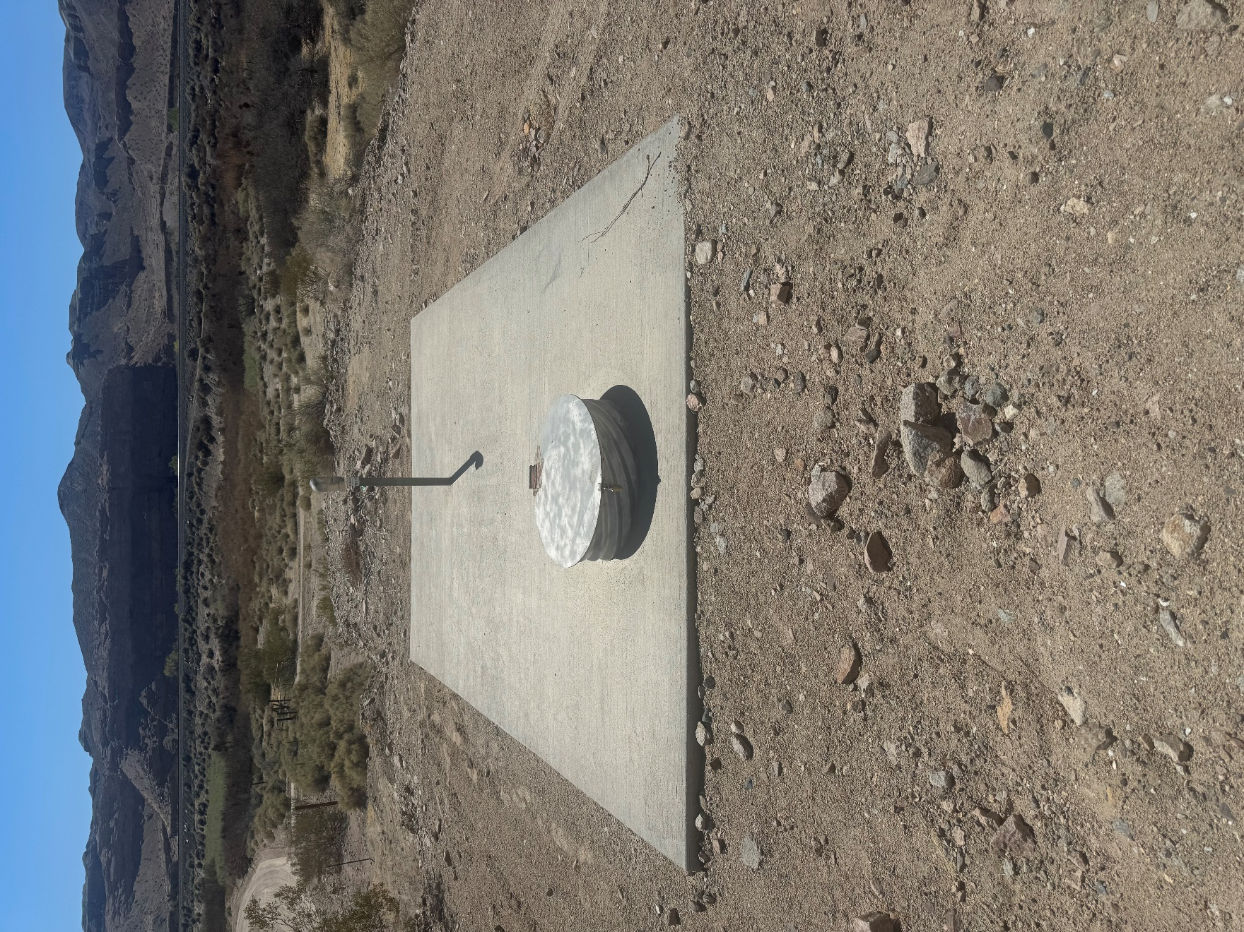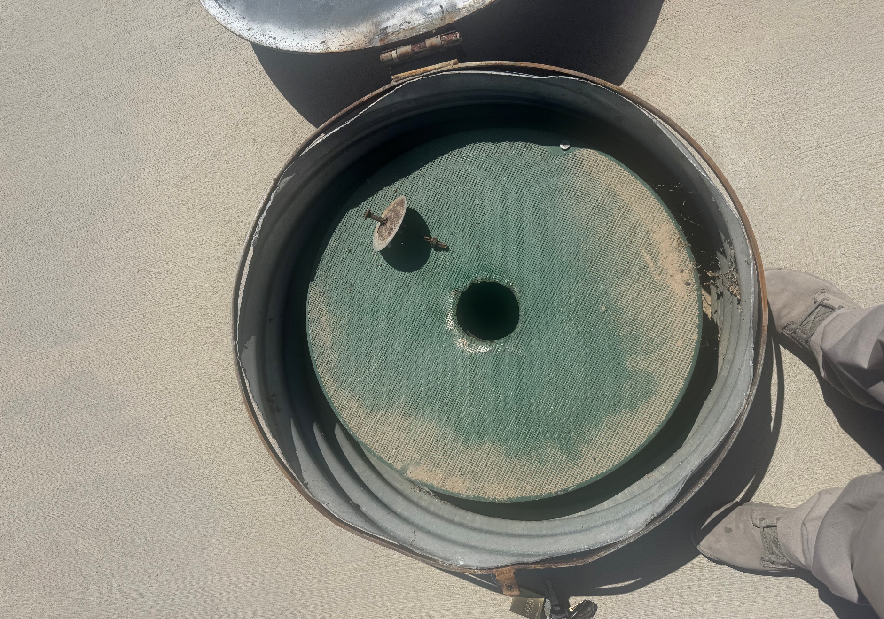

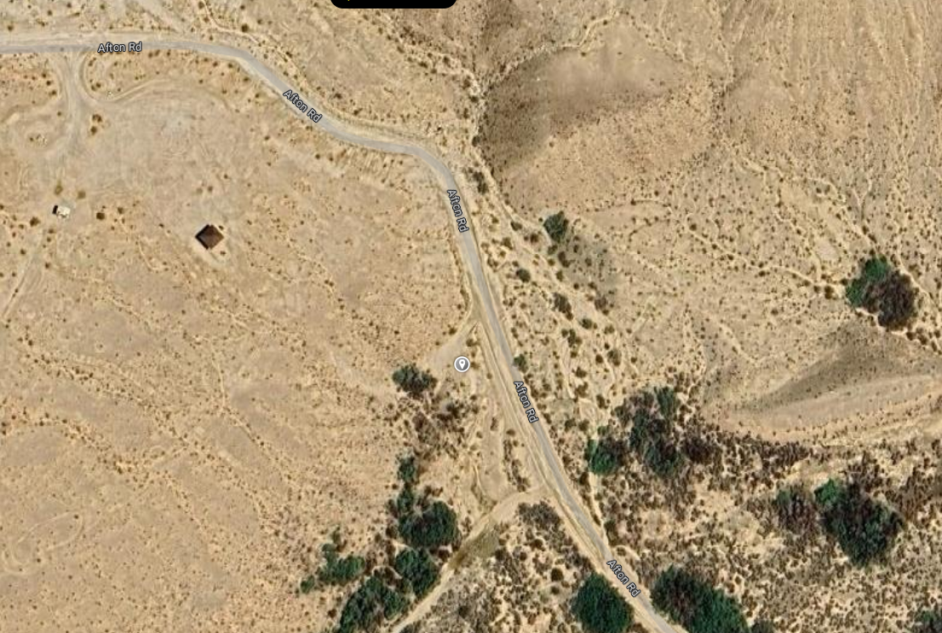

EX 4: Afton Canyon water testing sample collection point location and map.
GPS Coordinates: 35.038259, -116.384209

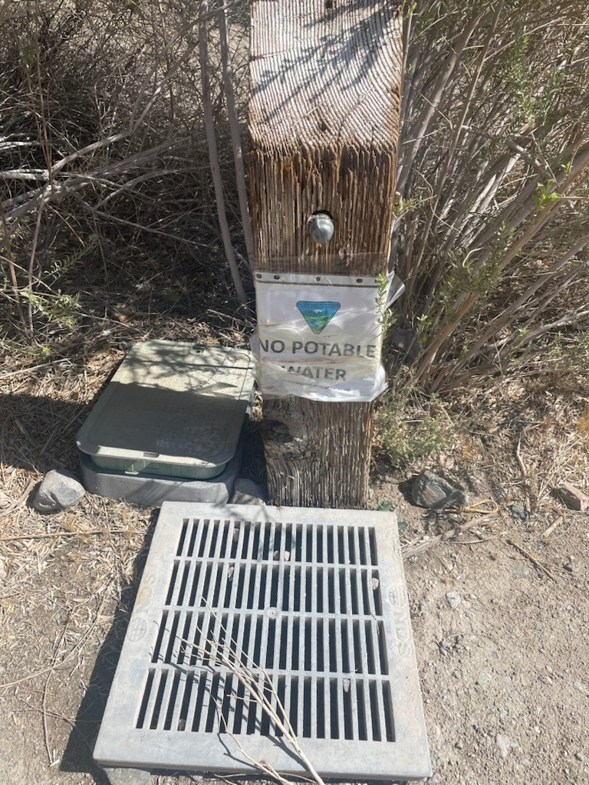

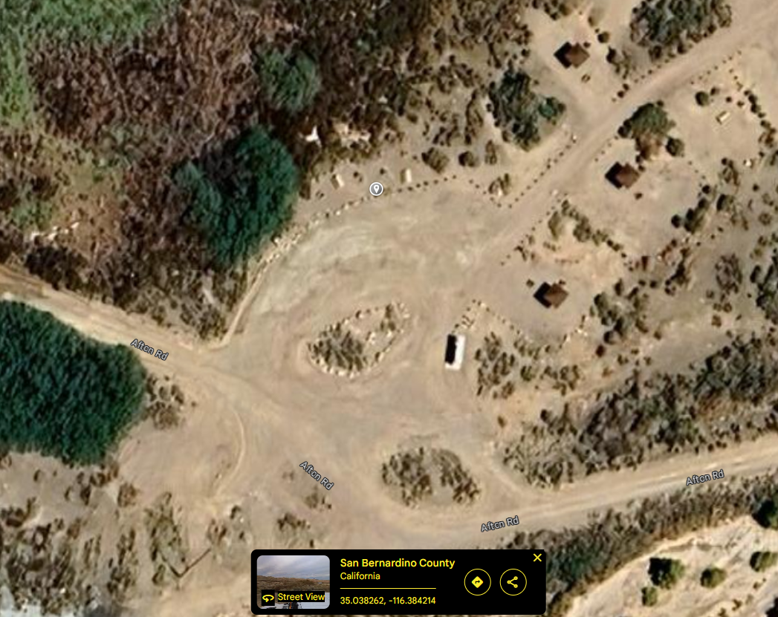

EX 5: El Mirage 1000-gallon above ground water tank, fill connection, water testing sample testing location, and location map.
GPS Coordinates: 34.622847, -117.542617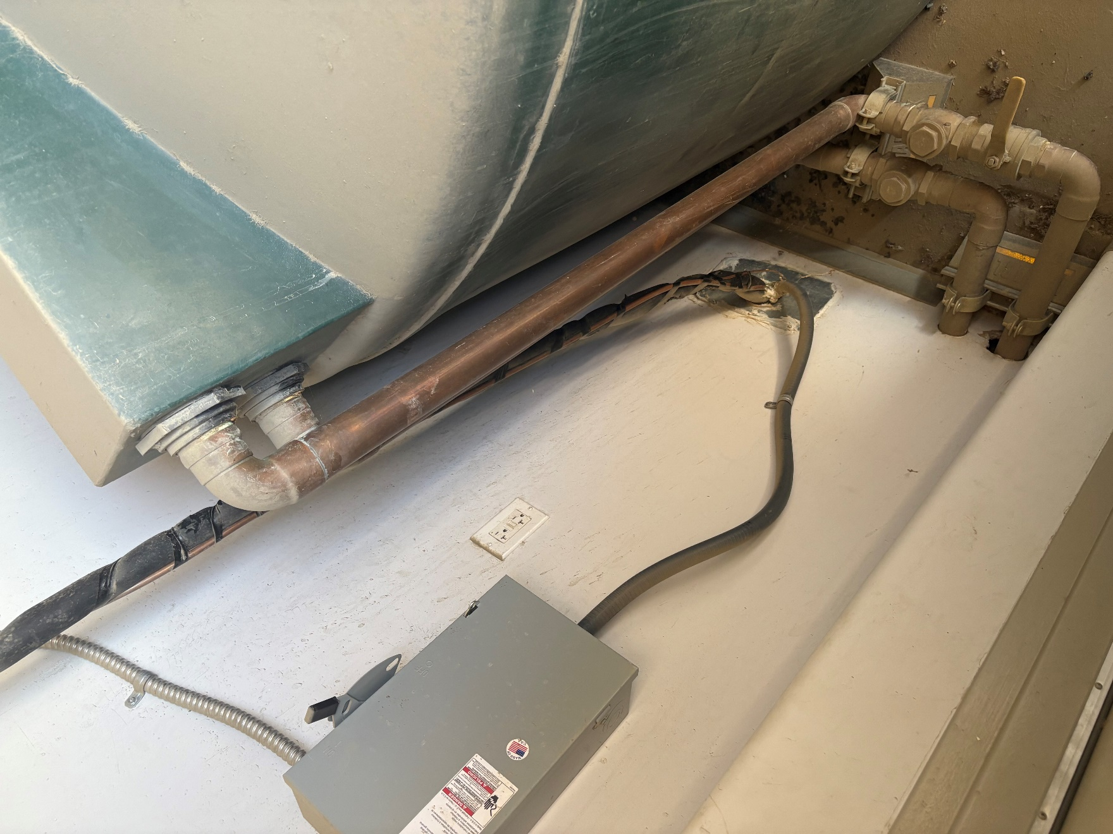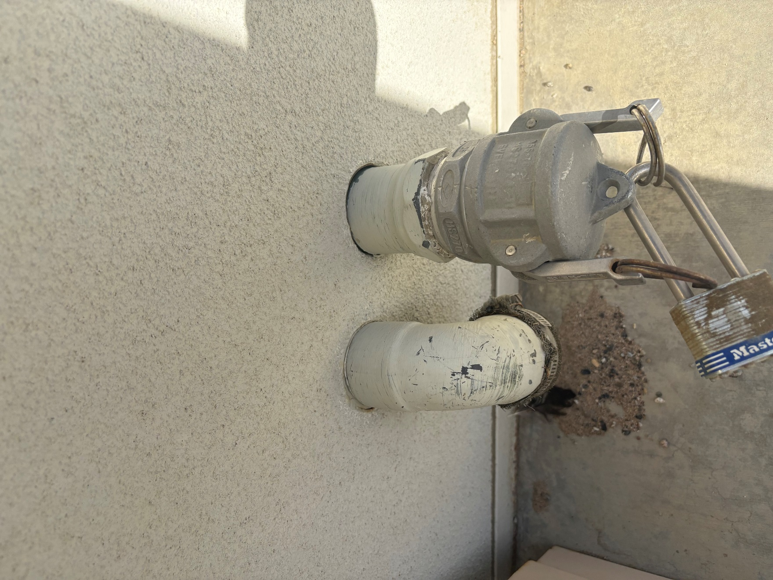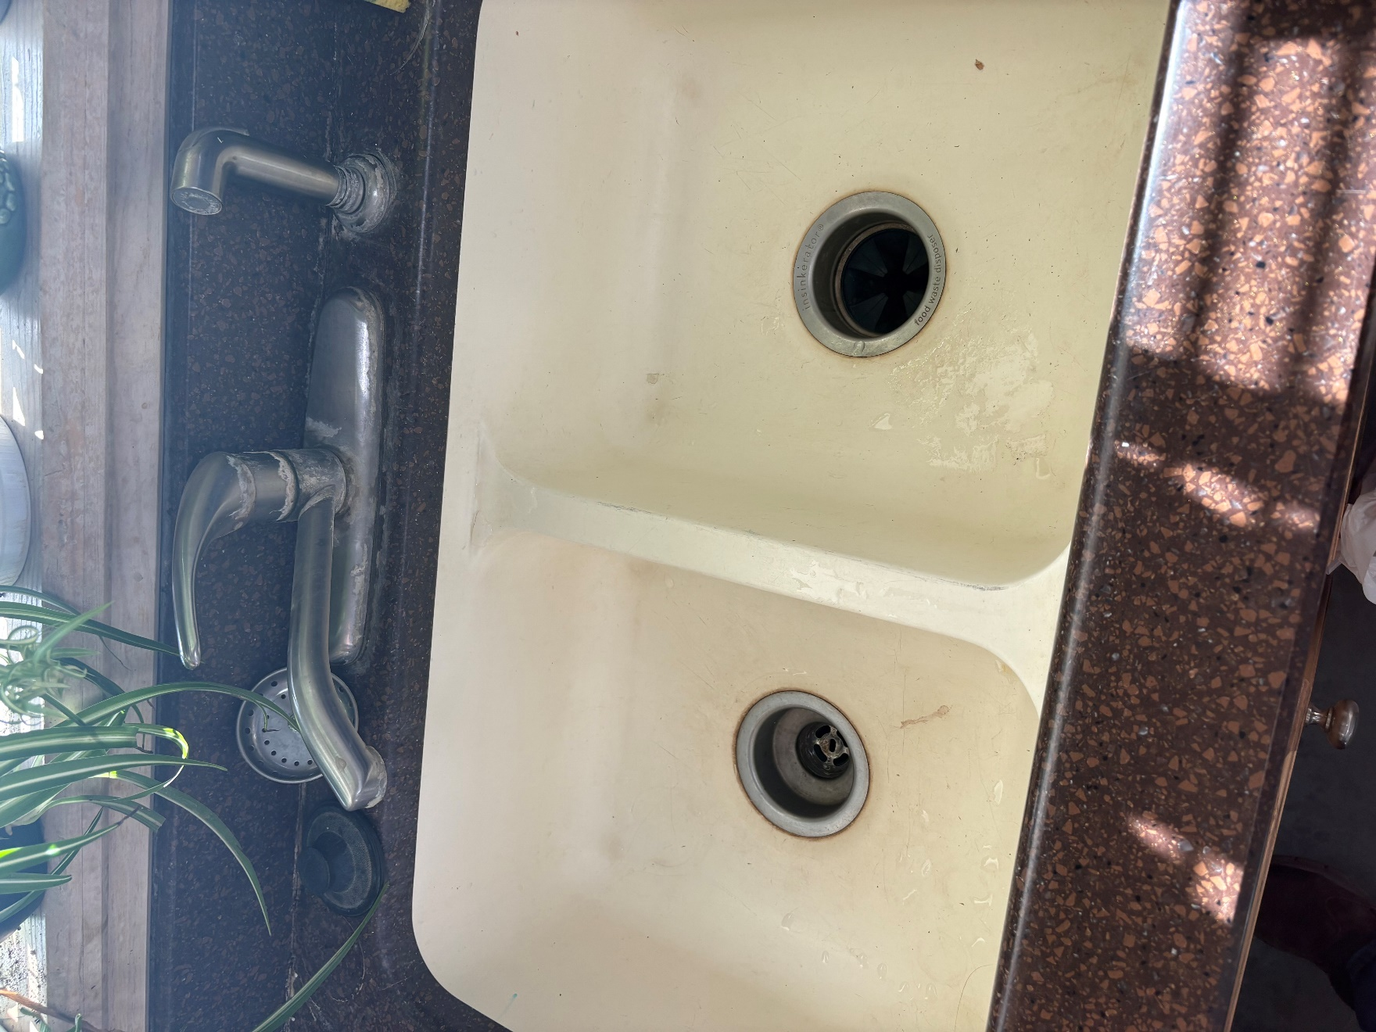

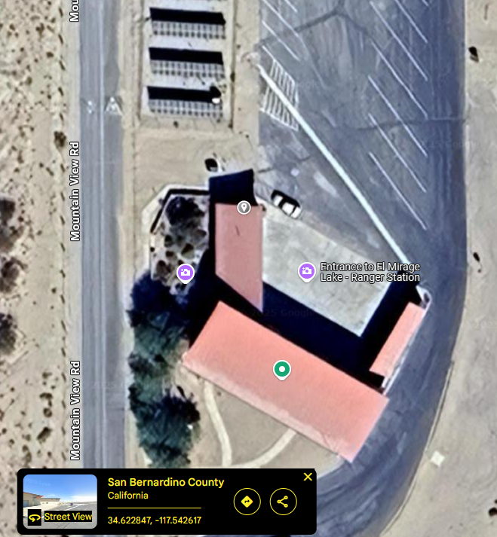

SECTION E: PERFORMANCE REQUIREMENTS SUMMARY (PRS)

Work Tasks to be Performed | Acceptable Quality Level | Method of Surveillance | Consequences, Remedies, and/or Deduction(s)
Task(s) 1-5 | No more than 2 unsatisfactory inspection result for duration of period of performance. | The COR or another Government Representative will inspect the facilities in-person during or after each delivery, filling/transfer and testing. | For 1 unsatisfactory inspection, the COR will document this and inform the Contractor what must be improved.  For 2 unsatisfactory inspections, a 10% deduction.

